

E-Portfolio

Anabela Mendes
Student nr:22124257
Lecture: Diola Bijlhout
Module: Creativity and Value Creation (BMHP5014- LON

Table of contents

Introduction …………………………………………………………1
Task 1 Mind map…………………………………….....................2
Task 2 Elevator pitch……………………………………………….3
Conclusion………………………………………………………..…4
Reference…………………………………………………………...5

Introduction:

In this E-Portfolio, I will present a project called Guineans Gathering Community Centre & Translator Service. This project is to help immigrants from the Guinean community with their everyday admin tasks and also a space to network with other members of the community who are in a similar situation.

People from Guinea-Bissau is a small country in West Africa with 2,104,206 million (2023) Population (WORLDOMETER,2022). When they come to this country, they don’t speak English and there is little to no help they can access to resolve their issues. They often struggle keeping with letters, appointments and finding work due to this barrier. Also, the fact that a majority of Guineans speak no English, makes it more difficult to find support in a predominantly English-speaking country. This community service will help close this barrier, allow members to learn English, keep up with admin tasks and meet other members of the community.

This Portfolio presents the project in Task 1 will be Mind Map and Task 3 will be an Elevator Pitch.

Task:1
Mind Map 
- Government help
- Community Collaborations

This Photo by Unknown Author is licensed under CC BY-SA
- Location

- Employers
Guineense Gathering Community
&
Translator Service

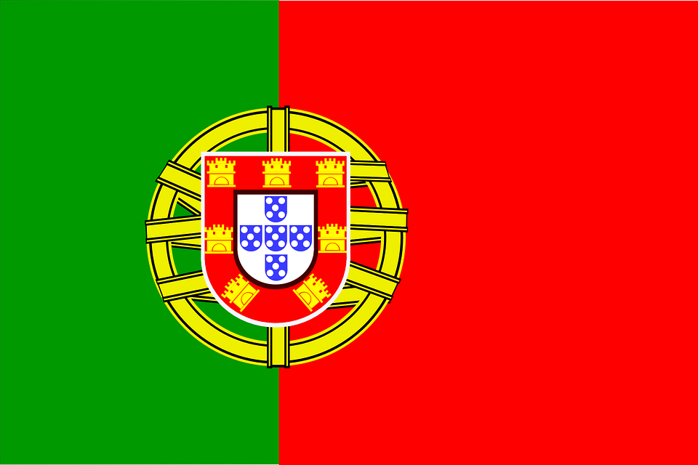

Services:
- English classes
- Interpreter
- Activities
- Health

Advertising
- Instagram
- Twitter
- Facebook
- Google

The following discussion is about the mind map drawn above.

At the heart Gathering Community Translator Service: This will be the centre where members of the Guinean community can go to, obtain translation support for a variety of matters, including letters, appointments, and interviews. The Guinean community is very small therefore there is a lack of resources available that help support the growth, development, and access of the community. When Guineans arrive in this country, they struggled a lot due to this and therefore hoped for a translation service they could access to sort out their issues. if the gathering community translation service when they arrived, it would have helped them settle extremely well in the UK.

Location:

After locating the area with the highest number of Guinean people, the plan would make it a perfect place to set up the gatherings. After speaking to several members of the Community and using data from the government website, (GOV, UK,2023) it was discovered that East London has the highest Guinean population. This would thus be the perfect place to start the community gatherings.

Government help, Community Collaboration:

After contacting Newham Council Business Support and Advice, who supports new businesses and credible projectors, it will be possible to secure a community centre located at 12 Avondale Court E16 2JH Canning Town. Also receive advice, guidance and potential funding to run the community gatherings will be sought for. (COUNCIL, 2023)

Employees:

Members from the Guinean community who have already settled in the UK will be hired as staff. They speak English and they are more than qualified to provide support for the members and help run the gatherings.

Services:

We will be offering English classes three days a week, Monday, Tuesday, and Wednesday. Classes will be open to Guinean members from all levels and will also consider other members outside the Guinean community to encourage integration. As for Thursday and Friday, we will dedicate this to group sessions where members can bring any issues, they need support with, including translation and form completion. The sessions will also allow members to network and get to know each other.

Advertising:

Flyers will be handed out to family, friends, and members of the public. also handed out flyers to shops, libraries, and door-to-door marketing. I further advertise on Instagram, Twitter, and
Facebook to reach a wider audience. Finally, the plan is to create a Google page where people can find details of the project.

Task: 3

Elevator Pitch

Hello, my name is Anabela Mendes, and I am the founder of the Guinean Gathering Community Centre which is a charitable project set up to help members of the Guinean community settle into the UK. Before I start this pitch, I would like to thank you for your time and attention.

I started this project firstly because, as a Guinean myself, when me and my parents first moved to the UK, it was extremely difficult for us to settle in because there were not many people from Guine-Bissau back in 2006. Therefore, we were extremely disadvantaged because there was nowhere to get support for translation to help with everyday administration. In 2019 there were 1 or 2 Guineans Translators services (LINGUISTPOINT,2023). We found it difficult to find employment and even settle into school. Reflecting back to these hard times, I strongly believe that our settlement experience would have been 10 times better, had we had connections with settled Guineans where we could seek advice and support. We would have benefitted from a community where we can socialise with like-minded people who are also in the same situation as us, while also being able to get support for things like council tax, Universal Credit etc. Unfortunately, for me and my family, the only solution was for me and my siblings to learn English as soon as possible so we can offer support to our parents. We struggled a lot during this time, and it extremely interfered with our overall quality of life. Research has shown that UK immigrants don’t have easy life first, after arrived (THEGUARDIAN,2023).

This is why I strongly believe in this project because I know that many Guineans will be able to get the support that my family did not have the privilege to have back then. The total number of Guinean settlers in the UK is increasing yearly, now more than ever and thus, I am confident that this project will positively change many lives.

Our excellent service of Gathering Community our goal is to provide 24/7 services such as translation support, application/interview support, English lessons, and community networking which as basic support services that will facilitate immigrants in navigating the UK better. I am not able to achieve this goal without your support, thus, every investment is equivalent to supporting a new member of the UK overall community.

Conclusion
This project is to help immigrants from the Guinean community with their everyday admin tasks and also a space to network with other members of the community who are in a similar situation.
This project will help all communities you don’t need to be African to get the help we help all races. By helping them with their application forms, and also helping them with appointment services.
I choose this project because is unique because there is no other project like this. Guinea-Bissau is a small country in West Africa with 2,104,206 million population (BMJ,2023). I have learned how to create a mind map and put all my ideas together I have never done something like that before I had so much fun creating my mind map and elevator pitch. I still have so much to learn from becoming a Changemaker.

References: ‌
Blog, M. (2018). Building a Mind Mapping Community - Part 1. [online] MindManager Blog. Available at: https://blog.mindmanager.com/start-lead-mind- mapping-community-work-part-2/ [Accessed 17 Mar. 2023].
‌
Aziz, N. (n.d.). Business support and advice. [online] Newham Council. Available at: https://www.newham.gov.uk/business-licensing-regulation/business-support-advice-1 [Accessed 30 Mar. 2023].

linguistpoint.co.uk. (n.d.). Guinea-Bissau Creole Translation Services | Linguist Point. [online] Available at: https://linguistpoint.co.uk/language/guinea-bissau- creole-translation-services [Accessed 18 Mar. 2023].

‌ data.worldbank.org. (n.d.). Rural population (% of total population) - Guinea-Bissau | Data. [online] Available at: https://data.worldbank.org/indicator/SP.RUR.TOTL.ZS?locations=GW. [Accessed 31 Mar. 2023].
‌
Wayne Paul, J., Alan Bezerra Rodrigues, R., Dawe, N., Ram, S., James Rupar, N., Raj Pandey, M., Paul, R., Thomsen, V., Jeffrey Forrest, R. and Seniuk Cicek, J. (2022). Defining Engineering Education Research: The Elevator Pitch. [online] tspace.library.utoronto.ca. Available at: https://tspace.library.utoronto.ca/handle/1807/126057 [Accessed 31 Mar. 2023].
‌
Office for National Statistics (2022). Population of England and Wales. [online] GOV.UK. Available at: https://www.ethnicity-facts-figures.service.gov.uk/uk-population-by-ethnicity/national-and-regional-populations/population-of-england-and-wales/latest[Accessed 31 Mar. 2023].

Frost, A. (2019). 6 Elevator Pitch Examples to Inspire Your Own. [online] Hubspot.com. Available at: https://blog.hubspot.com/sales/elevator-pitch-examples. [Accessed 31 Mar. 2023].
data.worldbank.org. (n.d.). Population, total - Guinea-Bissau | Data. [online] Available at: https://data.worldbank.org/indicator/SP.POP.TOTL?locations=GW. . [Accessed 5 April. 2023].

‌ linguistpoint.co.uk. (n.d.). Guinea-Bissau Creole Translation Services | Linguist Point. [online] Available at: https://linguistpoint.co.uk/language/guinea-bissau-creole-translation-services.
‌ Jenkins, S. (2022). Here’s the best way for Britain to solve the migrant crisis: give them work visas. The Guardian. [online] 3 Nov. Available at: https://www.theguardian.com/commentisfree/2022/nov/03/solve-immigrant-crisis-work-visas-populist- politics#:~:text=Immigration%20into%20Britain%20has%20not [Accessed 5 Apr. 2023].
‌

