Research on Corporate Social Responsibility: Case Study on Three Automaker Corporation

Course name: 21st Century Business and Societal Ethics

Course ID: BMDM7008

Student Name: Bowen Yu

Student ID: 2008848

8088 Words for Main Contents

Abstract
This report explains the current concept, application, difficulties and future development of corporate social responsibility under the framework of deontology, and combines three world-class automakers as case studies for in-depth research.

Keywords: Corporate Social Responsibility, Vehicle Manufacturers, Deontology, Management, Social Responsibility.
Table of Contents
1.0 Introduction 1
2.0 Literature Review 2
2.1 Corporate Social Responsibility 2
2.2 Deontology in CSR 3
2.3 Stakeholder Theory and Mendelow Matrix 5
3.0 Research Method 8
4.0 Content Analysis 9
4.1 Toyota Motor Corporation 9
4.2 Ford Motor 14
4.3 BMW 15
4.4 CSR Difficulties: The Negative CSR Cases of Three Automakers 17
4.5 Reflection 19
5.0 Conclusion 20
6.0 References 23
Appendixes 29
Appendix1: Toyota Philosophy 29
Appendix2: Toyota Code of Conduct 2018 32
Appendix3: Toyota Human Rights Policy 36
Appendix4: Traffic Safety Activities of Toyota 41
Appendix5: Toyota Environmental Challenge 2050 47
Appendix6: Human Rights and Environment of Ford Motor 48
Appendix7:Ford Motor UN Guiding Principle Report 55
Appendix8:BMW Group position regarding climate legal actions, 19.09.2021 70
Appendix9:BMW Group Supplier Sustainability Policy 72
Appendix10:SUSTAINABILITYQUESTIONNAIRE FOR SUPPLIERS. BMW-SPECIFIC EVALUATION OF SAQ 83

1.0 Introduction
Until today, corporate social responsibility has become a comprehensive measure of business. At present, corporate social responsibility has become the content of corporate strategy for most companies, and the core of its strategy is still the sustainable development of social, environmental and governance projects. (Everfi, 2022. Jackson, 2021. Vanco, 2021)

Corporate social responsibility is not just a business operation model of an enterprise, it is a practice to ensure that an enterprise fulfills its social responsibility. The successful implementation of corporate social responsibility strategy will allow business operations to affect the entire society, and the managers of these companies will promote social responsibility behavior by improving the environment, society and economy.(Jackson, 2021.)

In general, the main target of an enterprise's CSR behavior is its stakeholders. Simply put, stakeholders include people or organizations that have economic interests or investments in the enterprise as well as people or organizations that have no economic interests, including internal and external stakeholder groups within the organization: employees, investors, government departments , NGOs, etc. Due to the diversity of an organization's stakeholder groups, organizations generally combine internal and external stakeholder groups to carry out corporate social responsibility strategies. (Vanco, 2021.)

Under the impact of the current pandemic, the new social environment and crisis have caused obvious changes in the concept of consumers. Consumers are now more aware of current events and changes, and are more aware of physical, emotional, social and financial challenges. Consumers' expectations for companies have changed from a long-term perspective to a focus on current corporate social responsibility actions. For consumers, corporate social responsibility has become part of a company's reputation and image.(Jackson, 2021.) Therefore, corporate social responsibility actions have become more important in today's environment. In addition to being driven by stakeholder groups, corporate managers’ own cognition and sense of responsibility for corporate social responsibility are also the main driving forces for corporate social responsibility, that is, corporate managers will do what they think is beneficial and correct to society. thing. Such a spontaneous drive can be explained deontologically, that ethical behavior follows universal moral laws, that the morality of behavior should be based on whether the behavior itself is right or wrong, rather than the consequences of the action, and requires people to obey the rules and perform their duties. (Ethic, 2022)

This report will focus on corporate social responsibility. In the first part, the researcher will introduce the main drivers of CSR, namely the basic knowledge and framework of stakeholder groups and deontology, and explain their role in promoting CSR. Since CSR needs to be explained and evaluated in more detail, the researcher will explain and evaluate the CSR behaviors of three different auto companies in the second part: Toyota Motor Corporation, Ford Motor Corporation and BMW . Researcher chose car companies because car manufacturers are not just simply making cars, they are the performance of a country's comprehensive strength, and they are also major players in the construction and promotion of society. Toyota, Ford and BMW all represent large companies in the world and in Asia, America and Europe, and their corporate social responsibility behaviors can also represent the current state of corporate social responsibility in today's world companies to a certain extent. At the end, the researcher will explain and evaluate the future development of corporate social responsibility based on the analysis of the first two parts.

2.0 Literature Review

2.1 Corporate Social Responsibility
Generally, the corporate social responsibility of modern society is produced after the Second World War, especially in the 1960s when the development of corporate social responsibility was very rapid. Socially, social responsibilities such as the civil rights activities, female rights, consumer rights, and the development of environmental awareness have largely developed the corporate social responsibility. In the 1970s, state-level institutions for social responsibility, consumers and equality were established, which led to great progress in corporate social responsibility. In the 1990s, corporate social responsibility began to develop globally, that is, globalization and institutionalization.(Carroll, 2015) The development of corporate social responsibility has become a global concept with the interaction of thought and action. The scope of corporate social responsibility is not only to help companies abide by basic ethics and obtain benefits, it includes factors such as ethics, charity, law, etc., to improve social expectations of corporate stakeholders and modern organizations, and continue to be in the global market.(Carroll, 2015. Lindgreen and Swaen, 2010)

It should be noted that corporate social responsibility is a relatively subjective concept, so it lacks a generally accepted definition. In order to have a clear concept of corporate social responsibility, different scholars have put forward different views.(Carroll, 2015. Grigoris, 2016. Fitch, 1976.) On the one hand, corporate social responsibility specifies that a company's responsibility is to any group or individual that may affect or be affected by the achievement of the organization's goals. On the other hand, under this framework, corporate social responsibility also points out that companies need to conduct business activities under standards that meet or exceed the expectations of ethics, law, business and the general society. The main drivers for organizations to take corporate social responsibility measures are: internal organizational factors, competitor actions, investor organizations, consumers, government regulators and so on.(Grigoris, 2016) Generally, organizations adopting corporate social responsibility policies should not expect to gain benefits or rewards by adopting corporate social responsibility policies, but some corporate social responsibility policies have obvious benefits, including but not limited to:

- Improve organizational finances and performance.(Grigoris, 2016)

- Attract new employees, motivate existing employees, and reduce employee turnover.(Grigoris, 2016)

- Improve corporate social responsibility.(Grigoris, 2016)

- Strengthen the company's reputation in society.(Grigoris, 2016)

- Get more capital.(Grigoris, 2016)

An obvious feature is that due to the diversity of corporate stakeholder groups, their requirements for corporate social responsibility will continue to change. For example, some stakeholder groups will require companies to carry out corporate social responsibility actions in multiple aspects. However, some stakeholder groups only require companies to carry out detailed corporate social responsibility actions in one aspect.(Lindgreen and Swaen,2010. Schooley, 2021) This phenomenon has led to a very broad and complex concept of corporate social responsibility. However, so far, the importance of corporate social responsibility has not been reduced because of its complexity. On the contrary, many enterprises, especially large enterprises, have included corporate social responsibility in the obligations and responsibilities of corporate development.

2.2 Deontology in CSR
The "father" of deontology, the famous philosopher Immanuel Kant, believed that people could develop a coherent system of morality and ethics through the use of reason.(Chakrabarty and Erin. 2013, Freeman and Werhane,2008.) This moral ethics concerns the correctness of a person's actions and the motives for his actions. Simply put, deontology aims to critique people's actions and motives, rather than focusing on the consequences of their actions. (Chakrabarty and Erin. 2013, Freeman and Werhane,2008.Bcampus,2022.) Kant stated in his "absolute imperative" that the behavior of some things has an objective necessity in itself, and has nothing to do with other purposes. An absolute imperative is not the basis of action, it is the purpose of action itself. The absolute imperative is executed without regard to any other intent and purpose, nor does it vary depending on any particular situation.(Bcampus,2022.BBC,2014.) Putting Kant's absolute imperative in the deontological framework, it can be understood as: under deontology, if a person is doing a morally correct action, then he is doing a good thing, because it is good in itself and is It is unconditional, inevitable, and it needs to be followed.(Freeman and Werhane,2008.) For example: honesty is a good thing from the root, then people have the obligation to be honest and trustworthy unconditionally, and abide by morals and ethics. Therefore, from the point of view described above, deontological ethics teaches that something is right or wrong in itself, regardless of its consequences. People have a responsibility and obligation to do the right thing, even if the outcome is bad. In this sense, deontologists will insist on doing what is morally right, and will maximize behavior that makes those things better.

Deontology is concerned with human actions, not the consequences of human actions.(Bcampus,2022. BBC,2014.) Deontology emphasizes ethics, and ethics are obligations. Deontological people live in a world of rigorous morality and moral rules, and they think doing the right things because it is right and not doing the wrong things because they are wrong. For example: helping others because helping others is right. Don't kill, because killing is wrong. The view advocated by deontology emphasizes on the individual, it constrains individual behavior, and advocates correct individual morality and obligations.

If the above ethical and moral code of conduct is reversed, that is, deontologists need to think about this action before taking action to evaluate whether it is correct and positive. Generally, they will think about the following questions:

- Is this action correct or incorrect? (Freeman and Werhane,2008. Micewsk and Troy, 2007)

- Is this action acceptable to other rational people?(Freeman and Werhane,2008. Micewsk and Troy, 2007)

- Is this action universal? In other words, does it apply to other similar situations?(Freeman and Werhane,2008. Micewsk and Troy, 2007)

- Does this action respect the dignity of others? Or at least not denigrate the dignity of others?(Freeman and Werhane,2008. Micewsk and Troy, 2007)

Kant's deontology gives a criterion for evaluating morality. It can not only assess people's code of conduct, but also reflect social ethics, social regulations and laws. As mentioned above, the right and wrong proposed by Kant's deontology are not the right and wrong of their results, but that their actions conform or violate the moral code of conduct. Deontology, on the other hand, includes all people through absolute imperative, and sets up moral and ethical behaviors, so as to obtain the most beautiful humanities and society.(Freeman and Werhane,2008. Micewsk and Troy, 2007)

If deontology is combined with corporate social responsibility, it can be well found that Kant's absolute imperative and deontology can create a good ethical and moral framework for individuals in a business. At the same time, the moral ethics emphasized by deontology can serve as the driving force for the moral behavior of individuals in an organization. Individuals in an organization should act on the basis of conscientious ethics, so as to demonstrate the conscientious moral character of the organization as a whole. Beyond the individual, deontological principles will drive organizations to do what is good for society, reflecting the good morals inherent in organizations, i.e. demonstrating their corporate social responsibility.(Freeman and Werhane,2008. Micewsk and Troy, 2007)

2.3 Stakeholder Theory and Mendelow Matrix
In general, a stakeholder is anyone who can affect or be affected by an organization, strategy, or project. These personalities can be internal or external to the organization. (Donaldson and Preston, 1995. Mitchell, Agle and Wood, 1997. Johns and Wicks, 1999.) Mitchell, Agle, and Wood (1997) proposed that the stakeholder theory dates back to the early days of corporate social responsibility, and defined it as "corporate obligations to socially constituted groups other than shareholders that go beyond legal or contractual obligations On this basis, they ask: what are these groups, and how many of these groups does the company need to serve? How should their interests be balanced? How much should the company pay to distribute benefits and services?

Freeman (1984, 1990) mentioned that a stakeholder in an organization is any group or individual that can influence or be affected by the achievement of organizational goals, which has become the broadest definition of a stakeholder at present. The stakeholder theory is descriptive, describing the company as a competing interest group with intrinsic value. At the same time, stakeholder theory is also instrumental in that it establishes a framework for organizations to examine the links between the practice of stakeholder management and the achievement of various company goals. Stakeholder theory is also normative, pointing out that an organization's stakeholders are determined by the organization's interests and examining whether the company has any corresponding ability to create benefits. All interests have their own intrinsic value, and they are considered for their own sake. Finally, stakeholders are managerial and provide managers with advice, theoretical frameworks, and practical approaches.

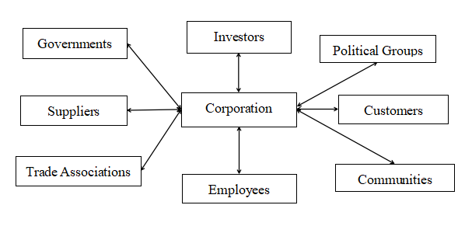
Figure1: Stakeholder Map. (Freeman,1984,1990. Donaldson and Preston, 1995.)

As can be seen from Figure 1, an organization's stakeholders are characterized by diversity and complexity. Due to the different areas that different organizations target, their key stakeholders also vary. Organizational managers therefore need to identify their organization's primary and secondary stakeholders, and be aware of their interests and drivers. Therefore, the mendelow matrix is one of the ways to help organizational managers identify their own stakeholders. medelow analyzes groups of stakeholders associated with an organization in terms of stakeholder power (ability to influence the organization's strategy or project resources) and stakeholder interest (the level of interest that stakeholders have in the organization's projects).(Olander and Landin, 2005)
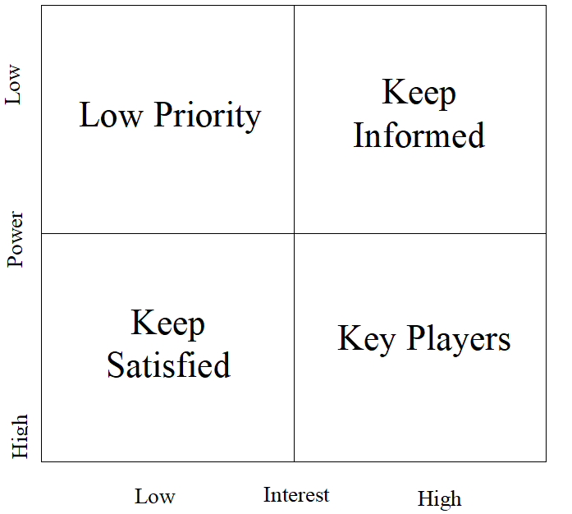
Figure2: Mendelow Matrix.(Olander and Landin, 2005. Oxford, 2018)

High Power, High Interest People: Fully attract these people and do the best to keep them satisfied. (Olander and Landin, 2005. Oxford, 2018)

High Power, Low Interest People: Try to keep them satisfied, but not let them get tired of organizational projects. (Olander and Landin, 2005. Oxford, 2018)

Low Power, High Interest People: Communicate fully with these people to ensure that no major situation arises, and get suggestions or ideas for project improvement from them. (Olander and Landin, 2005. Oxford, 2018)

Low Power, Less Interest People: Keep an eye out for changes in their level of interest and don't communicate too much. (Olander and Landin, 2005. Oxford, 2018)

Combining and applying stakeholder theory and the mendelow matrix, it is important to see that it helps organizational managers to understand, analyze, and manage the organization's primary and secondary stakeholders. In the next section, these theories will be applied in the case of three motor corporation, combined with the deontological theory mentioned earlier, to analyze the corporate social responsibility issues arising from various events in these three corporation, and demonstrate corporate efforts for corporate social responsibility.

3.0 Research Method
In order to have a better understanding of corporate social responsibility, the researchers chose qualitative research methods to collect literature on the main research objects of this report. The purpose of this is that the existing literature review can help researchers better understand the basic information of CSR, the meaning and role of the deontological driving force of CSR, and evaluate the future development of CSR. At the same time, the researchers combined the collected theoretical literature review with the CSR action cases of Toyota, BMW and Ford Motor Company, analyzed the existing CSR action phenomenon through theory, and obtained the researcher's proposal. relevant arguments and give an evaluation.

It is worth noting that because the theory of corporate social responsibility is a complex and extensive theory, in order to better combine other arguments for analysis, the researchers mainly collect information on the basic concepts and frameworks of corporate social responsibility. Such collections have created deficiencies that have not been further studied on CSR. Not only that, in the literature collection of deontology, the researchers also mainly collected the basic information of deontology and the application methods and frameworks of deontology related to business management, corporate social responsibility and management. Throughout the qualitative research exercise, the researchers collected more than 60 literature reviews, most of which were journals and reports, mainly from prestigious journals such as academy of management, and from online libraries such as jstor valid information. The content collected by the researchers is divided into corporate social responsibility, deontology, stakeholder theory, and corporate social action data on three automakers. Table 1 summarizes the summary of different types of major literature reviews collected by the researcher

Main Focus | Research Method(s) | Example(s)
CSR | Concept of CSR | Lindgreen and Swaen(2010). Grigoris(2016). Carroll(2015).Fitch(1976).
CSR | Difficulties and Solutions of CSR | Sheehy(2015). Schouten,Graafland and Kaptein(2014). Bondy, Moon and Matten(2012). Moncrieff(2015).Grigoris.(2016)
CSR | Future development of CSR | Strandberg(2002). Gupta and Sharma(2009). Moon and Shen.(2010). Boatright(2001). Garriga and Mele(2004).
Deontology | Concept of Deontology in Business and CSR | Chakrabarty(2015). Micewski and Troy(2007). Freeman and Werhane(2008).
Stakeholder Theory | Stakeholder theory and Mendelow Matrix framework | Donaldson and Preston(1995). Mitchell, Agle and Wood(1997). Jones and Wicks(1999). Olander and Landin(2005)
Content Analysis | Case Study from Toyota, Ford and BMW | Toyota(2020). Toyota(2018). Toyota(2020). Toyota(2021). Liker and Morgan(2006). Dyer and Nobeoka(2000).Ford(2021). Ford(2021). BMW(2021). BMW(2021). BMW(2020)

Table1: Major Literature of this report.

4.0 Content Analysis
In this part, researcher will analyze CSR actions of Toyota Motor Corporation, Ford Motor Corporation and BMW, to discuss and evaluate the current development and application of CSR. As mentioned above, corporate social responsibility is not only to serve the corporate stakeholder group, it is also driven by the internal managers of the enterprise through the basic theory of deontology. Deontology is not just a system of ethics and ethics, it gives managers the criteria by which to evaluate corporate ethics. It can not only assess people's code of conduct, but also reflect the provisions of regulations and laws. Deontology can subconsciously turn other people into absolutely rational deontologists through the moral framework of deontists. Therefore, this part will first explain the internal driving force of corporate social responsibility of three auto manufacturers, including corporate policies, corporate operation core and corporate culture, etc., to analyze the construction of corporate social responsibility within the enterprise. Following this, researcher will describe and evaluate the corporate social actions of the three automaker companies.

4.1 Toyota Motor Corporation
As the world's largest automaker and a leader in corporate management, Toyota Motor Corporation is already Japan's largest company and the world's ninth largest company, and has become the world's first automaker to sell more than 10 million vehicles a year business. Until now, Toyota not only has a leading global sales record, but also its corporate philosophy, advanced technology research and development, and good corporate social responsibility.

Toyota Motor Corporation's CSR has been integrated with the company's core philosophy, operating core and corporate guiding principles. After decades of development, Toyota's famous operating philosophy, the Toyota way (More details can see Appendix1), has combined social responsibility and corporate operation into one, and put forward the latest corporate operating philosophy:

TMC will combine its own software, hardware and partners to create the unique value of the Toyota way. (Toyota, 2021)

Software: TMC will strive to improve society through a human-centered design philosophy that fully utilizes the imagination of its employees. Toyota Motor Corporation will understand the nature of work and operations through genchi genbutsu (real places and real things, which refers to understanding the situation by observing what actually happens when you work).(Toyota, 2021)

Hardware: TMC will create a physical platform for the mobility of people and things and a flexible system that changes with software. (Toyota, 2021)

Partners: TMC will unite partners, communities, customers and employees to expand organizational capabilities and create happiness for all. (Toyota, 2021)

As can be seen from current Toyota way, TMC's current operating philosophy is not only to require employees to improve their work capabilities and create new organizational competitive advantages. TMC also requires organizational employees to bring positive work results to society. (Toyota, 2021) The most obvious point is that in Toyota Way, TMC asks to organize joint partners and bring happiness into society. From a deontological point of view, this is undoubtedly the use of organizational rules and regulations to formulate a good moral and ethical framework, and to influence organizational employees subconsciously, make "creating happiness" a responsibility and obligation, and let all employees and managers to accept and improve their own moral ethics.

Not only that, TMC's Code of Conduct Manual(2018) also clearly states the behavioral requirements of the organization's employees and the service requirements for stakeholder groups. In TMC's Code of Conduct Manual, TMC stated: The company has established close ties with society and stakeholders. As a member of society, TMC is engaged in causes that contribute to society in an open and fair manner. TMC strives to become an organization trusted by the international community through aggressive public relations, investor relations and philanthropy. TMC should not forget its gratitude to its stakeholders, therefore, regardless of the occasion, TMC will strictly deal with illegal and criminal acts and any socially unacceptable behavior. TMC also wants employees in the automotive business to realize the importance of traffic safety and to live a safe and happy life. TMC will always conduct its activities in a manner that does not cause unnecessary misunderstandings and work with humility, honesty and integrity. (More Detail can see Appendix2) (Toyota, 2018)

TMC's Code of Conduct further complements what Toyota's Toyota way says about the ethical framework and subconscious responsibilities and obligations. It points out the attitude of all employees of TMC towards their daily work, their attitude towards the company's stakeholders, and their responsibilities and obligations to contribute to society. For example, in the corporate communication program, TMC requires companies to communicate facts and behaviors fairly, openly, and accurately and in a timely manner. Not only that, in terms of traffic safety education, TMC's Code of Conduct Manual clearly states: In order to help create a safe society, TMC actively promotes traffic safety-oriented traffic in addition to the pursuit of safer vehicles. educational activities. Not only the employees of TMC, but also the industry responsibility of TMC and even automakers, and actively respond in the whole society to raise the awareness of social traffic safety. For illegal and uncivilized behavior, TMC will actively participate in the interaction of crime prevention and promote the construction of a safe society. TMC also cooperates with local communities to carry out disaster prevention and relief activities to help build communities. (Toyota, 2018)

Not only that, in order to face the religious, human rights and discrimination issues faced by large companies,TMC issued the Toyota Human Rights Policy (More detail can see in Appendix3) to formulate a correct moral and ethical framework and guide employees to have correct religious, cultural and gender awareness. In the content of human rights policy, TMC detailed the content of the organization's human rights policy, which includes remediation of human rights issues, organization education and training, and stakeholder cooperation. These include, but are not limited to: TMC will take immediate corrective action if a human rights issue has caused or contributed to an adverse impact on the business, and will continue to develop and operate practical remedial mechanisms. TMC provides appropriate education and training for all senior managers and employees and ensures that this policy is incorporated into the processes necessary to institutionalize human rights in the organization's activities. (Toyota,2021)

The above cases can prove that TMC is indeed carrying out relevant activities related to corporate social responsibility, including formulating various rules and regulations and establishing correct values and ethics. TMC's behavior can restrain and evaluate employees through the framework of rules and regulations from within the company, and through these ethical and moral frameworks, it can subconsciously influence employees and lead them to the correct corporate values and ethics. Through this series of rules and regulations, managers of TMC can also evaluate whether the company is doing the right behavior, whether it promotes the development of corporate social responsibility, whether it respects corporate stakeholders, and whether it is doing so. Whether the corporate social responsibility values of the company can be popularized to every employee and stakeholder. It is such a moral and ethical framework and corporate system that TMC has confirmed the corporate values and ethics from the inside. It not only helps corporate employees find correct working methods and social and ethical standards, but also help communication and exchange among the stakeholders of the enterprise further promoted the corporate social responsibility actions of TMC.

As a car manufacturer, TMC's main stakeholder group is the car buyer group. Therefore, social traffic safety is the top priority of TMC's corporate social responsibility actions. TMC addresses traffic safety by integrating people, vehicles, and the transportation environment. Since its inception,TMC has been conducting educational activities targeting stakeholder groups such as drivers and pedestrians to raise awareness of traffic safety. TMC has been upgrading or developing new traffic safety education programs, which have been implemented simultaneously in overseas branches in recent years. (More detail can see in Appendix4).(Toyota, 2019) These traffic safety behaviors include:

Safety education for all ages: For teenagers,TMC has set up a special traffic safety class to teach teenagers about traffic safety rules and to promote correct traffic safety awareness to their guardians.

Safe Driving Plan: The safe driving plan includes practical road driving, correct driving posture, vehicle movement and how to use car equipment safely, etc. At the vehicle-moving theme park in Odaiba, Japan, all visitors can take a one-hour driving safety course. Each driver is trained by a tailor-made safe driving instructor. In addition to adults and youth, TMC also provides content for the elderly to drive and experience automated equipment, allowing drivers to experience the various devices in the vehicle more deeply and reduce accidents. (Toyota, 2019)

Traffic Safety Plan for Overseas Markets: In addition to social contributions in Japan, TMC's social responsibilities also cover international markets and various subsidiaries. For example, in response to the poor traffic environment in Vietnam, TMC Vietnam has cooperated with the Traffic Bureau of the Ministry of Public Security of Vietnam to train the first batch of safe driving instructors since 2015. The training content includes safe driving skills and traffic safety awareness, as well as the use of vehicle equipment, the importance of child seats, the dangers of drunk driving and the severity of various traffic safety accidents. Not only that, in order to promote the improvement of the traffic environment, TMC donated cars to the Vietnam Police Department for the internal training of the police department. Until now, the police department of the Ministry of Public Security of Vietnam has trained 500 police officers every year, and a total of 2,000 people have completed the training content. (Toyota, 2019)

In addition to road safety, TMC is also contributing to the global environment. To address environmental issues, TMC established the Toyota Environmental Challenge 2025 plan in 2015 and set 2030 as a milestone for environmental challenges, so that everyone can face environmental issues and continue to address them from a long-term perspective environmental challenges. (More detail can see Appendix5).(Toyota, 2015,2019,2020)

By 2030,TMC plans to reduce carbon dioxide emissions by 25 percent or more from 2013 levels over the entire vehicle life cycle. With the support of infrastructure developers, governments and customers, the annual sales of electric vehicles exceed 5.5 million units. Compared to 2010, global average CO2 emissions from new vehicles are expected to be reduced by 35% or more. Compared to 2013, carbon dioxide emissions from factories around the world are expected to be reduced by 35%. At the same time, TMC will complete the establishment of a battery collection and recycling system worldwide, and build 30 model facilities for proper disposal of end-of-life vehicles. (Toyota, 2015,2019,2020)

Under such an environmental challenge project, TMC expects to completely eliminate all carbon dioxide emissions over the entire vehicle life cycle by 2050. Compared with 2010 levels, TMC's new vehicles will reduce global average carbon dioxide emissions by 90% by 2050, and global factories will achieve zero carbon dioxide emissions. (Toyota, 2015,2019,2020)

From the above, it is clear that the corporate social actions of TMC are all related to the stakeholders of the company. For key stakeholder groups such as car drivers, automotive industry stakeholders, etc., TMC has given the greatest degree of action to satisfy them. For pedestrians and social organizations,TMC has also carried out various social responsibility actions to satisfy them. As a large multinational company, TMC's social responsibility actions have covered the global region. It not only actively faces a series of future problems faced by the company, but also strives to solve emergencies and enhance its own reputation. In the first part, the researcher explained that corporate social responsibility under deontology can allow people to find correct morals, values and ethics, and to judge whether the behavior of individuals and enterprises is correct and whether it can influence the morality and ethics. to society and others, thereby enhancing the moral ethic of the entire organization. Judging from the current case,TMC's corporate social responsibility is very correct. Under the active corporate social action,TMC not only has a huge corporate team, but also attracts more young people to join TMC for further development and promote more development for corporate.

4.2 Ford Motor
In 2015, Ford Motor became the second largest automaker in the United States and the fifth largest in the world. As an automaker with more than 100 years of history, Ford Motor has a strong automotive culture and corporate history, which it brings to its social responsibility initiatives. Explaining the purpose of Ford Motor, Jim Farley, current CEO of Ford Motor, said: “The difference at Ford Motor is that Ford has a higher purpose. Ford employees serve others and improve lives, and strive to make The world is a better place." (Ford, 2020.)

From Jim's words, Ford Motor's purpose is displayed:

A Better Life: Ford Motor is committed to removing barriers to people's progress. Everyone should move freely in this world, pursue their dreams and live their best life.(Ford, 2020.)

Stronger Communities: Ford Motor's approach to business is about creating and building community bonds, whether it's employees, unions, customers, dealers, communities, businesses, or government.(Ford, 2020.)

Healthier Planet: Ford Motor takes decisive action to help change the world for the better by creating and promoting a sustainable future for our shared planet. (Ford, 2020.)

Help build a better world. (Ford, 2020.)

Ford Motor's purpose defines the direction of Ford's corporate social responsibility: Ford Motor defines the stakeholder group and establishes the goal of corporate social responsibility. Satisfying the group of corporate stakeholders and establishing bonds, promoting the benign development of the environment and driving the development of society are the main directions of Ford Motor's social responsibility behavior. Internally, Ford Motor develops a diverse and fair corporate atmosphere and conducts inclusive recruitment practices to fully respect employees. Ford Motor Employee Resource Group includes multiple employee organizations including the Middle East and North Africa Association, the Asian Indian Association, LGBT employees, Ford Women, the Ford Veterans Network, the Ford Network of African Descent, the Ford Hispanic and Ford Chinese Associations to satisfy different needs of every employee.(Ford, 2020.)

Ford Motor has put forward its own strategy for climate change: to achieve carbon neutrality by 2050, and to achieve zero emissions from vehicles and facilities. In 2035, use 100% local renewable electricity in all manufacturing. Not only that, but Ford Motor is the only U.S. automaker committed to the Paris Climate Agreement to reduce carbon dioxide emissions and partnered with California to set stringent automotive greenhouse gas standards. Ford Motor also joined the CEO Climate Dialogue and Climate Leadership Council and developed a comprehensive Sustainable Europe 2030 strategy. (More detail can see Appendix6)(Ford, 2020)

Ford Motor fully respects social human rights issues. Through the new "Policies Committed to Protecting Human Rights and the Environment" program, Ford Motor will improve the health and welfare of communities around the company, respect the rights of people in the community and environmental protection to promote comprehensive development. By leveraging the Ford Motor network, Ford's philanthropic arm, the Ford Motor Foundation, has been providing communities with resources to overcome barriers that limit upward mobility. In the context of the global flu, the Ford Fund focused on hunger, shelter issues, and more, and provided $3 million in funding to support nonprofits.(More detail can see Appendix6 and 7) (Ford, 2020)

It is clear that the typical CSR case made by Ford Motor has a clear goal: First, Ford Motor Company identifies its own group of corporate stakeholders and develops a feasible strategy for each group. Secondly, Ford Motor Company instills the correct sense of corporate social responsibility from within the enterprise through the corporate purpose and the explanation of the enterprise leaders, and affects the operation of the entire Ford Motor Company. It can be seen that, whether it is the respect of employees within the company, or the contribution made by the company to the social environment and social development, it can be summed up as Ford Motor Company's dedication to stakeholders, and the deontology of "doing the right thing". ” from the perspective of correct behavior.

4.3 BMW
As a century-old European car company, BMW has been focusing on the world's excellent automotive products and services since 1916. As of 2020, the BMW automotive division has a total of 108,676 employees worldwide, has production sites in 31 countries around the world, and delivered 2,325,179 vehicles, with a total revenue of 989.9 billion Euros.(BMW, 2022.) As a world-renowned car manufacturer, BMW has its own unique corporate strategy, which starts with four questions:

Business Location: What do we do? BMW stands for first-class personal mobility and contributes to the sustainable development of the planet. BMW harmonizes economy, ecology and society. As a result, BMW customers enjoy an excellent product and show a sense of responsibility. (BMW, 2022.)

Enterprise direction: what? BMW offers exciting products. High profitability ensures BMW's independence as a company. BMW uses powerful innovation and passion to shape the future of sustainable mobility. (BMW, 2022.)

Strategic Approach: Where? BMW focuses on customers and meets their different needs around the world. BMW combines groundbreaking technology, emotional offerings and personalized customers to create a unique overall experience. (BMW, 2022.)

Cooperation: how? BMW delivers class-leading performance. BMW's values are the basis for cooperation. BMW works with its partners internally and externally to achieve maximum efficiency and to bring about success together. (BMW, 2022.)

BMW has formulated a very clear corporate strategy and affirmed its corporate stakeholder and social responsibilities. For BMW, environmental protection is the top priority of corporate social responsibility. BMW has committed to a strategy of achieving complete climate neutrality by 2050 and has set a mid-term target for 2030: to reduce the CO2 emissions of cars to less than 40%, starting with raw materials and continuing through the supply chain, production and use stages.(More detail can see Appendix 8,9 and 10) In order to cater to the largest group of stakeholders: the living needs of car buyers, BMW has designed the latest new energy vehicle battery recycling technology, and plans to invest more than 30 billion euros in new energy vehicles in 2025, focusing on improving new energy vehicles. Performance, driving experience and safety of energy vehicles. By the end of 2021, BMW will have 1 million electric vehicles on the road and will continue to increase to meet the needs of car consumers. In addition to improving the environment and promoting new automotive technologies, BMW AG also actively promotes social and corporate human rights issues. BMW Motorrad is committed to prohibiting child labor, slavery, harassment and discrimination issues, and to ensure the rights to freedom of association and collective bargaining, as well as compliance with labor laws, ensuring working hours, job benefits and safety, and more. (BMW, 2022)

Combining the cases of the three automakers, it is clear that they have fully integrated corporate social responsibility into their corporate strategies and day-to-day operations. The purpose of this is that enterprise managers provide employees with a sense of social responsibility in line with the development of the enterprise through rules and regulations and the core strategy of the enterprise, and show the enterprise's stakeholder groups to the employees of the enterprise. Not only that, through corporate strategy, corporate managers can subconsciously convey the "correct" sense of corporate social responsibility to employees, and guide them to become partners with "correct" values. From a deontological perspective, these three automakers are undoubtedly doing the right thing and leading others to be equally absolutely rational deontologists. Enterprises also identify primary and secondary stakeholder groups by identifying stakeholders and take relevant actions. However, even with such a perfect start, they still expose behaviors that do not conform to corporate social responsibility and deontological corporate ethics in their daily activities. In the next part, the researchers will mainly explain and analyze these negative cases.

4.4 CSR Difficulties: The Negative CSR Cases of Three Automakers
In the last part, researcher mainly introduced the corporate social responsibility and internal and external driving force of Toyota, Ford and BMW. Obviously, they all have a clear understanding of the stakeholder group, and have a sound internal CSR drive, and finally made relatively satisfactory CSR results. However, they are not without problems related to corporate social responsibility. On the contrary, they have all experienced major corporate social responsibility crisis and corporate reputation crisis, which once threatened the development of enterprises. Among them, Toyota Motor Corporation's large-scale recalls that began in 2009 stand out. In 2009, because a Lexus es350 sedan lost control and collided on the highway, the National Highway Traffic Safety Administration conducted an investigation and finally found that the all-weather floor mats used on different vehicles were inappropriate and caused the accelerator pedal to be stuck. so that the vehicle loses control. After the news was released, it attracted media attention and reported it. In late September 2009, Toyota Motor Corporation decided to recall the vehicles to fix the fatal flaw and warned customers of the dangers of using incorrect floor mats. The recall includes eight vehicles including the Lexus es350, Camry and Prius. During this phase, the number of recalled vehicle products reached 4.26 million units in the United States and 6.1 million units in Canada and elsewhere. The incident seriously affected Toyota's reputation as a high-quality company, and was under suspicion from the global media and consumers. (Toyota,2021)

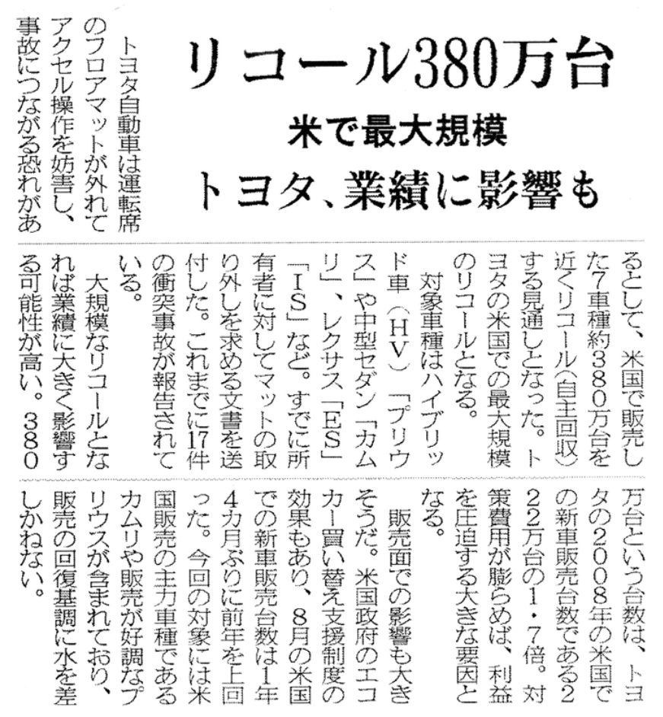
Picture1: News of Recall Situation from Toyota, shows that 3.8 million vehicle were recalled in U.S.(Toyota, 2021)

But this incident did not end. At the end of 2009, new problems appeared in Toyota's automobile products. The accelerator pedal of the vehicle could not or slowly return, which seriously affected the driving safety. Toyota Motor Corporation announced on January 21, 2010, that it recalled several flagship models including Corolla, rav4, and Camry in the United States. After that, the scope of the recall was expanded to the world, with a total of 4.44 million vehicles being recalled. In May 2009, the third-generation Prius had a problem with the abs control program, and Toyota Motor Corporation had to recall 440,000 vehicles worldwide on February 9, 2010 for repairs. (Toyota,2021)

Car recalls are an issue that nearly every automaker faces. In addition to Toyota's most typical car recalls, Ford Motor Co. has also recalled due to serious design defects: For example, Ford's famous pony car Ford Mustang has a global recall due to a serious safety risk due to a brake pedal problem. More than 15,000 Ford Focus models were recalled in the Chinese market due to a design flaw in the engine cover.(DPAC, 2021) Compared with safety concerns caused by car recalls, BMW's profit-driven reductions in car products are more disappointing to consumers. The new BMW 3 Series sedan has eliminated the traditional rear anti-roll bar, which can cause the vehicle to roll more when cornering and risk losing control of the vehicle. This is undoubtedly a major product design failure for BMW, which has always emphasized the driving feeling and driving experience of the vehicle. Not only that, the best-selling BMW 3 Series sedan has seen several engine cuts. The engine of the BMW 320 and 325 models eliminates the low temperature cooling kettle, which limits the engine operation. BMW has canceled services such as the automatic parking system and electronic unlocking functions, citing the "lack of chips", but the price has not changed significantly, which can not help disappointing owners.(Xinhua, 2021)

4.5 Reflection
To this day, these three car companies that represent the global car quality and high standards are still in constant negative news, causing social responsibility crisis and reputation crisis. This series of events can reflect the contradiction with Toyota Motor Corporation's internal and external corporate social responsibility and ethics. However, such contradictions can also highlight the difficulties of CSR and the complexity of implementation. Sheehy(2014) believes that one of the main reasons for the current difficulty in exercising corporate social responsibility is that management has too much power to measure and formulate freely. They can incorporate corporate social responsibility into management decisions and turn an organization's ethical behavior into organizational Intentional management measures, which create certain moral and ethical risks. Grigoris(2016) summarizes the difficulties of corporate social responsibility: The difficulties of corporate social responsibility mainly come from: 1. Lack of transparency. 2. Lack of consensus CSR standards or ineffective CSR standards. 3. Corporate social responsibility standards that do not meet the characteristics of the country. 4. The assessment of the dimension of corporate social responsibility is not sufficient. 5. Inappropriate selection of corporate social responsibility assessment criteria. Nowadays, almost all companies are promoting their own corporate social responsibility actions, which has become a globally recognized leading form for companies to actively participate in social responsibility construction and promote corporate change. However, it is precisely because corporate social responsibility has become the driving model of global business that it has developed a series of deviations. This kind of behavior makes today's corporate social responsibility a formulaic phenomenon. Sheehy(2014) pointed out that the difficulty of corporate social responsibility comes from the vagueness and diversity of its definition. Today, if a ten-billion-dollar company donates ten dollar, it can also be called corporate social responsibility. Likewise, Toyota's global remediation plan in the wake of the massive recall could be factored into Toyota's corporate social responsibility actions. The aggressive PR actions of Ford and BMW still keep consumers willing to buy their product and service. But as mentioned in the first and second parts, although corporate social responsibility is a relatively subjective perception, its origin comes from the ideology of social progress and the positive phenomenon of social progress. It also comes from a correct ethical and moral framework, and a subconscious mind of integrity. So, even with all the difficulties of corporate social responsibility today, even the huge disasters of the world's leading car companies such as Toyota Motor Corporation, Ford Motor Company and BMW, it cannot prevent a correct, honest and positive corporate society. Responsible actions and ideas go deep into the organization's action ideas and core. Therefore, in the next section, the researcher will further elaborate on the future development of current CSR.

5.0 Conclusion
This report focuses on corporate social responsibility, takes stakeholders and corporate social responsibility under deontology as the driving force, and combines the cases of the world's three top automakers to analyze the development status and predicament of corporate social responsibility. As mentioned earlier in this article, because the scope of corporate social responsibility is large and contains a wide range of content, the main limitation of this article is that the research on corporate social responsibility is pertinent rather than extensive. Similarly, the research on deontology is limited to the scope of management and business studies, lacking more in-depth research, which limits the theoretical research level of this report.

After the discussion of the full text, it can be found that there are contradictions in the promotion of corporate social responsibility in the cases of the three car companies. On the one hand, they have relatively complete corporate social responsibility theories, action principles, moral and ethical frameworks and many successful social responsibility actions. But on the other hand, they still have a catastrophic corporate crisis despite having a sound corporate social responsibility framework. In the last part, the researchers mentioned the difficulties related to the development of corporate social responsibility, which also affects the future development of corporate social responsibility. Strandberg (2002) believes that the current corporate social responsibility has become the main business scope of enterprises, but its development is relatively slow. The main reason for this situation is the inconsistency between the corporate social responsibility statement and corporate social responsibility actions, that is, companies will choose to protect their own interests and selectively ignore some social responsibilities.(Garriga and Mele, 2004) This situation can be concluded in the case in the previous section where BMW chose to reduce the allocation of the product without adjusting the price.(Xinhua, 2021.) Not only that, the current corporate social responsibility lacks a certain driving force (such as clear legal provisions), and today’s corporate social responsibility is still a huge subject with a subjective nature, which makes it impossible for companies to take collective actions to promote corporate social responsibility. development of. The complex corporate social responsibility content also increases the cost of enterprises in disguise, thus making it difficult for small and medium-sized enterprises to implement.( Garriga and Mele, 2004. Carroll, 2015. Grigoris, 2016. Fitch, 1976. )

However, various difficulties cannot prevent the continued development of corporate social responsibility, because it is an inevitable result of social development and progress. In the future, corporate social responsibility will be substantively incorporated into the strategic deployment of enterprises. (Moon and Shen, 2010. Boatright, 2001) The significance of corporate social responsibility will have both social and corporate strategic significance. Enterprises will abide by the standards of corporate social responsibility and create more strategic corporate actions. Under such development, the stakeholders of the enterprise will play a more important role. Stakeholders will not only directly participate in the company's CSR activities, they will also have influence and propose innovative and challenging values for the company. (Moon and Shen, 2010. Kell, 2018) Such a case can be seen in the NHTSA's attitude towards Toyota's vehicle recalls. It was the NHTSA's intervention that forced Toyota to take further steps.(Toyota, 2021) In the future, stakeholder groups will carry out activities together with enterprises, which is an inevitable innovation process. In the case of Toyota Motor Corporation, it can be seen that Toyota Motor Corporation has begun to cooperate with stakeholder groups (such as drivers, government Department employees, road traffic safety managers, etc. to cooperate to promote the development of corporate social responsibility.

Due to the development of society, enterprises, especially large multinational corporations such as Toyota, Ford and BMW, need to always pay attention to the development and changes of social responsibility. Nowadays, with the development of society, corporate social responsibility has become more than a simple manifestation of organizational social responsibility, and corporate social responsibility has become a sign that stakeholder groups view enterprises. Stakeholder groups will feel positive or negative about companies through corporate social responsibility actions, and this phenomenon has become particularly prominent in the context of the current global pandemic. Therefore, the development of corporate social responsibility will integrate the perceptions of stakeholder groups, social development and corporate development strategies to become a comprehensive corporate action.

For car companies, the current social responsibility tasks include carbon dioxide emissions, carbon neutrality, equity and diversity development, in addition to facing the global flu together. These emerging corporate social responsibility requirements indicate that companies need to update or redesign their corporate social responsibility strategies. The three auto companies combined corporate social responsibility with their own code of conduct, corporate development philosophy and core operations to further draw closer to stakeholders, which is in line with the development trend of corporate social responsibility mentioned above. As can be seen from the above part, Toyota, Ford and BMW are all actively carrying out corporate social responsibility actions, and have made outstanding achievements in environmental protection and social construction. Therefore, the development of social responsibility of automobile manufacturers requires enterprise managers to clearly recognize their own stakeholders and the development of society, and analyze the scope of their own actions from this, and finally make a contribution that is in line with their own reputation, interests and positive social contributions. behavior. As advocated by corporate social responsibility under deontology, companies need to do what subconsciously and absolutely rationally think is right, and use it as a correct moral and ethical framework to subconsciously affect all employees of the company - just like these three auto companies That way.

From the full text, the development of corporate social responsibility is a long and complicated process. It still takes a long time for accurate positioning and application. However, the future development of corporate social responsibility is objective, and it will surely develop with the development of society. For automakers, the development of CSR will focus on connecting the business with its stakeholders and place corporate responsibility actions within the main business scope of the business. Internally, corporate social responsibility will gradually change from corporate social action to corporate strategic action, and, like Toyota, Ford and BMW, will incorporate corporate social responsibility into the company's operating philosophy and code of conduct, thereby improve the company's own reputation and brand awareness, and improve its own comprehensive competitiveness.

6.0 References

- Bondy, K., Moon, J., & Matten, D. 2012. An Institution of Corporate Social Responsibility (CSR) in Multi-National Corporations (MNCs): Form and Implications. Journal of Business Ethics, 111(2), pp.281–299.
- BBC., 2014. About Duty-based Ethics. [online] bbc.co.uk. Available at: <https://www.bbc.co.uk/ethics/introduction/duty_1.shtml#top> [Accessed 25 January 2022]
- BBC., 2018. Japan's Kobe Steel indicted over quality scandal. [online] bbc.co.uk. Available at: <https://www.bbc.com/news/business-44895564> [Accessed 25 January 2022]
- BCampus. 2022. Deontology: Ethic as Duty. [online] opentextbc.ca. Available at: <https://opentextbc.ca/businessethicsopenstax/chapter/deontology-ethics-as-duty/#OSX_Ethics_02_05_Critique> [Accessed 25 January 2022]
- BOS., 2020. The problem with CSR: why companies need to listen to their activist employees. [online] .bos-cbscsr.dk. Available at: <http://www.bos-cbscsr.dk/2020/05/13/the-problem-with-csr-why-companies-need-to-listen-to-activist-employees/> [Accessed 25 January 2022]
- Boatright, J. R. (2001). The Future of Corporate Social Responsibility. Business & Professional Ethics Journal, 20(3/4),pp.39-48
- BBC., 2016. Toyota recalls 5.8 million cars over faulty Takata airbags. [online] .bbc.com. Available at: <https://www.bbc.com/news/business-37771220> [Accessed 25 January 2022]
- BMW., 2021. BMW Group position regarding climate legal actions, 19.09.2021.BMW Group.
- BMW., 2020. BMW Group Supplier Sustainability Policy. BMW Group.
- BMW., 2021. SUSTAINABILITY QUESTIONNAIRE FOR SUPPLIERS. BMW-SPECIFIC EVALUATION OF SAQ. BMW Group.
- BMW., 2022. Sustainability. [online] bmwgroup.com. Available at: <https://www.bmwgroup.com/en/sustainability.html> [Accessed 17 February 2022].
- BMW., 2022. BMW GROUP STRATEGY. [online] bmwgroup.com. Available at: <https://www.bmwgroup.com/en/company/strategy.html> [Accessed 17 February 2022]
- BMW., 2022. Society. [online] bmwgroup.com. Available at: <https://www.bmwgroup.com/en/sustainability/unser-fokus/gesellschaft.html#tabswitch-43d094f75a-tab2ID> [Accessed 17 February 2022]
- Carroll, A., 2015. Corporate Social Responsibility: The Centerpiece of Competing and Complementary Frameworks. Organizational Dynamics, 2015(44), pp.87-96.
- Corcut, S., 2020. The Evolution and the Future of Corporate Social Responsibility in a Post Covid-19 World. [online] .thesustainabilist.ae. Available at: <https://thesustainabilist.ae/the-evolution-and-the-future-of-corporate-social-responsibility-in-a-post-covid-19-world/> [Accessed 25 January 2022]
- CSR: Face of the future or fad? 2003. RSA Journal, 152(5517)
- Chakrabarty, S., & Erin, A. 2013. Comparing Virtue, Consequentialist, and Deontological Ethics-Based Corporate Social Responsibility: Mitigating Microfinance Risk in Institutional Voids. Journal of Business Ethics, 126(3), pp. 487–512.
- DoubleDonation., 2021. Corporate Social Responsibility: The Definitive Guide. [online] doublethedonation.com. Available at: <https://doublethedonation.com/tips/corporate-social-responsibility/> [Accessed 25 January 2022]
- Donaldson, T., & Preston, L. E. 1995. The Stakeholder Theory of the Corporation: Concepts, Evidence, and Implications. Academy of Management Review, 20(1), pp.65–91.
- Dyer, J. H., & Nobeoka, K. 2000. Creating and managing a high-performance knowledge-sharing network: the Toyota case. Strategic Management Journal, 21(3), pp.345–367
- DPAC., 2021. Changan Ford Motor Co., Ltd. recalls some Focus vehicles.[online] qiche365.org.cn. Available at: <https://www.qiche365.org.cn/index/recall/bulletin/id/2577.html> [Accessed 25 January 2022]
- Eldo, F., & Gianmarco, F., 2017. Ethics and Deontology in Business. [online] austinpublishinggroup.com. Available at: <https://austinpublishinggroup.com/business-administration-and-management/fulltext/ajbam-v1-id1007.php> [Accessed 25 January 2022]
- EthicCenters., 2016. Ethics Explainer: Deontology. [online] ethics.org.au. Available at: <https://ethics.org.au/ethics-explainer-deontology/> [Accessed 25 January 2022]
- Ethics.,2021.Deontology. [online] ethicsunwrapped.utexas.edu. Available at: <https://ethicsunwrapped.utexas.edu/glossary/deontology> [Accessed 17 February 2022]
- Everfi., 2021. Top 4 CSR Trends To Watch In 2021. [online] everfi.com. Available at: <https://everfi.com/blog/community-engagement/corporate-social-responsibility-trends/> [Accessed 17 February 2022]
- Fitch, H., 1976. Achieving Corporate Social Responsibility. The Academy of Journal Review, 1(1), pp.38-46.
- Freeman, E., & Werhane, P. 2008. A Note on Deontology. SSRN Electronic Journal, 2008(10).
- Ford., 2021. Corporate Social Responsibility. [online] ford.co.uk. Available at: <https://www.ford.co.uk/experience-ford/about-ford/corporate-social-responsibility> [Accessed 25 January 2022].
- Ford., 2020. Inclusive Hiring. [online] corporate.ford.com. Available at: <https://corporate.ford.com/careers/inclusive-hiring.html> [Accessed 17 February 2022].
- Ford., 2020. CULTIVATING A CULTURE OF BELONGING. [online] corporate.ford.com. Available at: <https://corporate.ford.com/careers/inclusive-hiring/diversity/respectful-and-inclusive-culture.html> [Accessed 17 February 2022].
- Ford., 2020. Sustainability. [online] corporate.ford.com. Available at: <https://corporate.ford.com/social-impact/sustainability.html> [Accessed 17 February 2022].
- Ford., 2020. Helping Build a Better World. [online] corporate.ford.com. Available at: <https://corporate.ford.com/microsites/integrated-sustainability-and-financial-report-2021/index.html> [Accessed 17 February 2022].
- Ford., 2020. Our Purpose. [online] corporate.ford.com. Available at: <https://corporate.ford.com/about/purpose.html> [Accessed 17 February 2022].
- Ford., 2021. Corporate. [online] corporate.ford.com. Available at: <https://corporate.ford.com/> [Accessed 25 January 2022]
- Ford., 2021. UN Guiding Principles Reporting Framework Index.Ford Motor Company.
- Ford., 2021. We Are Committed to Protecting Human Rights and the Environment.Ford Motor Company
- Fernando, J., 2021. Corporate Social Responsibility (CSR). [online] investopedia.com. Available at: <https://www.investopedia.com/terms/c/corp-social-responsibility.asp> [Accessed 25 January 2022].
- Freeman, R. E. 2010. Strategic Management: A Stakeholder Approach. Cambridge University Press.
- Freeman, R., & Evan, W. M. 1990. Corporate governance: A stakeholder interpretation. Journal of Behavioral Economics, 19(4), pp. 337–359.
- Garriga, E., & Melé, D. 2004. Corporate Social Responsibility Theories: Mapping the Territory. Journal of Business Ethics, 53(1/2), pp.51–71.
- Grigoris, G. 2016. The Challenges of Corporate Social Responsibility Assessment Methodologies. International Journal of Economics and Business Administration, IV(Issue 1), pp.39–55.
- Gupta, S., & Sharma, N. (2009). CSR- A Business Opportunity. Indian Journal of Industrial Relations, 44(3), 396–401.
- Harvey, K., 2021. The Future of Corporate Social Responsibility. [online] .texasceomagazine.com. Available at: <https://texasceomagazine.com/the-future-of-corporate-social-responsibility/> [Accessed 25 January 2022]
- Insider., 2021. Toyota just started building a 175-acre smart city at the base of Mount Fuji in Japan. Photos offer a glimpse of what the 'Woven City' will look like? [online] businessinsider.com. Available at: <https://www.businessinsider.com/toyota-city-of-the-future-japan-mt-fuji-2020-1> [Accessed 25 January 2022]
- Jones, T. M., & Wicks, A. C. 1999. Convergent Stakeholder Theory. Academy of Management Review, 24(2),pp. 206–221.
- Jackson,A., 2021. Corporate Social Responsibility: Tracking the Top Trends. [online] investopedia.com. Available at: <https://www.investopedia.com/ask/answers/011215/what-are-top-trends-corporate-social-responsibility.asp> [Accessed 17 February 2022]
- Jones, T. M. 1980 Corporate Social Responsibility Revisited, Redefined, California Management Review, 22(3), pp. 59–67.
- Kuzmin, O., & Khilukha, O. 2016. Regulation of stakeholders’ interests in corporate governance through negotiations. Economic Annals-ХХI, 161(9-10), pp.56–60.
- Kell, G., 2018. The Future Of Corporate Responsibility [online] .forbes.com. Available at: <https://www.forbes.com/sites/georgkell/2018/06/18/the-future-of-corporate-responsibility/?sh=210e8a0b6105> [Accessed 25 January 2022]
- Lindgreen, A. and Swaen, V., 2010. Corporate Social Responsibility. International Journal of Management Reviews, 12(1), pp.1-7.
- Ledecky, M., 2021. Corporate Social Responsibility: Past, Present, And Future [online] .everfi.com. Available at: <https://everfi.com/blog/community-engagement/csr-history/> [Accessed 25 January 2022]
- Lister., 2019. Toyota Hybrids Prove Faultless in What Car? [online] .listers.co.uk. Available at: <https://listers.co.uk/news/2019/09/toyota-hybrids-prove-faultless-what-car-reliability> [Accessed 25 January 2022]
- Liker, J. K., & Morgan, J. M. 2006. The Toyota Way in Services: The Case of Lean Product Development. Academy of Management Perspectives, 20(2), pp.5–20.
- Micewski, E., & Troy, C. 2007. Business Ethics - Deontologically Revisited. Journal of Business Ethics, 72(1), pp.17–25.
- Mitchell, R. K., Agle, B. R., & Wood, D. J. 1997. Toward a Theory of Stakeholder Identification and Salience: Defining the Principle of who and What Really Counts. Academy of Management Review, 22(4), pp.853–886.
- Moon, J., & Shen, X. 2010. CSR in China Research: Salience, Focus and Nature. Journal of Business Ethics, 94(4), 613–629.
- Moncrieff, L. 2015. Karl Polanyi and the Problem of Corporate Social Responsibility. Journal of Law and Society, 42(3), pp.434–459.
- Natalia,Y,C., 2021. CSR & Sustainability Trends in 2021. [online] .artemis.im. Available at: <https://artemis.im/csr-and-sustainability-trends/> [Accessed 25 January 2022]
- Olander, S., & Landin, A. 2005. Evaluation of stakeholder influence in the implementation of construction projects. International Journal of Project Management, 23(4), pp.321–328.
- Oxford., 2018. What is Mendelow’s Matrix and How It Is Useful? [online] .oxfordcollegeofmarketing.com. Available at: <https://blog.oxfordcollegeofmarketing.com/2018/04/23/what-is-mendelows-matrix-and-how-is-it-useful/> [Accessed 25 January 2022]
- OpenDemocracy., 2014. The problem with corporate social responsibility. [online] .opendemocracy.net. Available at: <https://www.opendemocracy.net/en/problem-with-corporate-social-responsibility/> [Accessed 25 January 2022]
- ProfessionalAcademy., 2022. Mendelow’s Matrix- Marketing Theories. [online] .professionalacademy.com. Available at: <https://www.professionalacademy.com/blogs/mendelows-matrix-marketing-theories/> [Accessed 25 January 2022]
- Stakeholdermap., 2008. Stakeholder Analysis, Project Management, Templates and Advice.[online] stakeholdermap.com. Available at: <https://www.stakeholdermap.com/stakeholder-definition.html> [Accessed 25 January 2022].
- Schooley, S., 2021. What Is Corporate Social Responsibility?. [online] businessnewsdaily.com. Available at: <https://www.businessnewsdaily.com/4679-corporate-social-responsibility.html> [Accessed 25 January 2022].
- Stanford. 2020. Deontological Ethics. [online] plato.stanford.edu. Available at: https://plato.stanford.edu/entries/ethics-deontological/> [Accessed 25 January 2022].
- Sheehy, B. 2014. Defining CSR: Problems and Solutions. Journal of Business Ethics, 131(3), pp.625–648.
- Strandberg, C. 2002. The Future of Corporate Social Responsibility. VanCity Credit Union, Canada.
- Schouten, C., Graafland, J., & Kaptein, M. 2013. Religiosity, CSR Attitudes, and CSR Behavior: An Empirical Study of Executives’ Religiosity and CSR. Journal of Business Ethics, 123(3), pp.437–459.
- Xinhua. 2021. BMW recalls 142,754 vehicles in China. [online] news.cn. Available at: <http://www.news.cn/english/2021-09/12/c_1310183170.htm> [Accessed 25 January 2022].
- Toyota., 2019. Toyota’s Social Contribution Activities. Toyota Motor Corporation. Toyota City, Aichi..
- Toyota., 2018. Toyota Code of Conduct. Toyota Motor Corporation. Toyota City, Aichi.
- Toyota., 2021. Toyota’s Human Rights Policy. Toyota Motor Corporation. Toyota City, Aichi.
- Toyota., 2015. Sustainability Data Book. Toyota Motor Corporation. Toyota City. Aichi.
- Toyota., 2020. More to Toyota than Meets the Eyes. Toyota Motor Corporation. Toyota City, Aichi.
- Toyota., 2021. Toyota Philosophy. [online] global.toyota. Available at: <https://global.toyota/en/company/vision-and-philosophy/philosophy/> [Accessed 25 January 2022].
- Toyota., 2021. Toyota Production System. [online] global.toyota. Available at: <https://global.toyota/en/company/vision-and-philosophy/production-system/> [Accessed 25 January 2022]
- Toyota., 2021. Social Contribution Activities. [online] global.toyota. Available at: <https://global.toyota/en/sustainability/esg/social-contribution/> [Accessed 25 January 2022]
- Toyota., 2021. Sustainability Fundamental Policy. [online] global.toyota. Available at: <https://global.toyota/en/sustainability/csr/policy/> [Accessed 25 January 2022]
- Toyota., 2021. Guiding Principles at Toyota. [online] global.toyota. Available at: <https://global.toyota/en/company/vision-and-philosophy/guiding-principles/> [Accessed 25 January 2022]
- Toyota., 2021. Sales, Production, and Export Report Results for October 2021. [online] global.toyota. Available at: <https://global.toyota/en/company/profile/production-sales-figures/202110.html> [Accessed 25 January 2022]
- Toyota., 2021. Toyota Breaks Ground for Woven City. [online] global.toyota. Available at: <https://global.toyota/en/newsroom/corporate/34827717.html> [Accessed 25 January 2022]
- Toyota., 2021. Voluntary Remedies and Recalls. [online] global.toyota. Available at: <https://www.toyota-global.com/company/history_of_toyota/75years/text/leaping_forward_as_a_global_corporation/chapter5/section3/item1.html> [Accessed 25 January 2022]
- ToyotaWovenCity., 2021. Woven City. [online] woven-city.global. Available at: <https://www.woven-city.global/> [Accessed 25 January 2022]
- Toyota., 2019. Takata Airbag Safety Recall. [online] .toyota.com. Available at: <https://www.toyota.com/recall/takata> [Accessed 25 January 2022]
- V, B., & Rupamanjari Sinha, R. 2012. Corporate Social Responsibility. Vikas Publishing House, New Delhi.
- Vanco., 2021.WHY CORPORATE SOCIAL RESPONSIBILITY IS MORE IMPORTANT THAN EVER. [online] vancopayments.com. Available at: <https://www.vancopayments.com/egiving/blog/corporate-responsibility> [Accessed 17 February 2022]
- Zhu,W., 2014. Toyota Motor Corporation in China and The United States Recalls in the Comparative Study on Communication Strategies. Shanghai International Studies University. Shanghai China.

Appendixes

Appendix1: Toyota Philosophy
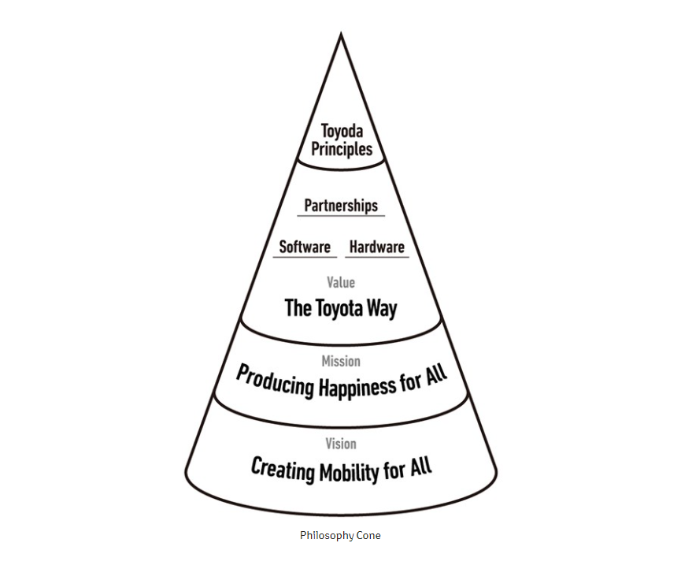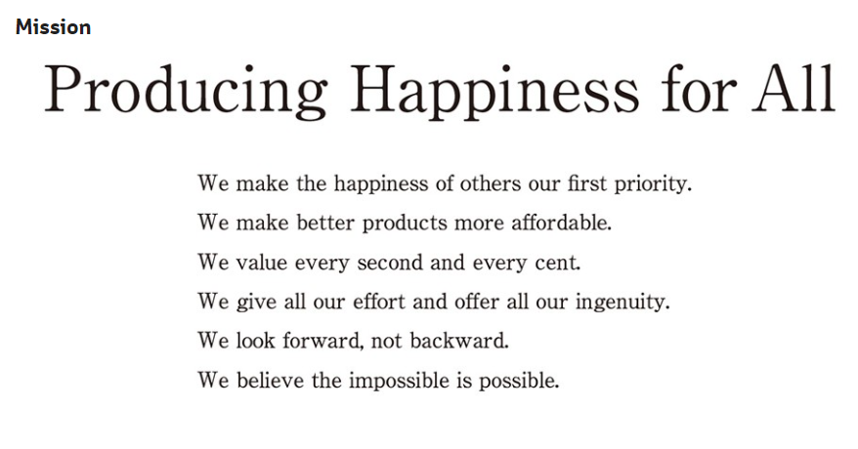
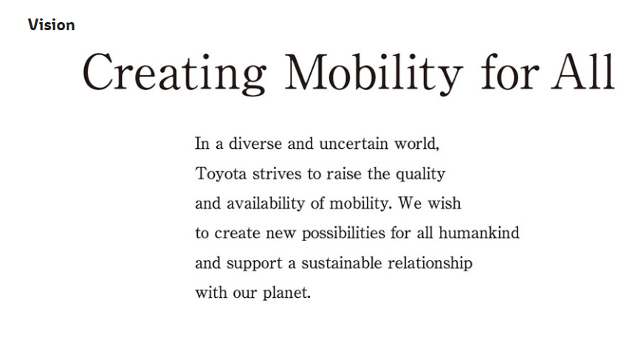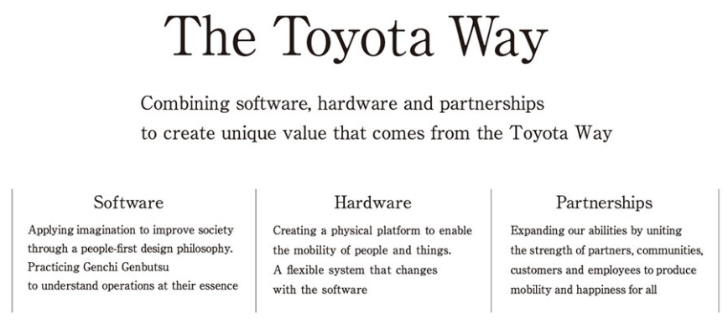

Appendix2: Toyota Code of Conduct 2018
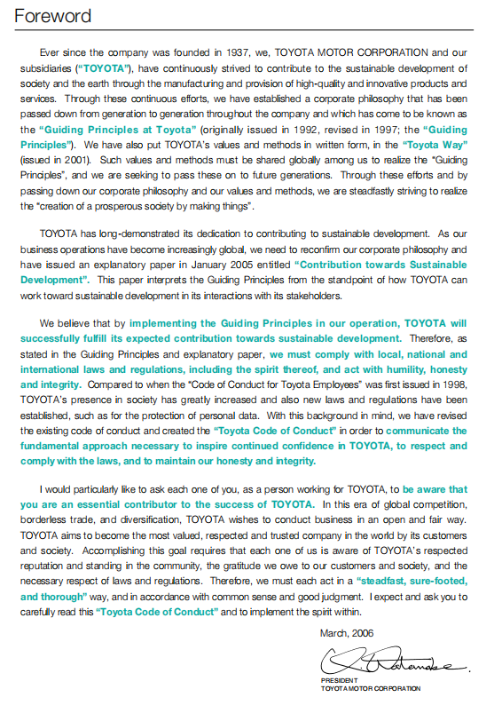
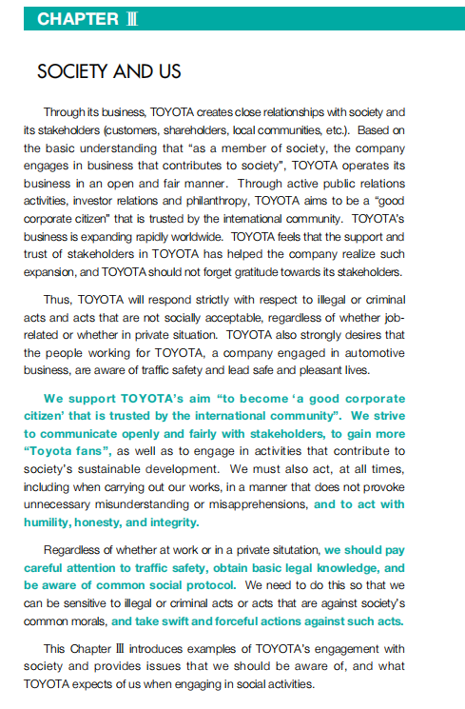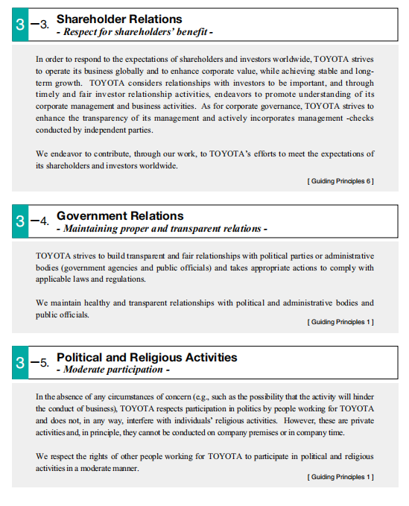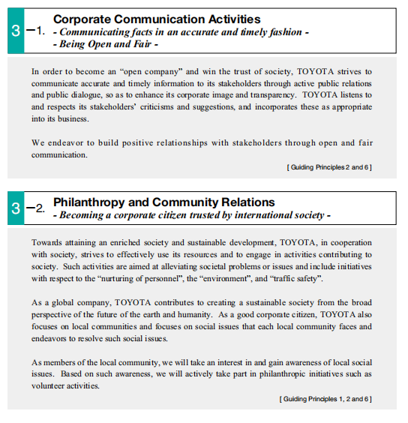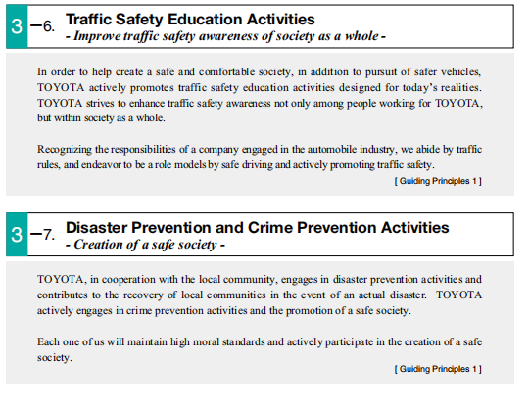

Appendix3: Toyota Human Rights Policy
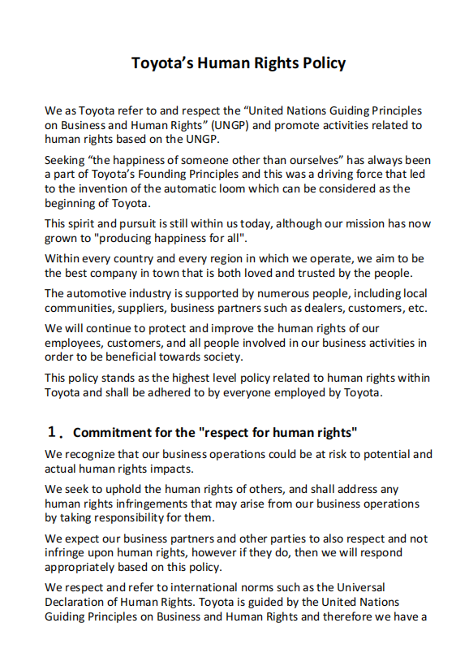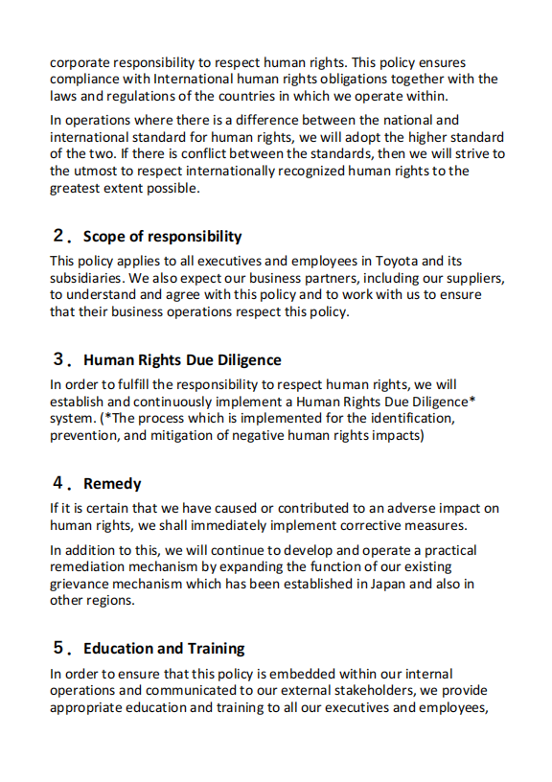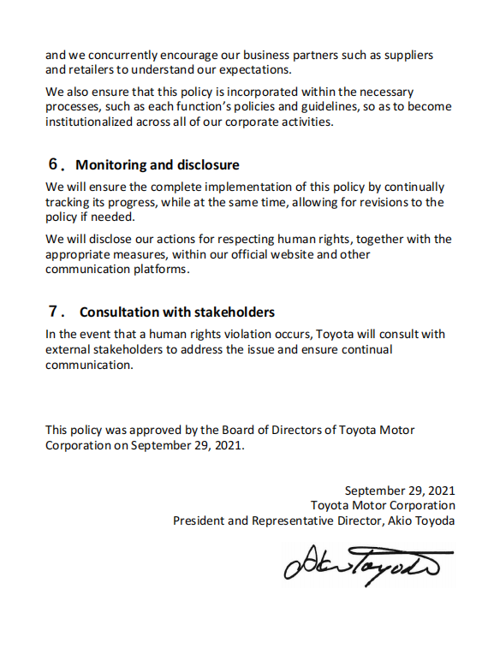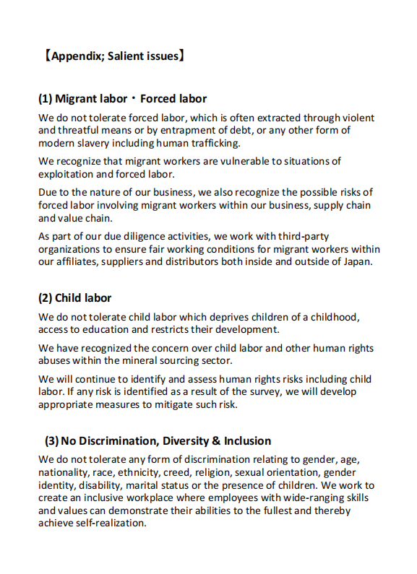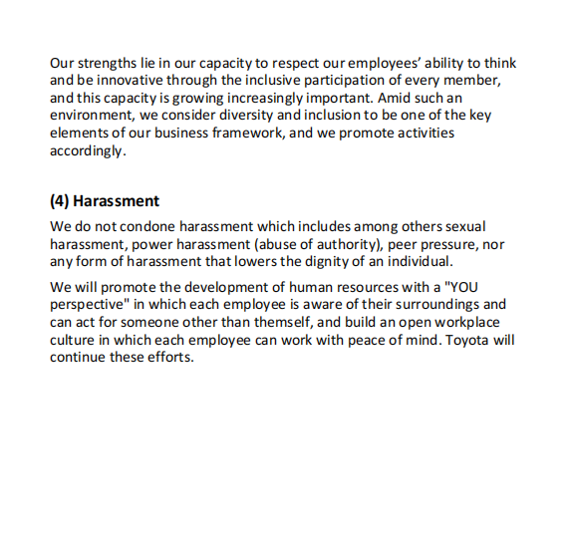

Appendix4: Traffic Safety Activities of Toyota
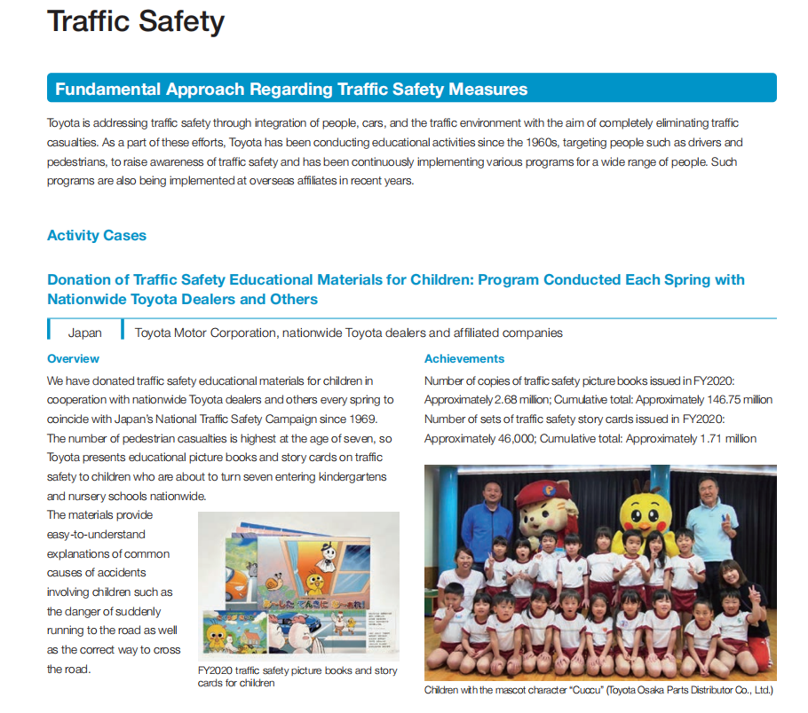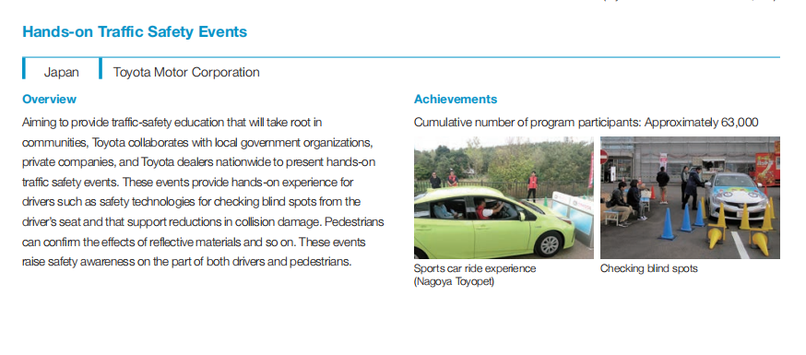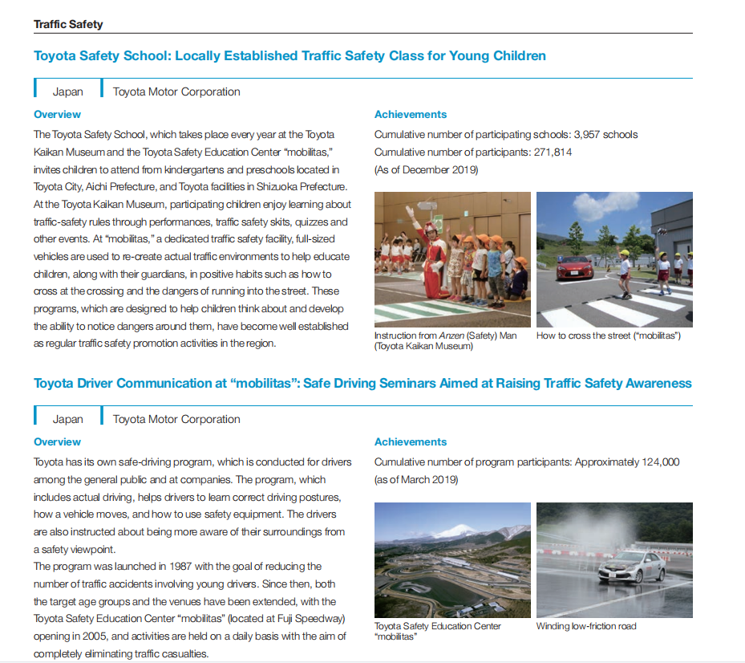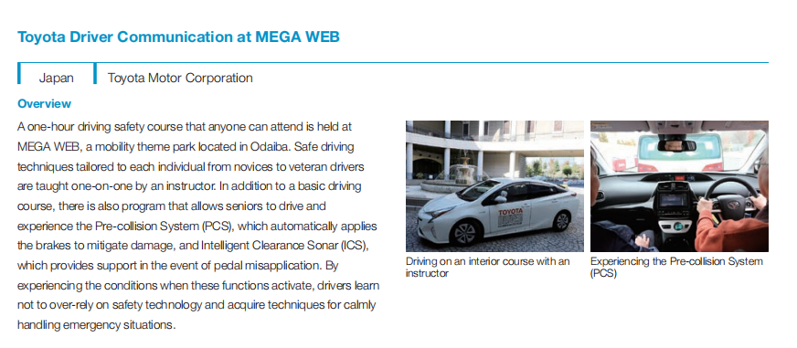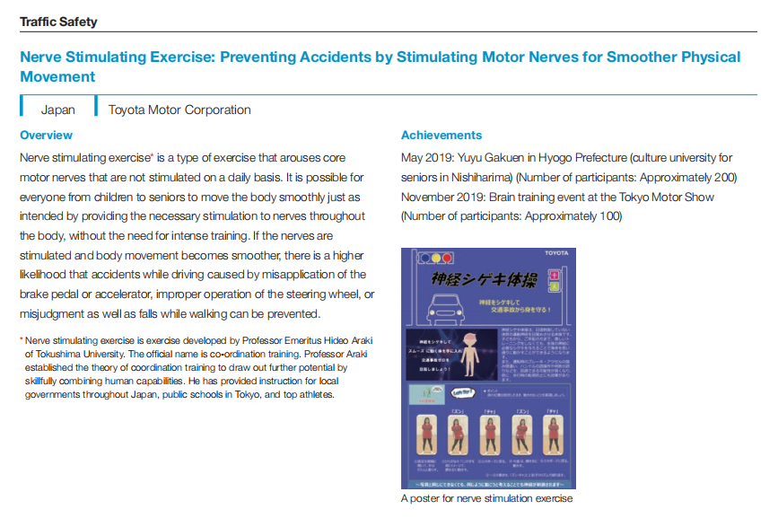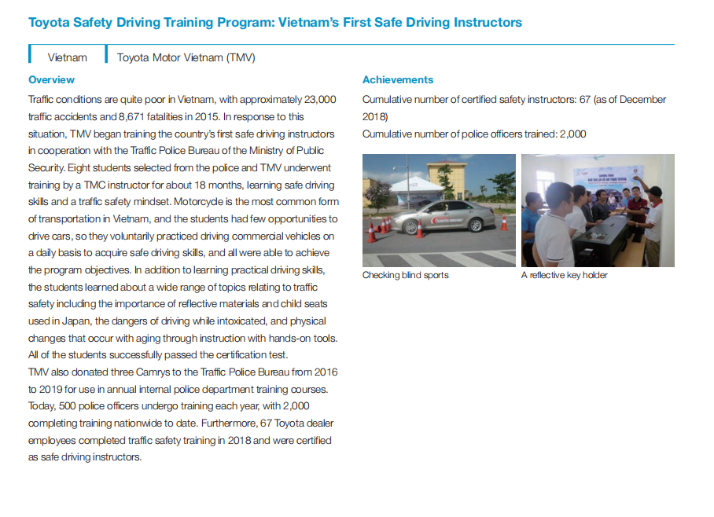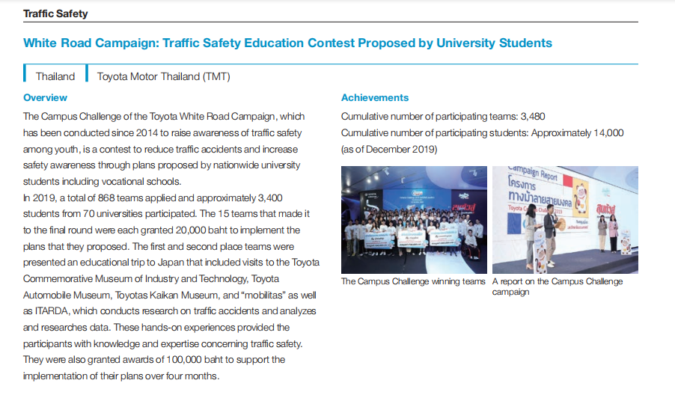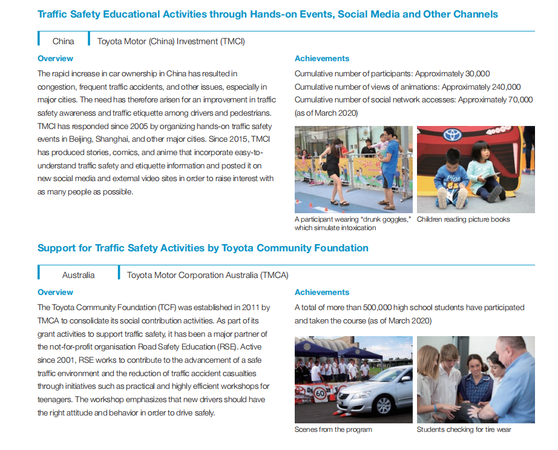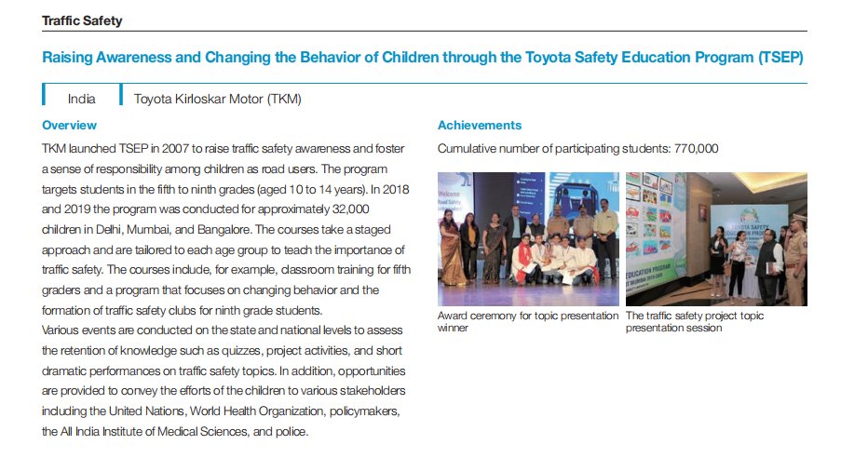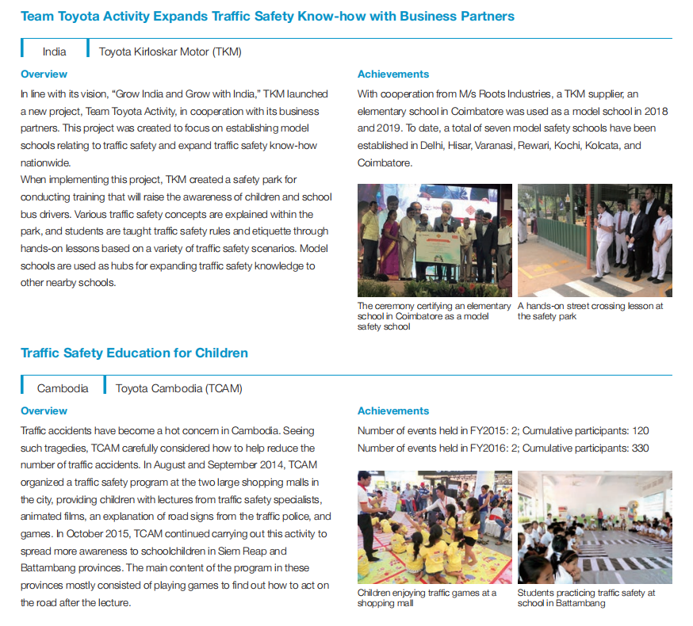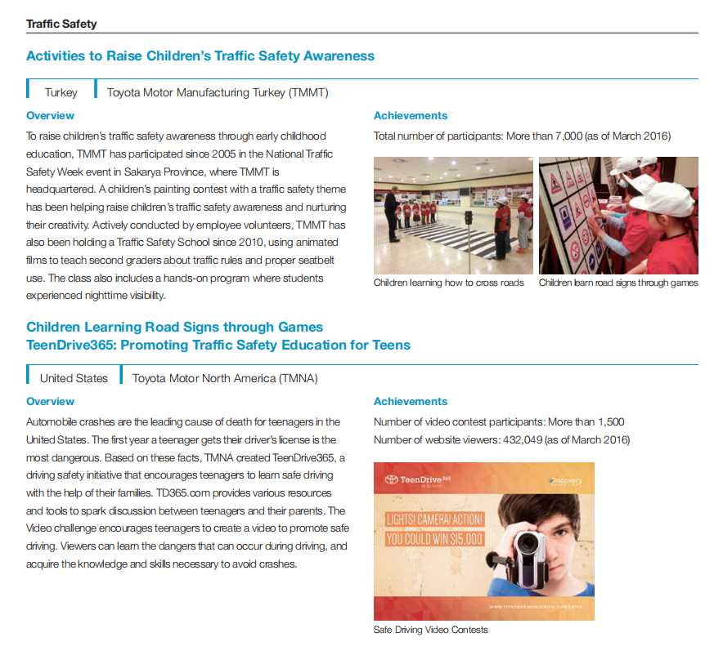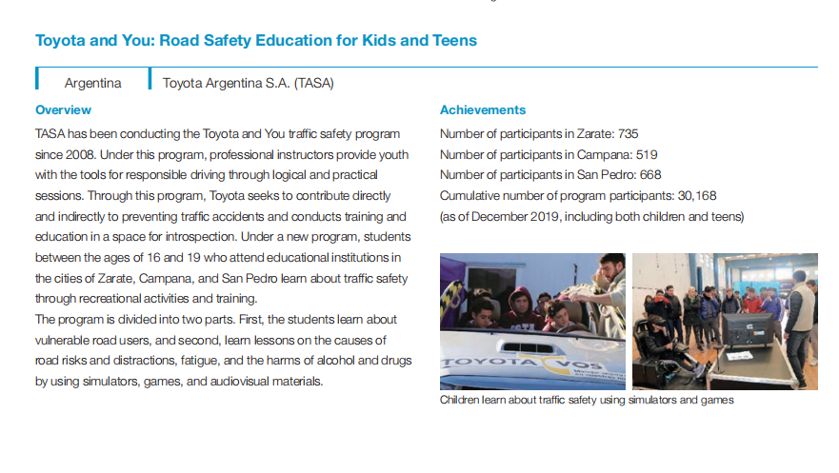

Appendix5: Toyota Environmental Challenge 2050

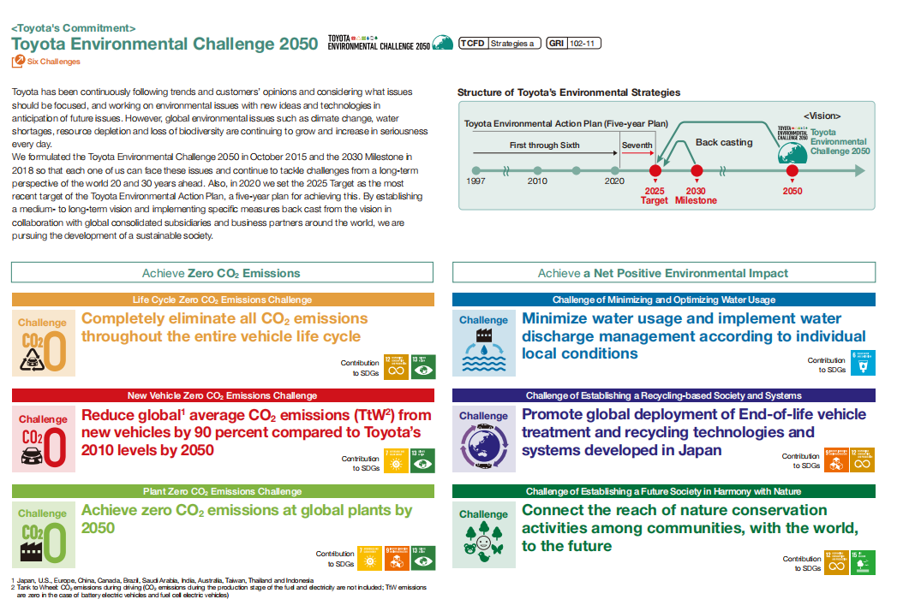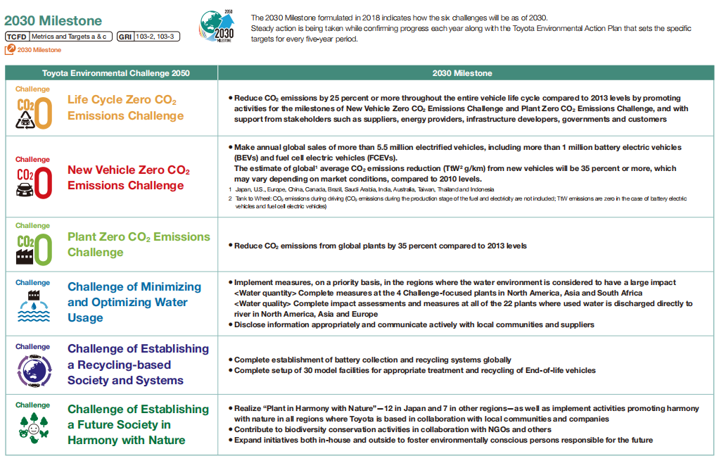

Appendix6: Human Rights and Environment of Ford Motor

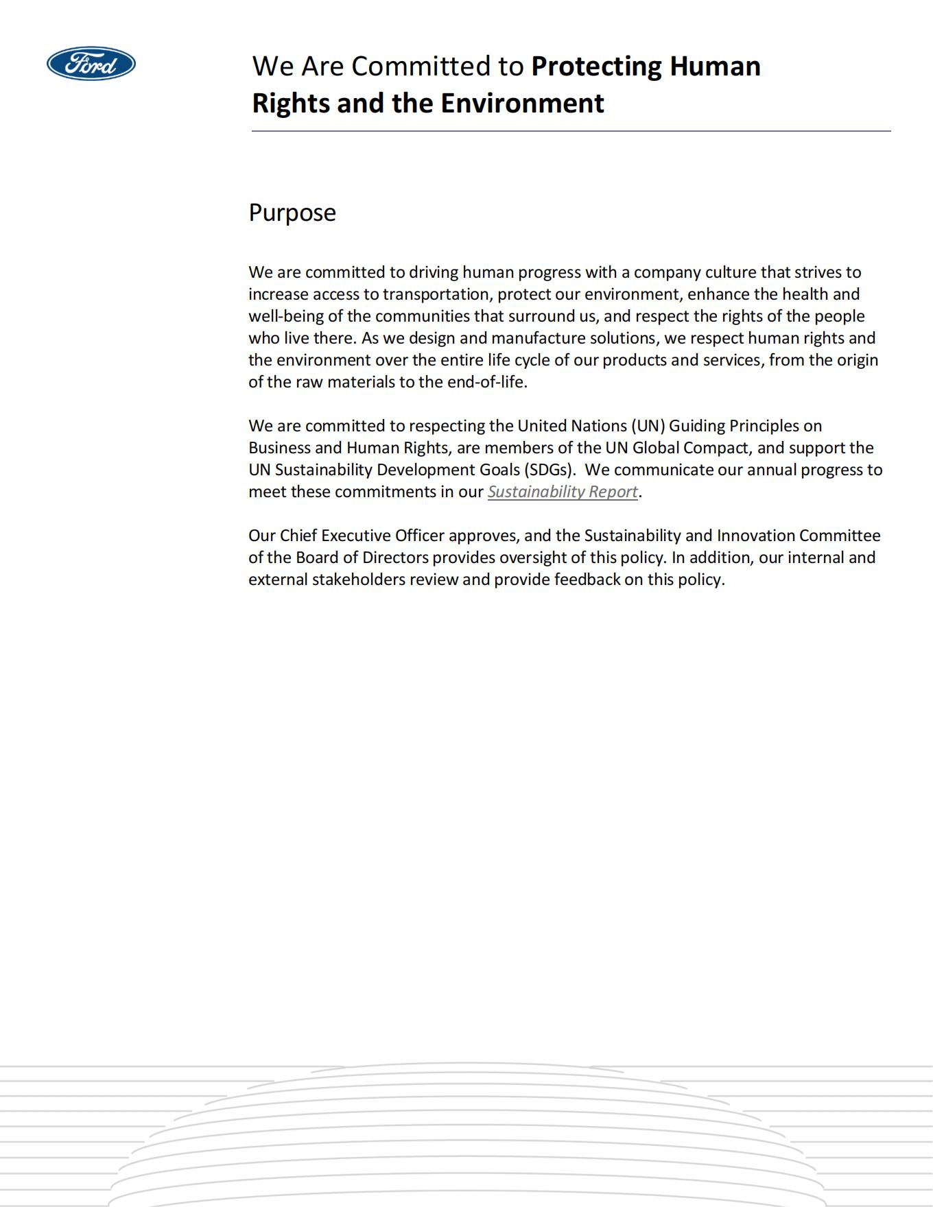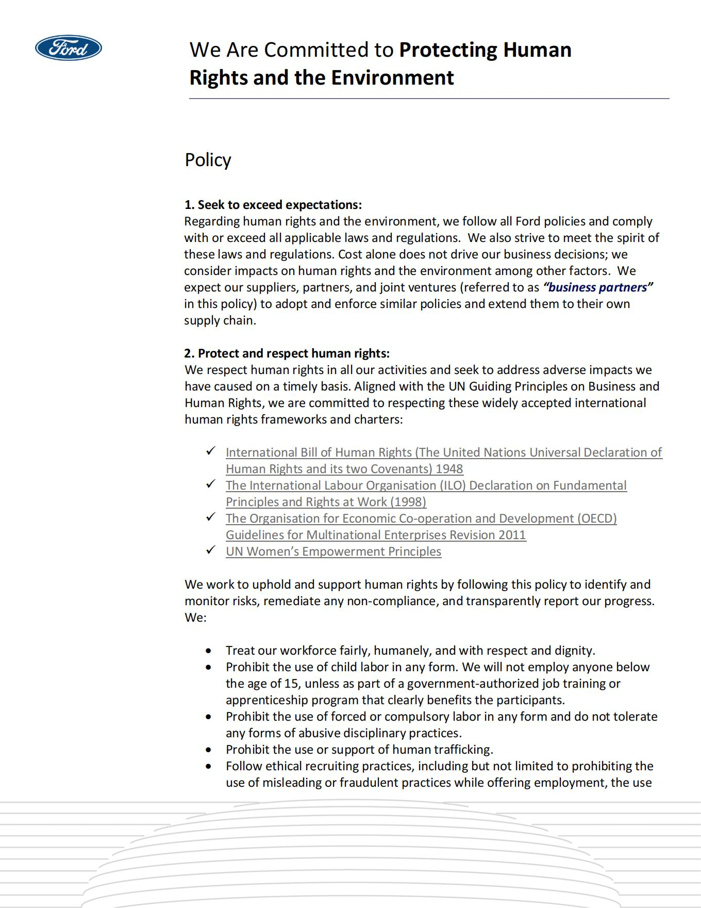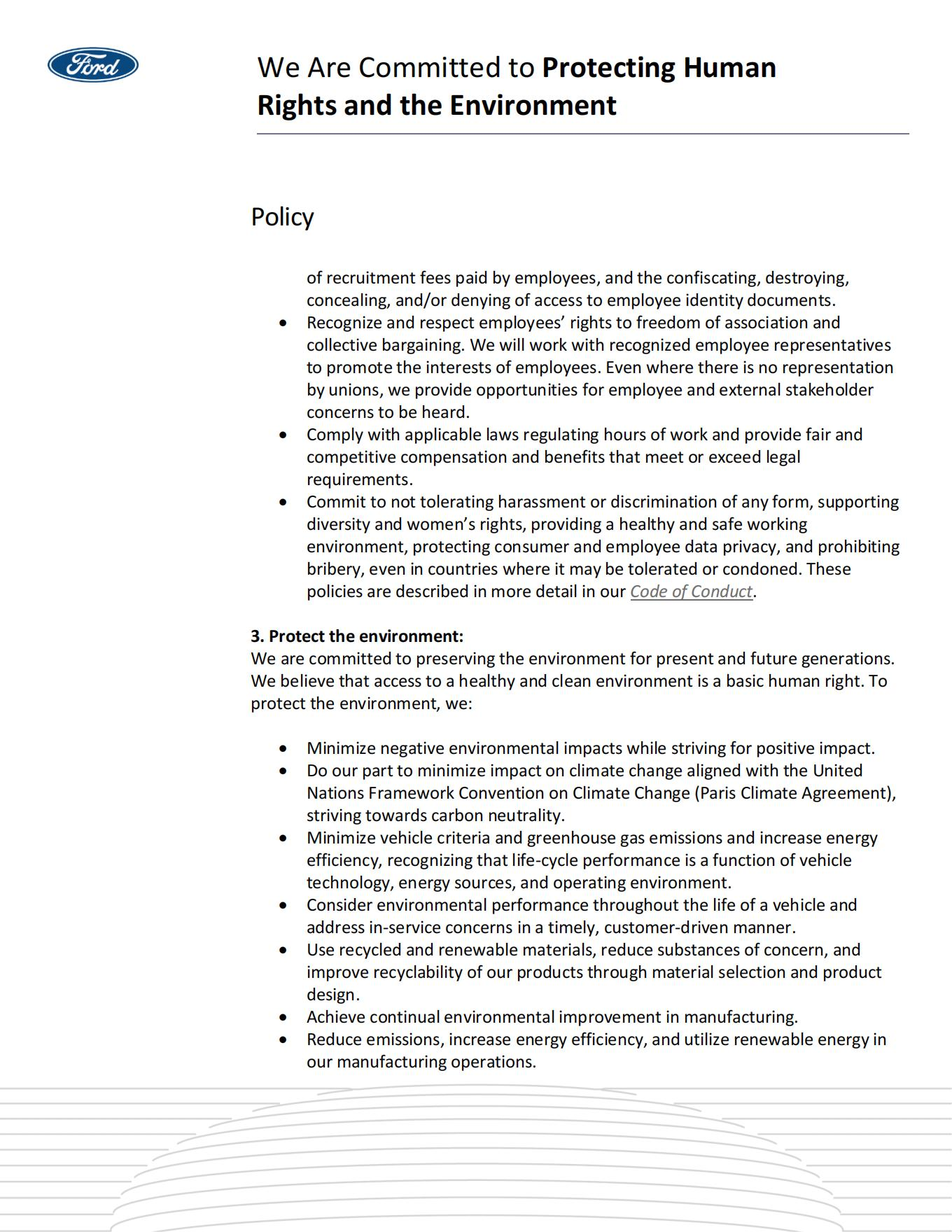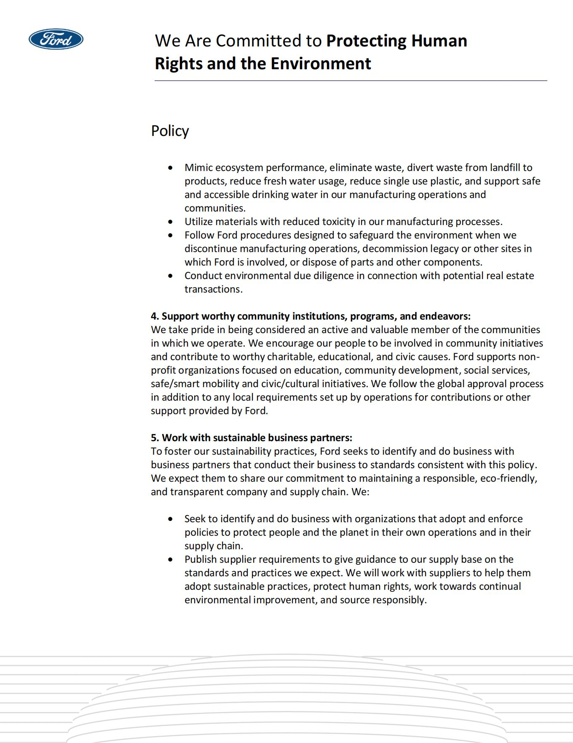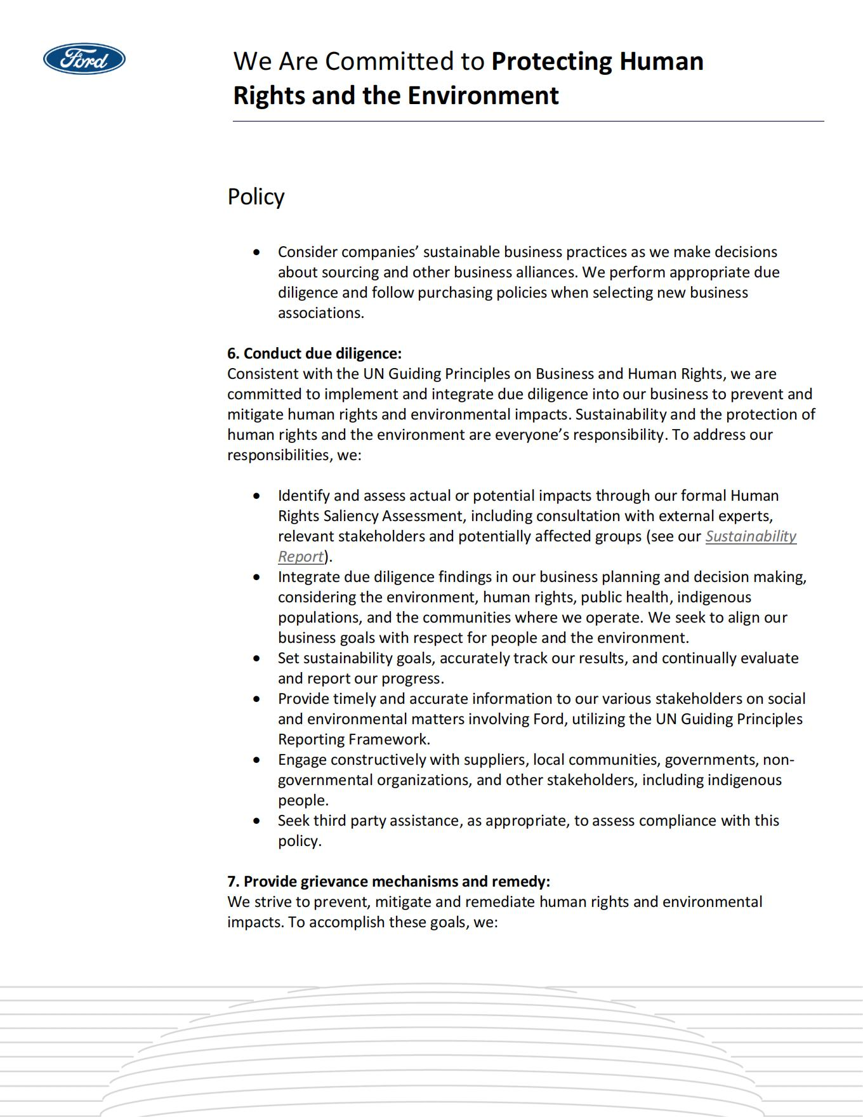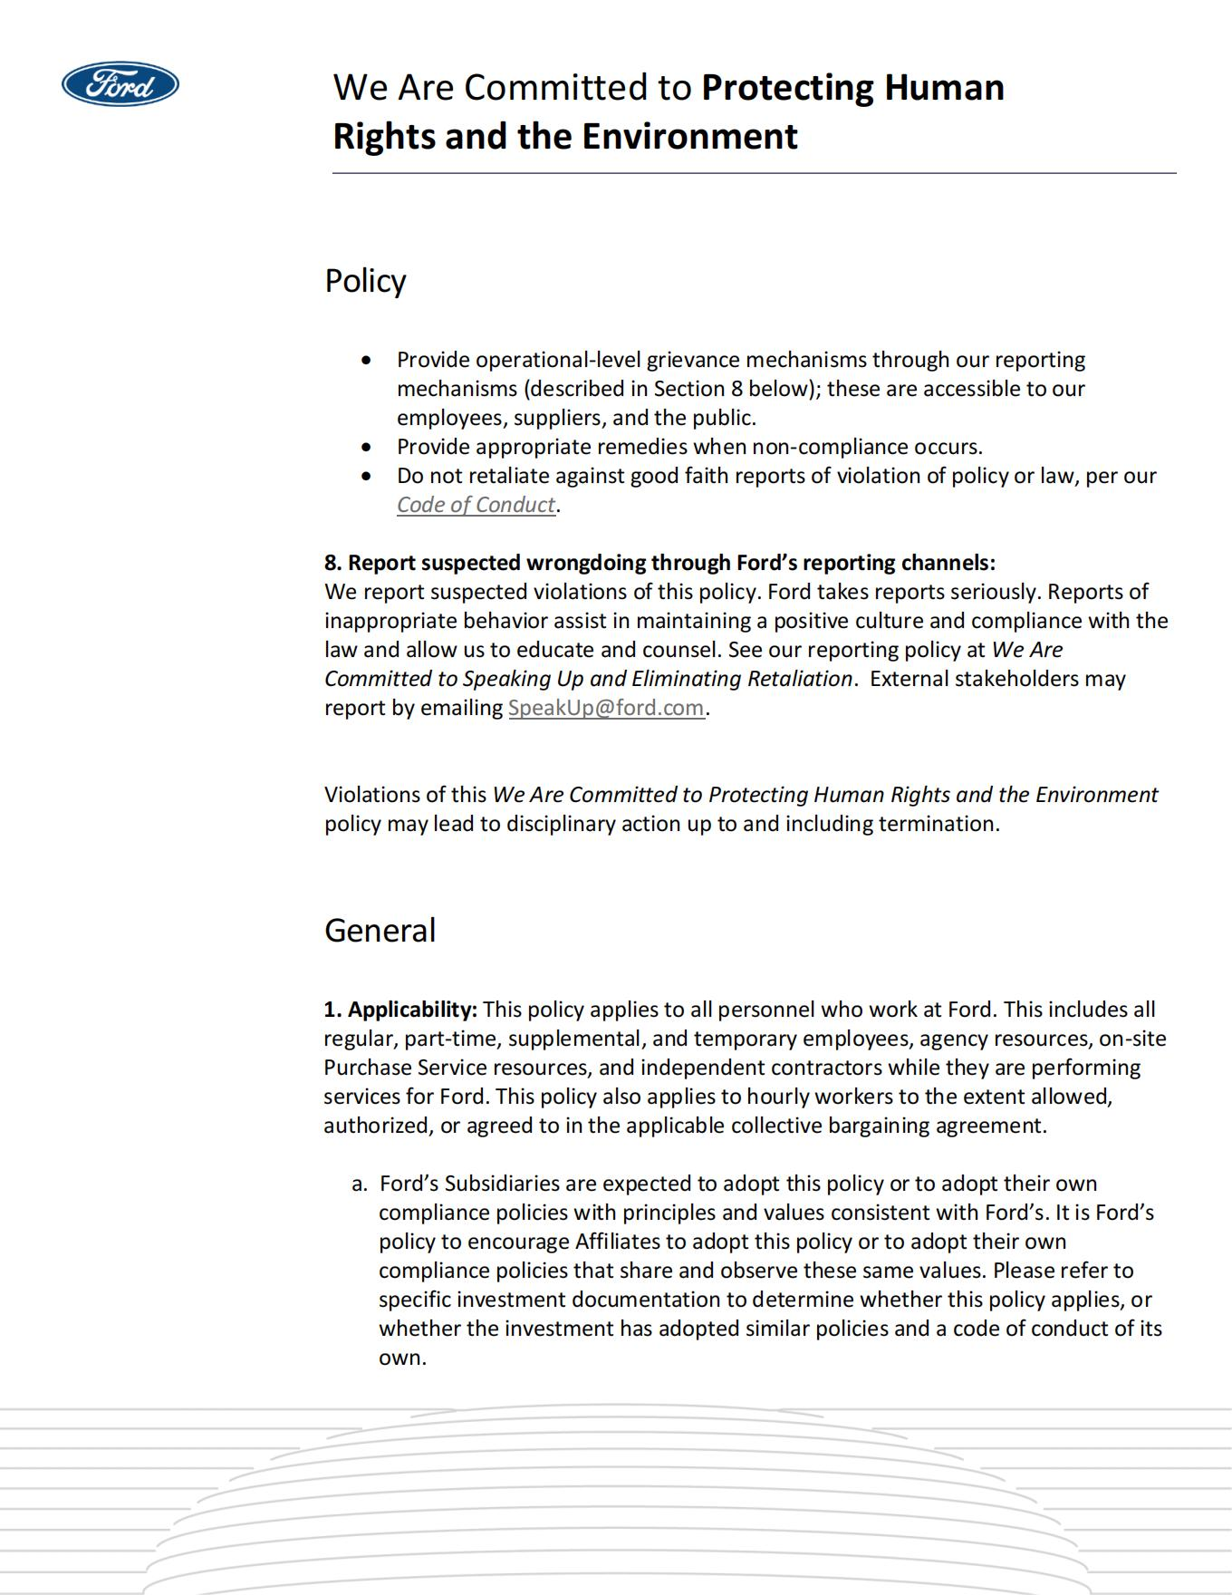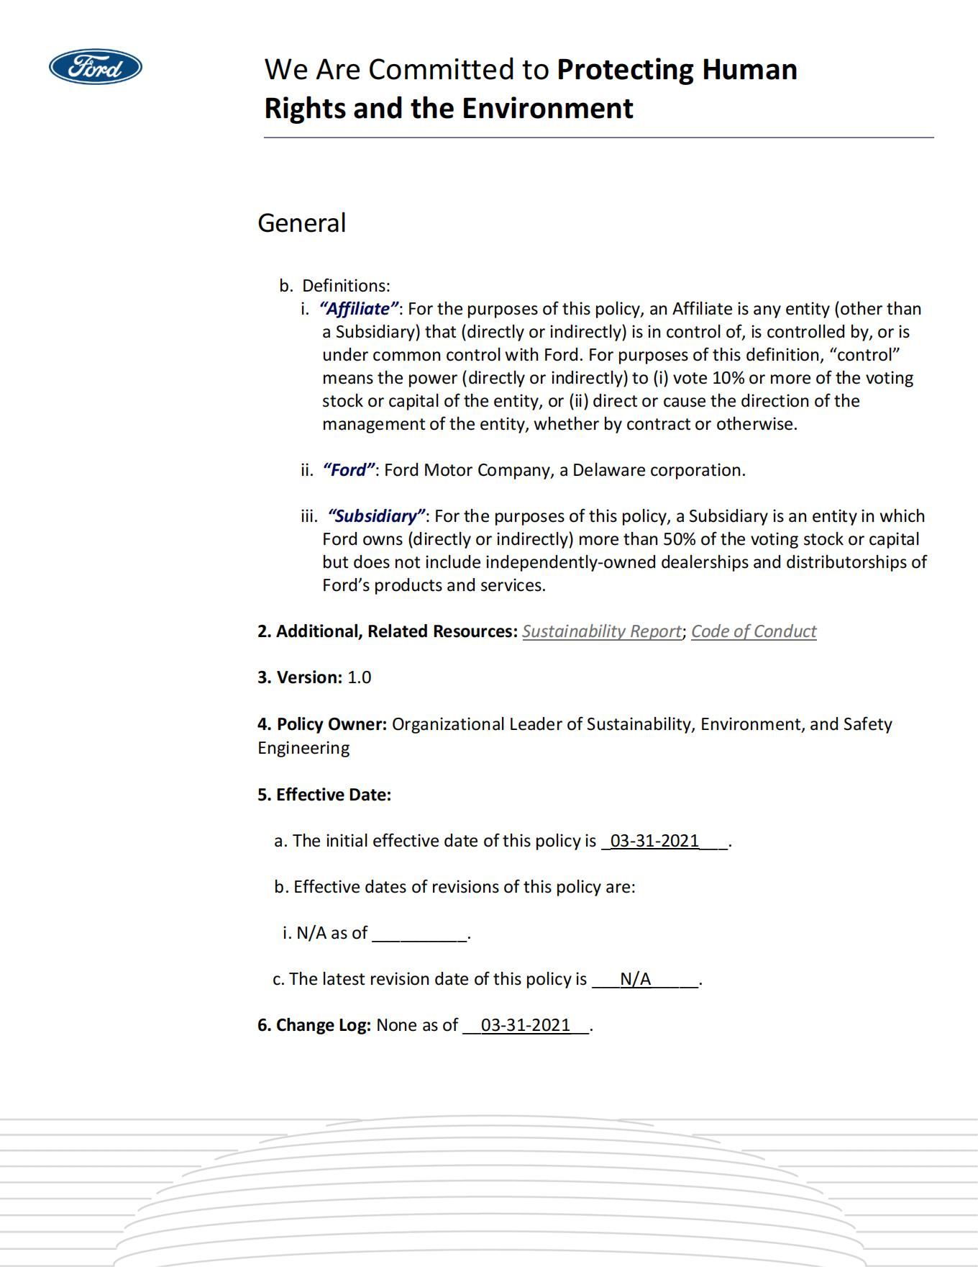

Appendix7:Ford Motor UN Guiding Principle Report
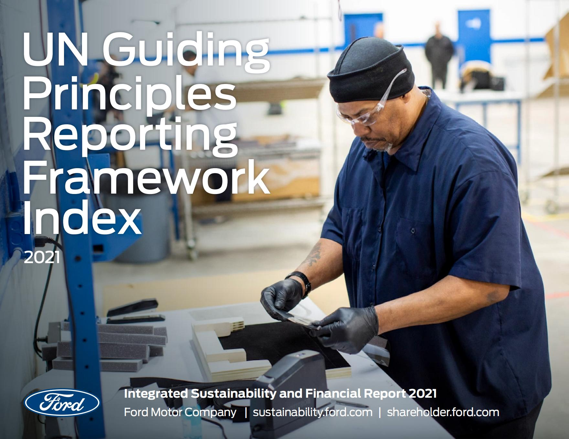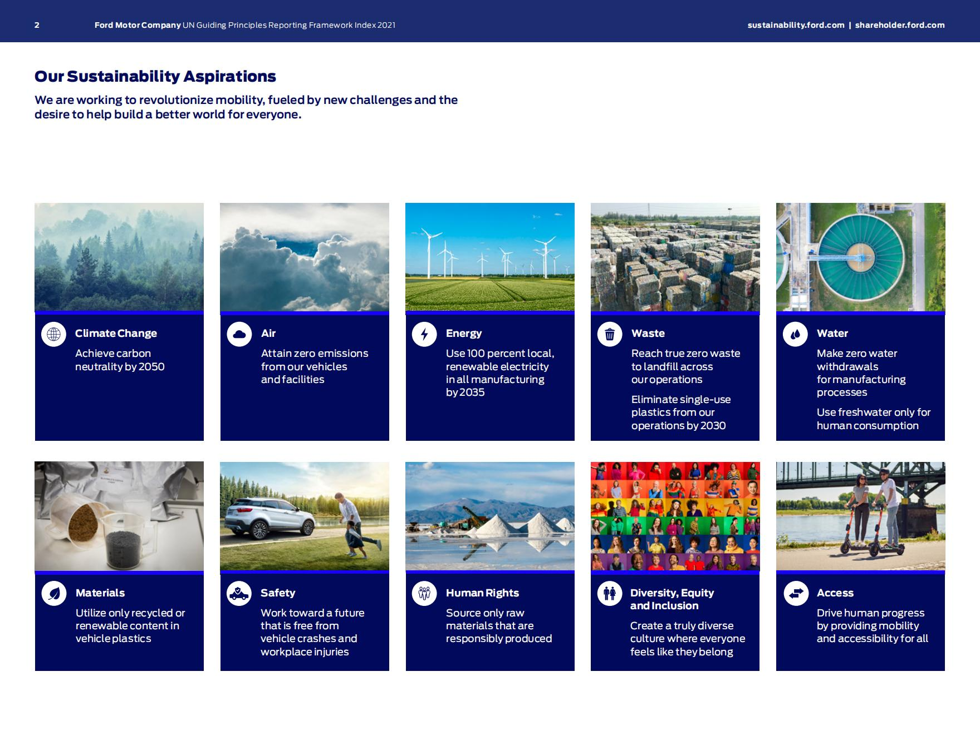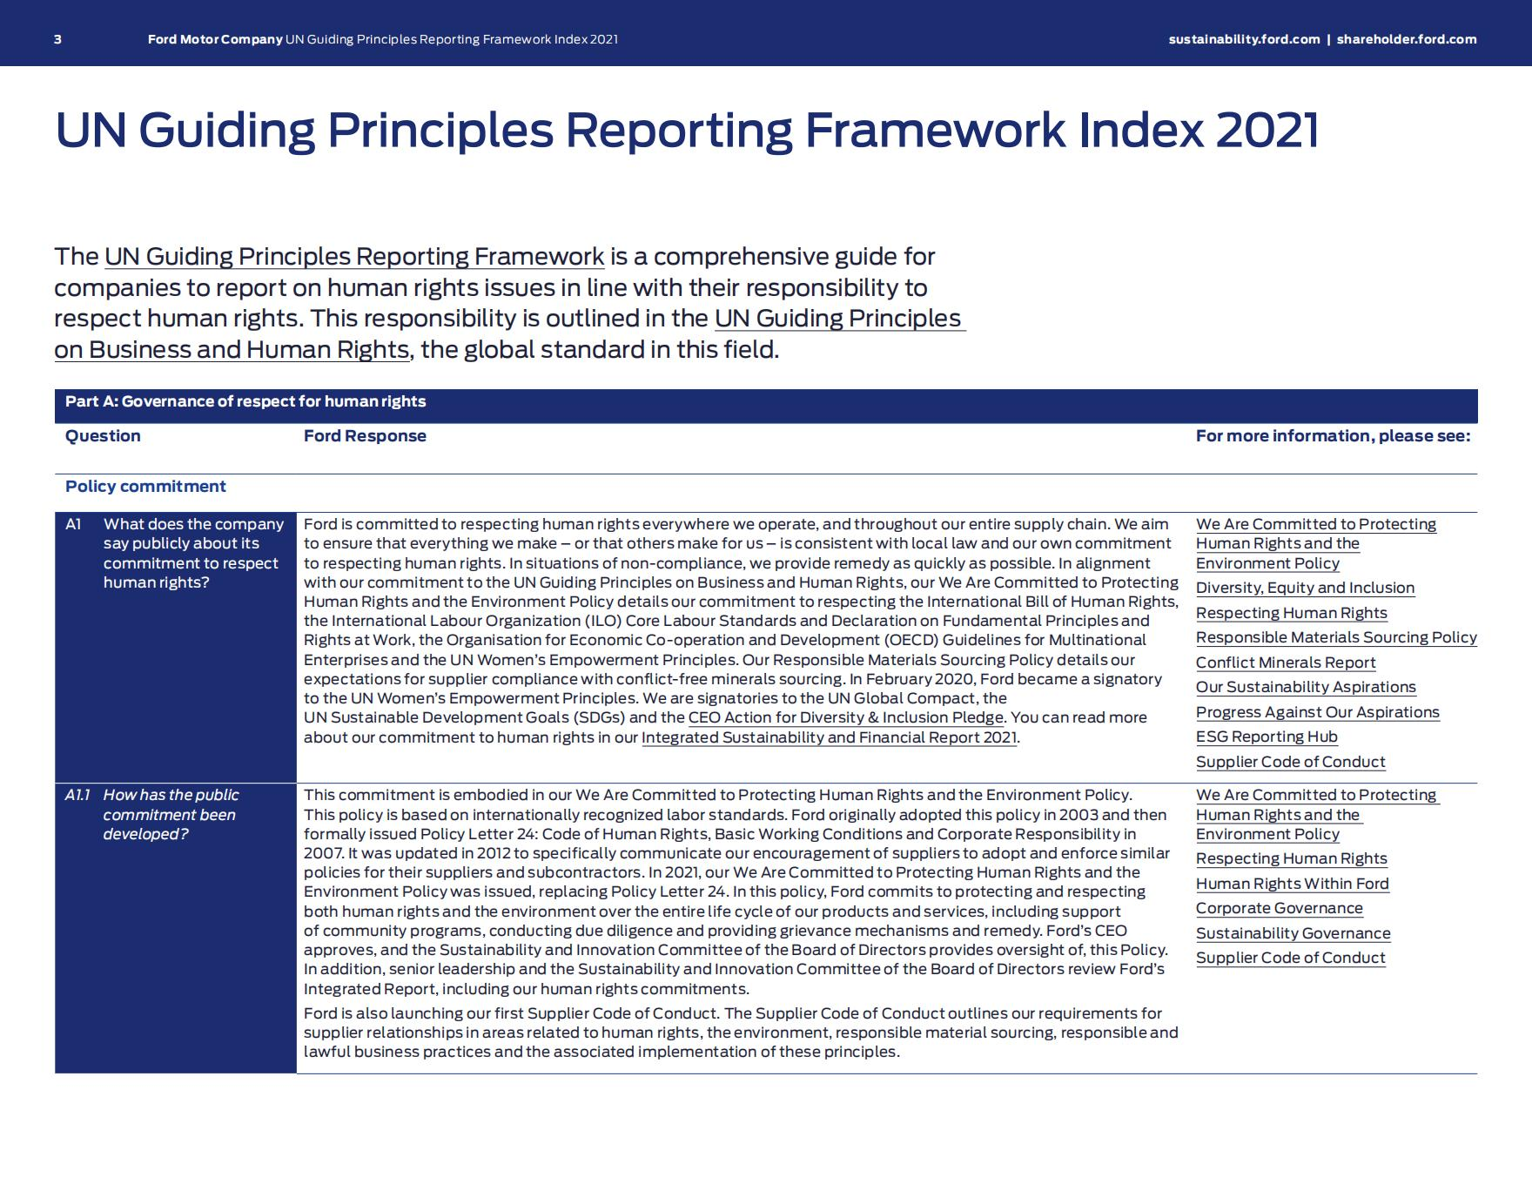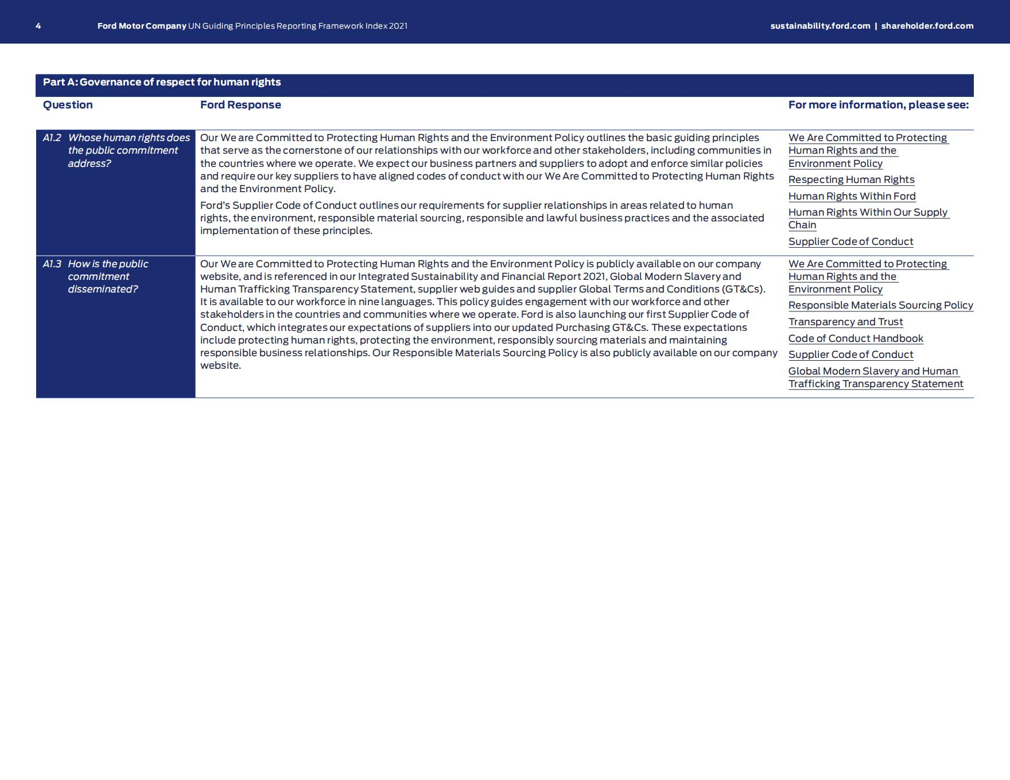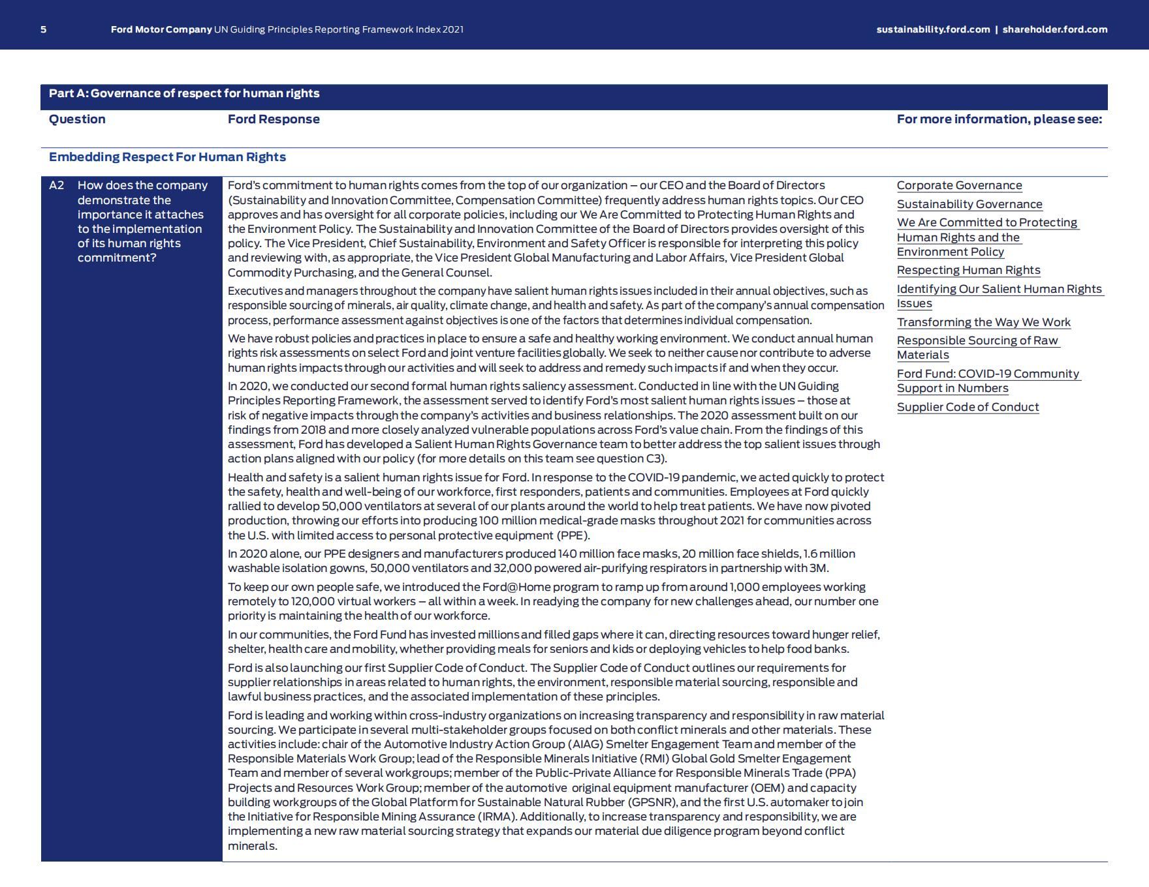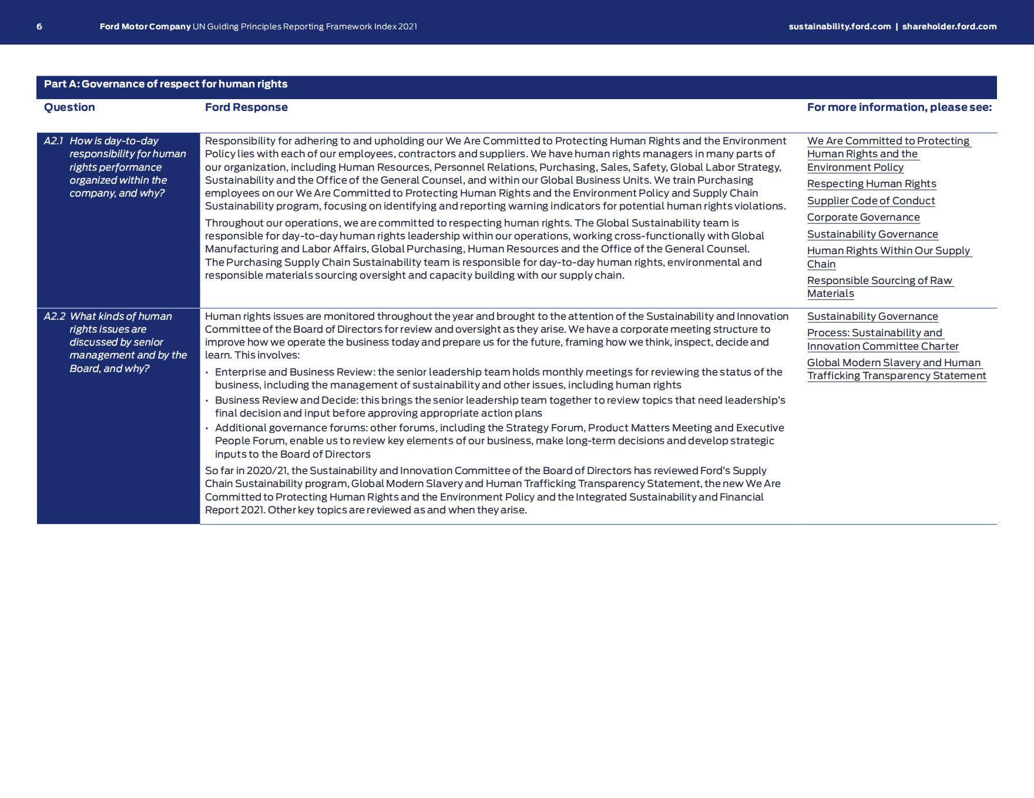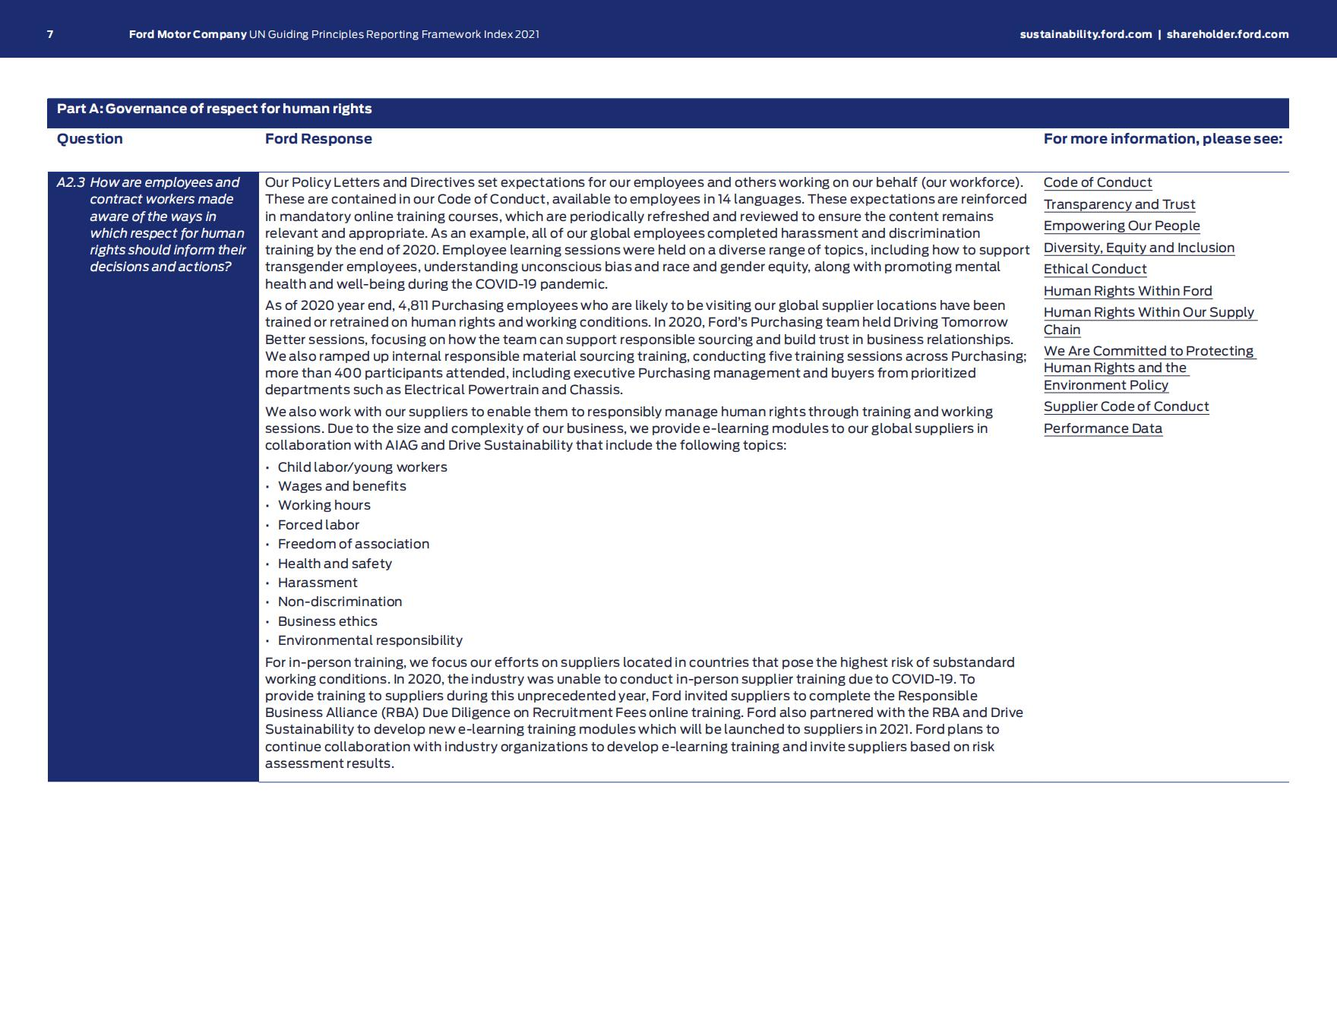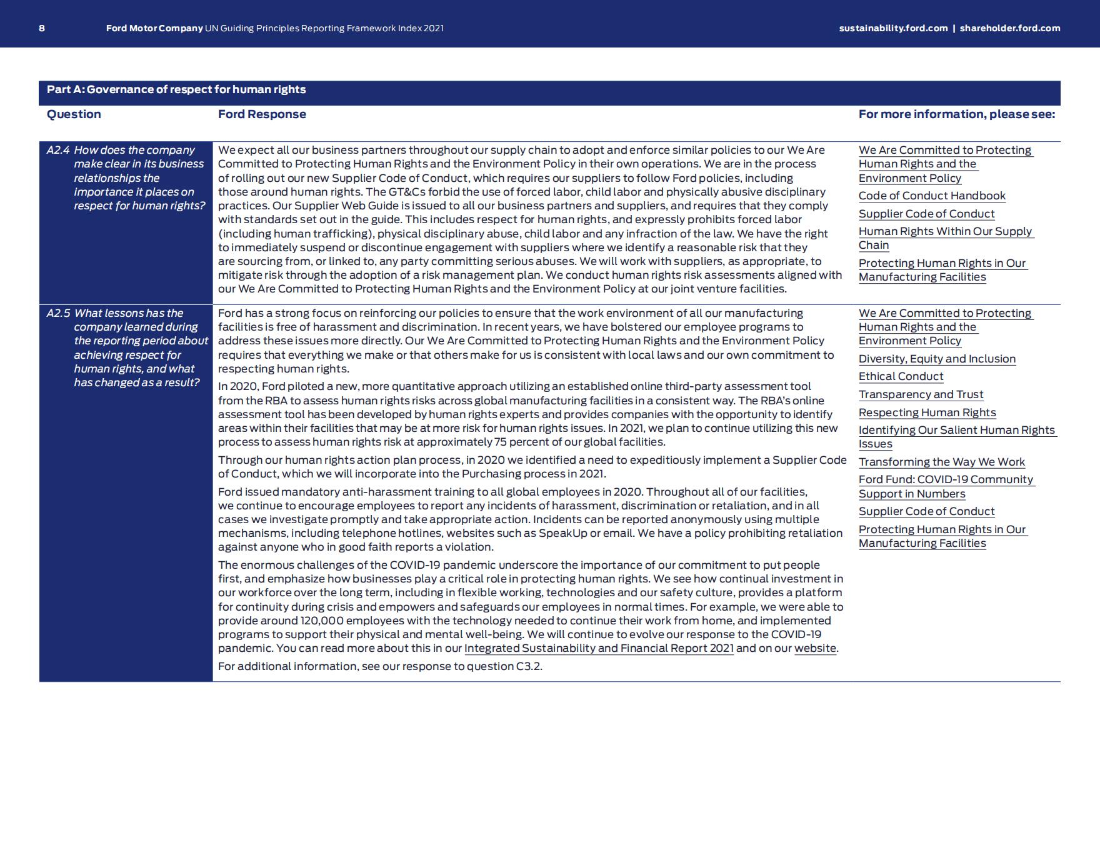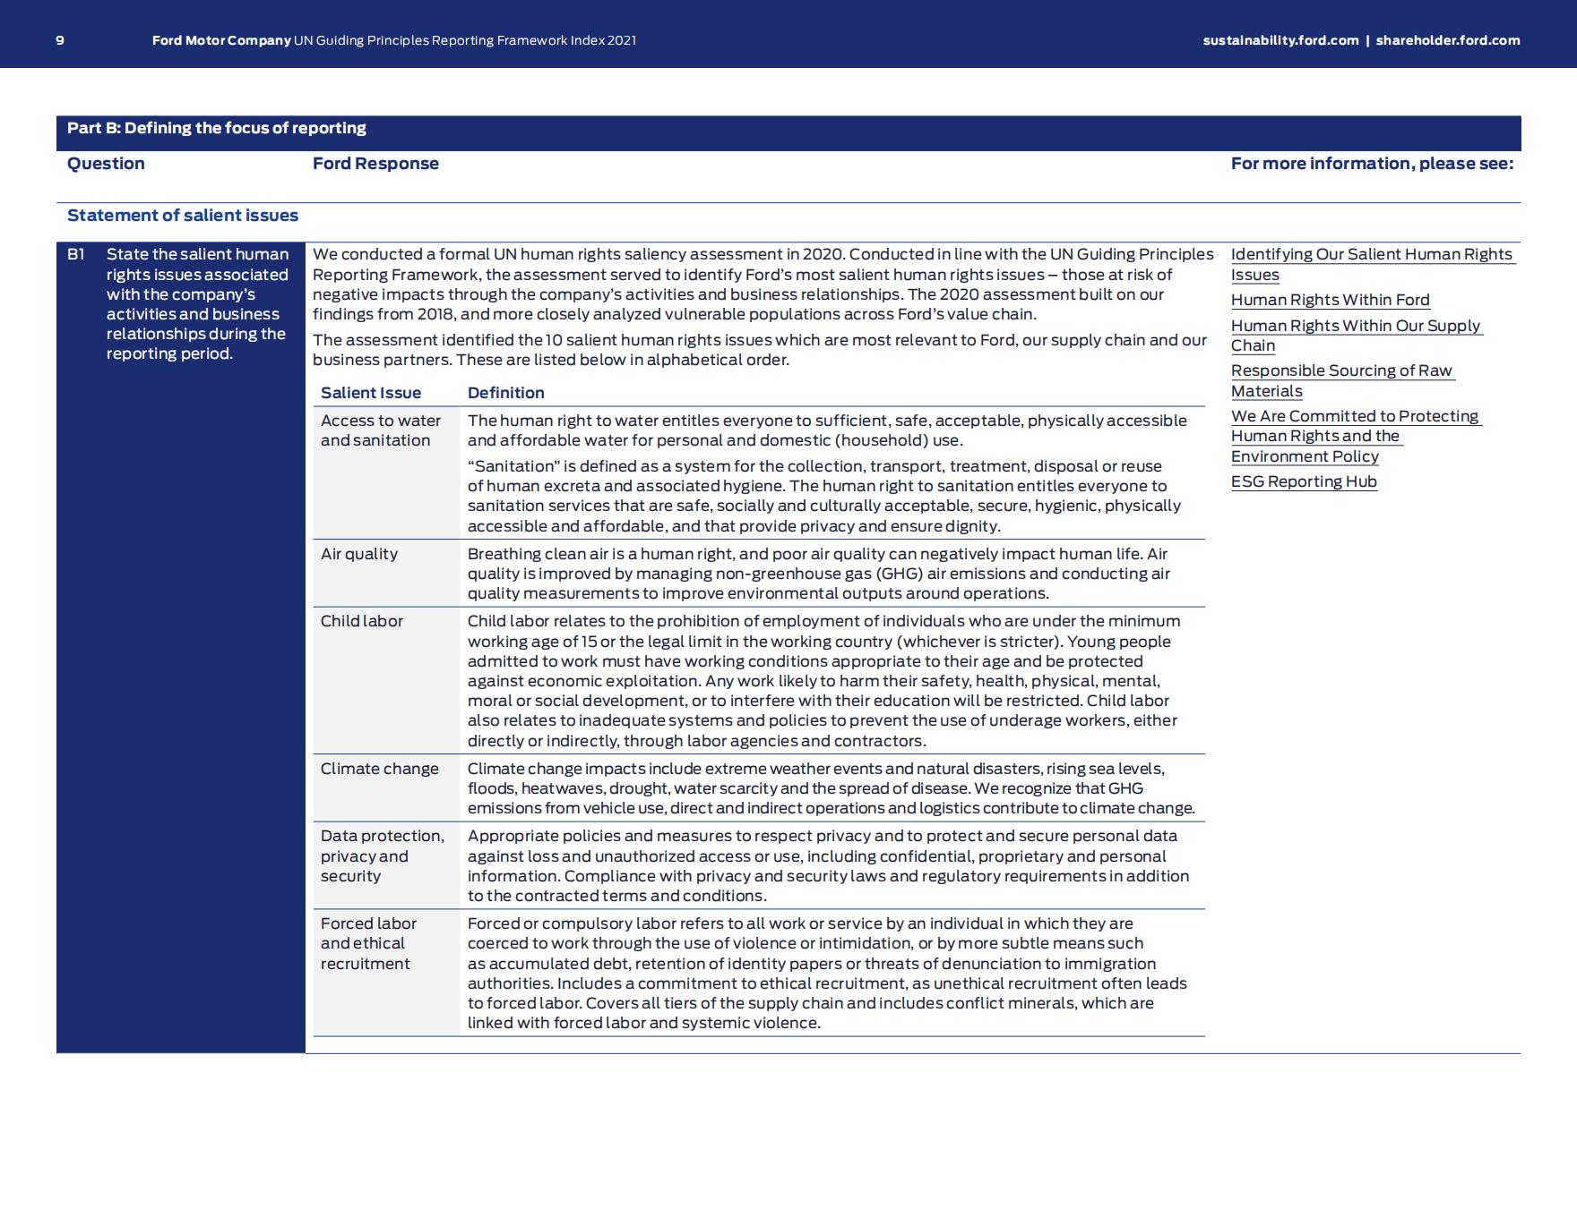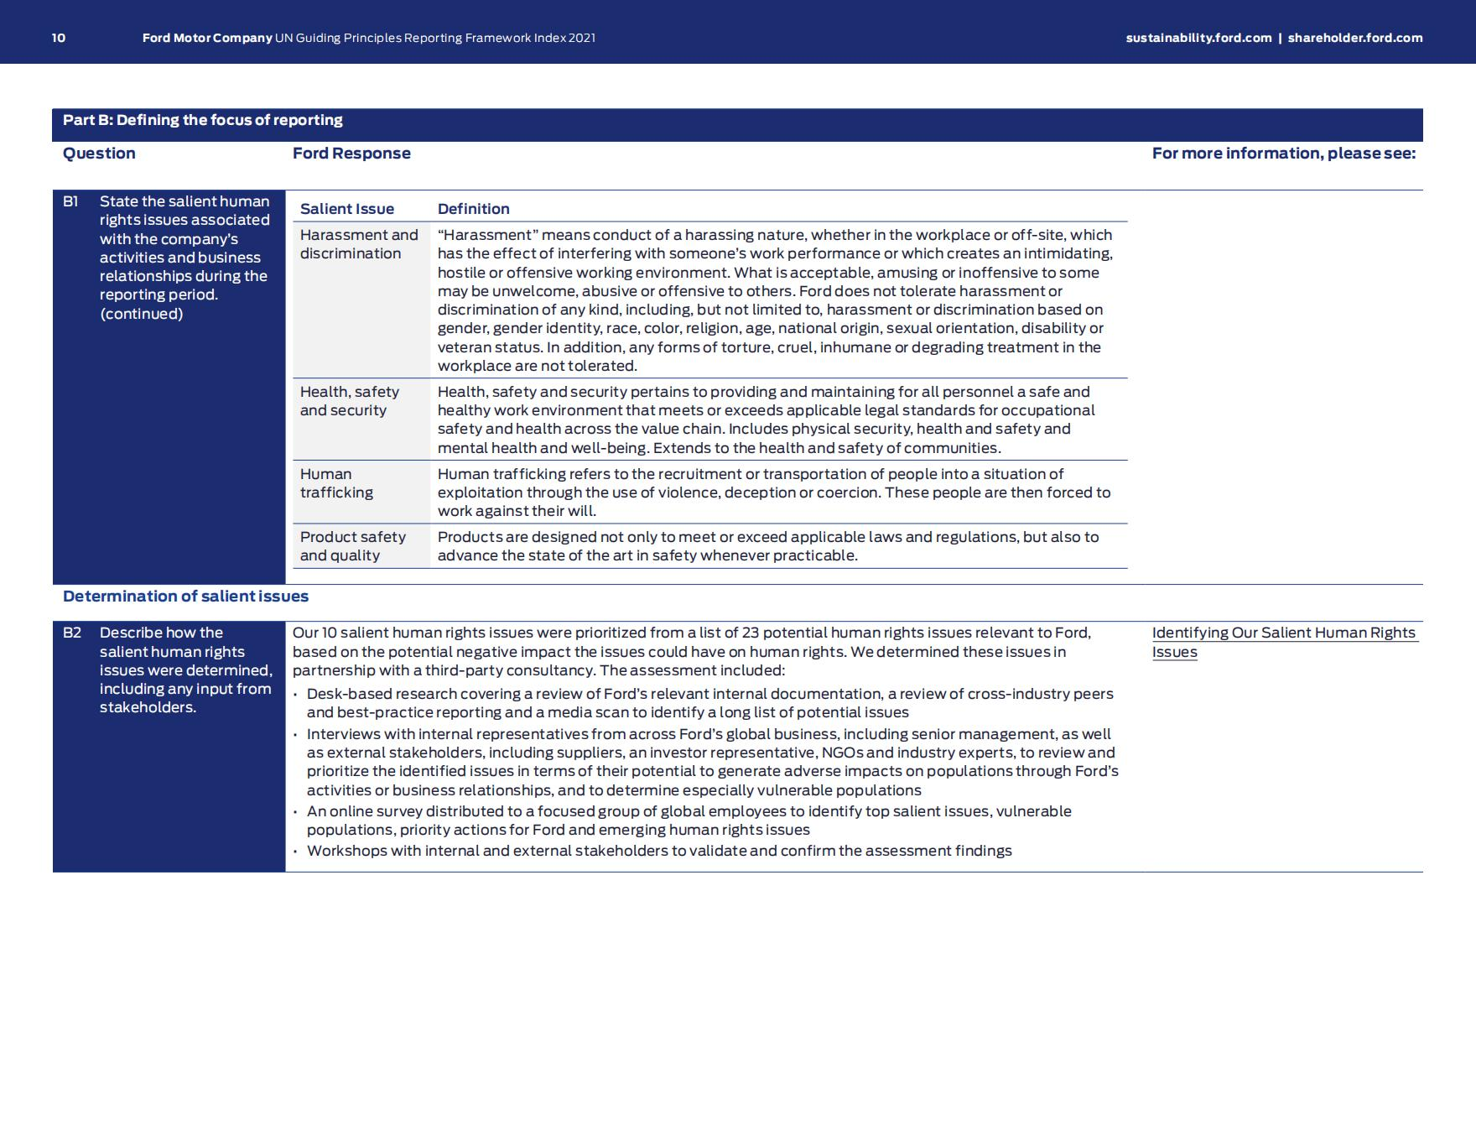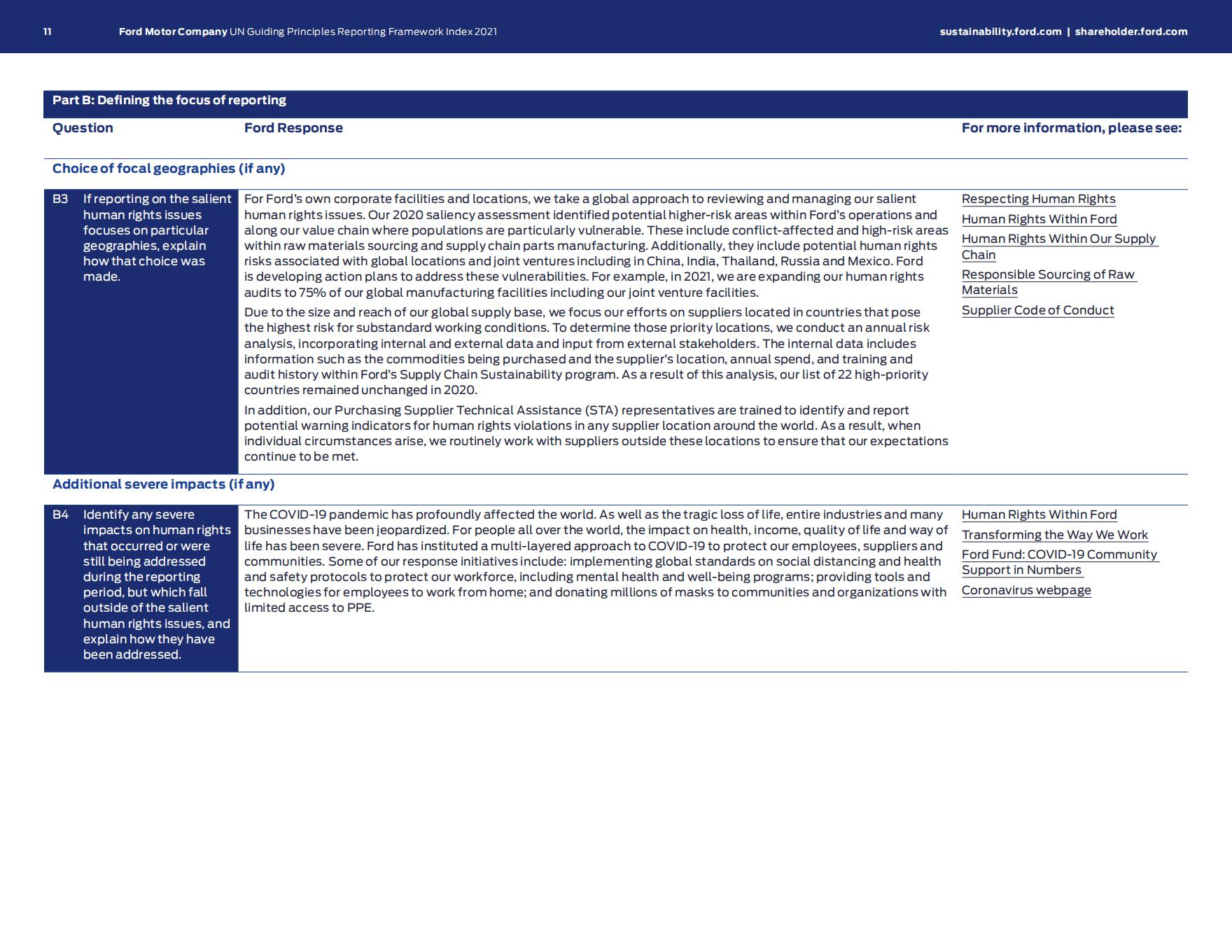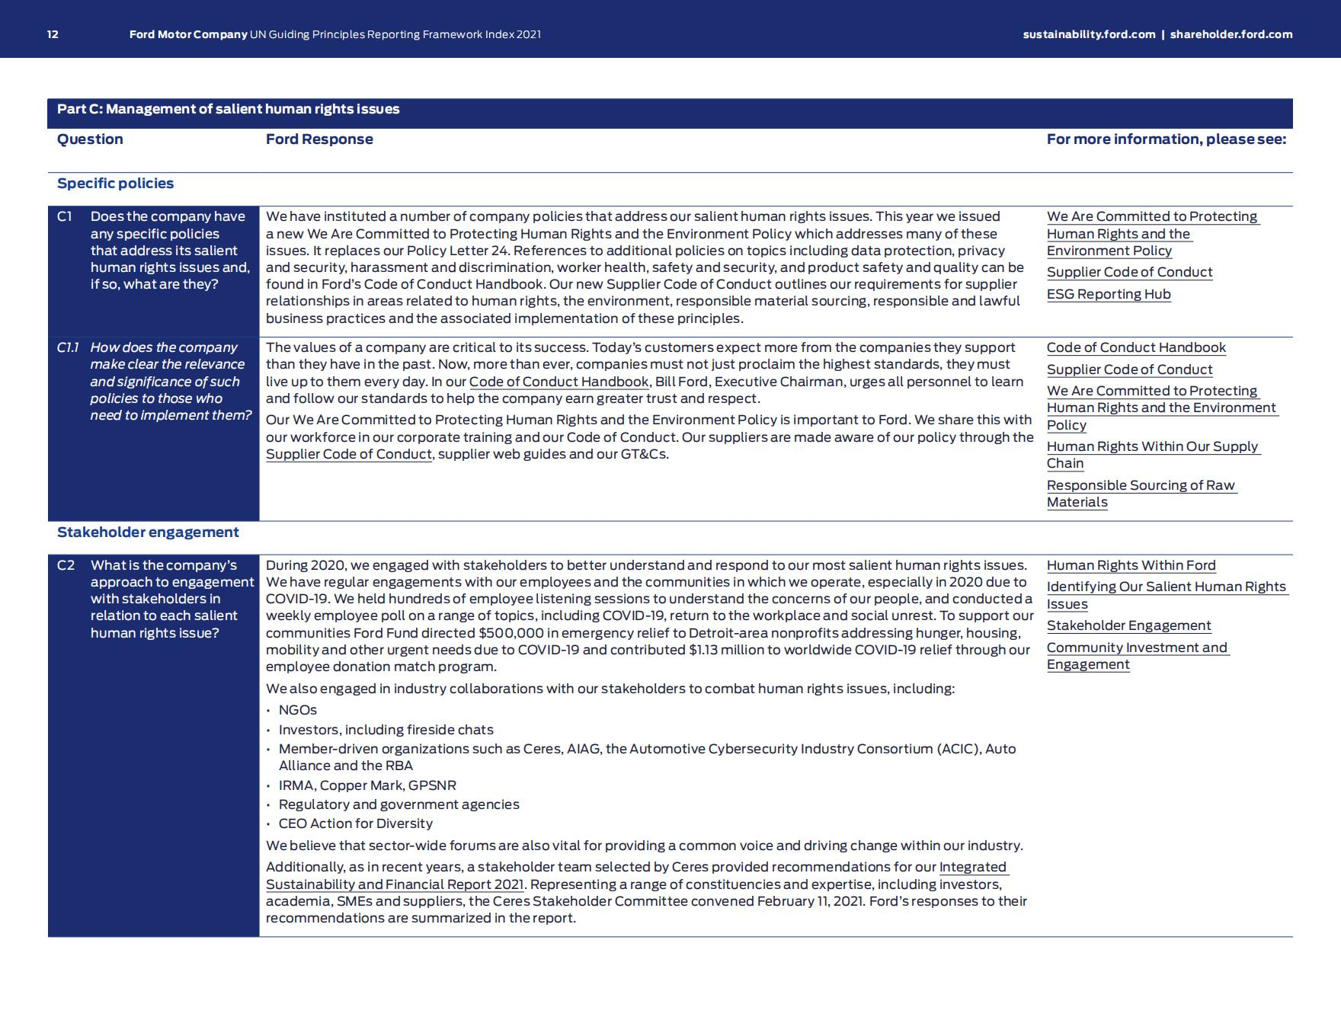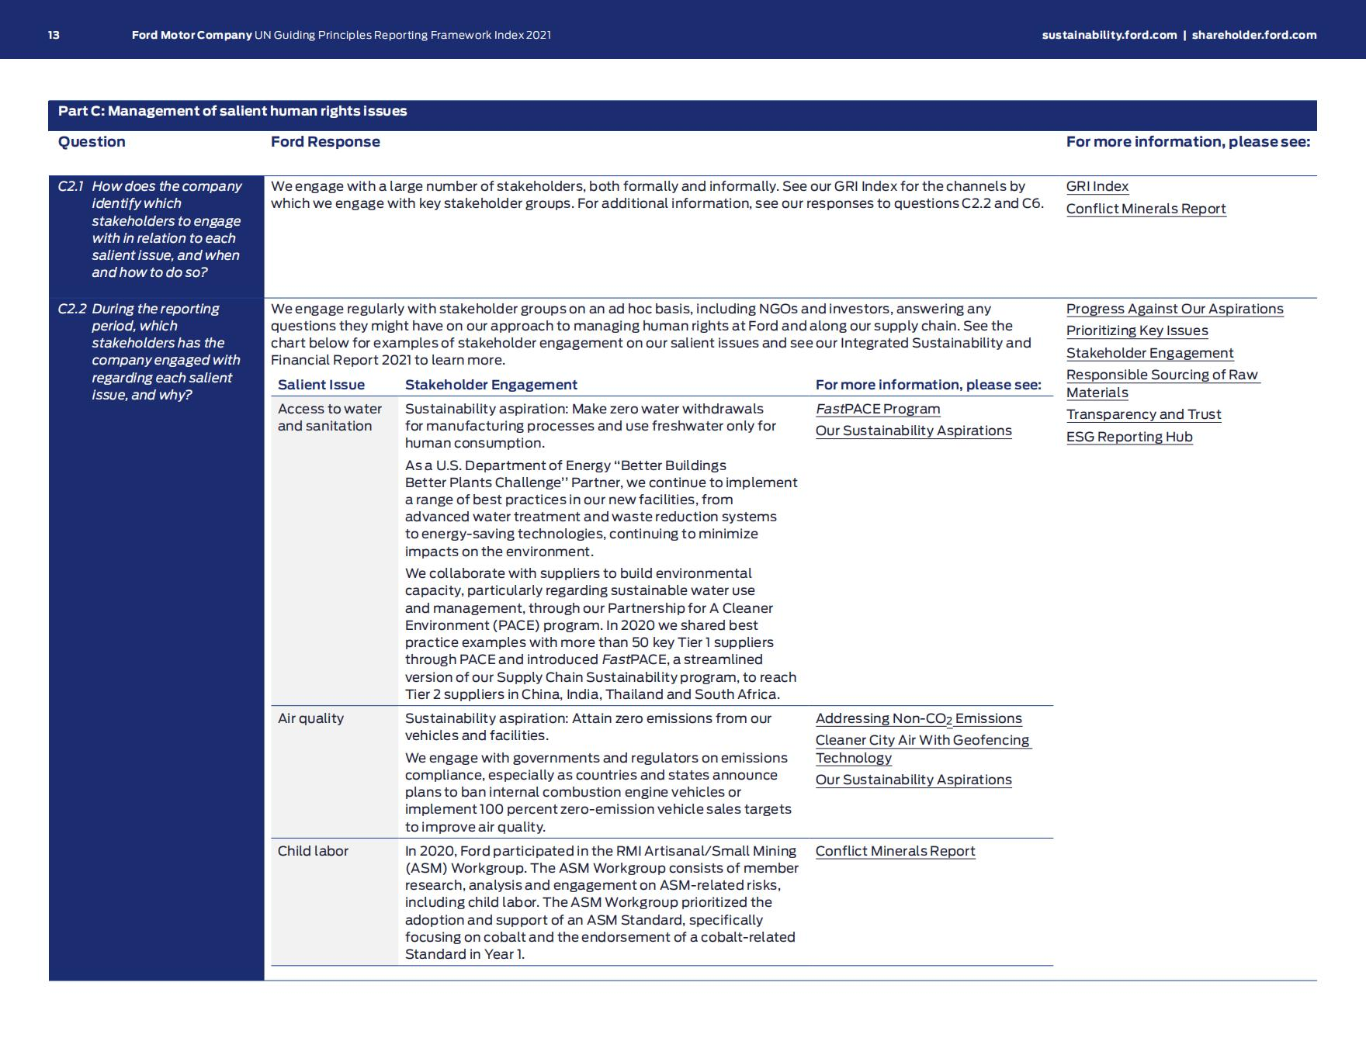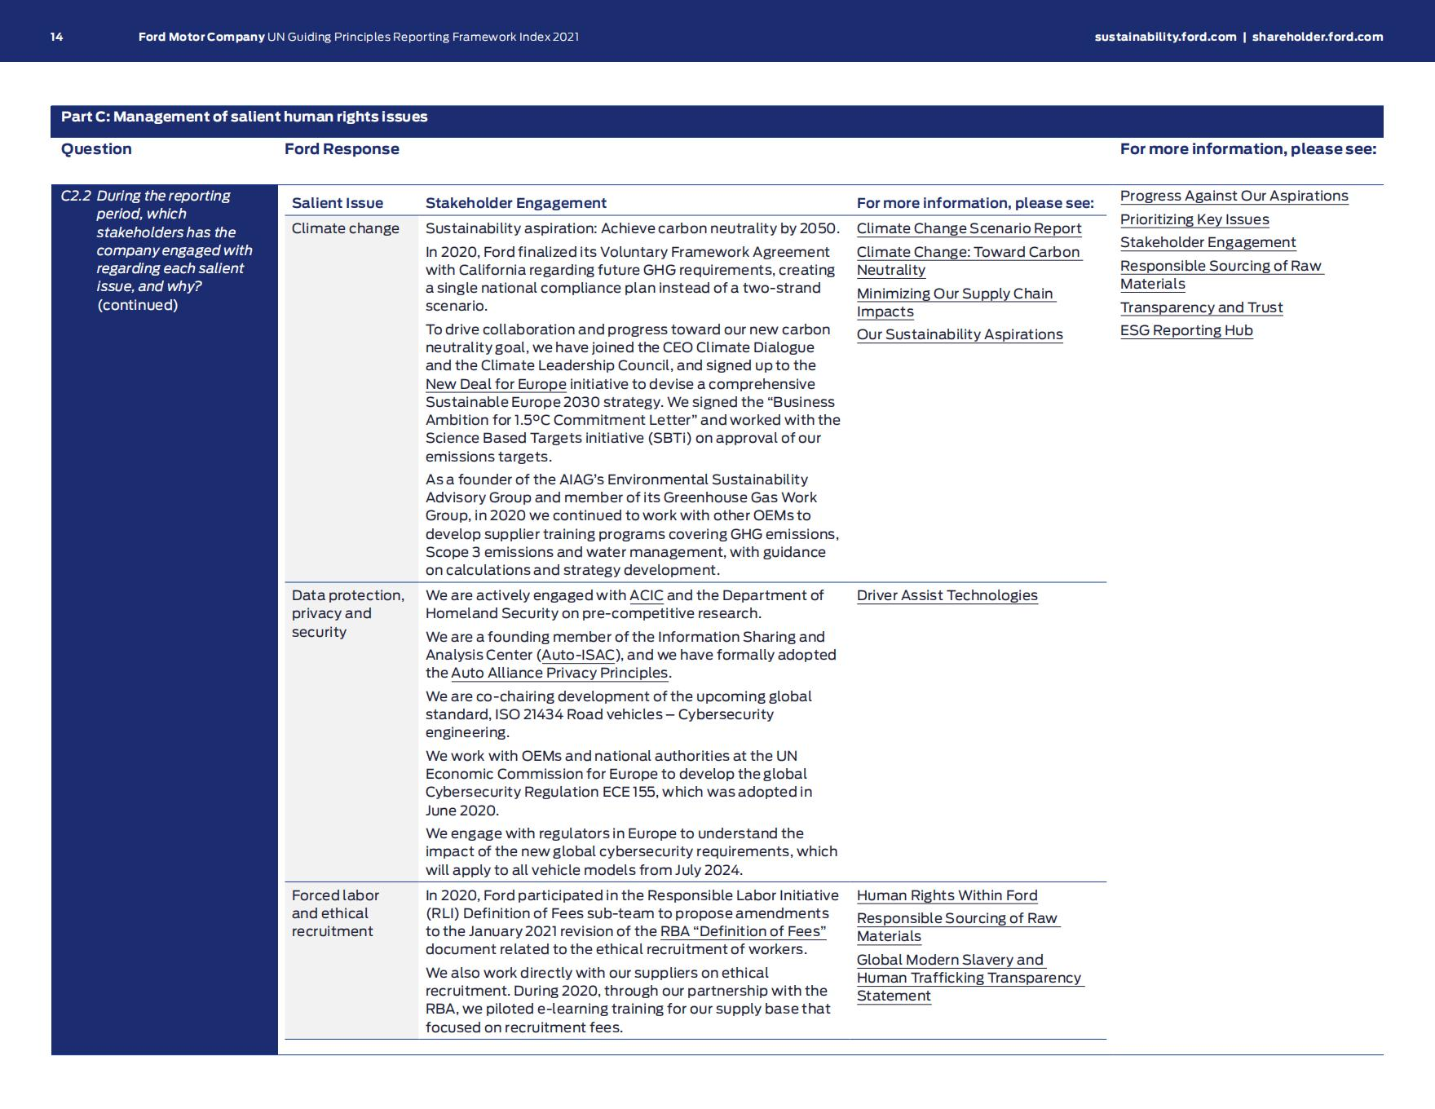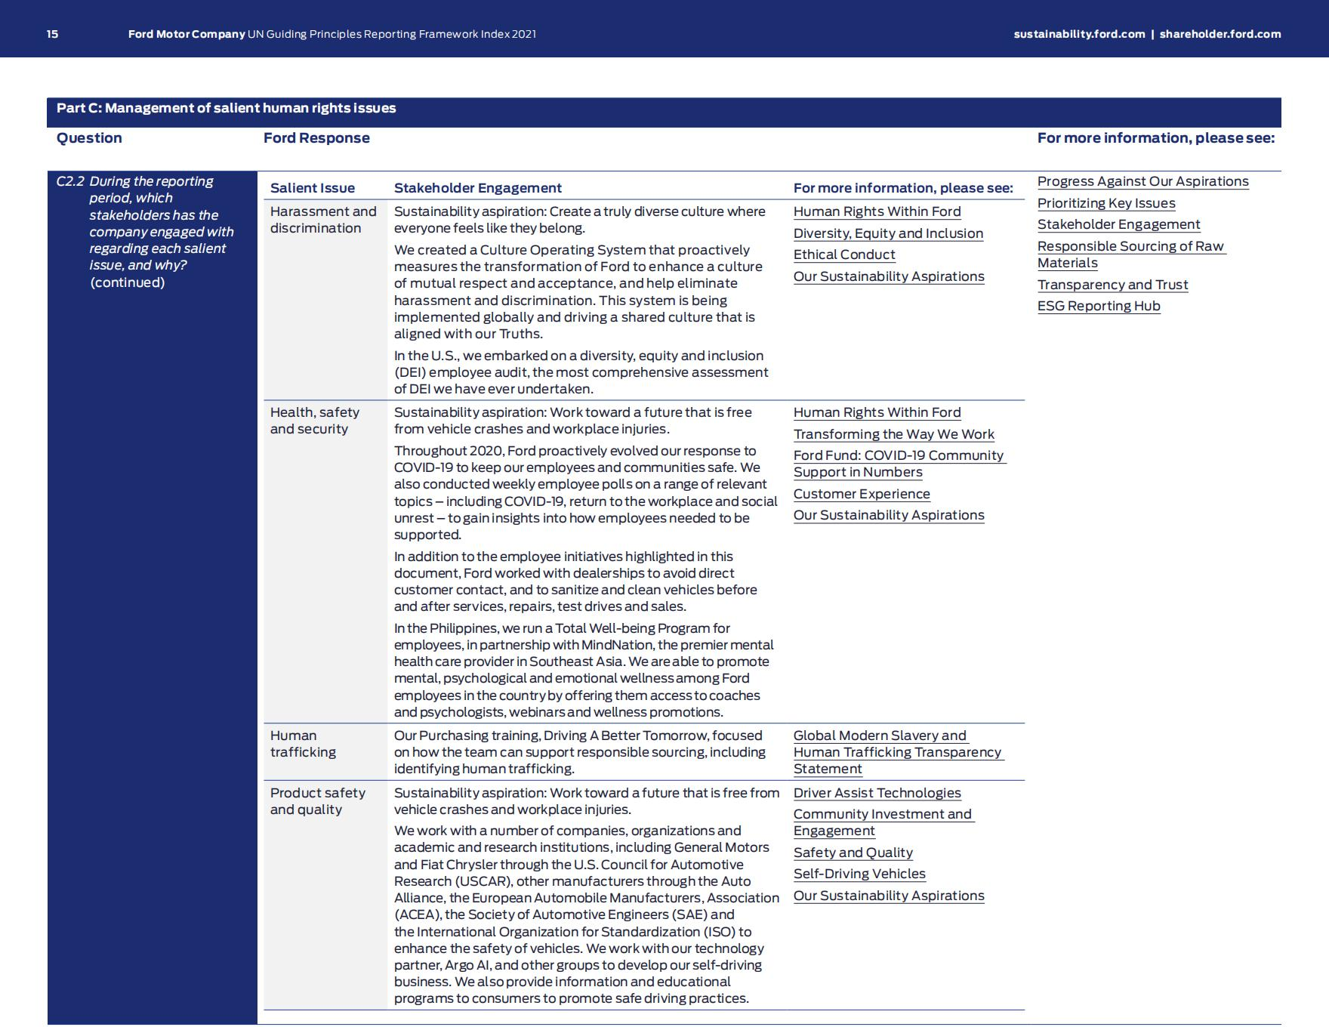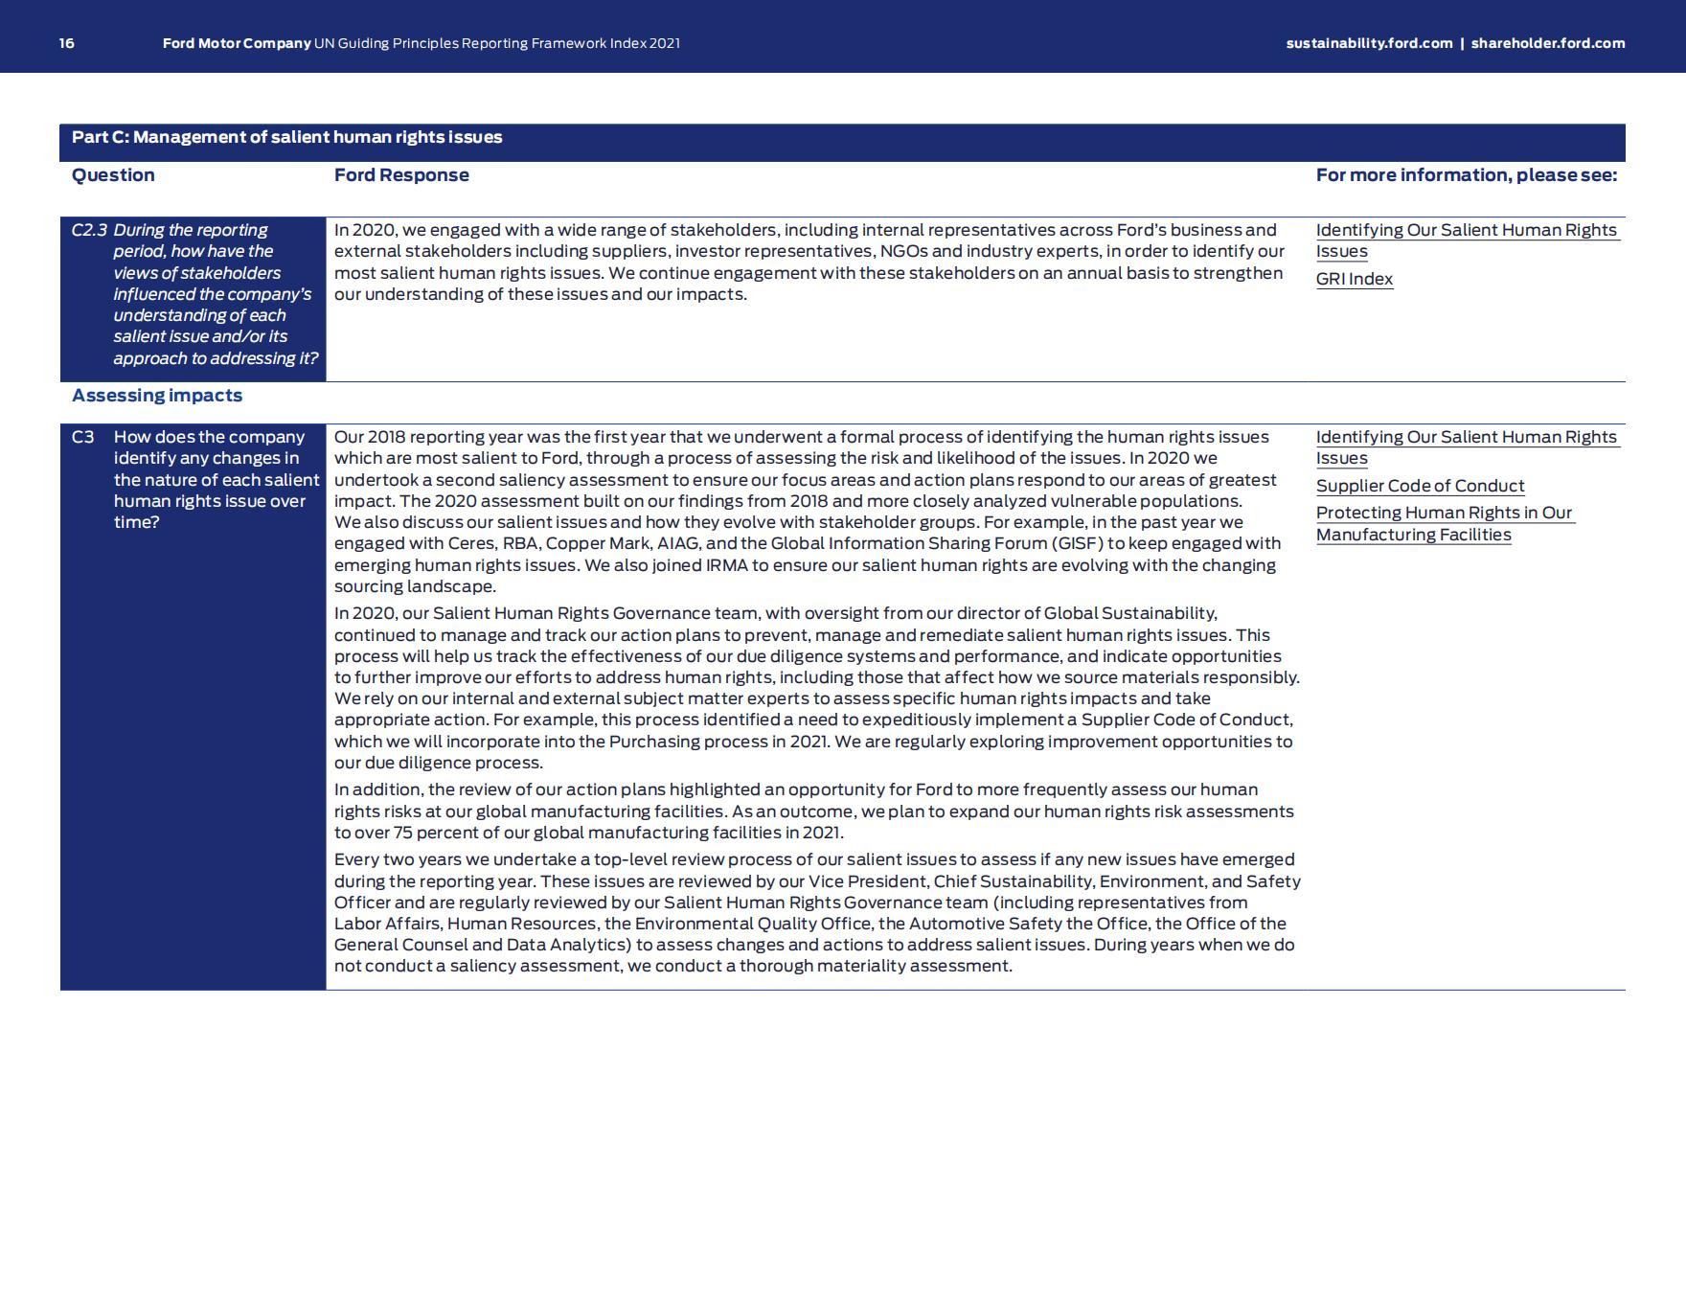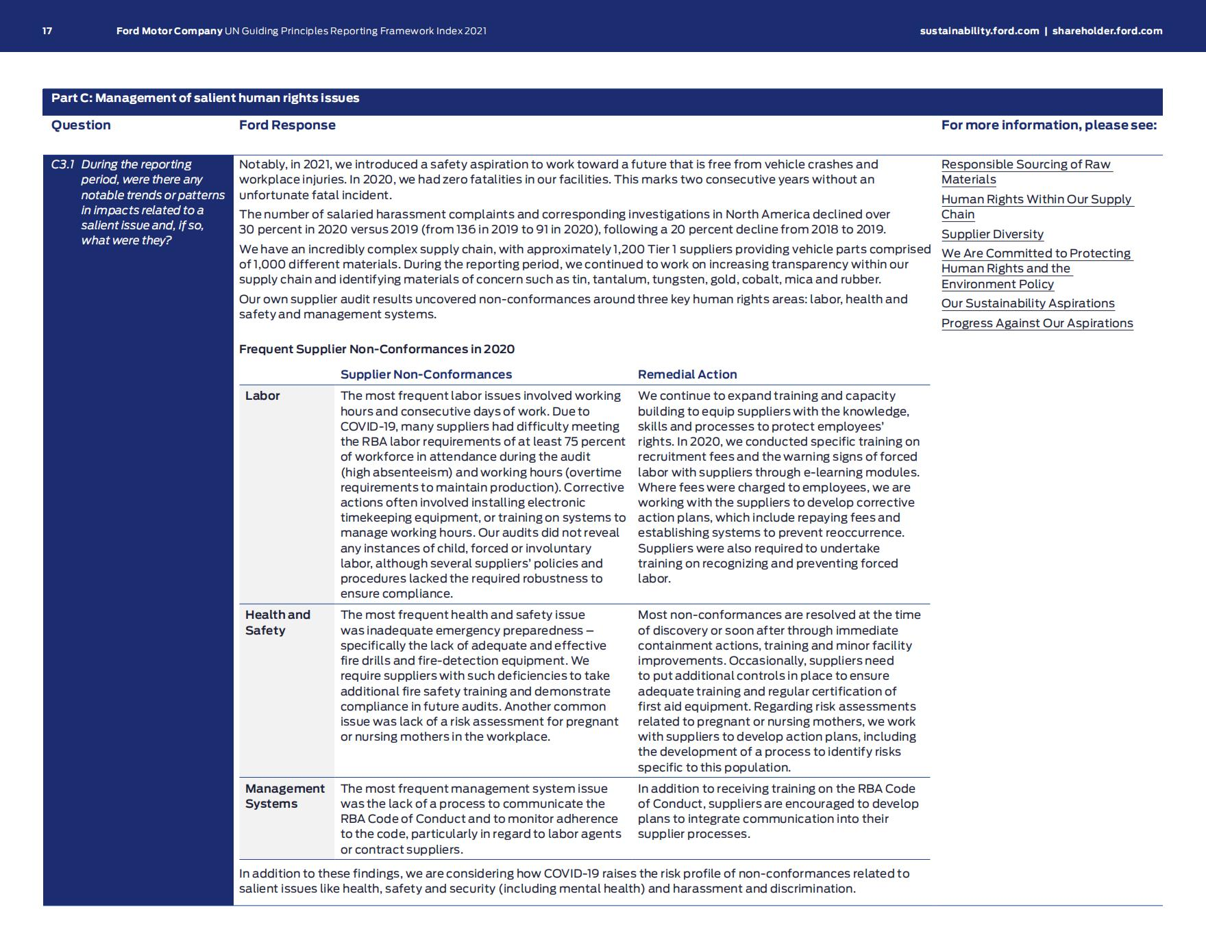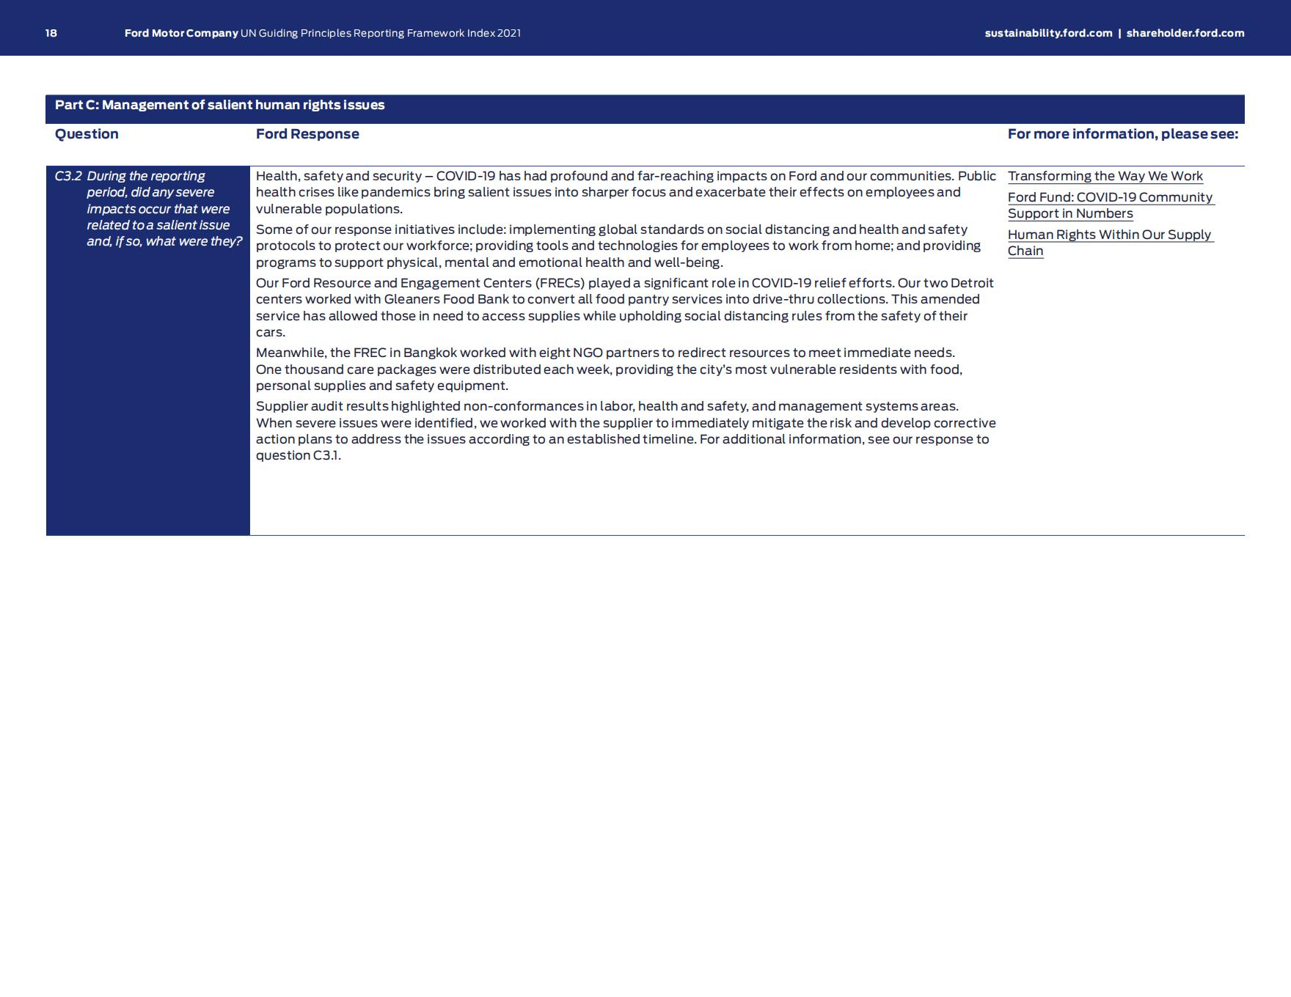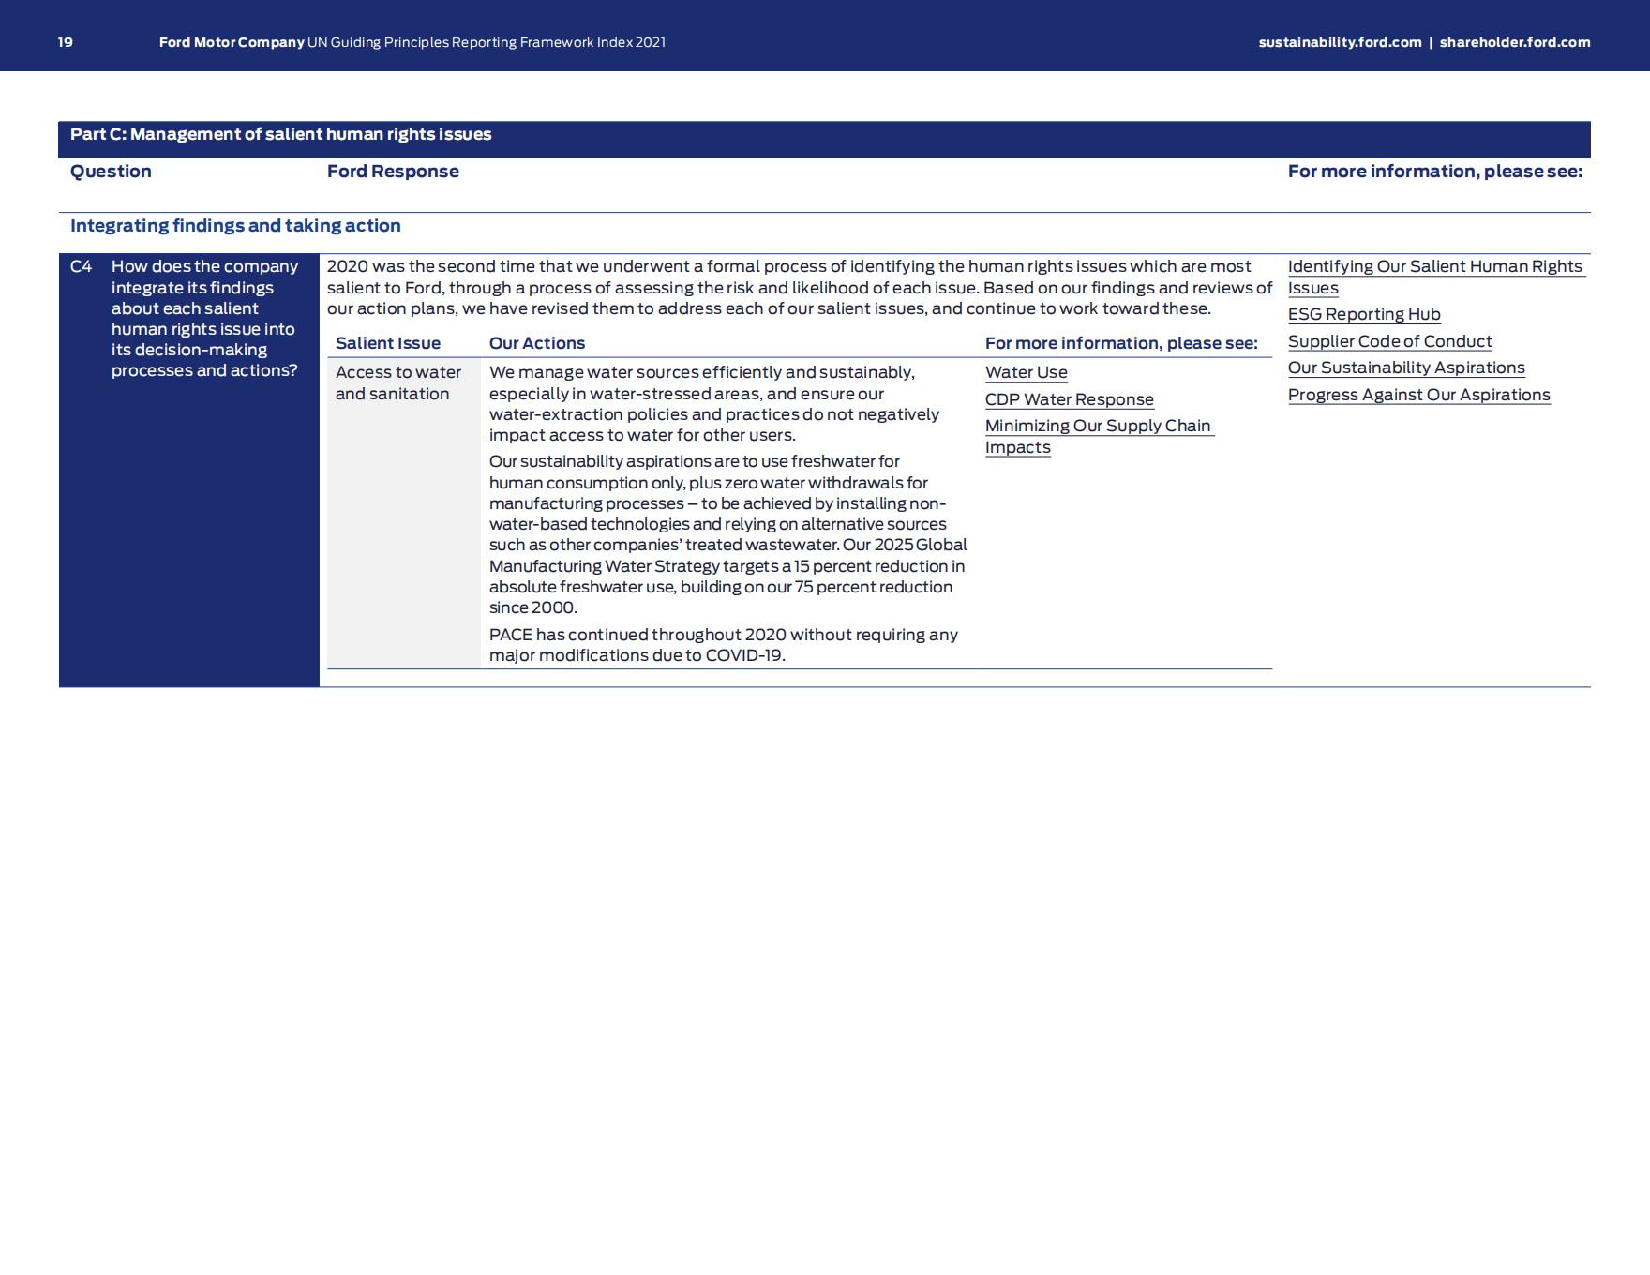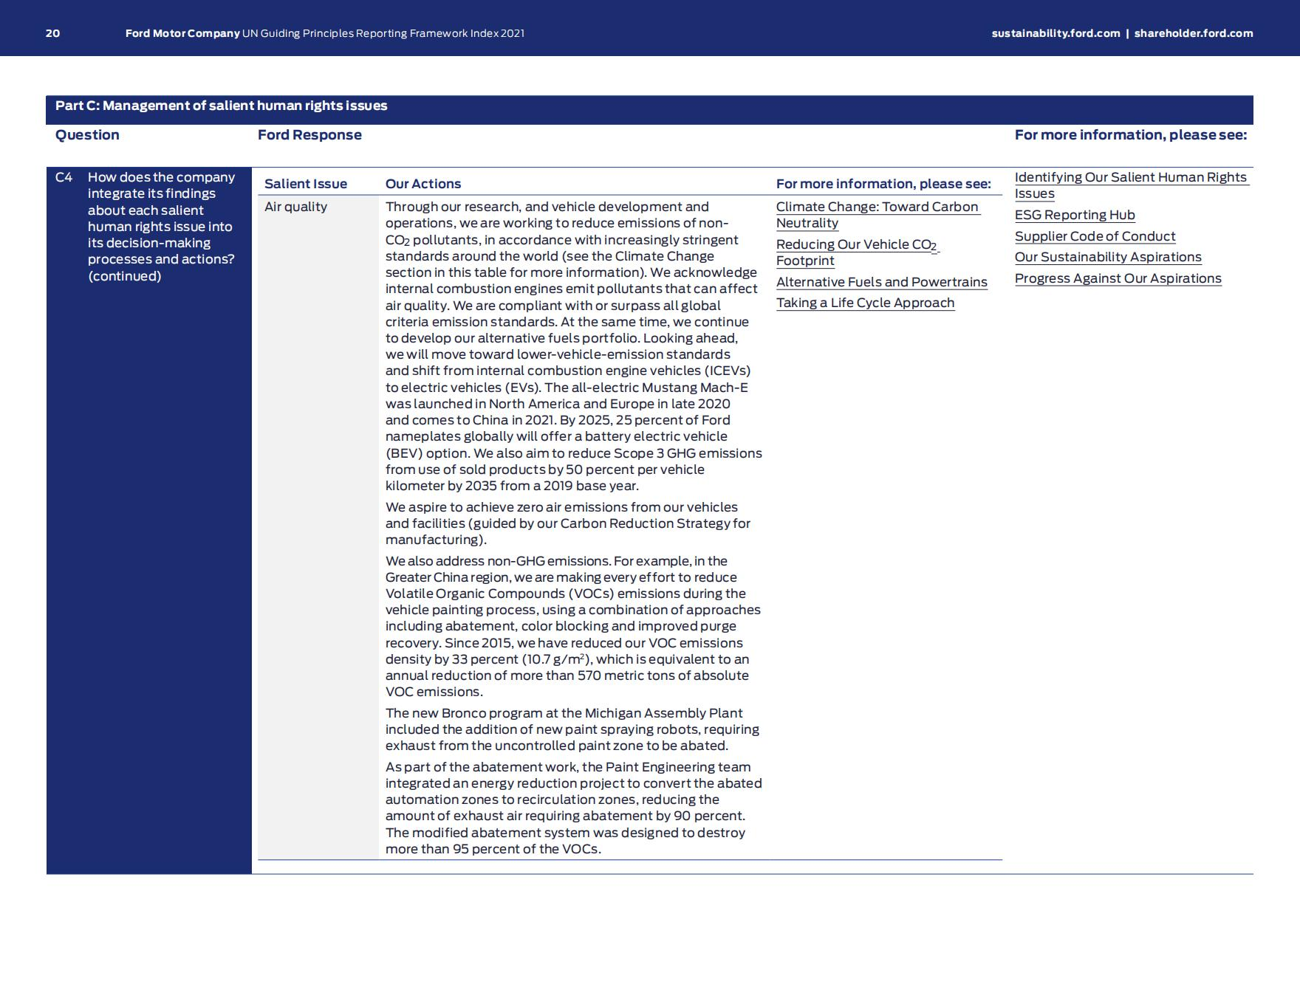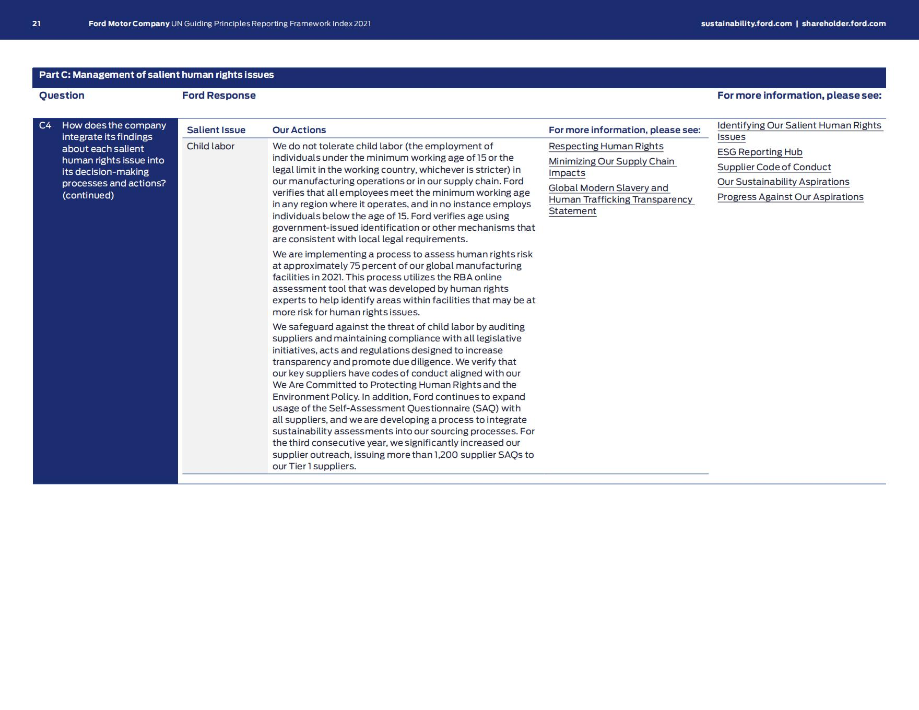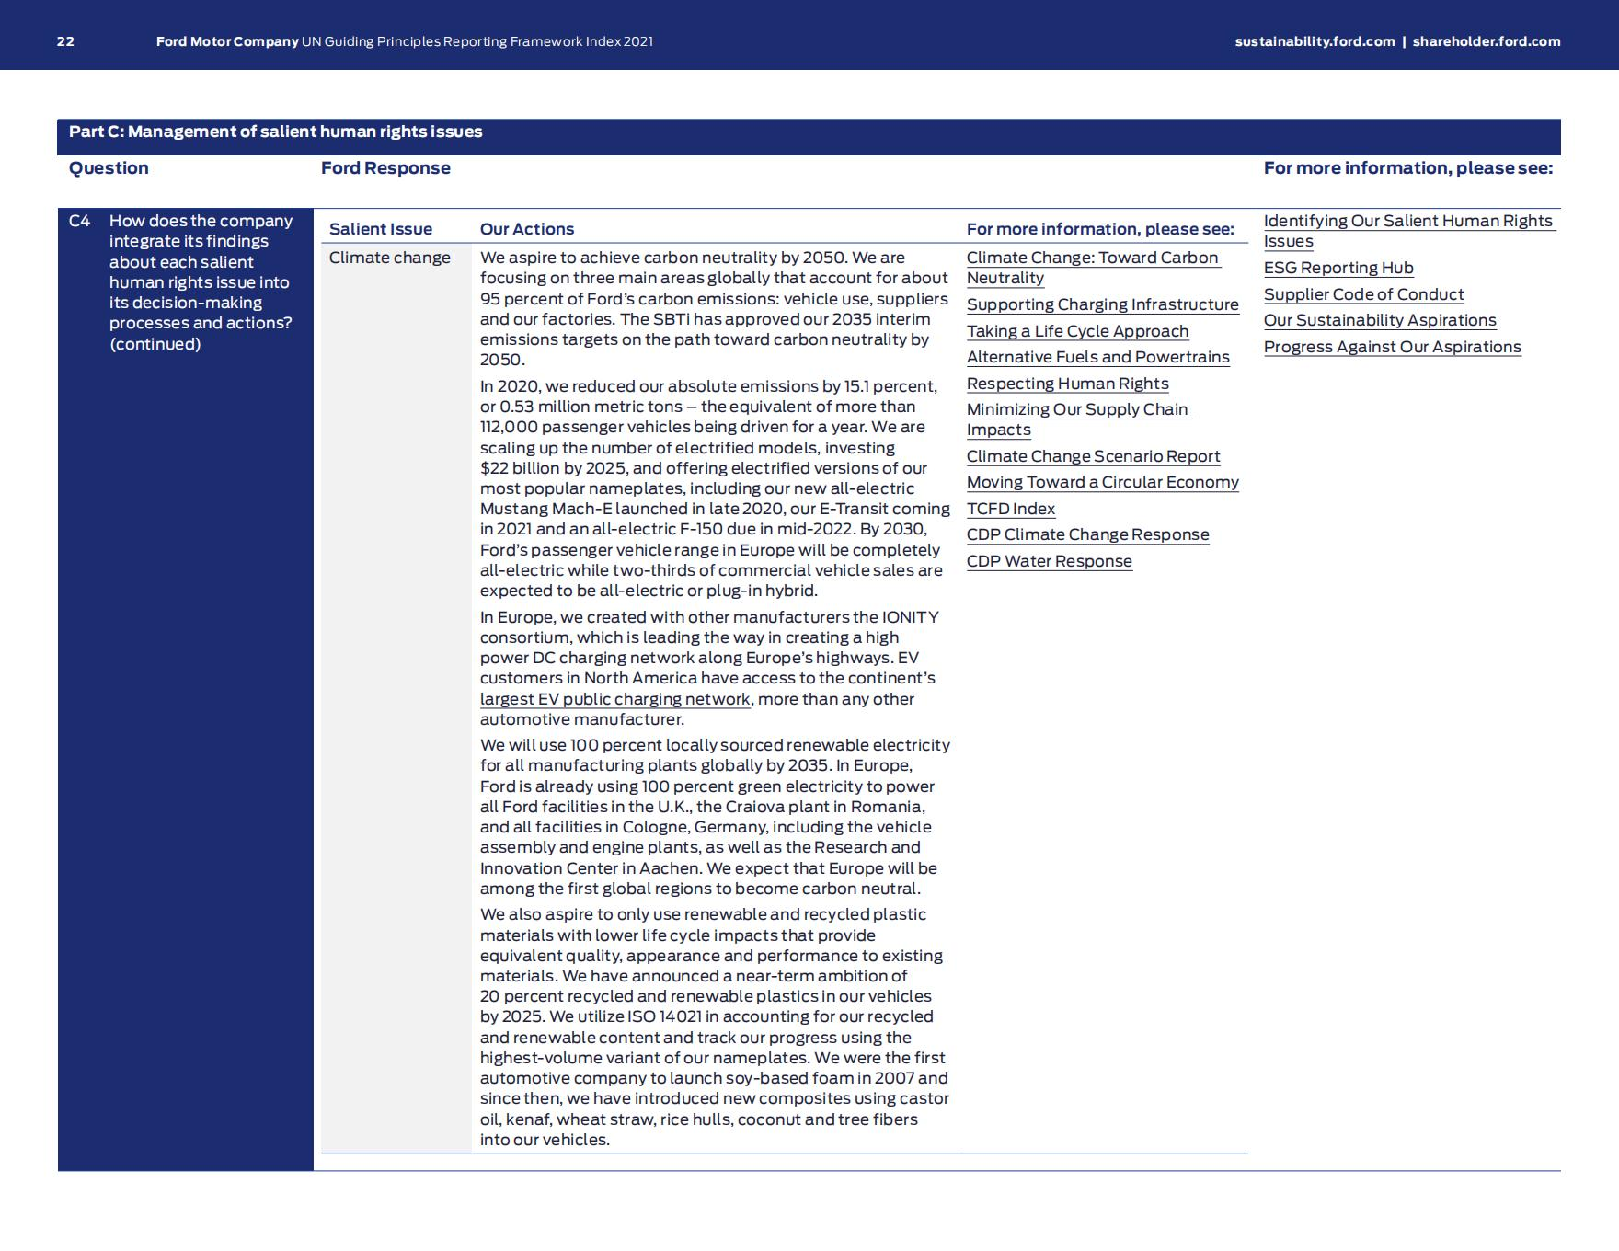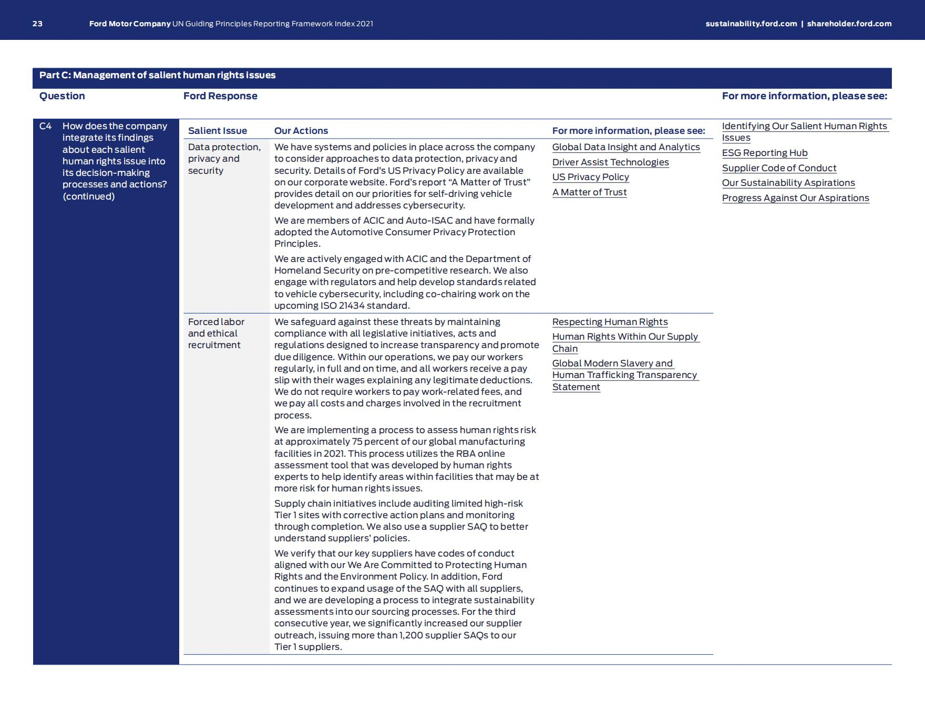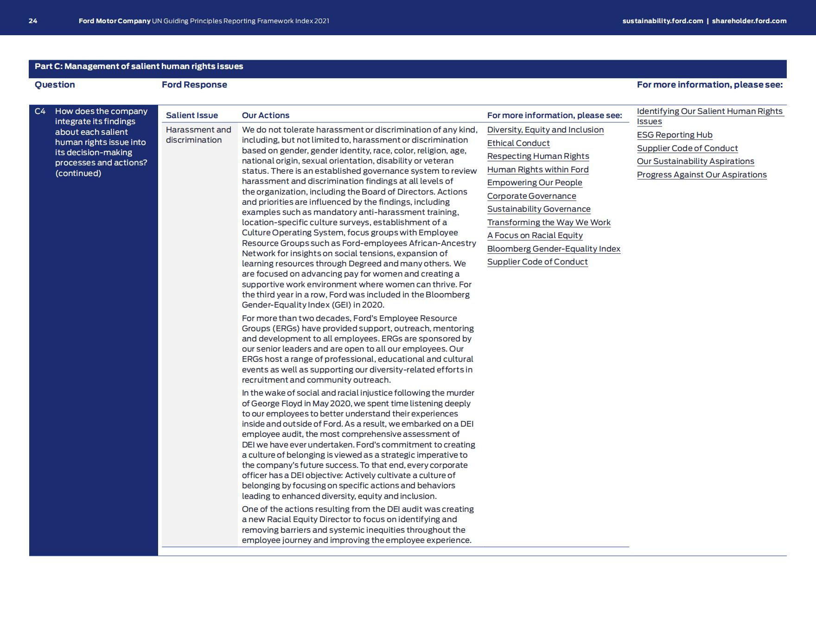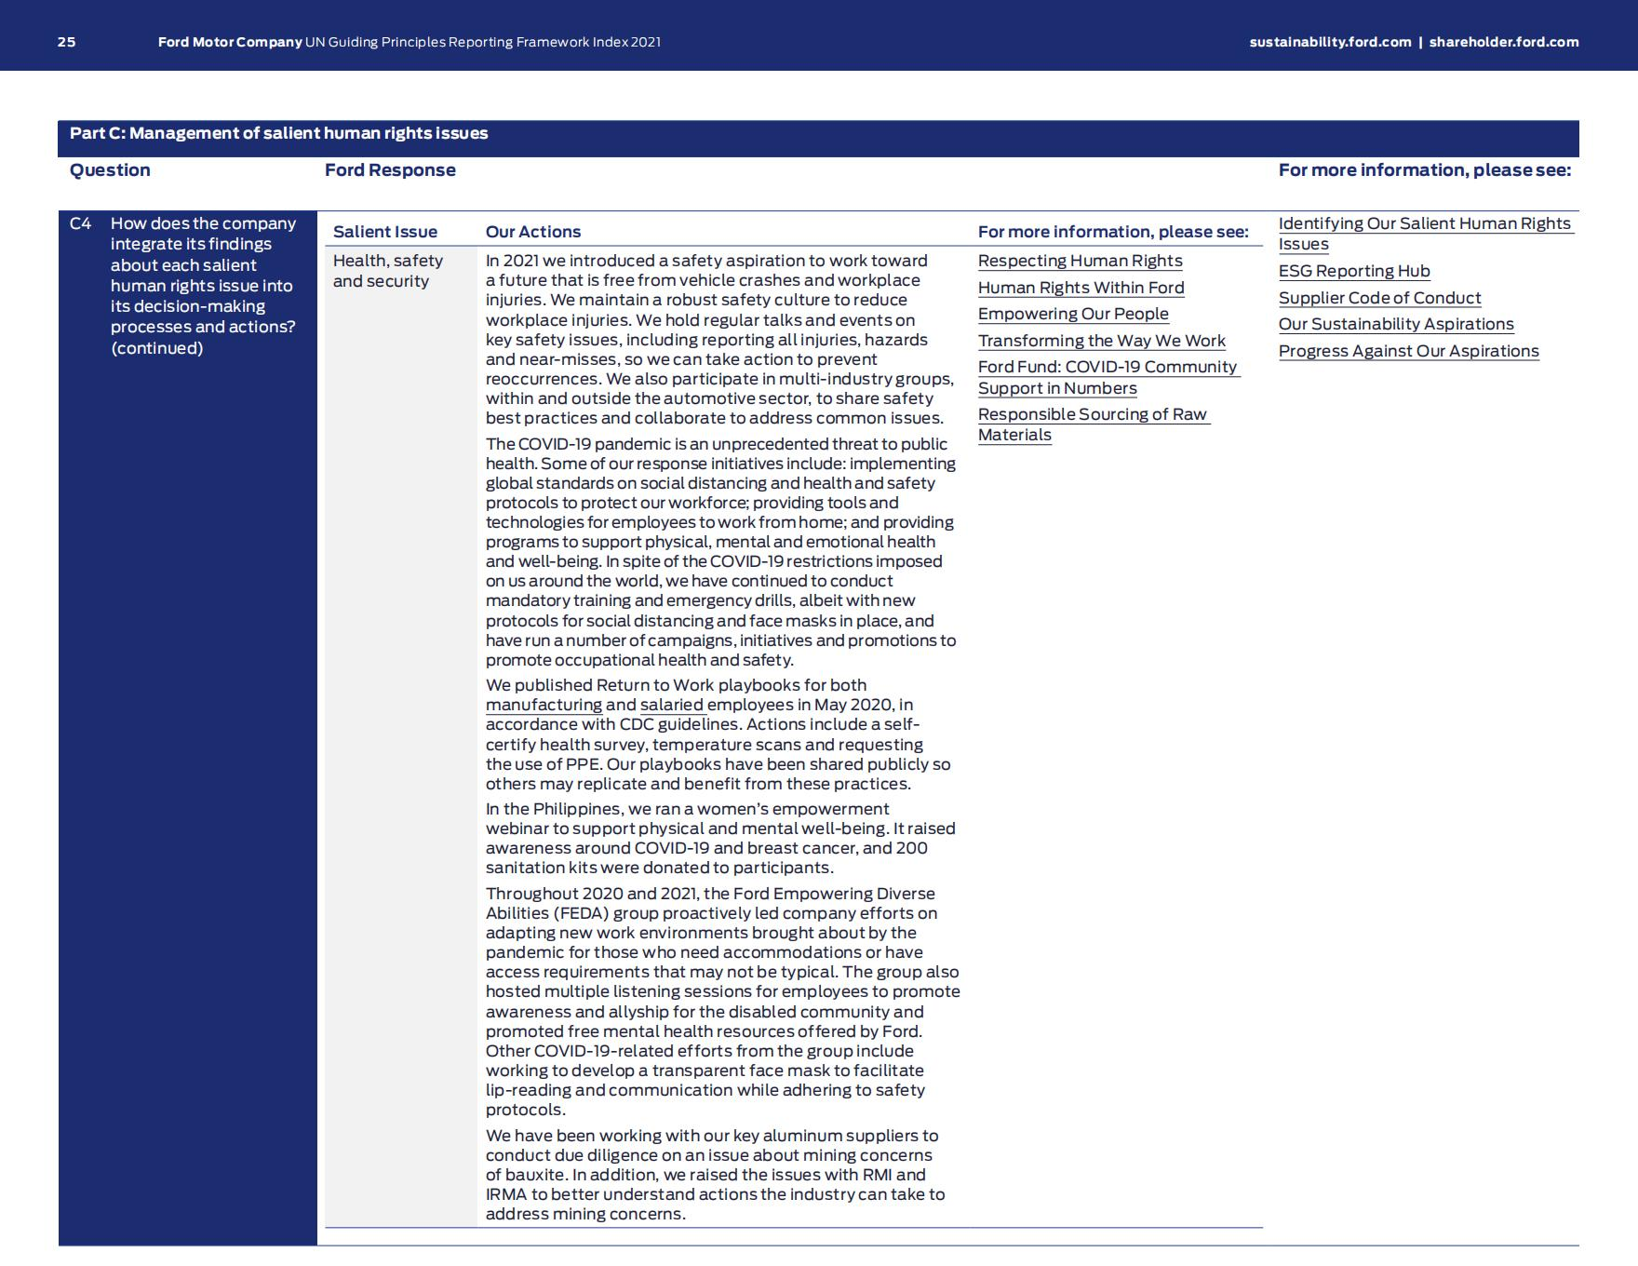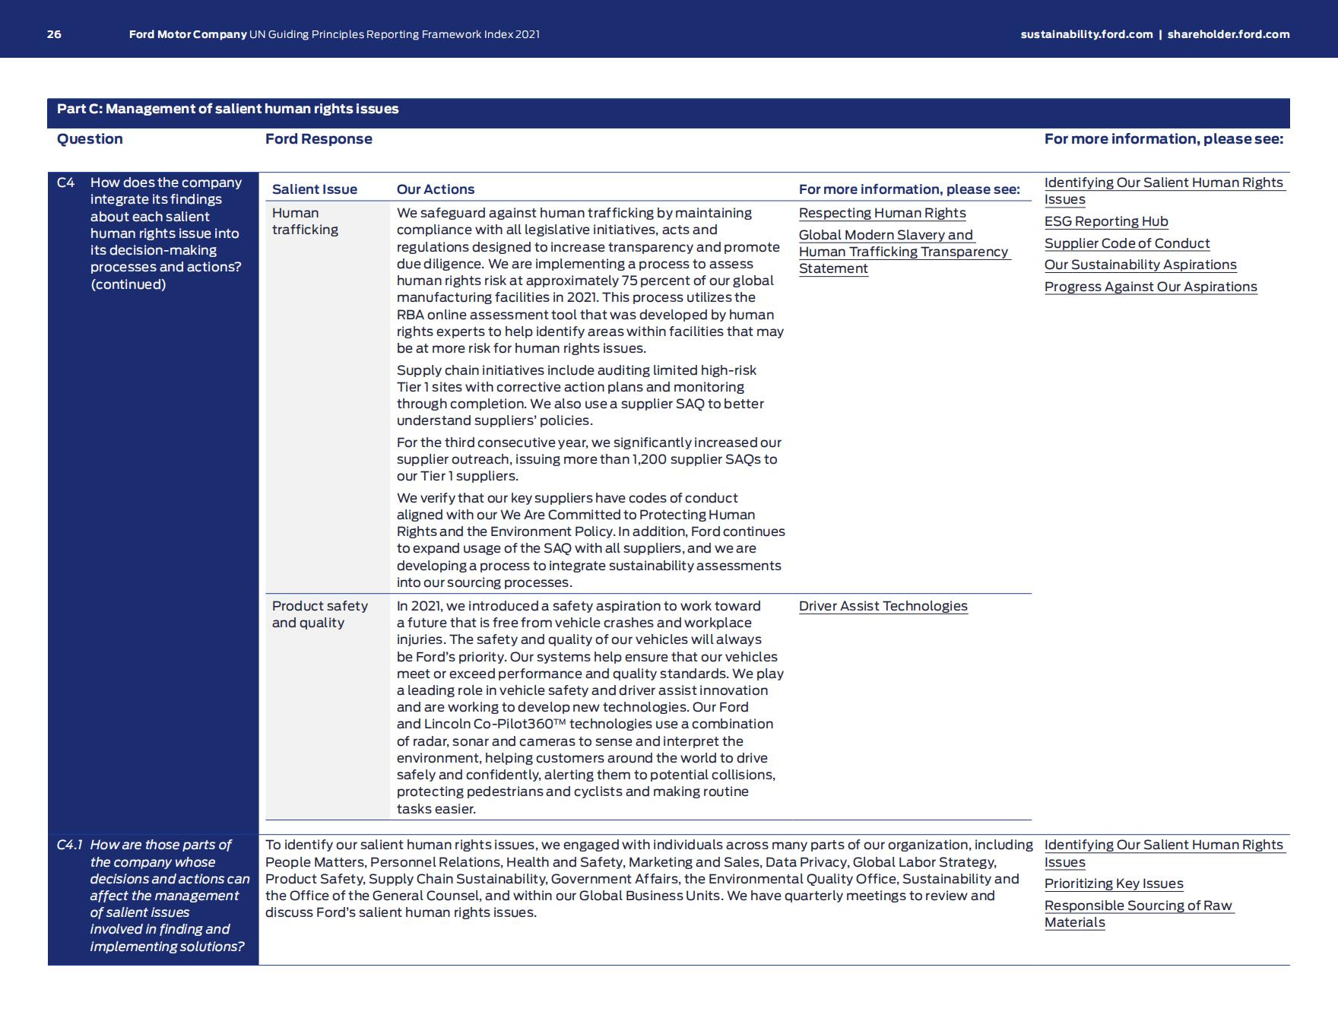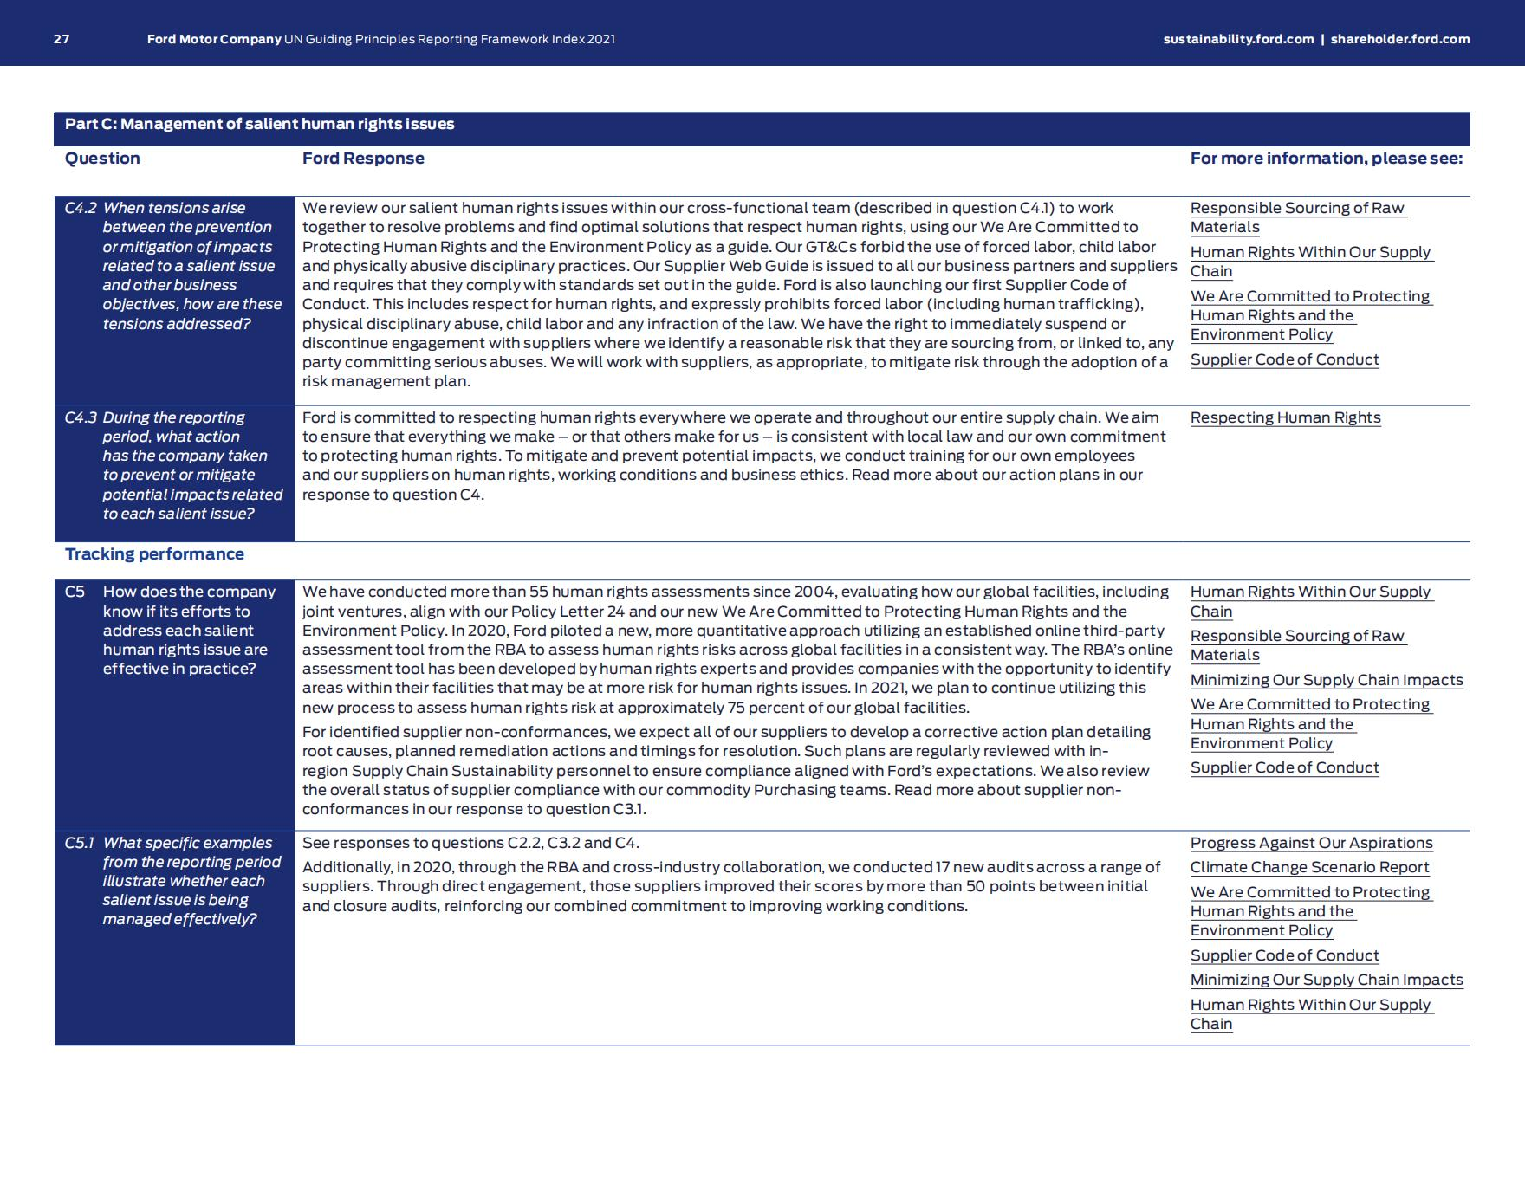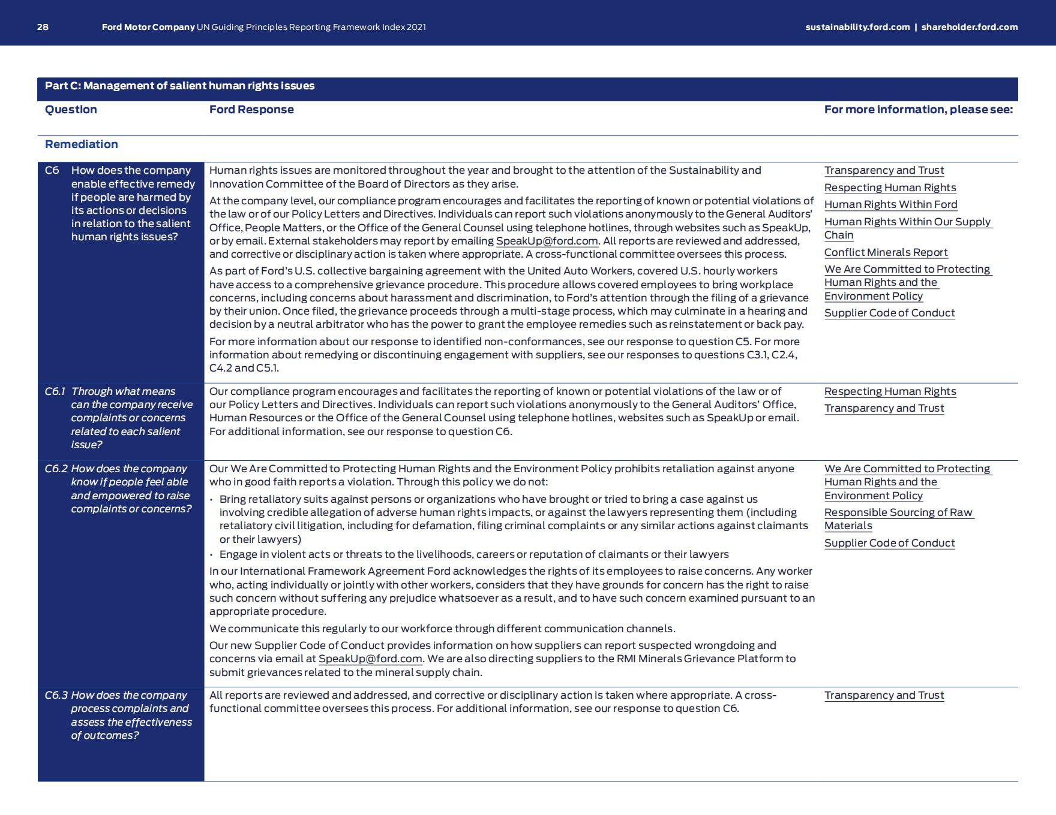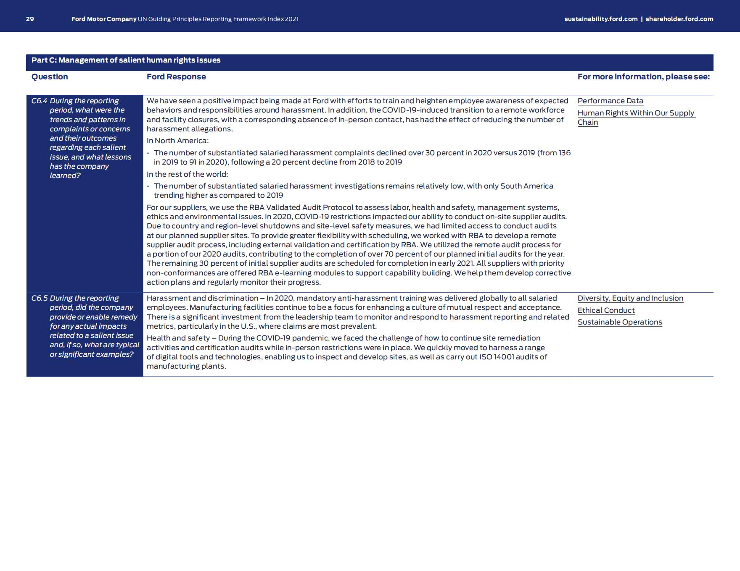

Appendix8:BMW Group position regarding climate legal actions, 19.09.2021
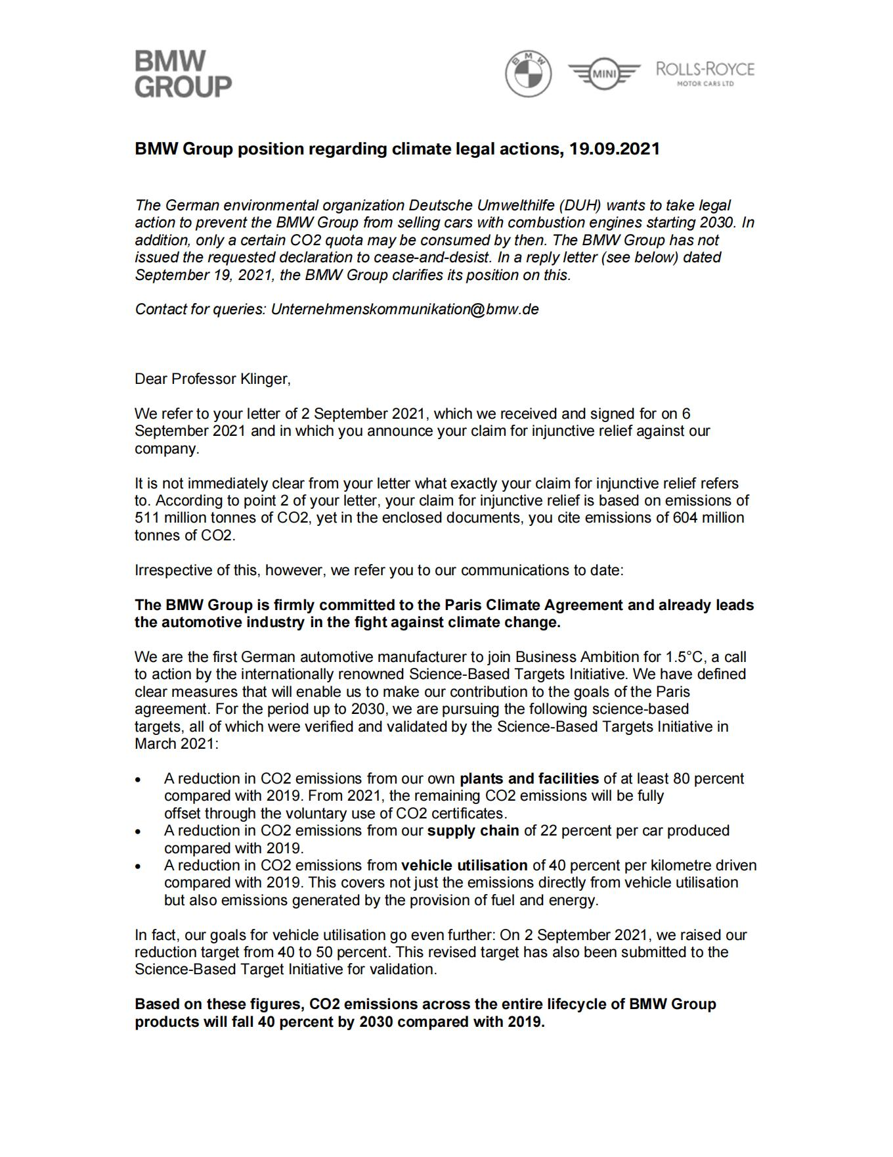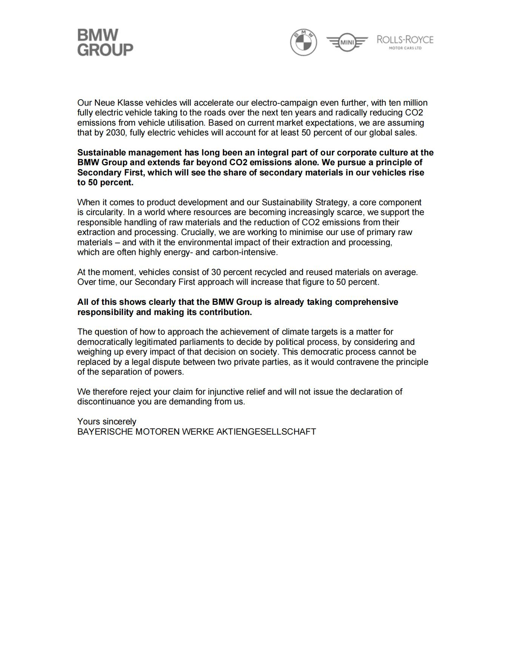

Appendix9:BMW Group Supplier Sustainability Policy

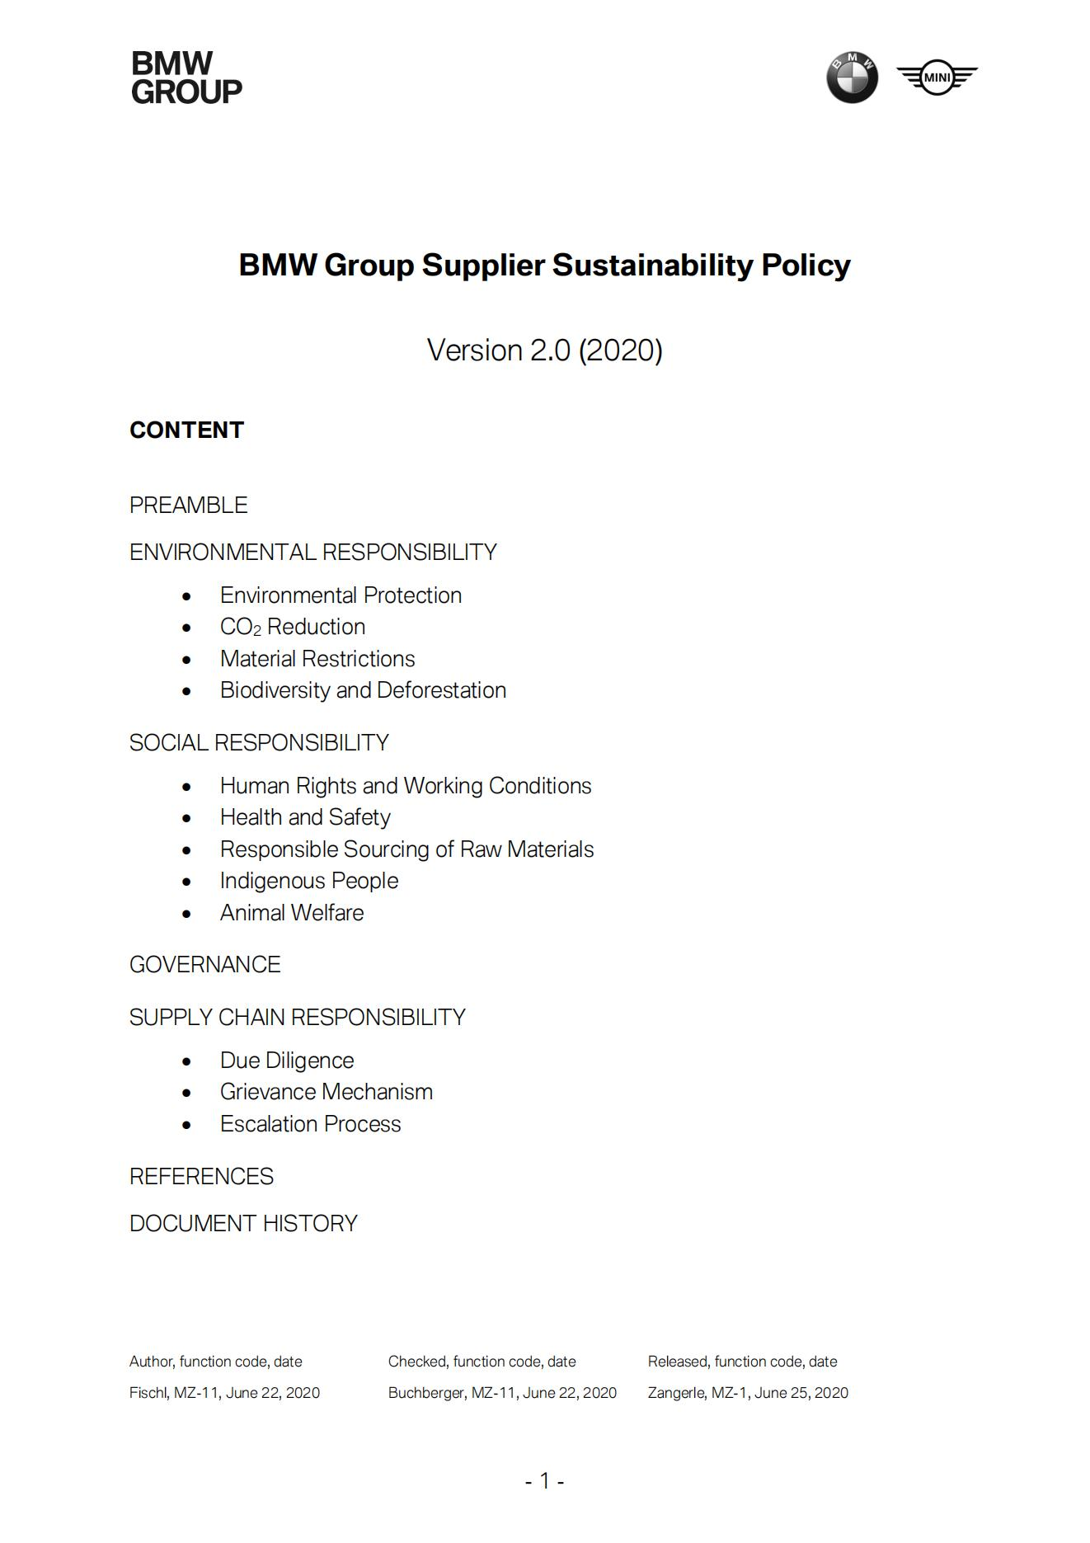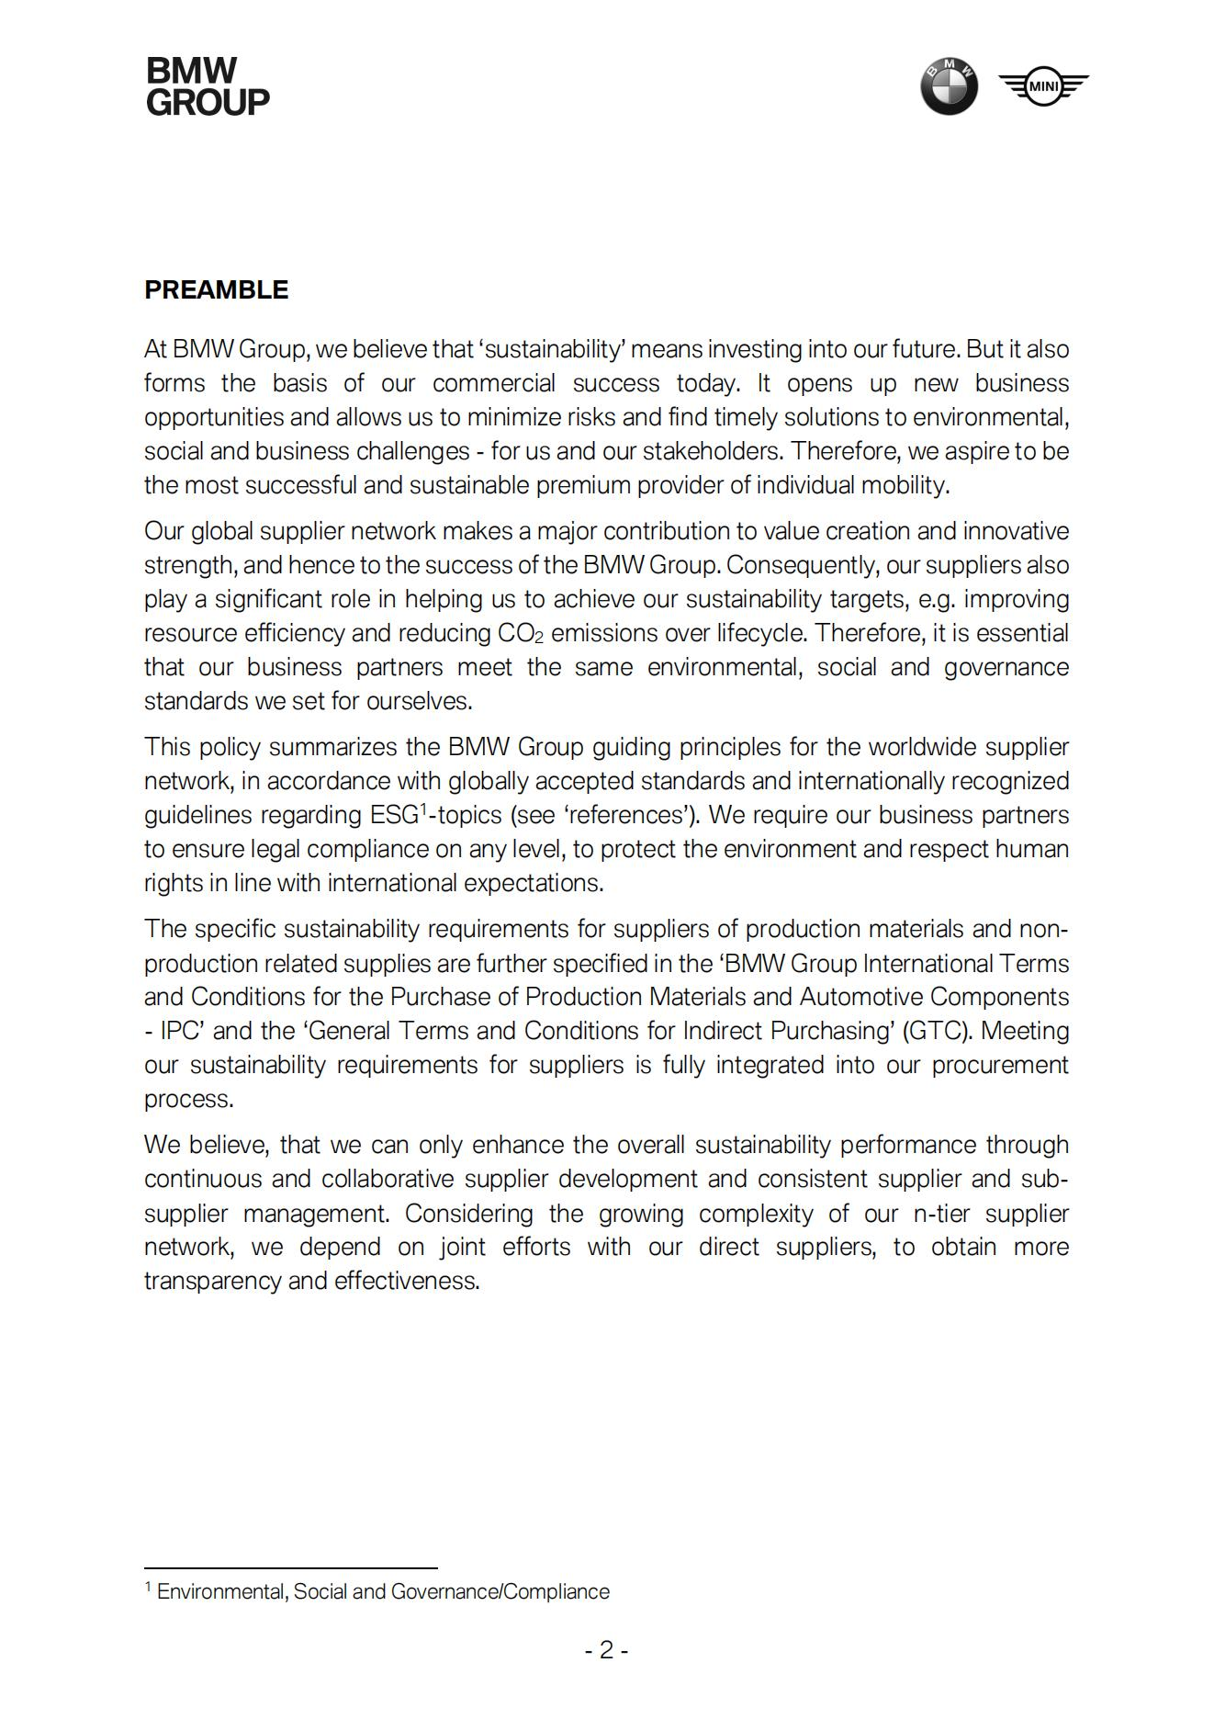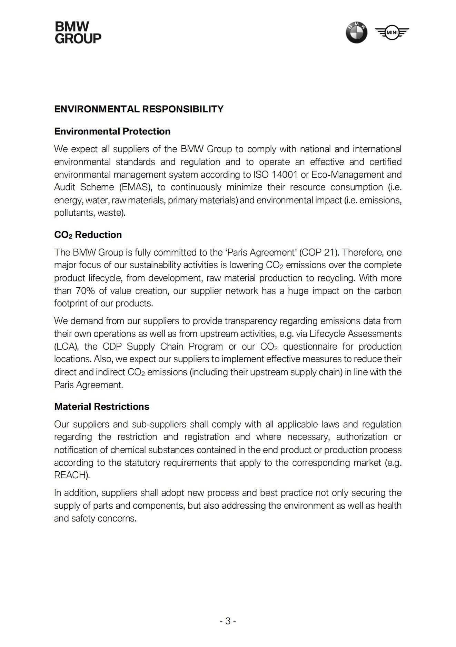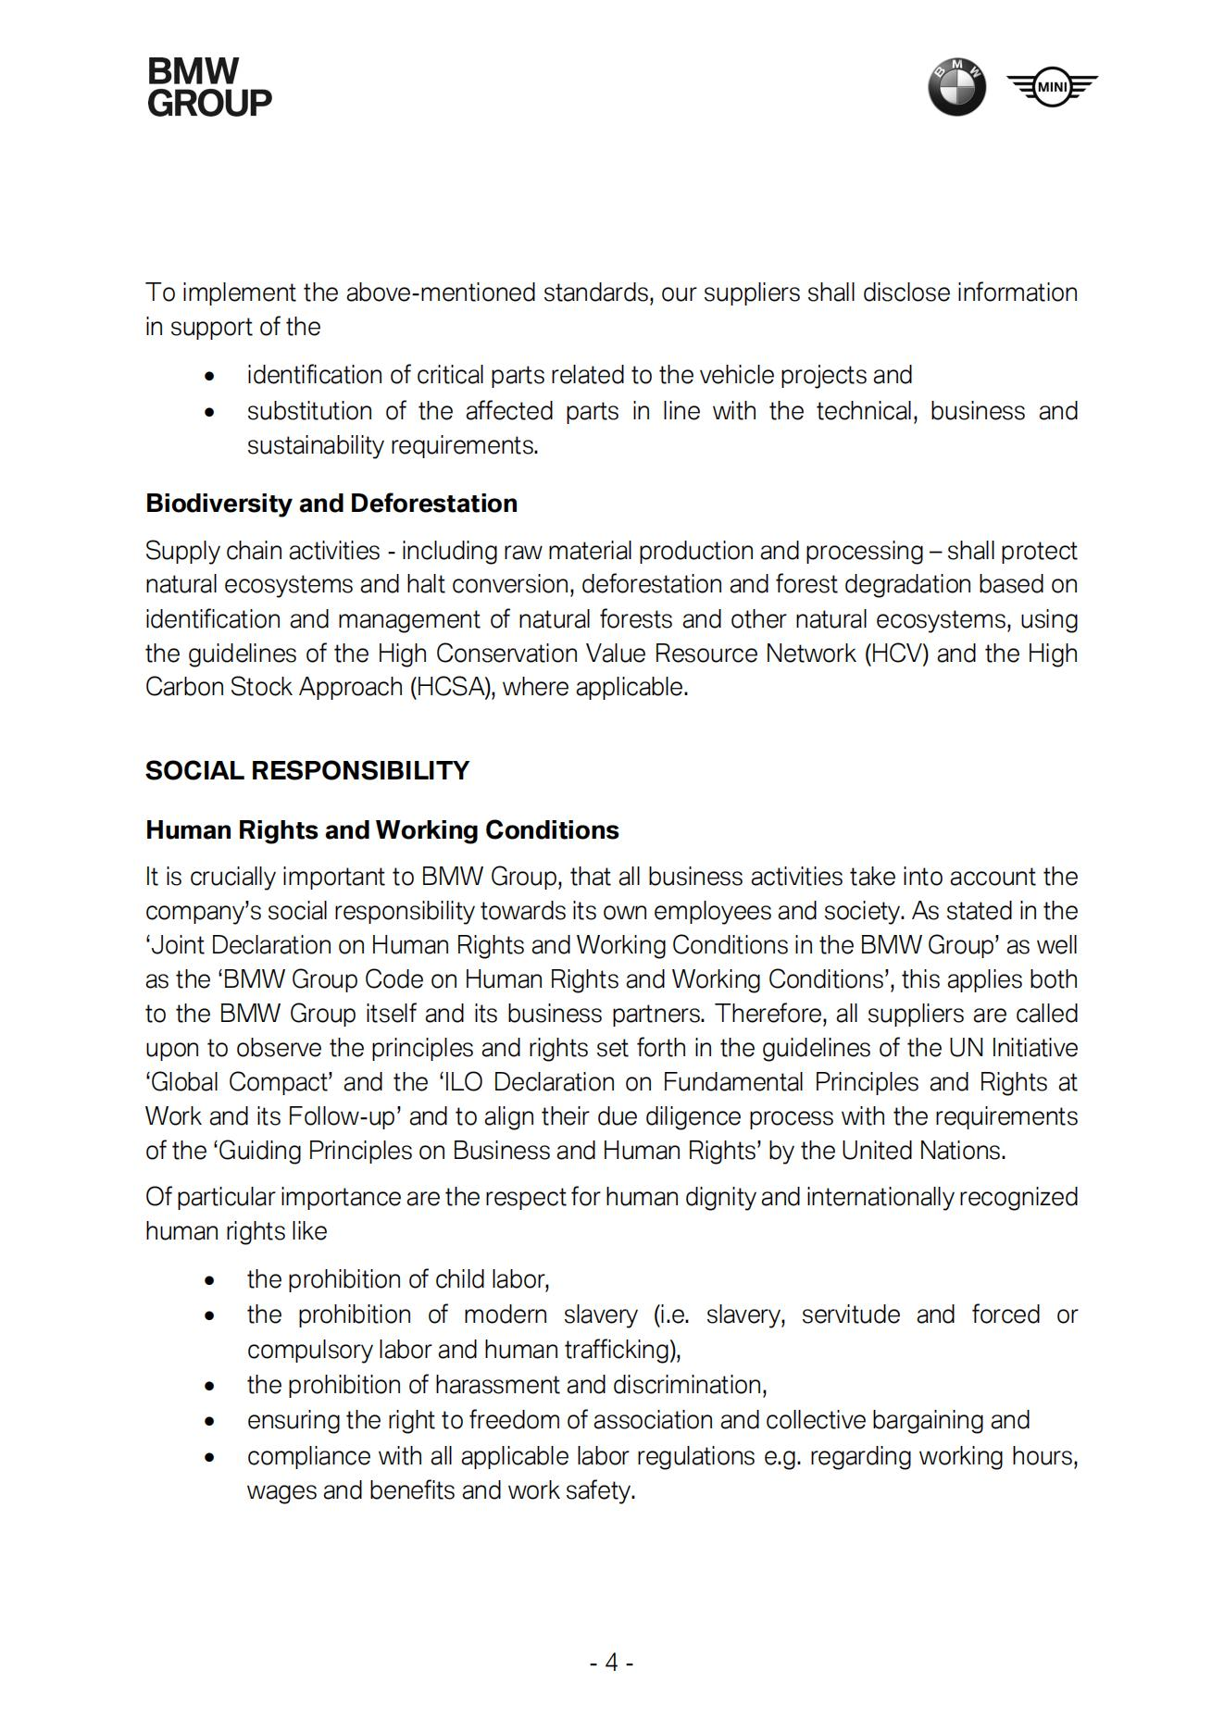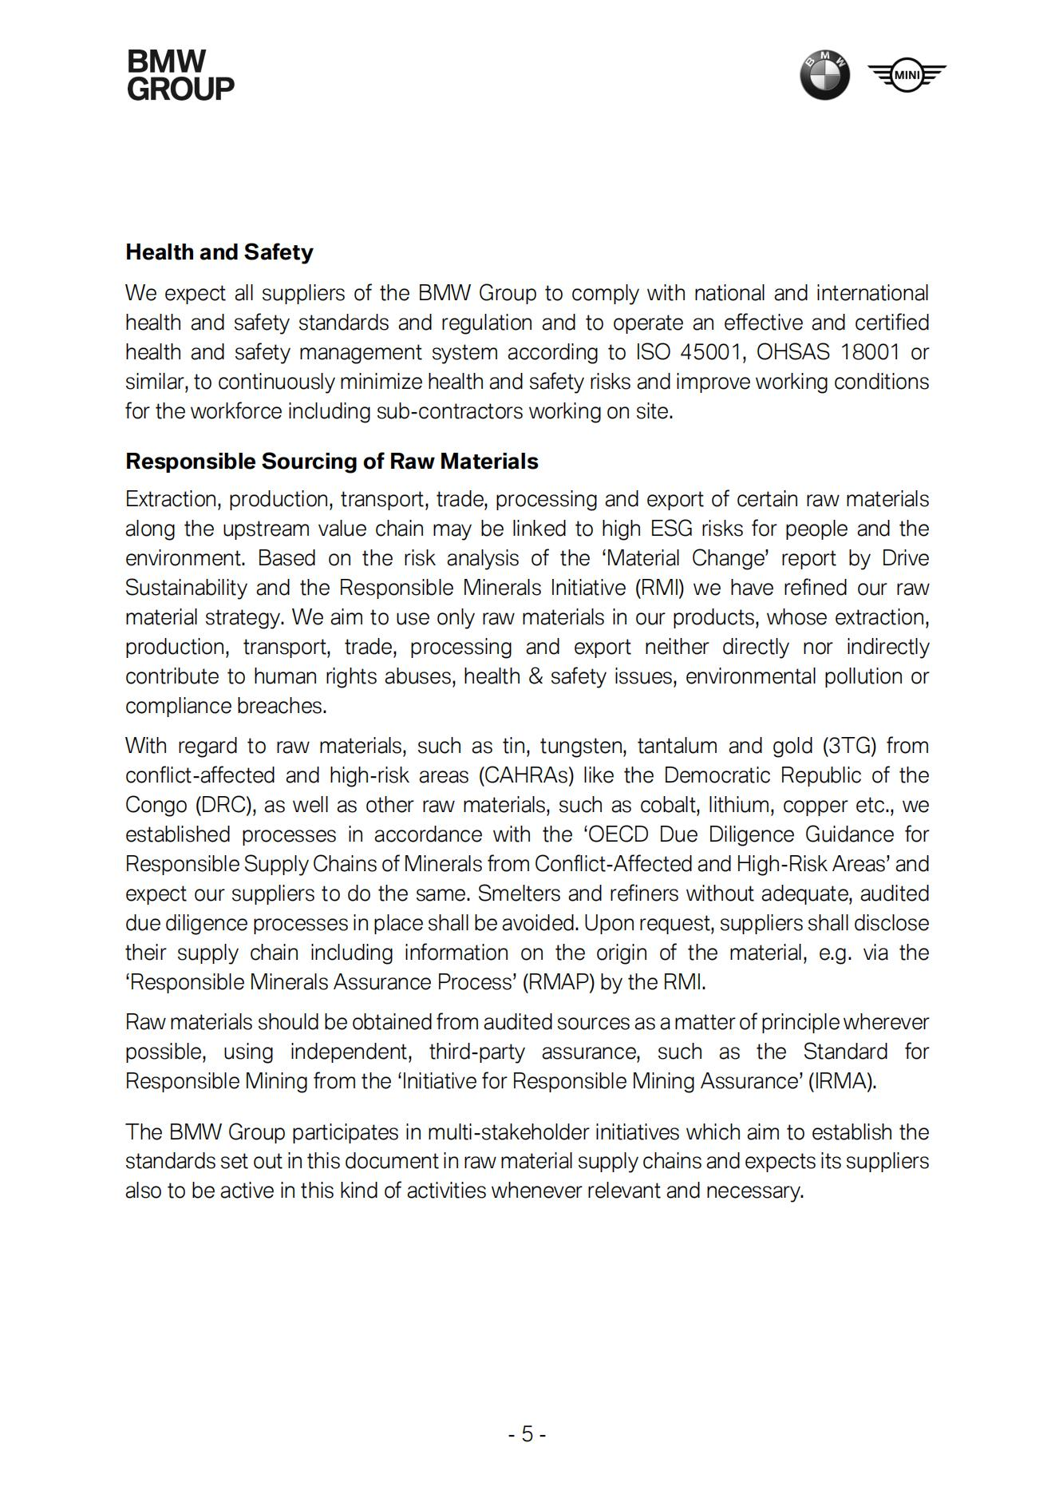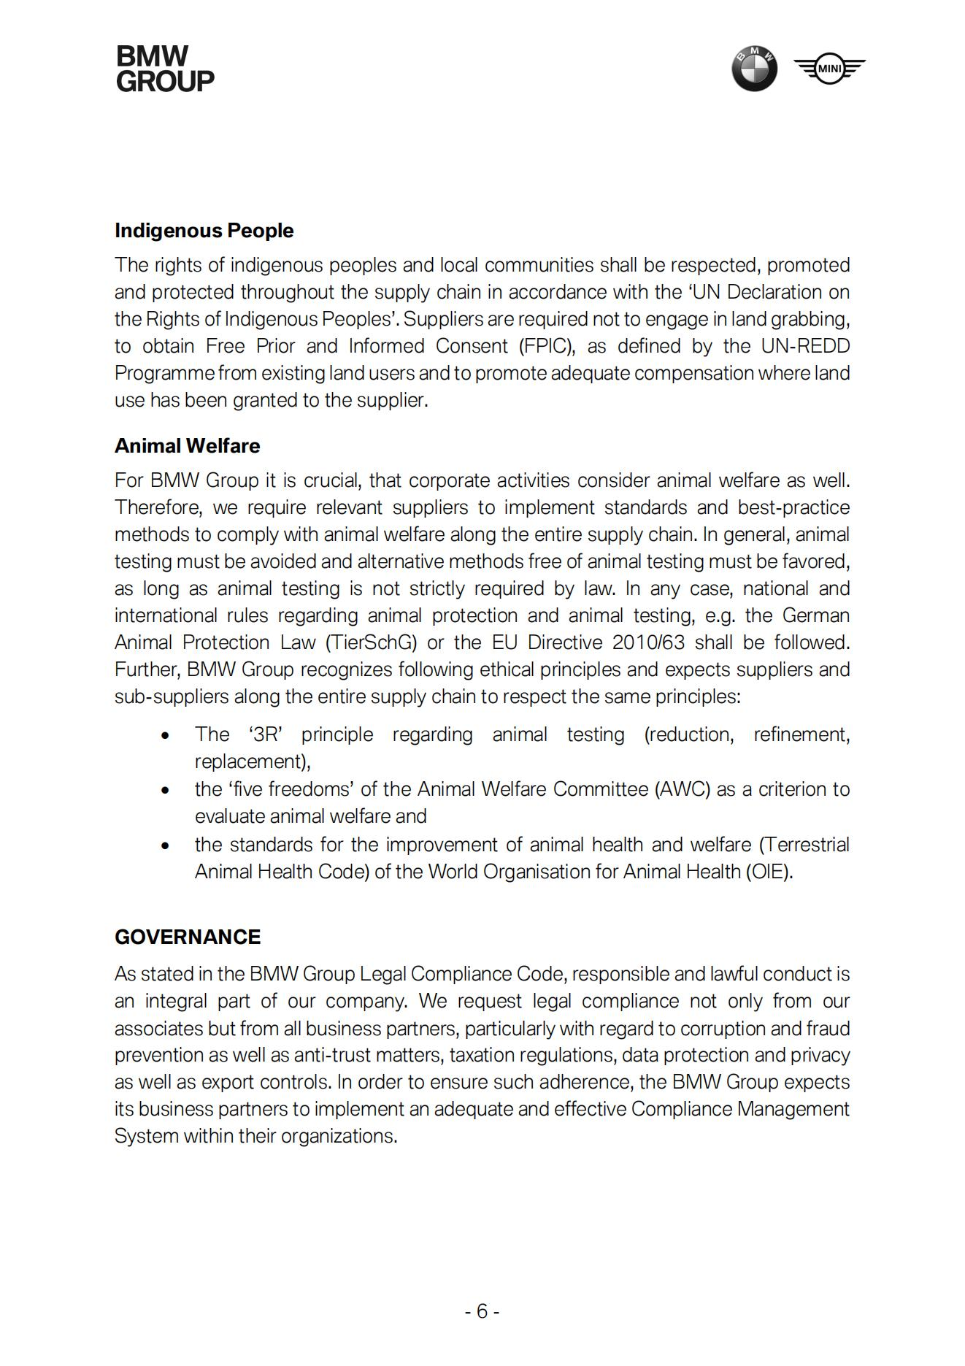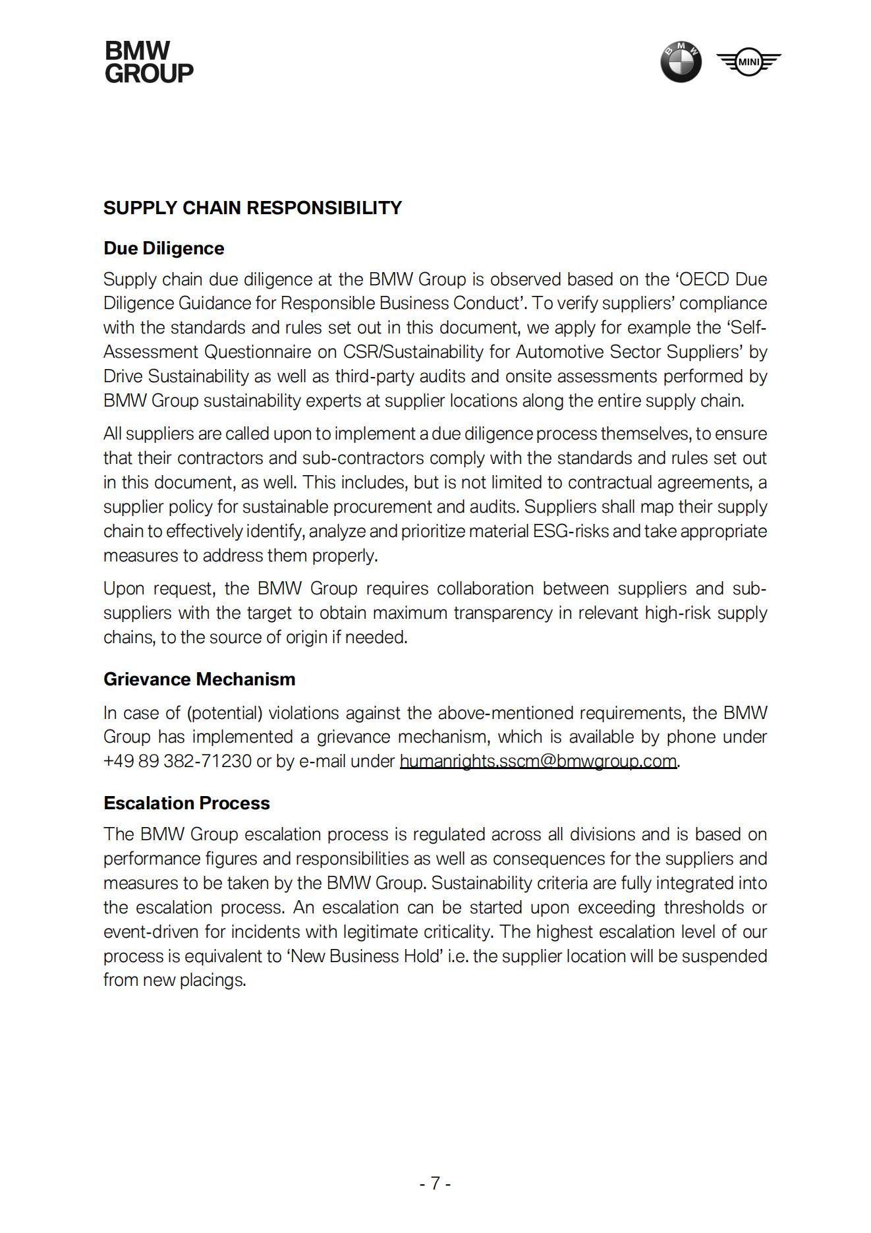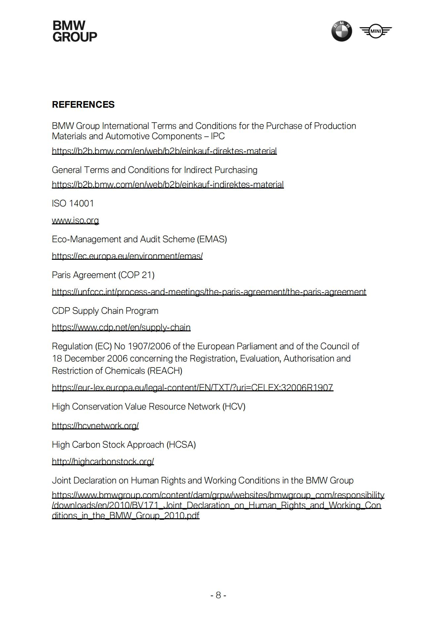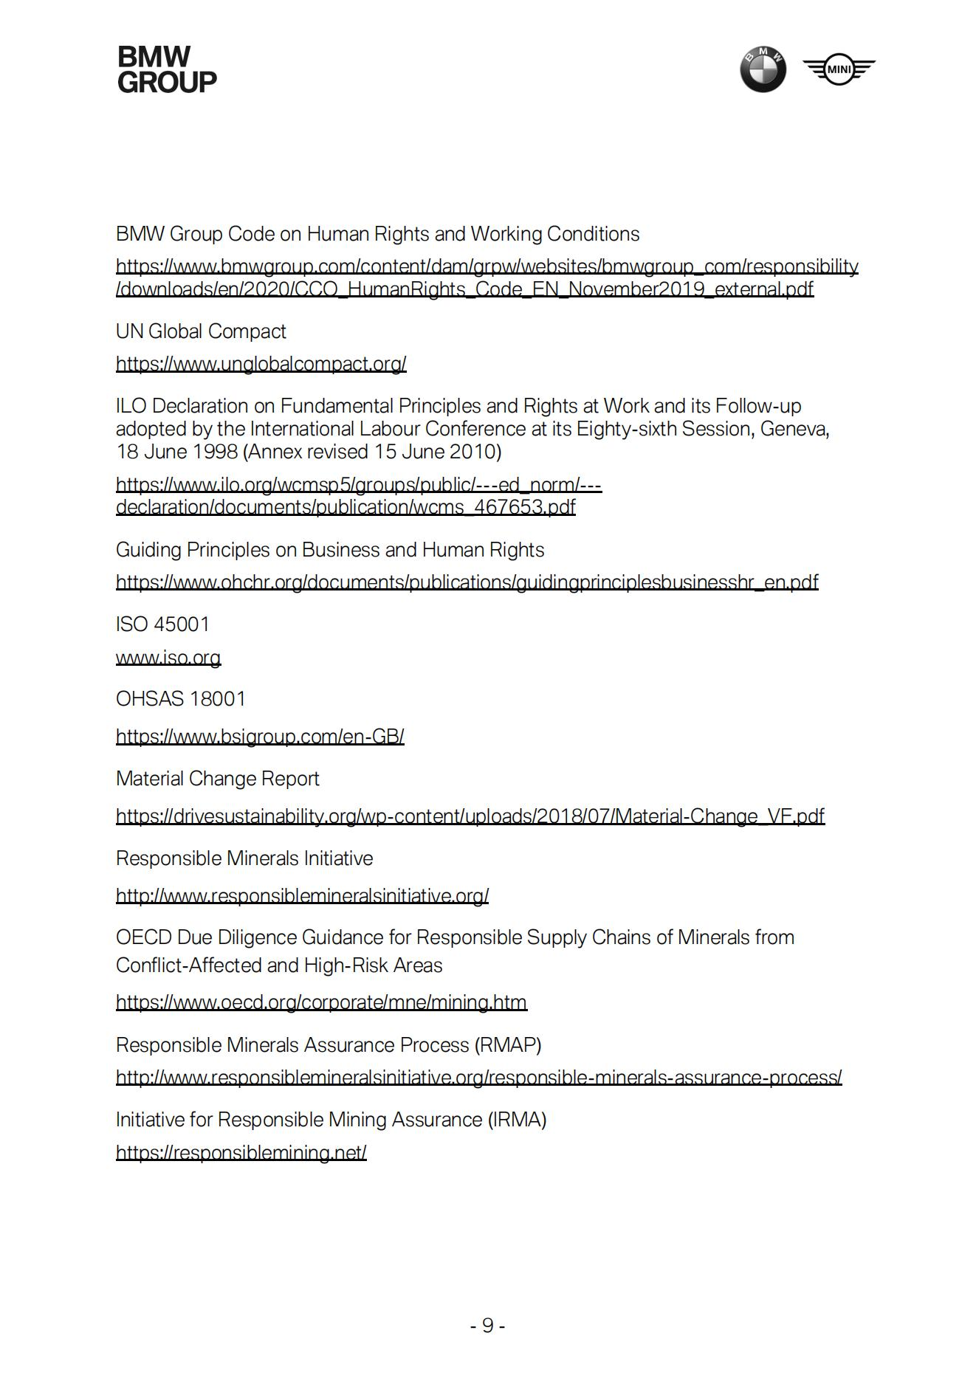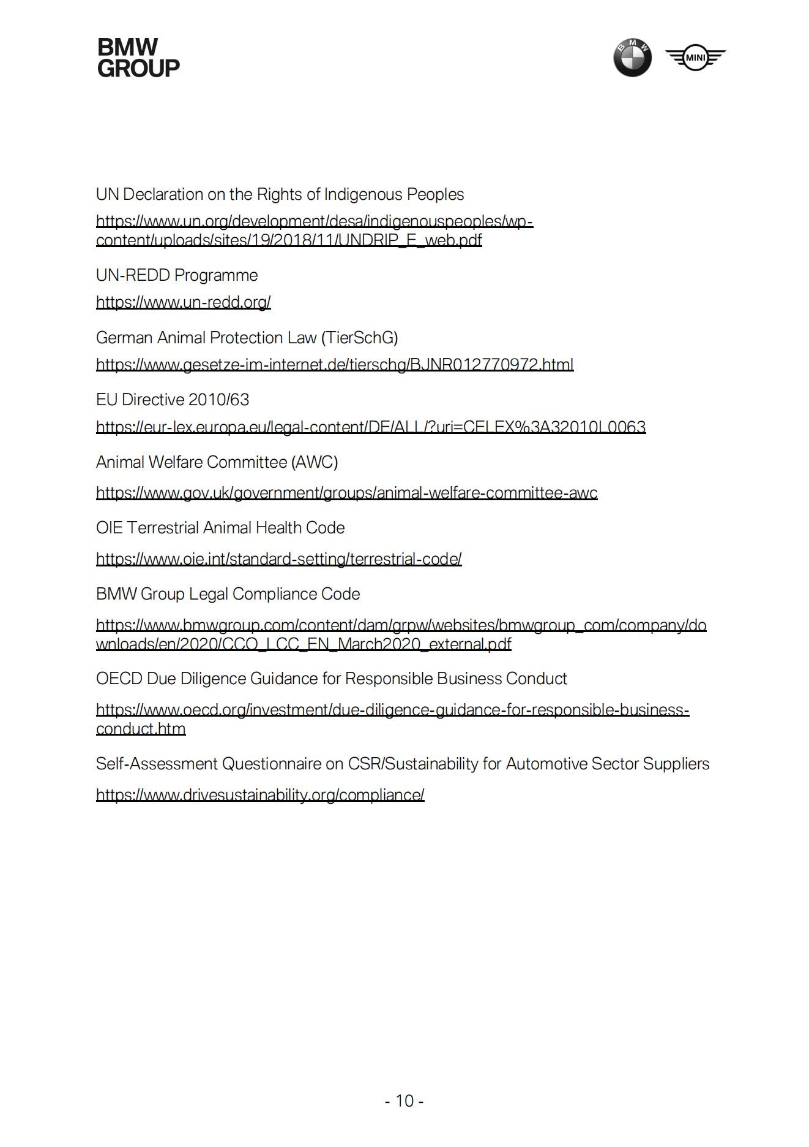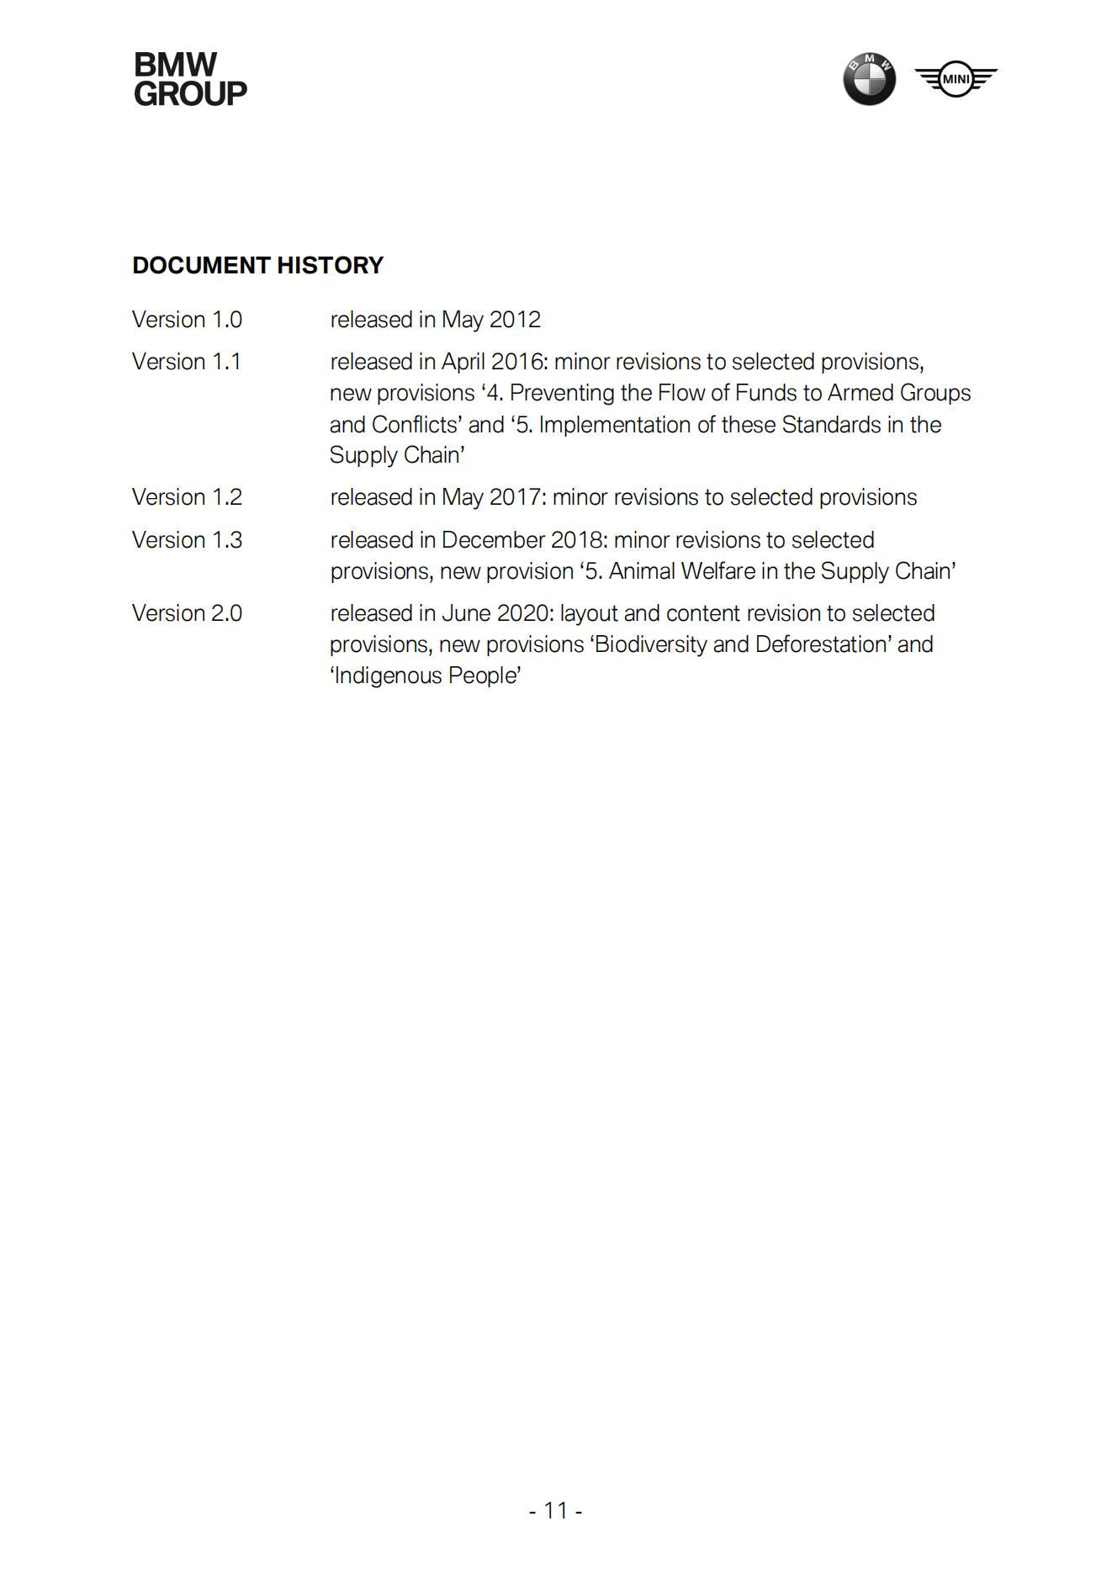

Appendix10:SUSTAINABILITY QUESTIONNAIRE FOR SUPPLIERS. BMW-SPECIFIC EVALUATION OF SAQ


