- Either –
- Meet with your line manager or other relevant person to thoroughly understand your organisation’s approach to employee engagement. If possible, attend an internal employee communications briefing/ employee representative meeting.

OR
- If you are already familiar with its approach, evaluate whether or not your organisation’s approach needs a review, based on your reading of current trends.

Record your findings on Turnitin (total word count: 750 words approximately). Use academic references to support your points.

Both my line manager and I agree that the employee handbook and intranet pages are excellent resources of engagement however the ‘human’ approach within PCC is personality driven.

The message that is given out by the Chief Executive Officer is clear but employee

engagement across the authority differs greatly. Having attended a number of communication briefings it is clear there is no consistency. The delivery medium seems to be related to the behaviour of the senior line manager who is delivering and this is copied by line managers throughout that Directorate. This is typical of local government organisations. A command and control senior manager recruits in their own image and demands mimicked behaviour.

HR Corporate Learning & Development has an inclusive approach. With the ongoing Culture Transformation project, we held a road show of events inviting all employees to become involved at all levels including elected members. They sat together freely and openly discussed different issues from their own perspectives. The sessions were framed and supported by trained facilitators and were extremely effective.

This approach reflects Purcell’s (2010) beliefs that the components of engagement include:-
- Employee trust in management
- Satisfaction with work itself
- Satisfaction with decision making in the workplace
- Quality of relationships between management and employees
- Satisfaction with pay received
- Job challenge
- Satisfaction with the sense of achievement from work
(Taylor & Woodhams 2016)

Opposite to this, the Public Protection Directorate is hierarchal and dictatorial in its behaviour and its communications. The term ‘seen but not heard’ springs to mind. Employees feel ‘done to’ rather than included. Ivask and Berlin describes such thinkers as hedgehogs who focus on the bigger picture and forget about the importance of engaging staff and the risks of disengaged employees. As a directorate they are effective in delivering objectives but sickness rates are high and retention of employees is low.

(Taylor & Woodhams 2016)

The Director in this work area was totally opposed to agile or homeworking, with the communication to his managers that staff needed to be seen. In the current pandemic he has fed back that productivity has remained constant and sickness levels have dropped. Team members are benefitting from the flexibility and are overall happier.

This would need further investigation to prove as a positive outcome but it would be interesting to revisit this in 6 months’ time.

This realisation is echoed in Macloed (2009) article in People Management where he highlights that employee engagement is the bedrock of the relationship between an employer and an employee. He goes on to suggest that this is the cue to the performance of an organisation and the harmony of its employees whilst at work.

Whilst reviewing the engagement approach with PCC it would be fair to say that in the past, namely pre March 2020 overall as an organisation we were poor at employee engagement. However, the pandemic has forced us to drastically change and at speed and I would conclude that we have done this with some success.

Researching this subject and approaches that highlight how engagement is changing I would note that some of these suggestions are already out of date. The pandemic has meant that the need for effective engagement has never been a bigger priority whilst also being faced with having to do this on a virtual basis. The well-being of employees has come to the forefront as an engagement need.

The authorities Chief Exec has taken to recording delivering weekly You Tube videos. These are not air brushed and offer the suggestion that we are all the same, in the same boat and need to work together. The message that he gives promotes values and the language he uses highlights trust and is non-judgemental. In the beginning he stressed that employees were individuals and would be allowed freedom in how they worked, and would be supported to do this. I remember listening to the first recording and feeling both empowered and a sense of responsibility, any indifferences that existed dissipated.

In considering MacLeod’s simple Four Enablers of Success I would suggest that:-

- Strategic Initiative – The Transformation project has presented a new vision, mission statement and behaviours profile that has been developed by employees for employees.
- Engage Managers – We still have work to do here. We have designed a programme of Leadership & Management sessions complemented by a programme of management coaching. Some managers still need to appreciate the emotional need of employee engagement and build relationships with their team members.
- Employee Voice – PCC are recognising the value in this. Undertaking short, focussed questionnaires and responding with ‘you said’, this is what ‘we are doing’. During the pandemic we have also introduced focus groups to look at how we support employees. I personally feel we are starting to listen rather than just hear.
- Organisational Integrity - Probably our weakest area as an organisation which could impact everything else that we do. Senior Line Managers who been in the authority for a long time are struggling to change or do not want to change! It’s a bit like realising that senior politicians have broken the COVID rules and yet nobody else can. Our Chief Executive has resigned and recruitment will commence for a replacement. This could be the opportunity we need to recruit an individual who will drive the new strategic approach and make it a success.

- Examine the employee handbook and any internal staff bulletins within your organisation and make some notes as to whether you think the content engages employees on topics that matter to them.

Record your findings on Turnitin by 29th July (total word count 500 words). Use academic references to support your views.

Pembrokeshire County Council has a very clear and easily accessible employee ‘handbook’, available to all staff via the internal intranet. The following is an example ‘snip’ of part of the intranet page. It is effective and time saving.

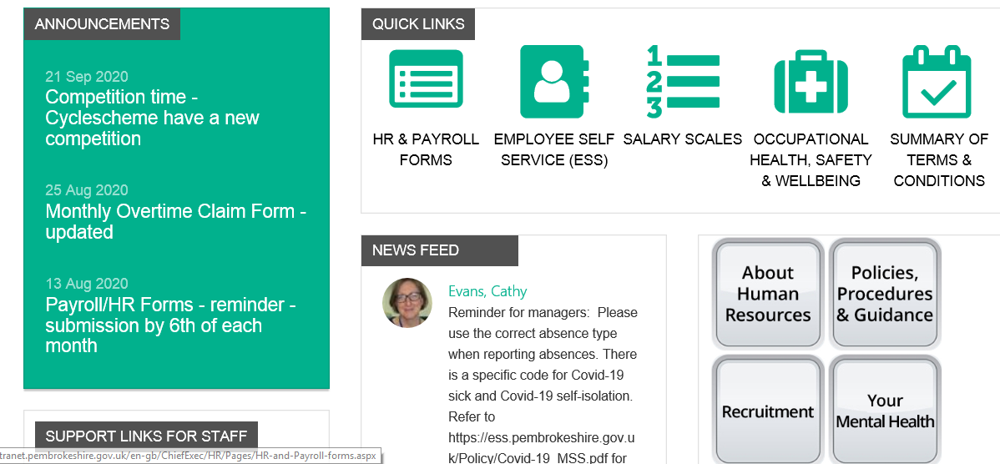

Information is written in simple English and the intranet web pages are easy to follow. An online handbook has allowed easy access for all employees.

There is a range of information, formal policy and procedures e.g. sickness and absence reporting, annual leave entitlement, home working etc. Informal support information relating personal issues like mental health and access to staff benefits like the cycle scheme are also included.

As you can see from the above, reminders are included as ‘announcements’ and there is a news feed to allow for new updates to be communicated quickly.

Support links to external organisations, Health Tool kits and Manager Resources are also located here.
This approach was introduced 18 months ago and the response has been very positive. In the past an employee would need to contact a HR Advisor for information, employee handbooks were held locally but were instantly out of date and rarely reviewed.

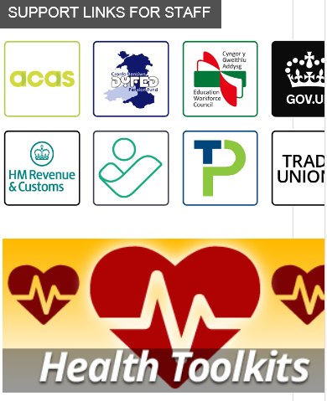
In light of the pandemic this resource has been particularly useful. HR have been able to act quickly and easily to ensure information is accurate and up to date. This is useful for managers in supporting team members and employees seeking information and guidance.
Staff bulletins are carefully vetted and the use of social media has become more common recently.

During the lockdown weekly You Tube videos were used to engage and update employees along with text messages to remind us to work from home and stay safe.

If I had any criticism, it would be in relation to the fact that some policies are written in a complicated way as if they are a legal document and can be confusing. This is improving as policies are being updated and the comparison between older and newer policies is easy to recognise.

Interpretation should always be clear however this is not always the case and issues have occasionally arisen because of this. Again this is being addressed as policies are being revisited.

Perhaps the biggest issue is, how this information is ‘used’ by a line manager. I have discovered that although a clear policy may exist, consistency of following this can differ. A typical example relates to study leave. The policy is clear and a line manager in one team will follow this where as in another team the line manager might go outside of this and it can cause friction.

There are also internal HR ‘rules’ which may offer flexibility but are not ‘advertised’ but allow a line manager to consider circumstances. Again this can cause some friction and suggests an unfair approach.

Overall I would conclude that we have a very positive and effective process in place.

- Discuss your development needs with your line manager as a result of the above activities, using the CIPD Profession Map as a basis for your discussion. Consider whether or not your skills in this area require improvement (for example delivering training on the topic/coaching line managers). Record your discussion (300 words approximately).

I used this for discussion as part of my monthly 1-2-1 conversation with my line manager. As part of the Corporate Learning and Development team we have had to adapt very quickly to moving the majority of our employee training from face to face to virtual.

My preferred medium of delivery is face to face and my skills with webinars and virtual coaching is limited.

We have discussed my nerves around delivering to a virtual audience, unable to ‘read’ body language or facial expressions and minimal learner engagement. My strength has always been engagement with my delegates and I am comfortable with challenges, questions and open discussions but am concerned that I will feel the need to ‘fill’ silences.

I already have a portfolio of coaching clients both internal and external who I need to re-engage with. I enjoy coaching and feedback has always been very positive.

We have agreed to the following plan for me to work towards by our next one to one:-

Design and record a 5 minute motivational webinar on a subject of my choice using the Go Webinar software. Pay particular attention engaging the ‘audience’ and retaining their interest. The webinar will be used as part of our weekly motivational webinars for managers. I will pilot this with the team at of one of our ‘scrum’ team meetings.

Re-engage with two coachees, preferably one internal and one external and agree with them the medium we are going to use i.e. skype, what’s app, etc.

Consider what information I need from them to be able to coach effectively. In the past as a new coach I used pre meeting questions to gather information before the coaching sessions, it may be valuable for me to return to this to help me become more comfortable and plan effectively.

References
Ivask, George, and Isaiah Berlin. “The Hedgehog and the Fox.” Russian Review, vol. 14, no. 4, Oct. 1955, p. 379, 10.2307/125900.
Mac Cloed, D, and N Clarke. Engaging for Success, Enhancing Performance through Employee Engagement. Department for Business, 2009.
Purcell, John. Building Employee Engagement Acas Policy Discussion Papers. ACAS, 2010BC.
Taylor, Stephen, and Carol Woodhams. Human Resource Management : People and Organisations. London, Chartered Institute Of Personnel and Development, 2016.
‌

