

Student Name : Flory Calin
Student ID: 1807318
An Assignment on

Effective Team Work and
Communication

Contents
Introduction: 3
What is Effective Communication? 4
The necessity of Effective Communication by Employers in Workforce: 6
Theories relevant to Effective Communication: 7
Theory of Fixed Structures: 7
Critical Theory: 7
Groupware Theory: 9
Models relevant to Effective Communication: 11
Shannon and Weaver Model: 11
Berlo’s Model: 12
Transactional Model: 13
Improving workplace communication and performance of employers: 15
Conclusion 16
References 17

Introduction:

Exchange of effective information among employees is very important in any organization especially when people work in teams. To do effective communication, we need to possess certain important skills because not everyone is born with the skill of better communication with whoever they meet. In this report, I am going to discuss certain theories relevant to effective communication with real-life examples. Here I am going to present how some well-known companies use which communication method or model relevant to them to establish the best communication system both within and outside their organization.

Effective Communication

Effective communication is much more than just exchanging information between two parties. It's mainly about realizing the feelings and motives behind that information. Besides conveying a message, a person also needs to listen properly so that he can understand what others are saying. Listening properly also make the other person feel being heard with importance. Effective communication usually combines a combination of 4 skills:
- Proper Listening: It helps both the parties involved grow respect for each other because hearing others emotions or complaints about something, stress or worry of one person gets relieved.
- Nonverbal Communication: It includes communication without using words. Usually, it means using gestures. One can use his hand to say hi to his friend just by simply waving a hand. It is usually used when both parties have an informal and friendly relation.
- Stress Management: Managing stress is an important issue in effective communication. People feel stress regularly from their family or work life, but not everyone has the ability to manage or handle that instantly so that it doesn’t affect his other activities.
- Presenting Oneself in an attractive way: To make any communication effective, a person must present himself in an attractive way so that his personality encourages other people to talk and communicate with him.
Communication is usually more effective when people become spontaneous in communicating with others. Actually, it is the effort given by a person that ultimately makes him a better communicator with anyone he meets.

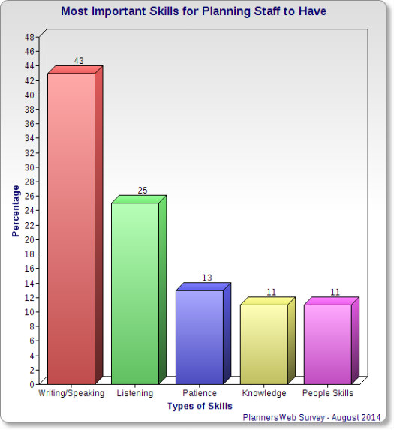
Figure: Necessity of speaking and listening skills
Source: (Cushman and King, 2016)
The figure shows that among the types of skills needed, an employee should be 43% effective in speaking and 25% effective in listening to make an effective communication.

The necessity of Effective Communication by Employers in Workforce:

It has been found in a Statistics that 85% of the success of an employee in an organization is directly linked with his communication skills (Garthwaite et al., 2017). An employee continuously needs to enhance his ability to communicate effectively in every situation he faces by developing both verbal and nonverbal skills. Effective communication helps employee receive certain benefits:
Feedback: One can give feedback about his job, responsibilities to top Management in the evaluation if he is known to others as a good communicator and his feedbacks are bound to be valued when making decisions.
Efficient Teamwork: By communicating properly one can perform well in a teamwork and direct other members in the team to work according to his advice. They can also together provide better results if everyone on the team has good communication skills.
Making oneself visible: Communicating with everyone in an organization makes an employee visible and known face. This helps top Management have a better impression on him because he has the ability to influence everyone.
Showing a positive attitude: Communicating frequently with others helps a person demonstrate his positive attitudes toward others. This helps him being the problem-solver of other persons within the company.
Shared Ideas: Communicating with top management helps a person share his ideas that might help make a better decision for the company which may later prove to be a really successful one. He may provide unique ideas that will take the company to its highest position which otherwise would not have been possible without his ability to communicate.
Increased responsibilities: Communication with almost everyone in the company may provide an idea of whether a person can be trusted with important responsibilities. This may also lead to his early promotion recommended by the management.

Theories relevant to Effective Communication:

Theory of Fixed Structures: The theory of Max Weber is the first to define the communication process within the organization. He clearly stated that communication within a company is hierarchical and known to all because it is structured. As it is a top-down theory, there remains no confusion about messages being sent to lower ones. Capabilities and Seniorities are maintained here in the communication process. For example, Starbucks Corporation follows conventional communication structure where they make a decision at the top level matching with customer demands and passes the information to next-level employees. Top management ensures through their established structure that operations are continuous with their planning.
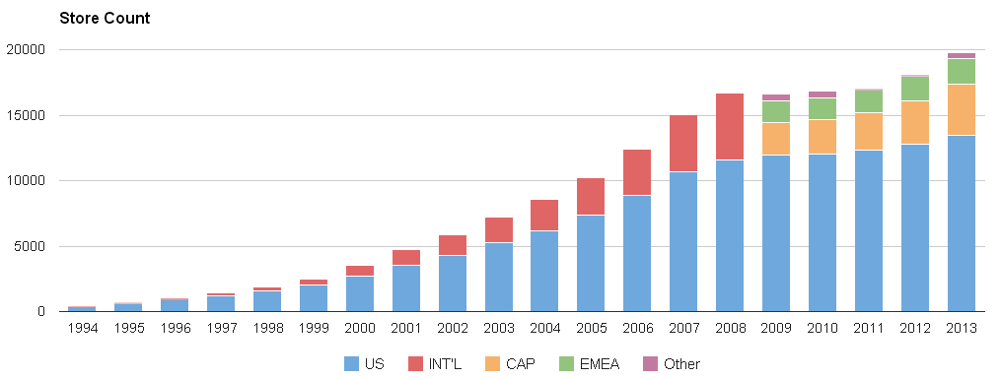
Figure: Growth of Starbucks
Source: (Haynes, 2016)
The blue portion of the graph is the overall growth of Starbucks. Over the year they have developed the most because of the communication level used at their company. Taking decision at the topmost level has helped them sustain their market position year by year.
Critical Theory: Under this theory, conflict is considered to be usual. Here employees resist managers in taking decisions and inter-departmental conflict exists for budget and influence. Here communication theory works as solving conflicts within the organization, encouraging employees to work harder and directing all employees to work under one goal. For example, Nestle uses critical theory to solve conflicts within their company. They encourage employees to work harder and motivate them to retain the best employees. Because of the change in customer taste, they recently faced weakening sales growth in recent years.
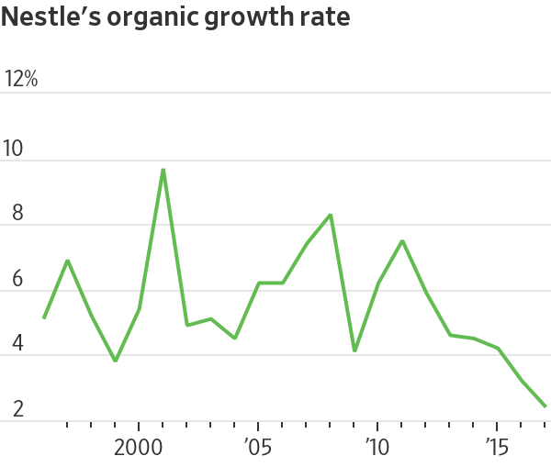
Figure: Growth rate of Nestle
Source: (Garthwaite et al., 2017)
Here the chart shows that after 2015 their growth rate has declined than ever before. Nestle is considering the reason for this decline as the inter-departmental conflict regarding which products will be more demanded by customers. This conflict has led them to the overall loss for the past 3 years. Nestle is now trying hard to create an effective communication system within an organization to overcome this loss.
Groupware Theory: This theory suggests with technological advances previous methods of communication can be changed. Here employees can communicate through interconnected mobile and computers so that everyone can receive new information at the same time. This theory has 3 pillars: Communication, collaboration, and coordination.
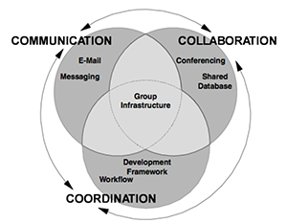

Figure: 3C’s

Source: (Pings, 2015)
E-mail is the messaging network that makes communication efficient. Now through the rapid use of e-mail, managing information from spam emails has become a challenge for managers. This is the only method that allows us to connect with any person at any corner of the world without cost. Collaboration is working together and sharing ideas to get the best result from the firm. In an effective collaboration, information must be shared. The team working must know what data they are using and how to use that. Finally, coordination is the combination of the overall work process. In a workflow, different segments of a project are divided into different departments and they have effective communication among them that help them complete the whole task within time.
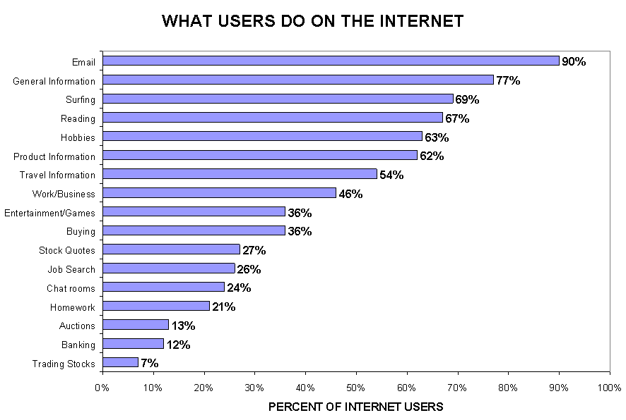
Figure: Use of e-mail
Source: (Hunt, 2014)
People mostly use email which means how much it has become an effective tool of communication. Most of the largest companies of the world- apple, Nestle, Unilever is hugely dependent on e-mail system to convey information to customers, receive feedback from them and communicate with their raw material suppliers.

Models relevant to Effective Communication:

Shannon and Weaver Model: This is the most popular model of communication. This model depicts that an information is originated from the person who brainstorms it. The one who will send is called the Information Source. The information is then transferred from the creator to other recipients. This model has 4 elements- Information Source, Transmitter, Channel and Receiver (Pings, 2015). For Example, this model plays an important part in the primary health care system. In television, videos on exercise and dieting, keeping the environment clean, dangers of smoking are regularly played. Pamphlets are used by the ministry of education to spread knowledge about certain facts everyone should know.


Figure: Shannon- Weaver Model
Source: (Hunt, 2014)
The chart explains how the primary health care system is followed by the Shannon-Weaver model. After reaching to the destination, feedback is given by its users which is again sent to the information source and if possible it is modified according to the recommendation.
Berlo’s Model: This model considers the emotional portion of the message. It is called SMCR model where S is for source, M is for message, C is for channel and R is for receiver.
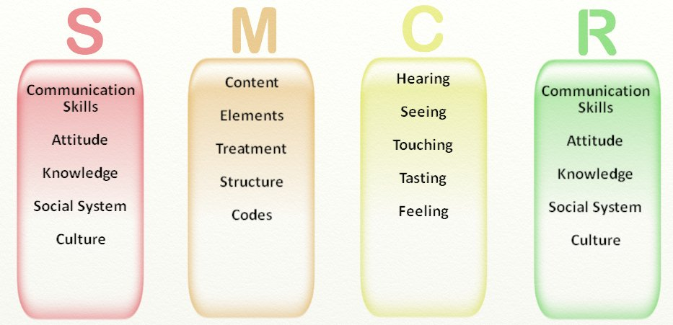

Figure: SMCR model
Source: (Corrado, Reider and Mapson, 2012)
This model is described in light of Mcdonalds’:
Source: The owner of Mcdonalds’ originated the idea of Mcdonalds’ and shared it with other people to start a business. He had excellent communication skills to share his idea with others and make them agree to help him start the business. He had the attitude to create a long-lasting impression on his initial assistants. He also had knowledge regarding how restaurants are run and how much money and staff is exactly needed. He knew the culture of his country so he chose chicken as his main raw material.
Message: Richard Mcdonald’ shared his idea of fried chicken business and how they should be sold. He also thought how to differentiate them from running products so that people would love Mcdonalds’.
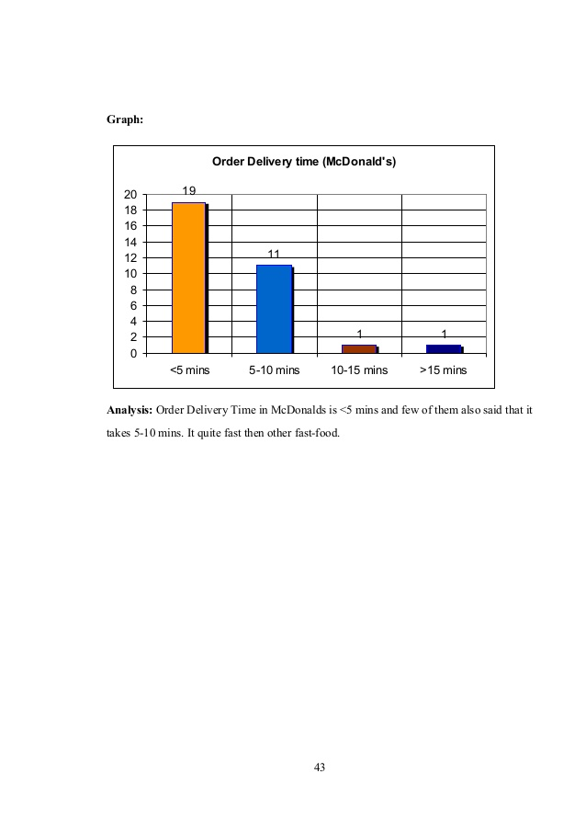
Figure: Order Delivery Time of Mcdonald’s
Source: (Cushman and King, 2016)
They have grabbed peoples attention by delivering them within 5 minutes of orders which were one of the business strategies that helped them beat other companies.
Channel: Mcdonalds’ heard from people what they would love as snacks and visited restaurants to check which items were ordered most. He himself tasted the most demanded them and tried to understand why people chose them most among so many food items.
Receiver: His employees could grab what he actually wanted Mcdonalds’ to be. They were provided knowledge on hamburgers, chicken fries. Following the social system and culture prevalent, Richard and his employees together made his firm one of the most demanded brand of food around the world.

Transactional Model: It is a two-way communication between sender and receiver. Here mainly face-to-face discussion, e-mail, phones are used. Here the purpose is to exchange information. This model gets affected if two parties are from different areas, of different language, have different culture etc.

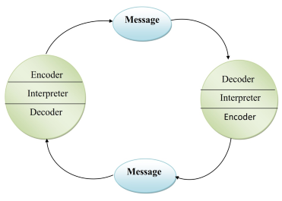
Figure: Transactional Model
Source: (Kalbfleisch, 2012)

This is the common model used in Unilever. They have to continuously interact with their suppliers to inform them about the condition of raw material. They have operation throughout the world so if the supplier and the person communicating with him is of different language, my face problem in frequent contact which may create misunderstanding among them even cause a loss for the company.

Improving workplace communication and performance of employers:

To improve the workplace communication, certain steps can be taken by both firm and employees:
Developing a sustainable plan: Unilever has taken this strategy. Developing a sustainable plan and communicating it throughout the organization helps strengthen the communication among employees and build good relation.
Analyzing Information Needs: It is important to know what information the stakeholders want and based on that tasks can be assigned throughout the organization. This will also increase communication between external and internal stakeholders.
Use of Technology: To smoothen the communication within and outside the organization, technological devices and methods must be used. Mobile, e-mails are now frequently used to communicate among employees. This also increases the overall efficiency of the organization.
Focusing on Culture: The culture of the country must be maintained within the organization. Besides scopes must be made for those who come from other countries. This will help create a friendly environment within the organization and increase employees’ internal communication.

Conclusion:
Building a good communication skill is a must for any employee. This has become the only vital topic in deciding how much a person is recognized or how much his works are appreciated. So it is the duty of an employee to develop himself so that he does not fall behind in competing with his fellow mates in the company. Building communication skills also create a sense of responsibility within a person. So this is the most focused thing nowadays on any job people prefer to enter.

References
Corrado, F., Reider, A. and Mapson, R. (2012). Communicating with Employees. Boston: Course Technology Crisp.
Cushman, D. and King, S. (2016). Continuously improving an organization's performance. Albany: State University of New York Press.
Garthwaite, C., Busse, M., Brown, J. and Merkley, G. (2017). Starbucks: A Story of Growth. Kellogg School of Management Cases, 1(1), pp.1-20.
Haynes, M. (2016). Why industry needs a business climate that encourages growth. Production Engineer, 65(7), p.14.
Hunt, G. (2014). Effective communication. Englewood Cliffs, N.J.: Prentice-Hall.
Kalbfleisch, P. (2012). An Introduction--Communication-Based Theory Development: Building Theories for Communication Research. Communication Theory, 12(1), pp.5-7.
Ons.gov.uk. (2018). Economy - Office for National Statistics. [online] Available at: https://www.ons.gov.uk/economy [Accessed 14 Nov. 2018].
Pings, V. (2015). COMMUNICATION - PROFESSIONAL NECESSITY. Nursing Research, 14(3), p.195.
Psychology Today. (2018). The 3 C's of Effective Communication. [online] Available at: https://www.psychologytoday.com/us/blog/high-octane-women/201304/the-3-cs-effective-communication [Accessed 14 Nov. 2018].
Wright, S. (2013). Community and communication. Buffalo, NY: Multilingual Matters.

