Lighting Layout and Sound Index Calculation

Task A
The first part of this assignment involves determining the best and most suitable solution to provide lighting for a proposed factory, while showing the calculations used.
The area of the factory is 60m by 24m, and with a ceiling height of 8m.
The working height of the benches is 1m from the floor.
The area of reflectance 0.3 for the ceiling, and 0.5 for the walls.
The specification for the lighting design proposes Fluorescent lamps in recessed louvre with DLOR of 50%. The size of the Luminaires is outlined at 1200mm by 200mm.
The Lighting Design Lumen (LDL) output required is 18000 Lumens, with the illumination requirements at the working plane in the factory area is 200 Lux (E), while also considering a Light Loss Factor (LLF) of 0.75.

Room Index
The Room Index (RI) needs to be calculated first, to use when looking up the Utilisation Factor (UF) with the aid of the table provided.
RI = (L x W)
Hm (L + W)
Hm = 8m – 1m (Height of working plane from floor)
Hm = 7m (Working plane distance from the Luminaire)
RI = 60m x 24m
7m (60m + 24m)
= 1440
7 x 84
= 1440
588
= 2.449

The Utilisation Factor

Once the RI is calculated, it can be used in conjunction with the reflectance factors to then plot on the Utilisation Factor (UF) table. The RI is rounded up to make sure adequate lighting levels are achieved, so 2.449 is thus 2.5 on the table, (figure 1).
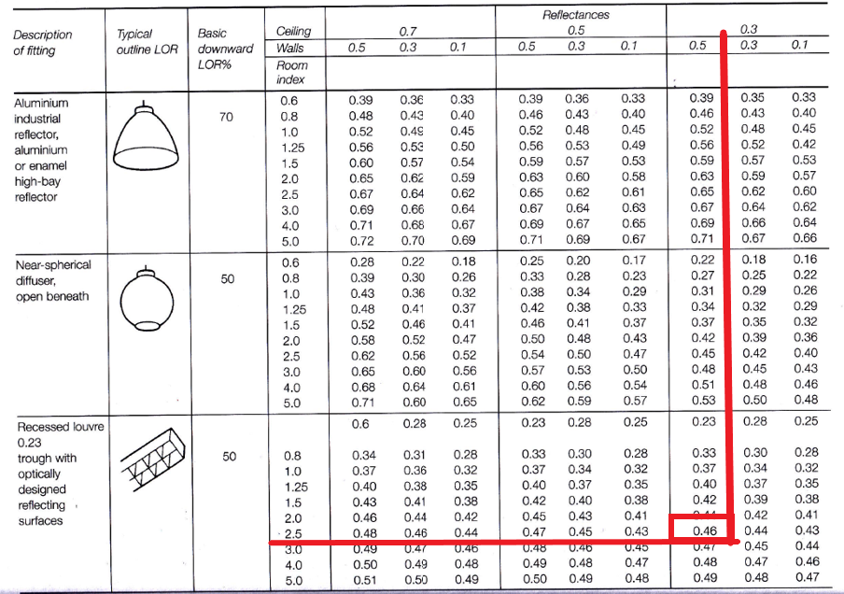
Figure 1 Utilisation Factor Table

By plotting the factors given before, and the RI calculated the UF is subsequently determined as 0.46.
UF = 0.46

The Number of Lamps Required
After all the figures required for the Number of Lamps (N) formula are supplied or calculated, it enables the use of this equation;

N = E x A .
F x UF x LLF
= 200 x (60 x 24)
18000 x 0.46 x 0.75
= 200 x 1440
6075
= 288000
6210
= 46.377
The number of lamps have been calculated as 46.377, although it is unacceptable to supply a lighting solution under the required amount, so the total is always rounded up. As well as the minimum lighting requirements it is also important to achieve an even luminance on the working plane, so rounding up to an even number makes this more achievable.
N = 46.377 48 Lamps Required

Spacing/Layout of the Luminaires
Based on the design that the fluorescent lamps are set in diffusing luminaires, the maximum spacing between each fitting must be calculated with the following formula;
Smax = 1.5 x Hm
= 1.5 x 7m
= 10.5m/Smax

This suggests the requirement for 48 Lamps, with a maximum spacing of 10.5m.
Considering this, the number of rows required for fit in the width of the factory must be calculated;
24m / 10.5m Smax = 2.29
There should be a minimum of 3 rows to conform to the recommendations and requirements. Considering this, I have chosen to go with the lighting layout of 4 rows of 12 lamps.
Next, the spacing of each row of lamps in the factory is must be determined. Subsequently, the distance from the walls should be ½ the ‘S’ value.
24m / 4 = 6mS
6m / 2 = 3mS½
This formula is repeated for the spacing of each lamp along the rows, with the length of the factory being 60m, and the equal spacing of 12 lamps.
60m / 12 = 5mS
5m / 2 = 2.5mS½
The layout can now be plotted to scale, based on the distance of each row from the walls of 3m, 6m between each row, and each lamp on every row starting 2.5m from the wall, and 5m between each lamp.
I have drawn the proposed layout that I believe to be the best fit as a solution to the lighting at this factory, refer to Figure 2.

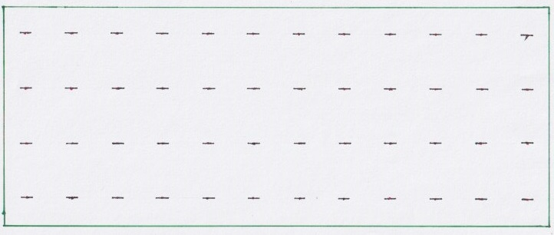
Figure 2 shows the sujested lighting disign
Drawn to scale of 1:2500
3m
2.5m
Task 2
To calculate the Sound Reduction Index (SRI) of a wall with an area of 20m² containing a window of 4m², an SRI of brickwork of 50dB, and the window being 10dB, the following method will be used with the area of each different material considered;
Brickwork: A1 = 20m² - 4m²
= 16m²
SRI = 50dB
Window: A2 = 4m²
SRI = 10dB
Although the SRI for each individual element of the wall is known, the overall SRI must be calculated, using the below formula.
SRI = $10(\log{10(\frac{1}{T}))}$
Now, using this formula, the T value can be calculated for each element and the overall T value can be used in conjunction with the above formula to reveal the overall SRI.
Brickwork T =
SRI=$10(log10\left(\frac{1}{T}\right))$
50=$10(log10\left(\frac{1}{T1}\right))$
5=$log10(\frac{1}{T1})$
1/T1=10⁵
T1=10‾⁵
T1=0.000010
Window T =
SRI=$10(log10\left(\frac{1}{T}\right))$
10=$10(log10\left(\frac{1}{T2}\right))$
1=$log10(\frac{1}{T2})$
1/T2=10¹
T2=10‾¹
T2=0.10
Then, to calculate the overall transmission of the wall, the average coefficient is worked out using the formula below:
To= $\left(T1×A1\right)+(T2×A2)$
$A1+A2$
= $\left(10‾^{5}×16\right)+(10‾^{1}×4)$
$16+4$
= $\left(0.000010×16\right)+\left(0.10×4\right)$
$20$
= $0.00016+0.4$
$20$
= $0.40016$
$20$
To= $0.020008$

Now that the overall transmission coefficient value has been calculated, it can be used in the previous SRI formula.
SRI = $10(\log{10(\frac{1}{To}))}$
= $10(\log{10(\frac{1}{0.020008})}$
= $10(\log{10(49.980008))}$
= $10×1.699$
= $16.99$
SRI = 17dB

The next part of this assignment will critique the implications of frequency and wavelength in internal sound management, while considering partition wall construction techniques and insulation choices.
Sound itself is produced by a range of rapid fluctuations in air pressure, which are picked up by human ear mechanisms. These vibrations are transmitted through air, any material of an elastic medium, and from one medium to another (Burberry, 1997).
The tolerance of noise varies between individuals, even when it originates from the same source. Although this acceptance is also influenced by other factors such as the type of environment, frequency, structure, and duration (McMullan, 2018). Considering this, when deciding on a suitable solution it becomes useful to evaluate the average degree of annoyance associated with the average noise exposure (McMullan, 2018).
The types of noise that cause problems within buildings can be categorised into three groups: source, path and receiver. All three of these areas are considered in terms of sound reduction to design quieter buildings (McMullan, 2018).
Some of these problems can be controlled and enforced by The Building Regulations, 2010, Document E, Resistance to the Passage of Sound. This is used in conjunction with BS 8233:1999, giving guidance for sound insulation and noise reduction for which materials, layout and design must be considered when building.
The transference of noise through a building is classed into two main types: ‘airborne sound’ and ‘impact sound’, which are determined by the source producing the sound (Chudley & Greeno, 2016). Impact sounds are defined as when the fabric of the building vibrates from direct contact with an object, and airborne sound sets vibrations with the fabric of the building when soundwaves reach it, as they are admitted from a source (Chudley & Greeno, 2016).
Sound reduction of a surface involves the reflection of sound waves striking the surface itself, and the subsequent energy being absorbed into the material as it passes through. This energy dissipates in the form of heat, through the solid parts of the material, therefore, denser materials work well at absorption, but metal is the exception (Chadderton, 2013). Materials such as timber, brick and concrete are good at absorbing soundwaves of a higher frequency, so as the human ear is sensitive to noise of around 1000Hz, this makes this type of material critical to acoustic design, meaning that higher frequency levels are targeted with sound insulation as they are most sensitive (Chadderton, 2013). Thus, it becomes difficult to insulate against low resonance frequency, as the common materials used in construction have a naturally low frequency of vibration (Chadderton, 2013). When considering these aspects in partition wall design and construction, it is important to assess how the partition interacts with other structural elements, as any holes or gaps through or around the wall could allow passage of sound (Riley & Cotgrave, 2018).
Over time, there has been much research into different materials and alternative methods for the construction and implementation of internal walls in terms of sound reduction and insulation. These include the concepts of corrugated cores (Shen, Xin & Lu, 2011) and the installation of spring dampers at carefully selected points between the studs (Wang et al, 2005, Mao & Shen, 2017). Although a better result is obtained using a discontinuous construction between the studs of internal walls, it is a similar technique used for floating floors (McMullan, 2018).
After conducting this review into the progress of construction science and technology that is currently being developed, it can be said that with these continuing improvements to technology and materials, new houses will be able to offer better acoustic comfort for the user that they were built for. This has important implications in the construction industry in terms of building efficiency, along with being a significant factor for good physical health.

References
Burberry, P (1979). Environment and Services. (4th ed.). United Kingdom: Batsford Halsted.
Chadderton, D (2013). Building Services Engineering. (6th ed.). England: Routledge.
Chudley, R & Greeno, R (2016). Building Construction Handbook. (11th ed.). England: Routledge.
Mao, Q. & Shen, H., 2017. Improvement on sound transmission loss through a double-plate structure by connected with a mass–spring–damper system. Advances in Mechanical Engineering, 9(7), pp. Advances in Mechanical Engineering, July 2017, Vol.9(7).
McMullan, R (2018). Environmental Science in Building. (8th ed.). England: Red Globe Press.
Riley, M & Cotgrave, A (2018). Construction Technology 1: House Construction. (4th ed.). England: Palgrave.
Shen, C., 2012. Theoretical model for sound transmission through finite sandwich structures with corrugated core. International Journal of Non-Linear Mechanics, 47(10), pp.1066–1073.
Wang, J., 2005. Sound transmission through lightweight double-leaf partitions: theoretical modelling. Journal of Sound & Vibration, 286(4/5), pp.817–848.

