
Applied Industrial Placement (SPORT)
M5X02295
Placement Portfolio Template

Student Name
Name – Jordan Protheroe
P Number – P149491
Report
Title –
Word Count –
References (Total) –
Job Title –
Organisation
Name –
Address –
Email –
Telephone Number –
Line Manager
Name – Hermon Yohannes
Position – Coach/Manager
Email –
Telephone Number – 07870 955755

TASK A – (Reflective Learning Log 1 - 500 words – First Experience of Placement)
Recommend to link the reflective experience to two different key themes.
During my first week within the work place experience I felt that there was a lot of knowledge the teams were throwing back at us which then shows myself that they are eager to learn new things and to listen and learn from their coaches and mentors. As the sessions went by in the early stages you could see that some of the youth members have taken upon themselves to select a leader for the group and a captain to go along with it. This showed myself how together they are as a group and as a family. Along with this the knowledge that went into coaching the children was quite good. The reason behind this is because they would not put a foot wrong in the drills that were set to them along with the amount they would ask at the end of the session, this again shows how much they want to learn, focus and become better players and people all together.

TASK A – (Reflective Learning Log 2 - 500 words – Mid Point Experience)
Recommend to link the reflective experience to two different key themes.
During the half way point within my work placement I could see how some of the children would bounce off one another. This was great to see as they are such an amazing bunch of children that are eager to learn and try new things. This was a key part in my learning within this placement because both myself and other senior members were given a task to go out and try to get more and more people attend the game and awards ceremonies we set out for the youth teams. This them entitled us to go out and promote the Tiger bay youth teams, this meant that we would be going door to door telling people about our upcoming events and matches along with posting and putting up leaflets to showcase our events again, we would also be putting them around the Wales Millennium Centre and we were able to get permission because of myself as I had worked within the building in the past so this was one good reason why I kept them as a close contact because you never know when your past may come in handy. With all that being said we had a much larger turn out as you will be able to see in one of the picture below, which them we were able to raise around close to £300 for all our the youth teams. This money would be going straight into the teams for the reward ceremonies and days out with the groups.

TASK A – (Reflective Learning Log 3 - 500 words – Mid Point Experience)
Recommend to link the reflective experience to two different key themes.
Within the half way point of my work place placement this was an opportunity for myself to attempt to deliver and coach a training session to one of the groups. This was a nerve raking experience for me as I know quite a lot of the group and was concerned that they would not take me seriously. This was very quickly the wrong thought I had of them because as soon as I started speaking and telling the group what will be happening within the day’s session, everyone was quiet and they also raised their hands when they wanted to speak to either myself or the other coaches. The communication and the energy off one another was bouncing and there was a great vibe between both myself and the entire group. This was key for me to try and get to know them that little bit more and to understand certain players strengths and weaknesses during my time coaching them.

TASK A – (Reflective Learning Log 4 - 500 words – Near end of Experience)
Recommend to link the reflective experience to two different key themes.
While my time is coming to an end within my work place placement the energy and momentum has not slowed down or stopped at any point because these teams are very focused on winning and improving themselves both on the fired and off the field. Some of the members of the team going to after school clubs so that they can study both English and maths within the community youth centre located 5 minutes away from where they train. During this time, I was shown by Hermon (coach) what he has been doing for the past few weeks and that was planning a boast trip around Cardiff bay along with a trip to Alton Towers in the beginning of September. He had been planning this just by himself as he wanted to keep it a surprise for the whole group. The money generated for this day out was all from the public attending thr matches and fundraiser in order to reward the youth for their hard work throughout the year. Being able to balance school work and playing football may be difficult for some people of that age but with the discipline they are able to make it work.

TASK A – (Add 250 words on link to future Continued Professional Development and Reference list based on total referenced material in Task A)
Continued Professional Development post placement (250 words - Link to pre placement module)

References from TASK A (10+ references)
- .

- .

- .

- .

- .

- .

- .

- .

- .

- .

- .

- .

TASK B – (YouTube Video – 10 x 1 min integrated video) (Experience, Roles, Improvements)
NOTE – Make sure the link works correctly
Website Link –

Link Password –

Video Duration –

Device used to create video –

Software used to create video –

Production contributors
Name | Position | Organisation

Picture | Text (Paragraph)
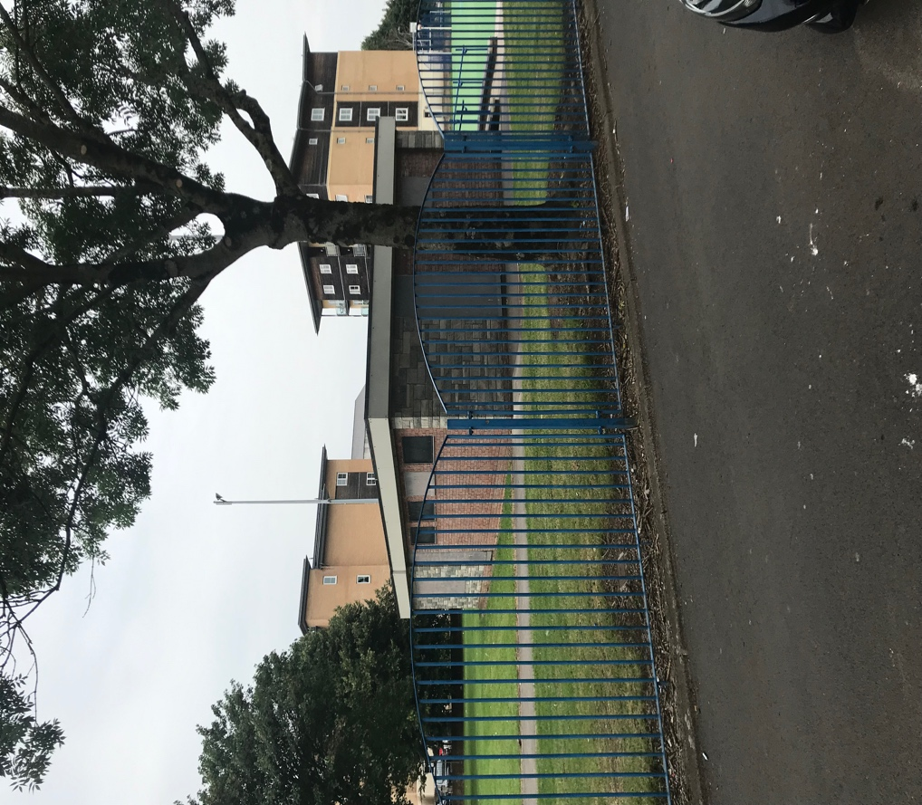 | This first image is where the different teams we have will go to change and have a little talk about our next upcoming opponents before the game. During half time they will again be within this small changing rooms along with the senior members of staff.
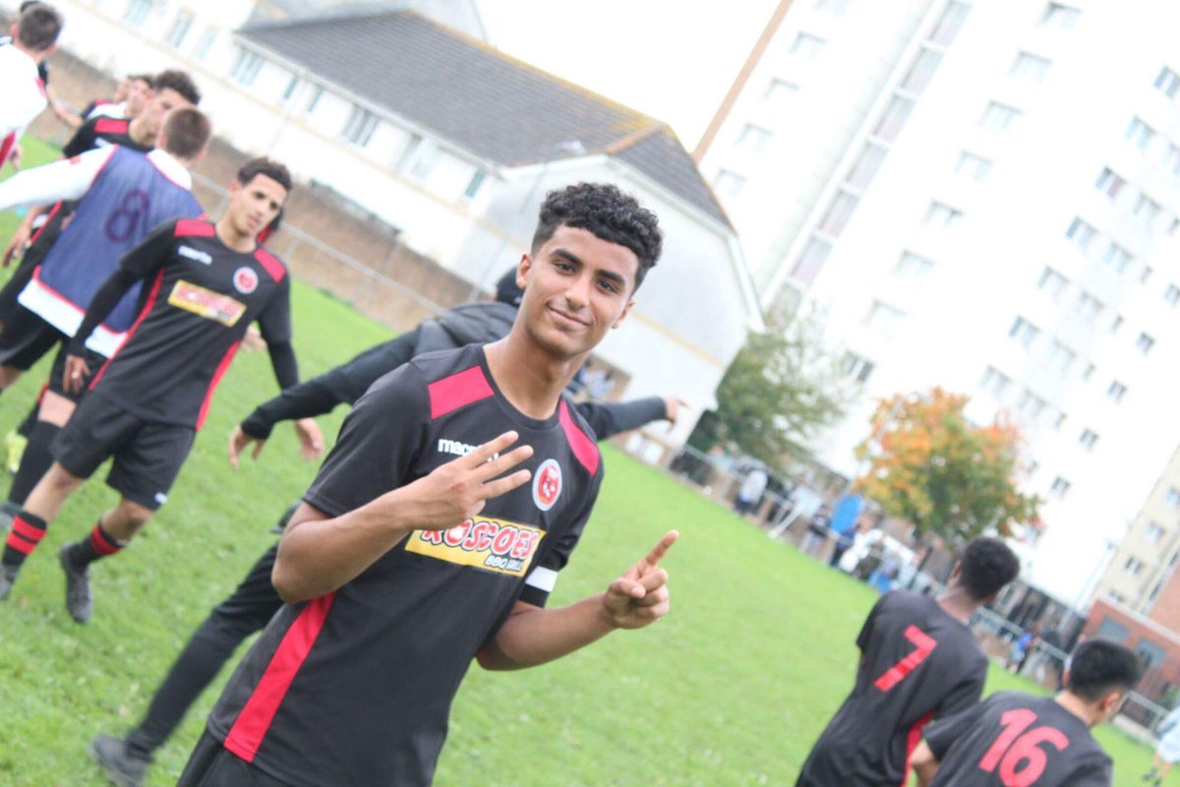 | This image is of one of our top players for the past two seasons. He has won many solo awards while being at the club with being the league’s top scorer. You can also see that he is showing in the picture that they had just won a game 3-1.
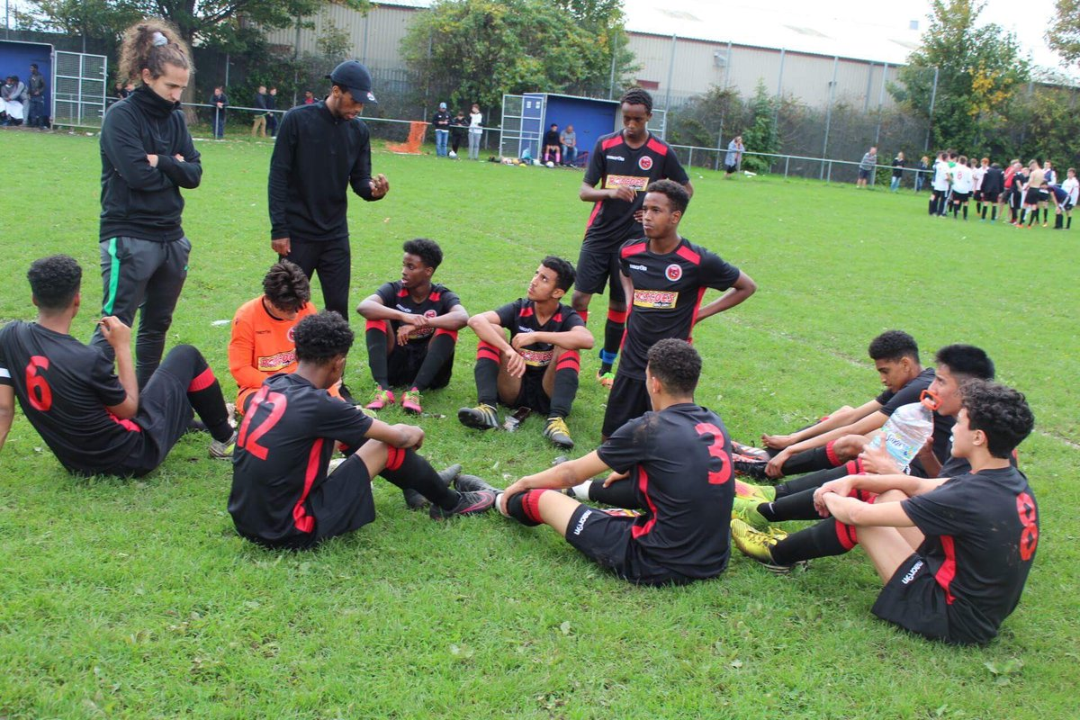 | During halftime one of our senior members of staff (coach) was giving the youth group some tips and a motivational speech to the group to encourage them because at this point they were losing 2-0.
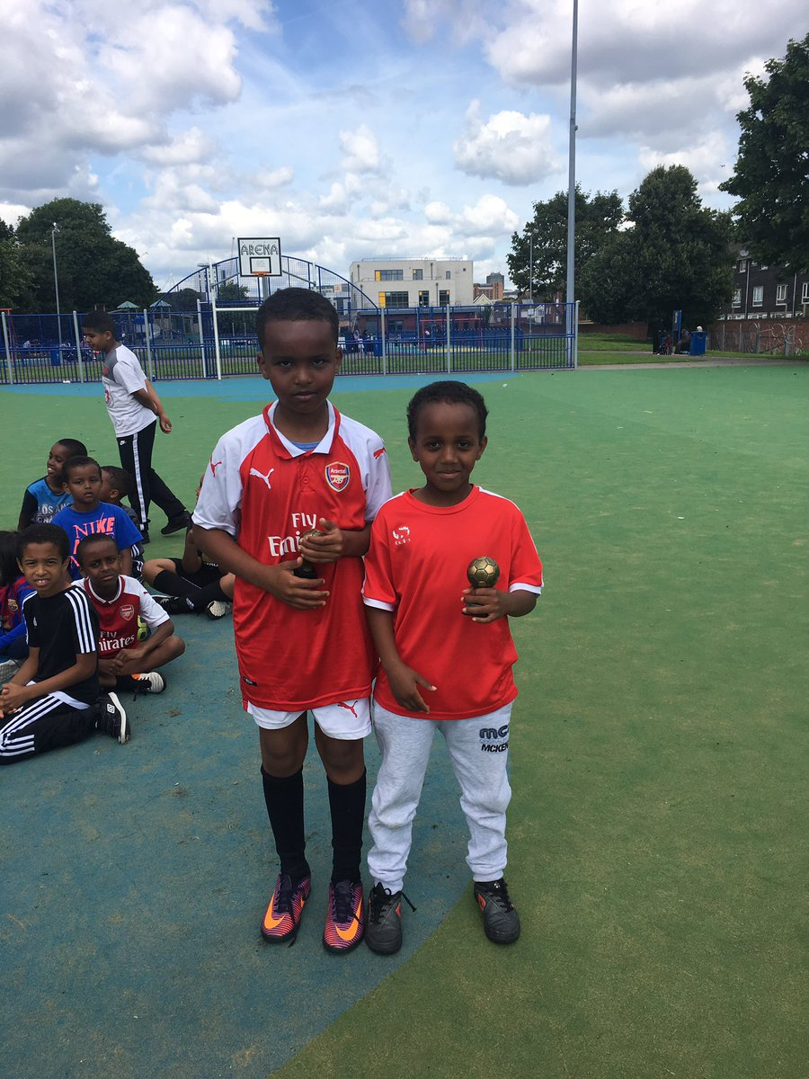 | Within this picture this is of two of our youngest boys receiving their awards for participation for throughout the season. They are given to these two specifically because they managed to play every single game of the season without getting a yellow or red card.
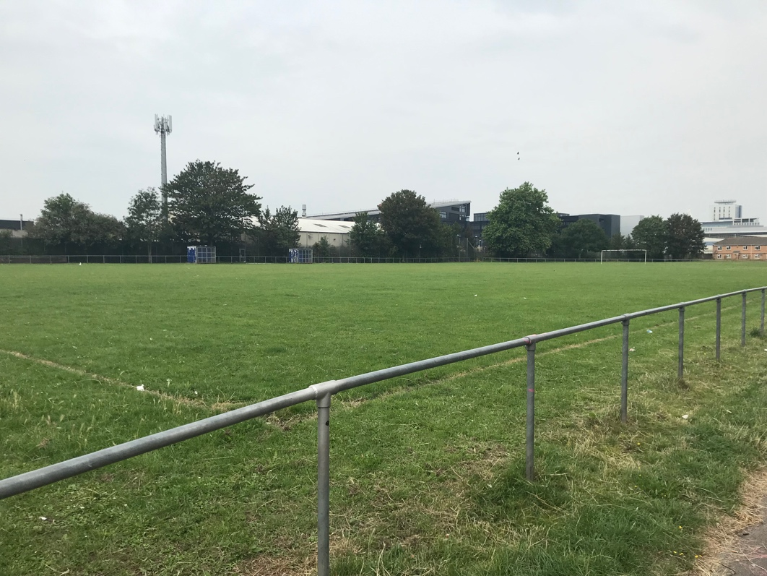 | This picture was taken to show you the size of the pitch our oldest group plays on. As you can see they have the wide open spaces and are able to get the full support of the home and local fans and family.

TASK B – (Picture Board – 5 pics (40MB upload limit to Turnitin) (Experience, Roles, Improvements)

TASK B – (Picture Board Cont.–5 pics (40MB upload limit to Turnitin) (Experience, Roles, Improvements)
Picture | Text (Paragraph)
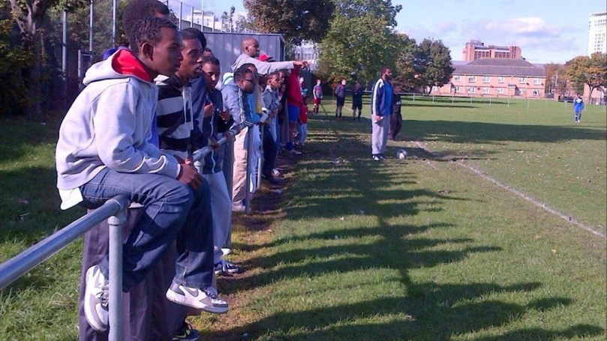 | This picture was taken during a game being played. As you can see the local home games attract a lot of support from the locals which is a great encouragement for our young groups. This may seem like a lot of pressure on our young teams but in reality this drives them that little more.
 | This picture was taken during the awards ceremony for three of our teams, the under 18s, under 16s and the under 13s group. This was taken because again they had a successful season winning the league and becoming champions once again.

TASK C Evidence – Employer Report (Signed),
NOTE – This will be compared against the report sent to the University.
NOTE – You will need to complete additional copies if you have more than one provider.

TASK C Continued Evidence – Employer Report (Signed),
NOTE – This will be compared against the report sent to the University.

TASK C Evidence – Ethics Form – Signed by Organisation and Lecturer
NOTE – You will need to complete additional copies if you have more than one provider.

TASK C Evidence – Ethics Form Continued

TASK C Evidence – Ethics Form Continued

TASK C Evidence – Ethics Form Continued

TASK C Evidence – Post Placement Review and Feedback
Dear Participant

Many thanks for your involvement in the work placement. I hope that you had a positive experience. The University of Wales Trinity Saint David reviews the provision annually for enhancement purposes and so we would be pleased to hear your feedback on any aspect of the placement.

Yours sincerely

Andrew Thomas, Placement Coordinator Sports Management Portfolio

Name of provider’s organisation: |  | Tiger Bay Youth Club
Name of student: |  | Jordan Protheroe
What were the positive aspects?
The positive aspects I got from my time here is that is was very fun and enjoyable to watch and coach such a great groups of boys and to see how much they want to learn new things.

Were there any problems?
I would say there was bot any problems as we always had a full group even if it was raining or not, there was no trouble at all.

Do you have any recommendations for enhancement for the future?
Possibly to start earlier and to maybe focus on getting more and more people involved in the community.

Signed: | J.Protheroe
Name in block capitals: | JORDAN PROTHEROE
Position (please tick one): | ☐ Placement Provider  ☒ Student  ☐ Placement Tutor |  | Date: | 30/07/2019

TASK C Evidence – Student Placement Induction Checklist
Student Name: | Jordan Protheroe
Name of Placement Provider organisation: | Tiger Bay Youth Club
Placement Site Address: | Cardiff Bay, Cardiff, CF10 5FE

Health & Safety Issues | No | Yes | Date
- Introduction to key staff members and their roles explained |  | X
- Location of welfare facilities (e.g. toilets, kitchen, rest room, showers, etc.) |  | X
- Emergency procedures |  | X
- Copy of safety policy received or location known |  | X
- Location of first aid facilities and contact for first aiders |  | X
- Fire procedures and location of fire-fighting equipment |  | X
- Accident/incident reporting and location of accident book |  | X
- Use/control measures for hazardous substances in the workplace (e.g. COSHH) – if applicable |  | X
- Display Screen Equipment Regulations and associated procedures – if applicable
- Manual handling procedures – if applicable |  | X
- Protective clothing/equipment arrangements – if applicable |  | X
- Instruction on equipment you will be using (list equipment) |  | X
- Specific training for tasks to be undertaken |  | X
- Specific information relating to risk assessments covering tasks to be undertaken |  | X
- Location of health and safety information and advice |  | X
- Specific disability related induction issues |  | X
- Other issues covered/to be covered please state: |  | X

As a minimum, the topics listed above should be included within the induction that you provide for the student on placement, preferably on their first day. Please check off the subjects as they are covered.

PLACEMENT PROVIDER CONFIRMATION

I confirm that the student has been provided with the induction specified above:
Signed: | H.Yohannes
Print Name: | Hermon Yohannes
Position: | Coach/Manager | Date: | 30/07/2019

STUDENT CONFIRMATION

I confirm that I have been provided with an appropriate induction as specified above:
Signed: | J.Protheroe
Print Name: | Jordan Protheroe
Position: | Volunteer | Date: | 30/07/2019

NOTE – If this is not completed please ask your supervisor on the placement to complete ASAP. However, please inform the placement coordinator at the earliest possible opportunity if this procedure does not take place.

ICATION for Sports Placement ETHICAL APPROVAL

This form must be completed and approved prior to undertaking any activity with the organisation. It will need to be signed by the student, placement organisation and a sports lecturer.

SECTION A: About You (Student)

Full Name: | Jordan Protheroe
Faculty/School/Centre: | Sport, Health and Outdoor Education
Campus: | Swansea Business Campus
E-mail address: | Jordanprotheroe1@gmail.com
Contact Telephone Number: | 07508418768
Student Number: | P149491 | Undergraduate | ☒
Programme of Study: | Sports Management | Taught Postgraduate | ☐
Director of Studies/Supervisor: | Andrew Thomas | Research | ☐

SECTION B: Placement Activity Organisation (Employer)

Does the activity involve collaborators outside of the University? |  | YES | ☒ | NO | ☐
If Yes, please provide the name of the external organisation and name and contact details for the main contact person:

Organisation | Tiger bay youth club
Contact person name | Hermon Yohannes
Contact person e-mail address
Contact telephone number | 07870 955755
Number of agreed contractual hours | 200

Location of activities
Identify all locations where activities will take place.
Cardiff Bay, CF1 5FE

The placement student will work within the companies ethical framework
Organization representative name | Hermon Yohannes
Signature | H.Yohannes | Date | 01/04/2019

SECTION C: Scope of Activity (Student)

Will the activities include: | YES | NO
Use of a questionnaire or similar research instrument? | ☐ | ☒
Use of interviews? | ☐ | ☒
Use of diaries? | ☐ | ☒
Participant observation with their knowledge? | ☐ | ☒
Participant observation without their knowledge? | ☐ | ☒
Use of picture, video or audio recording? | ☐ | ☒
Access to personal or confidential information without the participants’ specific consent? | ☐ | ☒
Administration of any questions, test stimuli, presentation that may be experienced as physically, mentally or emotionally harmful / offensive? | ☐ | ☒
If you have answered yes to any of the above then please explain below:

NOTE – PICTURE and VIDEO for assessment - make sure you have approval from organisation

SECTION D: Intended Participants (Student)

Who are the intended participants: | YES | NO
Students or staff at the University? | ☐ | ☒
Adults (over the age of 18 and competent to give consent)? | ☐ | ☒
Vulnerable adults? | ☐ | ☒
Children under 18? | ☒ | ☐
Prisoners? | ☐ | ☒
Young offenders? | ☐ | ☒
Those who could be considered to have a particularly dependent relationship with the investigator or a gatekeeper? | ☐ | ☒
People engaged in illegal activities? | ☐ | ☒
Others (please identify): | ☐ | ☒
If you have answered yes to any of the above then please explain below:

The intended group of participants are a range of children under the ages of 18 who live within this community.

SECTION E: Anticipated Risks (Student)

Outline any anticipated risks that may adversely affect any of the participants, the student and/or the University, and the steps that will be taken to address them.
Risks to participants
For example: emotional distress, financial disclosure, physical harm, transfer of personal data, sensitive organisational information
None

Risks to student
For example: personal safety, physical harm, emotional distress, risk of accusation of harm/impropriety, conflict of interest
None

University/institutional risks
For example: adverse publicity, financial loss, data protection
None

Control measures
List measures put in place to limit and manage any of the risks identified above
None

Disclosure and Barring Service
If the activity involves children or vulnerable adults, a Disclosure and Barring Service (DBS) certificate may be obtained before any contact with such participants. | YES | NO | N/A
Do you need a DBS certificate for this role? | ☐ | ☒ | ☐
Has a DBS certificate been obtained? | ☐ | ☐ | ☒
If yes, add picture copy below

SECTION F: Declaration (Student and Staff)

For Students:
The information which I have provided is correct and complete to the best of my knowledge. I have attempted to identify any risks and issues related to the employment activity.
Name of applicant: | Jordan Protheroe
Signature of student: | J.Protheroe | Date: | 03/06/2019

For Staff:
Placement Coordinator: | Hermon Yohannes
Signature: | H.Yohannes
Date: | 03/06/2019

Staff Checklist: The students completed/ submitted the following:

☒ | Completed all sections of the form in full.
☒ | Attached a copy of the DBS (where appropriate)
☒ | I can confirm that the activities has been approved providing they stay within the scope specified by the student.

Placement Employer Report - Evaluation of Student Performance

Student Name: Jordan Protheroe Dates of Employment: 01/04/2019/10/09/2-19

Interest in Work

○ |  |  | High interest in job. Very enthusiastic. |  |  |   | More than average amount of interest and enthusiasm for job. |  |  | ○  | Satisfactory amount of interest and enthusiasm for job. |  |  | ○  | Interest spasmodic. Occasionally enthusiastic. |  |  | ○  |  | Little interest or enthusiasm for job.
Initiative

○  |  |  |  | Self-starter. Asks for new jobs. Looks for work to do. |  | ○  |  | Acts voluntarily in most matters. |  |   |  | Acts voluntarily in routine matters. |  | ○  | Relies on others. Must be told frequently what to do. |  |  | ○  |  | Usually needs to be told what to do next.
Organisation and Planning

○  |  |  |  | Does an excellent job of planning and organising work. |  |   |  | Usually organises work well. |  | ○  |  | Does normal amount of planning and organising. |  | ○  |  | More often than not fails to organise and plan work effectively. |  | ○  |  | Consistently fails to organise and plan work effectively.
Ability to Learn

○  |  |  |  | Exceptionally quick. |  |   | Quick to learn. |  |  | ○  |  | Average. |  | ○  |  |  | Slow to learn. | ○  |  |  | Very slow to learn.
Quality of Work

  |  |  |  | Very thorough in performing work. Very few errors if any. |  | ○  |  |  | Usually thorough. Good work with few errors. | ○  | Work usually passes review. Has normal amount of errors. |  |  | ○  |  | More than average amount of errors for a trainee. |  | ○  |  | Work usually done in a careless manner. Makes errors often.
Quantity of Work

○  |  |  |  |  | Highly productive in comparison with other students. |   |  | More than expected in comparison with other students. |  | ○  |  | Expected amount of productivity for a student. |  | ○  | Less than expected in comparison with other students. |  |  | ○  |  | Very low in comparison with other students.
Judgement

○  |  | Exceptionally good. Decision based on thorough analysis of problem. |  |  |  | ○  |  | Uses good common sense. Usually makes the right decision. |  |   |  |  | Judgement usually good in routine situations. | ○  |  | Judgement often undependable. |  | ○  |  | Poor judgement. Jumps to conclusions without sufficient knowledge.
Dependability

 | Can always be depended upon in any situation. |  |  |  |  | ○  | Can usually be depended upon in most situations. |  |  | ○  | Can only be depended upon in routine situations. |  |  | ○  | Somewhat unreliable, needs above average checking. |  |  | ○  | Unreliable.
Please give your view of the student’s performance (see guidance definitions below):

 | A | B | C | D | E
Self-management & development |  | x
Managing Tasks |  | x
Communication skills | x
Working with & relating to others | x
Applying knowledge |  |  | x
Applying initiative in work problems |  | x

A - Outstanding
(consistently exceeded the standard expected of a placement student)

B -Very Good
(frequently exceeded the standard expected of a placement student)

C - Good
(always achieved (at least) the standard expected of a placement student)

D -Satisfactory
(achieved (at least) the minimum accepted standard for a placement student)

E - Unsatisfactory
(did not achieve the minimum accepted standard for a placement student)

Your opinion of their overall performance: __B___ (A to E)

Concluding Comments /Overall observations of Student Performance:

I found that Jordan worked very well and could see how much he was developing of the weeks and learning how things are done within our group.

Finally, could you please confirm that the student either completed the minimum requirement for placement (200 hours and 8 Weeks) or is in the process of completing this prior to the contractual term?

I confirm that I am the student’s nominated supervisor/their nominee and am able to comment knowledgeably on their performance whilst on placement.

Name Hermon Yohannes Signed H.Yohannes

Position Coach/Manager Date 15/07/2019 (Circa 1st August)



UWTSD SPORT
Placement

