REPORT

STUDENT NAME: DOGARI CRISTINA
Student number:2123451 Module name: Professional Career Development Module number: BMSW4005 Lecturer name: Rita Ukachi-Lois

Table of Contents
Introduction 2
Description 2
Feelings 2
Evaluation 3
Analysis 3
Conclusion 4
Action plan 4
Reflection on the role play 5
As the interviewer 5
As the interviewee 5
Conclusion 6
References 7
Appendix 8

Introduction
The purpose of this report is to describe my future career development plan. I will give an overview of my chosen career and discuss the skills I currently possess and how they will help me in my chosen career. Therefore, I will also discuss the skills that I think I will need in my career and why I think I will need them. I will show step-by-step how I intend to build these skills. At the end I will reflect on the job interview role play from my personal perspective and discuss what I learned from it and what I think I could have done better. This will be done by using Gibbs module of reflection. Gibbs module of reflection has six main stages: Description, Feelings, Evaluation, Analysis, Conclusion and Action Plan. The Gibbs module highlights the following:

Description
The career I have chosen and want to pursue in the next 2 years is a police officer and that is to apply for (PCDA) Police Constable Degree Apprenticeship. I decided to apply for the apprenticeship because, I think it is the best option to learn and practice at the same time, without wasting years. I will have the opportunity to receive the best training and preparation to meet the needs of London, that the police meet every day. I will be employed as an officer from day one, learning alongside experienced officers, while also having a salary. At the end, I will receive a fully funded degree. For this career I must hold a level 2 qualification in English Language at a GCSE grade or above and 64 UCAS points (METROPOLITAN POLICE,2022).
This career requires me to have these skills: communication skills, empathy, patience and calls, active listening, physical fitness, problem solving, time management and team working (indeed,2022).

Feelings
I feel that this profession will be hard and with many emotions and you always need to be strong, no matter what, to face any obstacle and be clear minded. This requires certain skills, and think I possess some of them.
Empathy is the skill that I possess, it represents an important part that an officer must possess because in a situation when someone is not a victim, you still have to offer empathy and bring an argument using phrases like: I understand/l can relate, but I give that are you saying. Communication skills, with this ability like a officer I will share my ideas, in the correct way, with correct words, I will understand others and I will be understood by the other and also it will help my to control my feelings. Time management, because like an officer you will need to do a lot of paper works, I need to know how to manage my time usefully not to stay over time at work because I did not get the report done (The 10 Code Mindset ,2020). The last skill which I possess is Active listening, this skill will help me a lot, because when a person knows that you are listening, they feel valued and therefore they will be more willing to talk with you (The 10 Code Mindset ,2022).

Evaluation
In this career you need to possess all the necessary skills to have a successful career. Unfortunately, I do not have all the necessary skills and have a lot to learn and practice. I think I will still need physical fitness skill, problem solving, team working and patience and calls. I will need them because each of them are very important.
Physical fitness is a very important part in police, because I see so many police which are out of shape ,and there are some that I do not trust, because I do not believe that they could physically meet their requirements on the job, to be able to protect me. An officer has to physically exert themselves, if they have not been working out, then their body does not know how to handle that kind of physical, and then they are not able to protect me, moreover it helps people cope mentally and physically with stress and policing is definitely a stressful job(The 10 Code Mindset ,2022). I need problem solving skills, because the problem is not always seen all at once, I need to know how to identify a problem, examine the facts and details of a crime to find the first step. Also, I need teamwork skill, because much of the job is about teamwork, and for this I need to cooperate, to participate and to contribute, to be reliable and honest, also motivate others. Team members need to be able to depend and rely on each other, because teams are built on trust.The last skill is patience and calm. Being patient is an essential skill for a police officer. An extremely tense or risky situation may occasionally occur in the future for an officer. To deescalate the situation and ensure that everyone feels safe, it is crucial that the officer maintains his composure under pressure in this circumstance (indeed,2022).

Analysis
Analysing I can say that I still need to develop, to obtain the skills that are missing for this career, I will also have to obtain level 2 qualification in English language and accumulate 64 UCAS points. Analysing all this information I understand that it is not so easy to become an officer, you have to be in a very good physical shape and have a good thinking to know how to act in an exceptional situation without fatal effects, because you cannot make mistakes in making an incorrect decision where a human's life depends on you.

Conclusion
In conclusion can say that I still have 2 years to prepare for this career to be eligible to apply. I think that from the beginning to be sure of what I am doing, I will apply for one year to be Community based volunteers to support policing on the street, with range of activities that aim to prevent crime, promote safety and make a positive contribution to my local communities(METROPOLITAN POLICE,2022).In order to face the challenges and situations that will arise during my career, I will need skills such as empathy, communication skills, time management and active listening that I already possess. Physical fitness, problem solving, team work and patience and calm are the skills I need to obtain through certain steps.

Action plan
In order to be accepted I will need to have all the documents, so I plan first of all to finish the university to get 64 UCAS points, and then to go to English courses to get a level 2 qualification. After I am accepted, I will need to prove, that I can cope with this job, and that I deserve to be accepted, because I possess all the skills. That is why I intend to build skills with are missing.
For physical fitness, I intend to train some of martial arts whether it is Brazilian, Jiu-Jitsu, Krav Maga techniques or MMA to have enough tools in my tool book, when it comes to techniques that are instinctive, and I must have enough physical stamina (The 10 Code Mindset ,2022). To develop the ability to work in a team, I will aim to work in a team every time I have the opportunity to develop trust in my team, to always try to listen to everyone's opinion, to clarify everyone's role so that everyone understands their responsibilities, to have a positive mindset and not to complain (UNIVERSITY OF THE PEOPLE,2022). To improve my problem-solving skills I will learn and put into practice how to understand and correctly identify the problem - first step, after I will do research behind the problem, I will consult with relevant people - second step. Third step will be visualizing the problem, I will highlight and define the area of the problem. The fourth step will be to brainstorm possible solutions, and the fifth step will be to identify the best answer (HAYS Working for your tomorrow,2022). To improve my patience and calm I am going to practice mindfulness, I will practice accepting the situation from the moment, even if it's unpleasant. I will build tolerance feeling a little uncomfortable, I will try to be playful, let myself feel broken to resist urgently fix everything and practice being a good listener (Cleveland Clinic,1995-2022).

Recruitment and selection
After I have done the role-play in class, I reflected on what it was like at the interview. I analysed how I did role play from both sides, as an interviewer and as an interviewee.

As the interviewer
Playing the role of the interviewer was a very interesting experience. Preparing to act as an interviewer, I learned many interesting and useful things. From the beginning it seemed easy to ask 5 questions per person in the group, but when I started in practice to get to know the job description and the application form, I realized that it is not so easy. I started thinking about what kind of questions I can offer so that in this short time I can find out this person from all points, see the way he thinks, see if he will cope with our company, understand what his abilities are, to see what he is interested in and if he has knowledge for the field he is applying for. For the first time, I saw the part of the interviewer that until now I did not draw attention to, because always answered but did not ask. I formulated five questions that seemed to me to be appropriate and that by answering them I will find out everything I need to know. I welcomed the interviewee with a smile and a handshake. But I think I could do better if I maintained eye-contact, body language which didn't use often, and maybe I should have made a small talk before the interview started.

As the interviewee
I really liked being the interviewee, even if it seemed a bit difficult because I did not know what questions would be offered to me, but I tried to give clear answers, with details and stick to the context, because I always debate the topic and talk a lot but not on the topic. I studied well and prepared myself to know the job description and in case he gives me questions related to the job, to show that I have prepared, and I am informed. I think that in some moments I could have answered better, but at that moment not enough ideas were coming. I tried to make eye contact but for a short time, because I was trying to do it and only succeeded for 8 seconds, because I was starting to forget what I wanted to say and was lost. I think I need to work on my emotions so that I can control them and be sure of myself, to make eye contact and not get lost. I also made a mistake when asked the interviewer what salary I will have, but for the future I will know that it is not correct.

Conclusion
To summarize I can say that the career will apply for will be police constable degree apprenticeship. This profession is one where people's lives depend on your actions, and it gives you a chance to form a better community. To be eligible to apply I need to have a level 2 qualification in English Language and 64 UCAS points. They also require skills such as empathy, communication skills, time management and active listening which already lack, and physical fitness, problem solving, teamwork and patience and calm are the skills I have to develop, because I do not have them. All the skills I do not have I will develop, already having a plan how and what I will do. I also plan to progress my career by doing everyday practice, training, sessions, learning, teaching, working, developing my skills and my knowledge every day and year. I will always ask for help from those with more experience and learn from them. Role-play interview for me was a good and pleasant experience from which I learned many interesting things and I made notes for the future, so that I know where to avoid making mistakes. It was a good preparation for the real interview in the future.

References

Cleveland Clinic (1995-2022) 7 Tips for Better Patience: Yes, You’ll Need to Practice! [Online] Available at: https://health.clevelandclinic.org/7-tips-for-better-patience-yes-youll-need-to-practice/ (Accessed: 4 November 2022)
HAYS Working for your tomorrow (2022) How to improve your problem solving skills [Online] Available at: https://www.hays.net.nz/career-advice/upskilling/improve-problem-solving-skills (Accessed: 4 November 2022)
Indeed (2022) 12 Necessary Skills for a Police officer [Online] Available at: https://uk.indeed.com/career-advice/career-development/police-officer-skills (Accessed:30 October 2022)
METROPOLITAN POLICE (2022) Community based volunteers [Online] Available at: https://www.met.police.uk/car/careers/met/police-volunteer-roles/community-based-volunteers/overview/ (Accessed: 4 November 2022)
MEROPOLITAN POLICE (2022) PC entry routes [Online] Available at: https://www.met.police.uk/car/careers/met/police-officer-roles/police-constable/overview/entry-routes/?gclid=Cj0KCQjwteOaBhDuARIsADBqReicA3aaoUxI0qUN9Q_eTLkUGDxnRK5oGuxskcS_Q7WrdUOdgS3yJuMaAlf9EALw_wcB&gclsrc=aw.ds (Accessed :26 October 2022)
The 10 Code Mindset (2020) How To Communicate As Police Officer [video]. Available at: https://www.youtube.com/watch?v=bDDEk8892Jk (Accessed:25 October 2022)
The 10 Code Mindset (2022) 5 Skills Needed To Be a Police Officer [In addition to some obvious stuff!] [video]. Available at: https://www.youtube.com/watch?v=IHQzC8hk3ck&t=179s (Accessed:30 October 2022)
UNIVERSITY OF THE PEOPLE (2022) How To Improve Teamwork Skills For Epic Success! [Online] Available at: https://www.uopeople.edu/blog/how-to-improve-teamwork-skills/ (Accessed: 1 November 2022)

Appendix

These are the 5 questions I asked the interviewee based on the interviewee's application form.

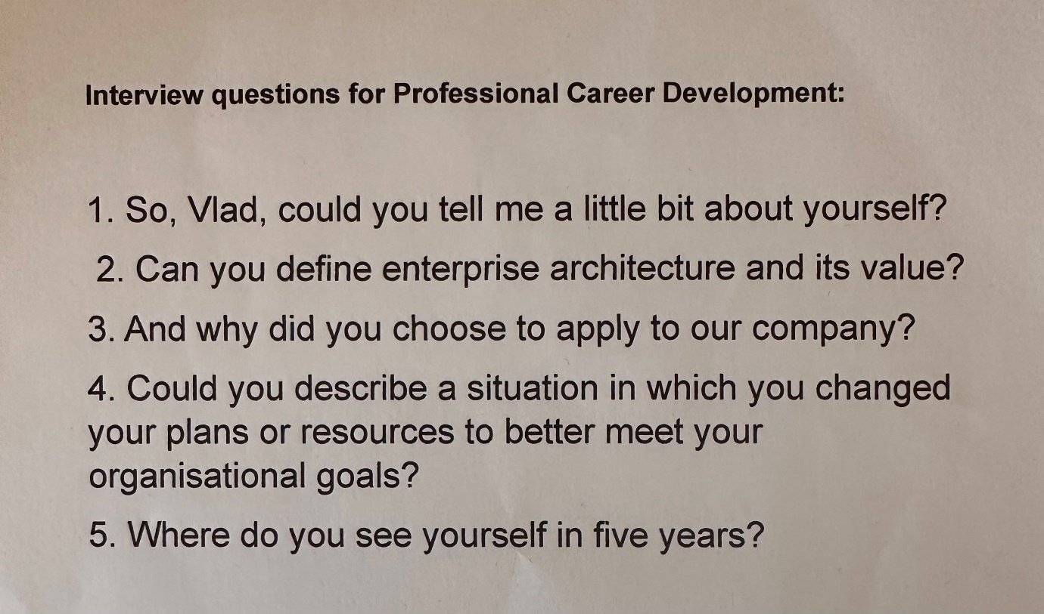

The question I raised in relation to the role towards the end of the interview process:
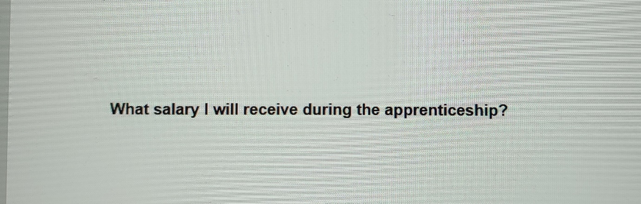
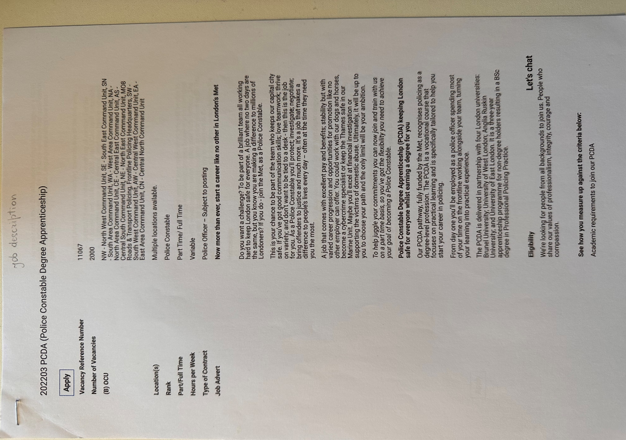
Job description:
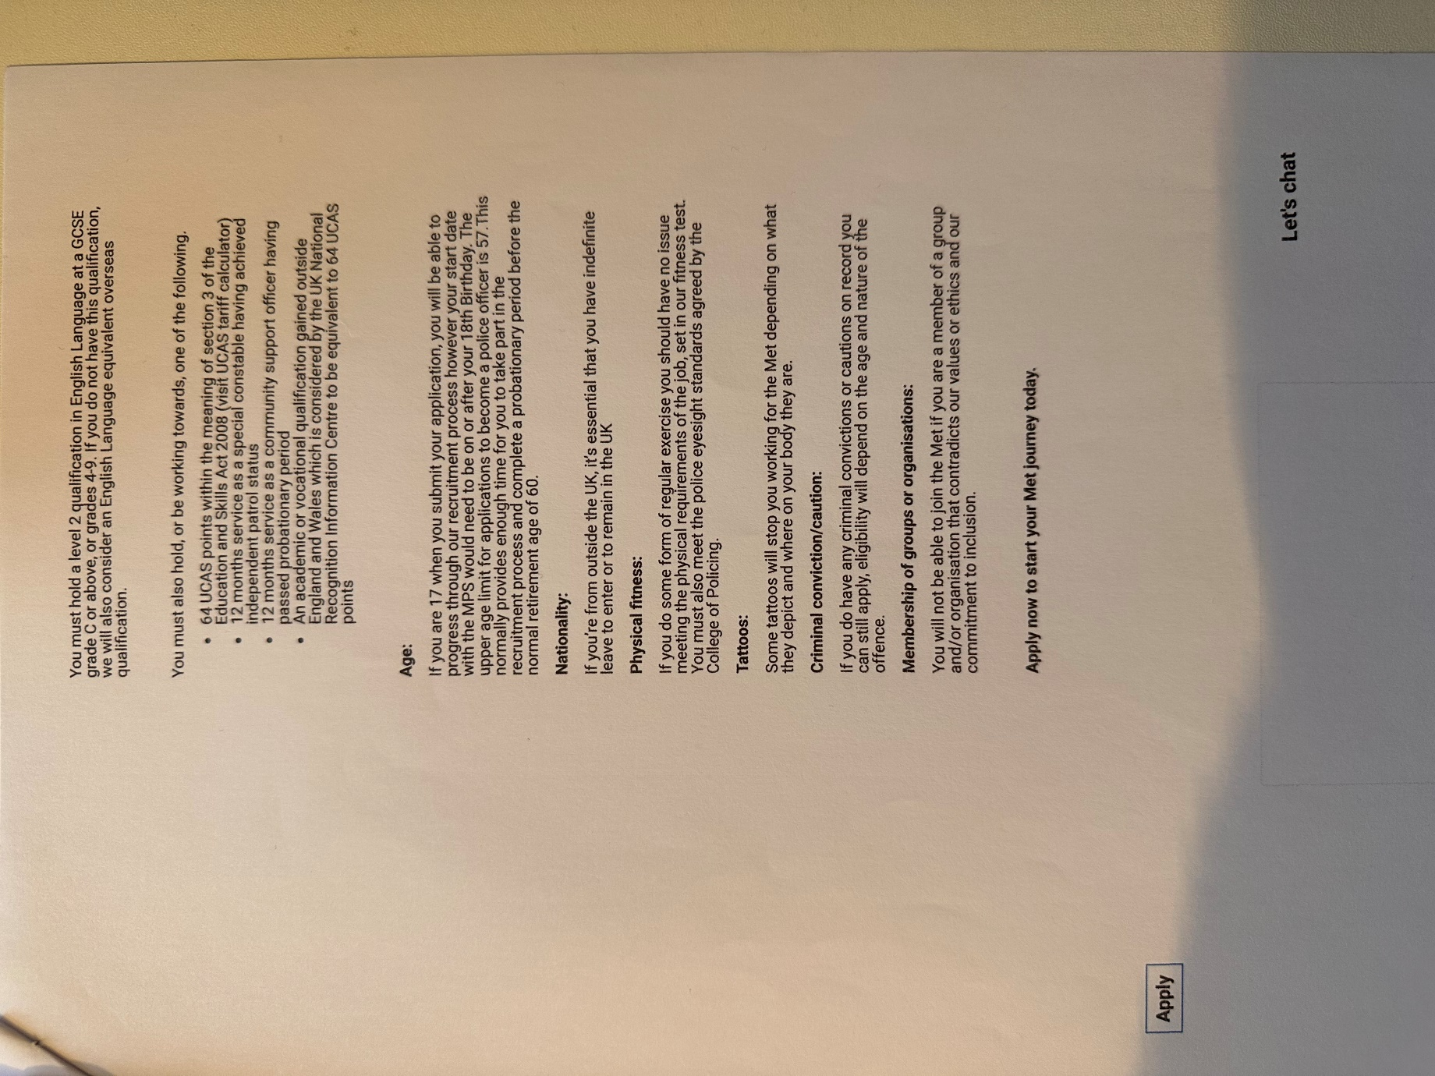

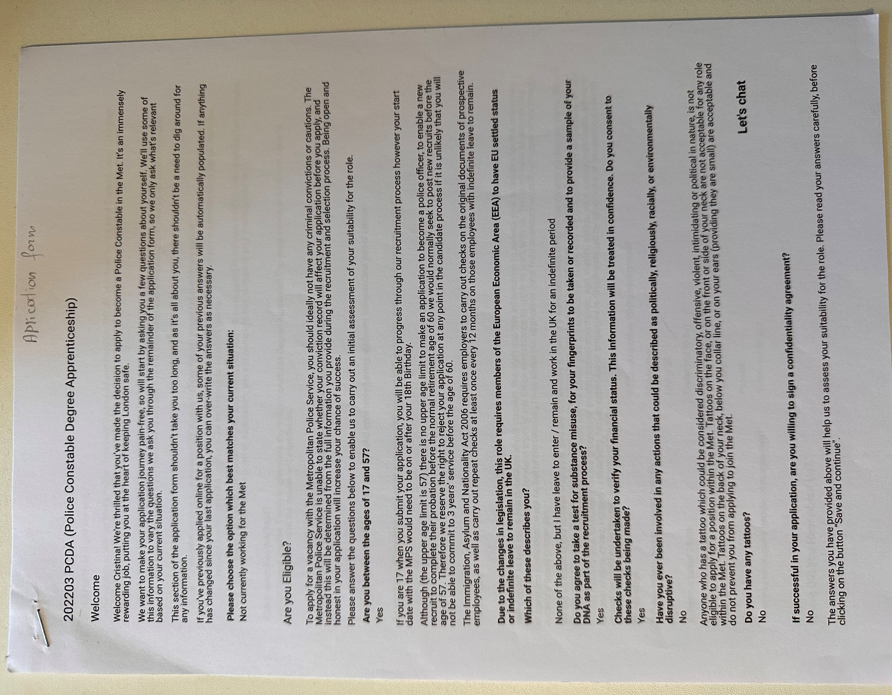
Application form:
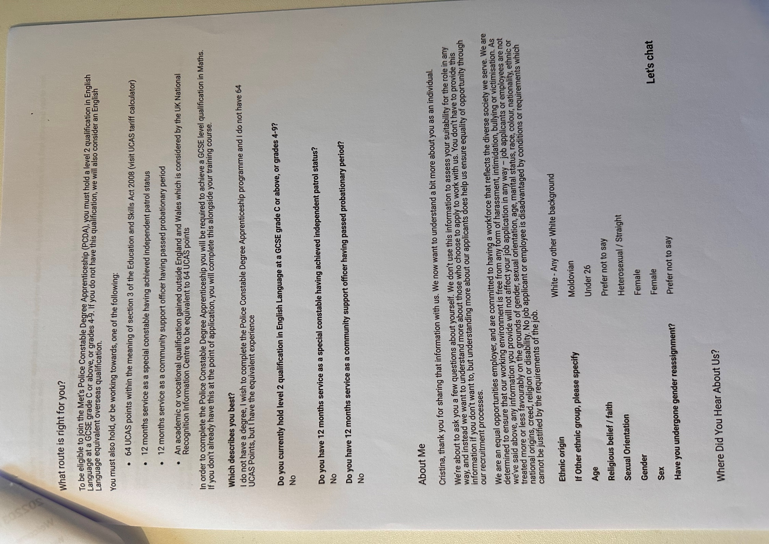
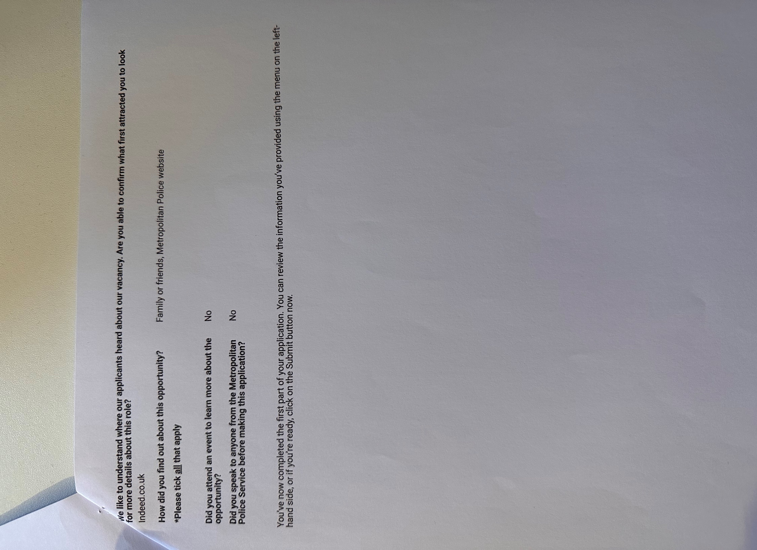
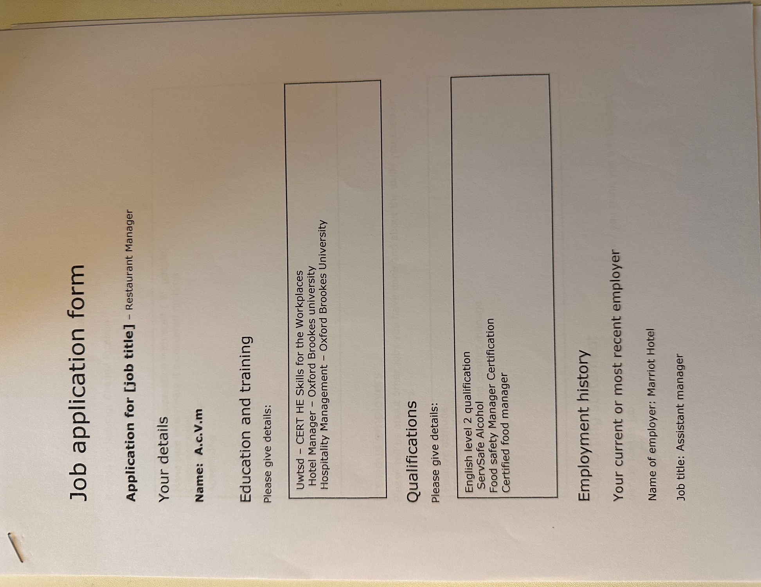
Activities during the class:



