Sheron Ahmed (2117695)

Sheron Ahmed 2117695
Sustainable hospitality and tourism management BMIH5006
Kathryn Roberts
The Future of Hospitality and Is It Profitable to Be Green?

Executive summary
In the context of hospitality and tourism industry, this research provides a critical understanding of the term sustainability. Milton Friedman’s 1950’s claim that ‘an organisations social responsibility is to increase profits’ is critically evaluated. Elkington’s triple bottom line will be expressed. The study will assess ‘sustainable good practice’ concepts within hospitality and tourism industry. For businesses to be sustainable, financial aspects are also relevant. Adopting green innovations could reduce expenses and increase revenues. The research emphasises the financial aspects, irrespective of whether businesses are motivated by customers or have a need to practice environmental responsibility. The study’s findings are supported by data and actual instances from industry models such as Doxey’s Irridex and Butler’s lifecycle model. The foreseeable future of hospitality and tourism is explored carefully in this report, with an emphasis on creating the right balance between sustainable practises and effectiveness.

Contents
Executive summary 1
Introduction 3
Sustainability 3
Financial resiliency 3
Sustainable developments and green business practises 4
Sustainable hospitality 4
Sustainable tourism 6
Destination management 6
Sustainable transportation 7
Recommendations 7
Conclusion 8
References 9
Appendices 13

Introduction
The economist Milton Friedman infamously argued in (1970) that, upon certain assumptions, business executives should concentrate purely on increasing profitability as opposed to serving the society. Friedman’s article was ground-breaking at the time. Milton Friedman’s claim fails to relate in present reality (Edmans. A, 2020). Sustainability is a problem for the businesses in the hospitality and tourism industry. There has been a global push in recent years for environmentally conscious and ethical practises in businesses sustainable developments and performances. The industry is therefore in a predicament and must reconsider its greener operational approaches. Despite the importance of profits to any organisation, over the years businesses have diversified. The environmental and social responsibilities of an organisations are increasingly more relevant to its economic success recently (Haski-Leventhal, 2018, pp16).

Sustainability
The Bruntland report released in (1987) refers to sustainability as “economic growths that meets the requirements of current generations rather than sacrificing the next generations abilities to fulfil their specific requirements” (Arowoshegbe et al. 2016, pp91). Elkington (1994) coined the term ‘Tripple Bottom Line’ to encourage the implementation of sustainable development in businesses corporate social responsibility (CSR). Informally known as ‘people, planet and profit’ from three pillars of sustainability (see appendix fig.1). The concept functioned as a framework for accounting industry’s that incorporated environmental, social and economic dimensions into the business performance models (Goh et al. 2020, p.119884).

Financial resiliency
Financial resilience is fundamental. A business must be able to sustain itself in order to meet these initial expenses whilst generating revenue in the long run. Resiliency enables business organisations within hospitality and tourism to recuperate swiftly through setbacks. Being sustainable and resilient are critical aspects in the travel and hotel industries. In the hospitality and tourism industry, sustainability is an integral determinant for consumer purchasing choices (Sebastian, 2023). Organisations technology and tourism can build resilience by prioritising local suppliers, adopting innovations in technology, and hiring sustainable specialised professionals. It highlights the measures necessary to ensure the industry’s long-term resilience, ensuring the development of sustainable, financially stable, innovative, green economy, that promotes employment opportunities thriving societies, and destinations where people are looking to reside, work and visit (GOV.UK, 2021).

Sustainable developments and green business practises
The 2030 Agenda, Change for Sustainability, which was accepted by every member nation of UN in September 2015, provides a global blueprint for harmony and success for humanity and the environment, both now and for the foreseeable future. Within it foundation happen to be the seventeen goals for sustainable developments that serve as a critical need intervention by all nations, industrialised as well as developing in a global commitment (see appendix fig.2). (UN, 2023). Traditional linear models have proven inefficient in light of the environment’s limited resources while there is an increasing strain on the natural resource aspects as the global population grows. The Circular Economy (CE) represents a significant paradigm shift in various sectors, shifting from linear to circular supply chains (Zhang.T, 2021).
The idea of Circular Economy (CE) relates towards a transformative economic framework that utilises renewable energy sources, waste removal of polluting chemicals and waste recycling. A circular, energy-efficient, and resilient economy necessitates creativity and expenditure in renewable developments, as well as improved trading conditions for sustainable goods and services (see appendix fig.3) (Gulseven. O and Mostert. J, 2019; pp36). Green practises, renewable energy sources, green cleaning products, green construction, recycling programmes and innovative technological advancements are being rapidly adopted by global organisations and industries (Hyseni.V, 2023). Green businesses strive to strike a balance with profits and environmental health. They integrate sustainable practises into their company’s decisions with the aim to minimise their negative impacts on worldwide and local environments. They accomplish this by providing goods that are recyclable or by greening their operations in making them more sustainable for the environment (ILO, 2023).

Sustainable hospitality
While the hotels and travel sectors make significant contributions to each revenue streams of the nations where they operate, they have a damaging effect on the natural world. The operations of hotels utilise huge amounts of energy, which consequently contributes to environmental degradation. Hotels and their operations not just contribute to environmental problems, customers likewise have an important role in causing these problems (Patwary et al. 2021). The basic concept of green hospitality is to provide guests with a comfortable and luxurious experience while minimising the environmental impact of the hotel’s operations (see appendix fig.4). This includes implementing sustainable practises, investing in environmentally friendly technologies, and raising environmental awareness. If done effectively, it has the potential to attracting a greater percentage of green-conscious guests (Ecobnb, 2023).
There are numerous approaches to become sustainable in the hospitality industry, from new buildings aiming for green credentials to existing hotels reducing water usage and food waste. The following are some examples of sustainable practises the hotel brands that undertaken notable efforts to lower their carbon emissions and provide ample of green facilities for their guests (Green Vacations, 2023). An example of Accor’s commitment to Planet21 initiatives towards sustainability are organise activities such as growing trees, mosquito nets distribution, health education activities, environmental area cleanup, organic food meals and much more. In 2011, Accor’s financial reports, net and income statements show an evident rise in expenditures due to sustainable growth, but revenue increased by 5.2% or approximately 6.100 million euros. As a result, the long-term development strategies had considerable effects on drawing customers, and the investment decisions were entirely driven by objectives. Furthermore, its income is increased by the organisation approach built around sustainable development and CSR activities (NGA, 2020; pp205). Highlighted by 1Concier (2020) are some sustainability trends in hospitality industry such as investments in energy star certified equipment, programmed energy control systems like insulation upgrade, LED lighting, heat preventing windows and draperies, energy-efficient circulation system, low-flow showerheads, bathroom fixtures, bedding and towel reusing. Non-toxic in-room amenities, plant derived packages, eco pump soap dispensers, sugar cane containers, FSC certified cardboard packaging. Recycling and waste reduction such as recycling programs for disposable paper, plastic and metal to stainless steel and straws, filtered water dispensers. Reduce transportation costs to the ecosystem such as reduce fuel consumption to shorten shipping routes, and using Bale packaging in transport vehicles (1Concier, 2020). These examples of achievement show that implementing sustainable practices not only economically feasible, but also extremely valuable in both the environment and the hotel’s bottom line.

Sustainable tourism
Tourism industry is made up of companies that offer a variety of goods, activities, and facilities related to travel by tourists. Tourism is a combination of corporate industries, a marketplace for demand and supply, an individual experience, and a complex global trend. Beyond tangible growth and promotion, tourism includes societal, cultural, and environmental issues. The tourism sector, like numerous other sectors, is facing an impending predicament about if they can maintain its rapid expansion rate without causing damage to the natural and built environments, both which needs to be protected and sustained if future generations are to benefit from the same advantages of travel and tourism as current travellers (Edgell, 2019). The essential drivers of sustainable tourism are demographic and social, political, science and environmental and technological developments (Fennell and Cooper, 2020). Here are five global case studies of sustainable tourism, 1. Bhutan’s controlled tourism, 2. a solar powered resort in Fiji’s Sixth sense, 3. a locally run backpackers in South Africa, 4. conservationist ‘voluntouring’ in Belize, and 5. a ecological travel company turned as an organisation in the Swiss nations (SUMAS, 2022).

Destination management
Destination branding requires long-term strategy, making choices, and management. Strategic marketing can result in an established brand with a psychological and profitable collaborative partnership. For effective communication through potential travellers, operators of destinations require appropriate expertise and an awareness of conventional and contemporary advertising platforms. Destination management emphasises the implementation of branding destinations and digital promotion for sustained development and competitive edge in the hospitality and tourism industries, providing techniques and resources for tourism advertisements and standards of excellence for enhanced tourism management approaches (IGI Global, 2020). Butler’s tourism destination life cycle model examines many steps in tourism development. Destinations for tourism have attributes that must be considered in planning a strategy based upon their life-cycle setting. Aside from Doxey’s Irridex model (see appendix fig.5), Butler’s theory model (see appendix fig.6) defines specific attitudinal and psychological responses for locations to assess the economic and social impacts of tourism developments by offering various approaches (Othomile and Makambe, 2019).

Sustainable transportation
Current transit operations, the environmental impact, and the complex nature with the present transport network are among the issues to be addressed. Transportation is a significant and growing contributor to the global emissions of carbon dioxide (CO2) but is also linked to a variety of other environmental issues, among these is air, noise and light pollution, resources depletion, society severance, declining ecosystems, and soil erosions. Alongside heavily urbanised economies, certain urban areas have promoted active transportation (walking and cycling) in Sweden, Germany, Netherlands and UK, whereas others rely heavily on public transportation (Adred, 2013). The ability to meet societal demand for travelling in a way that is green within its natural surroundings is the concept of sustainable transport, without damaging future generation’s transportation needs. Sustainable development necessitates the promotion of the environment, cost effectiveness and societal advancement (Rodrigue, 2023). Transportation is critical to encouraging accessibility, trading, economic development and employment. Innovative ideas in transportation are being influenced by emerging technologies, changing consumer habits, effective legislations (UN, 2021).

Recommendations
Embracing and incorporating CSR practices in hospitality industry’s operational strategies can encourage innovation, increase or improve an organisations global competitiveness and contribute to problem-solving in modern economy resulting to higher revenues in the long run (EHL Insights, 2023). Implementing sustainable practices within tourism, transportation and destination management in alignment with sustainable development goals (SDGs). The greening of business operations across the entire value chain through adoption of environmentally friendly offerings and solutions including sustainable conducts, energy sources that are renewable, ecologically friendly cleaning items, sustainable constructions, recycling initiative and revolutionary advances in technology.

Conclusion
Being mindful and resourceful of how sustainable hospitality and tourism destination management operates in their business can reduce the negative environmental and social impacts it may have across the world. Adhering to sustainable practices for any businesses or industry will draw the attention from green-conscious customers who look for ecofriendly products and services in hospitality and tourism to cater their needs in a responsible manner. Local and global hospitality and tourism organisations can make impactful changes to their supply chain operations and logistics by implementing sustainability in alignment with sustainable development goals, CSR, green marketing strategy.

References
Aldred, R., (2013) 16 The new mobilities paradigm and sustainable transport. Routledge International Handbook of Social and Environmental Change.
Arowoshegbe, A.O., Emmanuel, U. and Gina, A., (2016). Sustainability and triple bottom line: An overview of two interrelated concepts. Igbinedion University Journal of Accounting, 2(16), pp.88-126.
Clayton. M, (2015) John Elkington: Triple Bottom Line. Management Pocketbooks. [online] available at: https://www.pocketbook.co.uk/blog/2015/10/27/john-elkington-triple-botton-line/ (Accessed: 08 November 2023).
Ecobnb, (2023) Green Hospitality: Sustainable Practices for Hotels and Resorts. Available at: https://ecobnb.com/blog/2023/05/green-hospitality-sustainable-practices-hotels-resorts/#:~:text=The%20core%20principle%20of%20green,promoting%20awareness%20of%20environmental%20issues. (Accessed: 09 November 2023).
Edgell Sr, D.L., (2019). Managing sustainable tourism: A legacy for the future. Routledge.
Edmans. A, (2020) What Stakeholder Capitalism Can Learn from Milton Friedman. Oxford Business Law Blog. Available at: https://blogs.law.ox.ac.uk/business-law-blog/blog/2020/11/what-stakeholder-capitalism-can-learn-milton-friedman#:~:text=In%201970%2C%20Nobel%20Laureate%20Milton,a%20landmark%20at%20the%20time. (Accessed: 08 November 2023).
EHL Insights, (2023) 11 examples of CSR practices in hospitality industry. available at: https://hospitalityinsights.ehl.edu/csr-practices-hospitality-industry (Accessed: 11 November 2023).
Fennell, D.A. and Cooper, C. (2020) Sustainable Tourism: Principles, Contexts and Practices. Bristol, UK; Channel View Publications. Available at: https://doi.org/10.21832/9781845417673. (Accessed: 10 November 2023).
Green Vacations, (2023) Eco-friendly Hotel Chains. Available at: https://www.greenvacations.com/eco-friendly-hotel-chains/ (Accessed: 09 November 2023).
Goh, C.S., Chong, H.Y., Jack, L. and Faris, A.F.M., (2020). Revisiting triple bottom line within the context of sustainable construction: A systematic review. Journal of Cleaner Production, 252, p.119884.
GOV.UK, (2021) Policy paper Hospitality strategy: reopening, recovery, resilience. [online] available at: https://www.gov.uk/government/publications/hospitality-strategy-reopening-recovery-resilience/hospitality-strategy-reopening-recovery-resilience (Accessed: 09 November 2023).
Gulseven. O and Mostert. J, (2019) Application of Circular Economy for Sustainable Resource Management in Kuwait. IGI Global. Chapter 3 p35-48 DOI: 10.4018/978-1-5225-7915-1.ch003 Available at: https://www.igi-global.com/chapter/application-of-circular-economy-for-sustainable-resource-management-in-kuwait/221040 (Accessed: 09 November 2023).
Haski-Leventhal, D., (2018) Strategic corporate social responsibility: tools & theories for responsible management. London: SAGE. pp16.
Hyseni. V, (2023) Green Sustainability Available at: https://pecb.com/article/green-sustainability#:~:text=Some%20ways%20of%20achieving%20green,transport%20as%20much%20as%20possible (Accessed:09 November 2023).
IGI Global, (2020) Destination management and marketing: breakthroughs in research and practice. Hershey, Pennsylvania: IGI Global. Available at: https://doi.org/10.4018/978-1-7998-2469-5. (Accessed: 10 November 2023).
International Labour Organization (ILO), (2023) Green Business Guide. Available at: https://www.ilo.org/empent/areas/greening-smes/WCMS_882794/lang--en/index.htm#:~:text=Green%20businesses%20seek%20to%20balance,the%20global%20or%20local%20environment (Accessed: 10 November 2023).
Nga, M.N.T.T., (2020) Corporate social responsibility: a case study of Accor Hotels Group. Sustainable tourism: Shaping a Better Future, 203.
Othomile. O and Makambe. U (2019) ‘A close look into the socio-economic effects of tourism in a Bangwaketse village, south-western Botswana’, African journal of hospitality, tourism and leisure, 8(2).
Patwary, A.K., Omar, H. and Tahir, S., (2021). The Impact of Perceived Environmental Responsibility On Tourists’ intention To Visit Green Hotel: The Mediating Role Of Attitude. Geo Journal of Tourism and Geosites, 34(1), pp.9-13.
ResearchGate (a), (2023) The Doxey’s Irritation Index Model. Available at: https://www.researchgate.net/figure/The-Doxeys-Irritation-Index-Model_fig2_281464209 (Accessed: 10 November 2023).
ResearchGate (b), (2023) Butler’s model of the destination lifecycle. Available at: https://www.researchgate.net/figure/Butlers-Model-of-the-Destination-Life-Cycle_fig2_261191513 (Accessed: 10 November 2023).
Rodrigue; J.P; Dr, (2023) 4.4 Transportation, Sustainability and Decarbonisation. Available at: https://transportgeography.org/contents/chapter4/transportation-sustainability-decarbonization/ (Accessed: 11 November 2023).
Sebastian. N, (2023) Sustainability and resiliency are the top factors to survive in the hospitality industry. GoodFirms. Available at: https://www.goodfirms.co/resources/sustainability-resiliency-top-factors-to-survive-in-hospitality-industry (Accessed: 08 November 2023).
SlideModel.com, (2019) Circular Economy to Save the Planet Available at: https://slidemodel.com/circular-economy-to-save-the-planet/ (Accessed: 08 November 2023).
SUMAS Sustainability Management School, (2022) 5 examples of sustainable tourism around the world. Available at: https://sumas.ch/5-examples-of-sustainable-tourism-around-the-world/ (Accessed: 10 November 2023).
UN, (2021) Sustainable transport, sustainable development, Interagency report for second global sustainable transport conference. Available at: https://sdgs.un.org/sites/default/files/2021-10/Transportation%20Report%202021_FullReport_Digital.pdf (Accessed: 11 November 2023).
UN, (2023) Department of Economic and Social Affairs. Sustainable Development THE 17 GOALS. Available at: https://sdgs.un.org/goals (Accessed: 09 November 2023).
UNESCO, (2021) UNESCO and Sustainable Development Goals. Available at: https://en.unesco.org/sustainabledevelopmentgoals (Accessed: 08 November 2023).
Zhang, T. (ed.) (2021) Circular Economy: Recent Advances, New Perspectives and Applications. London, England: IntechOpen.
1Concier, (2021) Sustainability Trends In The Hospitality Industry: Ways To Make A Difference & Give Guests What They Want. Available at: https://www.1concier.com/IQ-DESK/Details/ArtMID/610/ArticleID/1050/Sustainability-Trends-In-The-Hospitality-Industry (Accessed: 09 November 2023).

Appendices
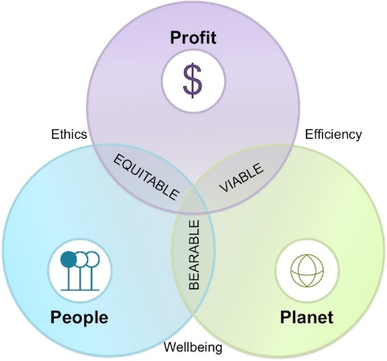
Figure 1. John Elkington: Triple Bottom Line
Source: (Management Pocketbooks 2015)
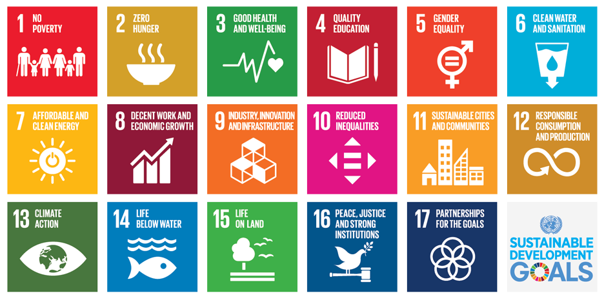
Figure 2. UNESCO and Sustainable Development Goals
Source: (UNESCO, 2021)
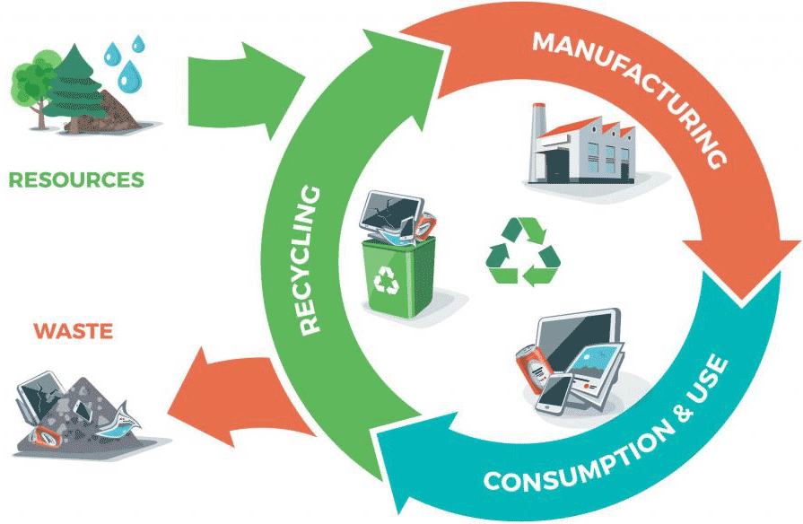
Figure 3. Circular Economy to Save the Planet
Source: (Slidemodel.com, 2019)
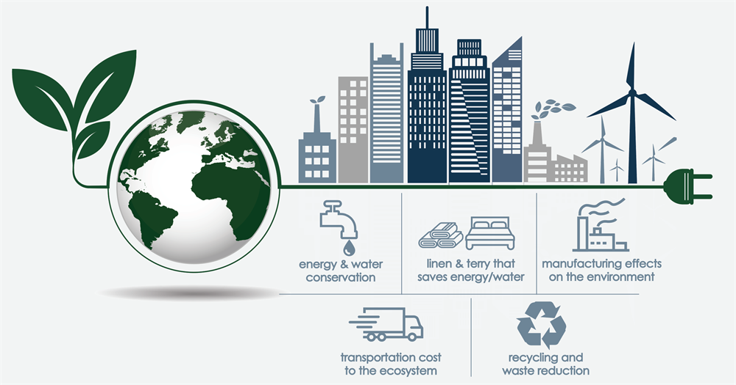
Figure 4. Sustainability Trends In The Hospitality Industry: Ways To Make A Difference & Give Guests What They Want
Source: (1Concier, 2021)
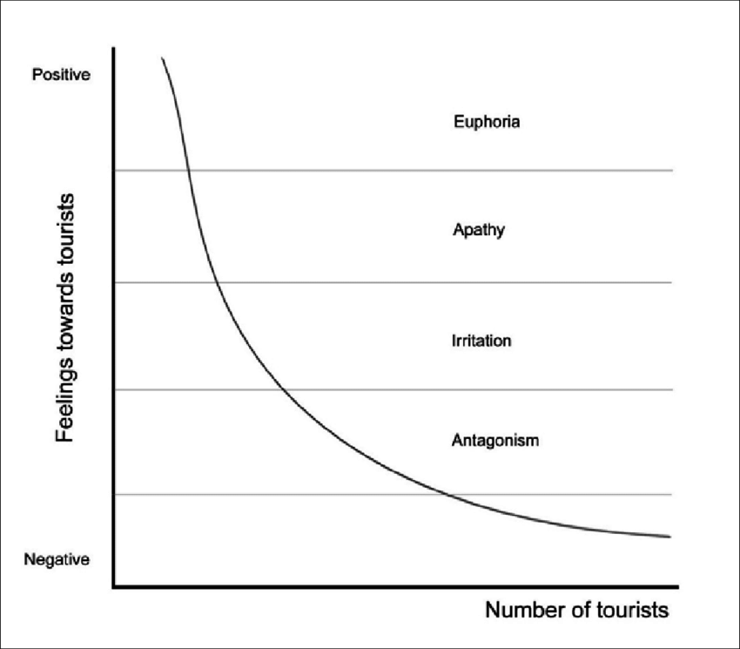
Figure 5. The Doxey’s Irritation Index Model
Source: (ResearchGate, 2023)

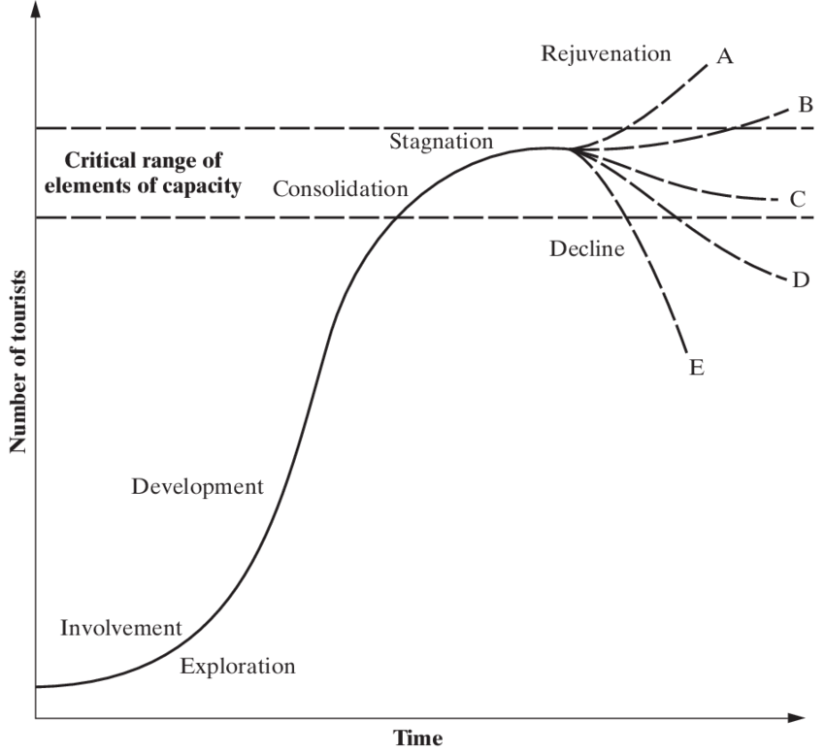
Figure 6. Butler’s model of the destination lifecycle
Source: (ResearchGate, 2023)

