

Assessment 1

Supporting Paper

Student name: Edit Tingyela
Student ID: 1917242

Module name: Mental Disorders and Psychopathology
Module code: BMHP6006
Lecturer name: Bianca Sanfilippo
Date: 14/04/2022

Introduction

This supporting paper introduces some information about mental health and then focuses on depression which is classified by ICD-10 MANUAL. After the classification, the definition is provided. The report presents a general overview of who is affected worldwide by depression to give a wider picture according to WHO? Then it narrows down the statistics to the UK. Above all, it shows the impact of COVID-19 as well. Aetiology, signs and symptoms, and diagnosis are described. Following them, types of depressive episodes and types of depression are introduced. Through the case study, the report demonstrates, that children and young people are also affected by this mental disease. To better understand the current situation of depression disorder, a general overview of the historical perspective is outlined. Historical treatments and current treatments are compared and an evaluation is made. The report presents the current legislation and the Nice guidelines for depression treatments. The recommendation is included for the best treatment of the patient. Finally, a conclusion is made.

Mental Health

As noted by MIND (2017) it is commonly known, that everybody has physical health, important to care for it. There are no differences in mental health, experiencing poor mental health means the general ways of thinking, feeling and reacting are challenging or even unmanageable. To get better crucial to have a combination of treatment, self-care and support.

Classification of depression by ICD-10

According to WHO (2019) the International Classification of Diseases was published with unique alphanumeric codes. Known illnesses and other health issues are identified, and mortality and morbidity data from different countries at different times are collected and analysed by ICD-10.
According to WHO (2010) ICD-10 manual classifies depression under this code:
- Chapter V
Mental and behavioural disorders (F00-F99) from different countries
- Mood [affective] disorders (F30-F39)
- F32 Depressive episode

What is depression?

Different organisations define depression dissimilarly, but some part of the definition is the same. According to WHO (2021) and Mental Health Foundation (2022) both classifications agree that it is a common illness. NHS (2022) and MIND (2019) define depression as a low mood that lasts for a long period and everyday life is affected by depression. Mood fluctuations or short-lived emotional responses to challenges of everyday life as noted by WHO (2021) do not mean depression.

Who is affected by depression?

According to the WHO (2021) depression has become a common disease in worldwide, around 280 million people are affected, expected 3.8% of the population. Young and old are affected, all types of people are, however, men are less affected than women. Children can suffer from depression as well. According to NHS Digital (2020) the Mental Health and Young People Survey (MHCYP) was made in 2017 and the results of the follow-up report in July 2020 show, that the number of mental disorders has increased, both boys and girls. In 2020 16.0% of children aged 5 to 16 years were mental disorders which are 5.2% more than in 2017. According to the WHO (2021) depression is one of the causes of suicide. As stated by WHO (2021) in 2019, 1 in 100 deaths happened by suicide globally. There are more risks after the COVID-19 pandemic such as financial crises, job loss, and social isolation.

Impact of COVID-19

According to Pieh et al (2021, pp. 328-337) epidemiological data are significantly higher about depressive, anxiety, and insomnia symptoms in the UK during the pandemic than during the pre-pandemic period. As stated by Nearchou et al (2020, pp. 1-19) youth mental health is impacted by covid 19, especially depression and anxiety in adolescents is affected. As shown by the Office of National Statistics (2021) 20% of men aged 16 to 29 years suffer moderate to severe types of depressive symptoms, much less than the women of the same age. Of them, 32% around 1 in 3 suffer some type of depression. The main causes of depression were lack of freedom and independence and the negative effect of COVID-19 on well-being.

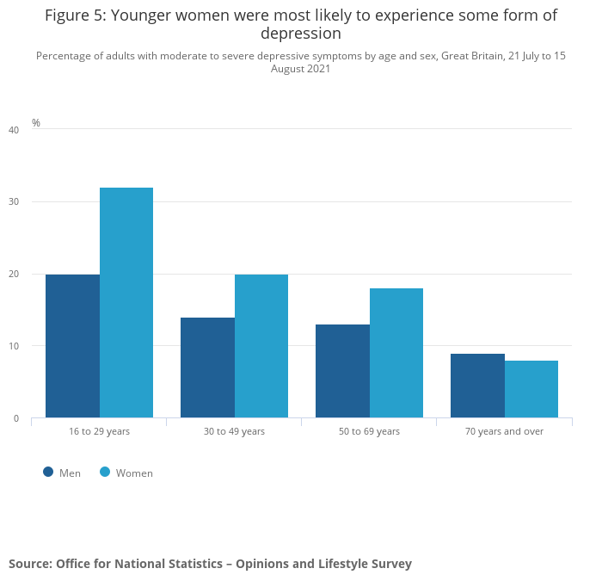
(Office of National Statistics, 2021)
Figure 1: Percentage of adults with moderate to severe depressive symptoms by age and sex, Great Britain, 21 July to 15 August 2021

Aetiology of the depression

According to MIND (2019) difficult experiences such as abuse (physical, emotional, sexual) traumatic events, loss of someone, also lots of smaller challenging experiences during childhood affect vulnerability to the later life depression. Depression is triggered by life events such as and relationships, losing or changing jobs, experiencing bullying. Health issues such as chronic problems, and changing lifestyles by health issues, can impact the mood, making it a potential risk for depression. Genetic inheritance is also one of the risks for depression besides that, growing up with depressed people can link to depression by experiencing depression behaviour. The side effect of medication and alcohol can cause depression. Vulnerability to depression is improved by lack of sleep, poor diet and lack of exercise. (MIND, 2019) As stated by NHS (2019) depression has Numerous causes that combine and trigger it.
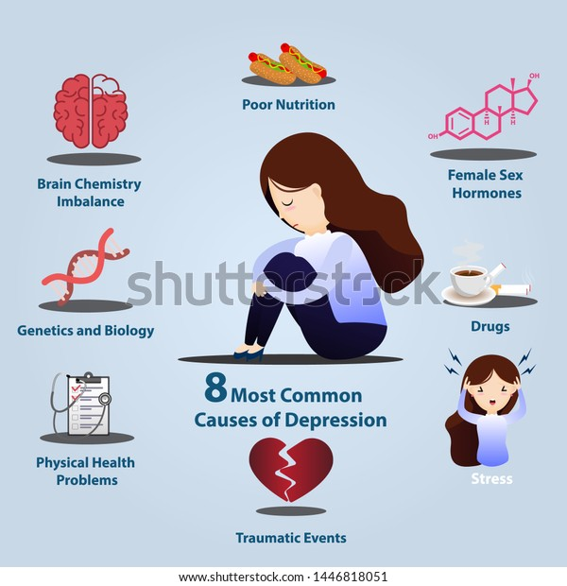
(shutterstock, 2021)
Figure 2: 8 Most Common Causes of Depression
Image Source: https://www.shutterstock.com/image-vector/8-common-causes-depression-infographics-signs-1446818051

Signs and symptoms of depression

According to (NHS (2019) psychological symptoms are:
- Continuous low mood or sadness
- Feeling hopeless, tearful
- Having low self-esteem
- No motivation
- Decision making too difficult
- Feeling irritable, worried
- Having suicidal thoughts

According to Mind (2019) the physical symptoms are:
- Luck of energy
- Weight loss, Weight gain
- Insomnia
- Loss of libido
- Moving and speaking slower
- aches and pains for no reason

Diagnosis of depression

According to NHS (2019) GP may carry out some urine or blood tests to rule out other possible illnesses such as underactive thyroid. In addition, as stated by NHS (2019) GP examines by asking questions about general health and feelings to determine the effect on mental and physical health. According to BPS (2020) the aim of this examination for the GP or other medical professional will classify the level of depression as Mild, Moderate and Severe to choose the appropriate treatment.

Type of depressive episodes

According to WHO (2010) there are within the ICD-10 manual three types of depressive episodes, mind, moderate and severe.
Mind
- The patient can continue most of the daily activities, just find it too difficult.
- Two or three symptoms of depression are present together.
Moderate
- The patient has great difficulty doing ordinary activities.
- Four or more symptoms of depression are present together. (WHO,2010)

According to NHS (2019) the patient who experienced severe depression it makes nearly impossible to get through daily activity, it is a high risk of self-harm and suicide.
Severe depression might have these symptoms:
- High risk of self-harm and suicide.
- Sometimes it is with psychotic symptoms
- hallucinations
- Delusions
- confused and disturbed thoughts

Types of depression

According to NHS (2019) there are four types of depression:
- Clinical depression
The range of symptoms is from mild to severe.

- Psychotic depression
Severe episode of depression with experiencing hallucinations and delusions. The suicide risk is increased.

- Postnatal depression
It is affected more than 1 in 10 women and also it is affected, fathers. Within the first year, it can start at any time. In addition to the signs and symptoms listed above special symptoms may also occur such as difficulty to bond with the baby, and thoughts about hurting the baby.

- Depression in children and young people
According to RC PSYCH (2022) the case study of the 15 years old girl is demonstrated how important to get help as early as possible.

Case study

She had not noticed her problem too much. She cut herself because her feeling was better.
She was falling out with her teachers, they said she wasn’t getting on with work. She thought she was thick. She stopped doing sports, she could not sleep well. Her parents took her to see the doctor She had talking therapy. When she started to talk more, then she started to realise how much she had changed, she used to be happy. During the talking therapy, things started to change, when she looked back she could realise how depressed she was. (RC PSYCH, 2022).

Historical view of depression

- Appeared in the second millennium B.C.E. in Mesopotamia. In many cultures, depression was believed to be caused by demons and evil spirits.
- imbalanced body fluids called humours were the cause of depression by theory of Hippocrates
- Christianity, dominated European thinking during the Middle Ages. There were Devil, demons and witches again the cause of depression.
- Robert Burton published "Anatomy of Melancholy," in 1621, he drew attention causes of depression such as poverty, fear, and loneliness. (Schimelpfening, 2020).

Historical treatment of depression

- Surgeries-creating holes in one`s skull
- Social isolation
- Beatings, Physical restraint,
- Starvation
- Greek and Roman doctors-Gymnastics, Massage, Diet, Music, Baths
- Hippocrattes-bloodletting, baths, exercise, and diet.
- Shackles, beating
- Exorcisms, drowning, and burning
- "lunatic asylums."
verywellmind (2020)

Contemporary treatment of depression

- MILD- Exercise; self-help; online CBT;
- MILD to MODERATE- Counselling; Cognitive behavioural therapy (CBT); Psychodynamic psychotherapy; interpersonal therapy
- MODERATE to SEVERE- Medicines such as antidepressants, Selective serotonin reuptake inhibitors (SSRIs), Tricyclic antidepressants (TCAs), Vortioxetine; Combination therapy;
- Severe- Mental health teams; Lithium; Brain stimulation such as electroconvulsive therapy (ECT);
- Other: Mindfulness; St John`s wort;
Sid effect of medicines
- SSRIs-nausea, headaches, dry mouth; problems having sex
- TCAs-heart to beat rapidly to smoke cannabis with, sweating, blurred vision, constipation, dry mouth;
- Generally from antidepressants:
- anxiety
- dizziness
- vivid dreams at night

Principles when working with people with depression

- Follow the NICE Guidelines
- Person-Centred Approach- asking the service users opinions, involving them to do decisions, treat people ferly with dignity and respect,-HUMAN RIGHTS ACT 1998.
- Equality ACT 2010.- To use anti-discriminatory practice.
- Mental Health Act 1983. -Cannot take away their liberty, unless it is necessary for health and safety.
- Confidentiality and DATA PROTECTION ACT 2018.
- Mental CAPACITY ACT 2005. - All the decisions should be based according to the service users’ needs.

Recommendation

It is Ok not to be Ok
- For anyone suffering from depression or any mental disorder should be able to speak openly and don’t be afraid of the stigma.
- The massage improved the patients symptoms from mild to moderate depression such as depressive mood, and general somatic symptoms, also emotional retardation and sleep disorders. (Arnold, M. M., Müller-Oerlinghausen, B., Hemrich, N., & Bönsch, D.,2020).
- Meditation Based Lifestyle Modification (MBLM) which is based on a healthy lifestyle and on the ethical principles of classical yoga, from mild to moderate depression. Benefits included relief of depression-related symptoms, increase in eudaemonic well-being, and personal empowerment, including self-regulation, self-confidence, and spiritual growth. (Bringmann et al., 2020).

Conclusion

To conclude, anyone can suffer from depression. It does not depend on age or gender. Depression is a common illness worldwide. Covid had an impact on mental diseases and the numbers of depression were raised. Usually, more than one cause is together in the development of depression. There are a lot of psychological and physical symptoms of depression.
There are three types of depressive episodes, mild, moderate and severe. The presentation showed 15 yers old girl case study to give an example to need help how important. In the past depression was from the devil and demons and the treatments compeer with the current time were scary. NICE gives clear guidelines for the treatments and also should follow the above-mentioned legislations to have the best treatments for the patients. For this purpose some alternative therapy as a recommendation was made.

References

BPS -The British Phycological Society (2020) Understanding Depression Why adults experience depression and what can help (Online). Available at:
https://www.bps.org.uk/sites/www.bps.org.uk/files/Member%20Networks/Divisions/DCP/Understanding%20depression.pdf (Accessed: 16 March 2022)

Christoph, P. et al. (2021) ` Mental Health During COVID-19 Lockdown in the United Kingdom`, Psychosomatic Medicine, 83(4), pp.328-337.

NHS-National Healthcare Service (2021) Depression (Online). Available at:
https://www.nhs.uk/mental-health/conditions/depression/ (Accessed: 16 March 2022)

NHS-National Healthcare Service (2019) Diagnosis-clinical depression (Online). Available at:
https://www.nhs.uk/mental-health/conditions/clinical-depression/diagnosis/ (Accessed: 17 March 2022)

NHS Digital-National Healthcare Service Digital (2020) Mental health of Children and Young People in England, 2020: Wave 1 follow up to the 2017 survey (Online). Available at: https://digital.nhs.uk/data-and-information/publications/statistical/mental-health-of-children-and-young-people-in-england/2020-wave-1-follow-up#resources (Accessed: 17 March 2022)

NHS-National Healthcare Service (2021) Treatment-Clinical depression (Online). Available at: https://www.nhs.uk/mental-health/conditions/clinical-depression/treatment/ (Accessed: 17 March 2022)

Nearchou, F. et al. (2020) `Exploring the Impact of COVID-19 on Mental Health Outcomes in Children and Adolescents: A Systematic Review`, International Journal of Environmental Research and Public Health, 17(22), pp.1-19.

Mental Health Foundation (2022) Mental health statistics: depression (Online). Available at:
https://www.mentalhealth.org.uk/statistics/mental-health-statistics-depression (Accessed: 16 March 2022)

Mind (2019) Depression (Online). Available at:
https://www.mind.org.uk/information-support/types-of-mental-health-problems/depression/about-depression/ (Accessed: 16 March 2022)

Mind (2017) What are mental health problems? (Online). Available at:
https://www.mind.org.uk/information-support/types-of-mental-health-problems/mental-health-problems-introduction/about-mental-health-problems/ (Accessed: 16 March 2022)

Mind (2019) What are the symptoms of depression? (Online). Available at: https://www.mind.org.uk/information-support/types-of-mental-health-problems/depression/symptoms/ (Accessed: 16 March 2022)

Mind (2019) What causes depression? (Online). Available at:
https://www.mind.org.uk/information-support/types-of-mental-health-problems/depression/causes/#ChildhoodExperiences (Accessed: 16 March 2019)

Office of National Statistics (2021) Coronavirus and depression in adults, Great Britain: July to August 2021(Online). Available at: https://www.ons.gov.uk/peoplepopulationandcommunity/wellbeing/articles/coronavirusanddepressioninadultsgreatbritain/julytoaugust2021 (Accessed: 16 March 2022)

Office of National Statistics (2021) Percentage of adults with moderate to severe depressive symptoms by age and sex, Great Britain, 21 July to 15 August 2021 (Online image) Available at: https://www.ons.gov.uk/peoplepopulationandcommunity/wellbeing/articles/coronavirusanddepressioninadultsgreatbritain/julytoaugust2021 (Accessed: 16 March 2022)

RC PSYCH-Royal College of PSYCHIATRISTS (2022) Depression in children and young people: for young people (Online). Available at:
https://www.rcpsych.ac.uk/mental-health/parents-and-young-people/young-people/depression-in-children-and-young-people-for-young-people (Accessed: 16 March 2022)

shutterstock (2021) 8 Most Common Causes of Depression (Online image) Available at: https://www.shutterstock.com/image-vector/8-common-causes-depression-infographics-signs-1446818051 (Accessed: 16 March 2022)

verywellmind (2020) History of depression (Online). Available at:
https://www.verywellmind.com/who-discovered-depression-1066770 (accessed: 14 March 2022)

WHO - World Health Organisation (2010) ICD-10 - International Statistical Classification of Diseases and Related Health Problems 10th Revision (Online). Available at:
https://icd.who.int/browse10/2010/en#/V (accessed: 14 March 2022)

WHO - World Health Organisation (2019) International Statistical Classification of Diseases and Related Health Problems (ICD) (Online). Available at: https://www.who.int/standards/classifications/classification-of-diseases (accessed: 14 March 2022)

WHO - World Health Organisation (2021) One in 100 deaths is by suicide (Online). Available at: https://www.who.int/news/item/17-06-2021-one-in-100-deaths-is-by-suicide (Accessed: 16 March 2022)

WHO - World Health Organisation (2021) What is depression. (Online). Available at:
https://www.who.int/news-room/fact-sheets/detail/depression (Accessed: 16 March 2022)

Pelda; Price, S. et al. (2014) ‘Planning for change’, Leadership and Business Planning, 15(3), pp. 154-166.

[Online image]

Equality Act 2010. Available at:
https://www.legislation.gov.uk/ukpga/2010/15/contents
(Accessed: 23 August 2021).

