Questions and Guidelines for Assessment Component 1


Changemakers: Creativity and Value Creation
Professions (BMHP5014)

Student name: Dayna Denny
Student number: 2408900
Lecturer’s name: Laila Surani

Innovation
Innovation refers to the implementation of new or significantly improved services, processes, or ways of working that enhance outcomes (Rogers, 2003). Unlike creativity, which focuses on idea generation, innovation involves putting ideas into practice. In health and social care, innovation is essential to improve patient safety, efficiency, and quality of care, particularly within resource-constrained systems such as the National Health Service. Rogers’ Diffusion of Innovation Theory explains how new practices are adopted over time through stages including knowledge, persuasion, decision, implementation, and confirmation (Rogers, 2003). For example, the introduction of electronic health records in UK hospitals improved information sharing and reduced medication errors, demonstrating innovation through technological implementation.
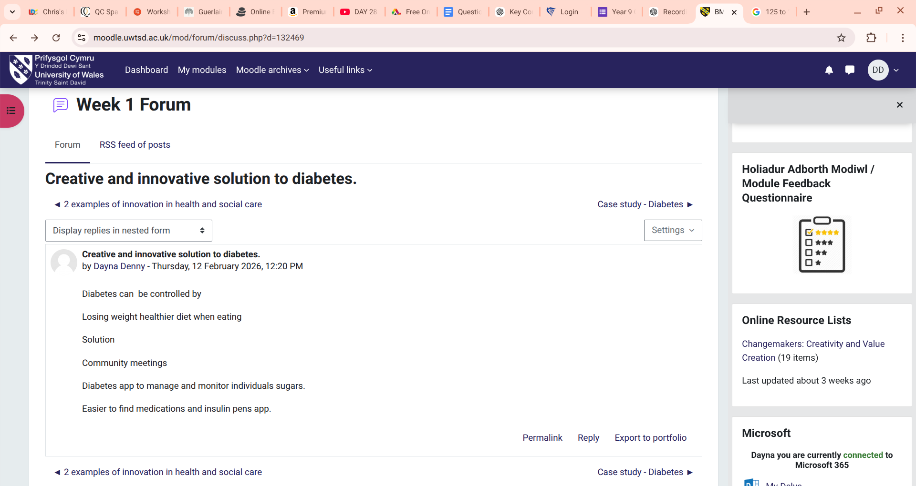

Creativity
Creativity is the ability to generate original and useful ideas (Amabile, 1996). In health and social care, creativity supports problem-solving, person-centred practice, and service improvement. Amabile’s Componential Theory of Creativity argues that creativity arises from domain-relevant skills, creative thinking processes, and intrinsic motivation (Amabile, 1996). This is particularly important in complex care environments where professionals must adapt to individual needs. For instance, a social worker designing a personalised support plan for a service user with complex needs demonstrates creativity by tailoring interventions beyond standard procedures.

Value Creation
Value creation in healthcare refers to improving patient outcomes relative to the cost of delivering care (Porter, 2010). It shifts focus from service volume to service impact. This concept is critical in health and social care due to financial pressures and increasing demand. Porter’s value-based healthcare framework emphasises measuring health outcomes that matter to patients while controlling costs (Porter, 2010). An example is a multidisciplinary team working in community care, which reduces hospital admissions while improving patient satisfaction and continuity of care.

Change
Change involves the process of moving from current practice to improved methods of working (Burnes, 2017). In health and social care, change is necessary to respond to policy reforms, technological advancements, and evolving patient needs. Lewin’s Change Management Model describes change as a three-stage process: unfreezing existing behaviours, implementing change, and refreezing new practices (Burnes, 2017). For example, implementing new infection control protocols during public health crises requires structured change management to ensure staff compliance and sustainable practice improvement.

Task 2 - Mind Map: Long Waiting Times in Health Care
Central Problem: Long waiting times in the National Health Service
Causes →
- Staff shortages → increased workload → burnout
- Rising ageing population → higher service demand
- Inefficient discharge planning → bed blocking
- Funding constraints → limited service capacity
Impacts →
- Delayed diagnosis and treatment → poorer health outcomes
- Increased anxiety and dissatisfaction among patients
- Staff stress → reduced care quality
- Health inequalities widen (vulnerable groups wait longer)
Solutions →
- Workforce planning and retention strategies
- Integrated care systems and improved discharge pathways
- Digital triage systems
- Preventative community-based interventions


Short Explanation
Long waiting times in the NHS are a significant health and social care challenge because delays in treatment can worsen health outcomes and increase inequalities. Using a systems thinking approach, problems such as staff shortages, funding pressures, and rising demand are interconnected rather than isolated (Meadows, 2008). For example, insufficient staffing contributes to burnout, which reduces productivity and further extends waiting lists. Delayed discharge planning also creates bottlenecks, limiting bed availability. If unaddressed, prolonged waits may lead to deteriorating conditions, increased emergency admissions, and declining public trust. Older adults and individuals with complex conditions are particularly affected. A whole-systems response—improving workforce retention, strengthening community care, and enhancing digital triage—can address root causes rather than symptoms, supporting sustainable service improvement and better patient outcomes.

Task 3 - Self-Reflection of Group Activity
Reflective Model: Gibbs’ Reflective Cycle
Gibbs’ Reflective Cycle provides a structured framework to analyse experiences and improve future practice (Graham Gibbs, 1988). During the class activity, we used divergent and convergent thinking to explore solutions to a problem. Divergent thinking involves generating multiple ideas and perspectives, whereas convergent thinking focuses on evaluating those ideas to select the most effective solution (J. P. Guilford, 1967).
Description and Feelings:
During the group task, we were asked to brainstorm solutions to a healthcare challenge. Initially, we used divergent thinking to generate as many ideas as possible. I contributed by suggesting digital tools and community outreach strategies. I felt confident sharing ideas but noticed that some group members were quieter.
Evaluation and Analysis:
When the group struggled to decide which idea was strongest, I suggested using a pros and cons list to compare our options. This applied convergent thinking by narrowing down the ideas logically. The activity helped me recognise that I naturally enjoy the creative stage of brainstorming but also value structured decision-making when working in teams.
Conclusion and Action Plan:
Overall, the activity improved my understanding of collaborative problem-solving. I learned that balancing creativity with analytical thinking helps groups reach effective decisions. Next time, I would actively encourage quieter members to share ideas earlier in the divergent stage to ensure a wider range of perspectives and stronger teamwork.

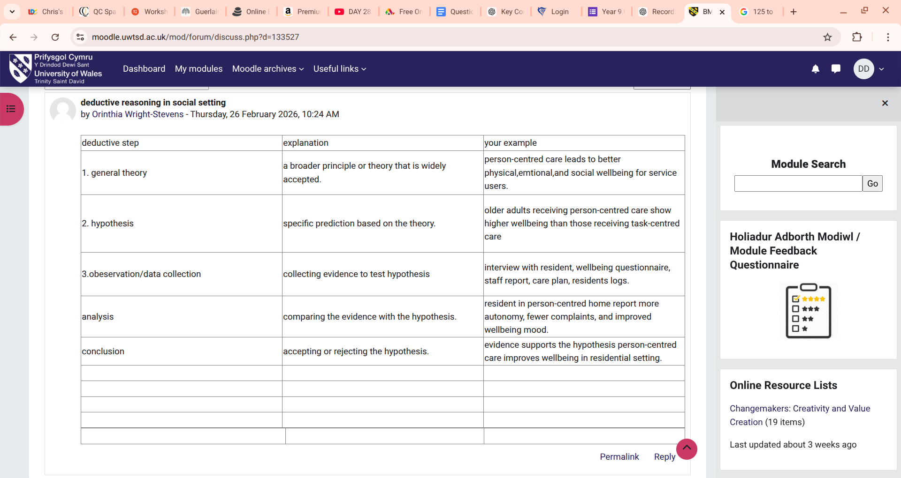

Task 4 – Case Study Analysis of a UK Innovation
Question -
A recent innovation within the National Health Service is the introduction of virtual wards, where patients receive hospital-level care at home using digital monitoring and remote support.
Problem or Need
The NHS has faced increasing pressure from rising demand, ageing populations and limited hospital bed capacity. Long hospital stays can also increase the risk of infections and reduce patient independence. Virtual wards were introduced to address these challenges by allowing appropriate patients to be safely monitored at home.
Creativity in the Solution
Creativity played a role in combining digital technology, remote monitoring devices and multidisciplinary teamwork to redesign how care is delivered. Instead of traditional inpatient treatment, clinicians use mobile apps and monitoring equipment to track patients’ vital signs remotely. This reflects Diffusion of Innovation Theory, which explains how new healthcare practices spread when they are perceived as useful and beneficial (Rogers, 2003).
Value Created
Virtual wards create value for patients, staff and the healthcare system. Patients benefit from receiving care in their own homes, which improves comfort and independence. Staff can monitor multiple patients efficiently using digital systems, while hospitals free up beds for those with more complex needs.
Outcomes Reported
Early evaluations suggest virtual wards can reduce hospital admissions, shorten inpatient stays and improve patient satisfaction. The programme has also helped reduce pressure on emergency departments while maintaining safe clinical oversight (NHS England, 2023; Leff et al., 2005).
Potential for Wider Use
Because the model relies on digital monitoring and integrated teams, it could be expanded to support people with chronic conditions or post-surgical recovery across different healthcare settings.
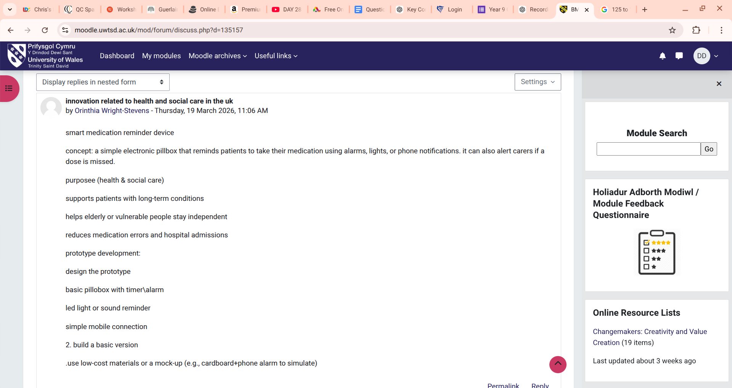

Task 5 - Research Task (200 words).
Question - Current Issue in Health and Social Care: Staff Stress and Burnout
Staff stress and burnout are major challenges within the National Health Service and wider UK social care sector. High workloads, emotional demands and staff shortages often create difficult working conditions that affect both staff wellbeing and quality of care.
One study by Christina Maslach and Michael P. Leiter (2016) examines burnout using Maslach Burnout Theory, which explains burnout through three dimensions: emotional exhaustion, depersonalisation and reduced personal accomplishment. Their research suggests that excessive workload, lack of control over work tasks and insufficient organisational support are key causes of burnout. In real healthcare settings, this can occur when nurses or social care staff manage large caseloads with limited time, leading to fatigue and emotional strain. This article helps explain the psychological impact of workplace pressures and why staff may struggle to maintain motivation and wellbeing.
Another study by Arnold B. Bakker and Evangelia Demerouti (2007) uses the Job Demands–Resources Model, which argues that stress develops when job demands exceed the resources available to employees. Their research identifies factors such as high emotional labour, time pressure and inadequate staffing as major contributors to burnout. However, they also emphasise that supportive leadership, teamwork and professional autonomy can reduce stress and improve resilience. This article helps highlight how organisational structures influence staff wellbeing.
Both articles agree that heavy workloads and insufficient support are major causes of burnout in health and social care environments. However, while Maslach and Leiter focus more on the psychological experience of burnout, Bakker and Demerouti emphasise organisational factors and the balance between demands and resources. Together, these studies provide a broader understanding of why staff stress occurs and how it may affect care quality in real practice settings.

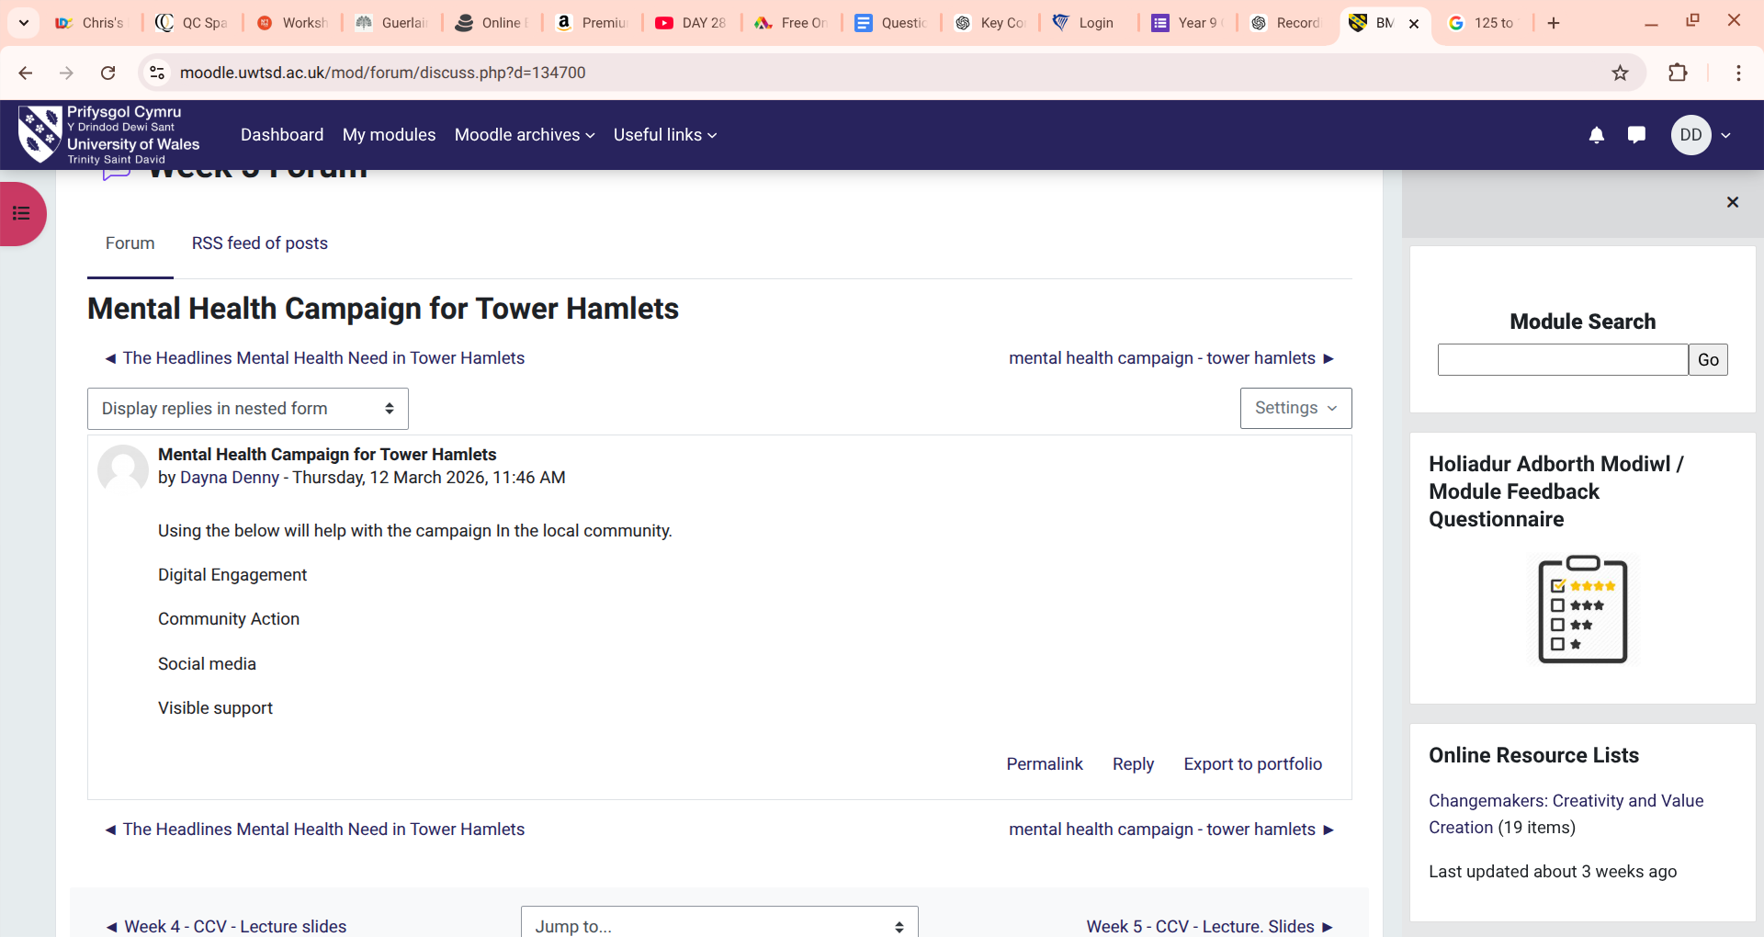

Task 6 - Wearable health technologies such as smartwatches and fitness trackers are increasingly used to support the management of chronic health conditions. These devices can continuously monitor health indicators such as heart rate, physical activity and sleep patterns, providing real-time data to both patients and healthcare professionals. Within the National Health Service, wearable technologies are being explored to help individuals manage conditions such as diabetes and cardiovascular disease. One key benefit is improved self-management, as patients receive instant feedback about their health and can adjust behaviours such as exercise or medication adherence. For example, wearable heart monitors can alert users and clinicians to irregular heart rhythms, enabling earlier intervention. The Technology Acceptance Model suggests that individuals are more likely to adopt health technologies when they perceive them as useful and easy to use. Research indicates that wearable devices can improve patient engagement and support long-term condition monitoring (Patel, Asch and Volpp, 2015).

2. Electronic Health Records and Communication (140 words)
Electronic Health Records (EHRs) are digital systems used to store and share patient information across healthcare services. In health and social care settings, EHRs improve communication between professionals by ensuring that patient records are accessible, accurate and updated in real time. Within the National Health Service, EHR systems allow general practitioners, hospital clinicians and community care teams to access shared patient data. This reduces the risk of errors and supports coordinated care planning. For example, if a patient with a chronic illness is admitted to hospital, clinicians can immediately view their medical history, medication records and previous treatments. This improves decision-making and patient safety. The Technology Acceptance Model highlights that healthcare professionals are more likely to adopt digital systems when they improve efficiency and clinical outcomes. Studies have shown that EHRs enhance interdisciplinary collaboration and reduce duplication of tests (Menachemi and Collum, 2011).

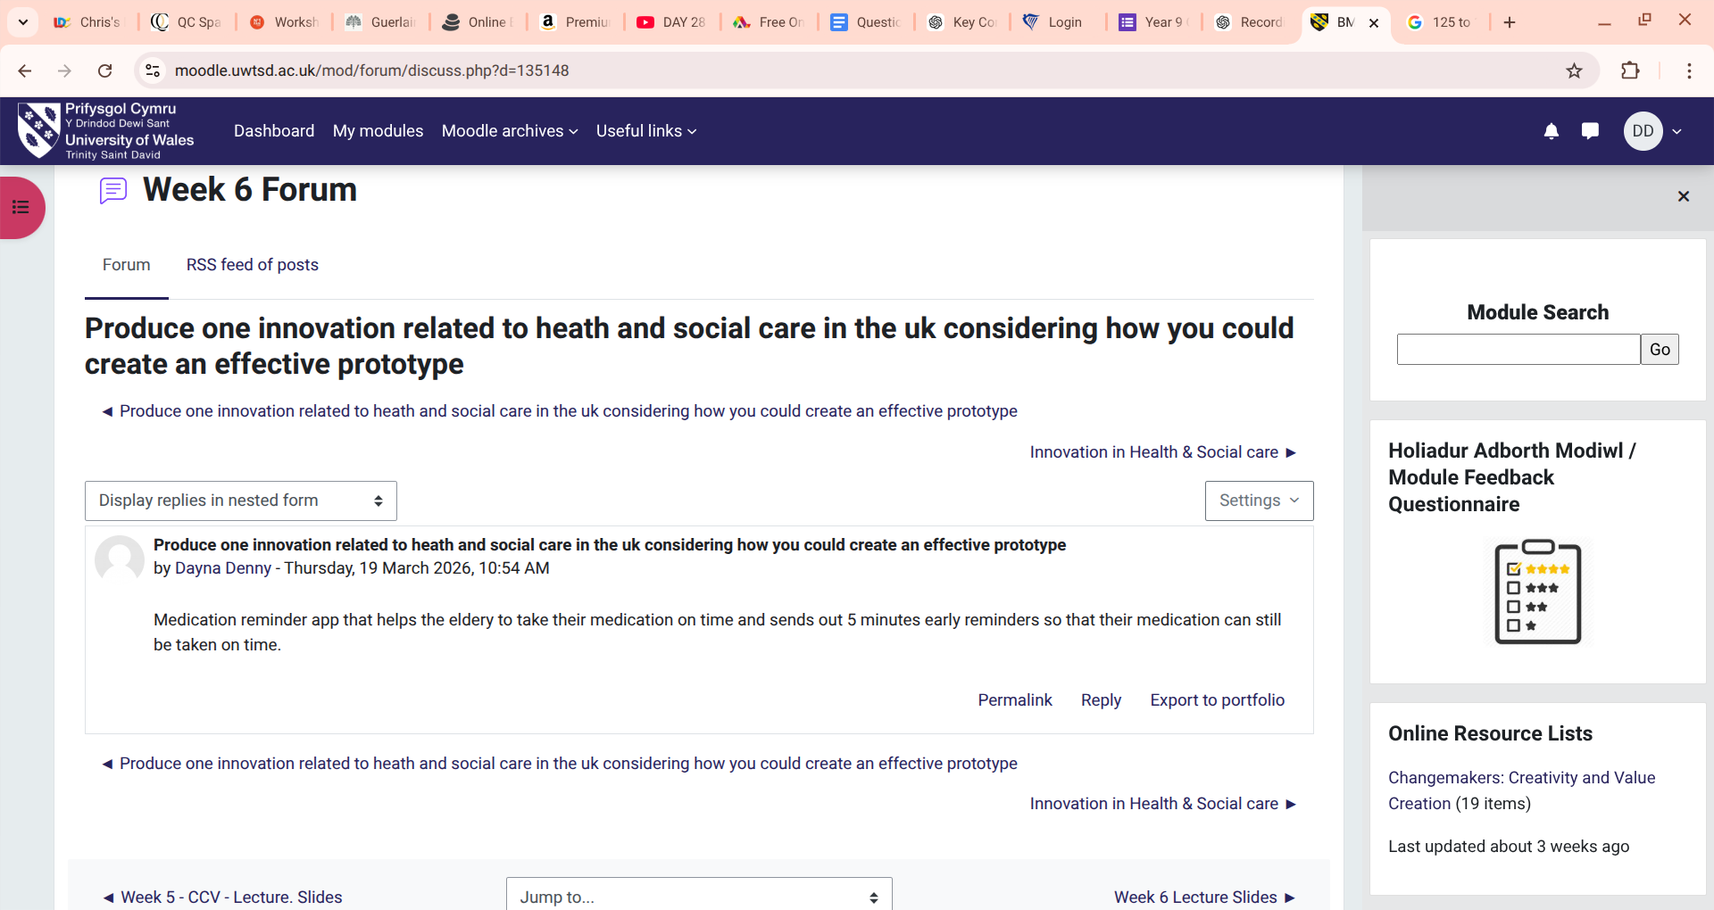

3. Digital Technology for Preventative Care and Health Promotion (140 words)
Digital technology can play an important role in supporting preventative care and health promotion by encouraging individuals to adopt healthier behaviours. Mobile health applications, online education platforms and digital screening tools enable healthcare providers to reach wider populations and promote early intervention. For example, the National Health Service offers digital services such as the NHS App, which allows users to book appointments, access health information and receive reminders for vaccinations or screenings. These tools can help prevent illness by encouraging early health checks and improving awareness of lifestyle risks. According to the Technology Acceptance Model, people are more likely to engage with digital health tools if they find them convenient and beneficial. Research suggests that digital health interventions can improve preventative behaviours such as increased physical activity and improved diet (Murray et al., 2016).

Task 7 - Understanding the NHS Leadership Framework (350)
Question

1. Summary of the NHS Leadership Framework (≈150 words)
The National Health Service Leadership Framework (also known as the Healthcare Leadership Model) outlines the key behaviours and qualities required for effective leadership in health and social care. It was developed by NHS Leadership Academy to guide staff at all levels in delivering safe, high-quality care. The framework identifies several core leadership behaviours including inspiring shared purpose, leading with care, evaluating information, engaging the team, and influencing for results. These behaviours help leaders create supportive environments where staff can collaborate, learn and improve services.
The framework is important because leadership has a direct impact on organisational culture, staff wellbeing and patient outcomes. Effective leadership encourages innovation and continuous improvement within healthcare systems that are often complex and resource-limited. Research suggests that strong leadership supports better teamwork, communication and service quality in healthcare settings (West et al., 2015). Therefore, the framework provides a structured approach for developing leaders who can improve care delivery and respond to changing healthcare demands.

2. Leadership Behaviour: Inspiring Shared Purpose (≈100 words)
One key leadership behaviour within the NHS Leadership Framework is inspiring shared purpose, which involves motivating staff by clearly communicating values and goals that prioritise patient care. Leaders who inspire a shared purpose encourage teams to think creatively about how services can be improved. For example, a ward manager might involve nurses and allied health professionals in designing new patient-centred care pathways. This collaborative approach helps staff feel valued and more willing to share innovative ideas.
This behaviour aligns with Transformational Leadership, which suggests that leaders inspire and motivate teams through vision, encouragement and support. By promoting a shared goal of improving patient outcomes, leaders can foster creativity and continuous service improvement.

Task 8 – Self-Reflection Journal Entry
During this module, my understanding of creativity and value creation in health and social care has developed significantly. At the beginning, I mainly associated creativity with artistic thinking rather than professional practice. However, through studying innovation frameworks and real examples from the NHS, I learned that creativity in healthcare often involves problem-solving, improving systems and developing new approaches to care.
Several activities influenced my learning, particularly the class discussions on divergent and convergent thinking and the task analysing digital innovation in healthcare. These activities helped me recognise that creative thinking can lead to practical improvements such as digital health tools, remote monitoring and more efficient communication systems. I also gained a deeper understanding of how value creation focuses on improving patient outcomes while using resources effectively.
This learning has changed how I view leadership and professional practice. I now understand that encouraging creativity within teams can support service improvements and better patient experiences. In my future career in health or social care, I would aim to contribute ideas that improve care delivery and collaborate with colleagues to solve complex challenges. Developing leadership skills and being open to innovation will be important for adapting to changes within healthcare systems and supporting high-quality patient care.

Reference List
Amabile, T.M. (1996) Creativity in context: Update to the social psychology of creativity. Boulder, CO: Westview Press.
Burnes, B. (2017) ‘Kurt Lewin and the Harwood studies: The foundations of OD’, The Journal of Applied Behavioral Science, 53(3), pp. 255–278.
Porter, M.E. (2010) ‘What is value in health care?’, New England Journal of Medicine, 363(26), pp. 2477–2481.
Rogers, E.M. (2003) Diffusion of innovations. 5th edn. New York: Free Press.
Meadows, D.H. (2008) Thinking in systems: A primer. White River Junction, VT: Chelsea Green Publishing.
Gibbs, G. (1988) Learning by doing: A guide to teaching and learning methods. Oxford: Oxford Polytechnic.
Guilford, J.P. (1967) The nature of human intelligence. New York: McGraw-Hill.
Leff, B., Burton, L., Mader, S., Naughton, B., Burl, J., Inouye, S., Greenough, W., Guido, S., Langston, C., Frick, K. and Steinwachs, D. (2005) ‘Hospital at home: Feasibility and outcomes of a programme to provide hospital-level care at home for acutely ill older patients’, Annals of Internal Medicine, 143(11), pp. 798–808.
NHS England (2023) Virtual wards including hospital at home. London: NHS England.
Rogers, E.M. (2003) Diffusion of innovations. 5th edn. New York: Free Press.
Bakker, A.B. and Demerouti, E. (2007) ‘The job demands–resources model: State of the art’, Journal of Managerial Psychology, 22(3), pp. 309–328.
Maslach, C. and Leiter, M.P. (2016) Burnout. Hoboken, NJ: Wiley.
Davis, F.D. (1989) ‘Perceived usefulness, perceived ease of use, and user acceptance of information technology’, MIS Quarterly, 13(3), pp. 319–340.
Menachemi, N. and Collum, T.H. (2011) ‘Benefits and drawbacks of electronic health record systems’, Risk Management and Healthcare Policy, 4, pp. 47–55.
Murray, E., Hekler, E.B., Andersson, G., Collins, L.M., Doherty, A., Hollis, C., Rivera, D.E., West, R. and Wyatt, J.C. (2016) ‘Evaluating digital health interventions: Key questions and approaches’, American Journal of Preventive Medicine, 51(5), pp. 843–851.
Patel, M.S., Asch, D.A. and Volpp, K.G. (2015) ‘Wearable devices as facilitators, not drivers, of health behaviour change’, Journal of the American Medical Association, 313(5), pp. 459–460.
Bass, B.M. and Avolio, B.J. (1994) Improving organizational effectiveness through transformational leadership. Thousand Oaks, CA: Sage.
West, M., Eckert, R., Steward, K. and Pasmore, B. (2015) Developing collective leadership for health care. London: The King’s Fund.
NHS Leadership Academy (2013) The healthcare leadership model. London: NHS Leadership Academy.

Gibbs, G. (1988) Learning by doing: A guide to teaching and learning methods. Oxford: Oxford Polytechnic.
Porter, M.E. (2010) ‘What is value in health care?’, New England Journal of Medicine, 363(26), pp. 2477–2481.

