Logbook Coursework
ACHA4011 Workshop & Practise
By: Will Gabriel (2404403)
Submitted: 15/04/2025

Table of Contents
Chapter 1 – Health and Safety overview 2
Chapter 2 – Machine Workshop Sessions 3
Chapter 3 – Engine Strip Sessions 4
Chapter 4 – Suspension Sessions 6
Chapter 5 – Advanced Manufacturing Sessions 7
Chapter 6 – Composition Session 8
Chapter 7 – Continued Professional Development 9
References 10

Chapter 1 – Health and Safety overview

During my time working on machines in the workshop—namely the lathe and milling machine—there were significant dangers to be aware of. Simple oversights could easily result in serious injuries, including the loss of extremities or even limbs. Because of this, our lecturers ensured that their health and safety briefings were engaging, clear, and impactful. They managed to keep the content interesting without compromising on the seriousness of the information. This approach was invaluable, as a dry or monotonous delivery can lead to disengagement and increase the risk of accidents.
The Health and Safety at Work etc. Act 1974 (HSWA) mandates the delivery of such briefings, which applies in the education setting these workshop sessions took place in. (HSWA, 1974) In an educational setting like ours, Section 3(1) of the Act is particularly relevant. It requires the employer (the university) to take reasonable steps to prevent students from being exposed to risks to their health and safety. This places a duty of care on the lecturers to act responsibly and minimise the likelihood of injury through their conduct and instruction.
Additionally, Regulation 9 of the Provision and Use of Work Equipment Regulations 1998 (PUWER) requires that anyone operating machinery must be adequately trained. (PUWER Act, 1998). This requirement was certainly met during the workshop sessions. We were given detailed explanations, followed by hands-on demonstrations, before being allowed to use any equipment independently. We were required to demonstrate our understanding as the final step towards independent operation, where every action was observed, questioned, and corrected if needed. This ensured that our exposure to risk was kept to an absolute minimum—not through guesswork, but through a deliberate blend of instruction and supervised practice.

Chapter 2 – Machine Workshop Sessions

During the workshop sessions, I manufactured two simple components using both the lathe and the milling machine. These were made to precise measurements and tolerances, as specified on the engineering drawing. This meant there was a necessity to learn both how to use the machines and also how to measure the finished products correctly.
We were given detailed instruction and supervision to ensure correct machine operation, also how to accurately measure the finished parts using micrometres. The lab technicians double checked my readings at first to make sure I was measuring and recording data correctly. Once confident in my abilities, they allowed me to proceed independently.
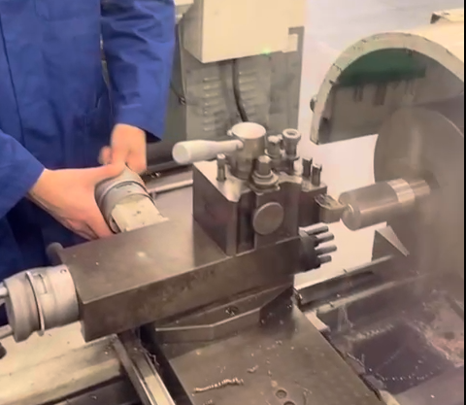
To meet the dimensional requirements, I had to develop fine control over the machine’s adjustment wheels. Slow, gradual, movements.
Photographed (Right; captured by Adrian Dix) is the initial stage of cutting/carving the largest cross-section element down to size; the lathe is operated by me; starting with the largest cross-section, which features the shallowest angle giving more margin to hone the feel and operation of the machine in, before tackling the narrower (more precise) aspects.
(Dix, 2024)

I was guided to shave down each element and leave a small bit of breathing room in the remaining material. Such as 0.5mm. This was done to achieve a smoother finish on the surface. Shaving down in bulk is quick but leaves a rougher surface, so taking 0.5mm off each cycle was time-efficient however the last cycle needs to be careful. This lighter contact reduced surface roughness and improved finish quality, a shallower touch, producing that smoother finish. The last stage was done in two 0.2mm cycles, with a 0.1mm on the final layer shave. The lead technician shared a common rule of thumb:
“Rough large, finish small.”

(Dix, 2024)

Chapter 3 – Engine Strip Sessions

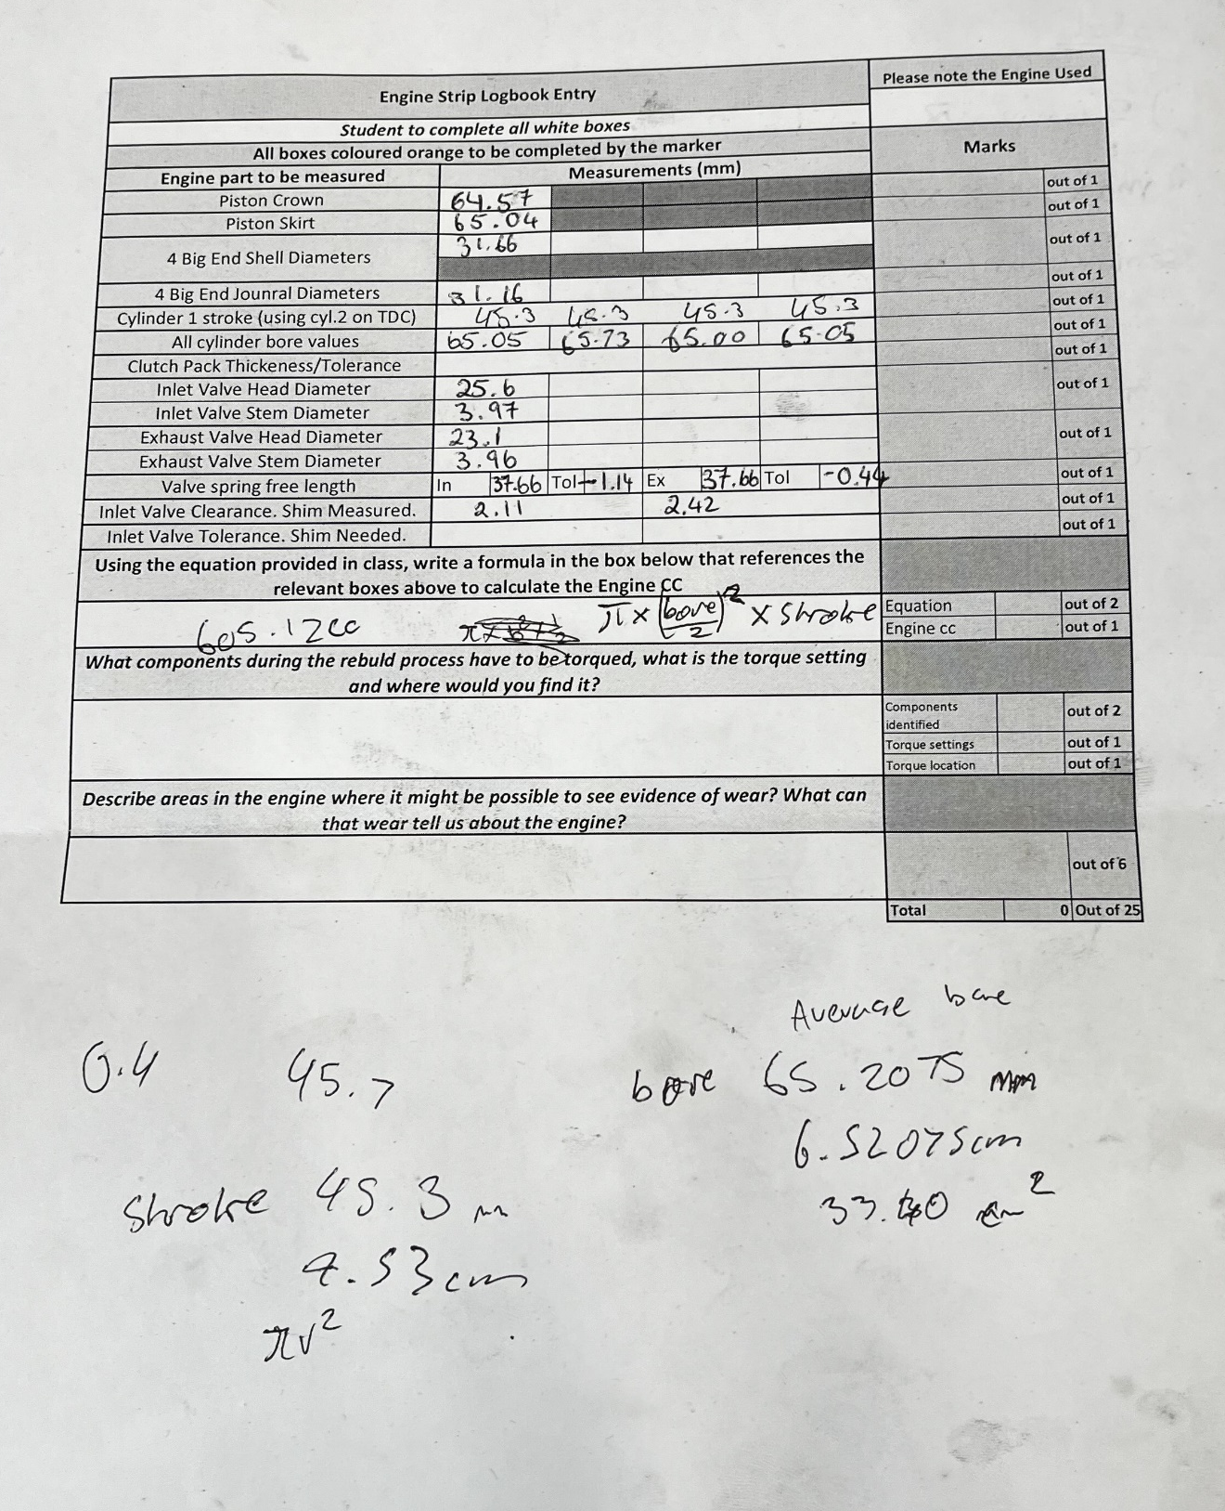
We extracted and reinstalled pistons in pairs, recording multiple data sets during the process (see photo above).
CC = n x (π/4) x D^2 x L
Engine CC / Total displacement = Number of cylinders x (π/4) x Bore^2 x Stroke

Using the data gathered from our sessions, I can calculate the engine CC by utilising the formula above. Although a formula is provided in the logbook, I used a different one to broaden my understanding.
By adding the four bore values, then dividing by four, I can find the average bore value of: 65.2075mm (6.52075cm)
The stroke was a consistent: 45.3mm (4.53cm)
There are 4 cylinders.
Plugging these values into the above formula provides the total engine displacement:
4 x (π/4) x 6.52075^2 x 4.53 = 605.122cc
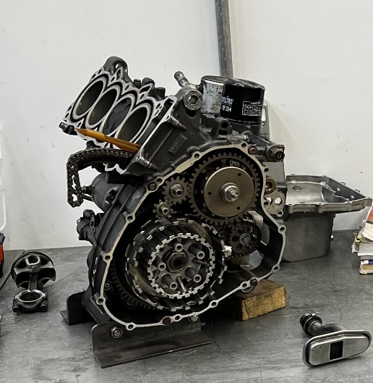
This aligns with having used an engine stated as being from a “Honda CBR600F 4 1999-2006”, validating the result.

(Gabriel, 2025)

Chapter 4 – Suspension Sessions

During these sessions, we recorded measurements to enable the carrying out of calculations related to motorcycle suspension performance, focusing on both front and rear systems.
Rear Suspension
Measurement | Value
Filled length | 151.4mm
Free length | 153.0mm
Spring rate | 97.5N/mm
Preload | 14.1mm
Shock Length | 330mm

These values enable calculations such as sag calculations:
Static Sag = 153mm – 151.4mm = 1.6mm
Rider Sag = 153mm – 97.5mm = 55.5mm
Rider Sag (%) = (55.5 / 330) x 100 = 16.8%
Typically, rider sag would settle around the 25-30% mark (Paul Thede, 2010). The recorded 16.8% infers that the setup is currently too stiff, indicating insufficient compression under rider weight/load.
Front Suspension
Measurement | Value
Compression Damping | 14 clicks
Rebound Damping | 8 clicks
Preload | 19mm
Fork Travel | 120mm
Rider Sag | 35mm
Weight | 64lb/in
Oil Weight | 5
Air Gap | 185mm

Rider Sag (%) = (35 / 120) x 100 = 29.2%
The front suspension seems to be well-balanced; the sag percentage is within what I understand to be the target/expected sag range of between 25-30%. Therefore, the front suspension doesn’t need much in the way of adjusting, it’s close to the limit (30%) but not yet over the limit – it’s within tolerance.

Chapter 5 – Advanced Manufacturing Sessions
From what I understand, the workshop includes some high-end gear like an autoclave, which is used for curing composite materials under heat and pressure — something that’s pretty essential in industries like aerospace, motorsport, and advanced prototyping. For example, in motorsport, carbon fibre body panels and aerodynamic components like wings and diffusers are often made using autoclaves to ensure they’re strong, lightweight, and properly bonded without air pockets or weak spots.
There’s also a laser cutter on-site, which is great for precise material cutting and design work, especially when speed and accuracy are important. For instance, laser cutters can be used to quickly create gaskets, brackets, or even custom dashboard panels for a bike or car (GenRight, 2025).
I’ve also heard there’s a tensile testing machine, which is used to pull materials apart to check their strength and behaviour under stress. Even though I didn’t get to see this in person, I can appreciate how useful that kind of data would be when choosing or validating materials for a project. For example, in the world of motorcycles or motorsport, you’d want to know the exact tensile strength of something like a suspension linkage or handlebar component — the last thing you want is a part failing under load mid-corner or during hard braking. We see companies like ProTaper providing these crucial components, having done the necessary research to achieve the optimal balance between weight and strength, giving us the most performance capability out of the smallest weight. (ProTaper Handlebars, n.d.)
Overall, I think the university’s setup for advanced manufacturing is well-rounded and gives a good intro to the kind of tools and techniques used in real industry settings. Even though I didn’t get to try everything myself, just knowing that equipment like the autoclave, laser cutter, and tensile testing machine are available shows the range of processes being supported here, and the equipment one might expect to see and use after university.

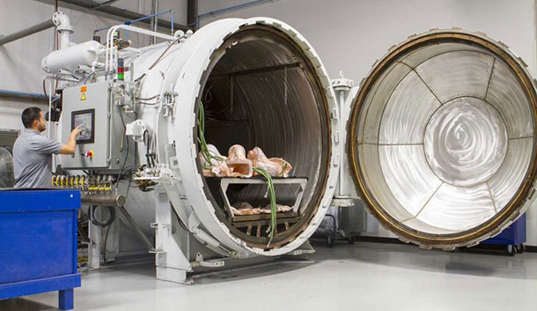
Photographed: Aerospace Composites Autoclave
(Autoclave, n.d.)

Chapter 6 – Composites Session
Composites are used everywhere in modern engineering where strength, weight-saving, and flexibility in design matter — motorsport, aerospace, marine, and even consumer electronics. While I’ve not had hands-on experience with making them myself, I’ve learned a lot from conversations with my brother, who works at Syensqo as a Lab Technician. He hand-cuts carbon fibre composite panels for testing, which has given me some insight into how precise and methodical the prep work has to be — before curing.
From what I understand, the layers of carbon fibre have to be laid out in very specific orientations depending on the stresses the part will face. It’s not just about stacking material; it's engineered, directional reinforcement. I don’t know the full intricacies of it all as I haven’t got experience working with composites directly, at least not yet.

Once cured (usually under heat and pressure in an autoclave), the result is a component that’s incredibly strong for its weight — ideal for things like motorcycle swingarms, body panels in F1 cars, or even structural brackets where metal would be too heavy. Or in the case of my brother, ideal for specific aerospace parts, where shaving off weight without sacrificing strength is a necessary improvement towards performance and efficiency.
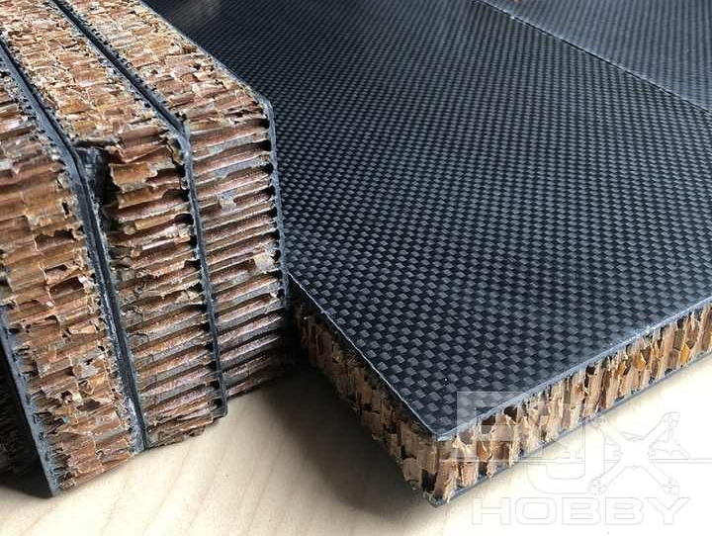
What’s stood out to me is how composites let you design beyond the limitations of traditional materials. You’re not just shaping a material; you’re shaping its internal structure and strength properties at the same time. In short, it’s pretty cool.
B
A
Image sources:
- (Atira, 2023)
- (Chengdu Nantai Tengfei Technology Co., Ltd., 2025)
One interesting development is the use of sandwich panels, which are a common composite structure made up of two strong outer skins and a lightweight core in the middle. The idea is to combine high stiffness and strength with minimal weight — sort of like an I-beam effect, but flattened out. These are often used in things like racing seat shells, undertrays, or even aircraft flooring, where rigidity matters but weight savings are crucial. The diagram I’ve included shows the basic layout of a sandwich panel, and the accompanying photo shows what the finished product can look like.
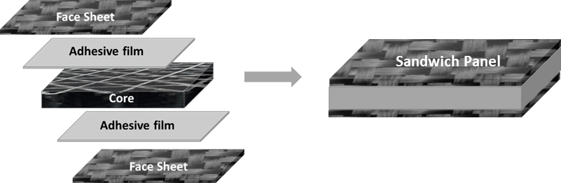

Chapter 7 – Continued Professional Development



References
Atira. (2023, March 2). https://atira.in/revolutionizing-sandwich-composites-panels-with-carbon-triangle-cores/. Retrieved from Ahmedabad Textile Industry's Research Association: https://atira.in/revolutionizing-sandwich-composites-panels-with-carbon-triangle-cores/
Autoclave. (n.d.). Retrieved from CompositesOne: https://www.compositesone.com/process/autoclave/
Chengdu Nantai Tengfei Technology Co., Ltd. (2025). Carbon Fiber Skin Sandwich Panels With Aramid/Nomex Honeycomb Core. Retrieved from Alibaba: https://www.alibaba.com/product-detail/RJX-custom-carbon-fiber-skin-sandwich_62498431490.html
Dix, A. (2024, December). Swansea, Wales.
Gabriel, W. (2025, January 23). Session photograph. Swansea, United Kingdom.
GenRight. (2025). Jeep YJ Laser Cut Aluminum Dash. Retrieved from GenRight Off-Road: https://genright.com/shop-by-vehicle/jeep-yj-87-95/jeep-yj-laser-cut-aluminum-dash/
HSWA. (1974, July 31). Health and Safety at Work etc. Act 1974. Retrieved from legislation.gov.uk: https://www.legislation.gov.uk/ukpga/1974/37/contents
Paul Thede, L. P. (2010). Race Tech's Motorcycle Suspension Bible. In Race Tech's Motorcycle Suspension Bible (Motorbooks Workshop): Dirt, Street, and Track (p. 124). Motorbooks.
ProTaper Handlebars. (n.d.). Retrieved from ProTaper: https://protaper.com/controls/handlebars/
PUWER Act. (1998). Provision and Use of Work Equipment Regulations 1998 (PUWER). Retrieved from Health and Safety Executive: https://www.hse.gov.uk/work-equipment-machinery/puwer.htm

