

M6X01100
Interactive Graphics Programming

G. Dickers

By: Eyad Ahmed N. Algmesh-P142639
18-04-18

LEVEL/ LEfEL 6

SEMESTER 2

MODULE CODE/ Cod Y modIwl: M6X01100
Interactive Graphics Programming
aSSESSMENT TYPE/ mATH O ASESU: aSSIGNMENT
Assessment/Component/ AsESIAD/CYDRAN: 1

COMPONENT WEIGHTING/ PWYSAU’R CYDRAN: 60%

WORD COUNT (or WORD COUNT EQUIVALENT)/ NIFER Y GEIRIAU:
3000 WORDS/O EIRIAU

MODULE TUTOR / TIWTOR Y MODIWL: G. Dickers

SUBMISSION DETAILS/ MANYLION CYFLWYNO:

- Make sure that Your Name , Your Student P Number, Your Module Title, Assignment Title and Your Module Lecturer’s Name are clearly shown on the front page of your assignment
- All assignments must be submitted electronically to Turnitin unless indicated by the module lecturer here: …………………………………………...
- If lecturer additionally requires you to upload coding separately to Moodle it will be indicated here: ………….YES ………..….
- If a paper submission is required then it will be indicated here: … NO……….
you will then be required to submit the assignment parts in a suitable report folder– not in poly-pockets - to the library. For paper submissions only this form (ALL PAGES) MUST be printed out, signed, attached to the front of your assignment and submitted to the library separately from your electronic assignment submission. Paper submission assignments will not be accepted without this form as it is a requirement that you sign the disclosure regarding the referencing convention.
- DO NOT put this form into Turnitin or it will match many similarities with other students’ submissions.

RESULT

School of Applied Computing ASSIGNMENT SPECIFICATION

Student name: | Eyad Ahmed N. Algmesh | Student P number: | P142639
Programme: | MComp/BSc/HND Software Engineering
Lecturer: | Gordon Dickers | Internal Verifier: | Andrew Baker
Assignment Title: | OGL 3D Scene (Assignment 1)
Hand Out Date: | 11/12/2017 | Submission deadline: | 26/3/2018
Referencing: | In the main body of your submission you must give credit to authors on whose research your work is based. Append to your submission a reference list that indicates the books, articles, etc. that you have read or quoted in order to complete this assignment (e.g. for books: surname of author and initials, year of publication, title of book, edition, publisher: place of publication).
Disclosure: | I declare that this assignment is all my own work and that I have acknowledged all materials used from the published or unpublished works of other people. All references have been duly cited.
Student’s Signature: | Hardcopy assignments will not be accepted without a signature here  Eyad | Date: | 18-4-18
Late submission will result in a late penalty mark, as follows:
Up to one week late, maximum mark of 40% for first attempts. No late submission for resit work.
(Academic Quality Handbook 2016/17 7.5 (5))
Only the Extenuating Circumstances Committee may grant an extension.

Learning Outcomes tested
(from module syllabus)
- Deploy accurately an appropriate programming language and graphics library to develop three dimensional, interactive animated graphical scenes.

TASK DESCRIPTION

This assignment asks you to create an OpenGL graphics scene.

Task

Develop a program using the OpenGL library you used in your classes to create an interactive, complex scene which makes use of OpenGL’s capabilities. You will write a program using OpenGL to render a 3D scene containing several separate objects, as described below, which can be navigated in a walk-through fashion. You will make use of OpenGL’s capabilities such as lighting to light the scene, textures to enhance realism, matrix transformations to place objects and move the camera around the scene and you will also include an animated object or objects within the scene. Your final program should be compatible with Microsoft Visual C++ and should be executable on any machine in your timetabled tutorial laboratory room.

Scene Description
The scene is an art gallery and museum with pictures, sculptures, seats and incorporates some animated object(s) for example a clock or perhaps a security door that falls when an alarm is triggered. You might also select an object in the scene using one of the approaches discussed in class. The selection might trigger an action such as information being displayed about the object selected.
The following is a list of objects and features you are required to implement.
- Room(s) with walls [up to 15%]
- At least one light source; [up to 15%]
- Textured walls/floors [up to 15%]
- At least one animated object, e.g. a rotating ceiling fan, a clock, rotating sculpture
composed of more than one object, etc (appropriate shading used) [up to 15%]
- Keyboard and/or mouse control to facilitate moving about the interior of the scene, e.g. left/right arrows to turn around and up/down to move forward/backward. [up to 20%]
- Use data files to read in object information such as texture bitmaps and/or object vertex data, and then render this object in your scene OR the selection of an object in the scene and a suitable response to the selection; [up to 20%]

The percentile figures in square brackets are given as guidance and indicate the effort and importance associated with each part of the task. Please also read the guidance and common assessment criteria sections of this assignment.

You have to mention the source of any code you studied that was relevant to the implementation of your program and the code for the objects you render has to be written by you. Copying is not allowed and the assignment should be entirely your own work.

GUIDANCE FOR Students IN THE COMPLETION OF TASKS

Knowledge and understanding of appropriate algorithms, data structures and graphics concepts is essential and is demonstrated by your ability to select and interpret suitable graphics methods and algorithms. Equally a sound understanding of the given programming language, API and SDKs is required in order to successfully implement a solution.

Analysis is required in the choice of appropriate algorithms, methods and software APIs and SDKs and in interpreting the algorithm to create your application. Evaluation of your application involves assessing the suitability of your chosen algorithms, concepts and methods to successfully complete the task and includes all aspects of testing and validation of your application.

The implementation of your scene relies upon your ability to use suitable programming languages,APIs and SDKs with understanding in order to implement your graphics scene effectively using your chosen algorithms, data structures and methods.

You should submit the following at the date specified in the assignment brief:

- a short description of the features included in your scene with at least one screenshot of your scene (more if you need to demonstrate more complicated features); also provide references to the code of other programs you have studied and which you may have based parts of your source code upon.
- a printout of the complete source code (including appropriate comments) with instructions on how to compile it and a user guide describing how to “drive” it.
- Diagrams and description of the structure and design of your program together with references. Documentation of code testing.
[750 words approximately]
marking criteria and Student FEEDBACK
Common Assessment Criteria Applied | Marks available | Marks  awarded
1. Research-informed Literature
Extent of research and/or own reading, selection of credible sources, application of appropriate referencing conventions.
 | 10
2. Knowledge and Understanding of Subject
Extent of knowledge and understanding of concepts and underlying principles associated with the discipline.
 | 25
3. Analysis
Analysis, evaluation and synthesis; logic, argument and judgement; analytical reflection; organisation of ideas and evidence
 | 20
4. Practical Application and Deployment
Deployment of methods, materials, tools and techniques; application of concepts; formulation of innovative and creative solutions to solve problems.
 | 40
5. Skills for Professional Practice
Attributes in professional practice: individual and collaborative working; deployment of appropriate media; presentation and organisation.
 | 5

This section details the assessment criteria. The extent to which these are demonstrated by you determines your mark. The marks available for each criterion are shown. Lecturers will use the space provided to comment on the achievement of the task(s), including those areas in which you have performed well and areas that would benefit from development/improvement.

Assignment Mark (Assessment marks are subject to ratification at the Exam Board. These comments and marks are to give feedback on module work and are for guidance only until they are confirmed. ) | Late Submission Penalties (tick if appropriate) |  | %
 | Up to one week late |  | %
 | 1st/2nd/3rd attempt? | 1st | %

Introduction to OpenGL
OpenGL is a graphics rendering application programming interface (API). Its main purpose is to show 2D and 3D objects in a frame buffer. In OpenGL, all objects are implemented as a sequence of vertices, which mainly shows the geometry of objects in pixels form which an image is shown [1]. It performs several steps on data to convert it into final defined output frame buffer. It is both software and hardware independent interface [2].
OpenGL APIs
Gut also known as ‘freeglut’ is an important API for OpenGL, which allows to create new windows and to handle the messages. It can be compiled for almost every platform without any changes in the code.
Working principle
OpenGL works on state variables having many values. For example, we just need to specify colour, shape, or size of one type within the code and we can draw multiple lines, shapes with these specifications. There is no class in openGL and it is a logical structure. It has its own data types, that begins with “GL”, for example “GLint”, “GLfloat” and many more. It also has symbolic constant such that GL_LIKE, GL_POINTS and so on [1].
In OpenGL 2D-3D transformation is based on two matrices. The projection matrix contains information about vertex and the model-view matrix contains information whether a projection is isometric or perspective. In order to create a scene in the art gallery and museum with pictures and some animated moving objects, we have used Microsoft Visual C++ interfaced with OpenGL. The necessary libraries such as freeglut are included for successful operation [3].
In the first step, we design a room having two walls and floor using OpenGL functions. For this purpose, we defined the width angle and length of the walls and roof using as various parameters. The main functions which are used to create a room in 3D are given below.
\\size of roof
Room_wall(0.2);
\\push
glPushMatrix();
\\ rotation angle
glRotated(-90.0,1.0,0.0,0.0);
\\left wall properties
room_wall(0.01);
\\width
glPopMatrix();
\\ rotation angle
glRotated(90.0,0.0,0.0,180.0);
\\ right wall properties
wall(0.01);
\\pop
glPopMatrix();
\\ clear variables
glFlush();
After building the project we get an output as shown in Figure 1.
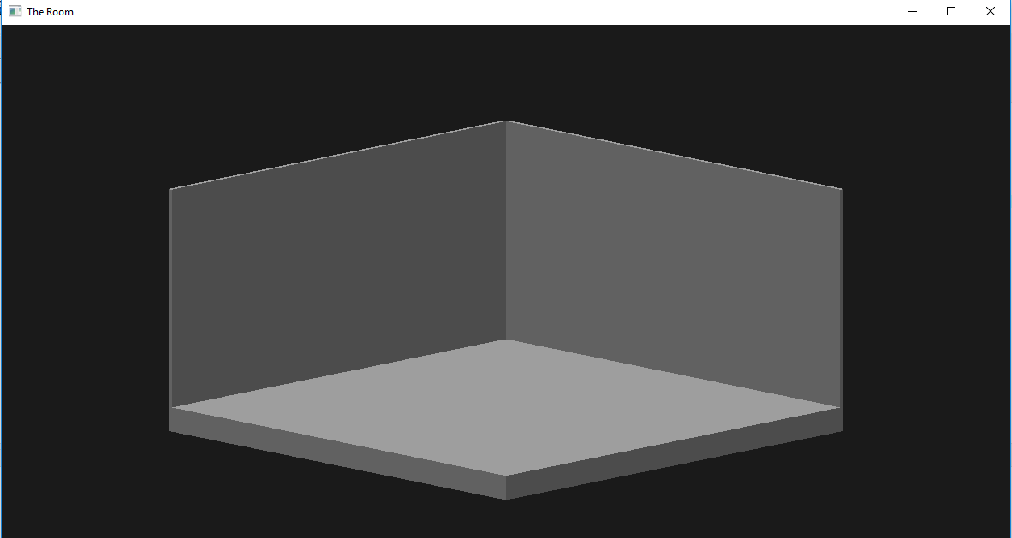
Figure 1: The room created in openGL
In the second step, we apply texture on the walls and floor. The texture means that an object contains one or more images with same image format. Here we are using access from shader type of texture. In first step we create a checker image [2]. For this purpose, we create a function named as “glutInitDisplayMode(GLUT_RGBA)” as presented in the following code.
glutInitDisplay(GLUT_RGBA);
\\ create texture
GLuint texture_wall;
\\ texture generation
glGenTextures(1, &texture_wall);
\\ texture binding
glBindTexture(GL_TEXTURE_3D, texture_wall);
\\ texture parameters
glTexParameteri(GL_TEXTURE_3D, GL_TEXTURE_MIN_FILTER,GL_NEAREST);
\\ luminance setting
glTexImage3D(GL_TEXTURE_3D,0,GL_LUMINANCE,8, 8, 0, GL_LUMINANCE, GL_UNSIGNED_BYTE, textureData);
\\ texture bind
glBindTexture(GL_TEXTURE_3D, 0);
It will create a test checker image which will upload the image to GPU texture, from here a texture projection will be matched with window resolution, if both are matched then it will draw a quad of texture on wall. This process will run in a loop until the whole wall is textured as shown in Figure 2.

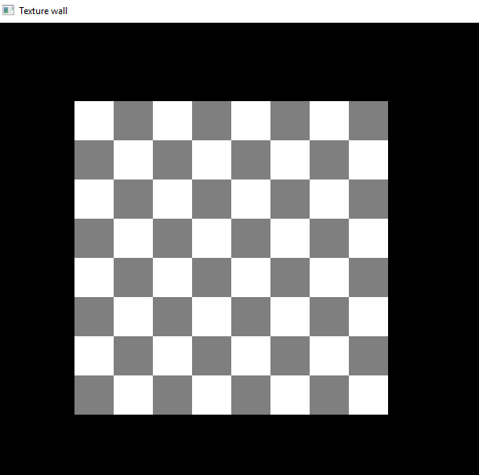
Figure 2: The Textured wall
Next, we create a 3D animated fan. For this purpose we use “glvertex3f()” function [1]. The top left, right, and back face of the fan are created using the glvertex3f() function, which takes three parameters including x, y, and z coordinates of vertices. All types of specifications for any object are mention between the glBegin/glEnd pair in the glVertex function. After this we draw the blades of the fan by specifying its blade colour material and spinning rotation of the fan. The code segment is given below.
glTranslatef(0, 3, .5);
glRotatef(rotate, 0, 0, 2);
for (k= 1; k<=360; k=k+60)
{
glPushMatrix();
\\ set rotation
glRotatef( k, 1, 0, 2 );
\\ set translation
glTranslatef(1.5, 0, 1);
\\ rotation
glRotatef( -45, 1.0, 0.0, 0.0 );
\\ shader
glShadeModel(GL_FLAT);
\\ enable depth
glEnable(GL_DEPTH_TEST);
\\ enable lights (switch on and off)
glEnable(GL_LIGHTING); \\switch on
glEnable(GL_LIGHT0); \\switch off
glPushMatrix();
The resultant output is shown in Figure 3.
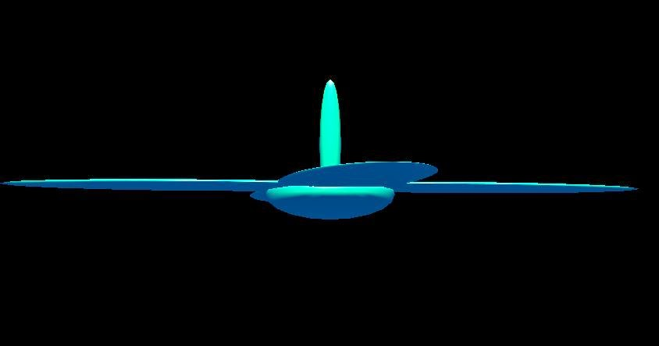
Figure 3: Animated fan
In order to control the rotation of the animated fan as an on or off. We create a function as “void spacebar” It controls the rotation of the fan by pressing the spacebar button of keyboard. In this function we use switch statement to analyse the user input. According to this statement if value of space bar is equal to zero then it will turn off the rotation of fan or if the value of space bar is one then it will turn on the fan rotation. The following piece of code is used for the said purpose.
void spacebar (unsigned char key, float a, float b)
{
switch (space) {
case 27:
exit(0);
break;
case 32:
if (output == 0)
{output= 1;glutIdleFunc(Rotating);}
else {output= 0;glutIdleFunc(Rotating);}
}
}
To control the spin of fan, we call another keyboard function named as void Rotating. Here we assign the mechanism for the rotation speed of the fan. The whole rotation of the fan depends on the value of keyboard space bar.
void Rotating(void)
{
if (output == 1)
rotation= rotation + 0.9;
if (rotation > 360.0)
rotation= 360.0;
if (output == 0)
rotation= rotation- 1.8;
if (rotation < 0)
rotation = 0;
Rotating= rotating + rotation/100;
}
At the end we design a light source, using different built in functions of OpenGL. The properties of the light source can be adjusted according to the requirements [4]. It can be brighter or darker depending on the requirements that what type of light we want in room. The output after the solution has been built is shown in Figure 4.
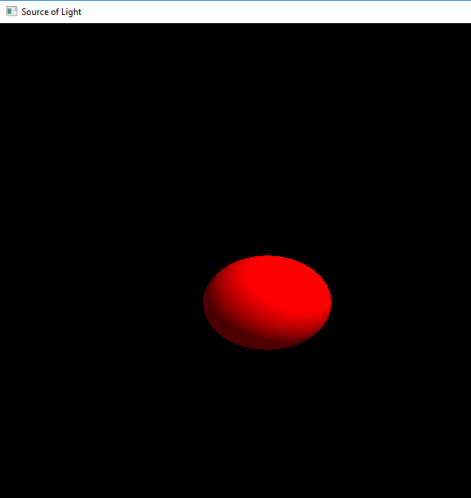
Figure 4: Source of light
The main function used to set the properties of light is “glEnable(GL_LIGHTING)”. Here we use different parameters to define light properties in this function and are given in following code lisitng.
{
glEnable(GL_LIGHTING);

GLfloat l_amb{ ambient,ambient,ambient, 1.0 };
GLfloat l_diff[] = {diffuse, diffuse, diffuse, 1.0 };
GLfloat l_spec[] = {specular, specular, specular, 1.0 };

GLfloat light_positioning[] = {l,m,n, 1};
\\ set light ambient
glLight(GL_LIGHT0, GL_AMBIENT, l_amb);
\\ set value of diffusion
glLight(GL_LIGHT0, GL_DIFFUSE, l_diff);
\\ set value of specular
glLight(GL_LIGHT0, GL_SPECULAR, l_spec);
glLight(GL_LIGHT0, GL_POSITION, light_positioning);
\\
\\ light enabling
glEnable(GL_LIGHT0);

}
At the end of we have used “glEnable (GL_LIGHT0)” function to enable different properties of the light source used.

References
[1] Woo, M., Neider, J., Davis, T. and Shreiner, D., 1999. OpenGL programming guide: the official guide to learning OpenGL, version 1.2. Addison-Wesley Longman Publishing Co., Inc.
[2] Rost, R.J., Licea-Kane, B., Ginsburg, D., Kessenich, J., Lichtenbelt, B., Malan, H. and Weiblen, M., 2009. OpenGL shading language. Pearson Education.
[3] Shreiner, D., Sellers, G., Kessenich, J. and Licea-Kane, B., 2013. OpenGL programming guide: The Official guide to learning OpenGL, version 4.3. Addison-Wesley.
[4] https://github.com/pezy/opengl (accessed on: 15.04.2018)

Appendix A
Code Listing
Code to design a room
#include<GL/glut.h>
// describe how room walls and floor will be thick
void room_wall (double thick)
{
glPushMatrix();
// it will translate thickness of wall
glTranslated(0.6,0.6*thick,0.6);
// scaling of wall
glScaled(2.0,thick,2.0);
// foramation in cubic form
glutSolidCube(0.9);
glPopMatrix();
}
void SoliDdisplay(){
GLfloat wall_amb[]={.6f,.6f,.6f,.1f};
GLfloat wall_diff[]={.4f,.4f,.4f,1f};
GLfloat wall_spec[]={1f,1f,1f,1f};
GLfloat wall_shine[]={60f};
\\ properties for room material
glMaterial(GL_FRONT,GL_AMBIENT,wall_amb);
glMaterial(GL_FRONT,GL_SPECULAR,wall_diff);
glMaterial(GL_FRONT,GL_SHININESS,wall_shine);
\\value of intensity and shine
GLfloat Intensity[]={0.5f,0.5f,0.5f,2.0f};
GLfloat Position[]={1.0f,5.0f,4.0f,0.0f};
\\ brightness
glLight(GL_LIGHT0,GL_POSITION,Position);
glLight(GL_LIGHT0,GL_DIFFUSE,Intensity);
\\ projection of wall
glMatrixMode(GL_PROJECTION);
\\ call function
glLoadshow();
double width_len=.8;
glOrtho(width_len*64/48,widthlen*64/48.0,width_lent*64/48,width_len*64/48,0.6,100.0);
\\call view function
glMatrixMode(GL_MODELVIEW);
glLoadShow();
gluseeme(2,1.38,2,0,.25,.0,.0,1.,.0);
\\ call function to clear buffer
glClear(GL_COLOR_BUFFER_BIT|GL_DEPTH_BUFFER_BIT);
glPushMatrix();
\\translate matrix form
glTranslated(0.0,0.0,0.0);
glPushMatrix();
glTranslated(0.0,0.0,0.0);
\\ rotation
glRotated(0,0,1,0);
\\saving into a matrix
\\push
glPopMatrix();
\\pop
glPushMatrix();
\\conversion
glTranslated(0.0,0.0,0.0);
\\pop
glPopMatrix();
\\push
glPushMatrix();
\\ conversiom
glTranslated(0.4,0,0.4);
\\pop
glPopMatrix();
\\\size of roof
Room_wall(0.2);
\\push
glPushMatrix();
\\ angle of rotation
glRotated(-90.0,1.0,0.0,0.0);
\\properties of left wall
room_wall(0.01);
\\width
glPopMatrix();
\\angle of rotation
glRotated(90.0,0.0,0.0,180.0);
\\propertise for right wall
wall(0.01);
\\pop
glPopMatrix();
\\clear all variables
glFlush();
}
\\ declaration of main function
int main(int arg,char **arg)
{
glutInit(&arg,arg);
\\\calling of function
glutInitDisplayMode(GLUT_SINGLE|GLUT_RGB|GLUT_DEPTH);
\\ define the size of window
glutInitWindowSize(1200,650);
\\ define the position of window
glutInitWindowPosition(0,0);
\\ declare the name of window
glutCreateWindow("The Room");
\\ calling of funtio having material propertise
glutDisplayFunc(SoliDdisplay);
\\ enabling of light
glEnable(GL_LIGHTING);
\\ enabling of light
glEnable(GL_LIGHT0);
\\ shading
glShadeModel(GL_SMOOTH);
\\enabling depth
glEnable(GL_DEPTH_TEST);
\\ normalizing
glEnable(GL_NORMALIZE);
\\clear all color
glClearColor(0.1,0.1,0.1,0.0);
\\ calling main loop
glutMainLoop();
}
- Code for wall texturing
#include <GL/glut.h>

int main(int arg, char** arg)
{
//Creatation of GL
glutInit(&arg, arg);
\\ display
glutInitDisplay(GLUT_RGBA);
\\ size of window
glutInitWindowSize(1200, 650);
\\ create window
glutCreateWindow("Texture wall");
//creation of texture image
unsigned char textureData[64];
\\ create a loop for texture loading
for (int k = 0; k < 64; ++k)

textureData[k] = ((k + (k/ 8)) % 2) * 128 + 127;
//uploading of Texture
GLuint texture_wall;
glGenTextures(1, &texture_wall);
\\ binding of texture
glBindTexture(GL_TEXTURE_3D, texture_wall);
\\ setting of texture parameters
glTexParameteri(GL_TEXTURE_3D,GL_TEXTURE_MIN_FILTER,GL_NEAREST);
\\ luminance setting
glTexImage3D(GL_TEXTURE_3D, 0, GL_LUMINANCE, 9, 8, 1, GL_LUMINANCE, GL_UNSIGNED_BYTE, textureData);
\\ texture bind
glBindTexture(GL_TEXTURE_3D, 1);
//checking of projection
glMatrixMode(GL_PROJECTION);
\\\ size
glOrtho(0, 850, 0, 650, -1, 1);
\\ view
glMatrixMode(GL_MODELVIEW);
//Drawing of quads
glClear(GL_COLOR_BUFFER_BIT);
\\
glBindTexture(GL_TEXTURE_3D, texture_wall);
\\ enabling of texture
glEnable(GL_TEXTURE_3D);
\\quads
glBegin(GL_QUADS);
\\ quad first
glTexCoord2i(0, 0); glVertex2i(100, 100);
\\2nd
glTexCoord2i(0, 1); glVertex2i(100, 500);
\\3rd
glTexCoord2i(1, 1); glVertex2i(500, 500);
\4th
glTexCoord2i(1, 0); glVertex2i(500, 100);
\\ ending of quad
glEnd();
\\ disable of texture
glDisable(GL_TEXTURE_3D);
\\ bind of texture
glBindTexture(GL_TEXTURE_3D, 0);
\\ clear of texture
glFlush();
\\ return value
getchar();
return 0;
}
- Code to design an animated fan controlled by keyboard
#include <GL/glut.h>
static GLint rotate = 0;
static GLint rotation= 0;
GLUquadricObj *object;
float length ; float wide ; float deep ;
int k;
void fbox(float length,float wide,float deep);
void Rotating();
void fan_Ren();

constant float output = 0;
void int(void)
{
GLfloat specular_fan[] = { 1.0, 1.0, 1.0, 1.0 };

\\ shine
GLfloat shininess_fan[] = { 50.0 };

\\ position
GLfloat position_fan[] = { 6, 2, 6, 1 };
\\ blue color
GLfloat blue[] = {2.0, 0.6, 0.0, 0.1};

\\ green color
GLfloat green[] = {0, 2.0, 1.0, 0.8};

diffusion
GLfloat diffuse[] = {4,4,4,4};
\\\
GLfloat ambient[] = {.17, .17, .17, .17};

\\\ specular
GLfloat lightspecular[] = {2, 2, 2, 2};

\\\shader
glShadeModel (GL_SMOOTH);

\\ set shine
glMaterialfv(GL_FRONT, GL_SHININESS, shininess);

\\ set position
glLightfv(GL_LIGHT0, GL_POSITION, position);

\\ enable light
glEnable(GL_LIGHTING);

\\ light enbling
glEnable(GL_LIGHT0);

\\ depth
glEnable(GL_DEPTH_TEST);
}

void show(void)
{

glClear(GL_COLOR_BUFFER_BIT | GL_DEPTH_BUFFER_BIT);
glLoadIdentity ();
\\ translation
glTranslatef(1, 0, -5);

gluseeme(7,6,7,0,1.8,0,1,0,1);
//Rotating(); call spacebar function
fan_Ren();
glutSwapBuffers();
glutPostRedisplay();
}

void Rotating(void)
{
if (output == 1)
rotation = rotation + 0.9;
if (rotation > 360.0)
rotation = 360.0;
if (output == 0)
rotation = rotation - 1.8;
if (rotation < 0)
rotation = 0;
rotate = rotate + speed/100;
}

void fan_Ren(void)
{
glPushMatrix();
//creation of Fan
glPushMatrix();
GLfloat blue[] = {1, .6, 0, .5};
GLfloatgreen[] = {0, 1, 0, .6};

glMaterialfv(GL_FRONT, GL_AMBIENT_AND_DIFFUSE, red);
//**********************************************
// creation of Base of fan
object = gluNewQuadric();

gluQuadricDrawStyle(object, GLU_FILL);
\\
gluQuadricDrawStyle(object, GLU_FILL);

\\ smoothing
gluQuadricNormals(object, GLU_SMOOTH);

\\ scaling
glScalef( 3 , 0.4 , 3 );
\\ enabling
glEnable(GL_NORMALIZE);
//radius of sphere
gluSphere(object, 0.20, 20, 20);
glPopMatrix();
// hagging part of fan
glPushMatrix();
gluQuadricDrawStyle(object, GLU_FILL);
\\ quadrants
gluQuadricNormals(object, GLU_FLAT);

\\ rotation
glRotatef(-80, 1, 0, 0);

\\ setting for cylinder
gluCylinder(object, 0.122, 0.124, 3, 19, 10);

glPopMatrix();

// motor of n
glPushMatrix();

\\ drawing of quadrants
gluQuadricDrawStyle(object, GLU_FILL);

\\ smoothing
gluQuadricNormals(object, GLU_SMOOTH);

\\ translation
glTranslatef(0.0, 3.0, 0.0);

\\ scalling
glScalef( 0.6, 0.6, 2);

\\ set enable
glEnable(GL_NORMALIZE);

\\ set sphere
gluSphere(qobj, 1 , 20 , 20 );
\\
glPopMatrix();

// fan blade
glTranslatef(0, 5, .6);

\\ set rotation
glRotatef(rotate, 0, 0, 2 );

\\ loop initialization
for (k = 1; k<=360; k=k+60)
{

\\push
glPushMatrix();
\\ set rotation
glRotatef( k, 0.0, 0.0, 1.0 );

\\ translation
glTranslatef(2, 0, 0);
\\ set rotation
glRotatef( -50, 2, 0, 0 );
\\ set model
glShadeModel(GL_FLAT);

\\ enable depth
glEnable(GL_DEPTH_TEST);

\\enable light
glEnable(GL_LIGHTING);
\\
glEnable(GL_LIGHT0);

\\push
glPushMatrix()

;
\\ set material
glMaterialfv(GL_FRONT, GL_AMBIENT_AND_DIFFUSE,color_green);

box(1.0,0.3,0.01);

glPopMatrix();
\\
glPopMatrix();
}

\\pop
glPopMatrix();
\\
glPopMatrix();
\\
glPopMatrix();
}

void changeshape (int l, int m)
{
\\ szeof port
glViewport (0, 0, (GLsize) l, (GLsize) m);

\\ check projection
glMatrixMode (GL_PROJECTION);

glLoad ();

glFrustum (-1, 1, -1, 1, 1.5, 20);
\\ matric view
glMatrixMode (GL_MODELVIEW);
}

void spacebar(unsigned char space, int a, int b)
{
switch (space) {
case 27:
exit(0);
break;
case 32:
if (rotation == 0)
{totation = 1;glutIdleFunc(rotating);}
else {rotation = 0;glutIdleFunc(rotating);}
}
}

int main(int arg, char** arg)
{
glutInit(&arg, arg);

\\\ clearbuffer
glutInitDisplayMode (GLUT_RGB | GLUT_DOUBLE | GLUT_DEPTH);

\\ size of window
glutInitWindowSize (640, 480);

\\ create window
glutCreateWindow ("Press Space Bar For Fan Rotation ");
init ();

glutDisplayFunc(show);

\\ reshape of window
glutReshapeFunc(changeshape);

\\ calling function to control rotation of fan
glutKeyboardFunc(spacebar);
\\ call main loop function
glutMainLoop();
return 0;
}
void box(float length, float wide, float deep)
{
static float x = length; static float y = wide; staticfloat z = deep;
\\ declarations of quarants
glBegin(GL_QUADS);
/ /top side
glVertex3f(x, y, -z);
\\
glVertex3f(-x, y, -z);
\\
glVertex3f(-x, y, z);
\\
glVertex3f(x, y, z);
// bottom side
glVertex3f(x, -y, -z);
\\
glVertex3f(-x, -y, -z);
\\
glVertex3f(-x, -y, z);
\\
glVertex3f( x, -y, z);
\\
glColor3f(2,0,0);
// front side
glVertex3f(x, y, z);
\\
glVertex3f(-x, y, z);
\\
glVertex3f(-x, -y, z);
\\
glVertex3f(x, -y, z);
\\ color
glColor3f(2,0,0);
// back side
// glColor3f(1.0,0.0,0.0);
glVertex3f(x, -y, -z);
\\
glVertex3f(-x, -y, -z);
\\
glVertex3f(-x y, -z);
\\
glVertex3f(x, y, -z);
\\color
glColor3f(2,0,0);
// left side
glVertex3f(-x, y, z);
\\
glVertex3f(-x, y, -z);
\\
glVertex3f(-x, -y, -z);
\\
glVertex3f(-x, -y, z);
\\
glColor3f(2,0,0);
// right side
glVertex3f(x, y, -z);
\\
glVertex3f(x, y, z);
\\
glVertex3f(x, -y, z);
\\
glVertex3f(x, -y, -z);
\\
glColor3f(2,0,0);
glEnd();
//return TRUE;
}
- SCode to create a light source
#include<GL/glut.h>
void show();
void seeme();
void create();

void spherecreation( static float sc, static float beta);

void AmbLight();
void PointLighting( static float a, static float b, static float c,static float cde, static float diffuse, static float specular);
\\ declare height
int height= 950;
\\ declare width
int width = 950;

int main(int arg, char *arg[])
{
glutInit(&arg, arg);
glutInitdisplay(GLUT_DOUBLE | GLUT_RGBA | GLUT_DEPTH);
glutInitsize(width, height);
glutInitposition(0, 0);

glutCreateWindow("Source of Light");

glutDisplayFunc(show);
\\ depth
glDepthFunc(GL_LESS);
\\ enable depth test
glEnable(GL_DEPTH_TEST);
\\ normalizing of depth
glEnable(GL_NORMALIZE);

cde();
PointLighting(2,1,2, 0, 1, 2);

seeme();
\\ loop initializing
glutMain();
\\ return value
return 0;
}

void cde()
{
\\ enabling of light
glEnable(GL_LIGHTING);
\\ declaration of prperties
double xyz = .5;
GLfloat g_am[] = {xyz,xyz,xyz, 0.1};
\\
glLightModel(GL_LIGHT_MODEL_AMBIENT, g_amb);
}

void PointLighting(static float a, static float b, static float c, static float ghq, static float diffuse, static float specular)
{
glEnable(GL_LIGHTING);

GLfloat l_amb{ ambient,ambient,ambient, 1.0 };
GLfloat l_diff[] = {diffuse, diffuse, diffuse, 1.0 };
GLfloat l_spec[] = {specular, specular, specular, 1.0 };

GLfloat light_positioning[] = {l,m,n, 1};
\\ set light ambient
glLight(GL_LIGHT0, GL_AMBIENT, l_amb);
\\ set value of diffusion
glLight(GL_LIGHT0, GL_DIFFUSE, l_diff);
\\ set value of specular
glLight(GL_LIGHT0, GL_SPECULAR, l_spec);
glLight(GL_LIGHT0, GL_POSITION, light_positioning);
\\
\\ light enabling
glEnable(GL_LIGHT0);

}

void spheredrawing(static float r, static float beta)
{
\\ select color of material
glColorMaterial ( GL_FRONT_AND_BACK, GL_AMBIENT_AND_DIFFUSE ) ;

\\ enable color of material
glEnable ( GL_COLOR_MATERIAL ) ;
\\ color
glColor4f(1f, 0f, 0f, beta);

\\ creat object
GLUquadricObj *quad;

quad = gluNewQuadrics();

\\ call by object
gluQuadricNormals(quad, GLU_SMOOTH);

\\ sphere
gluSphere(quad, r, 32, 32);
}

Void seeme()
{
\\ projection
glMatrixMode(GL_PROJECTION);

\\ load identity
glLoadIdentity();

gluPerspective(70, 1, 1, 100);
\\ view model
glMatrixMode(GL_MODELVIEW);
\\load identity
glLoadIdentity();

gluseeme(3, 2, 9, 2, 0, 2, 0, 1, 0);
}

void show()
{
\\ clear buffer
glClear(GL_COLOR_BUFFER_BIT | GL_DEPTH_BUFFER_BIT);
\\ set depth
glEnable(GL_DEPTH_TEST);

spheredrawing(2, 2);
sphererawing(1.4, .7);
spheredrawing(1.4, .3);
\\ swap buffers
glutBufferSwapping();
}

