  Time management | Lecturer: Christian Felices  University of Wales Trinity Saint David  Flavius-Florin Filimon  Student number: 2208335  Date: 10 of December 2022

Contents
Introduction 2
Main findings 3
Gibbs’ Reflective Cycle: Time management 3
Description 3
Feelings 3
Evaluation 3
Analysis 3
Conclusions 4
Action plan 5
Conclusion 6
Reference list 7

Introduction

In this report, I will discuss my time management skills, how they affect my personal life and profession, what I do well at the moment, and what I need to work on in order to transform this skill into a strength in the future.
In order to accomplish the purpose of this report, I will be using Gibbs Reflective Learning Circuit which was created by Graham Gibbs in 1988 to structure learning from events. Its cyclic nature makes it ideal for repeated encounters, allowing you to learn and plan from both good and bad outcomes (nursinganswers.net, 2018).

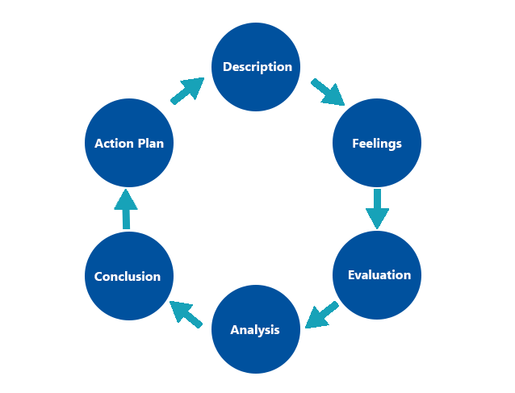

Main findings

Gibbs’ Reflective Cycle: Time management

Description
After the birth of my daughter, I have realised that I needed to improve the way I managed my time in order to be a good parent while also working to support my family financially. This conclusion came about as a result of the fact that I was able to see that it was necessary for me to improve the way that I managed my time because at that point I was feeling that I can’t manage with both roles successfully.
During a discussion I was having with my wife, we began discussing different approaches that would help us achieve greater levels of success. Following an internet search, we found that the University of Wales Trinity Saint David offers a course that assists students in improving their employability skills, including their ability to manage their time effectively. After having this discussion, I came to the conclusion that I should begin taking this course, sign up to be a student, and make the most of the opportunity to improve my employability skills. These skills, according to Holmes (2017), are more important in our day than they were fifty years ago because of the varied ways in which we structure our professions.

Feelings
During this time, I was experiencing fear and doubt about whether or not it was the right decision and the most effective way to increase my ability to manage time. Having said that, once I started the course, I had the impression that it is one of the best decisions that I have made, and I honestly believe that my wife is proud of me today because of it. Since the beginning, she has placed her faith in me and provided her support in order to encourage me to make the most intelligent choice possible under any circumstances. When I reflect on the past few months, I feel both proud and content with what I've been able to accomplish over that time.

Evaluation
After going through all of this, I can say that the thing that went well is the fact that I was able to face distraction after all. In addition, my abilities in time management have significantly increased, and I have learned new techniques to be more efficient and to avoid being distracted from my goal. During this experience, I had some challenging times when I was struggling to move forward, such as a lack of motivation, and there were times when I wasn't sure whether or not I would be able to complete this process. However, I can now say that I have more time for myself and my family than I did before. This is a positive aspect.

Analysis
I believe that the fact that I did not give up on my goal despite the fact that sometimes appeared procrastination, which, according to Cherry (2022), is the most significant factor in whether or not things go well and the act of delaying or putting off tasks until the very last minute, or even after the deadline has passed help me to improve my time management skills.
I also begin to put into practice all that I have learned during the course that I am taking at the University, including how to build a timetable, how to prevent multitasking, how to get rest, how to learn how to say no, how to set up deadlines, and how to begin giving myself rewards.
I think that if I had known from the very beginning about all of this, I would not be in that situation, and I would have been able to spend my time more efficiently.

I was used to living in a way that put everything off until the next day, which is one of the reasons why I believe that my time management was quite poor. However, the responsibility of being a parent as well as supporting my family forced me to change that way of living.
After making additional research on time management, I found out about ‘The Covey Time Management Matrix’ which according to (indeed.com, 2020) is a framework for prioritising your time and tasks in order to achieve the highest possible levels of efficiency and productivity.
This model, which was developed by Steven Covey, the author of “The Seven Habits of Highly Effective People”, employs a system with four quadrants in order to assist you in classifying each activity, responsibility, and aspect of your life based on the following criteria: urgency and importance.

Conclusions
After going through this, I have realised how important time is to our lives, provided that we are able to make the most of it.
According to Ho (2022), the ability to effectively manage time means allowing for a healthy work-life balance. The inability to effectively manage one's time can result in missed deadlines and increased stress. You can learn to practice time management right now, even if you've never done so in the past.
The best way for me to improve my weaknesses and turn them into strengths is to educate myself on how to effectively manage my time.
After taking a step back, I am able to see that things will be much easier now, and everything seems to be heading in the right direction, as long as I continue to follow the steps and put all that I have learned into practice.
In order for me to become an even better time manager, I will need to work on improving other abilities such as self-motivation, communication skills, determination, persistence, problem-solving, responsibility and confidence.

Action plan

I think that if I had to start improving my time management, I would add a few new ways to accomplish it, and I probably would research more and find new techniques to be more successful. I would also begin to eliminate tasks that are not necessary, and whenever it was necessary, I would learn how to combine two or more things at the same time. I would also learn how and when to take breaks, and I would learn how to ask for help. In addition to the things that I have previously learned and put into practice, such as avoiding distractions, remembering deadlines, not freaking out, not procrastinating, and creating goals, if I had to start improving my time management, these are the things that I would do.
After having this new experience and learning everything that I have, I am positive and my confidence has grown that in the future I will not fall into the same bad habits or make the same mistakes, and I will probably look for new possibilities to improve myself each and every day.

Conclusion

In conclusion, successful management of one's time is the key to achieving one's goals. The true benefit of effective time management is the way in which it improves the quality of our lives in every aspect (Webber, 1972). What we get from practising effective time management is not additional time but rather a better quality of life. When you become more efficient in how you use the time that is allotted to you, you will be able to spend more time with your loved ones, reduce the amount of stress in your life, increase the amount of work you get done, and have a greater chance of accomplishing the things you set out to do.
After putting everything I learn about time management into practice, my skills have improved, and I have realised that there are always new ways for our skills to be improved and that if you dedicate yourself to researching and achieving your goal, your chances of success will be higher.

Reference list

Cherry, K., 2022. What Is Procrastination?. [Online]
Available at: https://www.verywellmind.com/the-psychology-of-procrastination-2795944
[Accessed 12 December 2022].
Ho, L., 2022. The Importance of Time Management: 8 Ways It Matters. [Online]
Available at: https://www.lifehack.org/692542/the-importance-of-time-management
[Accessed 12 December 2022].
Holmes, K., 2017. What Employers Want : The Employability Skills Handbook. 2nd ed. Bath: Trotman Publishing.
indeed.com, 2020. The Covey Time Management Matrix Explained. [Online]
Available at: https://www.indeed.com/career-advice/career-development/covey-time-management-matrix
[Accessed 12 December 2022].
nursinganswers.net, 2018. Gibbs' Reflective Cycle. [Online]
Available at: https://nursinganswers.net/reflective-guides/gibbs-reflective-cycle.php
[Accessed 11 December 2022].
Webber, A. R., 1972. Time and Management. Melbourne: Van Nostrand Reinhold.

