

Name | Mihaela Ganchev (2013873)
Module | Principles of Health and Social Care
Module Code | BMHP5002
Assignment Title | Assignment1 Written Assignment
Lecturer | Mentesnot Mengesha
Submission Date | 7th January 2022

Table of Contents

Introduction…………………………………………………………………….…...….3
Purpose……………………………………………………………………….……...3-5
Approach………………………………………………………………………….….5-6
Discussion……………………………………………………………………………6-7
Recommendations…………………………………………………………………..8-9
References……………………………………………………………….…………9-10
Appendices……………………………………………………………………………10

Introduction
Care24Seven is a service that provides domiciliary care service. They have options such as live-in care and hourly care. The organization is providing patient centred care for elders, that are disabled or have other weakening illnesses like dementia, that makes them vulnerable. By being at home patients feel the most comfortable, filled with memories around and being able to be visited anytime by family or friends. Especially for people who can still be partly independent. Care workers are trained to maintain the highest levels of care with the assistance of individualized plans. Carers help in each aspect, such as cooking, cleaning, shopping, managing appointments and redeem prescriptions at the pharmacy. The staff is trained and compassionate about their work but also the patients themselves. They are flexible in terms of just taking care of the patients for few hours a day or full-time if it’s needed. There is also 24 hours support for emergencies and working staff during holidays. The best thing is that through the whole process they are at home. Contracts are made for 48-hours a week, which is basically two whole days of providing care, which in our case is not urgently required. After those two days, contract can be either cancelled or renewed. Breaks can be put between the days for the family. Families might struggle to support their relatives because of the costs. There is funding that helps but it is not easy to be accessed. Therefore, is domiciliary care more affordable then care in a care home. In care homes there are costs for the building and the care and in the case that this report is covering, there are two people which means it is even more expensive. Care24seven promises high quality, professionalism and honesty towards patients and their families. Standards are set highly, and this is what makes it even better than care residences. In care facilities people are mostly seen as a group, while in home care, people are always treated individually. The service provides also training to other companies and are motivating the staff to gain more knowledge and develop. (About us, 2019)

Purpose
The aim of the case study is to find the best option for Mr. and Mrs. T. They are still partly independent which means it is best for them to remain at home where they live all the time and feel the most comfortable. If someone recently had surgery or suffer from dementia, you are likely to feel overwhelmed and anxious. Their family is eventually not be prepared for this new responsibility, especially if it falls onto your shoulders when you're least expecting it, or if your daily schedule is already packed with tasks and commitments. They both would receive the complete medical attention, treatment, and supervision they need in the comfort of their own home, rather than having to stay at, or visit regularly, a specialised facility to receive care. A familiar and comfortable environment, surrounded by acquainted neighbours and acquaintances, is reassuring to know your loved one is receiving the highest level of care. Relatives can also always be aware of where the person receiving elderly care is and how to reach them when they live at home. Having elder care at home also offers many practical advantages. Compared to large facilities and large amounts of paperwork and trying to reach your loved ones at a particular time due to the schedule and peculiarities of the facility, you won't need to spend much time driving them to a facility or dealing with obstacles like paperwork. 1:1 care is promised in these cases. All the attention is on the patients and their needs. Home care has the highest rate in effectiveness of care. A profit of paying for home care is that it is usually more cost-effective than paying for a care facility or hospital. Special care facilities must influence loads of a similar expenses as any social unit for example food, maintenance, however there are also other costs of paying for rent. This ends up in either higher fees or lower quality of service. that's not the case with care at home. There are no extra fees, but they would furthermore have full management over the value and quality of care since they are partly independent. (Home care services, 2019) There are two options, they can either hire a private carer or through an agency. To hire a private carer is not easy, because you can not always make sure is the best fitting person for your preferences and there could be risks. Especially if their relative searches online for an employee, the person might not be qualified enough. Care24seven can be found on the CQC website, where they can see it’s feedback and rating. Hiring through their agency is easy and not complicated. They make sure carers are trained. Background checks are being made to make sure there are not any criminal convictions that could put patients in danger. Feedback and recommendations can be share if something is not as the patient wants it to be. (Hiring a private carer, 2019) Due to the condition of Mrs. T and her surgery, there will be rehabilitation and later physiotherapy needed, so she is able to move independently, without a moving frame. Post-operative care is very important. The care plan helps the patients to recover as quickly as possible. The agency consults with the hospital, that does the surgery, to provide the best suitable care. In cases like this support is required whether it is cleaning or easier tasks. Patients should try to do things that he is not recommended by a professional. (Post-operative care at home, 2019) As known, Mr. T has dementia, the care service provide support for dementia patients as well. This condition is very brutal and affects patients’ behaviour. It can not be always predicted and that is why they must be supervised so they can remain safe. Keeping a routing and same environment is help them to be more stable. The trained staff is taught how to react in different situations. They are adapting their language so they can be understood. Since it is a progressive illness, there could be also a live-in care hired. Surrounding play a huge role in dementia patients’ lives. New places and people might make Mr. T act more aggressive, therefore is it recommended for him remain at home, with different memories around him. (Dementia care, 2019)

Approach
A huge role plays equality between all of us, so this can be avoided. CQC analyses how all the policies might affect us, no matter of age, disabilities, marriage, and beliefs in this case. The policy is there to protect us as human beings and make sure we are all treated the same. CQC, as a regulation body makes sure everyone receives safe and qualitative care. They have as a responsibility to disclose equality objectives to comply with the provisions of the Equality Act 2010. These equality objectives will be in effect for four years to comply with rules. The plan that will be accomplished by 2025 provides us with fresh opportunity to contribute to the reduction of inequality. The five equality goals are priorities and objectives to assist promote equality for people who use health and social services, persons employed in health and social services. health care providers health and care that regulates our labour force. (Equality and human rights) Many people have spent a lot of time with their family members because of the COVID-19 problem. In other situations, this has resulted in extra tensions that have erupted into abuse and violence. Evidence from statutory and voluntary organisations throughout the UK indicates an increase in domestic abuse allegations, with Sanctuary reporting a 60% rise in calls and online requests between April 2020 and February 2021. The rise is assumed to be due to forced cohabitation, economic hardship, and virus-related anxieties. In the case of persons with dementia who are cared for at home by family members, this may be owing to the caregiver not being able to cope with restricted services, greater caring obligations, and fewer breaks. Those who live with an abusive partner or family member may be less inclined to seek assistance during the epidemic because they do not want to burden already overburdened emergency services. It should be reported it any case even if it is someone from a service that is showing abusive signs. Domestic abuse is more than simply physical assault and it can happen while the carer or other service providers are there. Other sorts of abuse might include emotional or psychological abuse, sexual abuse, financial, and neglect. Domestic violence can affect both men and women. They should call the police if someone is in urgent danger. If there is anyone with dementia that is being abused, it should be reported in accordance with the safeguarding policy. (Safeguarding adults with dementia during the COVID-19 crisis, no date)
Discussion
Paying for a carer at home can make a difference e.g., in Mrs. T’s situation, she will be able to easily move around the house. A problem they could be facing are the costs of a carer, which is approximately 20£ for an hour. Prices may be different compared to the please they live. For support they can contact their local council, that will help them with costs. They might not need a carer full-time but for a long term. There is a needs assessment that you can apply for and get financial help from them. Using financial statements and based on earnings and savings, the council then decides how he will contribute to the situation. They can also get the support themselves to independently hire a carer, which has disadvantage except you know someone. There are many ways to find the best possible agency. It can be searched by the National Health Services (NHS) website, Care Quality Commission (CQC) and the United Kingdom Homecare Association (UKHCA). On all these organizations approved agencies can be found. To avoid any issues, people can start by asking the agency several question like if the carer has experience in working with someone with the same needs, if there are extra charges and if the council supports them, they should ask if they can have a look at the contract. It is important to have contacts of the agency e.g., emergency phone number. The patients should always be treated with dignity and respect. Arrangements like how they should enter their house, or any confidentialities should be made between carer and patient. (NHS website) Since both Mr. and Mrs. T. are over the age of 85 they are over the state pension age. There are many benefits that they use. Attendance allowance can support them with up to 85.60£ if the care is needed day and night and 57.30£ if it is either day or night. This support is not related to your saving or income. Other available support are housing benefits, pension credit, council tax reduction and eventually NHS health costs, cold weather payments and winter fuel. (NHS website) Through care provided at home, patients also get more social contact, that helps them to not feel isolated. (Hourly care, 2019) This is especially important in the current situation due to Covid-19 pandemic. While certain legislative limitations have been reinstated in reaction to a new variation and increased infection rates, people's lives continue to be disrupted. Adults in need of care and assistance may now be targeted because of a variety of criteria. In general, they may require assistance with specific jobs, be less digitally aware, welcome more new acquaintances, be more self-assured, and, for many seniors, be richer. It has been demonstrated that social isolation increases the chance of abuse. Many elderly and handicapped persons spend significant periods of time alone at home under normal conditions and will continue to do so even if limitations are eased. Those who are most vulnerable to COVID-19 may not feel comfortable or prepared to interact freely. Those trying to undermine these weaknesses are ready to act in times of international crisis, and it remains a potential. Scams claiming to provide support and guidance on COVID-19 or financial assistance. Many of us may be concerned about family members being victims of fraudsters. This is a moment when we must all be particularly vigilant and look for any indicators that anything is awry. Adults who require care and support, or who are at danger of being abused or neglected and are unable to protect themselves due to their care and support needs, are subject to safeguarding obligations and responsibilities. This group was more separated in general, and social contact of any type was frequently experienced without proper care. There are various sorts of abuse, but the three that are most important to those receiving home care are physical, psychological, and financial. We may presume that the most likely source of misuse during the COVID19 situation is pecuniary. With continuous extra constraints on services, typical cutbacks in services as a result of positive cases among employees and people assisted, fear and isolation, the door remains wide for individuals who may wish to abuse those who are vulnerable. (Safeguarding adults and Covid-19)

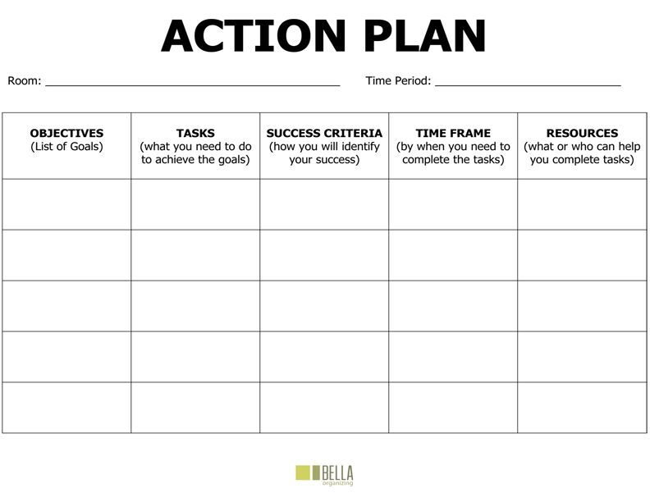
Recommendations

Care24seven contact them Easy and fast as soon as possible Relatives/Friends

Choice of carer ask the service ------------------ as soon as possible Research+People
Over pension benefits/ ----------------------- depends on how NHS, Council,
Council support contact council / NHS busy they are Relatives, Friends
Paperwork read the contract quick and easy directly after
Meeting new as soon as agency in case
Carer Sign the contract --------------------- contract signed of questions

(Appendix1)
As recommendation I have created this action plan, which both Mr. and Mrs. T. could follow to get all done. As first they should contact my recommended agency for hiring of well-trained carers, who can be either hourly working or full-time and live-in. To contact they will be required to call them or email them about their enquiry. On the phone, they should be able to answer quicker and give them answers for the next step. In this process their family or friends could help them. Secondly it will be the choice of carer, which is the step in which they will ask someone from the agency about a carer, who has experience in working with people with dementia and post-operatives. As soon as they have answered the question, they should be able to provide you with a contract. But first Mr. and Mrs. T. should contact their local council, NHS or over pension benefits to ask of what they are eligible as a support and directly after that they should apply. As soon as their application get accepted, they will be able to do the paperwork, where they should read the contract between them and the agency but also between the agency and the council (in case there is one). When this is done, they can sign it and as soon as possible they will be able to meet their carer and when it is all done, the carer will regularly visit them as they prefer and help them daily duties. If there are any issues with the carer, they should report it to the agency and CQC, since it will be against the policies and what they stand for.

References
About us (2019) Care24Seven. Available at: https://care24seven.com/about-us/ (Accessed: January 14, 2022).

Dementia care (2019) Care24Seven. Available at: https://care24seven.com/dementia-alzheimers-care/ (Accessed: December 14, 2021).

Equality and human rights (no date) Org.uk. Available at: https://www.cqc.org.uk/about-us/our-strategy-plans/equality-human-rights (Accessed: January 3, 2022).

Hiring A private carer (2019) Care24Seven. Available at: https://care24seven.com/hiring-a-carer/ (Accessed: January 2, 2022).

Home care services (2019) Care24Seven. Available at: https://care24seven.com/health-care-at-home/ (Accessed: December 14, 2021).

Hourly care (2019) Care24Seven. Available at: https://care24seven.com/hourly-care/ (Accessed: January 1, 2022).

NHS website (no date a) Benefits if you’re over State Pension age, nhs.uk. Available at: https://www.nhs.uk/conditions/social-care-and-support-guide/money-work-and-benefits/benefits-if-you-are-over-state-pension-age/ (Accessed: January 2, 2022).

NHS website (no date b) Help at home from a paid carer, nhs.uk. Available at: https://www.nhs.uk/conditions/social-care-and-support-guide/care-services-equipment-and-care-homes/homecare/ (Accessed: January 2, 2022).

Post-operative care at home (2019) Care24Seven. Available at: https://care24seven.com/post-operative-convalescent-care/ (Accessed: January 2, 2022).

Safeguarding adults and COVID-19 (no date) Social Care Institute for Excellence (SCIE). Available at: https://www.scie.org.uk/care-providers/coronavirus-covid-19/safeguarding-adults (Accessed: January 1, 2022).

Safeguarding adults with dementia during the COVID-19 crisis (no date) Social Care Institute for Excellence (SCIE). Available at: https://www.scie.org.uk/care-providers/coronavirus-covid-19/dementia/safeguarding (Accessed: December 14, 2021).

Appendices
Appendix1


