

Student name: Lisa Bailey
Student ID:2515480

Module name: Introduction to Health and Social Care
Module code:LCHS4003
Lecturer name: Ping Wu
Content page

Element 1 ……………………………………………………………..
Community mental health services are delivered through community mental health teams. People are usually referred by GPs, hospitals or social services. Teams provide assessment, treatment, medication management and psychological support while helping individual remain in their community. Services aim to support recovery and reduce the need for hospital admissions.

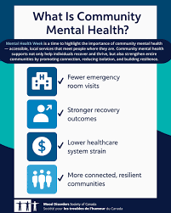
Community mental health services provide care and support for individuals experiencing a range of mental health conditions while allowing people to live independently and with their local communities. These Services aim to promote independence, recovery and improved quality of life. Care is delivered by multidisciplinary teams including psychologists, psychiatric nurses, and community social workers. These professionals collaborate to assess needs, develop care plans, and provide ongoing treatment and support within clinical settings as well as day centres, hostels and in-home support services. (Royal College of Psychiatrists, 2015)

Community mental health services offer support between primary care and hospital psychiatry, helping people receive treatment in the community.
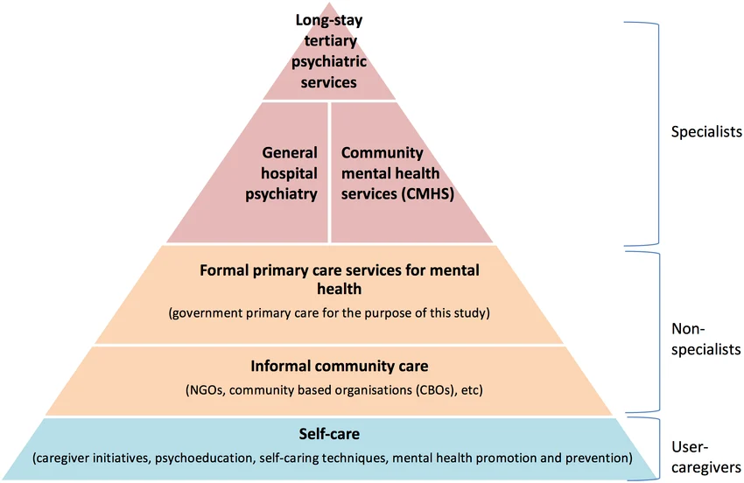WHO (2008)
History of mental health services. Mental health services in the UK relied on mainly on asylums. Following the Mental Health Act 1959, policy moved towards community-based care, leading to the closure of many psychiatric institutions and the development of modern community mental health services (NICE,n.d.) The shift towards community care continued through later policies, including the (CPA) and (CMHTs)
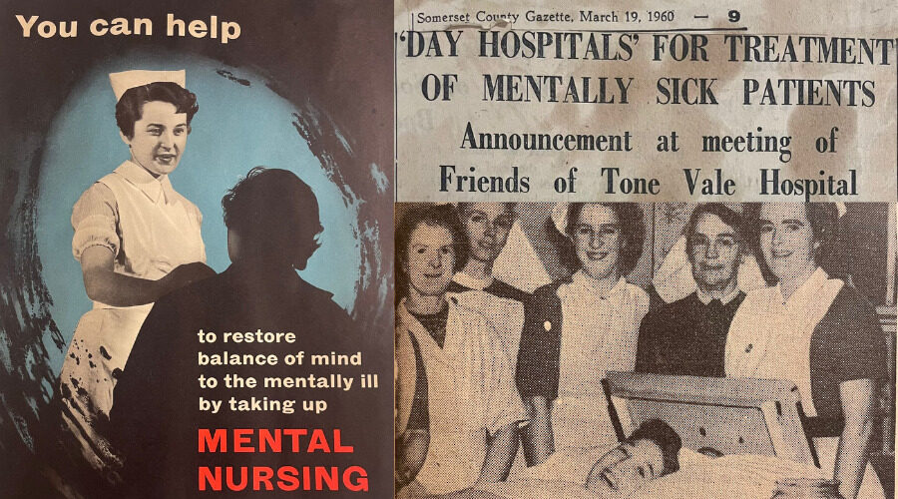
Role of community mental health services
The key roles of the community mental health service include: Assessment of mental health needs- assessing mental health risk factors and support requirements. Crisis intervention- providing prompt support for a mental health crisis. Creating person-centred care planning- developing care plans with service users and professionals to address individual needs. Regular reviews, psychological therapies and support, Medication management and monitoring, psychological therapies and support, Medication management and monitoring.

Challenges Waiting times for mental health support have increased, meaning many people experience delays accessing services. This prevents individuals from receiving timely assessments.
Staff shortages and funding pressures can affect the availability and quality of community mental health care. This may place pressure on services and staff supporting people with complex needs. (Mind, 2026)

Community mental health services
Lisa Bailey

Pharmacy Services
Community pharmacy has developed from a more traditional system of dispensing medication to a modern health care service.
The origins of community-based pharmacy in the UK can be linked to the development of the apothecary profession, whose role involved preparing and mixing medicines, including herbal remedies, alongside providing advice and medical treatments.
In the 19th century, pharmacy began to emerge as a regulated profession separate from medicine. A key milestone was the establishment of the Royal Pharmaceutical Society in 1841, which introduced professional standards and ethic guidance. (Royal Pharmaceutical Society, (2026). This marked a significant shift from the informal medicine preparation to a recognised health care profession.
Community pharmacy continued to develop during the 20th century, particularly with the introduction of the National Health Service in 1948. This marked a shift as community pharmacies became integrated into a public funded health care system, responsible for dispensing and prescribing medications. The need for pharmacists to prepare medicines manually has reduced, allowing their role to shift towards the safe supply of medications alongside providing advice to patients. This led to an increased focus on patient care within community pharmacy practice.
Community pharmacy services have continued to expand in recent years and now play a key role in delivering accessible health care services within the community. According to NHS England (n.d), pharmacies provide a range of clinic services, including blood pressure checks, smoking cessation support and contraception services. This accessibility allows patients to receive advice and treatment without the need for appointments, reducing pressure on Drs and improving access to care. Pharmacies are now also involved in delivering services such as the new medicine service, which supports patients in understanding and managing newly prescribed medications and vaccination programmes, including the flu vaccines. Pharmacists are also able to follow up with patients, reviewing their medication progress, offering support and guidance, and addressing any medication side effects and concerns. Alongside this, they may offer advice regarding lifestyle changes and well-being support, which offers a more person-centred approach to care. These services highlight the growing role of pharmacists within primary care. (NHS England, n.d.)
Despite these developments, community pharmacies do face several ongoing challenges. One key issue is the lack of integration with other parts of the NHS, such as GP services, hospitals, referrals and digital systems. ( Murray, 2016) Information is not always shared, and communication between the services can be poor, which makes care less coordinated. Another key issue is the increasing workload placed on community pharmacists who are often required to balance multiple responsibilities, which can limit the time for interaction with patients and may reduce the quality of personalised care. However, despite these challenges, community pharmacy remains significant in improving the quality of life for service users. It allows individuals to seek advice and treatment quickly, supporting early intervention and advice and education around managing more long term health conditions, helping to improve medication adherence and overall better health outcomes. In addition, community pharmacy contributes to reducing pressure on other health care services such as Gp services and hospitals by managing minor illnesses and supporting ongoing treatment. This highlights its importance within the health care system and its role in promoting individual and public health. Overall, community pharmacy has moved from a traditional dispensing role to a modern healthcare service that is essential for community care needs. This also helps to reduce health inequalities, particularly for individuals who may face barriers to accessing other health services.

Reference list
Mind (2026). ‘Mental health services are being set up to fail’ – Mind responds to the fall in proportion of NHS spending going to mental health despite record numbers contacting the NHS for support. [online] Mind.org.uk. Available at: https://www.mind.org.uk/news-campaigns/news/mental-health-services-are-being-set-up-to-fail-mind-responds-to-the-fall-in-proportion-of-nhs-spending-going-to-mental-health-despite-record-numbers-contacting-the-nhs-for-support/ [Accessed 16 Mar. 2026].
Murray, R. (2016). Community Pharmacy Clinical Services Review. [online] p.7/9. Available at: https://www.england.nhs.uk/commissioning/wp-content/uploads/sites/12/2016/12/community-pharm-clncl-serv-rev.pdf.
NHS England (n.d.). NHS England» NHS New Medicine Service. [online] www.england.nhs.uk. Available at: https://www.england.nhs.uk/primary-care/pharmacy/pharmacy-services/nhs-new-medicine-service/ [Accessed 22 Mar. 2026].
NICE (2018). Mental health and the NHS. [online] indepth.nice.org.uk. Available at: https://indepth.nice.org.uk/mental-health-and-the-nhs/index.html [Accessed 16 Mar. 2026].
Royal College of Psychiatrists (2015). Mental Health Services and Teams in the Community. [online] RC PSYCH ROYAL COLLEGE OF PSYCHIATRISTS. Available at: https://www.rcpsych.ac.uk/mental-health/treatments-and-wellbeing/mental-health-services-and-teams-in-the-community [Accessed 14 Mar. 2026].
Society, R.P. (2026). A brief History of the RPS. [online] www.rpharms.com. Available at: https://www.rpharms.com/about-us/history-of-the-society [Accessed 22 Mar. 2026].
van Ginneken, N., Maheedhariah, M.S., Ghani, S., Ramakrishna, J., Raja, A. and Patel, V. (2017). Human resources and models of mental healthcare integration into primary and community care in India: Case studies of 72 programmes. PLoS ONE, [online] 12(6). doi:https://doi.org/10.1371/journal.pone.0178954.

