
Assignment 2:
Operating Systems
CertHE Computing Skills for Workplace

Computer Architecture and Operating Systems. ACCA4022_LON
DR. Redhwan Al-Amri (Lecturer)
University of Wales Trinity Saint David
(London Campus)
Student Name: Olha Kozmenko
Student Number:2335644
Group: 02
Date: March 2026

Table of Contents
Introduction 1
1. Key functions of general Operating Systems 1
1.1 Process and Processor Management 1
1.2 Memory Management 2
1.3 File System Management 2
1.4 Security and Protection 3
2. Use of Windows OS CLI commands. 3
3. Use of Linux OS CLI commands. 7
4. Use of Windows OS scripts. 9
5. Use of Linux OS scripts. 12
Conclusion 14
References 15
Appendices 15

Introduction
This report is written as part of the Computer Architecture and Operating Systems module (ACCA4022) at the University of Wales Trinity Saint David. The purpose of this report is to explore how modern operating systems function and how they can be managed and automated through command-line interfaces. The report begins by examining the key functions of general-purpose operating systems, then moves on to practical demonstrations of Windows and Linux CLI commands. Following this, two scripting examples are provided for each system to show basic automation. All tasks are supported by screenshots taken from real environments and referenced using the IEEE format.

Key functions of general Operating Systems
An operating system (OS) is the most important software on a computer. It manages all hardware and software resources and allows users to interact with the machine. Without an OS, a computer cannot function [1]. Popular general-purpose operating systems include Microsoft Windows, macOS, and Linux. Although they look different, they all perform the same core functions [2].

1.1 Process and Processor Management
A process is a program that is currently running on the computer. The OS is responsible for creating, scheduling, and stopping processes. It decides which process gets CPU time and for how long. This is called CPU scheduling [1]. On Windows, users can see all running processes in the Task Manager. It shows the CPU usage for each process and allows users to end tasks that are not responding. This is useful for monitoring system performance in real time [3].
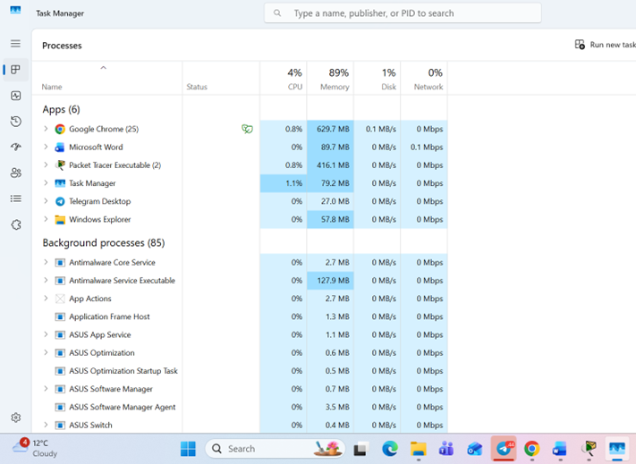
Figure 1: Windows Task Manager showing running processes, CPU and memory usage

Memory Management
Memory management is another key function of an OS. The OS controls how RAM is allocated to different programs. When a program starts, the OS gives it a section of memory. When the program closes, that memory is freed for other processes [2]. If RAM is full, the OS uses a part of the hard drive as virtual memory. This slows the computer down but prevents it from crashing. In Windows, memory usage can be monitored in Task Manager under the Performance tab [3].
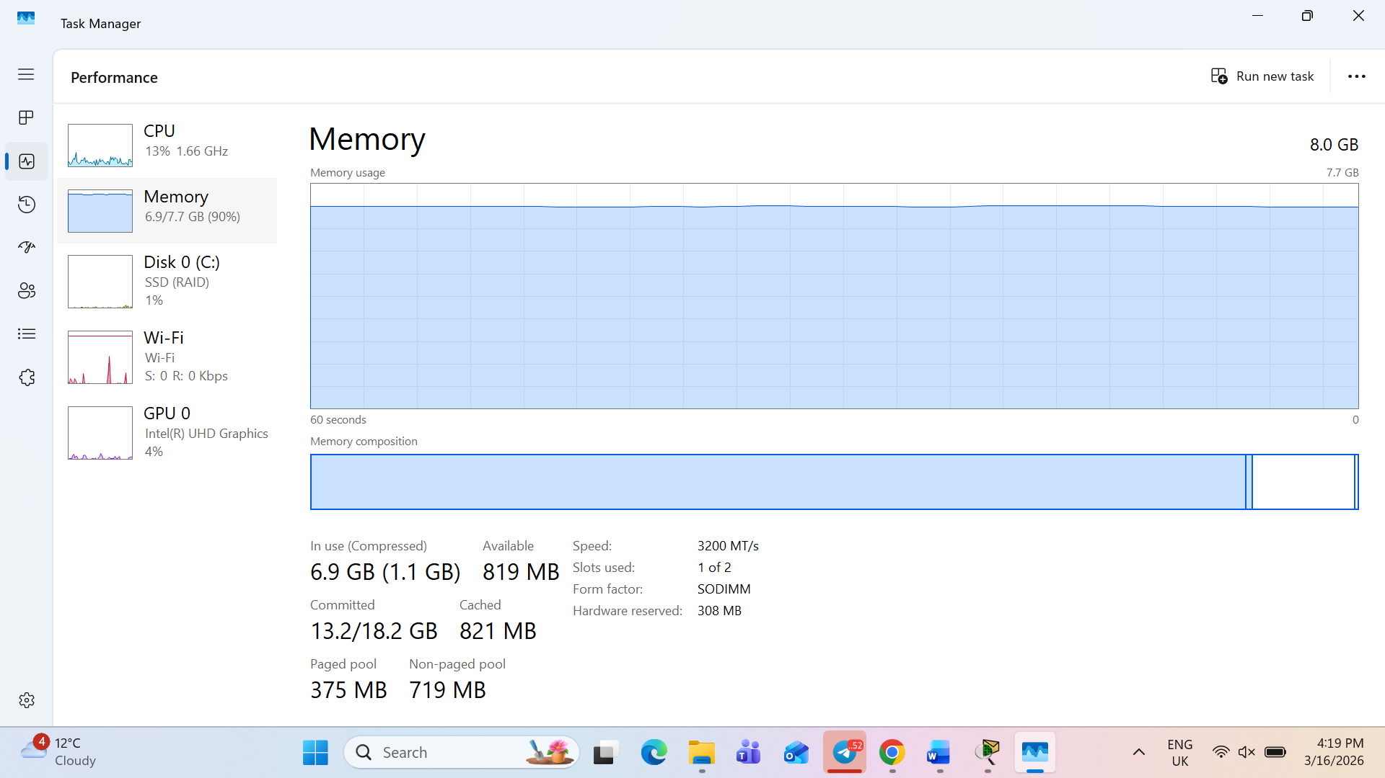
Figure 2: Task Manager Performance tab displaying RAM usage - 6.9 GB out of 8.0 GB in use

File System Management
The OS also manages how files are stored and organised on storage devices. It uses a file system, such as NTFS on Windows or ext4 on Linux, to keep track of where each file is saved [1]. Users can create, move, copy, and delete files through the OS. The file system also controls access permissions, which means it decides who can read or change a file. On Windows, this can be seen in File Explorer and also through the Properties menu of any file or folder [2].
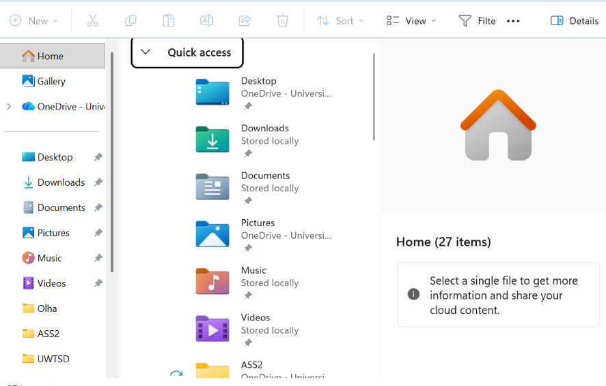
Figure 3: Windows File Explorer showing the folder structure including Desktop, Downloads, Documents and user folders

Security and Protection
Security is a very important function of any modern OS. The OS protects the system from unauthorised access by managing user accounts and passwords [3]. It also controls what each user is allowed to do. For example, a standard user cannot install software or change system settings without administrator permission. On Windows, user accounts and their permission levels can be managed through the Control Panel or the Settings app. The OS also works together with antivirus software and firewalls to protect against external threats [1].
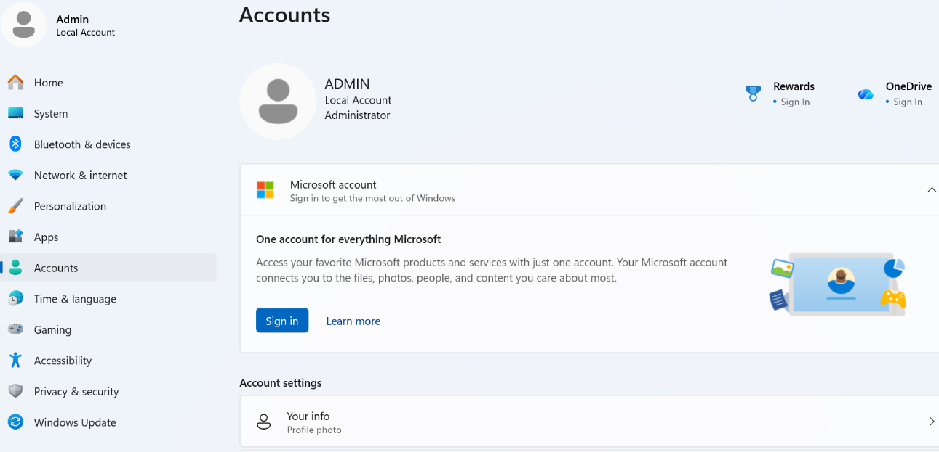
Figure 4: Windows 11 Settings - Accounts section showing Local Account with Administrator privileges

Use of Windows OS CLI commands.
Process Management
The tasklist /svc command displays all currently running processes on the system. Each process is listed with its name, Process ID (PID), and the Windows services associated with it. For example, lsass.exe runs the KeyIso, SamSs and VaultSvc services, while svchost.exe manages multiple services such as BrokerInfrastructure and DcomLaunch. This command is useful for monitoring which services are active and identifying processes that may be using system resources.
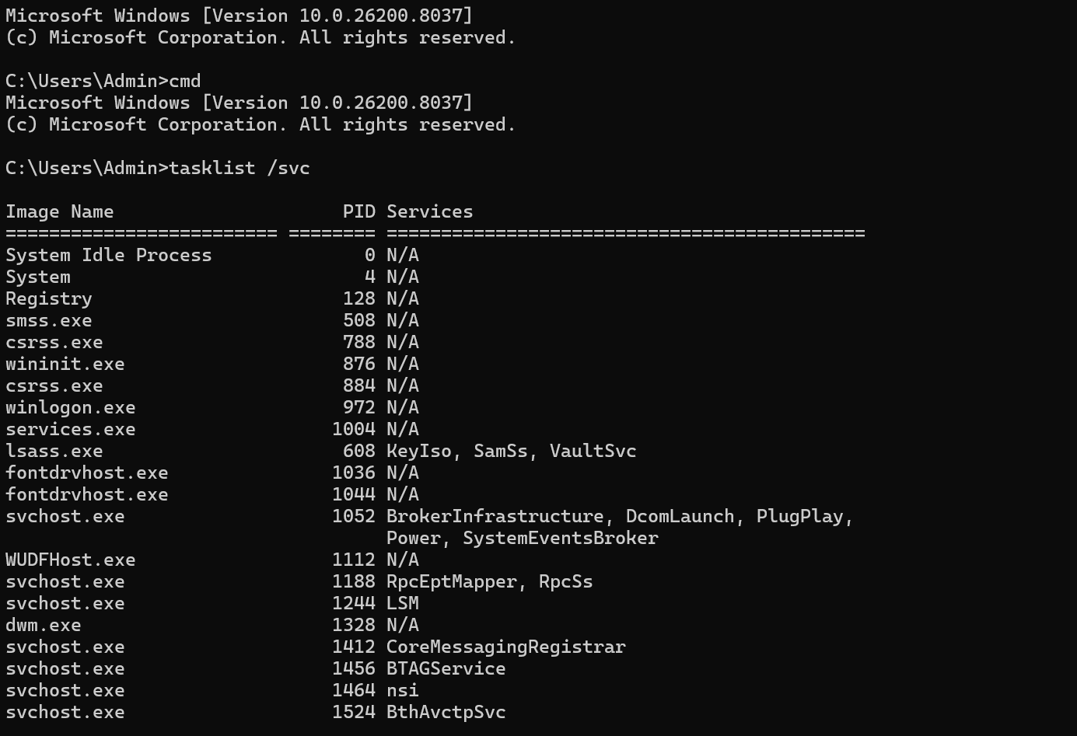
Figure 5: The tasklist /svc command displays all running processes with their PID and associated services
First, the tasklist | findstr mspaint command was used to filter the process list and find the Paint application. The result showed that mspaint.exe was running with PID 10168, using 211,660 K of memory. The pipe operator | combined the two commands to search within the output of tasklist. Then the taskkill /PID 10168 /F command was used to force-stop the process. The system confirmed this with the message "SUCCESS: The process with PID 10168 has been terminated."
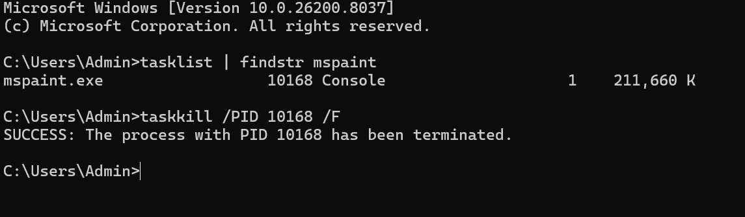
Figure 6: Using tasklist | findstr mspaint to locate mspaint.exe and taskkill /PID 10168 /F to terminate the process
The dir /a command was used to list all contents of the C:\Users\Admin directory, including hidden files and system folders that are not normally visible. The output shows standard folders such as Documents, Downloads, Music and OneDrive, as well as hidden system files like NTUSER.DAT which stores user registry settings and has a size of 21,233,664 bytes. Junction points such as Application Data and Local Settings are also visible, which are links to other locations on the system. This command is useful for viewing the complete contents of a directory including protected files.
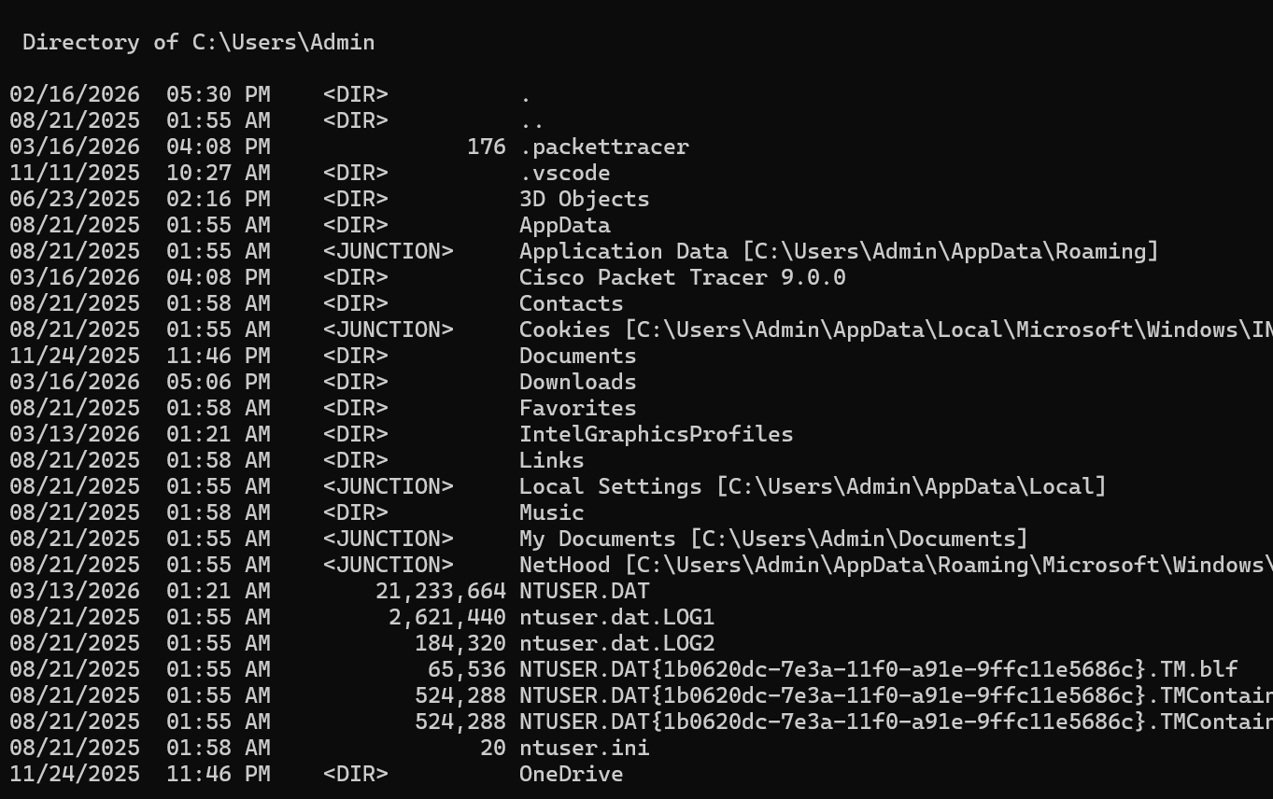
Figure 7: The dir /a command displaying all files and folders including hidden items in C:\Users\Admin
The mkdir C:\TestFolder command created a new directory called TestFolder on the C: drive. Then the copy command was used to copy the hosts file from the Windows system directory into the new folder, confirming "1 file(s) copied." Finally, the del /f command force-deleted the file from the TestFolder directory. These three commands demonstrate basic file and directory management using the Windows CLI.
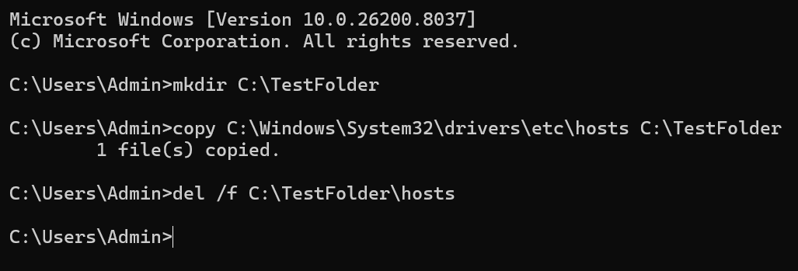
Figure 8: File management commands - mkdir, copy and del /f used to create a folder, copy a file and delete it
The ping -n 4 google.com command sent four packets to google.com to test network connectivity. All four packets received a reply with response times of 3ms, 6ms, 4ms and 6ms. The statistics show 0% packet loss with an average round trip time of 4ms, confirming a stable network connection.
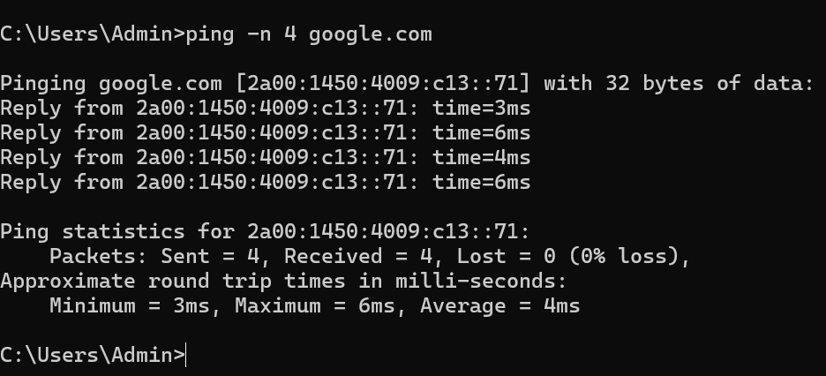
Figure 9: The ping -n 4 google.com command testing network connectivity to google.com

The ipconfig /all command displayed the full network configuration of the computer. The host name is DESKTOP-HOKL1DJ and the DNS suffix shows communityfibre.co.uk as the internet provider. The system has an Ethernet adapter with physical address 04-42-1A-AF-D9-35 and a Wi-Fi Direct Virtual Adapter. Both adapters show DHCP enabled, meaning IP addresses are assigned automatically by the network.
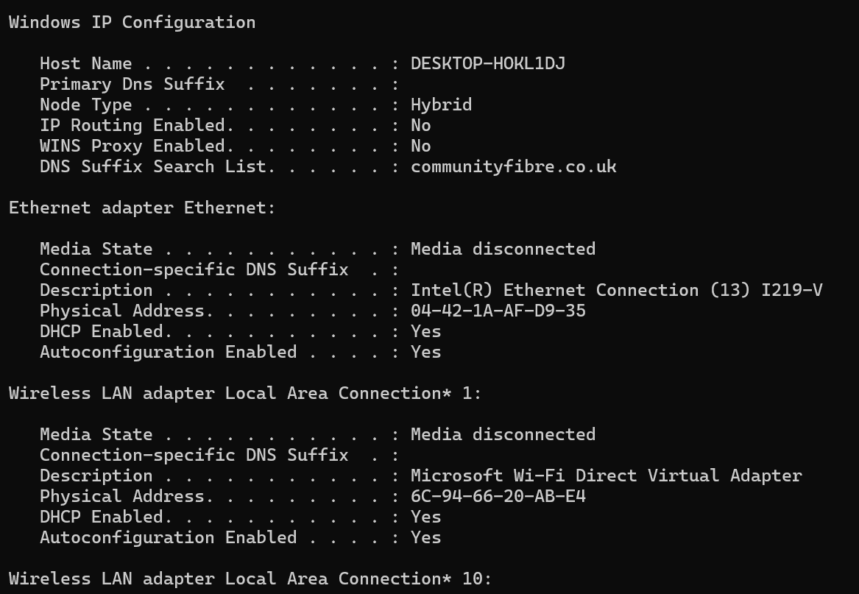
Figure 10: The ipconfig /all command displaying full network configuration of the system.
The net user command listed all user accounts on the system. The output shows four accounts: Admin, Administrator, DefaultAccount, Guest and WDAGUtilityAccount. The Admin account is the currently active user, while Guest and WDAGUtilityAccount are system accounts created by Windows. This command is useful for managing and monitoring user access on the system.
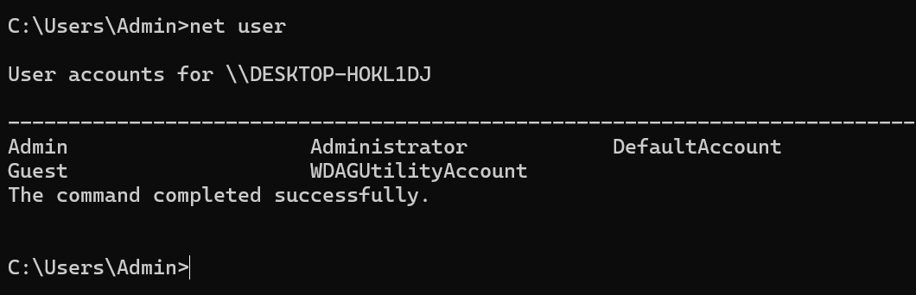
Figure 11: The net user command displaying all user accounts on DESKTOP-HOKL1DJ
The schtasks /query /fo LIST command displayed all scheduled tasks configured on the system. The output shows tasks such as iGoAudioTaskSession which is currently running, and two OneDrive update tasks scheduled for 3/17/2026. Each task shows its name, next run time, status and logon mode. This command is useful for monitoring automated tasks that run in the background without user interaction.
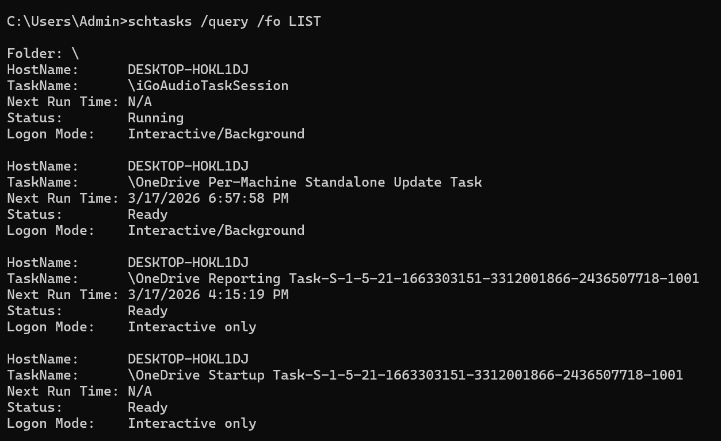
Figure 12: The schtasks /query /fo LIST command displaying scheduled tasks on the system

Use of Linux OS CLI commands.
The ps aux command displays all currently running processes on the Linux system. Each process shows the user, PID, CPU and memory usage, and the command name. For example, the init process runs with PID 1 using 0.1% CPU, and multiple kernel worker threads such as kthreadd and kworker are visible running in the background.
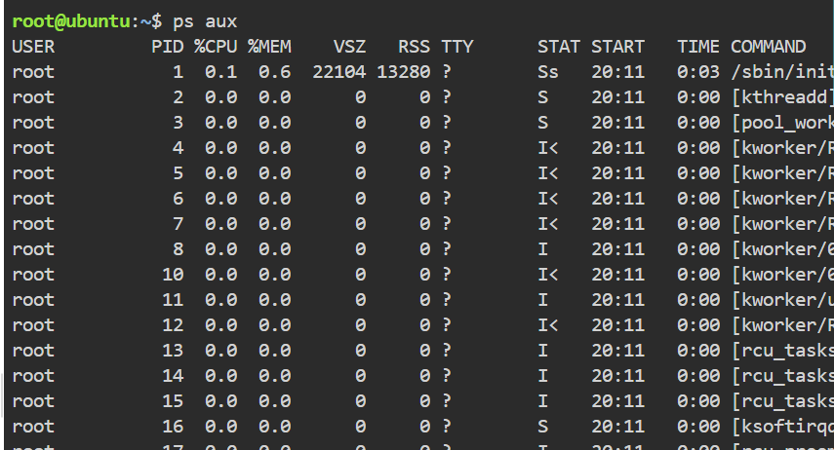
Figure 13: The ps aux command displaying all running processes in the Linux Ubuntu environment
A background process was created using sleep 100 &, which returned PID 1903. The ps aux | grep sleep command was then used to confirm the process was running. Finally, kill -9 1903 was used to terminate it. The output shows the process had already completed, confirmed by the message "Done sleep 100."
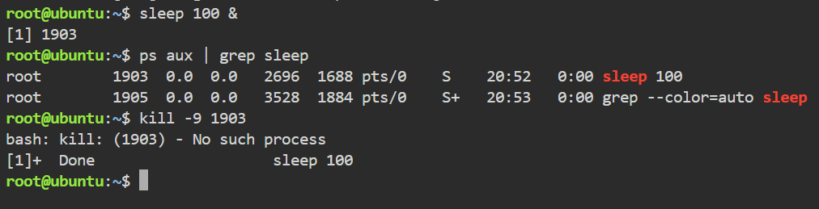
Figure 14: Using sleep 100 &, ps aux | grep sleep and kill -9 1903 to manage a background process in Linux
The ls -la command listed all contents of the home directory including hidden files. The -l switch shows detailed information such as permissions, owner and file size, while -a reveals hidden files starting with a dot. Files such as .bashrc and .profile are configuration files, while .ssh is a directory used for secure connections.
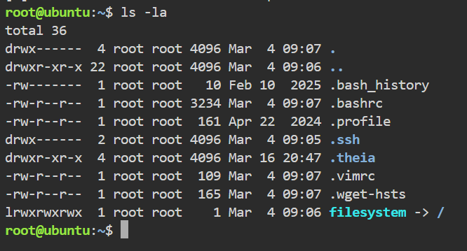
Figure 15: The ls -la command displaying all files and directories including hidden files in the Linux home directory
The mkdir testdir command created a new directory called testdir. Then cp /etc/hostname testdir copied the hostname file into that directory. Finally, rm testdir/hostname deleted the file. These three commands demonstrate basic file and directory management in the Linux terminal.
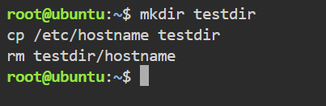
Figure 16: File management commands mkdir, cp and rm used to create a directory, copy a file and delete it in Linux
The ping -c 4 google.com command sent four packets to google.com. All four packets were received with response times of 4.48ms, 4.15ms, 4.34ms and 4.42ms. The statistics confirm 0% packet loss with an average round trip time of 4.346ms, showing a stable network connection.
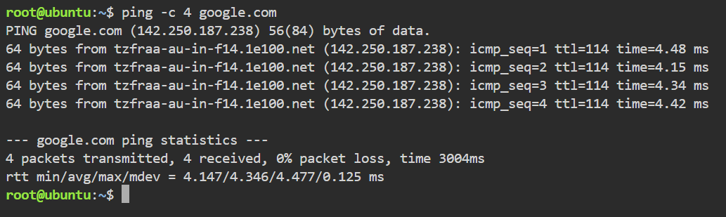
Figure 17: The ping -c 4 google.com command testing network connectivity in Linux

The ip addr command displayed all network interfaces on the system. The loopback interface lo has IP address 127.0.0.1, which is used for internal communication. The main network interface enp1s0 has IP address 172.30.1.2 and is active. A Docker network interface is also visible with IP 172.17.0.1.
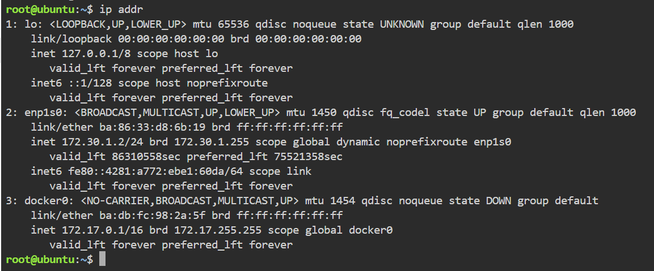
Figure 18: The ip addr command displaying network interface configuration in Linux
The whoami command returned "root", confirming the current user is the system administrator. The id command provided more detail, showing uid=0, gid=0 and groups=0, all assigned to root. In Linux, uid=0 means the user has full administrative privileges over the system.
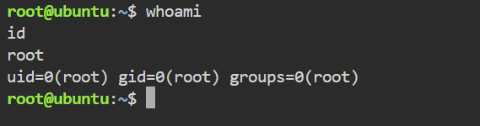
Figure 19: The whoami and id commands displaying current user information in Linux
The crontab -l command lists all scheduled tasks for the current user. The output shows "no crontab for root", meaning no automated tasks have been configured yet. In a real environment, crontab entries are used to schedule scripts or commands to run automatically at set times.
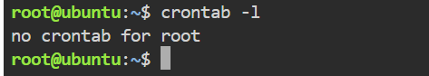
Figure 20: The crontab -l command showing scheduled tasks for the root user in Linux

Use of Windows OS scripts.
Script 1 is a Batch script that demonstrates the use of variables, user input and conditional statements. Three variables are defined: username, date_today and os. The script displays a formatted system information report showing the current user as "Admin", the date as 03/17/2026 and the operating system as Windows 11. The user is then asked whether they want to see running processes. When "yes" is entered, the script runs the tasklist command and displays all active processes.
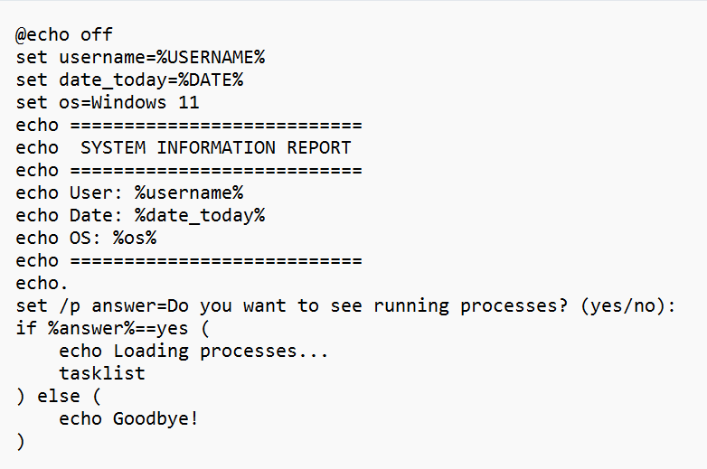
Figure 21: Script 1 - System Information Batch script code showing variables, user input and conditional statement
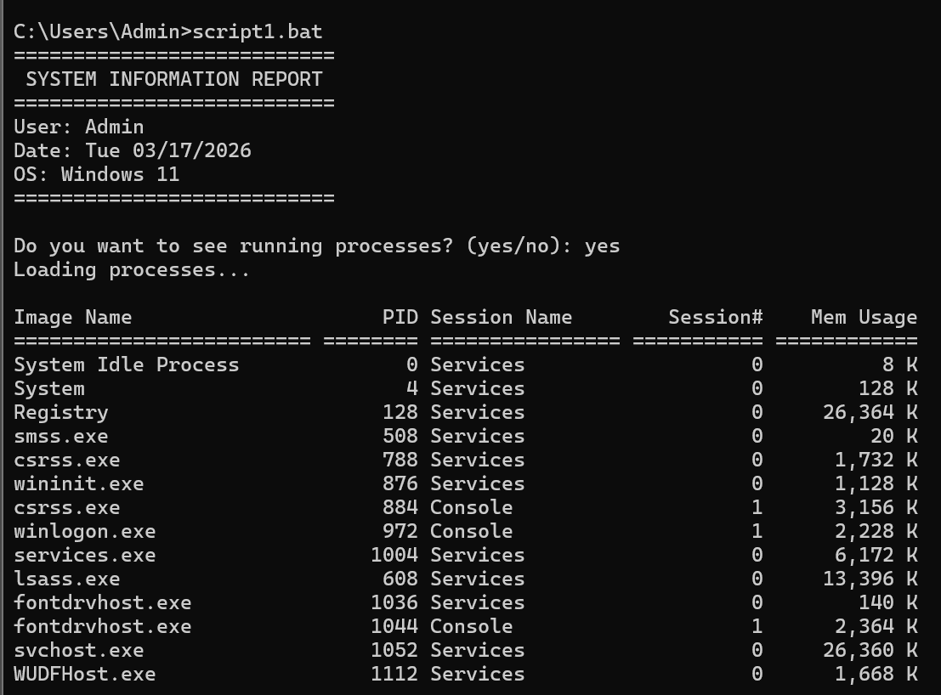
Figure 22: Script 1 execution output showing system information and running processes after user entered "yes"
Script 2 is a Batch script that demonstrates variables, user input, arithmetic operations and a loop. The user enters two numbers which are stored as variables. The script then calculates both the sum and product using the set /a command. The results are displayed in a formatted output showing 5 + 3 = 8 and 5 x 3 = 15. A loop using :loop and go to then counts from 1 to 3, demonstrating basic iteration in Batch scripting.
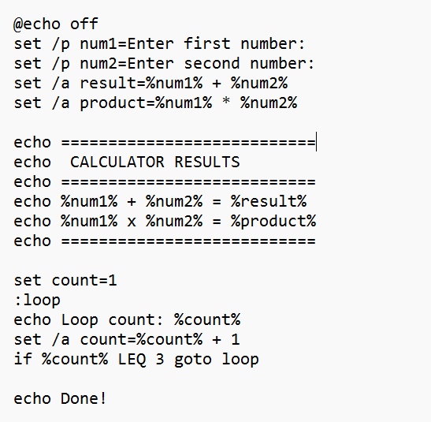
Figure 23: Script 2 - Calculator Batch script code showing variables, user input, arithmetic operations and a loop
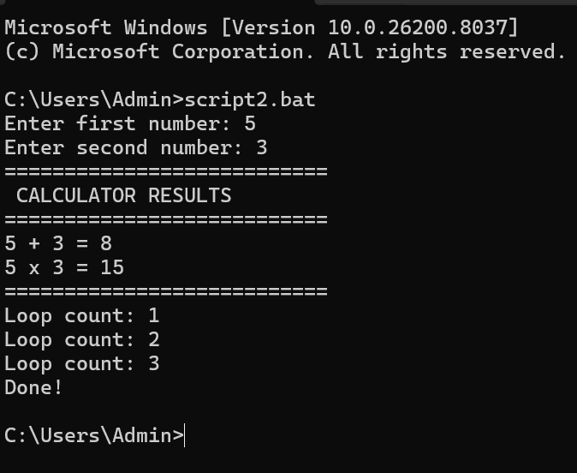
Figure 24: Script 2 execution showing calculator results: 5 + 3 = 8, 5 x 3 = 15, and loop counting from 1 to 3

Use of Linux OS scripts.
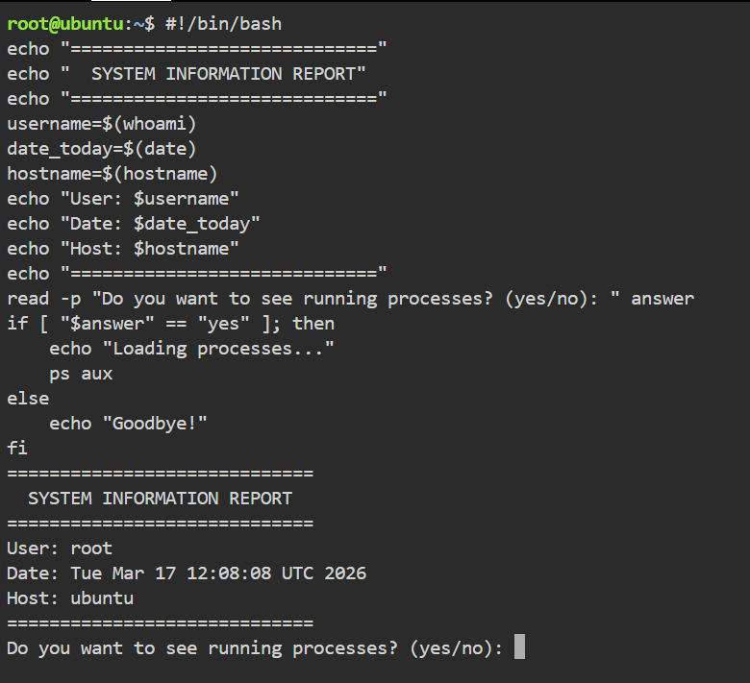

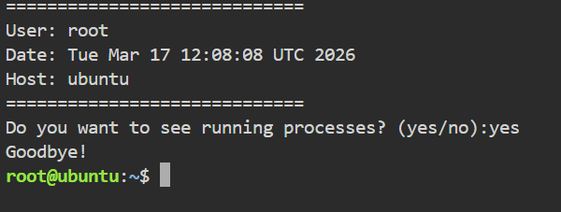
Script 1 is a Bash script that uses variables, user input and a conditional statement. Three variables are defined using command substitution: username stores the result of whoami, date_today stores the output of date, and hostname stores the system name. The script displays a formatted report showing User: root, Date: Tue Mar 17 12:17:31 UTC 2026 and Host: ubuntu. When the user enters "yes", the script runs ps aux and displays all active processes.
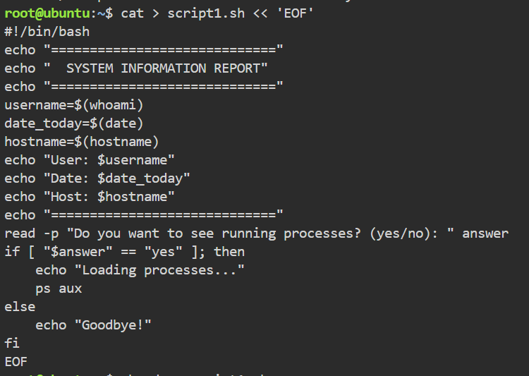
Figure 25: Script 1 - Bash script code showing variables, user input and conditional statement
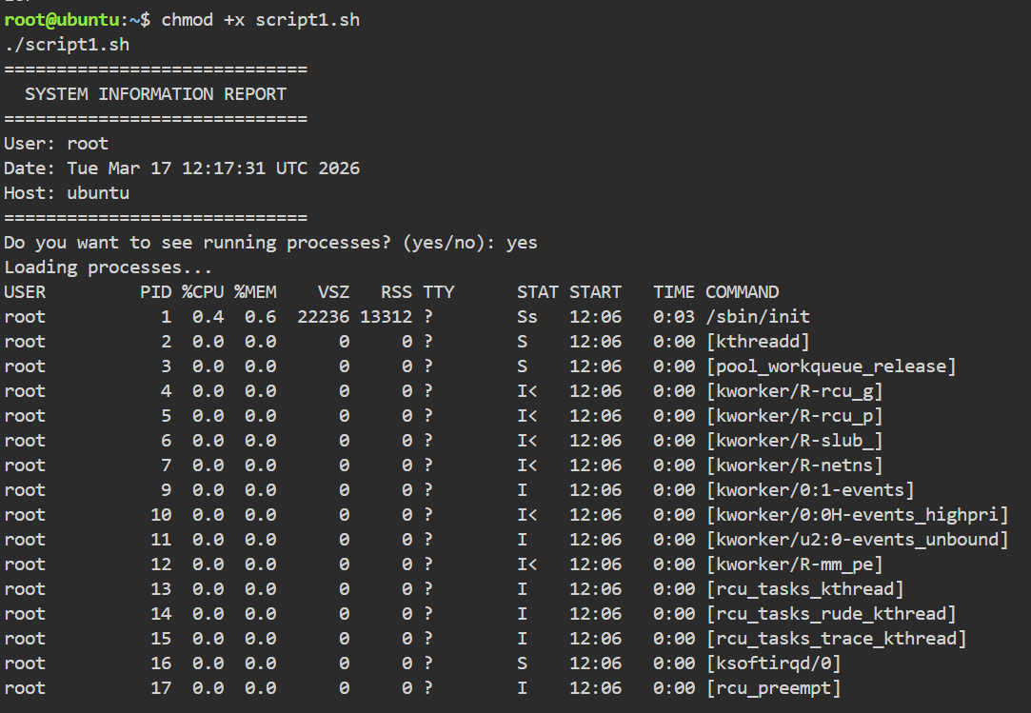
Figure 26: Script 1 execution showing system information - User: root, Date: Tue Mar 17 UTC 2026, Host: ubuntu - and running processes after entering "yes"

Script 2 is a Bash script that demonstrates user input, arithmetic operations and a while loop. The user enters two numbers which are stored as variables. The script calculates the sum and product using $(( )) arithmetic syntax, displaying 5 + 3 = 8 and 5 x 3 = 15. A while loop then counts from 1 to 3, incrementing the count variable each time until the condition is no longer true, ending with "Done!"
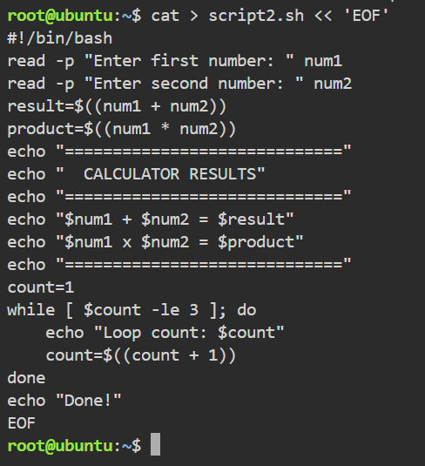
Figure 27: Script 2 - Bash calculator script code showing variables, arithmetic operations and a while loop
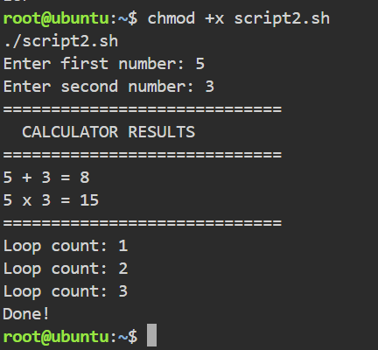
Figure 28: Script 2 execution showing calculator results: 5 + 3 = 8, 5 x 3 = 15, and loop counting from 1 to 3

Conclusion
This report has explored the key functions and practical management of modern operating systems, focusing on both Windows and Linux environments. The first section demonstrated that operating systems perform four essential functions: process management, memory management, file system management, and security. These functions work together to ensure the system runs efficiently and securely.
The second and third sections showed practical use of CLI commands on both Windows and Linux. On Windows, commands such as tasklist, taskkill, ipconfig and schtasks were used to manage processes, files, network and scheduled tasks. On Linux, equivalent commands including ps aux, kill, ls -la and crontab performed similar functions, demonstrating that both systems follow the same core principles despite different syntax.
The fourth and fifth sections demonstrated basic scripting on both platforms. The Batch and Bash scripts successfully used variables, user input, arithmetic operations and loops to automate simple tasks. This shows that automation through scripting can save time and reduce manual work in real-world environments.
Overall, this report has shown that understanding operating systems at command-line level is an essential skill for anyone working in computing.

References
[1] A. Silberschatz, P. B. Galvin and G. Gagne, Operating System Concepts, 10th ed. Hoboken, NJ: Wiley, 2018.
[2] A. S. Tanenbaum and H. Bos, Modern Operating Systems, 4th ed. London: Pearson, 2015.
[3] Microsoft, "Task Manager," Microsoft Learn, 2024. [Online]. Available: https://learn.microsoft.com/en-us/windows-server/administration/windows-commands/tasklist
[4] Microsoft, "Windows commands reference," Microsoft Learn, 2024. [Online]. Available: https://learn.microsoft.com/en-us/windows-server/administration/windows-commands/windows-commands
[5] Microsoft, "Net user command," Microsoft Learn, 2024. [Online]. Available: https://learn.microsoft.com/en-us/windows-server/administration/windows-commands/net-user
[6] Microsoft, "Ping command," Microsoft Learn, 2024. [Online]. Available: https://learn.microsoft.com/en-us/windows-server/administration/windows-commands/ping
[7] The Linux Foundation, "Linux man pages," die.net, 2024. [Online]. Available: https://linux.die.net/man/

Appendices
Appendix 1 - Tutorial Activity on OS Types
What is an Operating System? An OS is software that connects the user with the hardware. Without it, you cannot use a computer. I learned that Windows, Linux and macOS are all examples of general-purpose operating systems.
Types of Operating Systems In the tutorial I learned there are different types:
General-purpose OS - like Windows 11 on my laptop
Mobile OS - like Android on phones
Real-time OS - used in hospitals or factories where speed is critical
Difference between Windows and Linux Windows is easier to use because it has a graphical interface. Linux is more technical but free and open-source. During this assignment I used both systems and noticed that Linux commands are shorter but more powerful.
Appendix 2 - Lecture Activity Log
Evidence of engagement with module lectures
Lecture 1 - Introduction to Operating Systems In this lecture I learned about the main types of operating systems including Windows, Linux and macOS. We discussed how an OS manages hardware and software resources and why it is essential for any computer system.
Lecture 2 - Process and Memory Management This lecture covered how the OS schedules processes using the CPU and how RAM is allocated to running programs. I learned about virtual memory and how it is used when RAM is full.
Lecture 3 - File Systems and Security We looked at how files are organised on storage devices using file systems such as NTFS on Windows and ext4 on Linux. The lecture also covered user accounts and access permissions.
Lecture 4 - Command Line Interface In this lecture we practised using CLI commands on both Windows and Linux. I learned how to navigate directories, manage files and monitor system performance using the terminal.

Appendix 3 - Evidence of Engagement with Online CPD Course
Cisco Networking Academy - Operating Systems Basics
I enrolled in the Cisco Networking Academy "Operating Systems Basics" course to support my learning for this assignment. The course covers four main modules: The Windows Operating System, Linux Overview, Application Software and Mobile Operating Systems and Security. The screenshots below show my engagement with the course including Module 2 Linux Overview and Module 4 Mobile Operating Systems.





