
Skills for the Workplace
Module Assignment Submission
Student Name: | Sarah-louise Johns
Student Number: | 2012606
Module No: | BMSK4005
Module Title: | Professional Career Development

Statement of Confirmation of Authenticity
By the act of making this submission, the student declares that this is the work of the student named above. The work has not, in whole or in part, been knowingly presented elsewhere for assessment, or where assessment has been built on a previous assessment, this has been identified. Where materials have been used from other sources it has been properly acknowledged. If this statement is untrue, the student acknowledges that an assessment offence has been committed.
Attention is drawn to the plagiarism and unfair practice policies of both the University and of ILM.

Table of Contents
Section 1: Know how to identify development needs 3
1.1 Identify learning styles for self and another 3
1.2 Use a simple technique for identifying development needs for self & another 4
1.3 Identify potential barriers to learning for self and another. 6
1.4 Explain how these barriers to learning can be overcome. 6
Section 2: Know how to develop self & others to achieve organisational objectives 6
2.1 Analyse learning/development options to meet needs of self & another. 6
2.2 Identify support mechanisms for the development of self & another 7
2.3 Prepare development plans for self & another 7
Self 7
Person 2 8
2.4 Method used to monitor the development of self & another. 9
Section 3: Know how to prepare for the recruitment process 10
Reflection on the Recruitment Process 10
3.1 Description 10
3.2 Feelings 10
3.3 Evaluation 11
3.4 Analysis 11
3.5 Conclusion 11
3.6 Action Plan 11
References 12
Appendix A 12
Appendix B 12
Appendix C 12

Section 1: Know how to identify development needs
Identifying the development needs of a person whether it is you or another person using the VARK method, it was evident that everyone experiences different methods and techniques of learning in order to absorb the information provided to them.
This method can identify the following; visual, audio, reading and writing and there are a number of ways in which you can identify individual development needs. For example, you may receive feedback from colleagues or your tutor/teacher about an area in which you are weaker. You may have an interest in a particular area and want to develop your knowledge and skills. Identifying learning and development needs starts with knowing yours or another’s current and future needs and then assessing existing levels of skill, attitudes and knowledge. This then provides options for development.
For example; I wish to progress further in my career. Currently, in my position as a care giver, I don’t have the skills and knowledge to qualify for a higher ranking position. I would therefore have to find out what is required in order to gain this position and then look at some practical ways for me to advance my current skill and knowledge in order to be able to progress.

Identify learning styles for self and another

After taking the VARK questionnaire, It was clear that my strongest area of learning was through reading and writing. I believe this to be true, as my love for reading developed through my mother, who was also a passionate and keen reader of many books. It was a passion that was passed down to me and as a result I still continue to use this method of learning to this day. This type of learning style would mean that in order to gain further knowledge I would find it easier and more beneficial exploring inside a book rather than try an alternative method. Whilst I understand that this is my preferred personal learning style, I also can identify that my weakest learning style would be that of visual and audio.
When asking the same questions to another participant, it showed that their preferred learning style was through visual demonstration. This visual learning style was developed from a young age and still plays a big role in their ability to progress further. Their weakest area was learning through reading and writing. This person would find it rather difficult to absorb information if they were asked to complete a task given via a leaflet/book and they would have a better learning experience with a more hands on approach in order for them to take in the information shown to them in a working environment or any given task

Self
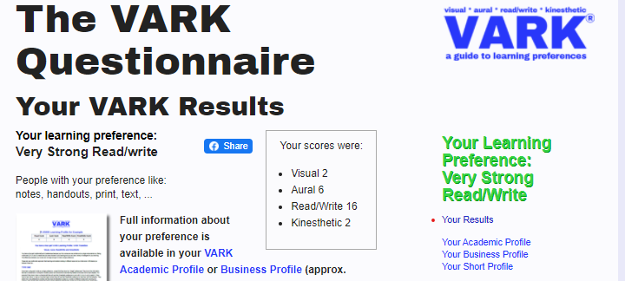
Honey and Mumford
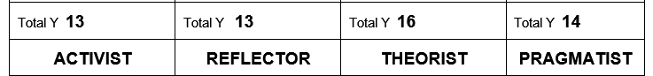

In my Honey and Mumford styles, I can see that my strongest style is that of a theorist. accepting my strengths are in building a concept of a theory on the basis of my analysis. I find I am good at taking different pieces of information and finding the ways that they function. I find reading or researching the information to be a start of topic.

Other Person
In the Honey and Mumford styles, I can identify that the strongest learning style for person 2 was that of a activist. The person benefits for a hands on approach. They tend to go with most thing and enjoy having a go…. Activists are considered to be most keen to DO in terms of a learning cycle.
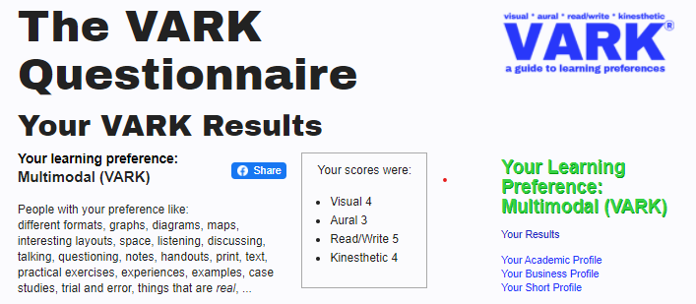

Use a simple technique for identifying development needs for self & another
- Asking question, though it is simple it can be beneficial to myself to receive feedback
- Monitor my performance
- Make a development plan for myself

These techniques benefit both myself and person 2…..

SWOT Person 1

STRENGTHS  Observant  Patience  Multitasking  Good listener  Always caring for others  Organising  Independent  Strong minded  Opinionated  Positive attitude  Team player | WEAKNESSES  Audio learning  Public speaking  Modern technology  Stubborn  Over caring on occasion
OPPORTUNITIES  Applying drive and determination to turn weaknesses into strengths.  Improving my level of learning skills.  Improving my knowledge by researching. | THREATS  Becoming discouraged and low due to difficulties when implementing the development plan of action.  Losing motivation easily.

Identify potential barriers to learning for self and another.
The several barriers I have identified have the potential to impact negatively on me and/or another to learning. I will expand on these individually to show the pros and cons on how these can be barriers to someone such as myself who is a single parent in education and how it affects another person.
CHILDCARE
As a single parent with 3 children of school age, I currently have the ability to learn remotely given the circumstances around the present pandemic. This means that while I can develop and learn from home and have the resources available to myself such as online classes, it means that this is not a current barrier to myself. However, when classes are to resume outside of the home and within the university this would become an issue. Whilst I have an older child who can be left unattended given her age, I then have to think and priorities, plan and organise childcare for my other 2 children. This example would then be a barrier if I was unable to pre plan arrangements in order for me to attend these classes within the university. This I identify as a barrier….
The childcare barrier however does not apply to the other participant due to having no children currently.
FINANCE
Expanding a bit form above, being a single mother and currently unemployed I rely upon the government UC. This set amount given to myself is to cover expenses within the home for myself and that of my children. As many would understand this amount has to be budgeted and therefor many things have to take priority….. for example; once I have covered the food bill, clothing, school funds, energy supply, there isn’t a lot left so I then have to think about travel expense, could I afford travelling back and forth to the university?. Could I stretch my finance to get supplies?, could I afford childcare for my children? And so on….. another barrier could also appear in a form of weather I could financially afford an internet bill. If I was unable to cover these costs I could not have the ability to learn remotely as I am currently doing. Another example of financial barrier is the fact without the assistance of student finance I could not afford the fees in order to study to better my skills, knowledge.
Many others however have the benefit of not needing the help and financial support in order for them to study so this wouldn’t be a barrier to them.
TRAVEL
This barrier however can apply to anyone. Whilst there are many travelling options such as a car, train, public transport etc, the financial barrier can also tie within this bracket. For example;
A car requires tax, mot, insurance….. can these expenses be covered in order for u to have the luxury of using a car…. For many this isn’t an available option such as myself who has to rely on public transport. Those few who are lucky enough to live closely within the proximity of the university can walk the distance, however those with possible physical health issues or disabilities don’t have that option and rely on other forms of transport.
SUPPORT
Support can come in many forms such as family, friends, class mates, tutors, partners, children, agencies, doctors etc…… I find that having support whilst learning is crucial to anyone including myself. I’m grateful for the fact I’m surrounded by support. I know I can turn to any of the above and find the support I need.
Whether it is physically, emotionally, financially, or even just to have a break mentally. I also acknowledge that there are people within the university and my class, who may feel like they have no support. This can be a barrier for others as some may also find it difficult to open up and reach out for that support.

1.4 Explain how these barriers to learning can be overcome.
PRIORITIES
Recognising what your priorities are first and foremost is so important. You should take all the above and write down what is most important. for instance in my personal circumstances I would firstly have to prioritise my home and my children then see what my options are and what I can and can’t do.
Can I cover all house expenses on a budget? (finance) this is vital to learning how to make decisions and recognising where I/others need the support….
Can you get childcare? (support network) do I/others have the support in order to attend the university.
Can you afford the childcare? (finance) always best to research what options are available via support network and online through DWP….
Can you afford the transport to the university on a daily basis?
Can you provide time to commit to learning? (planning)
Doing some research is always best before jumping into a commitment.
All these barriers can be overcome with support and advice…..
Overcoming any barrier can seem quite overwhelming. However, making sure you have done all your research in advance and doing the following which all seem to tie and link together will help myself and others.
Time management
keep a diary for classes, posted notes. Setting alarms. Get into a routine.
Babysitter/ child care make sure the people/person you have asked to provide care for understands that you have made a commitment in attending your classes and in return, ask them if they are committed to you in order for you to keep attending.
Outside help Research what help is available. There are so many options available to anyone wishing to gain higher education. Such as, student finance if your need financial assistance, knowing where to start… speak to a career advisor. Ask the university for assistance. Ask within your support network. If you don’t have internet access, research where your nearest library is and what’s the policy for using they’re computers in order for you to study etc..
Finance Over research as much as possible. Understand what support you can get.
Preparation in all said above can help overcome a barrier to learning. When you have prepared yourself, mentally, financially, physically and more, your already half way through in breaking those barriers to learning down.
Selfcare;
While it is a key to prioritise, it is also important to remember yourself. You have to make yourself a priority too. Looking after yourself mentally should be top of any list. I believe it can benefit you in many ways. I myself have my time when my children are in bed. I will priorities and prepare they’re school uniforms ready for the morning or even they’re lunches then I have a bit of me time.
I find having a bubble bath helps to relax my muscles and allows me to clear my head from all the stress of the day. Listening to music I also find is my go-to when I feel most stressed and this helps to calm me into a relaxing mood.
There are many more ways in order to help with personal selfcare;
- Talking on the phone
- Going for a walk
- Listening to music
- Think of some good memories that make you smile or laugh
- A bath
- Some may find cooking a form of relaxing
- Confidence building
- Give yourself some positive motivation

Section 2: Know how to develop self & others to achieve organisational objectives
Time management; Set alarms so I or other, get used to a routine of getting up on time, getting to where I or other, need to be at an acceptable time. Set my goals to a time frame.
Preparation; always prepare for whatever i have to study for, or for whatever task I’m/other are asked to fulfil within the workplace.
Prioritising; always prioritise what is most important to myself/other
Financial advice; seek as much advice as possible to know what options are available to self/other
Routines; get myself/other into a routine, set times for each task…… home… study….. work…..etc
Pre prepare;; always pre prepare on anything i/other wish to achieve
Research; get all the details and research as much as possible on the topic I/other require
Online assistance

2.1 Analyse learning/development options to meet needs of self & another.
Analysing the learning development options came come in the form of class mates, support groups, management, many cases can be your supervisor. All observations in these fields may help with mine or another’s development. It’s all about also knowing your abilities.

2.2 Identify support mechanisms for the development of self & another

I identify my support mechanisms to be that of my family and partner. I find myself lucky that I have this positive support to turn to on a daily basis. During my time on this current course I can also identify that my tutor is also a form a support mechanism as I can turn to her for support regarding my work, my worries, my concerns etc. I also identify my class mates to be a support. I feel that as a group should myself or another have difficulty in understanding a topic, then there are people there ready to help and support me through my time of need.
Person 2;
Identifying the support mechanisms of another it was quite nice to hear this person also has a large family network who offer support in the form of emotion, physical, and rarely but finance support. they also encourage him to gain further in life and work. He also finds that his supervisor, is a good support for him, and that of friends.

2.3 Prepare development plans for self & another

Self

Part 1: Personal Analysis
See SWOT Analysis in 1.2

Part 2: Setting Goals

What do I want to learn? | What do I have to do? | What support and resources will I need? | How will I measure success? | Target Date for Review
How to gain more experience in the care sector | Study the topic inside and out, research | Internet, agencies, work experience  Friends, family | By how much I’ve learnt. Compare start to currently. | 12 months
Apply to study for the job I require | Preparation  Research  Gain experience, knowledge | Friends and family  Online research  Tutor  Supervisor  Internet | By how much more I have learnt and the understanding of every topic | 24 months
I want to be a qualified health care provider/ nurse | Continue to learn alongside someone with experience, continue university  Always expect changes and learn as times change | Tutor  Online research  Friends  family | By gaining the degree I set out to gain then using my knowledge and skill to adapt to wherever I may go within the care sector | 3 years

Part 3: Personal Objectives

Short Term Goals (next 12 months)

Pass the CertHE course

Medium Term Goals (2-3 years)
Learn how the company operates, understand what skills I need to progress, GET THE DEGREE

Long Term Goals (3-5 years)
Gain the qualifications needed to put into action all that I’ve learnt… NEW JOB

Person 2

Part 1: Personal Analysis
SWOT Person 2

STRENGTHS  Motivated  Strong minded  Always willing to learn new  Caring  Hard working | WEAKNESSES  Stubborn  Impatient  No patience  IT technology
OPPORTUNITIES  Apply my drive and passion to learn new skills  Learn something new  Show determination in all areas | THREATS  Loose motivation quickly  Ability to wait patiently

Part 2: Setting Goals

What do I want to learn? | What do I have to do? | What support and resources will I need? | How will I measure success? | Target Date for Review
Business law | Attend university | Family/friends  Research online | How far I can take it | 12 months
How a business is run and operated | Gain experience, take all the information available and support | Tutor,  Family  Friends  Online  Workplace supervisor | How much more understanding I have of how things operate | 24 months
Gain the degree and open a business | Take everything I know and put it into action | Stated above | If I am to succeed | 3 years

Part 3: Personal Objectives

Short Term Goals (next 12 months)
Research courses and support available
Medium Term Goals (2-3 years)
Attend university to gain the knowledge

Long Term Goals (3-5 years)
Get a degree and set up a business

2.4 Method used to monitor the development of self & another.
Methods I currently use are the following
Calendar…… keep a reminder of dates, classes, home life, appointments etc
Diaries………..it’s always a good way to express your feelings and emotions when writing them down.( coping mechanism). It is also good to keep record of things past and upcoming
Planning……….the more I prep, the more I plan, the smoother my day goes. It also helps to plan things in advance for future commitments
- Research
- Posted notes
- Self praise
All that have been listed above benefit myself and other as a method to monitor current and future development needs.

Person 2;
The methods currently being used are very similar to my own.
Alarms set via phone with alert messages
Posted notes
Relying on family to inform with 24h notice

Section 3: Know how to prepare for the recruitment process

Reflection on the Recruitment Process


Gibbs (1988)

3.1 Description

Example of COMPETENCY BASED INTERVIEW ( THE STAR APPROACH)
THE ACRONYM STAR STANDS FOR THE FOLLOWING; Situation Task Action Result

STEP 1; SITUATION OR TASK….
DESCRIBING A SITUATION;
There was an occasion in my previous job where I had to deal with a difficult client. It wasn’t my client however, my co- worker was dealing with the situation. Whilst handling paperwork on a case I was writing up about, I couldn’t help but overhear the commotion outside of my office door. I could hear my co worker requesting if the client could lower her voice, however this seemed to anger her more therefor my co- worker couldn’t seem to calm the lady for her to explain what the matter/situation was. After offering some assistance it came to light that the client had been given wrongful information and it of course, frustrated her. I realised that all the situation needed was for some time and a calm environment to explain/ answer any worries/questions the client had..

STEP 2; ACTION…….
ACTION TAKEN FOR THE SITUATION;
I OFFERED MY CO-WORKER SOME ASSISTANCE BY TAKING THE TIME TO TALK TO THE CLIENT IN A CALM AND QUIET INVIROMENT WHERE SHE WOULD BE FREE TO EXPRESS ANY CONCERNS/WORRIES/QUESTIONS WITH MYSELF.. I OFFERED HER MY TIME TO WHICH I WAS HAPPY TO DO, AS THIS WAS A SITUATION THAT COULD HAVE CHANGED DIRECTION AT ANY TIME. AFTER OFFERING THE CLIENT A BEVERAGE TO CALM THE ANGER SHE POTRAID IT WAS CLEAR THIS WAS BEING EFFECTIVE AS HER ANGER SEEMED TO SETTLE KNOWING SHE COULD TALK TO MYSELF AND ID BE THERE TO ANSWER.WHILST LISTENING TO THE CLIENT, IT WAS A CLEAR CASE OF MISS COMMUNICATION. THE CLIENT HAS HEARING ISSUES AND AS A RESULT, THINGS THAT WERE TOLD TO HER SHE MISS HEARD AND THEREFOR GOT ANGRY WHEN SHE QUESTIONED WHAT SHE THOUGHT SHE HAD HEARD…

STEP 3; RESULT
HOW THE SITUATION ENDED;..
I WAS EFFECTIVE IN ASSISSTING THE CLIENT WITH THE CORRECT INFORMATION AND OFFERING AN APOLOGY ON BEHAVE OF MYSELF AND MY CO-WORKER FOR THE UNFORTUATE CIRCUMSTANCES THAT LED TO THE SITUATION. I FELT IT WAS IN MY BEST INTEREST TO STEP IN AND OFFER THAT SUPPORT TO BOTH MY CO-WORKER AND CLIENT AFER BEING ABLE TO RECOGNISE THAT THE CLIENT HAD HEARING DIFFICULTIES, I HAD THE KNOLEDGE IN SIGN LANGUAGE WHICH MADE THE SITUATION LESS CONFRONTATIONAL BY USING THIS METHOD OF COMMUNICATION. AFTER THIS I WAS ABLE TO PROVIDE MY CO-WOKER WITH VALUABLE INFORMAION REGARDING THE CLIENT FOR FURTHER COMMUNICATION SHOULD THERE EVER BE ANOTHER ACCURANCE SUCH AS THIS.

3.2 Feelings
I felt that the situation could have been handled a lot smoothly. I was happy in the fact I knew a skill (sign language) and was able to use it in order to assist both parties in that situation.

3.3 Evaluation
I found it to be both bad and good for the following reasons;
It was good for the co-workers looking in to see that there are many forms of communication. Having a bit of patience and being able to recognise the barriers and finding solutions around them is better for all involved in order to take the next step forward.

The bad part however was the fact that due to not recognising the communication barrier, a situation arose that could have not only been avoided but it could have been handled differently if my co-worker had just asked for assistance and support.

3.4 Analysis
In making sense of the situation I understand both sides, that of my co-worker and that of her client. I understand the frustration of the client as she was unable to say or express what she needed to and as a result the only way to express her anger was to (lash out) so that emotion could be visually seen.
I also understand from my co-workers point as to being unaware of her clients needs she was unable to communicate in the correct manner as a professional. However having insight into it now, I’m sure my co-worker will go forward and possibly develop a new learning in ways of communication.

3.5 Conclusion
I don’t think there was much more I could have assisted with, but I was happy to assist my co-worker and explain that she would either have to learn some basic signing in order to communicate with her client or she would have to ask for assistance when needing to communicate in future.

3.6 Action Plan
If the situation was to happen again and the communication barrier was still an issue, I think given my knowledge and skill of signing, I would have to request that if the client was to be present in future that I also to be present so I’m able to assist to avoid another conflict situation.

References

Gibbs, G. (1988) Learning by doing; A guide to teaching and learning methods. London: FEU

Appendix A

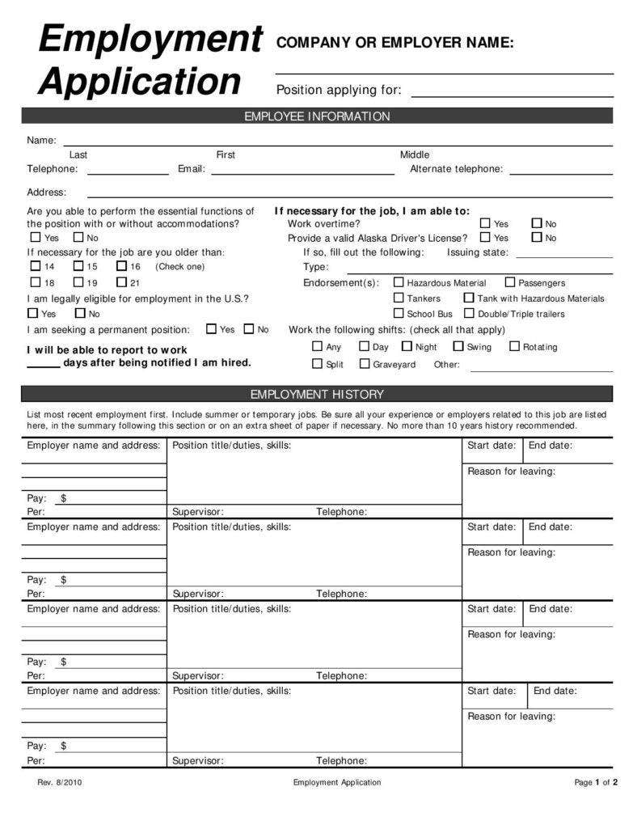

Appendix B

Sarah-louise johns
7 Paviland Place, Portmead, Swansea, SA5 5JT · 07394 393933
swensley1989@gmail.com
I’m enthusiastic and determined, with a strong work ethic and experience in customer service, hospitality, cleaning and care. Honest and trustworthy, with a friendly nature, I build effective working relationships, actively collaborating as part of a team, and using my own initiative to efficiently work alone. I am eager to gain new skills and experience, recently partaking in training to enhance my existing skills and knowledge. I adopt a flexible and responsible approach to work, displaying commitment and attention to detail, resiliently adapting to change and challenge.
Having gained esteemed academic qualifications, now that my children are older, I am seeking an opportunity to demonstrate my competence, whilst continuing to develop and progress my skills.
- Skills
- Willing & Eager to Help  - Receptive & Quick to Learn  - Reliable & Adaptable | • Builds Effective Working Relationships  • Self-motivating & Enthusiastic

- work history
    - mar 2014 – present
  - carer, swansea
Providing all elements of personal care, food preparation & service and administering medication for my disabled mother. Cleaning the home; laundry duties; organising her diary and accompanying her shopping and to appointments; proficient with the use of all medical machinery including oxygen & sleep apnea machines and changing oxygen tanks.

    - mar 2007 – sep 2007
  - kitchen assistant, salt/ the george, mumbles, swansea
Completing kitchen and bar duties as required at a popular public house. Carrying out food preparation, assisting the chefs, pot washing and ensuring the kitchen areas were hygienically maintained. Serving food and beverages efficiently, and polite interaction with customers.

    - aug 2006 – dec 2007
  - assistant kitchen manager, parkdean holidays ltd, porthcawl
Completing kitchen and bar duties as required, within a busy holiday resort. Carrying out food preparation; assisting the chefs; ensuring the kitchen areas were hygienically maintained; stock rotation and ordering. Serving food and beverages politely and efficiently, dealing with customer queries and complaints in a constructive manner.

    - aug 2005 – may 2008
  - cleaning supervisor, initial rentokil, llansamlet, swansea
Completing and overseeing all cleaning duties – vacuuming, dusting, mopping, waste disposal etc at Swansea’s Matrix Building. Monitoring consumables; stock checking and ordering; arranging the replacement of damaged office furniture; reporting incidents/ issues; staff rotas and short-notice cover; acting as a staff liaison with payroll/ admin queries etc.

    - apr 2005 – nov 2007
  - commercial cleaner, bhs, princess way, swansea
Carrying out all cleaning duties on the shop floor and staff areas of the large department store. Use of floor polishing machine, ensuring toilet areas hygienically maintained, working in accordance with COSHH and Health & Safety regulations.

    - feb 2004 – aug 2008
  - manager, donut den, swansea market, swansea
Efficiently serving customers at a busy stall; preparing beverages, doughnut batter and toppings; competent use of the machinery. Overseeing other staff members; organising staff rotas; training junior members of staff; assisting with staff recruitment and interviewing. Stock monitoring, rotation and ordering; cash handling & banking; maintaining accurate records on company databases.
- Education
    - 2020
  - care academy, highfield qualifications, alpha safety, swansea
Level 2 Award in Moving People Safely (RQF)
Level 2 Award in Safeguarding and Protecting Children & Young People (RQF)

    - 2014
  - entry levels 1, 2 & 3, gingerbread, neath Port Talbot
Health & Social Care
    - 2006
  - gcse, daniel james community school, swansea
A* English Literature; Mathematics; Drama; Food Technology; Child Development
A English (Language); Welsh (2nd Language); Geography; Design & Technology; Information
Technology
B Science – Dual Award (combined Biology, Chemistry & Physics); French; Italian; Physical
Education
- Activities
In my spare time I enjoy spending time with my children and planning educational outings. I enjoy reading, writing, organising, meeting up with friends & family, and also playing bells in the award-winning Swansea Silver Rhythmaires Marching Jazz Band.

references
Available upon request

Appendix C

Sarah-Louise Johns 7 Paviland avenue Portmead Swansea SA5 5JT
Mrs Jones Child Services Civic centre Swansea

RE; OPPORTUNITY IN SOCIAL CARE

Dear Mrs Jones
I am very keen in applying for the post of social worker that was recently advertised on the following website of indeed.com and enclose my CV for your consideration.
I am currently a social worker with 8 years of experience in the DEF social services department. My experience involves the successful management of a demanding caseload including the elderly and those younger with vulnerable learning disabilities and/or mental health issues. I have the ability to deal with what can be difficult and emotional issues in a calm and controlled environment whilst in a practical manner by locating the individuals best needs.
My ability to communicate and reach agreement with other agencies such as primary care practices and psychology, is first class and I have a team approach to establish what is best for each individual. I am used to working unsocial hours including evenings and weekends.
I would love the opportunity to discuss my application further with yourself and welcome the opportunity to attend an interview. I shall be in contact within a few days to check if an informal discussion about the post is possible.
I look forward to hearing from you
Yours thankfully
S Johns

Appendix D

Honey and Mumford
No. | Statements | Put Y or N
1 | I have strong beliefs about what is right and wrong, good and bad. | Y
2 | I often ‘throw caution to the wind’. | N
3 | I tend to solve problems using a step-by-step approach, avoiding any ‘flights of fancy’. | Y
4 | I believe that formal procedures and policies cramp people’s style. | Y
5 | I have a reputation for having a no-nonsense, ‘call a spade a spade’ style. | Y
6 | I often find that actions based on ‘gut feeling’ are as sound as those based on careful thought and analysis. | Y
7 | I like to do the sort of work where I have time to ‘leave no stone unturned’. | Y
8 | I regularly question people about their basic assumptions. | N
9 | What matters most is whether something works in practice. | Y
10 | I actively seek out new experiences. | Y
11 | When I hear about a new idea or approach I immediately start working out how to apply it in practice. | Y
12 | I am keen on self-discipline such as watching my diet, taking regular exercise, sticking to a fixed routine etc. | Y
13 | I take pride in doing a thorough job. | Y
14 | I get on best with logical, analytical people and less well with spontaneous, ‘irrational’ people. | Y
15 | I take care over the interpretation of data available to me and avoid jumping to conclusions. | Y
16 | I like to reach a decision carefully after weighing up many alternatives. | Y
17 | I’m attracted to novel, unusual ideas than to practical ones. | N
18 | I don’t like ‘loose-ends’ and prefer to fit things into a coherent pattern. | Y
19 | I accept and stick to laid down procedures and policies so long as I regard them as an efficient way of getting the job done. | Y
20 | I like to relate my actions to a general principle. | Y
21 | In discussions, I like to get straight to the point. | Y
22 | I tend to have distant, rather formal relationships with people at work. | N
23 | I thrive on the challenge of tackling something new and different. | Y
24 | I enjoy fun-loving spontaneous people. | Y
25 | I pay meticulous attention to detail before coming to a conclusion. | N
26 | I find it difficult to come up with wild, ‘off-the-top-of-the-head’ ideas. | N
27 | I don’t believe in wasting time by ‘beating about the bush’. | N
28 | I am careful not to jump to conclusions too quickly. | Y
29 | I prefer to have as many sources of information as possible, the more data to mull over the better. | Y
30 | Flippant people who don’t take things seriously enough usually irritate me. | Y
31 | I listen to other people’s point of view before putting my own forward. | Y
32 | I tend to be open about how I’m feeling. | N
33 | In discussions, I enjoy watching the manoeuverings of the other participants. | Y
34 | I prefer to respond to events on a spontaneous, flexible basis rather than plan things out in advance. | Y
35 | I tend to be attracted to techniques such as network analysis, flow charts, branching programmes, contingency planning etc. | N
36 | It worries me if I have to rush out a piece of work to meet a tight deadline. | Y
37 | I tend to judge people’s ideas on their practical merits. | N
38 | Quiet, thoughtful people tend to make me feel uneasy. | N
39 | I often get irritated by people who want to rush headlong into things. | Y
40 | It is more important to enjoy the present moment than to think about the past or the future. | Y
41 | I think that decisions based on a thorough analysis of all information are sounder than those based on intuition. | Y
42 | I tend to be a perfectionist. | Y
43 | In discussions, I usually pitch in with lots of ‘off the top of the head’ ideas. | Y
44 | In meetings, I put forward practical realistic ideas. | N
45 | More often than not, rules are there to be broken. | Y
46 | I prefer to stand back from a situation and consider all the perspectives. | N
47 | I can often see inconsistencies and weaknesses in other people’s arguments. | Y
48 | On balance, I talk more than I listen. | Y
49 | I can often see better, more practical ways to get things done. | Y
50 | I think written reports should be short, punchy and to the point. | Y
51 | I believe that rational, logical thinking should win the day. | Y
52 | I tend to discuss specific things with people rather than engaging in ‘small talk’. | Y
53 | I like people who have both feet firmly on the ground. | Y
54 | In discussions, I get impatient with irrelevancies and ‘red herrings’. | Y
55 | If I have a report to write I tend to produce lots of drafts before settling on the final version. | N
56 | I am keen to try things out to see if they work in practice. | Y
57 | I am keen to reach answers via a logical approach. | Y
58 | I enjoy being the one that talks a lot. | Y
59 | In discussions, I often find I am the realist, keeping people to the point and avoiding ‘cloud nine’ speculations. | Y
60 | I like to ponder many alternatives before making up my mind. | N
61 | In discussions with people I often find I am the most dispassionate and objective. | N
62 | In discussions I’m more likely to adopt a ‘low profile’ than to take the lead and do most of the talking. | N
63 | I like to be able to relate current actions to a longer-term bigger picture. | Y
64 | When things go wrong I am happy to shrug it off and ‘put it down to experience’. | Y
65 | I tend to reject wild, ‘off-the-top-of-the-head’ ideas as being impractical. | Y
66 | It’s best to ‘look before you leap’. | Y
67 | On balance, I do the listening rather than the talking. | N
68 | I tend to be tough on people who find it difficult to adopt a logical approach. | Y
69 | Most times I believe the end justifies the means. | Y
70 | I don’t mind hurting people’s feelings so long as the job gets done. | N
71 | I find the formality of having specific objectives and plans stifling. | N
72 | I’m usually the ‘life and soul’ of the party. | N
73 | I do whatever is expected to get the job done. | Y
74 | I quickly get bored with methodical, detailed work. | N
75 | I am keen on exploring the basic assumptions, principles and theories underpinning things and events. | Y
76 | I’m always interested to find out what other people think. | N
77 | I like meetings to be run methodically, sticking to the agenda etc. | Y
78 | I steer clear of subjective or ambiguous topics. | Y
79 | I enjoy the drama and excitement of a crisis situation. | Y
80 | People often find me insensitive to their feelings. | Y

2 | 7y | 1 Y | 5y
4y | 13y | 3 y | 9y
6y | 15y | 8 | 11y
10y | 16y | 12y | y19
17 | 25 | 14y | 21y
23y | 28y | 18y | 27
24y | 29y | 20y | 35
32 | 31y | 22 | 37
34y | 33y | 26 | 44
38 | 36y | 30y | 49y
40y | 39y | 42y | 50y
43y | 41y | 47y | 53y
45y | 46 | 51y | 54y
48y | 52y | 57y | 56y
58y | 55 | 61 | 59y
64y | 60 | 63y | 65y
71 | 62 | 68y | 69y
72 | 66y | 75y | 70
74 | 67 | 77y | 73y
79y | 76 | 78y | 80y
Total Y 13 | Total Y 13 | Total Y 16 | Total Y 14
ACTIVIST | REFLECTOR | THEORIST | PRAGMATIST

