Student Name: Fateha Altafi
Student ID : 2309157
Module: Community Care and Management of Longer-term Conditions
Module code: LCHS7003
Lecturer: Dr Aishat Bakre
Assignment Title: Component 1 Information Booklet of Long- term Condition Management

LIVING WELL WITH
DEMENTIA

A UK information booklet for people living with dementia and those who support them
Understanding the condition • Evidence-based care • Person-centred support
Prepared October 2026

Contents 3
1. Understanding dementia 4
2. Causes and risk factors 4
Non-modifiable risk factors 5
Modifiable risk factors 5
3. Physical, psychological and social impact 6
Physical and practical impact 6
Psychological impact 6
Social impact 7
Impact on families and carers 7
4. Diagnosis and evidence-based NHS treatment 7
Medicines 7
Non-drug support 8
5. Person-centered care and supported self-management 8
6. Models for improved long-term condition care 9
UK model: The House of Care 9
International model: The Chronic Care Model 10
7. National and local health and social care policy 12
Local agenda: Birmingham and Solihull 12
8. Planning ahead and end-of-life care 13
9. Recommendations for improving care 14
Conclusion 14
References 15
1. Understanding dementia
Dementia describes symptoms caused by diseases that damage the brain, affecting memory, thinking, communication, judgement, mood and everyday activities. It is not one disease or an inevitable part of ageing. Symptoms and progression differ, so support must reflect each person’s needs and preferences (NICE, 2018). Alzheimer’s disease is the most common cause and often affects learning and recent memory. Vascular dementia is associated with impaired blood supply to the brain and may follow a stroke. Dementia with Lewy bodies can involve fluctuating attention, visual hallucinations and movement difficulties, while frontotemporal dementia may initially affect language, behavior or personality (WHO, 2026; NICE, 2018). The WHO estimated that 57 million people were living with dementia worldwide in 2021, with nearly 10 million new cases annually. In the UK, the Alzheimer’s Society estimated around 982,000 people were living with dementia; numbers are expected to rise as the population ages (WHO, 2026; Alzheimer’s Society, 2024). Estimates vary with methods, age profiles and diagnosis rates, so they indicate service demand rather than predict an individual’s experience. Dementia can affect independence, relationships, finances and community participation, while increasing demand for health and social care and unpaid family support.

2. Causes and risk factors

Dementia usually develops through complex interactions between biological processes, health conditions and social circumstances. Risk factors can increase probability but rarely explain an individual case. Distinguishing risk from cause is important, population-level associations do not mean a person’s choices cause their dementia, and risk reduction cannot guarantee prevention.

Non-modifiable risk factors

Age is the strongest known risk factor because dementia becomes more common as people get older, although it is not an inevitable part of ageing. Family history and inherited genetic variants may increase risk; rare mutations can have a stronger effect, while common variants generally alter probability rather than determine outcomes. People with Down’s syndrome have a higher risk of Alzheimer’s disease because of genetic factors associated with chromosome 21. These factors show why dementia cannot be reduced to lifestyle choices alone (NHS, 2026; WHO, 2026).

Modifiable risk factors

High blood pressure, high LDL cholesterol and diabetes can damage blood vessels and increase vascular brain injury; identifying and managing them supports cardiovascular and brain health. Smoking, harmful alcohol use, obesity and physical inactivity are also associated with risk. Hearing loss, untreated vision loss, depression, social isolation, air pollution and limited educational opportunities have been identified as potentially modifiable factors (WHO, 2019; Livingston et al., 2024). Associations differ in strength and certainty, and some factors may interact across a lifetime. Access to healthy food, safe places to exercise, education and timely healthcare are unequal, so prevention advice alone can unfairly place responsibility on individuals. Services should combine practical support for vascular health, smoking cessation, sensory checks and social connection with action on barriers to access.

The 2024 Lancet Commission estimated that addressing 14 potentially modifiable risk factors could prevent or delay around 45% of dementia cases at population level (Livingston et al., 2024). This estimate models potential effects across populations; it is not a prediction for an individual and does not mean all cases are preventable. Prevention should therefore be presented as risk reduction, not a guarantee or a reason to blame people who develop dementia.

3. Physical, psychological and social impact

Physical and practical impact

As dementia progresses, a person may need more support with eating, drinking, sleeping, continence, mobility, medication and personal care. Some dementias also affect movement or swallowing, while pain may be difficult to communicate. Sudden confusion, reduced alertness, new walking problems or abrupt behavioral change should not automatically be attributed to dementia: infection, dehydration, pain, medicine effects or delirium may need prompt assessment. Delirium during hospital admission is associated with poorer outcomes for people with dementia (Han et al., 2022; NICE, 2018).

Psychological impact

A diagnosis can bring shock, sadness, fear, anger or relief. Some people experience anxiety, depression, hallucinations or distress as the condition changes. Behavior described as ‘challenging’ may communicate an unmet need: agitation, for example, may reflect pain, fear, noise, boredom or tiredness. Staff should investigate causes and try calm communication, meaningful activity and environmental changes before medication, unless severe distress or immediate risk requires urgent action (NICE, 2018). Person-centred approaches may improve quality of life and some psychological or behavioral outcomes, although studies differ in setting, intervention and outcome measures (Kim and Park, 2017; Lee et al., 2022). This uncertainty supports individual review rather than assuming one intervention will work for everyone.

Social impact

Dementia may affect friendships, hobbies, driving, employment, money management and familiar social roles. Stigma, inaccessible services and communication difficulties can lead to isolation; busy social settings may become tiring. Familiar routines, meaningful activities, supportive relationships and dementia-friendly communities can help preserve identity and wellbeing. Care planning should consider culture, language, faith, housing, finances and relationships rather than treating everyone alike. Under the Mental Capacity Act 2005, capacity is decision-specific and time-specific: a diagnosis alone does not remove the right to decide, and people should receive practicable support to make their own choices.

Impact on families and carers

Relatives and friends may provide meals, personal care, transport, supervision, reassurance and advocacy. These responsibilities can affect sleep, employment, finances, relationships and carers’ own health. Research links carer quality of life with health, relationship quality and access to formal help; loneliness is also a concern (Oliveira, da Mata and Aubeeluck, 2024; Liao et al., 2024). Professionals should ask what support a carer is willing and able to provide, rather than treating family care as unlimited or cost-free. In England, a Care Act 2014 carer’s assessment can consider wellbeing, work, relationships and whether caring remains sustainable. Information, respite, peer support and attention to carers’ own health should be offered according to need. With consent, families can contribute valuable knowledge while confidentiality and the person’s wishes remain central (Care Act, 2014; NICE, 2019).

4. Diagnosis and evidence-based NHS treatment

Anyone who is worried about changes in memory or their ability to manage everyday tasks should contact their GP. An initial assessment may include discussing the changes, a physical examination, reviewing medicines, blood or urine tests and an assessment of thinking and memory. If dementia remains a possibility, the GP may refer the person to a memory clinic or another appropriate specialist. A diagnosis should lead to understandable information, an agreed plan and ongoing support, rather than leaving the person and their family to work out the system on their own (NICE, 2018).

Medicines

For those individuals with mild to moderate Alzheimer’s disease, NICE recommends that drugs such as donepezil, galantamine or rivastigmine might be considered. Memantine can be used in the case of moderate Alzheimer’s disease when these drugs cannot be employed, or in cases of severe Alzheimer’s disease.

Clinicians should discuss likely benefits, side effects, monitoring and the person’s priorities before treatment. These medicines may provide modest symptomatic benefit for some people, but they do not cure dementia or reverse brain damage. Suitability depends on dementia subtype, other conditions, interactions and the person’s response; treatment should be reviewed and stopped or changed when appropriate in line with guidance (NICE, 2011; NICE, 2018). The aim is a shared decision, not prescribing automatically because a diagnosis has been made.

Non-drug support

Group cognitive stimulation therapy should be offered, where appropriate, to people with mild to moderate dementia. Themed activities and discussion can support cognition and social interaction. Cognitive rehabilitation and occupational therapy can help people pursue meaningful goals, adapt routines and continue daily activities. Physical activity, hobbies, communication support, hearing and vision care, pain management, sleep support and psychological treatment for anxiety or depression may also help. Reviews report benefits for some outcomes, but study quality, interventions and effects vary, so services should avoid promising a uniform result (NICE, 2018; Desai et al., 2024; Cao et al., 2023; Bennett et al., 2019; Ojagbemi and Akin-Ojagbemi, 2019). When distress occurs, staff should check for pain, infection, medicine effects, unmet needs and environmental triggers. Antipsychotics are not a routine response because they carry serious risks; they should be considered only for severe distress or risk of harm, with careful monitoring and review. Care should be reassessed as needs change, prioritising comfort, independence and quality of life.

5. Person-centered care and supported self-management

Person-centered care recognises that everyone has a personal history, relationships, abilities, preferences and rights. The person should not be defined only by their symptoms. In practice, this means listening to their views, adjusting how information is shared, providing meaningful choices and involving relatives in ways that respect consent and confidentiality. This approach depends on the principle that the person must remain central to care, rather than being defined by dementia (Kitwood, 1997; Brooker, 2007).

NICE advises services to support people to express their views and adapt information to their circumstances and stage of dementia (NICE, 2018; Serbser-Koal et al., 2024). Supported self-management aims to preserve choice and control; it does not mean leaving someone to cope alone. In earlier stages, calendars, reminders, routines and practical adaptations may help with everyday tasks. A trusted supporter can assist as needs change while continuing to ask what matters to the person. Evidence suggests self-management support may help autonomy and daily functioning, but the evidence base is limited and approaches must be adjusted to cognition, relationships and social circumstances (Huis in het Veld et al., 2020).

Communication can be supported by reducing background noise, using short sentences, allowing time to respond and offering one choice at a time. Music, gardening, cooking, walking and faith activities should be adapted rather than automatically stopped. Safety reviews can consider medication, cooking, falls, finances and getting lost while avoiding unnecessary restrictions. A ‘good day plan’ can record preferred routines, food, calming approaches and important relationships. Interpreters, accessible information and non-digital contact options help prevent language, disability, poverty or digital exclusion from blocking support. However, person-centred care can become an aspiration rather than practice when staff lack time, training or services to offer. Leadership, supervision, continuity and genuine involvement are therefore essential. Evidence supports person-centred approaches, but outcomes vary by setting and implementation (Chenoweth et al., 2019; Berkovic et al., 2024).

6. Models for improved long-term condition care

UK model: The House of Care
The House of Care is a UK framework for personalized support for people with long-term conditions. It brings together an informed and engaged person and carer, professionals working in partnership, supportive organizational arrangements and effective commissioning. Its components aim to enable shared care and support planning and depend on leadership, resources and collaborative culture (NHS England, 2016). For dementia, this is useful because goals can include maintaining a valued activity, reducing distress during personal care or remaining safely at home. However, a plan alone cannot resolve shortages in home care, respite or specialist support; it must lead to funded actions and be reviewed as the person’s needs change.
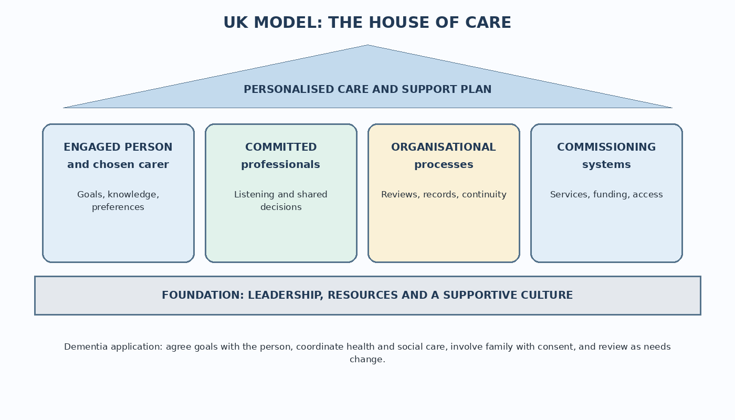
Figure 1. The House of Care adapted for dementia care. Source: adapted from NHS England (2016).

GPs, memory services, social care and therapists should coordinate actions, while commissioners ensure appropriate services exist. Planning should include carer wellbeing, housing, finances and future needs. The model’s strength is its focus on partnership and the conditions needed to make personalized plans real. Its limitation is that local service capacity and fragmented commissioning can prevent agreed actions from being delivered. Success should therefore be judged by the person’s outcomes and experience, not by completed paperwork alone (NHS England, 2016; Chenoweth et al., 2019).

International model: The Chronic Care Model
The Chronic Care Model was developed in the United States to improve care for long-term conditions. It connects community resources, self-management support, care-delivery organisation, decision support, clinical information systems and the wider health system. It proposes that outcomes improve when informed patients and prepared, proactive teams work together (Wagner et al., 2001). In dementia services, its system-wide perspective can support planned reviews, specialist advice, community groups and better information-sharing. However, its emphasis on an ‘active patient’ needs adaptation as cognition changes; responsibility must not be transferred from services to the person or family. Supported decision-making and proportionate carer involvement are essential.
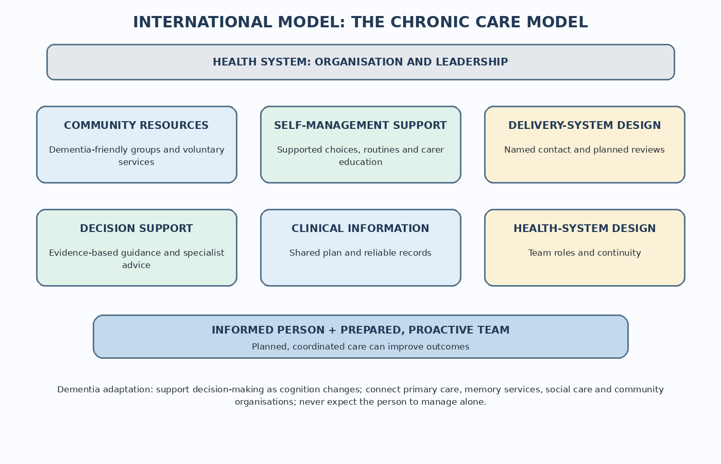
Figure 2. The Chronic Care Model adapted for dementia services. Source: adapted from Wagner et al. (2001).
Community resources may include dementia-friendly groups; self-management support may involve routines and carer education. Care delivery can include a named professional and planned reviews. Decision support draws on current guidance and specialist advice, while shared records may improve communication. As cognition changes, teams must adapt the model by supporting decision-making, involving carers appropriately and coordinating NHS and social care (Wagner et al., 2001; Huis in het Veld et al., 2020). Compared with the House of Care, the Chronic Care Model gives greater attention to information systems, clinical decision support and the wider service infrastructure; the House of Care more explicitly foregrounds personalized conversations and commissioning. Together they offer complementary perspectives, but neither is a dementia-specific intervention and neither guarantees better outcomes without resources, workforce skills and accountability. Services should evaluate continuity, quality of life, access and carer experience rather than count completed plans alone.

7. National and local health and social care policy

In England, the Care Act 2014 places duties on wellbeing, prevention and carer assessment within adult social care. These principles support intervention before crisis, but legal duties do not guarantee that home care or respite will be available. Eligibility thresholds, local budgets and workforce capacity shape what people receive. Implementation should therefore be assessed through timely access, continuity and outcomes, not simply the number of assessments completed (Care Act, 2014). NICE guideline NG97 covers assessment and diagnosis, coordination, medicines, non-drug interventions, carer support, staff training and future planning. It recommends a named professional to coordinate care and reviews when needs change. Guidance can reduce unwarranted variation, but impact depends on training, commissioning and accessible services. Recommendations should be applied with clinical judgement and attention to individual circumstances, rather than mechanically (NICE, 2018).

The Department of Health and Social Care’s 2025 10 Year Health Plan for England emphasises prevention, care closer to home, neighborhood teams and digital services. Digital tools may improve coordination, but digital-first services can disadvantage people with cognitive or sensory impairment, language barriers or limited internet access. Telephone, face-to-face and accessible non-digital options should remain available. The plan’s real effect will depend on workforce, funding, local readiness and transparent evaluation; broad policy commitments alone do not demonstrate improved dementia outcomes.

Local agendas: Birmingham and Solihull

The Birmingham and Solihull Dementia Strategy 2023–2028 identifies priorities including prevention and information, timely diagnosis and support, crisis avoidance and personalised planning, including end-of-life care (Birmingham and Solihull Integrated Care Board, 2023). These priorities align with both care models through early intervention, coordination, carer support and future planning. Their value, however, depends on delivery across health, social care and voluntary organisations, with clear responsibility for people who move between services.

A published strategy does not prove that care has improved. Local services should monitor waiting times for diagnosis and post-diagnostic follow-up, access to carer assessments and respite, whether care plans lead to action, crisis admissions and feedback from people with dementia and carers. Results should be compared across communities to identify barriers related to language, culture, disability, income or transport.

8. Planning ahead and end-of-life care

Dementia can shorten life, but its course is difficult to predict. Palliative care should respond to the person’s needs, promote comfort and dignity, relieve symptoms, support relationships and respect preferences. NICE advises considering palliative needs from diagnosis because it can be difficult to identify when someone has reached the final stage (NICE, 2018). Early conversations can record trusted contacts, preferred place of care, cultural or spiritual needs, sources of comfort and views about future treatment. Where appropriate, discuss a health and welfare Lasting Power of Attorney, an advance statement and an advance decision to refuse treatment; these have different legal effects, so accessible advice may be needed. Planning is especially valuable while the person can participate, but preferences should be revisited because people may change their minds while they have capacity (Dening et al., 2012). Plans should be shared, with consent, and reviewed after hospital admission or major changes. If a person lacks capacity for a specific decision, the Mental Capacity Act 2005 requires the best-interests decision with appropriate consultation. Planning should cover pain, swallowing difficulties, comfort and whether hospital transfer would meet the person’s goals. Families also need emotional and practical support. These conversations require time, clear language and opportunities to revisit decisions.

9. Recommendations for improving care

First, offer every person a named contact after diagnosis, with clear instructions for reaching them, to coordinate GP, memory, social care and community support. Second, review care plans against goals that matter to the person; record who will act, by when and how progress will be assessed (NICE, 2018). Third, treat carers as people with their own needs: ask about sleep, health, employment and finances, and offer assessment, education, respite information and peer support. Fourth, make services inclusive through interpreters, accessible formats, sensory adjustments, outreach and non-digital contact. Monitor who misses diagnosis or follow-up and work with communities to address barriers. Fifth, make advance care planning an ongoing conversation and connect palliative care with routine dementia services. Finally, publish measures of quality of life, continuity, post-diagnostic support, carer wellbeing, avoidable crises and inequalities. These actions combine the House of Care’s partnership focus with the Chronic Care Model’s attention to teams and community resources. They require staff, time, training and services, so commissioners should identify who is accountable and review progress with people living with dementia and carers.

Conclusion

Dementia can affect health, emotions, relationships and social participation, but it does not remove a person’s identity or right to be involved in decisions. Medicines and non-drug approaches may help with some symptoms, while coordinated care, carer support and accessible community services remain essential. The House of Care and Chronic Care Model offer complementary ways to organize support, but their value depends on implementation and evaluation. Care should remain person-centred throughout the condition, including at the end of life.

References
Alzheimer’s Disease International (2024) World Alzheimer Report 2024: Global changes in attitudes to dementia. London: Alzheimer’s Disease International. Available at: https://www.alzint.org/resource/world-alzheimer-report-2024/ (Accessed: 15 October 2026).
Alzheimer’s Society (2024) ‘Dementia scale and impact numbers’. Available at: https://www.alzheimers.org.uk/about-dementia/dementia-statistics-and-facts/dementia-scale-and-impact-numbers (Accessed: 4 October 2026).
Bennett, S., Laver, K., Voigt-Radloff, S. et al. (2019) ‘Occupational therapy for people with dementia and their family carers provided at home: a systematic review and meta-analysis’, BMJ Open, 9(11), e026308. Doi: 10.1136/bmjopen-2018-026308.
Berkovic, D., Macrae, A., Gulline, H. et al. (2024) ‘The delivery of person-centered care for people living with dementia in residential aged care: a systematic review and meta-analysis’, The Gerontologist, 64(5), gnad052. Doi: 10.1093/geront/gnad052.
Birmingham and Solihull Integrated Care Board (2023) Our dementia strategy 2023 to 2028. Available at: https://www.birminghamsolihull.icb.nhs.uk/health-information/dementia/our-dementia-strategy (Accessed: 4 October 2026).
Brooker, D. (2007) Person-centred dementia care: making services better. London: Jessica Kingsley Publishers.
Cao, Y., Wang, N., Wang, Q. et al. (2023) ‘Effects of cognitive stimulation therapy on patients with dementia: an umbrella review of systematic reviews and meta-analyses’, Experimental Gerontology, 177, 112197. Doi: 10.1016/j.exger.2023.112197.
Care Act 2014, c.23. Available at: https://www.legislation.gov.uk/ukpga/2014/23/contents (Accessed: 4 October 2026).
Chenoweth, L., Stein-Parbury, J., Lapkin, S. et al. (2019) ‘Effects of person-centered care at the organizational-level for people with dementia: a systematic review’, PLOS ONE, 14(2), e0212686. Doi: 10.1371/journal.pone.0212686.
Dening, K.H., King, M., Jones, L. and Sampson, E.L. (2012) ‘Advance care planning in dementia: do family carers know the treatment preferences of people with early dementia?’, PLOS ONE, 7(7), e40854. Doi: 10.1371/journal.pone.0040854.
Department of Health (2009) Living well with dementia: a National Dementia Strategy. London: Department of Health. Available at: https://www.gov.uk/government/publications/living-well-with-dementia-a-national-dementia-strategy (Accessed: 15 October 2026).
Department of Health and Social Care (2025) Fit for the future: 10-year health plan for England. Available at: https://www.gov.uk/government/publications/10-year-health-plan-for-england-fit-for-the-future (Accessed: 4 October 2026).
Desai, R., Leung, W.G., Fearn, C. et al. (2024) ‘Effectiveness of Cognitive Stimulation Therapy (CST) for mild to moderate dementia: a systematic literature review and meta-analysis of randomized control trials using the original CST protocol’, Ageing Research Reviews, 97, 102312. Doi: 10.1016/j.arr.2024.102312.
Han, Q.Y.C. et al. (2022) ‘Prevalence, risk factors, and impact of delirium on hospitalized older adults with dementia: a systematic review and meta-analysis’, Journal of the American Medical Directors Association, 23(1), pp. 1–11. Doi: 10.1016/j.jamda.2021.09.008.
Huis in het Veld, J.G., Verkaik, R., van Meijel, B. and Francke, A.L. (2020) ‘A systematic meta-review of self-management support for people with dementia’, Dementia, 19(2), pp. 253–269. Doi: 10.1177/1471301218772894.
Kim, S.K. and Park, M. (2017) ‘Effectiveness of person-centered care on people with dementia: a systematic review and meta-analysis’, Clinical Interventions in Aging, 12, pp. 381–397. Doi: 10.2147/CIA.S117637.
Kitwood, T. (1997) Dementia reconsidered: the person comes first. Buckingham: Open University Press.
Lee, K.H., Lee, J.Y. and Kim, B. (2022) ‘Person-centered care in persons living with dementia: a systematic review and meta-analysis’, The Gerontologist, 62(4), pp. e253–e264. Doi: 10.1093/geront/gnaa207.
Liao, X., Wang, Z., Zeng, Q. and Zeng, Y. (2024) ‘Loneliness and social isolation among informal carers of individuals with dementia: a systematic review and meta-analysis’, International Journal of Geriatric Psychiatry, 39(5), e6101. Doi: 10.1002/gps.6101.
Livingston, G., Huntley, J., Liu, K.Y. et al. (2024) ‘Dementia prevention, intervention, and care: 2024 report of the Lancet standing Commission’, The Lancet, 404(10452), pp. 572–628. Doi: 10.1016/S0140-6736(24)01296-0.
Mental Capacity Act 2005, c.9. Available at: https://www.legislation.gov.uk/ukpga/2005/9/contents (Accessed: 4 October 2026).
National Institute for Health and Care Excellence (2011) Donepezil, galantamine, rivastigmine and memantine for the treatment of Alzheimer’s disease (TA217). Available at: https://www.nice.org.uk/guidance/ta217 (Accessed: 4 October 2026).
National Institute for Health and Care Excellence (2018) Dementia: assessment, management and support for people living with dementia and their carers (NG97). Available at: https://www.nice.org.uk/guidance/ng97 (Accessed: 4 October 2026).
National Institute for Health and Care Excellence (2019) Dementia: quality standard (QS184). Available at: https://www.nice.org.uk/guidance/qs184 (Accessed: 4 October 2026).
National Institute for Health and Care Excellence (2020) Supporting adult carers (NG150). Available at: https://www.nice.org.uk/guidance/ng150 (Accessed: 15 October 2026).
NHS (2026) Dementia. Available at: https://www.nhs.uk/conditions/dementia/ (Accessed: 4 October 2026).
NHS England (2016) Personalized care and support planning handbook: the Year of Care approach. Available at: https://www.england.nhs.uk/wp-content/uploads/2017/02/ltc-yoc-handbook.pdf (Accessed: 4 October 2026).
Ojagbemi, A. and Akin-Ojagbemi, N. (2019) ‘Exercise and quality of life in dementia: a systematic review and meta-analysis of randomized controlled trials’, Journal of Applied Gerontology, 38(1), pp. 27–48. Doi: 10.1177/0733464817693374.
Oliveira, D., da Mata, F.A.F. and Aubeeluck, A. (2024) ‘Quality of life of family carers of people living with dementia: review of systematic reviews of observational and intervention studies’, British Medical Bulletin, 149(1), pp. 1–12. Doi: 10.1093/bmb/ldad029.
Serbser-Koal, J., Rommerskirch-Manietta, M., Purwins, D. and Roes, M. (2024) ‘Person-centredness in dementia care: an integrative review of theoretical approaches’, BMJ Open, 14(6), e085051. Doi: 10.1136/bmjopen-2024-085051.
Wagner, E.H., Austin, B.T., Davis, C., Hindmarsh, M., Schaefer, J. and Bonomi, A. (2001) ‘Improving chronic illness care: translating evidence into action’, Health Affairs, 20(6), pp. 64–78. Doi: 10.1377/hlthaff.20.6.64.
Waheed, W., Mirza, N., Waheed, M.W. et al. (2020) ‘Recruitment and methodological issues in conducting dementia research in British ethnic minorities: a qualitative systematic review’, International Journal of Methods in Psychiatric Research, 29(1), e1806. Doi: 10.1002/mpr.1806.
World Health Organization (2019) Risk reduction of cognitive decline and dementia: WHO guidelines. Geneva: World Health Organization. Available at: https://www.who.int/publications/i/item/9789241550543 (Accessed: 15 October 2026).
World Health Organization (2026) Dementia. Available at: https://www.who.int/news-room/fact-sheets/detail/dementia/ (Accessed: 4 October 2026).

