

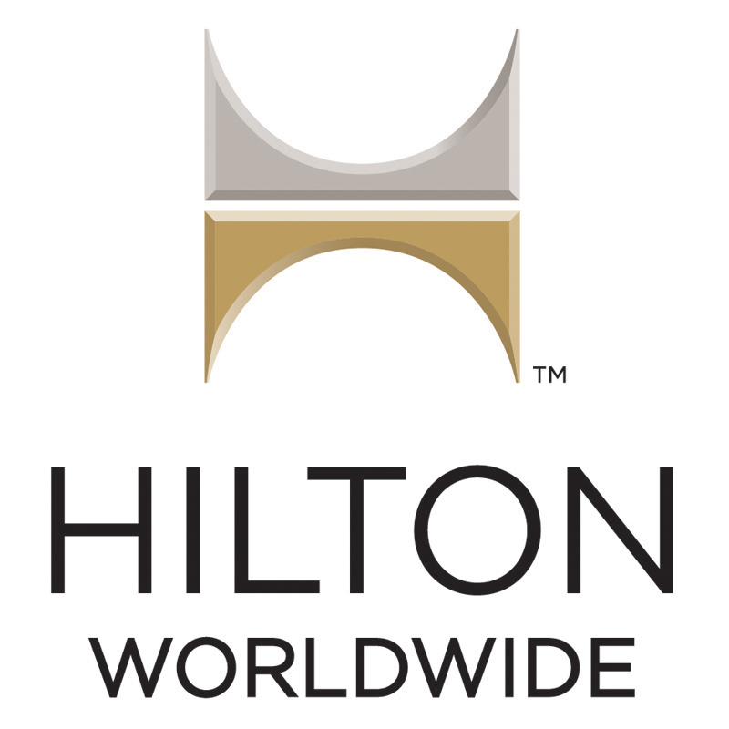 Hilton Worldwide Holdings

Student name: Polina Hristova Eneva
Student number:1714688
Module Title: LCBB4002
Module Assignment title: Community Engagement

Table of Contents
INTRODUCTION 1
DISCUSSION 1
SWOT/PESTEL ANALYS……………………………………………………………………1
CONCLUSION 1
REFERENCES………………………………………………………………………………...1
APPENDICES…………………………………………………………………………………1

INTRODUCTION
Hilton Worldwide Holdings Inc., still known as a Hilton Hotels Corporation, is an American Multinational Hospitality Company that guides and franchises a wide portfolio of hotels and resorts. In 1919 was found by Conrad Hilton. Over the next few years, he bought more hotels in Texas. In 1925 he opens the high building hotel, Dallas Hilton (first hotel including his name).In 1927 he opened the firs hotel with cold water and air conditioning in public areas. Now the corporation is guided by Christopher J. Nassetta
Hilton is headquartered in Tyson Corner, Virginia. As of September 2018, its portfolio includes more than 5,600+ properties with over 900,000 rooms in 113 countries. Prior to their December 2013 IPO, Hilton was ranked as the 36th largest privately held company in the United States from Forbes. They have 42 million loyal HHonors members and serve millions of costumers in a year who are quite pleased and loyal to the company system.
In 1947, Hilton acquired Roosevelt Hotel and in 1947 the hotel became with televisions in the rooms. This is the first hotel in the world where became TV satellite. In the same year Conrad Hilton purchased Waldorf Astoria Hotel New York and years after until now they’re 31 hotels in Astoria, NYC. The luxuries are only 5*, that’s why they are in resorts group. Every 5 years currently they are closed undergoing on exciting renovations.
In 1950 Hilton created the first reservation office in the world titled “HILCRON”. The office started with 8 members staff to dealing with all bookings between the hotels in the company, In this time the hotels was 28.
In 1979, 91 years old Conrad Hilton founder died.
In 1987, HHonor surpassed competing loyalty programs by offering member credit hotel points and airline credit flight and staff creating benefits by points depending on their annual experience years.
The mission of Hilton is to expand their business in systematic way, working for their profit and shareholder without compromising customer services. They would like to lead Hospitality Industry globally in all segments
Hilton Worldwide sence being founded remains success and quality. Until now the company is still staying true to their Vision, Mission and Values. They delivering exceptional guest experience, they always doing the things right, they’re leaders in their-own industry, they operate with discipline and always working as a good team.
Hilton Worldwide is able to serve any costumers, traveling everywhere in the world for every travel need which they have. The room in every building around the branches are different for any type of guests, with different prices to be comfortable for everyone to visit Hilton Worldwide hotels. They have price-point for view and early check-in and late check – out. The wi-fi is free of charge, depends from the location is possible free parking, but most of the places doesn’t have permission for free of charge, because of the location in different cities with different rules and permit points. The hotel having a good strategy to keep the costumers and staff. The hotels have many of inclusive packets including breakfast or dinner or alcohol or all-inclusive. Many choices for many different types of guests.

Discussion
The company ranked first in the list “Happiest companies in America”. The company interviewed more than 80 000 employees with such performances life as work-life balance, company culture and reputation, and about the relationships between employees and managers.
In Hilton Worldwide Holdings Inc., is working business serving people and their team members extend the passion every single day beyond hotel walls. They varies backgrounds and proven experience of successful, they’re well targeted to keep Hilton at the foreground of the hospitality industry. Doesn’t matter in which department they working, every single person in this organisation have opportunity to grow up. The company sponsors so many charity, HHonors in one of them. This charity giving to employees chance to donate points ( for example 10 000 points = £45 or $50), every employee can earn more money by points. After that, every employee can use these points if is travelling in different country and enjoying free hotel for one brilliant holiday by donated points. This giving every employee good rest time and saving from pocket money. Hilton Worldwide get together employee with different skills, working in different departments who wants to improve themselves with language and skills in different study programs. They giving almost everyone choice to develop in verves where their good workers. Every single employee have different skills and education and this doing the organisation so colourful and productive. That’s why Hilton Worldwide is in high range, because employees supporting the organisation to working so well. The staff understand the importance of upholding the motto of all brand's reputation and the effort required for implementation a world – proven hospitality experience, since it's with Hilton Hotels & Resorts then they promise an exceptional communication about guests experience every time.

Hilton Worldwide accredits that it is crucial that employees have the necessary knowledge and skills to do their jobs effectively and have the ability to grow and develop in all aspects . At Hilton Worldwide there is a big opportunity of learning starting from on-the-job training and virtual courses, to management development programs and learning seminars.
In every single city around the globe is working different team as a PR (public relation or resources). As a PR role for example in Hilton Worldwide is to focus on regional stories and national media and blogger outreach program for traveling, lifestyle and food media.PR activities focused on Meeting & Events industry, food and beverage. Strategy is a proactive media and key issues with topics as interviews with applied employee and executive managers. Communicating with colleagues, maintaining and updating information about organisation in website. Must to engage with social media and also update the information. Sourcing and sponsorship opportunities. Preparing the annual reports, doing promotional videos and photography.
As a Public relation role, need very good IT skills, social media and communication skills also. Good visual memory, analytical and problem-solving skills. To be ability to cope with pressure and competence. The most important is employee in this position to be self-motivated and willingness to learn.
The training is very important before everything, except the skills everyone need qualifications.

SWOT Analysis

Conclusion

Hilton Worldwide provide excellent customer service and keeping improving their standard for remain them leader in Hotel Industry. They always come up customer centric strategy. They always looks for improvement in their service via research, complaint and keeping customer involvement in new product i.e. Defining Customer Service. All this is done by Management & HR team. HR also carries work of drilling in to lowest level of the organization. Implementing customer service and improving it is the key objective of the HR. They start it from recruiting. Then they used different equipment like Training, Rewards, “YES” campaign (etc for maintaining standards). They also shared best practices in their group. That is how they Support Customer Satisfaction. With above points we can say that “ HRM is not seen as important in itself, but is important because it supports – even defines – customer satisfaction”.

References
Books and Journals:
David Carey & John E. Morris Crown 2010, King of Capital: The Amazing Rise, Fall and Rise Again of Steve Schwarzman and Blackstone Archived 2011-01-08 at the Wayback Machine, pp. 254.
Peter Lattman and Lingling Wei et. Al. 2010 "Blackstone Reaches Deal to Revamp Hilton's Debt,' Wall Street Journal; Hilton Worldwide press release, Apr. 8, 2010; King of Capital, pp. 299–300.
Online:
Hilton Worldwide 2019[online] Available Through <https://en.wikipedia.org/wiki/Hilton_Worldwide>

