Business Report- Comparison of Shangri-La Hotels and Travelodge Hotels

Module code: BMIH5007
Module name: Financial Management for the Hotel Industry Student Name: Elena-Petronela Ciubotariu Student ID: 2219782
Module Tutor: Tristan Hawkins

Table of Contents
Introduction 3
Discussion on the Organisations 3
Comparison of Revenue 3
Market Position of the Organisation 3
Potential Growth of the Organisations 3
Financial Commitment to CSR of the Organisations 3
Recommendations 3
Conclusion 3
References 3

Introduction
This report aims to acknowledge the business operations of Travelodge and Shangri-La Hotel along with discussing the important components associated with marketing initiatives by these hotel businesses. The comparison between the revenue will be highlighted in this report along with mentioning the key difference between the strategies adopted by these hotel businesses regarding achieving better market share. The market position along with the essential factors associated with the potential growth of the hotel businesses will be discussed in this report. The significance of financial commitments towards CSR initiatives will be discussed in this report.

Discussion on the Organisations
The changes in the factors associated with the external business environment in the hospitality sector of the UK reflect the need for better financial planning with enhanced management of the resources to ensure sustainability in the business growth along with the fulfilment of the vision of the hotel businesses in the competitive business market. The business strategy adopted by Travelodge has consistently focused on the efforts towards offering convenience to the guests through constant betterment of the services that required appropriate understanding of the needs and expectations of the consumer base along with proper analysis of the feedback and reviews regarding the experiences from the past customers which enable them to incorporate the most suitable initiatives for addressing the concerned challenges and issues (Travelodge, 2024). The most significant aspect associated with the financial stability of Travelodge is correlated with the determination of the most effective pricing strategy that constantly monitors the prices offered by the competitors to ensure better customer retention which is considered the most important factor for their success in the hospitality sector of the UK.
The business strategy adopted by Shangri-La Hotel is greatly focused towards the optimum utilisation of the resources for better revenue management that promotes the development of suitable initiatives towards ensuring the essential facilities for enhanced guest experience leading to better sustainability of the business growth aspects (Shangri-La, 2024). The influence of the social media marketing strategy by the marketing team of Shangri-La Hotel significantly helped them to obtain the attention of a large consumer base leading to enhanced brand awareness in the competitive hospitality business. The adoption of enhanced technology in the customer service segment resulted in better efficiency associated with the room booking system enabling the management of the Shangri-La Hotel to ensure the proper availability of rooms per the requirements of the potential customers. The differentiation of services through marketing the premium rooms separately to achieve better revenue greatly influenced their business growth globally.

Comparison of Revenue
The key components associated with business growth in the hospitality sector are greatly correlated with the fulfilment of the needs and expectations of the customers along with addressing the challenges and issues regarding supply chain management which promotes the development of better arrangements for the guests leading to enhanced customer satisfaction (Drury, 2021). The approach of both Travelodge and Shangri-La Hotel towards implementation of suitable changes in the business model due to constant changes in the external business environment along with fluctuations in the economic factors resulted in the accomplishment of great success regarding revenue collection that enables them to evaluate their business process further to achieve a competitive advantage. The various factors associated with financial stability in the hospitality sector greatly depend on the ability of the operations management to effectively utilise the resources through proper implementation of an appropriate revenue management system which has the potential to allocate the available resources to the overall operational activities based on the priorities which enhances the productivity of the business process leading better services (Bhimani, 2006). The focus of the marketing approach of the Shangri-La Hotel towards communicating with the consumer base regarding acknowledging the business purpose along with enabling the potential customers to give their opinions about the business initiatives for better customer service through social media platforms significantly helped the hotel business to achieve enhanced revenue despite the devastating impact of the pandemic on the business sector.
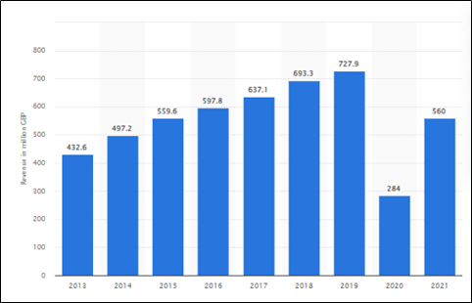
Figure 1: Revenue of Travelodge in the United Kingdom
(Source: Statista, 2024)
The gradual growth of the revenue of Travelodge can be seen in the graph that was greatly impacted by the pandemic along with the negative consequences associated with Brexit that caused financial losses to the majority of the businesses operating in the hospitality and tourism sector of the UK (Statista, 2024). The great understanding of the management of Travelodge regarding the incorporation of effective revenue management along with addressing the key challenges associated with customer service resulted in paving the way for enhanced business growth.

Market Position of the Organisation
The ability of the business organisations to obtain better market share in the competitive business environment along with ensuring enhanced sustainability associated with business growth aspects requires a proper understanding of the factors of the external business environment while focusing on the effectiveness of the adopted strategy for business functions leading better efficiency in the operations management which promotes enhanced customer satisfaction (Walker, 2021). The graph highlights the brand awareness of Travelodge among the population of the UK which reflects the potential of the hotel business to obtain a great market share in the hospitality sector of the UK through better engagement in the marketing initiatives which comprises effective promotional activities that have the potential to influence the perspectives of the potential customers along with retaining the existing loyal customers leading enhanced business growth which aims to fulfil the goals and objectives associated with the business purpose of the hotel business (Statista, 2024).
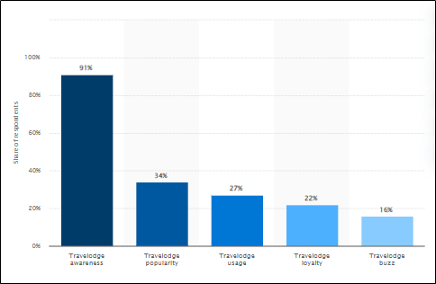
Figure 2: Brand Profile of Travelodge
(Source: Statista, 2024)
The global presence of Shangri-La Hotel significantly influenced its brand awareness through a better understanding of the needs and expectations of the diverse consumer base that helped them to formulate effective business strategies aimed towards better alignment with the changes in the requirements of the guests regarding essential arrangements which enhances the experiences through utmost comfort (Praditya and Purwanto, 2024). The incorporation of the digital marketing strategy by Shangri-La Hotel resulted in a better evaluation of the perspectives of the consumer base regarding their value chain which is highly essential for understanding the important factors associated with the business process leading to better scope for the hotel business to achieve enhanced business growth that significantly influence the annual revenue which can be utilised for incorporating advanced technology in the operational functions that can address the challenges and issues associated with the carbon footprint which is responsible for damaging the reputation of the business (Seal et al., 2008). The incorporation of skill development initiatives for the employees along with adopting a competitive remuneration policy significantly enhanced employee engagement resulting in increased productivity that greatly increased customer satisfaction (Shakeel et al., 2020).

Potential Growth of the Organisations
The factors associated with business growth are significantly influenced by the strategy adopted by the business organisations regarding the alignment of the efforts towards the fulfilment of the goals and objectives of the organisation with the essential changes that need to be implemented in the business functions for addressing the challenges associated with the fluctuations in the business environment that can impact the financial stability which is interrelated with the various aspects of business expansion in the future (Seal, 2019). The approach towards a better understanding of the expectations of the customers along with incorporating essential business policies by both Travelodge and Shangri-La Hotel resulted in great success for both the hotel business in the hospitality sector of the UK which highlights their potential to obtain enhanced market share through better strategies associated with brand awareness (Atrill and McLaney, 2021). The potential growth of a business organisation in today’s business market greatly depends on the ability of the management to identify the most suitable technology that has the potential to resolve the challenges and problems associated with the effectiveness and efficiency of the operational functions which requires proper evaluation of the core principles of the Ansoff’s Model which enables the organisation to adopt suitable business strategies as per their need (Zugay, B. and Zakaria, R., 2023).
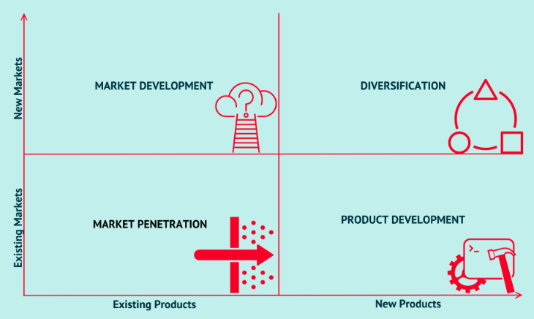
Figure 3: Ansoff’s Matrix Model
(Source: Zugay and Zakaria, 2023)
The approach of Shangri-La Hotel towards market penetration strategy through developing an effective pricing strategy that can greatly influence the perspectives of the consumer base along with offering affordable prices of the hotel rooms has the potential to enhance the business growth in the competitive hospitality sector where consistent focus on the business strategies adopted by the leading competitors is highly important (Prasad, 2020). The product development strategy by Travelodge focuses on addressing the challenges and issues faced by customers when room bookings through the incorporation of digital technology that has the potential to monitor the real-time data associated with the online activities of the potential consumers along with enabling the business representatives to plan allocation of resources according to the interpretation of the data regarding expected room booking.

Financial Commitment to CSR of the Organisations
The increasing concerns of the consumer base towards the challenges associated with environmental and societal issues led to the incorporation of effective corporate social responsibility initiatives to highlight the voluntary efforts towards resolving those problems that significantly impact the overall reputation of the business organisation leading to enhanced brand awareness among the consumer base (Guilding, 2014). These initiatives require suitable allocation of funds that will be utilised in respective CSR programs which need to consider an effective revenue management approach which has the potential towards optimum utilisation of resources resulting in prevention from financial instability. That can impact the business growth. The most important aspect associated with the sustainability of the business functions is correlated with carbon emissions from the operational activities which requires the incorporation of sustainable business practices to achieve a net zero carbon emissions. The reduction in the dependency of the operations management of Travelodge and Shangri-La Hotel on non-renewable energy resources through shifting the energy requirements by utilisation of sustainable energy resources can greatly influence the effectiveness of the CSR initiatives. This approach requires suitable expenditure which can result in fluctuations in the profitability aspects leading slowdown in the overall business growth. Consistent financial support to the poor section of society through partnering with various NGOs that provide essential commodities associated with basic needs highlights the commitments of these hotel businesses towards their focus on the betterment of society (Jagels, 2007). The alignment of the employee policies with the initiatives of the HRM aims to enhance the skills and knowledge of the workforce to promote better career development through the incorporation of digital systems in the HRM that have the potential to evaluate the progress of individual employee resulting in better performance leading enhanced customer service. The CSR initiatives that consider the betterment of the local community through providing job opportunities can result in better cooperation from the stakeholders towards enhanced business growth.

Recommendations
- The incorporation of a digital marketing approach by Travelodge that utilises diverse social media platforms for communicating with a large consumer base resulting in enhanced brand awareness can lead to better sustainability regarding business growth in the competitive business environment (Jain et al., 2023).
- The training programs aim to enhance the skills and knowledge of the employees along with aligning their career development efforts with the goals and objectives associated with the business purpose of the organisation can significantly accomplish the ultimate vision more effectively (Sanders and Wood, 2024).
- The adoption of a diversified marketing strategy by Shangri-La Hotel that focuses on differentiating the premium services from the regular affordable services can greatly enhance their revenue through proper analysis of the perspectives of the consumer base regarding their business approach.
- The incorporation of sustainable business practices that lead to a reduction in the overall carbon emission from the operational functions of the hotel business can greatly influence the perspectives of the customers resulting in enhanced brand awareness (Khan et al., 2021).
- The hotel businesses need to focus on the fluctuating global economy that can severely impact their financial stability which requires the incorporation of digital technology in revenue management that has the potential to proactively formulate suitable measures to avoid business losses (Tranter et al., 2014).

Conclusion
This report has discussed the significance of marketing initiatives along with the requirement for evaluation of the financial aspects in the hospitality sector for a better understanding of the essential changes that need to be incorporated into the existing business operations for achieving better sustainability associated with business growth. The market positions of Travelodge and Shangri-La Hotel in the hospitality sector of the UK have been evaluated highlighting the various business strategies adopted for addressing the challenges and issues associated with the changing business environment.

References
Atrill P, McLaney E 2021. Management Accounting for Decision Makers, FT Prentice Hall
Bhimani A, (Ed) 2006. Contemporary Issues in Management Accounting, Oxford
Drury C 2021. (11th Ed) Management and Cost Accounting, London, Prentice Hall
Guilding, C.2014. (3rd Edition) Accounting Essentials for Hospitality Managers, London, Routledge
Jagels, M. 2007. Hospitality Management Accounting, London, Wiley.
Jain, V., Sheth, J.N., Mogaji, E. and Ambika, A., 2023. Customer-Centric Support Services: An Introduction to the Next Frontier for Competitive Advantage in the Digital Era. In Customer Centric Support Services in the Digital Age: The Next Frontier of Competitive Advantage (pp. 1-10). Cham: Springer International Publishing.
Khan, S.A.R., Yu, Z., Panait, M., Janjua, L.R. and Shah, A. eds., 2021. Global corporate social responsibility initiatives for reluctant businesses. IGI Global.
Praditya, R.A. and Purwanto, A., 2024. The Role of Viral Marketing, Brand Image and Brand Awareness on Purchasing Decisions. PROFESSOR: Professional Education Studies and Operations Research, 1(01), pp.11-15.
Prasad, L.M., 2020. Principles and practice of management. Sultan Chand & Sons.
Sanders, N.R. and Wood, J.D., 2024. Foundations of Sustainable Business. John Wiley & Sons.
Seal W 2019. (6th Ed) Management Accounting, London, McGraw Hill
Seal W, Garrison RH, Noreen E 2008. Management Accounting, McGraw Hill
Shakeel, J., Mardani, A., Chofreh, A.G., Goni, F.A. and Klemeš, J.J., 2020. Anatomy of sustainable business model innovation. Journal of cleaner production, 261, p.121201.
Shangri-La, 2024. Luxury Hotel in London | Shangri-La Hotel, At The Shard, London. [online] Available at: <https://www.shangri-la.com/en/london/shangrila/
Statista, 2024. Annual revenue of Travelodge UK from 2013 to 2021 [Online] Available at: <https://www.statista.com/statistics/429089/travelodge-total-revenue-united-kingdom-uk/#:~:text=Travelodge%20revenues%202013%2D2021&text=Travelodge%20UK%20generated%20revenues%20of,year's%20total%20of%20284%20million
Statista, 2024. Travelodge brand awareness, usage, popularity, loyalty, and buzz among hotel customers in the UK in 2022 [Online] Available at: <https://www.statista.com/forecasts/1335657/travelodge-hotels-brand-profile-in-the-uk
Tranter, K. Stuart-Hill, T. Parker, J. 2014. Introduction to Revenue Management for the Hospitality Industry, London, Pearson
Travelodge, 2024. Travelodge | Great value hotels throughout the UK & Ireland. [online] Travelodge. Available at: <https://www.travelodge.co.uk/>
Walker J 2021. Introduction to Hospitality, Harlow, Pearson
Zugay, B. and Zakaria, R., 2023. Ansoff matrix. SAGE Publications, Inc.

