

Module: CHANGEMAKERS: BUILDING PERSONAL BRAND FOR SUSTAINABLE EMPLOYMENT
Student Name: Emilia Dunguiongue
Student ID:2328855
Module code: BMHP5015
Lecturer Name: Caroline Salami

Table of Contents
1. Introduction 3
2. Job Description of the Selected Job 3
3. Analyse the Skills Required for the Job and Assess the Skills and Experience 5
4. Development of Personal Skills and Resources 6
5. Action Plan and Timeline 7
6. Communication of Skills to Potential Employers 9
7. Conclusion 10
Reference List 11

1. Introduction
A changemaker primarily utilises their personal brand for driving both positive environmental and social impact that in turn fosters sustainable and long-term development. A personal brand is considered as an effective tool for the changemaker irrespective of self-promotional aspect to develop career resilience, developing trusted reputation and attracting opportunities. This report analyses the job description for the role of Registered Nurse in the UK care homes with the detailed of related skills and the development of personal skills and resources effectively also evaluates the action and communication of skill to employers in a clear, evidence-based, ethical commitment, person-centred care to enhance to impactful manner.
2. Job Description of the Selected Job
The role of Registered Nurse across the UK care home setting has been selected to be pursued in the future
The role of Registered Nurse evaluates the blend of compassionate care and clinical ability, which defines the health as well as social care sector (Zumstein‐Shaha and Grace, 2023). Furthermore, this position includes offering person-centred and high-quality care to residents with diverse mental and physical health needs. The nurse is significantly responsible to administer medications safely, ensure a supportive and secure environment along with the development of effective care plans (Alrabadi et al., 2021). Moreover, an essential aspect regarding the respective role is utilising professional judgement for making crucial decisions and supporting social and psychological well-being aspects of the residents.
Core Responsibilities
The various core responsibilities evaluated within the respective job description involves evaluating, implementing, planning, and assessing care plans for the residents (Spacey et al., 2021). Furthermore, this profession monitors health conditions along with responding to medical changes for the patients promptly.
Person Specification
The person specification for the concerned role involves commitment, patience, and empathy for delivering dignified care. Moreover, excellent interpersonal and communication abilities are needed as the person specification for the role of Registered Nurse especially in developing trust with families and residents (Bahari et al., 2024). Hence, this role is especially appealing due to its comprehensive approach to care that combines medical responsibilities with social and emotional support.
The concerned role significantly aligns with my interest in person and ethical-centred practice along with the long-term to contribute towards health and social care innovation. The care home setting offers a specific opportunity for developing long-term relationships with residents in terms of understanding their evolving requirements along with proving their autonomy and dignity (Moilanen et al., 2021). These elements are the core values within modern nursing.
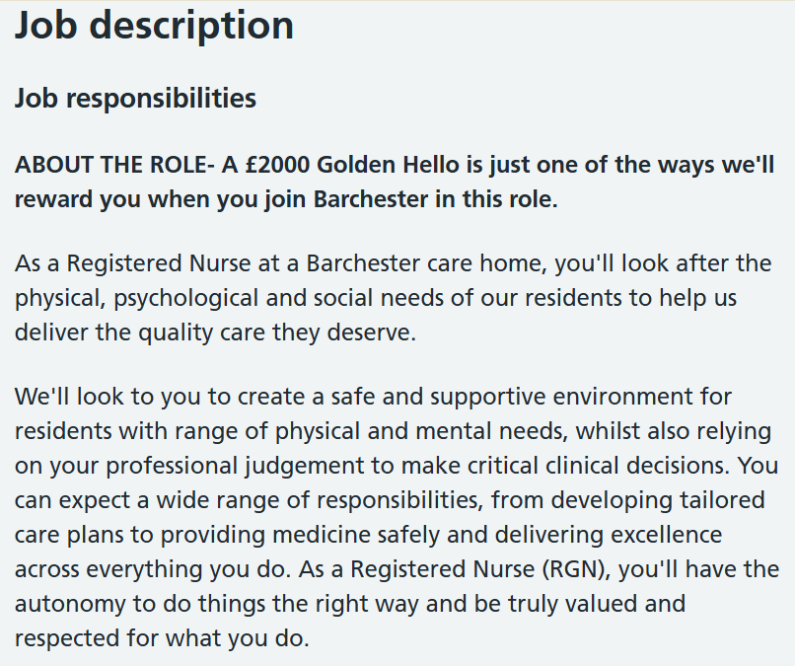
Figure 1: Job Description of Registered Nurse
(Source: NHS Jobs, 2024)
Figure 1 demonstrates that Barchester Healthcare is effectively known for its investment within staff development along with providing career and training progression opportunities (NHS Jobs, 2024). Furthermore, Figure 2 efficiently supports my level of ambition to make professional growth along with developing a tangible gap in the lives of people.
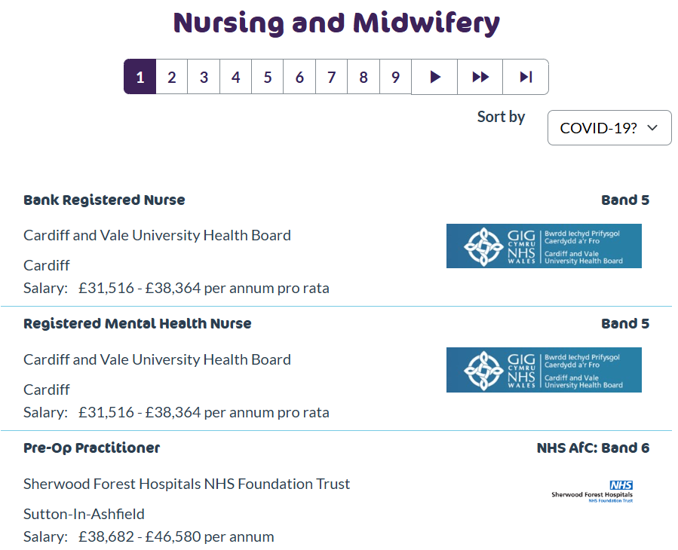
Figure 2: Job Vacancy for Registered Nurse
(Source: NHSJobs.com, 2025)

3. Analyse the Skills Required for the Job and Assess the Skills and Experience
They are several essential skills based on the role of Registered Nurse at Barchester Healthcare are important to gain success in the concerned position. The respective job requires a blend of collaborative practice, emotional intelligence, and clinical competence (Sun-Hee,2022). These skills are important to be owned by this job position to attain success in the health and social care sector.
Core Skills
The core skills for this job position involves communication and interpersonal skills, leadership, and accountability skills along with adaptability and resilience. The attainment of leadership and accountability skills often enable nurses to lead shifts, ensure compliance with care standards, and supervise care staff (Stucky, Wymer and House, 2022). Furthermore, the interpersonal and communication skills help the nurses to develop trust with multidisciplinary teams, families, and residents effectively (Younas et al., 2023). Moreover, adaptability and resilience primarily allow nurses to work in a flexible care home particularly during the management of end-of-life or complex care (Forward et al., 2024). As a result, reflecting on my present skill set, I significantly bring effective communication and analytical skills from my background as a strategic manager and senior business analyst. The concerned skills perfectly fit into healthcare, especially in areas including multidisciplinary collaboration, risk assessment, and care planning.
Strengths, Areas of Improvement and Use of Tools
My strengths involve strategic communication that enables me to elaborate complex information precisely. Strategic communication is important when reporting to healthcare professionals or liaising with families (Chen et al., 2023). Furthermore, my academic work within health and social care particularly on social isolation and elderly mental health has effectively evaluated my understanding level about compassionate care. However, the areas of improvement involve familiarity with specific nursing protocols and hands-on clinical skills. As a result, I have registered in Care Certificate training that covers person-centred care, safeguarding and infection control.
Health and Social Care-Related Experience and Qualifications
My voluntary experience within the dementia care unit has been especially formative. I have provided support to the residents with daily activities, learned the process of nurses in balancing clinical duties with emotional support along with seeing care-planned meetings. The concerned experience articulated my commitment to a person-centred care and stood for the significance of reflective practice and teamwork. The experience in health and social care helps to develop foundational skills including communication, holistic assessment, and patient advocacy (Alexis et al., 2022). Therefore, I bring an effective ethical foundation and transferable skills with active development of sector-specific experience and clinical competencies that are required to thrive in a role of Registered Nurse.

4. Development of Personal Skills and Resources
I significantly focus on linking my values including evidence-based practice, ethical leadership, and compassion with the estimations of modern nursing for developing an effective personal brand across the UK health and social care sector. My personal brand shows a commitment to continuous learning, strategic thinking, and person-centred care.
Resources for Developing and Promoting my Personal Brand
The relevant tools and platforms that have been used by me for developing and communicating my personal brand involve professional networks, reflective portfolio and LinkedIn and National Health Service (NHS) Jobs Profile effectively. I significantly engage with peers and mentors through Royal College of Nursing (RCN) and the NHS Trusts forums. Proper engagement with mentors and peers within the health and social care sector helps Registered Nurse for skill refinement and guidance (Okunade et al., 2023). Furthermore, I document learning from mentor feedback, ethical case studies, and care placements for proving commitment and growth. Moreover, I stand for my voluntary experience, strategic health or social care projects and Care Certificate training.
Unique Value
My unique selling point involves the ability for translating complex strategic and academic insights into compassionate and practical care. For instance, I have helped in implementing a structured reminiscence activity plan based on elderly mental health research during a voluntary placement within the dementia care unit. Hence, it improved reduced behavioural distress and residency engagement that proved the process of theory-informed practice to enhance outcomes. Furthermore, I bring advanced communication as well as stakeholder engagement skills extensively. The stakeholder engagement and communication skills help the Registered Nurse to improve care coordination and enhance patient outcomes (Williams et al., 2021). Moreover, I owned emotional intelligence and ethical reasoning skills particularly in end-of-life care.
Resources Required for Bridging Skill Gaps
I am pursuing specialist training in palliative support and dementia care through NHS Trusts, Level 3 Diploma in Health and Social Care to improve procedural understanding and clinical knowledge for meeting the complete requirements on the role of Registered Nurse. As a result, I aim to provide meaningful contribution to the evolving requirements of UK care homes through effective combination of strategic insight with evidence-based and compassionate care. The integrated approach of strategic insight improves the work environment for nurses, improves the healthcare system, and enhances patient outcome (Rostami et al., 2025). Furthermore, my personal brand articulates a commitment to lifelong learning, innovation, and ethical practice, which are the essential qualities for this job position.

5. Action Plan and Timeline
Timeline | Action Steps | Aspects and Resources
By August 2026 | - Completing Care Certificate & Basic Life Support (BLS).  - Volunteering in care settings.  - Beginning Level 3 Diploma in Health & Social Care. | - Enrolling with the help of the local NHS Trust. Covers safeguarding, infection control, and person-centred care.  - Continuing placements in dementia units and elderly care homes to build hands-on experience.  - Developing foundation for clinical knowledge and care planning (Prestwich, Flanagan and Khan, 2025). It is significantly offered by City & Guilds.
By June 2027 | - Shadowing Registered Nurses.  - Enrolling in Functional Skills. | - Arranging placements in care homes or NHS wards to observe medication administration, wound care, and safeguarding.  - Required for nursing degree entry. It is available through local colleges or online platforms.
By September 2028 | - Applying for Nursing Associate Apprenticeship or Access to Nursing course.  - Continuing volunteering and reflective journaling. | - A stepping stone to full nursing registration effectively combines paid work with study (Mouw, Kalleberg and Schultz, 2024).  - Building a portfolio for interview preparation and university application.
By December 2029 | - Beginning Bachelor of Science Nursing (Adult).  - Engaging in clinical placements. | - Applying through Universities and Colleges Admission Services (UCAS) to universities like University of Plymouth or University of West London.  - Gaining supervised experience in hospitals, community settings and care homes.
By November 2031 | - Graduating and registering with Nursing and Midwifery Council (NMC).  - Applying for a Registered Nurse role in a care home. | - Completing degree and passing Objective Structured Clinical Examination (OSCE) in case of requirement. Furthermore, applying for NMC registration.  - Targeting employers like Barchester Healthcare along with highlighting ethical, person-centred and strategic strengths.
Table 1: Action Plan
(Source: Author)
Table 1 proves the action plan showing ethical development, practical experience, and academic progression. It ensures that I am completely prepared for offering evidence-based, compassionate, and safe care as a Registered Nurse.

6. Communication of Skills to Potential Employers
I plan to utilise a combination about a professionally written Curriculum Vitae (CV), a reflective portfolio, and a LinkedIn profile to communicate my skills effectively to a potential employer for a role of Registered Nurse across the UK. Each platform significantly stands for unique values, experiences, and competencies, which is structured with person-centred and ethical nursing practice.
CV
A CV helps to provide a comprehensive and detailed document that outlines the complete professional history involving experience, skills and extensive education of a person (Gottlieb, Promes, and Coates, 2021). My CV will involve a professional summary with a precise statement that highlights my commitment to compassionate strategic communication, ethical leadership, and care. Furthermore, essential experiences in terms of voluntary work within dementia care units involving emotional support for residents and structured activity planning will be included in my CV. Moreover, training and certifications including Basic Life Support (BLS) and Care Certificate along with ongoing Level 3 Diploma in Health and Social Care as well as transferable skills in stakeholder engagement and strategic planning.
LinkedIn Profile
A LinkedIn profile refers to a professional online page, which serves as a digital resume and summarises the experience, education, career history and skills of a person effectively (Kashive and Khanna, 2023). My profile in LinkedIn will demonstrate heading with ‘Aspiring Registered Nurse’ with a featured section of articles and posts that reflects on my voluntary experiences, care ethics and elderly mental health. Furthermore, the skill endorsements will involve adaptability, care planning, empathy, and communication with recommendations for the testimonials from care coordinators and mentors that evaluate my growth and dedication.
Reflective Portfolio
A reflective portfolio is treated as a collection of work, which contemplates the professional and personal development of a person through a critical self-reflection process (Beka and Kulinxha, 2021). The reflective portfolio will include an action plan with a five-year roadmap in order to become a Registered Nurse that reflects my commitment to continuous development. Moreover, the case reflections with real-life scenarios from care placements along with learning logs with relevant insights from shadowing experiences and training sessions will be involved in the reflective portfolio precisely.

7. Conclusion
The report evaluated and structured career pathway Toward becoming a Registered Nurse within UK care homes, emphasising the integration of person-centred care, ethical values, and strategic insight. It outlined the essential skills and responsibilities of the nursing role and demonstrated how these align with professional effectiveness compassionate practice, and effective stakeholder engagement and communication. Additionally, the report assessed a personal action plan that incorporates academic progression, volunteering, training, and portfolio development. A comprehensive CV,LinkedIn profile, and reflective portfolio were also produced to support continued professional growth and to prove competencies identified throughout the report.

8. Reference List
Alexis, O., Cooke, J., Shimumbi, L. and Worsley, A. (2022) ‘The role of the nurse advocate in health and social care’, Mediterranean Nursing and Midwifery, 2(3), pp. 140-146. Available at: DOI:10.5152/MNM.2022.220875
Alrabadi, N., Shawagfeh, S., Haddad, R., Mukattash, T., Abuhammad, S., Al-rabadi, D., Abu Farha, R., AlRabadi, S. and Al-Faouri, I. (2021) ‘Medication errors: a focus on nursing practice’, Journal of Pharmaceutical Health Services Research, 12(1), pp. 78-86. Available at: https://doi.org/10.1093/jphsr/rmaa025
Bahari, Z., Vosoghi, N., Ramazanzadeh, N., Moshfeghi, S. and Aghamohammadi, M. (2024) ‘Patient trust in nurses: exploring the relationship with care quality and communication skills in emergency departments’, BMC nursing, 23(1), p. 595. Available at: https://doi.org/10.1186/s12912-024-02241-z
Beka, A. and Kulinxha, G. (2021) ‘Portfolio as a tool for self-reflection and professional development for pre-service teachers’, International Journal of Learning, Teaching and Educational Research, 20(2), pp. 22-35. Available at: https://doi.org/10.26803/ijlter.20.2.2
Chen, W., Chung, J.O.K., Lam, K.K.W. and Molassiotis, A. (2023) ‘End-of-life communication strategies for healthcare professionals: a scoping review’, Palliative medicine, 37(1), pp. 61-74. Available at: https://doi.org/10.1177/02692163221133670
Forward, C., Bayley, Z., Walker, L., Krygier, J., White, C., Mwaba, K., Elliott-Button, H., Taylor, P. and Johnson, M.J. (2024) ‘Homecare workers needs and experiences in end of life care: rapid review’, BMJ Supportive & Palliative Care, 14(e3), pp. e2330-e2340. Available at: https://doi.org/10.1136/spcare-2023-004737
Gottlieb, M., Promes, S.B. and Coates, W.C. (2021) ‘A guide to creating a high‐quality curriculum vitae’, AEM Education and Training, 5(4), p. e10717. Available at: https://doi.org/10.1002/aet2.10717
Kashive, N. and Khanna, V.T. (2023) ‘Emerging HR analytics role in a crisis: an analysis of LinkedIn data’, Competitiveness Review: An International Business Journal, 33(6), pp. 1179-1204. Available at: https://doi.org/10.1108/CR-03-2022-0029
Moilanen, T., Kangasniemi, M., Papinaho, O., Mynttinen, M., Siipi, H., Suominen, S. and Suhonen, R. (2021) ‘Older people’s perceived autonomy in residential care: An integrative review’, Nursing ethics, 28(3), pp. 414-434. Available at: https://doi.org/10.1177/0969733020948115
Mouw, T., Kalleberg, A.L. and Schultz, M.A. (2024) ‘“Stepping-stone” versus “dead-end” jobs: Occupational structure, work experience, and mobility out of low-wage jobs’, American Sociological Review, 89(2), pp. 298-345. Available at: https://doi.org/10.1177/00031224241232957
NHS Jobs (2024) Registered Nurse (RGN) - Care Home. Available at: https://www.jobs.nhs.uk/candidate/jobadvert/E0177-24-0731 (Accessed: 1 November 2025).
NHSJobs.com (2025) Nursing and Midwifery. Available at: https://www.nhsjobs.com/job_list/s1 (Accessed: 1 November 2025).
Okunade, B.A., Adediran, F.E., Balogun, O.D., Maduka, C.P. and Adegoke, A.A. (2023) ‘Capacity building in Nigeria's healthcare sector: A review of skill development and mentorship initiatives’, World Journal of Advanced Research and Reviews, 20(3), pp. 906-923. Available at: https://doi.org/10.30574/wjarr.2023.20.3.2540
Prestwich, A., Flanagan, C. and Khan, S. (2025) ‘Impact of UK national clinical communication guidelines on adults’ perceptions of doctors and treatment commitment’, Health Communication, pp. 1-12. Available at: https://doi.org/10.1080/10410236.2025.2458647
Rostami, V., Hatam, N., Bahrami, M.A., Rakhshan, M. and Shokri, A. (2025) ‘Transforming Nursing Practices: A Comprehensive Review of Performance Improvement Strategies’, Health Science Reports, 8(5), p. e70804. Available at: https://doi.org/10.1002/hsr2.70804
Spacey, A., Scammell, J., Board, M. and Porter, S. (2021) ‘A critical realist evaluation of advance care planning in care homes’, Journal of Advanced Nursing, 77(6), pp. 2774-2784. Available at: https://doi.org/10.1111/jan.14822
Stucky, C.H., Wymer, J.A. and House, S. (2022) ‘Nurse leaders: transforming interprofessional relationships to bridge healthcare quality and safety’, Nurse Leader, 20(4), pp. 375-380. Available at: https://doi.org/10.1016/j.mnl.2021.12.003
Sun-Hee, K.I.M. (2022) ‘The mediating effect of self-regulated learning on the relationships among emotional intelligence, collaboration, and clinical performance in Korean nursing students’, Journal of Nursing Research, 30(3), p. e212. Available at: DOI: 10.1097/jnr.0000000000000494
Williams, L.J., Waller, K., Chenoweth, R.P. and Ersig, A.L. (2021) ‘Stakeholder perspectives: communication, care coordination, and transitions in care for children with medical complexity’, Journal for Specialists in Pediatric Nursing, 26(1), p. e12314. Available at: https://doi.org/10.1111/jspn.12314
Younas, A., Inayat, S., Dal Molin, A. and Durante, A. (2023) ‘Nurses’ challenges to developing interpersonal relationships during integrated care for complex patients’, Western journal of nursing research, 45(10), pp. 894-901. Available at: https://doi.org/10.1177/01939459231189789
Zumstein‐Shaha, M. and Grace, P.J. (2023) ‘Competency frameworks, nursing perspectives, and interdisciplinary collaborations for good patient care: Delineating boundaries’, Nursing Philosophy, 24(1), p. e12402. Available at: https://doi.org/10.1111/nup.12402

