Management, Leadership and Project management

Students are required to complete a fully costed business plan for a project with an annual budget of £50,000 PA

The writer has been tasked with creating a business plan for a hypothetical project. This project receives fifty thousand pound per annual funding from external funders. Within this essay the writer will provide completed fully costed business plan for a project with an annual budget of fifty thousand pound per annual. this business plan will contain a description of the project, and how this project fills a need or gap within youth work provisions. The writer will provide the processes they will use to show results of the projects successes to existing or potential funders, these results will show if the project is a success, if it is benefiting young people and how it can be improved. In this business plan the writer will provide a full breakdown of cost for one year. The writer will provide a timescale through out the year to show the spending. The writer will relate and link to youth work theory though out their business plan as the project will be youth work based.
The writer has chosen to develop an internet-based youth work service within wales, called cyber-youthwork. The internet plays a big part in young people lives, with the growing popularity of social media young people are spending most of their time online, when identifying the writer discovered that there was room to add youth work. Currently the writer can find no youth work provisions for young people online and would like to fill that gap. The project will be accessed via our cyber-drop in feature on the webpage. staff and young people will be able to play virtual games such as scrabble or online pool or just have a general chat about concerns the young person may have, this project will be young person lead as it is for young people. and will be completely voluntary this links to youth work theory as youth work is voluntary the young person’s discretion. As stated,
One of the fundamental aspects of youth work practice is that young people should choose to engage and access the provision when it is required or needed by them.
(The National Youth Work Strategy for Wales, 2014)

This will make it more engaging for young people and give the brand a more positive perception rather that appearing to just be a troubleshooting project that only deals with problems after the fact. At the start the project will be available from three pm to one am everyday day for young people to access when in need.
The writer has identified this need through analysing the growing popularity of social media and by studying the affects social medias is having on young people.

here is an example of one of the pages that provoke a need for an online youth work presence: Bullying and social media are key worries for young people. (bbc.co.uk,2019)
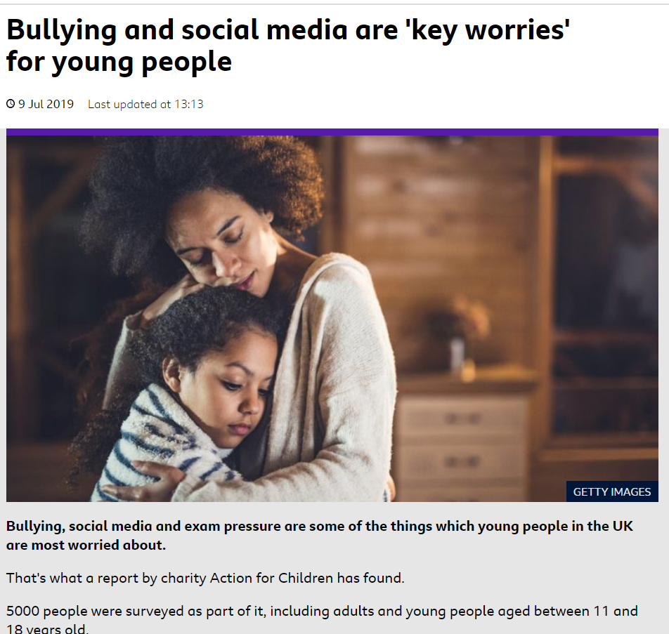

this news article informs on matter of bullying and social media pressures affecting young people, the young people who were surveyed as part of the articles research explains that the feel the need to be viewed to have “the perfect life” to avoid reticule from their peers. Other articles read by the writer mention that young people have linked social media directly to bullying and teen suicide, this is what Cyber-youth work will attempt to combat.
When bullying takes place online and a young person clicks the CEOP button on social media webpages, CEOP is a police run service that takes cybercrimes, when a cybercrime occurs such as a person posting revenge porn to threatening another person online the CEOP button can be pressed. This button will then alert a police agent of all the chat logs and relevant picture or videos to inspect. If a crime is found police can then convict a person due to their online actions. Now imagine if a is a young person on young person bullying situation, does this need to go to the police to be dealt in a criminal manner? Or is this being where cyber-youth work can take place? Young people can be educated and supported online by youth workers and then referred to youth centres within their area for additional support.
Therefore, the writer would like to link with the CEOP service to educate and support young people. (Ceop.police.uk,2016)

There is not currently any youth project that functions and operated on the internet therefore there is a clear gap for a project like this, and with all the bullying, suicide and depression linked to social media and the internet there is also a clear need.
This project will combat bullying between young people on social media through education and a youth work approach. This project will also provide young people with a place to go online for advice or help. This project will be able to signpost young people to youth projects within their local area, this project will not be an outreach project specifically, but outreach will an aspect of what the project does. The project will network with youth clubs and youth services. This project will work as an individual web page presence for young people to access when online and work within the already well established CEOP button found on all social media sites. (link of ceop button) this will allow youth workers to access a situation of bulling that occurs online and educate young people who may be bullying perpetrators of the affects and dangers of bulling, youth workers will also be able to ensure the wellbeing of young people who may be affected. I believe this social and educative approach is more effective than a criminalisation approach that may otherwise be taken. The university of Manchester conducted a study that showed young people are more likely to be violent or display harmful behaviour when treated like criminals the study suggests that young people should be treated fairly, young people should not be viewed as the problem but rather society and their environment. (Stafford, 2018)
This project and its workers will be carried out with the youth work valves carried out, workers will follow the 5 pillars of youth work and work in an educative, participative, empowering, inclusive and expressive way. Staff will need to be youth work trained and trained in crisis prevention and harm prevention staff will also ideally be trained in the five ways to wellbeing. This project can help reduce suicide, bullying and loneliness withing young people when online and in their day to day lives. The writer believes strongly that this will be a meaningful and beneficial service for young people, by examining the 11 aspects to a meaningful service (Lawrie,1995) the writer has set these aspects and youth work values to be the key to the success of this project. Meaning full project. 11 aspects to a meaningful service.
this project will be set up by the writer, the writer will be responsible for initiating and managing the project. The writer will first have to locate a building for the cyber- youth work project to work in. In an ideal world the project can be absorbed in to an existing youth centre or in a government service such as the police, a county youth service or CEOP to avoid spending costs of renting and maintaining a building. This will also allow for existing over heads such as management committees to be used to supervise and provide supervisions to Cyber-youth work project staff and volunteers. This would be an ideal circumstance as this will allow for money to be better spent on training and maintaining a staff team. The next step to getting this project going would to be to design a webpage that allowed young people to log on and chat to a youth worker to receive advice. Another feature of the app would allow young people to click a button on social media that would link them to a youth worker in case of the young people being harassed or bullied online. The youth worker will act as a mediation and educative service to stop and prevent bullying occurring again. Staff and young people will also be able to play online games as part of the website. This web page will also have a feature with allows young people to locate their nearest youth project.
The next step would be to recruit a staff and volunteer team. This team will be made up of youth workers and volunteers, staff members and volunteers will receive training such as conflict resolution, five ways to wellbeing, mental health first aid, advice and guidance, restorative practice and youth work if needed. The project will have one fulltime youth worker responsible for managing the project and two part time youth workers to help with the day to day running. The project will rely on volunteers and students that may be on placement to help and support the project. Along with training there will be frequent supervisions with staff and volunteers to ensure wellbeing and quality of work is satisfactory. Volunteers will be recruited from volunteering agencies such as SCVS, this project will also be open for accepting student volunteers. There will be week staff and teem meeting to ensure quality of work and health and wellbeing of staff, there will also be monthly reviews of the project to highlight any areas for improvement.
Here is a copy of Cyber-youth work staffing structure; 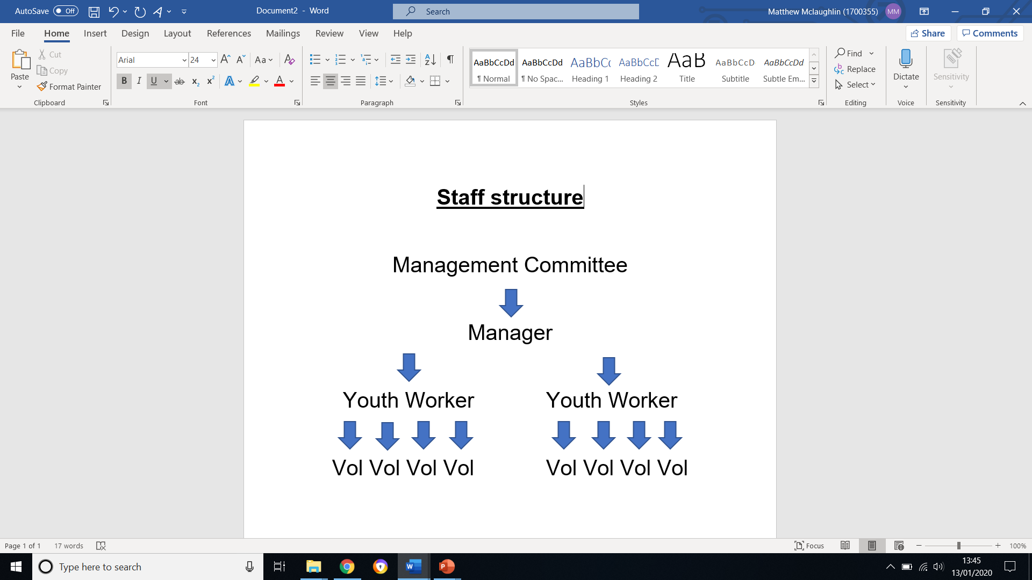
As seen above the chain starts with the management committee, the management committee will be responsible for ensuring the manager is supported in their role, that they keep of task and manage affectively. Next, we have the manager who is over all responsible for the running of the project, it is the managers job to ensure that workers and volunteers are supported and working affectively. Next, we have the youth workers who are responsible for working with in the project and interacting with the young people online, the youth workers are also responsible for managing the volunteers. Finally, we have the volunteers who are responsible for engaging with young people, supporting youth workers and suggesting ways to improve the service.
next the manager will need to create or adapt policies for the project such as safeguarding procedures and data protection procedures. In this period the manager will also have to set up links with social media and CEOP to make the project active and ready for staff members. This step may take some time and require some meetings. It is up to the manager to educate and train all staff and volunteers of these policies, this may take place in the staff introduction pack when starting employment or volunteering.
The next step would be to design shift patterns the writer suggests that Cyber-drop in will be open for ten hour a day between the hours of three pm and one am. Young people will be able to access this service during these times. Staff will be rotated on for ten-hour shifts this means there will be one paid member of staff on every shift. This staff member will be responsible for handling any safeguarding issues that may arise during this time. volunteers will also be present at this time to relieve pressure off staff members.
The next Cyber-youth work would need to do a marketing campaign, this project would need to get their name out there and known among young people online, this could be a short video that can be uploaded online, and posters sent out to schools and youth services. The cyber-youthwork team could also do talks in schools and youth clubs. The project can also have a project launch day where it invites professionals from the local youth service, police and other agencies to give them an idea of what Cyber youth work is and what it does. This is a good networking opportunity and will help when referring young people to youth services.
And finally, to operate and support young people online while referring to youth services in their local vicinity. This is where the project will be running with full steam, ensuing that youth work is an online presence and is accessible for young people. during this time staff are required to save conversations with young people and make a log of how many times the young person uses the service and to refer them to their local youth club. Staff should then make a call to the club to check if the young person is engaging. This will help prove to funders that the project is working as it should and their money is well spent.
The way we will collect feedback and statistics to evaluate and pass on to funders is to keep a log of the chats and how many young people access our services. We can then check how many young people have been referred and have gone to their local youth club or project. We will check this by a follow-on call to organisations to see if young people have attended. This can be put into a spread sheet to review the projects performance. At the end of each chat with young people online there will be a shot survey they young people can choose to complete to provide the project with feedback. This will also allow young peoples voices to be heard as stated in the U.N.C.N.C article 12,
Every child has the right to express their views, feelings and wished in all matters affecting them, and their views considered and taken seriously. The right applies at all times, for example during immigration proceedings, housing decisions or the child’s day-to-day home life
(Unicef UK, 1992)

At the start of the year is when the most spending of funding will occur as the writer will need to spend funds on job adverts, creating and maintaining a web page, marketing, equipment, staff and volunteers’ expenses. The project will avoid a lot of costs buy working in a government or youth service building to avoid paying rent and running costs such as gas electric and water costs. The project will also save on hiring an accountant and overheads as these will be in place from the youth service. from the start of the project there will need to be a full-time member of staff to set up the project. This member of staff will be the manager or the project and will receive fifteen pound per hour and will be contracted to thirty-two hours per week accumulating to an annual salary of twenty-four thousand six hundred pound. This is going off the general wage of a manger on from the Indeed website. This member of staff will need to put out a job advert looking for two part time workers who will get paid ten pound per hour and will be contracted for twenty hours per week making an annual salary of ten thousand four hundred pound each again taken from the indeed webpage. From completing quotes online, the writer estimated that it would cost two hundred and forty pounds to advertise the job role for one month on indeed and charity job finder. Other ways to get applicants is to advertise on social media or through word of mouth. From the writer’s research website can costs from two hundred pounds to six hundred pounds to build and maintain a website and domain. Wix.com quoted three hundred and fifty pounds to create and maintain a domain and a webpage. It will cost Twenty-three pound ninety-nine pence for one thousand leaflets to be printed to advertise the service these leaflets are quoted from vista print. a video advert will cost around one thousand two hundred pounds to make and advertise. The project will need a computer server the writer has found the Dell PowerEdge T140 server, which will cost four hundred and seventy-nine pound ninety-nine pence. This server will be paramount to get the project up and running as it allows many different computers to access the same files, which will be ideal for a project like this. The server also comes with a five-year manufactures warranty. The project will need five Acer 315, 15 inch-A4, 4GB, 64GB, Chromebook laptops that are two hundred and seventy-nine pound ninety-nine pence each, the writer chose these Laptops as they are fast have good processing speed and are combatable with our server these laptops also have a two year manufacture warranty . the total cost for the laptops is one thousand three hundred and ninety-nine pound ninety-five pence. Leaving one thousand two hundred fifty-six pound and seven pence for volunteer expenses.
Here is a pie char that shows the budget and the spending;

This cart shows that the majority of spending will be on staff salary, with the other spends contributing to setting up the project, 2.5% is unrestricted with the expectation of more money joining this fund due to slippage in the salary as for the first couple of weeks of the funding it is unlikely that there would be a full staff team.
As stated above a lot of the cost come at the start of the year to get the project up and running with other costs such as salaries and volunteer expenses spread out through the year. The manager will be responsible for fundraising to ensure the security of the project for the future, the manager will start by attempting to gain additional funds for a internal funding officer whose sole role is to raise funds, after this we would look to scale the project up and extend the hours. As the writer believes this project will be beneficial for young people for many years to come.
In conclusion the writer has identified a need for an online youth work presence as there is currently not one active. With the growing popularity of social media and the growing concern on the affects social media is having on young people it is an ideal time to launch such a project. The project will work with in the youth work values and principles to ensure young people are properly supported by staff, staff will be trained up before starting the job role to ensure safety and wellbeing of young people and the staff themselves. The idea of the project is to be an online youth club but also have the aspect of conflict resolution if needed. The core value of the project is to educate and ensure the wellbeing of young people. the project will spend the fifty thousand pounds per annual of setting up the project, equipment and staffing to ensure the success of the project.

References
Bbc.co.uk. (2019). Bullying and social media are 'key worries' for young people - CBBC Newsround. [online] Available at: https://www.bbc.co.uk/newsround/48919239 [Accessed 13 Jan. 2020].
Ceop.police.uk. (2016). CEOP. [online] Available at: https://www.ceop.police.uk/safety-centre/ [Accessed 13 Jan. 2020].
Dera.ioe.ac.uk. (2012). national youth work strategy. [online] Available at: https://dera.ioe.ac.uk/19353/1/140221-national-youth-work-strategy-en.pdf [Accessed 3 Sep. 2019].

Dixson, A. (2018). Top 10 Components of a Business Plan - SmartAsset. [online] SmartAsset. Available at: https://smartasset.com/small-business/top-components-of-a-business-plan [Accessed 13 Jan. 2020].
Donnelly, L. (2019). Social media linked to increased risk of mental health problems. [online] The Telegraph. Available at: https://www.telegraph.co.uk/news/2019/09/11/social-media-linked-increased-risk-mental-health-problems/ [Accessed 13 Jan. 2020].
Lawrie (1995). Lawries meat sciences. [online] Ubblab.weebly.com. Available at: https://ubblab.weebly.com/uploads/4/7/4/6/47469791/lawries_meat_science.pdf [Accessed 13 Jan. 2020].
Stafford, J. (2018). Treating young people like criminals actually makes violent crime worse. [online] Treating young people like criminals actually makes violent crime worse. Available at: https://www.manchester.ac.uk/discover/news/young-people-criminals/ [Accessed 10 Jan. 2020].
Unicef UK. (1992). UN Convention on the Rights of the Child (UNCRC) - Unicef UK. [online] Available at: https://www.unicef.org.uk/what-we-do/un-convention-child-rights/ [Accessed 12 dec. 2019].
Write your business plan. (2014). Write your business plan. [online] Available at: https://www.sba.gov/starting-business/write-your-business-plan [Accessed 13 Jan. 2020].

