My feelings of the trip to Hafod (grid reference SN 768 736) can best be summed up thus: I would rather not do that again, at least certainly not at this time of year. Whilst the trip along the Ladies’ Walk and past the church at Hafod lived up to the picturesque Tyrol-inspired promise, the most memorable part of the trip was the journey back (haford.org, 2019). Phenomenological analysis of a site is often based on the feelings of an individual, and can be used to explain previous interactions with the landscape. From a such a standpoint, recalling what I felt at various points, the most memorable part of the landscape was the road at Ysbyty Ystwyth; which is only natural since this is where the majority of time was spent.
Hafod is stunningly picturesque, with the tall trees bordering the at-times steep path, difficult terrain, waterfalls and handrailed drops. Experiencing this path with the drop ledges and ‘viewing platforms’ I could certainly sympathise with Elizabeth Fry who had taken a turn along the path. The show starting to fall and settle created a seemingly haunting beauty along sections of the path especially the stretch parallel to the River Ystwyth. However, being generally clumsy unfit and increasingly cold; the weather soon lost its novelty and with it the enjoyable aspect of the walk. BBC journalists who walked the Hafod estate for an online feature called ‘Weatherman Walking’ describe the landscape as ‘adding a bit of wow to the picturesque’ and this is certainly the case though braver and fitter than I they also experienced the Gentleman’s Walk and Alpine bridge (BBC Wales Nature, 2019). Walking along parts of the Lady’s Walk it is clear to see how at times a bit of regency-style matchmaking could be achieved by playing to chivalry and stereotypical female frailty since by the end of the walk I was feeling rather less than top-form.
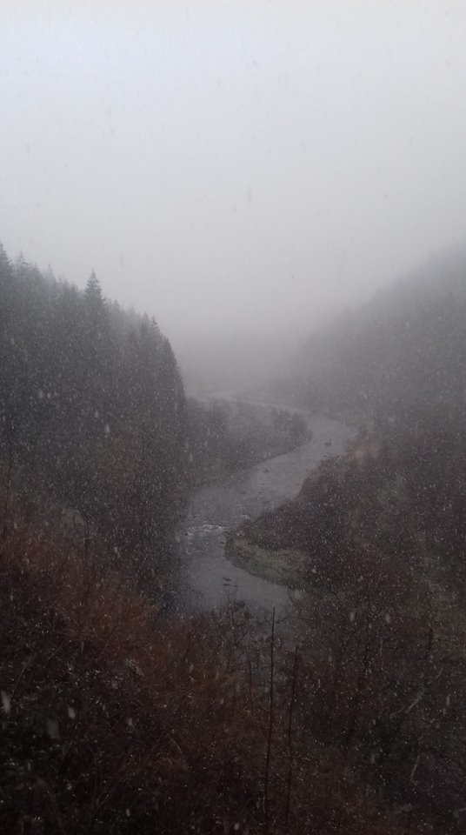
(The River Ystwyth in the snow, my photo)
It would be interesting to return at another time of year, decidedly warmer and dryer at least and trying the walk again, or possibly a different walk such as the Ystwyth Gorge route, the next time I feel particularly brave (haford.org 2019)
As previously stated however the impressions left by my experiences of the actual walk at Hafod quails against those of the trip back to Lampeter. Many of my thoughts towards Mercedes vans, snow, Wales and the RAC cannot be summed up in language anywhere close to academic, but suffice to say they are far from complementary. If there is anything that I will remember in years to come of the trip it will be the incredible sense of resignation and yet anger to everything about the situation and more solidly the intense feeling of cold and wet that seemed to sap every bit of strength I had after helping to push the van. Or possibly the sense of relief at rescue and returning to Lampeter which is one of the few times I’ve genuinely felt that way returning to campus.
Reference List
Bbc.co.uk. (2019). BBC - BBC Nature & Outdoors - Hafod Estate. [online] Available at: http://www.bbc.co.uk/wales/nature/sites/walking/pages/mid_hafod_estate.shtml [Accessed 31 Jan. 2019].
Hafod.org. (2019). Hafod Estate - Discover the Picturesque, walks, ravines and cascades - Self-guided Walks. http://hafod.org/walks.html [Accessed 31 Jan. 2019].
Tilley, C. (1994). A phenomenology of landscape. Oxford: Berg Publishers.

