

BA (Hons) Leadership and Management Skills for the Workplace

Module: Knowledge and Information Management Skills for the Workplace

Module code: BMSW 5106

Student: Rupia Hussain-ID: 2010133

Lecturer: Rejwan Bin Sulaiman

Assignment Task-1: Knowledge and Information Management of Amazon.com

Executive Summary
The report explains how Amazon grew from a simple online bookstore to a multinational company known around the world and a stable strong competitor in the market for many established industries. Critically evaluates how Amazon manages knowledge to be more customer-centric, by creating a sustainable unique systematic process to obtain personal data and use the information to give customers easy, comfortable experiences and services. Which encourages customer retention and satisfaction. Amazon’s understanding of the importance of knowledge management and theories is used systematically and embeds the organisation framework. Evaluations of knowledge management models like Nonaka, Wiig, and Choo’s, indication what strategies Amazon using to reach customers. Amazon has managed to provide and serve customers around the world during the Coronavirus pandemic when most renowned and stable industries fail to meet customer demand. Amazon.com’s success in using knowledge management theories to its advantage to stay ahead of competitors with products and services. Also, recommendations for improvements, with high success bring many threats to the organisation which needs to address constantly to maintain the position to keep customers and employees safe.

Table of Content

- Introduction page- 4
- Importance of Knowledge and Information Management……………………….. page-4
- Types of Knowledge and Information pange-4-5
- Background of Amazon…………………………………………………………...page-6-7
- Amazon achieving competitive advantage page- 7-8
- Types of knowledge management models page - 8-9
  - Nonaka spiral model
  - Wiig model
  - Choo’s Sense-making model
- Evaluation of models and theories page -10
- Systematic knowledge management ……………………………………..….....page-10-11
- Managing knowledge and information: Success and Failure………….….....page- 11-13
- Effective knowledge management……………………………………………..……page-14

- Conclusion………………………………………………………………………...……page-14

- Recommendation………………………………………………………………..…….page-15

- Reference………………………………………………………………………..…page-16-17

.
- Task -2: Poster Presentation Title’- Practical Evaluation of the Proposed Knowledge Management Framework for Amazon………………………….………………..page-18-19

- Introduction
The purpose of authoring this report is to establish how Amazon.com acquires customer focus information and how it is managed. The e-commerce company, with its endless selection and drive to deliver convenience and low prices became the top leading retailer and an essential service for many consumers at the height of the coronavirus crisis (Demir, 2017). Satisfying customer needs and demands by making them available to them. The report will explore Amazon.com’s information knowledge management systems. How they obtain customer information and store it and, use it to provide customer-centric service and products. From the start, Amazon has managed to get customers' attention with their unique approach to having available required products. Collecting and processing the data of an individual is the key to providing relevant services to consumers and staying ahead of the trending demands of evolving shopping experiences.
Amazon.com is an online enterprise which headquarters based in Seattle America. Founder Jeff Bezos in 1994. Amazon is famous for selling market-leading e-book readers Kindle and Kindle Fire. Amazon has expanded products like electronics, books, housewares, toys, clothing, music, and movies. Amazon's famous web business is cloud computing, renting data storage. Amazon.com has millions of customers selling products direct to them or as a middleman connecting customers to the sellers (Hall, 2022). During the Covid-19 households relied on online shopping and Amazon's growing trends seem to continue even after the pandemic.

- Importance of Knowledge and Information Management

It is critical to build knowledge and information management competence in the organisation to achieve and sustain competitive advantage. There are many well-established theories that organisations can adapt to and integrate knowledge management into the organisations in structure systems (Kazuo, 2007). Knowledge management usually refers to the organisation’s technologies used to store and share information for employees and customers to access when needed to facilitate accurate decision-making and enhance communications. The element of knowledge management consists of the organisation’s people, process, content, and strategy.
Purpose of knowledge management: - Knowledge management systems help organisations to improve agility. Enhance business processes to communicate and support employee development and team collaborations. An integrated KM system can help employees report and analyse information faster and better decisions makings which helps increase the organisation's innovation rate to achieve its goal and objectives. Any organisation must gather information store and share the data within the company to use to its advantage. Companies have a constant stream of data every day, it is paramount to manage the overloaded information properly. Proper knowledge management can help organisations to learn more about their customers and clients which can accede to effective decision-making to build a positive culture and innovations (Quast, 2015). Data offers a wealth of information for any organisation and its managers, but processing correctly can be overwhelming. If the information not managed properly within the organisation, it could lead to the downfall of the company and in the same way, having the necessary Knowledge Management system in place can lead to the company’s success. Amazon.com has administrated this process successfully from the early stage and continued to dominate even during Covid-19.

- Types of Knowledge and Information
Knowledge management is the process of information collected by an organisation that can be shared and analysed in a way that can be easily understood and made accessible to employees and employers. Information is derived through comparisons of data with other data into an interpretive framework of an organisation. The objectives of knowledge management for an organisation are to do things effectively and efficiently (Sanchez, 2003).
There are many types of knowledge, expert, potential, factual, procedural, and reasoning knowledge however, there are three main types of Knowledge: Explicit, Implicit and Tacit all of which are found in any organisation, specific to that organisation.
- Explicit knowledge: Explicit knowledge acquired through physical means like Guides, reports, and Manuals. Allowing companies to share knowledge across the company’s departments and employees (IMB Cloud Education, 2020).
- Tacit knowledge: Usually acquired through encounters and experience, which makes it challenging to share or transfer to others. This experience can relate to language and expression which can make it hard to explain or understand others (IMB Cloud Education, 2020).
- Implicit knowledge: literature equivocates implicit knowledge with tacit knowledge. Implicit knowledge can be a tacit and explicit mixture of both, which can be obtained with practice or documentation to be able to transfer or share within an organisation (IMB Cloud Education, 2020).

Knowledge management is integrated through organisation employees, (people) technology, innovation, revenue, goals, and process. Knowledge is anything meaningful to us or the organisation. It is crucial to maintain knowledge management for the growth and survival of the organisation and stay ahead of competitors’ markets, knowledge must be processed, shared, used, and stored in an organisation systematically through employees.

An effective knowledge and information management system would allow easily to develop, keep, and share the latest information across the organisation seamlessly. Which also creates a culture that can significantly improve efficiency and employee happiness (Starmind, 2020).

- Knowledge and information management within Amazon
Amazon.com has evolved from a small e-Commerce bookseller to a worldwide online retail giant enterprise. A strong competitor for many businesses not just online but also for high street retailers too. Amazon.com has successfully connected millions of customers with product information by using advanced knowledge management (Rosenberg, 2014). Amazon.com successfully practise a system to serve customers a personalized way to find what they are looking for and a quick buying process.
One of the major key features of Amazon.com is the “1 Click Checkout” button. This feature can be set up when opening a new account with all personal details and payment methods. This feature can be activated or disabled according to the customer's choice. Many customers find this feature very convenient and prefer to use it for quick checkout. This feature captures all details of customers and enables Amazon.com to track the activity of the customer, their search, interest and what they purchased, which helps Amazon.com to suggest more ideas and relevant goods go with what they have bought which encourages more sales. It also offers customers a better shopping experience. They do not have to search and waste time thinking or browsing, it is already done and ready for them. They just need to select and pay which attracts customers, more for the convenience and quick service. Which creates customer delight. Amazon continues to remind customers what they ought to buy following their recent purchases. If the customer did not buy at the first suggestion, there is a continuous reminder to buy it. This is a virtual persuasive way of getting customers to buy the things they would not have brought or go looking for them. This technique also adds more customers and selling growth.

- Amazon achieving competitive dominance
Amazon had made it easy and simple for users from the early stage by keeping one portal and one interface amazon.com, unlike many other big companies Amazon always allowed customers to come to the same portal for all their needs, electrics, books, clothing, small to big items, no matter what they are looking for all available at one site, make it easy to remember and use, search is quicker and focused, reduce anxiety and increase comfort and familiarity.
Amazon always maintained presentation consistently, with product specifications, multi-sellers offer the same product, and buyers can see price comparisons with other facilities like quick delivery, free delivery or even reduce delivery charges. Also, customers review and product in use, real pictures. All in one place below the product pictures and details which help boosts confidence for buyers to purchase the product.
Amazon provides easy-to-read information, and content to the point, the way it is organised and displayed attracts customers' likeness. If any additional details are offered, they would give an option “click here” which gives customers the choice that they can make to their need, rather than sieving through too many details or reading.
Amazon keeps the power controls of everything on their site but has given the burden of providing true and correct upstream content creation to the product companies, making it compulsory for the companies to adhere to Amazon design standards, practise, and policies. Which frees Amazon from any falsifying product information. Gives the middleman a safe platform to address should any issues that arise with customers and products without damaging Amazon's reputation.
Amazon builds knowledge awareness by crowdsourcing with users, by displaying customer reviews and ratings featuring customer's analysis of: - like you, most and least helpful tabs with images, previously and bought together. Customers’ past data is used to promote and encourage better services and future shopping experiences.
Amazon has a great alert system to keep customers “in the know” with products and services. I like and use this feature particularly, it gives peace of mind not to over-run free trial subscriptions, Amazon reminds me and alerts me from start to end with an option to carry on or end the subscriptions. With personalization, knowledge management can increase productivity and awareness of new products without new research. Also, has clear after-purchase options for cancelling, or making changes all this feature adds to customers’ user-friendly experiences. 24/7 Amazon amazing online customer service with a click “help” easy-to-follow instructions to find the answers to any queries. This is a creditable feature to Amazon customer satisfaction and productivity. It saves time and costs for the company, by lowering phone calls to customer service. Amazon.com is available to any digital device with easy user functions. The layout is the same no matter what device you use. Adds value to familiarity and content consistency.

- Types of knowledge management models

6.1 Nonaka knowledge spiral model (1995) Ikujiro Nonaka models testify to only two main sources of knowledge Tacit and Explicit knowledge. Which is transferred in four ways.
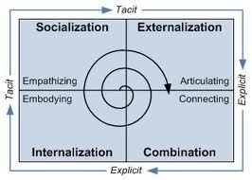 (Model image: sites.google.com, n.d.)
- Socialisation (tacit to tacit) - shared knowledge verbally.
- Externalization (tacit to explicit) - passing verbal ideas in written form
- Internalisation (explicit to tacit) - learning by doing, remembering/ storming in mind.
- Combination (explicit to explicit) - sourcing documented knowledge to create new knowledge in written form
As new knowledge develops the cycle repeats to be utilised in the organisation systematically according to the organisation's work frame to obtain objectives and goals.

  - The Wiig Model Karl Wiig proposed a knowledge management model in 1993. Insisting knowledge will be useful and valuable only when organised and synchronized. The model aims to make an organisation more intelligent and use knowledge sharing easily individually and across the organisations (Essekia, 2018) The model has four steps cycle:
- Build knowledge: tacit and explicit, from first-hand experiences, peers, education, Training, media, and books.
- Hold knowledge: in people, in tangible forms, books, manuals and documents
- Pool knowledge: using adequate Knowledge Management systems: internet, database, crosstalk with experts, group of people through discussions.
- Applying knowledge: use the knowledge in a work context embedded according to organisation work processes and tasks.
Wiig has expressed you have to have complete information to utilize it properly. Remembrance accumulates in repositories embedded in the organisation with synthesised access to retrieve to perform tasks. Allowing to analyse, evaluate and observe content to the objective of the organisations to implement.

6.3. The Choo Sense-Making KM Model- established in 1998. Focuses on three elements- sense-making, knowledge creation, and decision-making. All are connected to feed into the organisation. Organisational action can be made by absorbing the external and internal environment following Choo's sense-making cycle. Each phase brings out the strengths of processes to make effective decision-making. This model is well suited to hypothesis and scenario testing for any company.

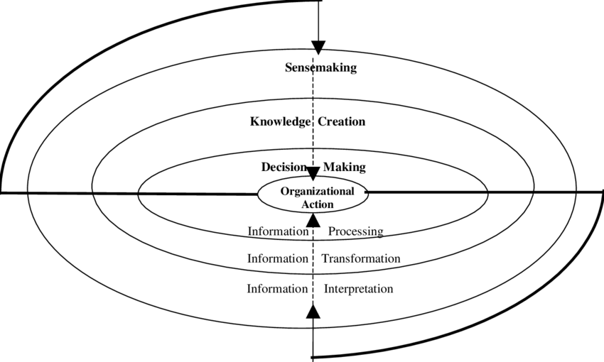 (Model Image: Holsapple, Clyde & Joshi, K. D. 1999)

- Evaluation of models and theories

Nonaka supposed his theories around tacit and explicit knowledge, The spiral model concentrates most of the knowledge development through human contacts. Within an organisation, employees play a crucial part in building and managing knowledge, and information and the flow of activities generates the transfer and application of knowledge.

Choo’s sense-making defines the organisation’s purpose of perception of problems the organisation needs to deal with and codify to find an accurate solution. Any organisation will pose two types of knowledge, tacit and explicit knowledge exploring this information will result in making new knowledge which leads to progressive decision-making in the interest of the organisation's goals and purpose.
Wiig's model of the knowledge management cycle is stepping ahead in more advanced to manage knowledge in the organisation and to use and retain the facts which can be retrieved to manage tasks more efficiently. Compare this to Nonaka and Choo’s theories. Wiig demonstrates in more depth calculation of any knowledge to the organisation by acquiring, understanding, and refining information therefore employees can work smarter and contribute to organisational goals.

- Systematic knowledge management

Amazon has utilized all kinds of knowledge information management models in every way possible to achieve personalised customer services and customer satisfaction. To stay ahead of market competitors. Amazon's knowledge management took steps further than the Wiig’s model applies. To reach customers by constantly keeping up with a change of knowledge and changing ways of making it tangible for employees in the organisation throughout the departments to create smooth sharing and applying.
A simple universal ongoing cycle (below diagram) of how Amazon might have managed knowledge and embedded it into the company infrastructure frame system to retain and retrieve the knowledge to be shared around the organisation, to be used to the highest potential of any knowledge to gain profitability, customer satisfaction and retention.

- Managing knowledge and information: Success and Failure

9.1. In the year 2000 Amazon.com launched Marketplace. Amazon sensed that there is no online platform putting a variety of sellers under one roof.

After analysing the research and information, they approached sellers of various products if they would be joining Amazon's online platform to come together to give the customer access to their products and a better shopping experience.

Amazon's decision to profit from the third-party seller made it a simple systematic rule, anyone can sell their product and services on the Amazon website for a percentage of a fee. Sellers still have the advantage of promoting their company name but are bounded by Amazon's terms and conditions of producing advertising and description down to the design and settings of the products (Rathee, n.d.).

9.2. AWS March 2006 Amazon web services were launched, offering IT infrastructure services to businesses form of web services. Also known as cloud computing (Amazon, 2019). An example of Nonaka's knowledge management strategy. Amazon again sense the market trends and noticed that there are not many companies providing this service and the growth of the internet is explicit and definite.

Considering the market investigations and creating a product with a high probability of success and profit.

Making the decision AWS using the market analysis to support their company data storage. Saving revenue instead of paying different companies now Amazon will provide the same services with much more flexibility, low cost, and available with various applications and options (Amazon, 2019). 40% of Amazon's profit now comes from AWS (Rathee, n.d.).

9.3. Amazon logistics as Amazon has become a multinational company of e-commerce need of own transportation become necessary. Use of theories like the Wiig KM model a market ships, and delivery operations. After Royal Mail, Amazon Logistics is the second largest leading company in the UK (Buchman, 2018).

9.4. Kindle e-book reader 2007. Amazon has again demonstrated the crucial management of knowledge using every stage of Choo’s theories. Amazon’s decision to make available to customers the first digital e-book reader with zero profit was a great hit and a gamble. Charging customers only the devices making charge but cleverly made resources and books available on Kindle can be purchased only on the Amazon.com platform. Which led to making a profit and tremendous success product all-round.

9.5. 2014 the launch of the smartphone fire mobile. Was not going to plan although all research and information were taken to understand, and analysed decision-making was not as effective as much like other successful decisions made in the past. They were too late to launch the smartphone Amazon fire, as Apple (2007) already launched its first smartphone followed by Android in 2008. The market has already been captured by these tough competitors which led to Amazon's fire failure. Information and knowledge are in constant change it is paramount to manage this knowledge in a strategic way across the company to stay ahead to make an effective decision for the organization (Rathee, n.d.).

was lacking in meeting the demands of fast secure deliveries, and even Amazon itself was falling in need of transportation. Although other recognised companies were tackling the demand there was still a huge gap in need and room to explore the avenues. Amazon's team observes the analyses and sets by putting ideas together to create a solution to their own needs and make a profitable business venture out of it too. 2012 Amazon decided to start an experiment in the UK the idea of freight started small for their own need. The competitors did not take that as a serious threat, slowly Amazon started to capture the market giving tough competition to major logistics companies. Now Amazon has Its aircraft, chartered

- Effective knowledge management

Amazon has been undoubtedly successful in achieving its maximum potential by following knowledge management procedures. Amazon had a few difficulties but most of the time they got it right. Amazon.com’s rise was based on many strategies and theories, but a great part of that success was based on managing knowledge strategy infrastructure and knowledge sharing across the organisation department. Amazon has managed to focus on giving customers the freedom to choose many options to suit their needs. Making available items at right time. Amazon had the advantage of first mover in the markets with many products which was a success and Amazon had worked extremely hard to stay at the top. It all happened due to the fact they have an effective knowledge information management system in place, continually changing and adding increased data which is analysed by a group of experts and made the decisions well. Amazon has embedded knowledge in the structure systematically well made it accessible to the employees, who can share and use the information in their roles. They have managed to capture customers' attention with many of their features and give customers facilities to make easy buying and selling.
- Conclusion

Amazon has come a long way from a small bookstore online to this multinational company that expanding and evolving around the world. But as you grow bigger, and better even greater responsibilities and work get involved. Amazon has invested revenue, resources, and human power in every stage of its development and success to become one of the greatest competitors in the market nationally and internationally. Amazon has embedded knowledge and information management well as new knowledge is courteously developed and is quick to analyse and share the information through the systematic procedures they have in use. Organisations like Amazon confusedly made use of theories like the Nonaka KM model to the creation of the first foundation of knowledge, Wiig KM theories to apply to relevant tasks and Choo’s KM model for accurate decision makings, developing and enhancing strategies internally and externally.

- Recommendation

  - Amazon needs to put more anti-fishing interventions more rigorous. Amazon is one of the highest targets for hackers. Amazon needs to increase and improve more ways to tackle this issue. Millions of customers' data and seller’s details are at risk. A multinational company like Amazon should continuously upgrade these security measures to protect customers employees and partners.
- Personally, being one of Amazon's customers, I feel venerable and at risk of hacking. Getting my data and banking details obtained by scammers. I have been sent many fake emails and texts on many occasions asking to press links and call numbers to find out why my account has been frozen or confirming the purchase of services or items. Which I did not buy or asked for it. it is done so realistically it is exceedingly difficult to determine if it sums or really from Amazon customers who do press the link provided by the faked message which opens the door to the scummers.
- By improving this issue Amazon will be tackling the most serious issues of online concerns for all. It will boost customer confidence and secure the personal confidential data of customers, employees, and associated business partners

  - Contacting the sellers- it is not noticeably clear how to contact the seller regarding any product queries. It is not indicated whether the seller has received or read the message sent.
- In the past customers, found it difficult to communicate with the sellers regarding item quality and availability enquiries. Customers found it a bit confusing to find a way to contact the seller. Eventually when many customers managed to write to sellers did not get a reply. In this situation, many customers intend to choose not to buy the products. which miscarriage sales and lacks customer satisfaction.
- Amazon should give a clear indication of contacting sellers and recognise time-bound when sellers answer customers. Also, clear options to further their enquiry if they wish to do so.
- Amazon has many amazing options but needs to improve in this area, like the strong arrival competitor eBay. Doing so will improve customer satisfaction and experience. Create opportunities for more sales and customer user friendly.

- Reference

Amazon (2019). About AWS. [online] Amazon Web Services, Inc. Available at: https://aws.amazon.com/about-aws/ [Accessed 9 Dec. 2022].
Buchman, E. (2018). The Rise of Amazon Logistics. [online] Transport Topics. Available at: https://www.ttnews.com/articles/rise-amazon-logistics [Accessed 9 Dec. 2022].
Chaffey, D and Wood, S. (2005). Business Information Management. Improving Performance Using Information Systems. (shared by the lecture)
Demir, M. (2017). Management Information System: Case Study of Amazon.com. Quest Journals Journal of Research in Business and Management, [online] 4, pp.2347–3002. Available at: https://www.questjournals.org/jrbm/papers/vol4-issue11/B4111117.pdf [Accessed 16 Dec. 2022].
Essekia (2017). What is Knowledge Management - A Comprehensive Introduction. [online] Helpie WP. Available at: https://helpiewp.com/what-is-knowledge-management/ [Accessed 2 Dec. 2022].
Essekia (2018). 4 Knowledge Management Models That Can Supercharge Your Organisation - Helpie WP. [online] Helpie WP. Available at: https://helpiewp.com/knowledge-management-models/ [Accessed 25 Nov. 2022].
Hall, M. (2022). Amazon.com | History & Facts. [online] Encyclopedia Britannica. Available at: https://www.britannica.com/topic/Amazoncom#ref306969 [Accessed 23 Nov. 2022].
Holsapple, Clyde & Joshi, K. D.. (1999). Description and analysis of existing knowledge management frameworks. 15 pp. 10.1109/HICSS.1999.772796.
IMB Cloud Education (2020). What is Knowledge Management. [online] www.ibm.com. Available at: https://www.ibm.com/cloud/learn/knowledge-management#toc-types-of-k-PhEhdnhI [Accessed 24 Nov. 2022].

Kazuo, I. (2007). Knowledge creation and management: new challenges for managers. New York: Oxford.
Patel, R. (2021). Models of Knowledge Management (KM Models) Explained. [online] The Cloud Tutorial. Available at: https://www.thecloudtutorial.com/knowledge-management-models/ [Accessed 21 Dec. 2022].
Quast, L. (2015). Why Knowledge Management Is Important To The Success Of Your Company. Forbes. [online] 1 Jul. Available at: https://www.forbes.com/sites/lisaquast/2012/08/20/why-knowledge-management-is-important-to-the-success-of-your-company/ [Accessed 23 Nov. 2022].
Rathee, D. (n.d.). How Jeff Bezos made Amazon a $1.6 Trillion company? | Business Model of Amazon | Dhruv Rathee. [online] www.youtube.com. Available at: https://www.youtube.com/watch?v=CAwokHvMFlY [Accessed 25 Nov. 2022].
Rosenberg, M. (2014). The Knowledge Management Genius of Amazon.com. [online] Learning Solutions Magazine. Available at: https://learningsolutionsmag.com/articles/1480/the-knowledge-management-genius-of-amazoncom [Accessed 23 Nov. 2022].
Sanchez, R. (2003). Knowledge management and organizational competence. Oxford ; New York: Oxford University Press.
Sannito, J. (2016). knowledgemanager [licensed for non-commercial use only] / Choo Sense-Making KM Model. [online] knowledgemanager.pbworks.com. Available at: http://knowledgemanager.pbworks.com/w/page/83148898/Choo%20Sense-Making%20KM%20Model [Accessed 3 Dec. 2022].
Sarayreh, B. Mardawi, A. and Aldmour, R., 2012. Comparative study: The Nonaka model of knowledge management. International Journal of Engineering and Advanced Technology, 1(6), pp.45-48.
sites.google.com. (n.d.). Knowledge Management - Knowledge Platform. [online] Available at: https://sites.google.com/site/knowledgeplatform2701/knowledge-management-1 [Accessed 15 Dec. 2022].
Starmind (2020). What Is Knowledge Management and Why Is It So Important? [online] www.starmind.ai. Available at: https://www.starmind.ai/resources/what-is-knowledge-management-and-why-is-it-so-important [Accessed 1 Dec. 2022].

BA (Hons) Leadership and Management Skills for the Workplace

Module: Knowledge and Information Management Skills for the Workplace

Module code: BMSW 5106

Student: Rupia Hussain-ID: 2010133

Lecturer: Rejwan Bin Sulaiman

Assignment Task-2: Evaluation of Proposed Knowledge Management Framework Individual Poster

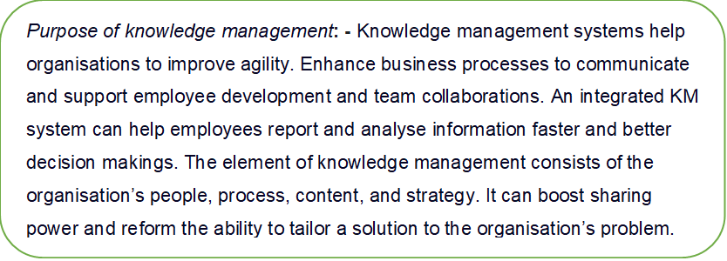
Practical Evaluation of the Proposed Knowledge Management Framework for Amazon
Challenge & recommendation- One of the biggest challenges for amazon is security, which is in constant threat of hacking, online fishing and scum. Amazon holds a vast number of customers, clients and partners' private and essential data which is a constant fraudulent target. Amazon needs to invest in more rigorous quality ICT resources and tools to monitor and protect data. Having in place robust artificial intelligence and human expertise security measures can improve however, must be shared across the departments to maintain resistance from hackers and scammers. Which will increase and strengthen customer confidence, confidentiality, accusation and retention.

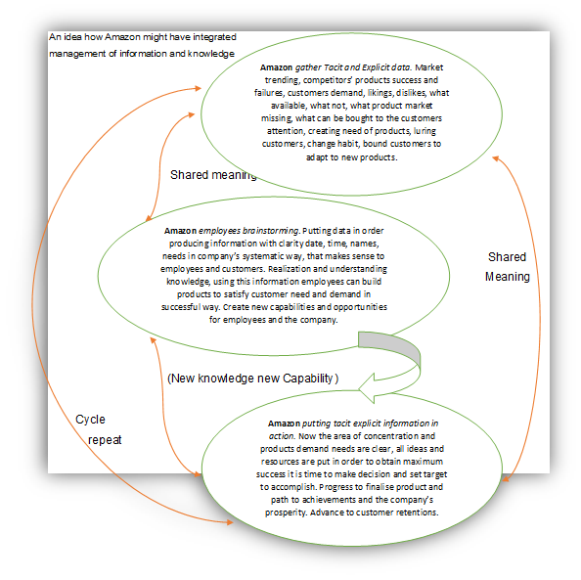

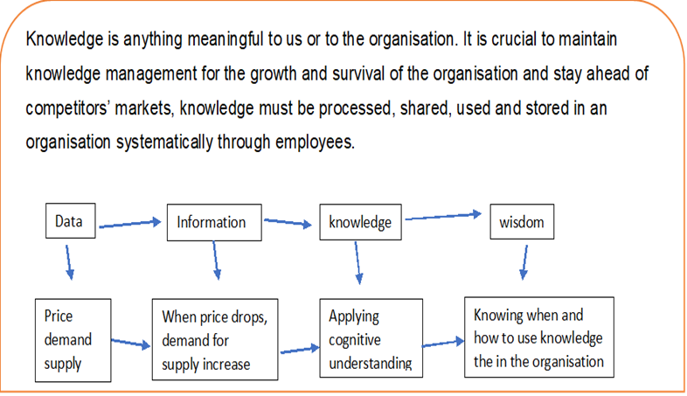

Evaluation Nonaka supposed his theories around tacit and explicit knowledge, most of the knowledge developed through human contacts. Employees play a crucial part in building and managing knowledge, and information. The flow of activities generates the transfer and application of knowledge. Choo’s sense-making defines the organisation’s purpose of perception of problems the organisation needs to deal with and codify to find an accurate solution. Any organisation will pose two types of knowledge, tacit and explicit knowledge exploring this information will result in making new knowledge which leads to progressive decision-making in the interest of the organisation's goals and purpose. Wiig's model of the knowledge management cycle is stepping ahead in more advanced to manage knowledge in the organisation and to use and retain the facts which can be retrieved to manage tasks more efficiently. Compare this to Nonaka and Choo’s theories. Wiig demonstrates in more depth calculation of any knowledge to the organisation by acquiring, understanding, and refining information, therefore employees can work smarter and contribute to organisational goals. Amazon has used multiple KM theories successfully to maintain competitors' advantages and retain customer satisfaction.

