Design of shaped charges

Emma Lane 2313851

Module: Advanced Physics for OME
Module code: ACDB5015
Lecturer: Kelvin Donne

Abstract
This project uses numerical modelling to investigate how different shaped-charge configurations behave during detonation. Two 2D axisymmetric models and one 3D model were created, each using materials and explosives commonly reported in peer-reviewed shaped-charge studies. Copper liners with Composition B and TNT fills were chosen for the 2D cases because they are widely used in experimental and numerical work, where their collapse behaviour and jet formation are well documented. For the 3D model, a tantalum liner and an HMX-based explosive were selected, reflecting research showing how higher-density liners and more energetic explosives produce noticeably different jet characteristics.
Both ALE and SPH methods were tested for handling extreme deformation. Consistent with the literature, the ALE mesh failed early due to severe distortion, whereas the meshless SPH approach remained stable and captured the complete liner collapse and jet formation. The results highlight how material choice, explosive performance, and numerical method all influence shaped-charge behaviour, and they show why SPH is often preferred in peer-reviewed studies when deformation becomes too large for mesh-based methods.

Table of Contents
Abstract 2
1. Introduction 4
2. Shaped Charges 5
2.1 The History of the Shaped Charge 5
2.1.1 The Cavity Effect 5
2.1.2 Shaped Charge Research 5
2.1.3 The Munroe-Neumann Effect 5
2.1.4 Developing the shaped charge design 7
2.1.5 Germany's development and deployment 7
2.1.6 United States and United Kingdom adoption 7
2.1.7 Post-War Shaped Charge 7
2.1.8 Other uses for shaped charges 8
3. Computer modelling 9
3.1 Computer modelling for military use 9
3.2 Computer modelling and shaped charges 10
3.3 ABAQUS and other modelling software 10
3.3.1 ABAQUS's use in defence 10
3.3.2 Meshing 11
3.3.3 Lagrangian and Eulerian method 12
3.3.4 Common meshing problems 12
4. Modelling the Shaped charge 14
5. Results 15
5.1 Comp B 15
5.2 2D TNT 16
5.3 SPH 17
5.4 Attempt at ALE 17
References 19
Appendix A 21
Appendix B 26

Introduction
Shaped charges are one of the most significant technologies to emerge in the field of explosive engineering. They are valued for their ability to focus chemical energy into a highly efficient, penetrating jet. Developed in the late nineteenth and early twentieth centuries, shaped charges have evolved through continuous refinement of liner geometries, explosive formulations, and manufacturing techniques.
This assignment examines the history and evolution of shaped charges and their design. Then, exploring the fundamental design principles that govern shaped charge performance, including liner material, cone angle, stand-off distance, and explosive characteristics. As computational modelling has become increasingly central to engineering analysis, the assignment will also investigate the development and limitations of modern simulation software, the challenges posed by material behaviour, mesh distortion, and the extreme stress and strain rates encountered during these explosive events, while contrasting the advantages with traditional live-fire testing, demonstrating how costs can be reduced. Safety improved, while also acknowledging the aspects of real-world behaviour that remain difficult to capture computationally.
The assignment concludes with an analysis of three shaped-charge models developed in Abaqus.

Shaped Charges

The History of the Shaped Charge

The Cavity Effect
While credit goes to Max von Foerster for the discovery of the actual cavity charge effect, having reported his discoveries in 1883, some people believe that an 18th-century philosopher, theologian and mine engineer, von Baader*, was the first to record advocating the principle of hollow cavities at the forward end of a blasting charge in mining. [1] *Many sources have recordings of von Baader’s research; however, there seems to be doubt about his first name and country of origin, as shown in Reference 1.

Shaped Charge Research
During the 1880s, two German researchers, Max von Foerster and Gustav Bloem, conducted independent research on the effects of hollow cavities (such as simple depressions and hollow spaces) and observed an increase in penetration power. It was this that would lay the groundwork for Charles Munroes widely known investigations. [1]

The Munroe-Neumann Effect
Professor Charles E Munroe was an American civilian chemist employed by the U.S Navy. While working with explosives at the U.S. Naval Torpedo Station, Rhode Island, he detonated an explosive block with lettering stamped on its surface (Figure 1, Appendix), which was imprinted on a nearby metal plate. This showed that the explosive energy had been focused rather than spreading evenly; this became known as the ‘Munroe effect’. [1]
Munroe’s work provided the first widely recognised scientific explanation of how hollow cavities can concentrate explosive energy and laid the foundation for modern technology and the emergence of conical metal-lined designs.
Further testing demonstrated the lined cavity principle by defeating a massive steel target. Munroe describes a defeat of "a safe twenty-nine inches cube with walls four inches and three-quarters thick, made up of plates of iron and steel,...when a hollow charge of dynamite nine pounds and a half in weight and untamped was detonated on it, a hole three inches in diameter was blown clear through the wall, though a solid charge of the same weight and of the same material produced no material effect. The hollow cartridge was made by tying the sticks of dynamite around a tin can, the open mouth of the latter being placed downward..." [2]
Egon Neumann, a German explosives researcher, claims to be the original discoverer of the hollow charge effect and to have patented its application through the Westfälisch-Anhaltische Spregstoff Actien Gesellschaft (WASAG), showing that Neumann was amongst the first to see the practical potential of hollow charges. Egon Neumann's work is reflected in the term ‘Munroe-Neumann effect’. [3]

2.1.3a Physics of Jet formation
The effectiveness of a shaped charge stems from the physics of how a metal liner collapses. When the explosive surrounding the cavity detonates, it generates high pressure, causing the solid liner material to behave like a fluid. This behaviour is described by hydrodynamic theory, which applies when the pressures are so high that material strength becomes negligible compared to the forces acting on it.
As the detonation wave travels through the explosive, it collapses the metal liner inwards along the axis of symmetry. The liner material flows together and forms two distinct components:
- A high-velocity jet, consisting of the front portion of the liner, which stretches into a long, thin stream of metal
- A slower, thicker slug, formed from the rear portion of the liner
Over the years, understanding of hollow-charge behaviour improved; it became clearer that the dramatic increase in penetration observed in early experiments was not solely due to a cavity concentrating the blast, but the way the metal liner collapses when the explosive detonates. The pressures involved are so high that the liner behaves more like a fluid than a solid for a moment.
The liner inwards along its axis when the detonation wave reaches the cavity. As the material folds in on itself, it forms two distinct parts: a long, narrow jet at the front and a slower, thicker mass of metal behind it, called the slug. The jet gives a shaped charge its penetrating ability. Travelling at several kilometres per second, it erodes armour through a high-velocity impact process.
The liner's shape and material significantly influence the jet's shape. Narrower cone angles tend to produce longer, faster jets capable of deeper penetration, while wider angles create shorter jets that make broader but shallower holes. Copper became the preferred liner material because of its ductility and ability to form a coherent jet. However, denser metals such as tantalum are used when a heavier, more compact jet is required.
This understanding of how the liner collapses and how the jet behaves provided the scientific foundation for the shaped-charge designs developed in the 1930s and refined throughout the twentieth century. [4] [5]

Developing the shaped charge design
It wasn’t until the 1930s that the shaped charge design began to emerge for military use. A German physics student, Franz Rudolph Thomanek, conceived an anti-tank round based on a hollow charge. Thomanek designed many prototypes, many of which proved disappointing. In 1937, Thomanek collaborated with Hubert Schardin. Schardin believed that hollow-charge effects were due to the explosives generating shock waves. It was during the testing of this idea in February 1938 that Thomanek conceived the hollow-charge liner effect (Holladungs-Auskleidungseffekt). [3]
As rearmament was ramping up due to the anticipation of a second world war, several nations, such as Germany, the Soviet Union, the United States, and the United Kingdom, recognised the potential of the shaped charge for defeating armoured vehicles, each using the technology to adapt their tactical needs. By the start of World War II, shaped charges had moved into mass production as weapons.

Germany's development and deployment
Germany was the first nation to hold shaped-charge weapons on a large scale. Early designs included the Hohlladung 3kg demolition charge and the Panzerwurfmine; however, the most influential weapon was the Panzerfaust (Figure 2). A 1.8-pound warhead that could penetrate up to approximately 8 inches (200 mm) of armour, depending on the variant, at close range. It was cheap to produce, disposable and devastating at short range. [6] The Germans also produced the Panzerschreck, which had an extended range than that of the Panzerfaust but a similar penetration depth. Many believe this was based on the American bazooka.

United States and United Kingdom adoption
America introduced the M1 bazooka in 1942; it was the first man-portable rocket launcher to use a shaped-charge warhead in combat. It could penetrate a depth of 3 inches of homogeneous steel armour. Following a British report that the Germans were increasing the armour thickness of their Panzer tanks, America sought to improve the M1 and developed various designs throughout the war. They ended with the M9 Bazooka, which could penetrate up to 4 inches of armour. [7]
The British developed the Projector, Infantry, Anti-tank (PIAT) (figure 3). This used a spigot mortar system to launch. The warhead was robust and capable of penetrating the armour of the German Panther and Tiger tanks at close range. [8]

Post-War Shaped Charge
After World War II, many nations recognised the value that shaped charges had in anti-tank warfare. They also realised their limitations, such as inconsistency, crude standoff arrangements, and sensitivity to manufacturing tolerances.
Military and civilian engineers began work to address these limitations and conducted further research into liner materials, during which oxygen-free copper was trialled. Cone angle optimisation to allow for a deeper, more stable jet formation. Stable and uniform explosives to improve safety. Ensure correct detonation times by improving fuzing systems and optimising standoff distances for maximum jet development.
The start of the Cold War in the 1950s brought about the emergence of Anti-tank guided missiles (ATGMs). Where, instead of relying on infantry soldiers to get dangerously close to the target, missiles could be deployed at long range.
During the 1970s – 1990s, tank armour was evolving to disrupt or absorb shaped charges, reducing penetration. To counter this, America and Britain developed the tandem-charge warhead, which has two charges: a small one at the front, which clears a path for the main charge to penetrate and defeat the armour. This technology is still used today. In Britain, research establishments such as the Armament Research and Development Establishment (ARDE) played a significant role in evaluating shaped-charge performance, studying armour interactions, and contributing to early guided-missile programmes such as Malkara and Swingfire. [1] [3]

Other uses for shaped charges
Beyond military applications, the shaped charge’s ability to focus explosive energy has made it indispensable in several civilian industries. There are many uses for shaped charges outside of military use; a few of these consist of:
The oil and gas industry is the most extensive non-military use of shaped charges, having adopted them for well perforation, where small charges are used to punch precise holes through steel casing and into rock formations.
Demolition engineers began using linear-shaped charges to cleanly and safely cut beams, cables, and other strong structural materials.
The aerospace industry uses more miniature versions of them, not for penetration but for clean, instantaneous separation, such as emergency releases.
In mining and quarrying, it is used to break rock, create boreholes, and reduce unwanted fracturing while improving overall safety. [9]
Overall, the shaped charge has evolved to be one of the most versatile and influential technologies in both military and industrial engineering.

Computer modelling
Computer modelling is essential to modern engineering and science; it enables complex systems to be analysed in a controlled, virtual environment, thus avoiding the need for expensive, time-consuming, physical experiments. Modelling allows ideas to be tested quickly and safely by recreating real-world behaviour. Engineers can study how materials respond to stress, how structures behave over time, and how different design choices influence performance. The increase in computing power has enabled these models to become more detailed and accurate, giving researchers insights that would have been impossible to obtain through experimentation alone. Today, computer modelling is used in everything from aircraft design and weather forecasting to medical research and defence science, making it one of the most versatile, influential and valuable tools in modern technology.

Computer modelling for military use
Computer modelling allows defence engineers and scientists to predict, test, and refine systems before any prototype is built. Before these tools were available, development depended on live experiments, which were expensive, time-consuming, and often restricted by safety, weather, and range availability. Through the 1980s, as computing power grew, simulation became a cost-effective and safer alternative.
Modelling allows the analysis of materials' responses under specific conditions, such as high strain rates, shock loading, or fragmentation, without recreating these environments physically. This is especially valuable when studying jet formation, blast effects, and armour response, which are too fast and intricate to capture fully with traditional methods. Simulations provide controlled settings where events can be slowed down, repeated, and analysed in depth.
Modelling also gives defence the ability to explore new designs at significantly less cost. Armour systems, personal protective equipment, and blast-resistant structures can be virtually built and evaluated, enabling comparisons of materials, geometries, and configurations. This speeds up development and improves safety by identifying potential issues before live trials.
Although computer modelling has not replaced physical trials, it has reduced the number of live firings required. Simulations help narrow down design options so that only the most promising concepts move on to full-scale testing. This approach of virtual and physical experimentation has become standard practice in defence engineering, enabling safer, faster, and more cost-effective development of new technologies and weapon systems. [10]

Computer modelling and shaped charges
Before computer modelling, shaped-charge research relied on physical testing, high-speed photography, and trial-and-error. These methods were essential in early development, but they had their limitations. Shaped charges involve swift and complex physical processes, and even the best high-speed cameras struggle to capture every detail. Key events, such as detonation behaviour, shock-wave propagation, liner collapse, casing deformation, fragmentation, and jet formation, occur in microseconds, making them almost impossible to observe directly.
By virtually recreating shaped-charge events, researchers could slow down the process, view it from multiple angles, and analyse it in ways that physical testing alone could not. Simulations enabled the study of how jets form, how they interact with different materials, and how armour responds under extreme loading, all without the cost and safety challenges associated with live firings. [10]
During the 1960s to 1980s, the development of hydrocodes, numerical tools designed to simulate material behaviour under the high pressures and strain rates produced by explosives, occurred. These early codes enabled researchers to approximate the fluid-like behaviour of metals during detonation, something previously impossible to model accurately. Two main approaches emerged: Lagrangian methods, which track material as it moves, and Eulerian methods, which observe how conditions change at fixed points in space. The introduction of these techniques gave engineers greater insight into shaped-charge physics and improved the accuracy of predictive modelling. [5] [11]

ABAQUS and other modelling software

ABAQUS's use in defence
ABAQUS is widely used in defence work because it can handle the kind of messy, fast, and highly nonlinear behaviour you get with explosives and high-strain-rate problems. In shaped-charge studies, it provides a way to examine how the liner, casing, and target materials behave during detonation without running live tests each time. The explicit solver is handy because it can capture linear collapse, jet formation, and the early stages of jet–target interaction. ABAQUS also has a decent range of material models, so metals, ceramics, composites, and armour steels can be represented in a way that’s close enough to reality for this kind of work. You still need physical tests to validate things, but the software lets you try out ideas, compare designs, and get a feel for how things behave before building anything.
One of the reasons ABAQUS works well in this area is that it allows you to define materials based on their behaviour under extreme loading. Defence problems often involve a mix of ductile metals like copper or aluminium, brittle ceramics, high-strength steels, and layered composite systems. ABAQUS has models that can handle all of these. For example, ductile metals can be modelled with plasticity and damage laws that include strain-rate effects. Armour steels can be assigned high-strain-rate behaviour, so they respond realistically under impact. Even more complex armour setups, such as layered composites or reactive armour, can be built from multiple material definitions.
This flexibility matters in shaped-charge simulations because the behaviour of the liner, casing, explosive, and target all affects the result. Copper liners need models that capture their ductility and ability to form a stable jet. Steel casings often require erosion or failure criteria to represent fragmentation. Target materials — whether RHA, ceramics, or composites — need to be able to absorb shock, crack, or deform depending on what they’re made of. ABAQUS handles these interactions through contact algorithms that account for penetration, erosion, and high-velocity impact, which helps build a clearer picture of how the whole system behaves. [12] [13]

Meshing
Choosing the proper mesh density in ABAQUS requires careful refinement: too little, and you miss essential features; too much, and the file becomes unmanageable. In shaped-charge modelling, this balance becomes even more delicate because the physics occur so quickly and over such small regions. The liner collapse and the jet formation both require perfect resolution. These are the areas where a few microns of mesh size can make the difference between a jet that forms cleanly and one that looks nothing like reality. ABAQUS lets you tighten the mesh exactly where the action will occur while keeping the rest of the model lighter, enabling simulations to run fast enough to be practical. You therefore need insight into where the material will deform the most, where the shock wave will travel, and where you need to see the finer details. Once you understand the problem's physics, the mesh almost designs itself. Good meshing tells ABAQUS which parts of the model matter most. [14]

Adaptive meshing/ALE
Adaptive meshing, often used via ALE (Arbitrary Lagrangian–Eulerian) techniques in ABAQUS, is a valuable tool when it works properly. In shaped-charge simulations, materials stretch, flow, and deform so violently that a regular mesh can become twisted or distorted beyond use. ALE meshing steps in by allowing the mesh to move independently of the material, constantly reshaping itself to stay clean and usable even as the geometry changes dramatically. This is useful when modelling jet formation, where the metal behaves more like a fluid than a solid. Instead of the mesh tearing itself apart as the jet stretches into a long, thin filament, ALE keeps the elements well-shaped and evenly distributed. The result is a simulation that remains stable and accurate for far longer than a purely Lagrangian mesh could. In practical terms, ALE meshing lets you better follow the physics, with fewer numerical problems and a much clearer picture of how the jet evolves. It is one of the reasons ABAQUS remains a powerful tool for explosive and impact modelling. [14] [15]

Lagrangian and Eulerian method

Lagrangian method
The Lagrangian method feels most natural to imagine. You can think of it as attaching tiny GPS trackers to every bit of material in your model and then watching where each piece goes. As the material moves, stretches, bends, or breaks, the mesh moves with it.
This approach is great when you care about how a solid object deforms, for example, how a shaped-charge liner collapses in the first few microseconds. Because the mesh adheres to the material, you get a clear picture of how each part behaves over time.
But there’s a catch. If the material deforms too much — like when the liner stretches into a long, thin jet — the mesh can become horribly distorted. Imagine trying to pull a net into a needle shape; eventually, the net can’t cope. That’s why Lagrangian methods struggle once deformation becomes extreme. [16]

Eulerian method
The Eulerian method does not follow the material; instead, you keep the mesh fixed in space, like a 3D grid. The material then flows through that grid, and the solver keeps track of what’s inside each cell at any moment.
This is perfect for situations where the material behaves more like a fluid, as is the case during the later stages of shaped-charge jet formation. The jet stretches and flows at high speed, but because the mesh doesn’t move, it never distorts. [16]

Common meshing problems
Even powerful tools like ABAQUS, meshing can go wrong in ways that quietly undermine a simulation. Some issues are apparent, but many only show up later as strange results, unstable runs, or behaviour that doesn’t match what the physics tells you should happen.
One of the most common problems is using a mesh that’s too big in areas where the physics change rapidly. In shaped-charge modelling, this usually shows up around the liner apex or the jet-impact zone. If the elements are too large, the jet may form incorrectly or penetrate far less (or far more) than it should. On the other hand, creating a mesh that’s unnecessarily fine doesn’t just slow the simulation down; it can make it unstable, especially in explicit dynamics where tiny elements force small time steps.
Another frequent issue is element distortion. As materials deform, stretch, or flow, the mesh can become skewed or twisted. In a shaped-charge simulation, the liner collapses so violently that poorly chosen elements can fold in on themselves, causing the solver to crash or produce non-usable results. This is one of the reasons ALE, or adaptive meshing, is so valuable: it helps prevent the mesh from tearing apart during extreme deformation.
Poor transitions between fine and coarse regions are another damaging mistake. If the mesh jumps abruptly from tiny elements to much larger ones, it can create artificial reflections of shock waves or introduce numerical noise; however, this can look like fundamental physics, which is why smooth, gradual transitions are so important.
In short, most meshing errors come down to the same core issue: the mesh doesn’t reflect the physics of the problem. When the mesh is built thoughtfully, aligned with expected deformation, refined where needed, and stable under extreme loading, the entire simulation becomes more trustworthy. [17] [15]

Modelling the Shaped charge
For this assignment, three shaped-charge setups were selected: two for 2D modelling and one for 3D modelling. The choices were made after reviewing a range of papers and textbooks to identify which materials and explosives are commonly used and which behave predictably in simulations. The aim was to select cases that clearly demonstrate differences while remaining realistic and supported by existing research.
For the first 2D model, a steel casing, copper liner, and Composition B fill were chosen. This combination is used so often in the literature that it is effectively treated as a standard reference case. Copper is known to deform predictably under high strain rates, so it is often used when the basic liner collapse behaviour needs to be clearly understood. Composition B is also well documented, which helps reduce uncertainty in the early stages of the simulation. Because of this, the configuration was used as a baseline.
In the second 2D model, the steel casing and copper liner were kept the same, but the explosive was changed to TNT. This was done because TNT is one of the most widely studied explosives and behaves differently from Composition B. By changing only the explosive, the effect of detonation characteristics on the liner could be isolated more clearly. Research suggested that TNT would produce a noticeably different collapse profile, so it was selected to create a meaningful comparison with the first model.
For the 3D model, a more advanced setup was selected: a steel casing, a tantalum liner, and an HMX-based explosive. Tantalum was chosen because it is much denser than copper and is used in shaped charges where different jet behaviour is required. HMX was selected because it performs better than TNT or Composition B, providing a stronger contrast with the 2D cases. Using this combination in 3D allowed more complex deformation patterns and material behaviour to be captured than would be possible in a 2D axisymmetric model.
Overall, the three configurations were selected to provide a balanced set of cases. The two 2D models allowed controlled comparisons by changing only one variable. In contrast, the 3D model introduced a different liner material and a higher-energy explosive to explore how these factors influence shaped-charge behaviour. The selections were guided by what is commonly reported in the literature and by the need to keep the study realistic while still showing apparent differences between the models. [3] [18] [19]

Results

Comp B
The velocity–time plot (Figure 4) gives a good sense of how different points along the liner start moving as the simulation gets underway. Each curve comes from a node along the CASELINER-1 path, and although they’re all slightly different, they follow the same general pattern. At the beginning, everything is basically still. Then, somewhere between about 0.1 and 0.25 ms, the velocities shoot up quite suddenly, reaching around 4–5 m/s. After that first burst of acceleration, most of the curves flatten out, suggesting the liner settles into a more stable motion once the initial stress waves have passed. One node shows a peak of roughly 6.5 m/s, which usually indicates that the region is carrying a greater load than the surrounding material. That’s not unusual in high-rate simulations where stress waves move quickly and unevenly, but it can also be a sign of numerical issues like element distortion or contact instability. The warning about the large number of XY data objects indicates that velocity was pulled from many nodes, which helps spot trends, but it makes the plot look a bit noisy.
The maximum principal stress contour helps show where the material is actually being pushed the hardest. Most of the liner sits in a moderate stress range, but there are clear red and yellow patches where the stresses spike. These are the areas where cracking or tensile failure would be most likely to start. The thin, distorted region on the right side is especially noticeable. Its stretched, jagged appearance suggests the elements there have deformed far more than they should, likely beyond what the mesh can realistically handle. This kind of behaviour is pretty common in explicit analyses when the mesh is too coarse for strain, or when contact forces cause elements to fold or collapse.
When you look at the velocity and stress plots together, they tell a consistent story. The sudden jump in velocity lines up with the stress wave seen in the contour plot, and the nodes that behave oddly in the velocity graph are the same ones sitting in the high-stress regions. That points to dynamic instability — parts of the liner are being pushed past their limits. The explicit job error that occurred earlier aligns with this, too, since explicit simulations tend to fail when deformation becomes excessive or the loading is too aggressive for the mesh to handle.
From a modelling perspective, there are a few things worth noting. Using explicit analysis makes sense here because the problem involves high strain rates, wave propagation, and extensive contact — all of which explicit solvers handle well. The results clearly show those effects. But the simulation could probably be improved by tightening the mesh in the high-stress areas, reducing the stable time increment, or applying smoother loading to avoid numerical shocks. It would also help to extract velocity from fewer, more carefully chosen nodes, making the plots cleaner and easier to interpret.

2D TNT
The maximum principal stress contour (Figure 5) provides a clear picture of how the liner behaves in the early part of the simulation. At around 3.24×10⁻⁴ seconds, there’s a massive buildup of stress on the right-hand side where the interaction zone sits. The colours change very sharply in that area, which tells you the stress gradients are incredibly steep, precisely what you’d expect when a shock wave is moving through the material. You can also see both tensile and compressive stresses occurring simultaneously, which makes sense given the complex loading during an explosive event. The thin, jagged shapes forming along the boundary are a bit of a giveaway that the mesh is starting to distort, and the solver is clearly struggling to keep things stable. The stresses climb to around 10 GPa, which is in the right ballpark for shock loading, but it’s also high enough that the mesh and material model are being pushed to their limits. The message at the bottom — “Abaqus/Explicit aborted due to errors” — basically confirms this. Explicit jobs tend to fail when elements distort too much, the stable time increment collapses, or a failure criterion gets triggered. The messy geometry near the high-stress region indicates that the simulation was on the verge of numerical breakdown.
The velocity–time plot helps make sense of what’s going on. Each curve is a node along the CASELINER-1 path, and together they show how the liner starts to move once the shock wave hits. At the beginning, everything is at rest, as expected, before the detonation reaches the liner. Then, between about 0.07 and 0.12ms, the velocities shoot up as the shock front arrives and the material suddenly accelerates. The wobbles and oscillations that follow are typical — they come from wave reflections, impedance mismatches, and sometimes just numerical ringing, which is common in explicit simulations. Most nodes eventually settle into a plateau around 4–5 m/s, indicating that the material has reached a steady particle velocity after the initial momentum transfer. One node spikes much higher than the rest, which usually means it’s either near a free surface or sitting in a region where the mesh was already starting to distort right before the simulation crashed.
When you look at the stress and velocity plots together, they line up nicely. The sharp rise in velocity matches the stress wave seen in the contour plot, and the nodes that experience the highest tensile stresses are the same ones that show the most significant jumps in velocity. The fact that the simulation failed shortly after the peak stresses and velocities isn’t surprising — once the mesh can’t cope with the deformation, explicit analyses tend to fail quickly.
Physically, the results show what you’d expect: a shock wave moving through the liner, rapid acceleration of the material, and intense localised stresses that could mark the start of material failure. But there are also some apparent limitations. The extremely high stresses might be partly real, but they could also be exaggerated by mesh distortion or by insufficient resolution in areas with steepest gradients. Since the job aborted, anything that happens after that point can’t really be trusted. To improve things, the mesh would need refining in the high-stress regions, and it might help to use hourglass control, add a suitable damage or erosion model, or tweak the time-step controls or mass scaling to keep the simulation stable for longer.

SPH
The velocity–time plot (Figure 6) gives a straightforward picture of what the SPH particles are doing as everything kicks off. At the start, nothing moves, which makes sense because the shock hasn’t reached the liner yet. Then, at roughly 0.08–0.1ms, all the curves suddenly shoot upwards. That is basically the moment the loading wave hits, and the particles start to accelerate. Most of them top out somewhere between about 2.5 and 4.5 units, but there’s a fair bit of variation. Some particles take off quickly, others hang back a bit, and a few look like they’re being shielded. The little wiggles and spikes in the curves aren’t surprising — SPH tends to do that, especially when shock waves and reflections are bouncing around. As the simulation progresses, the curves begin to settle and drift closer together, suggesting the motion is calming down into something more stable. The tallest spikes usually come from particles near the jet tip or right on the axis, although if a spike looks too sharp or out of place, it’s probably just the solver struggling rather than fundamental physics.
The Von Mises stress plot supports this. The particles form a clear cone-shaped pattern, which is precisely what you’d expect once the material starts collapsing inwards and creating a jet. The bright red areas show where the stresses are highest — those regions are basically being pushed to their limits and are probably yielding quite heavily. The green and yellow patches near the tip show where the stress is changing rapidly, which is normal in high-strain-rate problems. A few particles have broken away from the leading group, which could be early fragmentation or just the SPH method shedding particles when things get too intense. It’s worth saying that SPH stress values shouldn’t be treated as exact numbers; they’re more of a general indicator because SPH doesn’t capture sharp stress gradients as cleanly as a traditional mesh.
When you look at both plots together, they line up nicely. The particles that shoot up to the highest velocities are the same ones sitting in the high-stress regions. So, the material isn’t just moving fast — it’s also deforming a lot. The combination of rapid acceleration, concentrated stresses near the axis, and particles spreading out afterwards all point towards shock compression, plastic flow, jet stretching, and the early stages of fragmentation. That’s all typical for something happening at very high strain rates.

Attempt at ALE
The ALE adaptive meshing method was attempted (Figures 7-10) to handle the model's large deformations, but it just didn’t work out. In theory, ALE should keep the mesh under control by smoothing and remeshing as things deform, but in this case, it quickly fell apart. As you can see in Figures X–Y, the mesh started to distort so badly that Abaqus/Explicit eventually gave up and stopped the job.
The main problem was that the elements in the ALE region were getting completely wrecked. Abaqus kept reporting errors about excessive distortion in the ErrElemExcessDistortion sets for Step 1 and Step 2. Even with adaptive meshing turned on, the deformation was just too much. As the liner collapsed and the material flowed inward, many elements stretched, folded, or collapsed in on themselves. Once the mesh gets to that point, there’s no recovering it — the solver can’t keep going.
On top of that, Abaqus also complained about zero or negative element mass in ErrElemZeroALEMass Step1. That usually means the remeshing has gone so far that some elements have almost no volume left or have inverted. When that happens, the explicit solver can’t calculate mass or inertia correctly, so it shuts the whole thing down to avoid producing nonsense.
All this really shows that ALE isn’t suited to this level of deformation. It works fine when things deform significantly but remain within reasonable limits, as in fluid-structure interaction problems. But it still relies on a mesh, and in this simulation, the deformation was way beyond what a mesh can handle. The liner was undergoing significant plastic deformation, sharp velocity gradients, and substantial material being squeezed into a small region. ALE couldn’t keep up, even with all the adaptive controls turned on.
This is precisely why the SPH model behaved better. SPH doesn’t rely on elements at all, so it doesn’t suffer from distortion or collapsing meshes. The fact that the ALE model failed so quickly basically confirms that mesh-based methods struggle when deformation becomes extreme, whereas particle-based methods can handle it much more reliably.

References

[1] | D. R. Kennedy, “HISTORY OF THE SHAPED CHARGE EFFECT The First 100 Years,” Defense Technical Information Center , Los Altos, California, 22/03/1990.
[2] | N. named, “Shaped Charges,” Science Toys, Not Known.
[3] | Paul.F.Kisak, “A Comprehensive Guide to Munitions,” in Bullets. Bombs, Artillery. Mines, Missiles & Explosives, Dunstable, Creative Commons Attribution-Share Alike 3.0, pp. 221 - 222.
[4] | P. C. &. W.J.Flis, “Recent developments in shaped charge technology,” Propellants, explosives, pyrotechnics, vol. 11, pp. 99-114, 1986.
[5] | P. S. H. Z. H. C. R. G. Jiaxin Yuan, “Artificial neural network-based prediction of jet characteristics from shaped charge parameters,” Journal of Applied Physics, no. 138, 024901, 2025.
[6] | J. Guttman, “HistoryNet,” 05 03 2012. [Online]. Available: https://www.historynet.com/panzerfaust-an-armor-fist-to-knock-out-allied-armor/. [Accessed 16 12 2025].
[7] | M. J. Reardon, “The Bazooka,” in A History of Innovation: U.S Army Adaption in War and Peace, Government Printing Office, 2010, pp. 73 - 75.
[8] | R. B. Smith., “Warfare History Network,” 05 2002. [Online]. Available: https://warfarehistorynetwork.com/article/ordnance-the-british-piat-projector-infantry-anti-tank-gun/. [Accessed 20 12 2025].
[9] | J. Hall, “Shaped Charges: Harnessing Precision in Explosive Technology,” Alfords, 20 01 2025. [Online]. Available: https://www.explosives.net/shaped-charges-explosive-technology/. [Accessed 20 12 2025].
[10] | K. Niemeyer, “Modelling and Simulation in Defence,” Klaus Niemeyer.
[11] | “Resolved Analytics,” [Online]. Available: https://www.resolvedanalytics.com/cfd-physics-models/lagrangian-vs-eulerian-phase-models. [Accessed 21 12 2025].
[12] | Corporate, “Simulia,” Dassault Systemes, 2026. [Online]. Available: https://discover.3ds.com/test-and-validate-your-product-faster-abaqus?utm_medium=cpc&utm_source=bing&utm_campaign=202201_glo_sea_en_op51508_labl_brand-topV2_eno_all&utm_term=abaqus-phrase&utm_content=search&msclkid=5324f6ecbd5a1424f17c9fb05d698628. [Accessed 03 01 2026].
[13] | G. R. J. &. W. H. Cook, “A Constitutive model and data for metals subjected to large strains, high strain rates, and high temperatures,” Defense Systems Division & Air Force Armament Laboratory , 1983.
[14] | M. Veidth, “CAE Assistant,” 20 06 2024. [Online]. Available: https://caeassistant.com/blog/abaqus-mesh-a-guide-to-meshing/. [Accessed 03 01 2026].
[15] | A. A. u. manual, “ABAQUS,” ABAQUS, [Online]. Available: https://classes.engineering.wustl.edu/2009/spring/mase5513/abaqus/docs/v6.6/books/usi/default.htm?startat=pt03ch14s06.html. [Accessed 04 01 2026].
[16] | M. Veidth, “CAE Assistant,” 30 06 2025. [Online]. Available: https://caeassistant.com/blog/coupled-eulerian-lagrangian-abaqus/. [Accessed 04 01 2026].
[17] | C. Bucka, “GOENGINEER,” 13 05 2025. [Online]. Available: https://www.goengineer.com/blog/abaqus-meshing-tips-accurate-stress-results. [Accessed 04 01 2026].
[18] | Y.-g. L. B. L. H. X. X. C. J. Z. Jun-run Li, “Wiley online libary,” International journal of aerospace engineering, 27 06 2024. [Online]. Available: https://onlinelibrary.wiley.com/doi/full/10.1155/2024/7646255?msockid=042bc9ca20e66f500da6da1021de6e14. [Accessed 04 01 2026].
[19] | T. L. Davis, The Chemistry of Powder and Explosives, Massachusetts: Angriff Press, 1943.

Appendix A
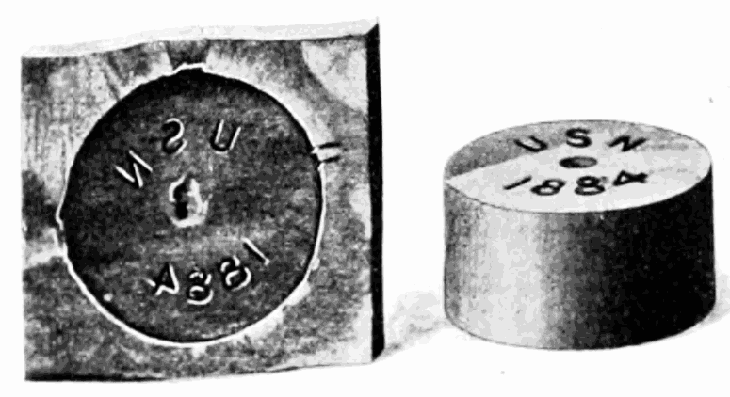
Figure 1 A visual of the Munroe Effect [2]
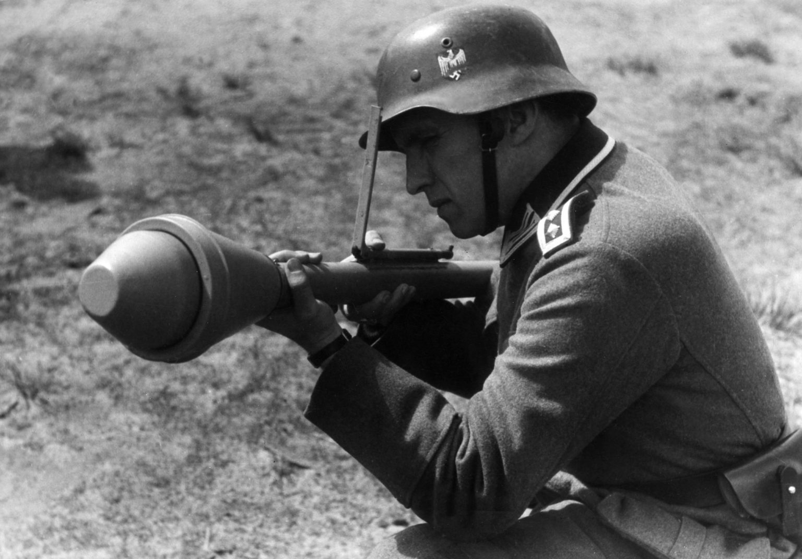
Figure 2A German soldier operating a Panzerfaust in 1944 [6]
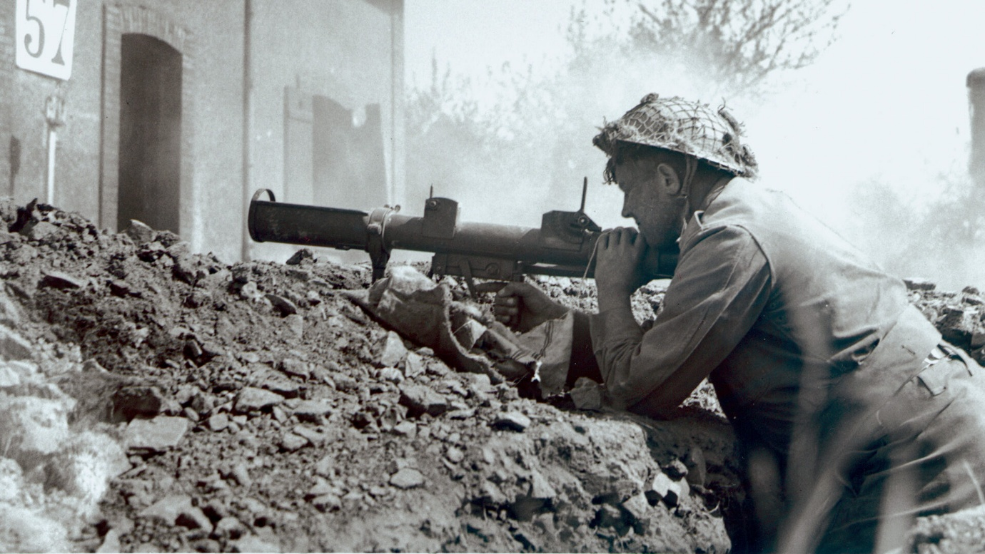
Figure 3 British PIAT [8]
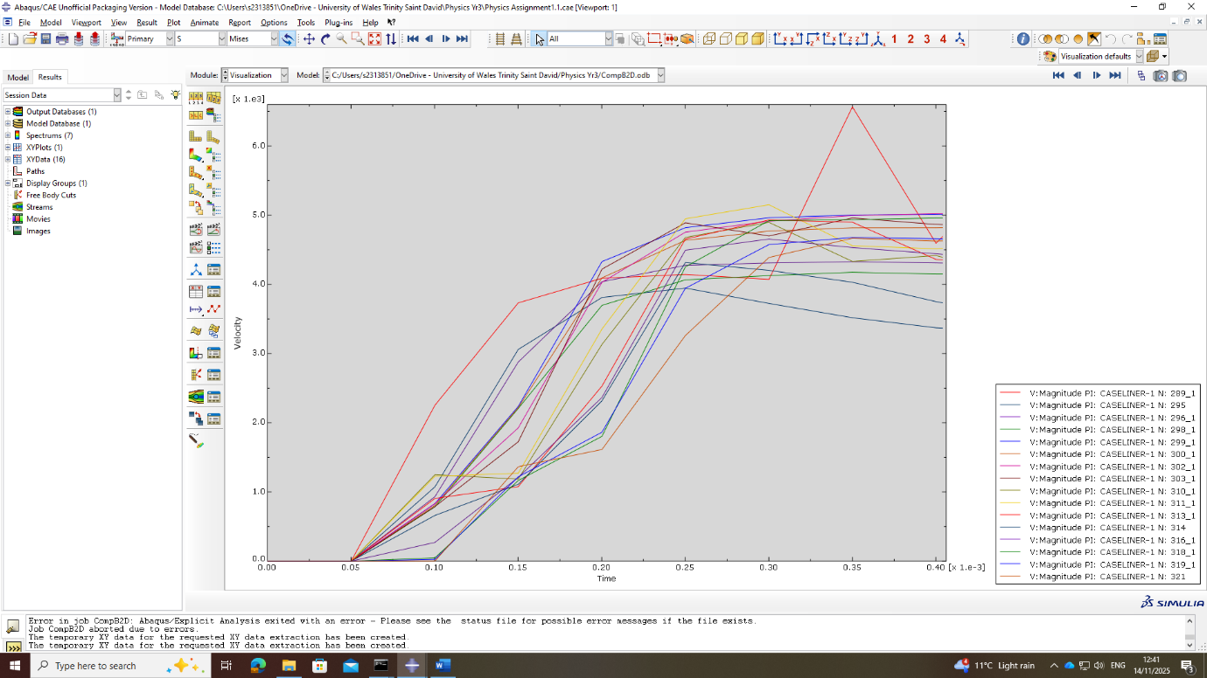
Figure 4 Comp B velocity graph
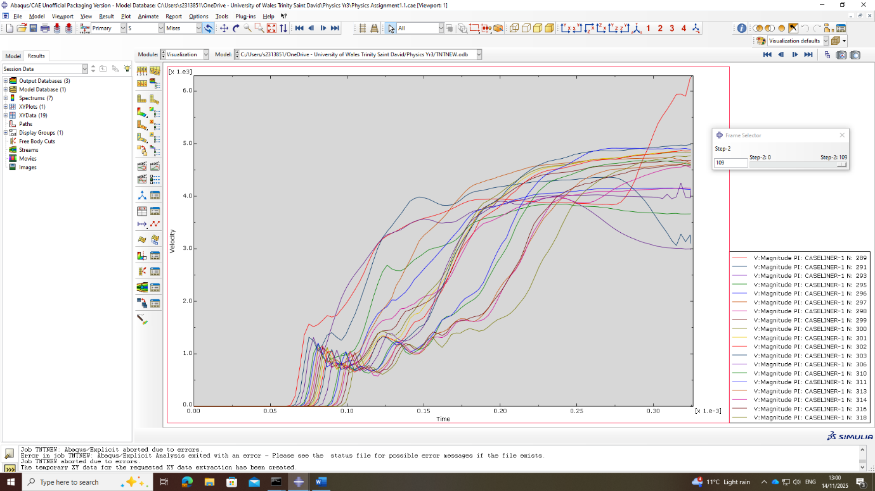
Figure 5 TNT Velocity graph
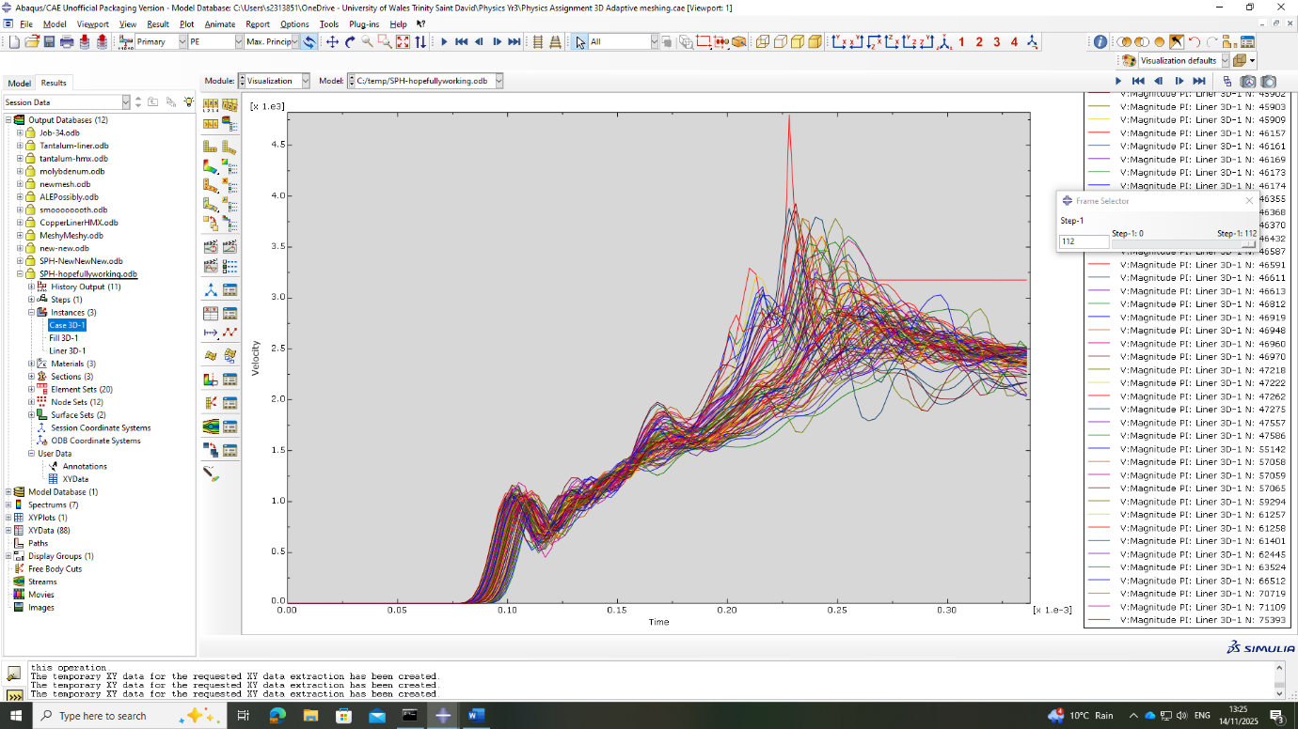
Figure 6 SPH velocity graph
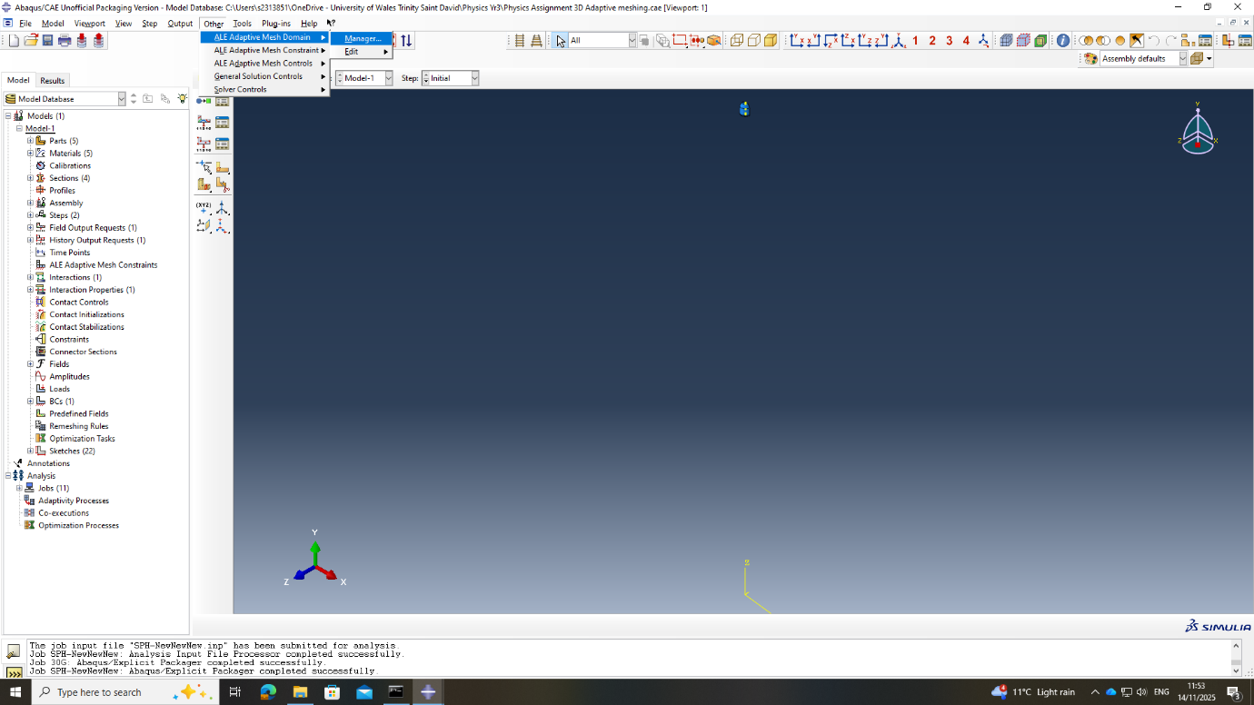
Figure 7 ALE Step 1
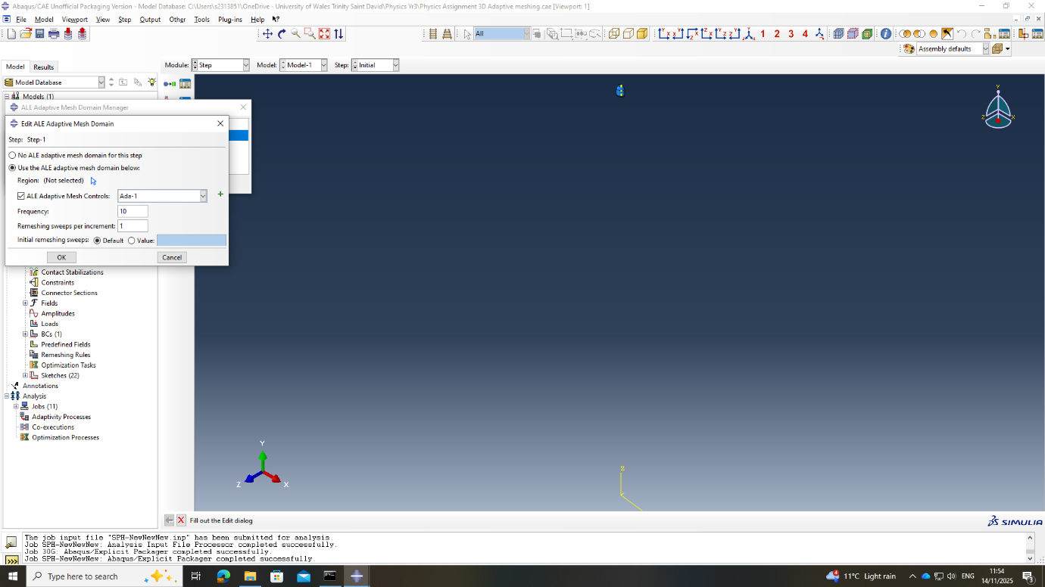
Figure 8 ALE step 2
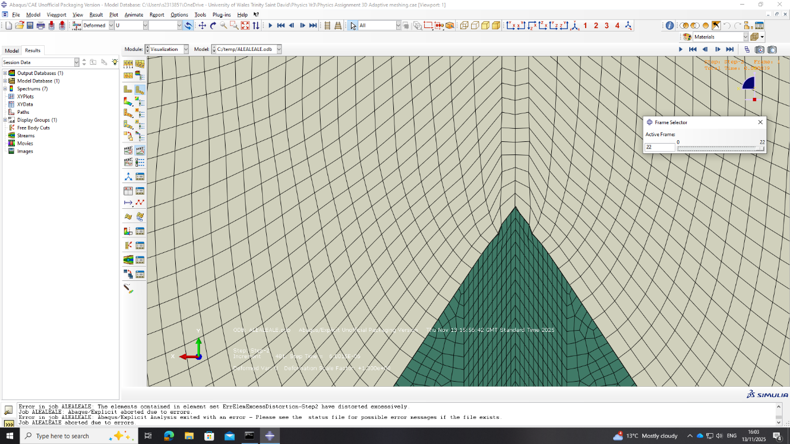
Figure 9 ALE Crash Point
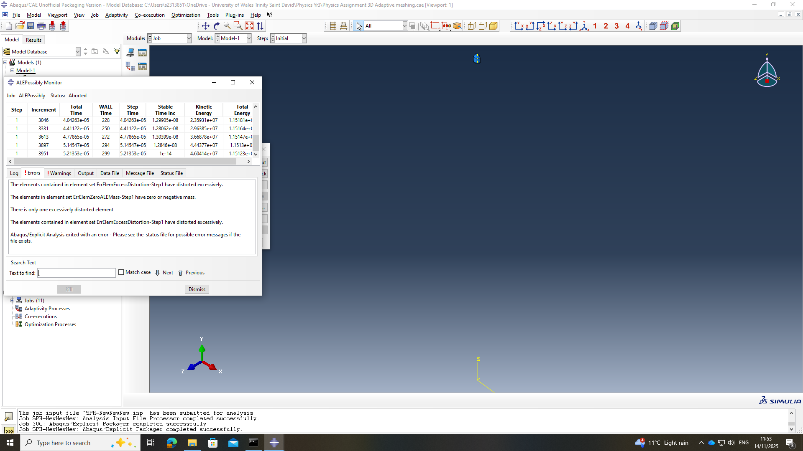
Figure 10 ALE Error message

Appendix B
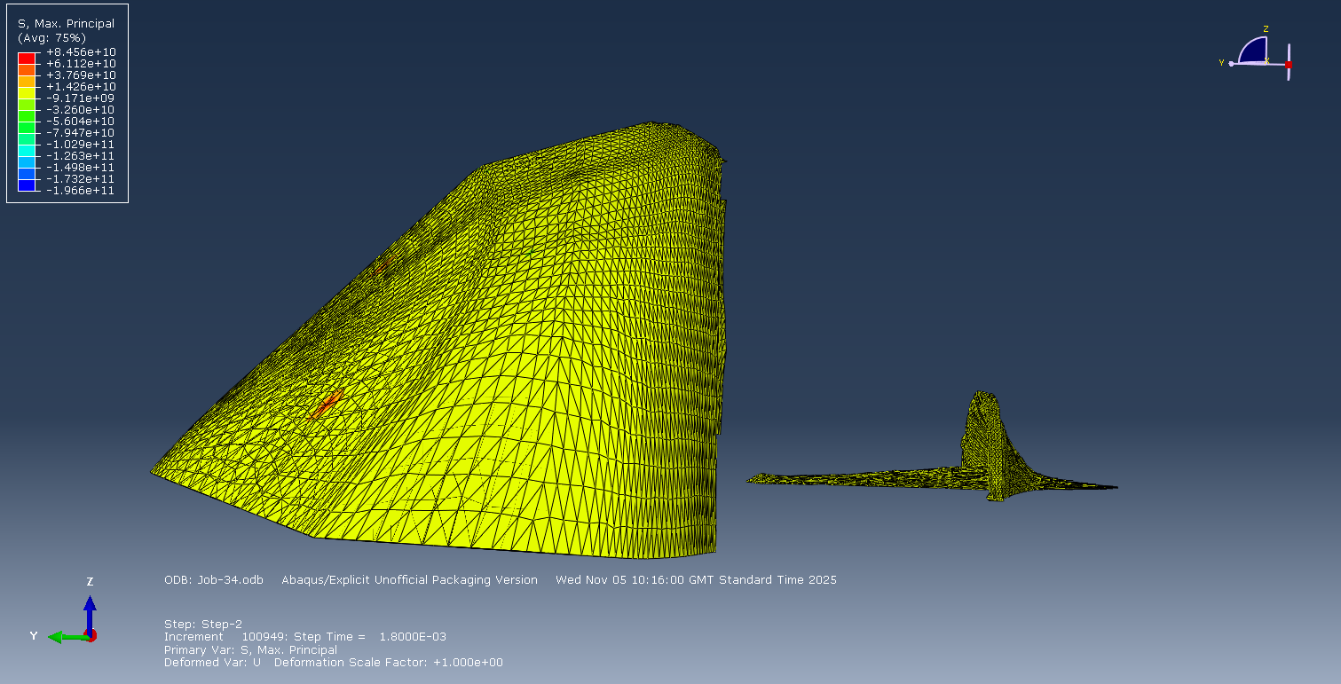
Figure 11 Side View of the 3D model
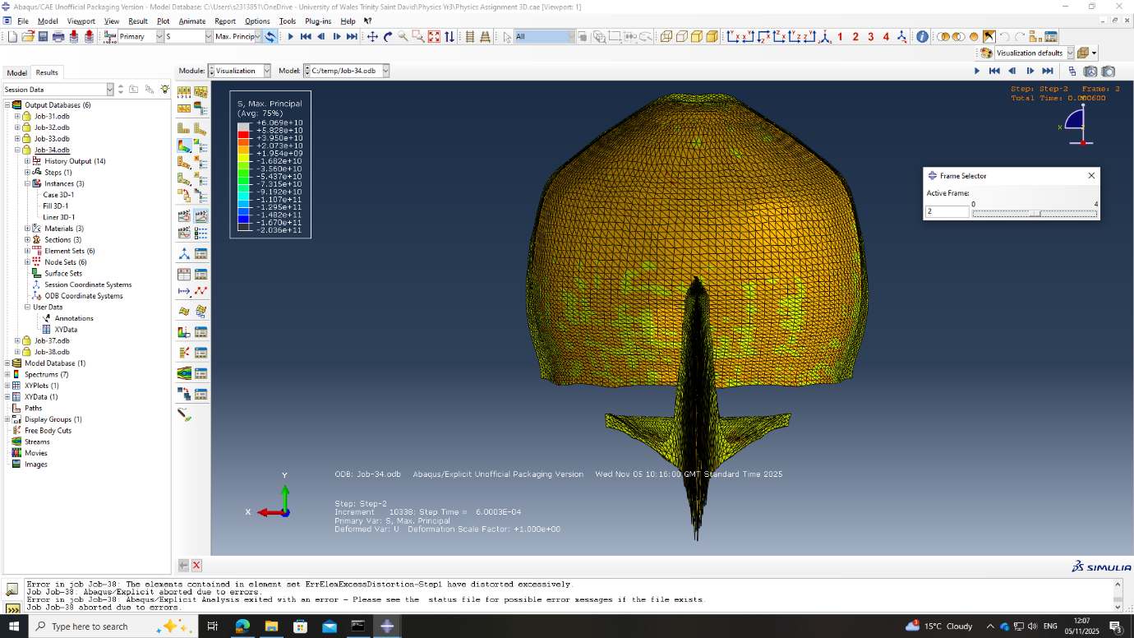
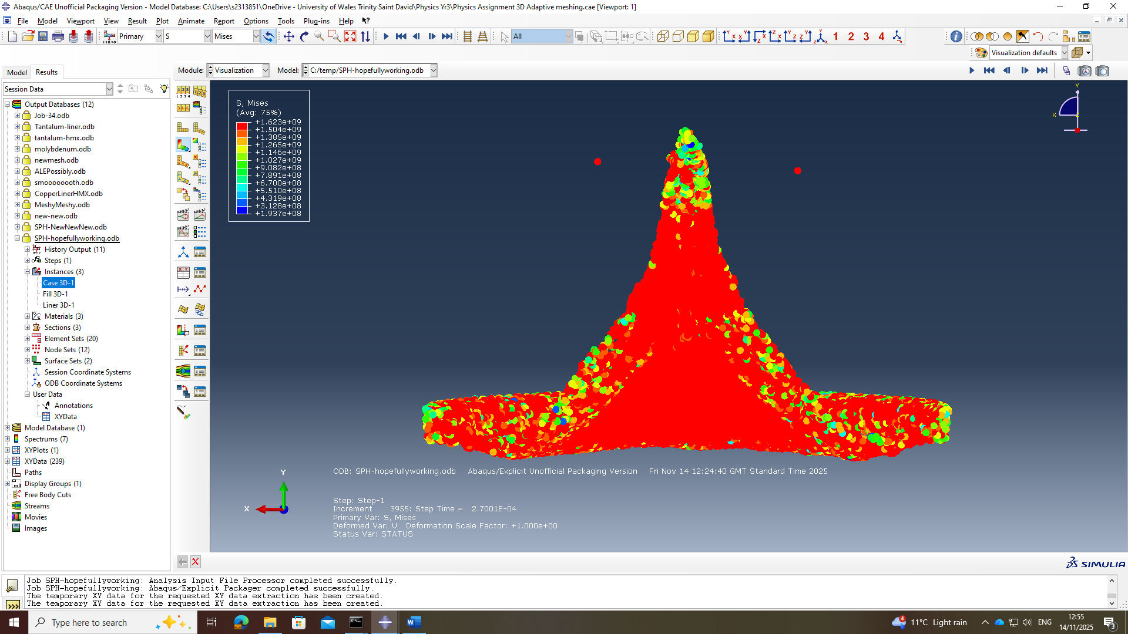
Figure 12 2D 180-degree view
Figure 13 SPH Liner
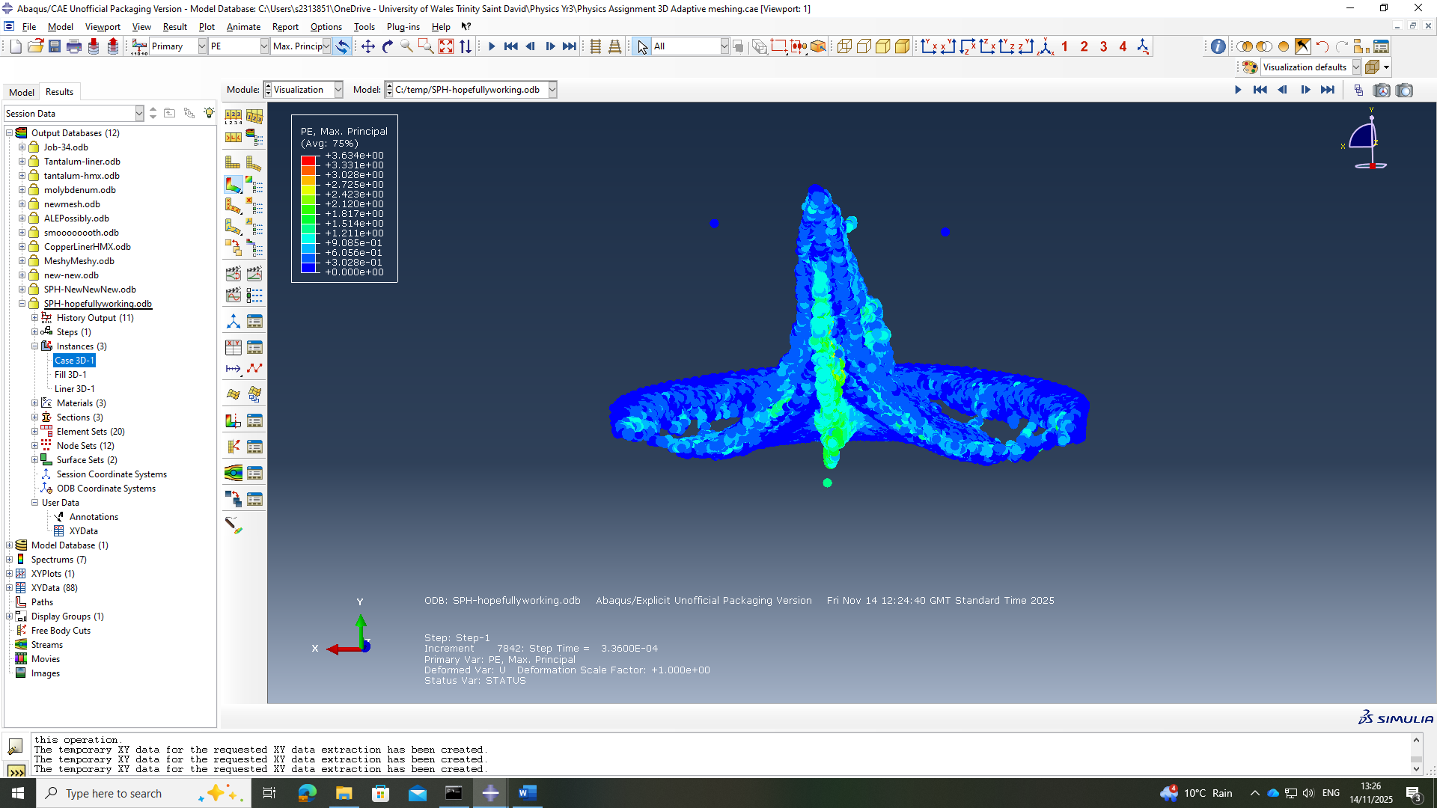
Figure 14 SPH Jet forming

