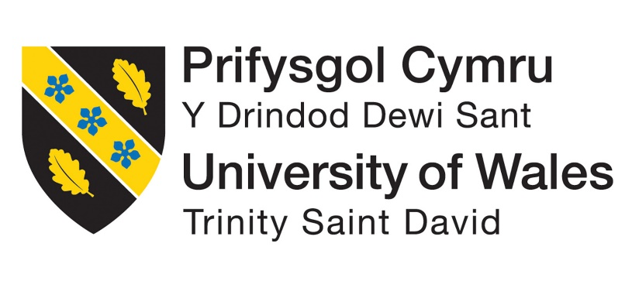
Lessons from Hassan Fathy. What can we learn from the principles of Fathy’s ventilation and design strategies?
School of Architecture, Built and natural Environment.
Course: BSc Architecture

Name: Callum David-John Arnold
Student Number: 2108209
Module code: ACAA6003
Word count: 9488
Date: 21/04/2024

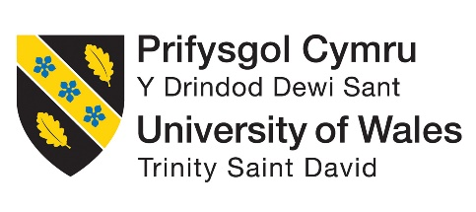

Author’s Declaration
I declare that the work in this dissertation was carried out in accordance with the regulations of the University of Wales, Trinity Saint David. The work is original except where indicated by special references in the text and no part of the dissertation has been submitted for any other degree.
Any views expressed in the dissertation are those of the author and in no way represent those of the University of Wales, Trinity Saint David.
The dissertation has not been presented to any other University for examination either in the United Kingdom or overseas.
I hereby give permission for my work, if accepted, to be available for photocopying and inter-library loan, and for the title and summary to be made available to outside organisations.


Signed:

Date: 21/04/2024

Copyright statement
The copyright of this dissertation rests with the University of Wales, Trinity Saint David. No information derived from this dissertation shall be published without prior written consent of the University.

Signed:

Date: 21/04/2024

Abstract

This dissertation examines Hassan Fathy’s influence on natural ventilation strategies. It aims to establish a connection between modern examples adopting Fathy’s design principles, aiming for a cleaner future by reducing the reliance of mechanical systems.
Chapter I sets the scene with a detailed explanation of the importance of ventilation, through data of health and wellbeing, linking back to the recent COVID-19 pandemic. It further investigates the carbon footprint created by the ventilation systems currently in use, and therefore the need to resolve this issue.
Chapter II briefly studies the various ventilation types ranging from mechanical to the main discussion of the dissertation, natural ventilation. Due to the focus on natural ventilation, each strategy is explained, and it continuously referenced throughout the dissertation.
Chapter III covers the architect ‘Hassan Fathy’, indulging into his background, education, design philosophies and principles and contribution to the revival of vernacular architect.
Chapter IIII explores the wind catcher’s historical evolution and various cultural types. It explains its working principles, illustrating airflow utilisation for cooling.
Chapter V explores the architectural innovation and cultural sensitivity demonstrated in Hassan Fathy’s projects, New Gourna village and New Baris village. Fathy’s work in these villages integrate traditional architectural forms and building techniques, while resolving the issues of cooling and heating in the arid climates.
Chapter VI examined the modern integration of ventilation technologies in De Montfort Univertiy’s, Queen’s building, blending Fathy’s techniques with experimental design. It provides background details, ventilation types and operation in each room, and the structure and form chosen to enhance the cooling efficiency.
Chapter VII explores another example of natural ventilation in the modern world, Houghton Le-Springs Primary Care Centre. It focuses on E-stack R-series systems and thermal walls, emphasising their role in achieving natural ventilation. The chapter also discusses how these strategies adapt to seasonal changes, ensuring comfort and sustainability in the care centre.
Last Chapter is a conclusion that links the studies of the buildings above to Hassan Fathy’s philosophies and design principles. It further promotes the use of naturally ventilated systems highlighting the current modifications and experimental technologies developed to increase efficiency, with the use of modern technologies.
Acknowledgement
I would like to express my sincere gratitude to my dissertation tutors, Ryan Stuckey, and Ian Standen, for their unwavering support and guidance throughout my dissertation studies.
I am also thankful to my family for their enduring support and encouragement.

Table of Contents
PAGE TITLE PAGE NO

Author’s Declaration 2
Copyright statement 3
Abstract 4
Acknowledgment 5
List of illustrations 7-8
List of Tables 9
Introduction 10
Methodology 10
Chapter I – Introductory Chapter 13-15
Chapter II – Ventilation 16-20
Chapter III – Hassan Fathy 21-23
Chapter IIII – Wind catcher 24-27
Chapter V – Fathy’s Work 28-34
Chapter VI – Qatar University 35-37
Chapter VII – DeMontfort University, Queens Building 38-45
Last Chapter – Houghton Le-Springs Primary Care Centre 46-52
Conclusion 53-55
Reference List 56-59
Bibliography 60-61

List of illustrations
PAGE TITLE PAGE NO
14
15
17
18
18
19
20
21
24
24
25
26
28
30
32
32
33
33
35
36
36

Figure 1: Global temperature average (Credit: NASA)
Figure 2: Global greenhouse gas in 2023 (Credit: Earth Observatory)
Figure 3: Single sided ventilation (Credit: Clean air stars)
Figure 4: Cross ventilation (Credit: Clean air stars)
Figure 5: Lee House (Credit: F. Guerra)
Figure 6: Stack ventilation (Credit: Clean air stars)
Figure 7: Chimney effect ventilation (Credit: M. Pearce)
Figure 8: Hassan Fathy (Credit: V. Bertini)
Figure 9: Wind catchers found in Iran (Credit: Iran in Depth)
Figure 10: Wind catchers found in Iran (Credit: Iran in Depth)
Figure 11: Working principles of the wind catcher (Credit: N. Benkari)
Figure 12: Classification of wind catcher (Credit: P. Ghaemmaghami)
Figure 13: Plan of New Gourna Village (Credit: H. Fathy)
Figure 14: Vaults above openings (Credit: J. Steele)
Figure 15: New Baris Village (Credit: V. Bertini)
Figure 16: Vaults in New Baris Village (Credit: V. Bertini)
Figure 17: Sections from New Baris (Credit: H. Fathy)
Figure 18: Bernoulli Principle (Credit: H. Fathy)
Figure 19: Qatar University (Credit: R. Halbe)
Figure 20: Wind catchers at Qatar University (Credit: R. Halbe)
Figure 21: Sections of Qatar University Campus block (Credit: Hiddenarchitecture.net)
Figure 22: DeMontfort University, The Queens Building (Credit: Short and Associates)
Figure 23: Working airflow section (Credit: Short and Associates)
Figure 24: Plan of The Queens Building (Credit: Short and Associates)
Figure 25: Auditorium air flow principles (Credit: Building Services Journal 1997)
Figure 26: Table showing interzonal opening data (Credit: Building Services Journal 1997)

38
39
40
42

42
PAGE TITLE PAGE NO
44

Figure 27: Mechanical labs working ventilation diagram (Credit: T. Peffer)
Figure 28: Houghton Le-Springs reception – concept (Credit: P+HS Architects)
Figure 29: Houghton Le-Springs reception (Credit: P+HS Architects)
Figure 30: Thermal wall working principle (Credit: CIBSE)
Figure 31: CO2 levels taken from sensors (Credit: CIBSE)
Figure 32: Plan of sensor locations (Credit: CIBSE)
Figure 33: Winter ventilation system (Credit: Breathing Buildings)
Figure 34: Summer ventilation system (Credit: Breathing Buildings)

46

47
49
50
51
51
51

List of Tables
PAGE TITLE PAGE NO

Introduction
This dissertation will introduce the topic of solution to climate emergency due to energy usage in buildings, through the design principles of Hassan Fathy. As the world grapples with escalating environmental challenges, the imperative to mitigate carbon emissions and foster sustainable practices in the built environment has become increasingly urgent. Within this context, the work of Hassan Fathy offers a compelling framework for reimaging architectural design and ventilation strategies to align with principles of environmental stewardship and resilience.
Hassan Fathy is an Egyptian architect renowned for his pioneering work in sustainable vernacular architecture, offers a compelling vision for addressing these challenges. Fathy’s philosophy centred on the integration of local materials, passive cooling techniques, and community engagement, emphasising a holistic approach to architectural design that prioritises environmental harmony and social equity. By drawing inspiration from traditional building practices and indigenous wisdom, Fathy challenged prevailing notions of architectural modernism and offered a blueprint for creating resilient and culturally resonant built environments.
Throughout this dissertation, the discussion will unfold by examining the applicability and efficacy of Fathy’s design principles in addressing contemporary environmental concerns. Drawing from a diverse array of literature, case studies, and empirical research, this study seeks to elucidate how Fathy’s ideas can inform and inspire sustainable building practices in the present day. By analysing the convergence of vernacular architecture, passive ventilation strategies, and environmental sustainability, this research aims to contribute into a deeper understanding of the potential pathways towards a more ecological conscious built environment.

Methodology
In researching material for this dissertation, I engaged on three different sources:
- Literature review from library resources and desktop study
- Government and legislative data
- Documentary sources

Literature review from library resources and desktop study
A desktop study was conducted throughout the dissertation studies, beginning with climate, and health and well-being data to set the scene. This is further explored throughout the dissertation, through a series of articles, journals, and webpages, all that held valuable data that is relevant to the topic of discussion. Library sources involved accessing a wide range of academic sources on natural ventilation strategies, sustainable architecture, along with exploring Hassan Fathy’s philosophies through a series of book published by himself.

Government and legislative data
Government and legislative data were accessed to gather information on regulations, policies, and standards related to the topic of the dissertation. This included reviewing official documents, reports, and publications from governmental agencies and legislative bodies at local, national, and international levels. By examining these sources, insights were gained into regulatory framework and legal requirements shaping the subject matter.

Documentary sources
Documentary sources encompassed a variety of materials such as documentaries, video, and multimedia presentations relevant to the research topic. These sources provided visual and auditory insight into real world examples, case studies, and how certain systems work. Creditable sources like national geography and the architects journal have been used to gain information on climatic data, and how systems of natural ventilation works.

Aims
-To analyse the key characteristics of Hassan Fathy's vernacular design and ventilation strategies, elucidating the principles that underpin his approach to sustainable architecture.
-To compare data from current mechanical ventilation systems with projects that have integrated passive and natural ventilation concepts, identifying similarities, differences, and potential areas for improvement.
-To highlight the positive effects of natural ventilation systems on health and well-being, exploring empirical evidence and case studies that demonstrate the benefits of indoor environmental quality.
-To conclude by exploring the potential for natural ventilation to become a standard practice in new and old developments, using Hassan Fathy’s idealism, considering the challenges and opportunities associated with adoption.

Objectives
-Conduct a comprehensive review of literature on Hassan Fathy's principles of sustainable vernacular architecture, focusing on his design philosophy and ventilation strategies.
-Gather data on current mechanical ventilation systems in buildings and projects that have implemented passive and natural ventilation solutions, including case studies and empirical research.
-Analyse the health and well-being outcomes associated with different ventilation strategies, considering factors such as indoor air quality, thermal comfort, and occupant satisfaction.
-Synthesize findings to assess the feasibility and potential impact of incorporating passive natural ventilation principles into mainstream architectural practice, with a focus on scalability, cost-effectiveness, and environmental sustainability.

Chapter I – Introductory chapter

Throughout history, the significance of indoor quality has attracted increasing attention among researchers, policy makers and the general public. On average we spend 90% of our time indoors (Dimitroulopoulou et al., 2023) whether it be in residential, commercial, or institutional settings, the quality of indoor air has profound implications on health, comfort, and productivity. Among the various factors influencing indoor air quality, mainly driven by pollution, ventilation system, density and humidity levels, and environmental conditions, ventilation emerges as a fundamental component of building design and operation, playing a critical role in ensuring the removal of pollutants and satisfactory air exchange.
The importance of ventilation in our built environments cannot be overstated as its purpose serves beyond simply providing fresh air. Effective ventilation systems serve a multitude of purposes with management of indoor humidity levels, maintaining consistent temperatures, and reducing the concentrate of indoor pollutants. These pollutants encompass a range of substances, such as volatile organic compounds (VOCs), particulate matter and biological contaminates. Furthermore, proper ventilation mitigates any risks associated with the pollutants like allergens, mould, and airborne pathogens, thereby safeguarding the health and well-being of the occupants inside the spaces.
As the Covid-19 pandemic continues to reverberate worldwide, its impact on society remains fresh in our collective consciousness. The emergence of new variants and the resistance of transmission challenges underscore the urgent need for proactive measures to mitigate the spread of infectious diseases within out indoor environment. By providing the exchange of outdoor air with indoor air, effective ventilation will reduce the concentration of these infectious agents, therefore reducing the risk of transmission and creating a cleaner, healthier environment inside (UK Health Security Agency, 2021).
As well as the health and well-being factors, it is vital to consider the environmental impacts of ventilation systems. With the building industry contributing nearly 40% of global energy-related co2 emissions (Agenda, 2021), sustainable building, design and control has become more important than ever. Currently, many ventilation systems rely heavily on high energy demanding systems further contributing to the effects of climate change.
It is estimated that nearly 20% of the total global electricity demand is used for cooling purposes via air conditioning and electric fans inside buildings (Østergaard et al., 2022), and with the constant increase of urbanisation and industrialisation, especially those of poorer countries who have only recently began to develop, we are expected to see this figure increase.
While the Earth’s climate has undergone changes throughout its history, the current warming trend is unprecedented in the past 10,000 years. According to data compiled by (NASA, 2023), global temperatures have been rising at an alarming rate over the last two centuries. Utilising information gathered from various sources such as ice core, rock, and tree rings, along with rigorous scientific assessments, (NASA, 2023) has determined that the Earth’s temperature has increased by approximately 1.36 degrees Celsius (2.45 degrees Fahrenheit) since the last 19th century preindustrial era.
In 2023, the Goddard Institute for Space Studies conducted an analysis of annual global temperature, revealing that 2023 marked the hottest year on record. Further analysis of monthly temperature data from June to December indicated that July of that year was the hottest month ever recorded. Figure 1 shows a graph illustrating the global temperature averages from the 19th century to the present day, clearly showcasing the upwards trend in land-ocean temperatures over time (NASA,2023).
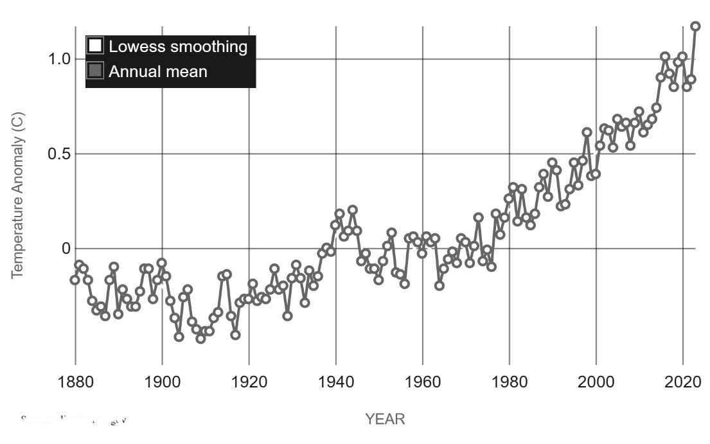

Figure 1: Global temperature averages (Credit: NASA)

The primary factor driving the rise in temperature is the growth of greenhouse gases, which result from the extensive combustion of carbon-rich resources such as coal, natural gas, and oil. The dependence on these finite resources is inherently unsustainable and has detrimental effects on the environment. Not only are these actions depleting limited reserves, but they are also causing significant harm to the planet. Consequently, there has been a marked increase in the concentrate of greenhouse gases in the atmosphere.
These greenhouse gases act like a blanket, trapping heat within the Earth’s atmosphere. As more greenhouse gases accumulate, this metaphoric blanket thickens, intensifying the heat retention effect and exacerbating global warming (Earth Observatory, 2023). The consequences of this phenomenon are significant, impacting eco-systems, weather patterns, and overall climate stability. It underscores the urgency of transitioning to renewable energy sources and adopting sustainable practices to mitigate further environmental degradation and minimise the adverse effects of climate change.
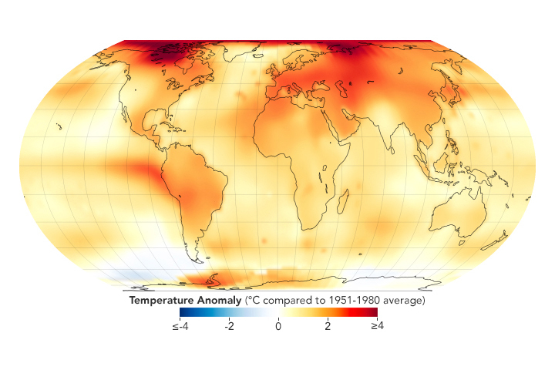

Figure 2: Global greenhouse gas in 2023 (Credit: Earth Observatory)

With the huge demand of electricity for cooling, through mechanical solutions, it has caused significant implications from an energy consumption standpoint. This substantial energy usage places a considerable strain on electricity grids and infrastructure, particularly during peak demand periods, has resulted in the increase of carbon-embodied fuels to be used to maintain the requirements needed, and therefore contributes to higher greenhouse gas emissions and environmental degradation.
In light of escalating global temperatures and the rise in greenhouse gas emissions, there is a pressing need for alternative ventilation solutions to mitigate the energy consumption and adverse impacts of global warming, while maintaining the integrity of health and wellbeing factors, within out built environment.

Chapter II – Natural Ventilation

Natural ventilation relies on passive airflow through opening such as windows, door, vents, and chimneys exchanging indoor air with outdoor. It harnesses natural forces such as wind and buoyancy to facilitate airflow without the need for mechanical systems. Natural ventilation is often used in residential buildings due to its simplicity and low to no operating cost. It is also possible for these systems to be used in commercial, and institutional facilities, with an example being De-Monford University’s, facility of technology, located in Leicester. Its effectiveness, however, does come down to factors of building design and climatic conditions.
Natural ventilation offers a range of beneficial factors for buildings and occupants alike. It promotes energy efficiency by harnessing natural air movements to cool and refresh indoor spaces, reducing the reliance on mechanical systems and lowering energy consumption (Rodrigues. et al., 2019). With the reduction of mechanical systems, reliance on fossil fuels are eliminated, and results in a reducing the greenhouse gases produced,
Furthermore, natural ventilation enhances the connection between indoor and outdoor environments, fostering a closer relationship between man and nature. By bringing in fresh outdoor air into indoor spaces, natural ventilation strategies creates a healthier and more pleasant environment for occupants, promoting wellbeing and comfort (Kensek. And Noble, 2015).
There are various types of natural ventilation systems available each with its own mechanisms, application, and features:

Single-sided ventilation
Single sided ventilation, also known as unilateral ventilation, is the use of opening on one side of the building, utilising windows, and vents. This is used where space within a project is limited and works by airflow creating a pressure difference between indoor and outdoor environments, induced by temperature and moisture, driving the movement of air into and out of the building. The effectiveness of this system depends on the size and location of the opening, prevailing wind direction and the buildings orientation.
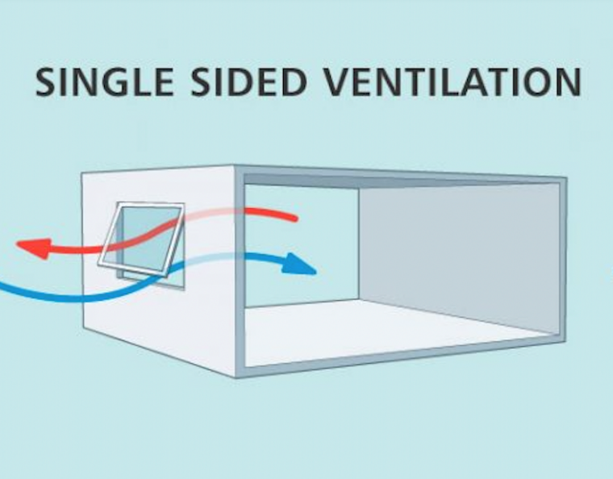

Figure 3: Single sided ventilation (Credit: Clean air stars)

Single-sided ventilation is commonly used in buildings with limited opportunities for cross-ventilation due to narrow or deep floor plans, urban environments with adjacent buildings blocking airflow and rooms with only one exterior wall. Where privacy or security is a concern, this system is favoured as it minimises the number of openings on the building (Stouhi, 2021).
While single-sided ventilation can be effective in certain contexts, it may not provide uniform airflow throughout the building, leading to potential variations in indoor air quality and thermal comfort. Additionally, reliance on natural forces such as prevailing winds for ventilation may limit its effectiveness in areas with unpredictable or stagnant air flow. To conflict this, and therefore enhance the performance of this strategy, wind deflectors, louvers and/ or adjustable vents can be incorporated to optimise airflow and mitigate potential drawbacks.

Cross ventilation
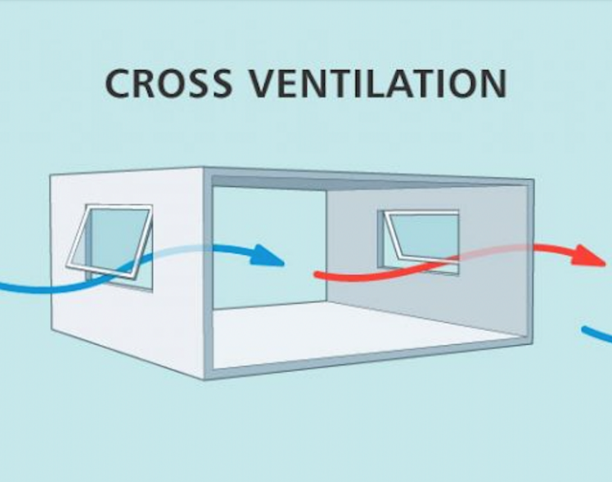
Cross ventilation is a strategy that utilises the flow of air through openings on opposite sides of the building to exchange air. This airflow creates a pressure difference, driving fresh outdoor air through one opening, and expelling stale stagnant air through the opposite opening, through windows, vents and doors. The effectiveness of this strategy, much like single sided, depends on size of openings, location, orientation of the building and prevailing wind speed and direction. Windows and vents should be positioned to capture the prevailing winds and channel the airflow into the interior, while having a direct flow to the exhaust opening (Stouhi, 2021).
Figure 4: Cross ventilation (Credit: Clean air stars)

This ventilation strategy is particularly well-suited for buildings with narrow open floor plans, multiple exterior walls, or rooms that are regularly occupied, hence the need for consistent airflow. Commonly this system is found in residential, recreational, and commercial buildings. The Lee House, designed by Eduardo Glycerio and Studio MK27, located in Porto Feliz, Brazil, is a prime example of cross ventilation techniques. It is organised in a single volume ground floor site with rooms and opening out to the garden. All the openings in the living room are recessed, allowing the air to flow directly through (Archdaily, 2013).
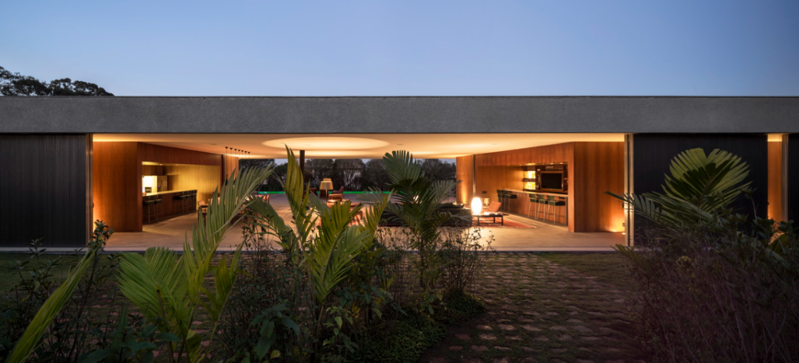

Figure 5: Lee House (Credit: F. Guerra)

By harnessing the natural force of wind through cross ventilation, it provides a cost effective and energy efficient means of ventilating, while enhancing the connection between indoor and outdoor environments, fostering a sense of openness, vitality, and connection to nature within the built environment.

Stack Ventilation
Stack ventilation is a strategy that harnesses the buoyancy of warm air to facilitate the exchange of indoor and outdoor air in the space. It relies on the principle that warm air is less dense and therefore rises, creating a pressure difference between the top and bottom of a building. This pressure difference drives airflow, with warm air escaping through high openings, such as vents or clerestory windows, while cooler air enters through lower openings (Stouhi, 2021).
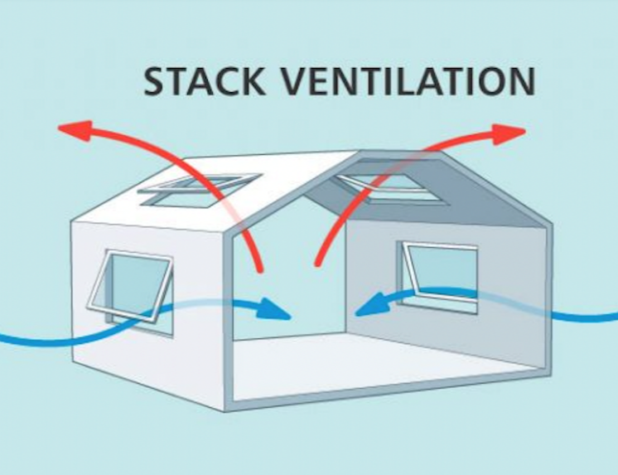
Figure 6: Stack ventilation (Credit: Clean air stars)

The mechanisms of stack ventilation involves warm air rising as spaces inside heating up through sources of solar radiation, occupants, and equipment. The accumulation of warm air at the upper levels create a positive pressure, while cooler air at the lower levels create negative pressure. This pressure difference induces airflow, with warm air escaping through high openings and cooler air entering through lower openings. The buoyant force of warm air escaping, draws in cool air from the surroundings, creating a natural circulation pattern that facilitates the constant exchange of air (Designing buildings, 2023).

Chimney Effect Ventilation
Chimney effect ventilation systems are very similar to that of stack ventilation, with reliance on cold air being drawn in through low openings of a building and removing less dense warm air through openings at high points of the building.
Chimney effect ventilation is particularly in tall buildings with vertical shafts, such as atriums or stairwells, that allow warm air to accumulate at the top with ease. It is also commonly found in buildings with high ceilings, clerestory windows or skylights that provide a natural outlet, acting as a chimney for the warm air. An example of this style of ventilation is found in The Eastgate Centre, designed by Mick Pearce, located in Harare, Zimbabwe. This design employs passive and energy-efficient climate control solutions to cool residents, inspired by termite mounds (National Geography, 2018). As the building requires ventilation all year round, the architect created a self-regulating ventilation system to maintain the buildings temperature and air quality to suit the residents and the office workers. This ventilation strategy saved the purchase, installation, and maintenance of otherwise very expensive and heavy energy consummative traditional mechanical systems.
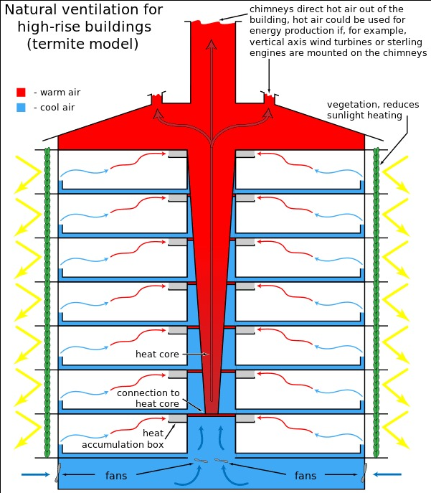
Figure 7: Chimney effect ventilation (Credit: M. Pearce)

Chapter III - Hassan Fathy

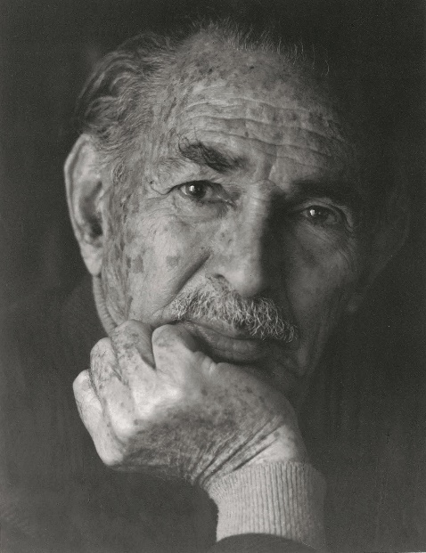

Figure 8: Hassan Fathy (Credit: V. Bertini)

In the realm of sustainable architecture, few figures loom as large as Hassan Fathy, whose pioneering work in vernacular architecture and ecological design continues to inspire architects, planners, and activists around the world. One of the cornerstones of Fathy’s approaches to sustainable design was his innovative use of natural ventilation strategies to create comfortable, healthy, and energy-efficient buildings. Drawing inspiration from Egypt’s rich architectural heritage, Fathy embraced passive cooling techniques; being cross ventilation, stack ventilation and earth sheltered design to harness the cooling power of natural airflow and thermal mass. By orientating buildings to capture prevailing winds, incorporating shaded courtyards and wind towers, and employing breathable materials such as abode and mud brick, Fathy sought to create indoor environments that were ventilated, temperate, and resilient to climatic extremes. His holistic approach to ventilation not only minimised the need for mechanical cooling systems, but also fostered a deeper connection between occupants and their surroundings, blurring boundaries between indoor and outdoor spaces (Bertini, 2020).
The Islamic architect – engineer – inventor – professor, Hassan Fathy, otherwise known as Hassan Bey, emerged as one of the most influential architects of the 20th century, renowned for his groundbreaking work in vernacular architecture and sustainable design. Born, 23 March 1900, in Alexandria, Egypt, Fathy was raised in a culturally rich and diverse environment that exposed him to a wide array of architectural styles, from ancient Egyptian monuments to Islamic palaces and European colonial buildings (Steele, 2018).
After completing his primary education in Egypt, Fathy pursued further studies in architecture at Cairo University school of fine arts, where he was introduced to the principles of western architectural theory and practice. His academic training was later augmented by a period of study at the prestigious École des Beaux-Arts in Paris, where he immersed himself in the classical traditions of European architecture.
It was Fathy’s experiences living and working in rural Egyptian villages during the 1930s that truly shaped his architectural vision and set him on a distinct path. While serving as an advisor to the Egyptian Ministry of Education, Fathy witnessed first-hand the profound socioeconomic disparities and environmental degradation plaguing Egypt’s rural communities. Inspired by the resilience, resourcefulness, and communal spirit of the villagers, Fathy became increasingly disappointed with the prevailing paradigm of western-style architecture, which he viewed as inherently unsustainable, and culturally insensitive.
Fuelled by the desire to address the pressing social, economic and environmental challenges facing Egypt, Fathy embarked on a radical rethinking of architectural practice, grounded in a deep respect for vernacular architectural traditions and an unwavering commitment to social justice. Rejecting the conventional wisdom of his time, Fathy advocated for a return to the principles of indigenous architecture, which he believed offered a more humane, harmonious, and holistic approach to building design. Drawing inspiration from Egypt’s rich architectural heritage, including the ancient mud-brick temples of upper Egypt and the timeless adobe villages of the Nile Delta, Fathy sought to revive and reinterpret these ancient building techniques and transfer this into the modern era (Kloosterman, 2023).
Furthermore, Fathy believed that by teaching local residents of Egypt poorer communities how to build, using his vernacular principles, that they would be able to construct homes and buildings that were cost-effective, environmentally appropriate, energy efficient, and accessible to all. This principle was originally opposed by high officials due to monetary issues, however inspired the communities of his projects and therefore became a catalyst for positive social change and environmental stewardship (Gandhi, 2023).
Through his visionary experiments with passive ventilation n and ecological design, Hassan Fathy demonstrate the transformative potential of architecture to mitigate climate change, promote public health, and foster social equity.
Fathy has designed over 150 separate projects, from modest country retreats to full scale communities consisting of public buildings, markets, school, places of worship, and recreational facilities, his fame mostly came from the ideas of simple, cost-effective designs for people less fortunate than others. His most noticeable is the villages of New Gourna and New Baris. Through use of experimental and vernacular architecture design techniques, these villages became a huge success, and stand as monuments of sustainable culturally sensitive design (Damluji, and Bertini, 2018).

Chapter IIII – Wind Catcher

Historic
The wind catcher, otherwise known as ‘Malgaf, ‘wind scoop’, or ‘Badgir’, was known to be the most iconic ventilation system that had been used in traditional architecture. The design of the towers are dependent on its climatic conditions and location, and vernacular context, with a variety of shapes, sizes and materials being used (Shokoohi, 2021).

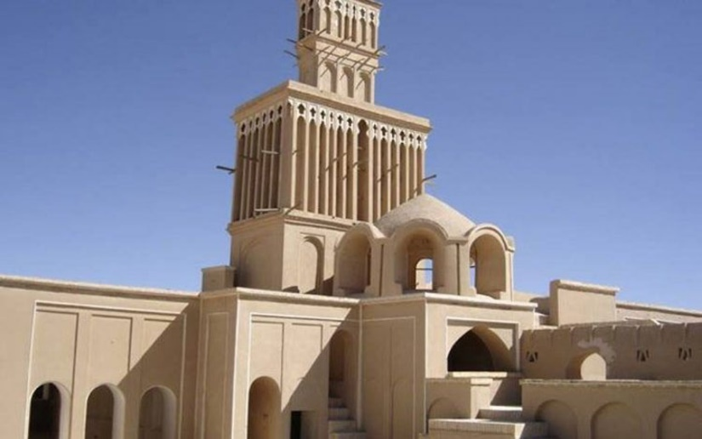
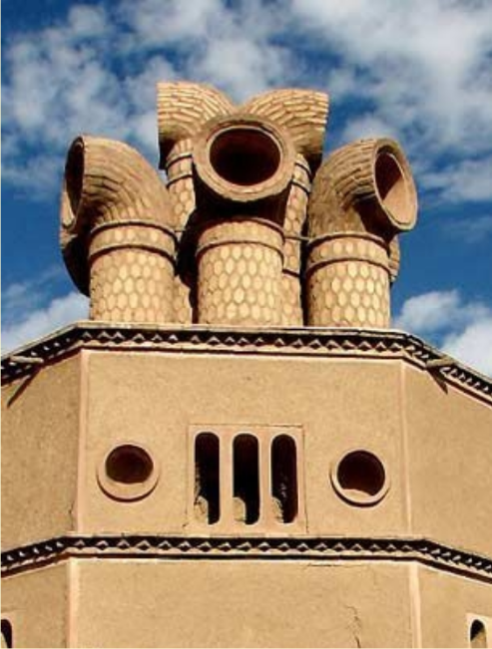
Figure 10: Wind catcher found in Iran (Credit: Iran in Depth)
Figure 9: Wind catcher found in Iran (Credit: Iran in Depth)

The wind catcher has been found in many different countries throughout history, especially those of tropical region such as Eastern Europe, Western Asia, and North Africa. Typically, these structures would be constructed using clay, wood or brick and are built upon rooftops where they are open to the elements, allowing them to be efficient in harnessing the breeze.
Originally, the idea of the wind catcher was believed to have been conceived around 3000BC, by the Persian empire, with the intended use of chimney-like structure during cooler evenings which would keep the space below well-ventilated in the event of large bonfires. Others, however, believe it dated back to 1300BC, with Eqyptian paintings showed triangular elements on top of Pharaoh Nebamuns residence, convincing historians that the idea was derived by the Egyptian empire (Stouhi, 2021).

How it works
The wind catcher consists of several key components, the windward opening, vertical shaft. It provides natural ventilation due to the effects and stack buoyancy effect. Wind effect is the main driving mechanism and is due to the difference in pressure on the windward sides compared to that of the leeward side of the wind catcher. The wind that enters along the windward opening removes heat from the space below through convection and evaporation heat transfer, resulting in chilling. The buoyancy effect is the secondary effect in this process, in which hot, less dense air moves upwards, and cold, high dense air moves downwards (Abdolhamidi, 2018). Figure 11 shows this working principle.
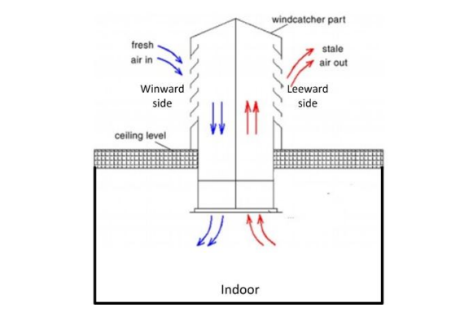

Figure 11: Working principle of the wind catcher (Credit: N. Benkari)

When the wind hits the windcatcher, it creates a positive high-pressure zone on the windward opening and a negative low-pressure zone on the leeward opening. The wind intends to match this pressure from high pressure regions in the space, to the lower pressure regions. As a result of this movement, fresh air is allowed to move through the tower, removing hot stale air through the leeward side. This is called wind effect, and this is predominant (Fathy, 1986).
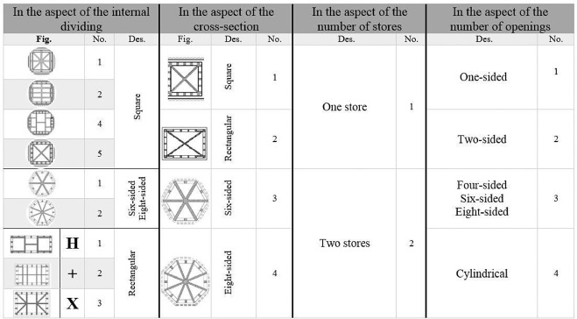
Wind catchers come in various kinds and styles. They are classified into a series of groups, including the number of openings, number of stores, cross section, and the interior dividing. The most noticeable difference come under the cross sections and opening. Figure 13 below, illustrates the different classifications of wind catchers according to the series of groups. Wind catchers are adapted to different conditions, with a one-design-fits-all being unavailable. Uni-directional, Bi-directional, Multi-directional and cylindrical structure are systems explored in different regions; however, the square sectioned vertical tower is the most traditional method. Figure 12 below illustrates the classification groups.
Figure 12: Classification of wind catchers (Credit: P. Ghaemmaghami)

Cross section
Usually, cylindrical catchers are more complicated than those of square, rectangular, hexahedral, and even tetrahedral, making them very uncommon; however also are classified as one of the most efficient design due to its aerodynamic values.
Square and rectangular towers, being easy to construct, happen to be the most conventional of the options, without the need for calculation of aerodynamics.

Openings
One sided wind catcher have an inlet incoming the northern direction, which only work to bring the cold air into the space. They types can often be found in Ardakan and Mybod and were often used as an exhaust for fires in the space below. One sided are more resistant to storms, due to reduced number of openings to allow pollutants and dust to enter. Two-sided wind catchers, often referred to as twin wind catchers, allow for a division of two parts in the shaft, usually paired with brick blades (Benkari, 2017). These wind catchers are often found in buildings for wealthy people, for the addition of cooling of stored water. Four sided are much taller and larger than the others and used in desert-like-climates. Often, they allow for the cooling of stored water, and are very common in hot and humid areas in need of dense ventilation. It has four directional/ oblique openings, hence the name sectioned, and occasionally internal blades or shafts, which impact the velocity and turbulence of airflow (Stouhi, 2018). Air close to the surface tends to be of lower quality due to dust and pollutants, therefore, to battle this; towers are built higher where winds also tend to blow stronger and cooler further contributing to the cool environment below. However, in some areas dust can be difficult to avoid so filtration systems can be introduced which allows dust to be dumped within a pit below the shaft and bugs to be deterred by insect mesh.

Chapter V – Fathy’s Work

New Gourna Village – 1945-47
As Hassan Fathy began his architectural endeavours in Bahtina, employing mud brick techniques, his innovative work caught the attention of high officials in Egypt. During this time, the Department of Antiques faced challenges with the inhabitants of Gourna al Gadida tunnelling into slopes near their houses to pillage ancient artifacts to sell and smelt for crude ingots. After the complete removal of a large stone bas-relief from one of the tombs, it became the tipping point for the department, prompting them to take decisive action to halt the destruction and relocate the whole settlement. Officials and the Department of Antiques approached Fathy to design the new village.
The site allocated was 50 acres of agricultural land, near the West bank of the river Nile, in Luxor, which was acquired by compulsory purchase from a local landowner and intended to rehouse 7000 villagers. Fathy quickly came to the realisation this meant moving a complex network of blood and marital relations and began to work on dismantling and reassembling the whole society. He established that the village was split into four tribes and was determined to retain the four-part division in the new village (Steele, 2018).
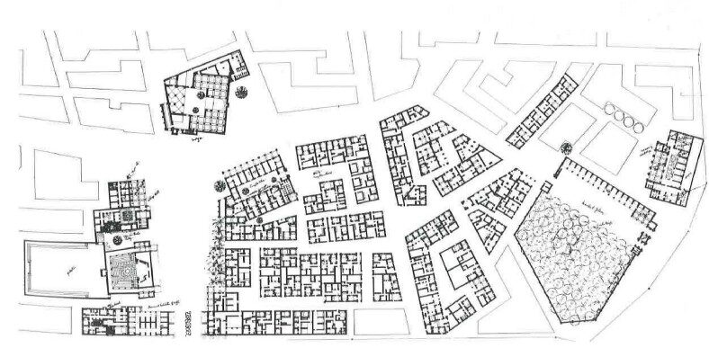Figure 13: Plan of New Gourna Village (Credit: Hassan Fathy)

Fathy saw new Gourna not only as a large architectural commission but also as a prototype that might provide an answer to the reoccurring problem of housing in Egypt peasants in a safe, sanitary, and inexpensive way.
Close to the proposed settlement was the cities of Kufa and Mecca, which upon further analysing, established that all the buildings were built in a similar vernacular style with materials widely available given the baron locations; being mud brick. Fathy had previous experience with this material therefore saw it as the ideal material to use in the new village. He also analysed the forms which the buildings were divided into. The division was that of three distinctive parts: the square base, cylindrical central shaft, and domed caps (Damluji, and Bertini, 2018). This division is also identifiable in other examples contemporised with them, across the red sea in the Hijaz region of Arabia. This would definitely establish the vernacular identity that Fathy aimed to revive.
Initially Government bureaucracy had diminished the momentum of Fathy’s vernacular idealism, but he was still persistent in his belief that vernacular architecture could become the national style. Fathy’s reliance on natural materials widely available in New Gourna’s context, rather than steel and concrete lead to lower building cost and lower profits to large construction companies opposing all of his powerful adversaries.
Due to the prohibitive cost of mechanical cooling, heating, and ventilation, Fathy predicted that entire design on natural ventilation, dividing each room into a square domed area connected to a rectangular vaulted space to allow for air transfer to occur. This rectangular space as originally design to contain a pool of water to further cool the air coming through slots in vaults located above it, and further ventilation was provided by operational windows seated opposite openings creating cross ventilation (Fathy, 1989). This design was remarkably functional and environmentally comfortable.

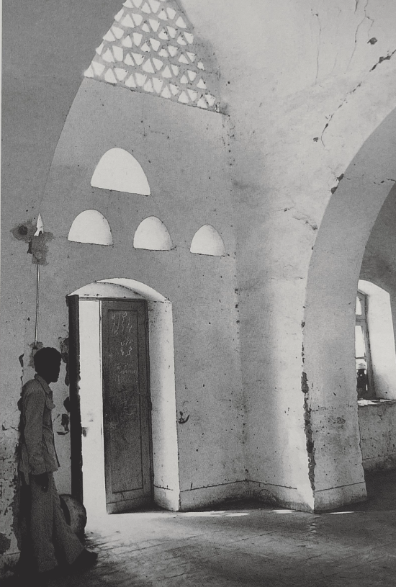
Figure 14: Vaults above openings (Credit: J. Steele)

It was one of Fathy’s first large project which implemented the use of wind catcher ventilation system. With the spaces and masses created being so dense, the techniques that were adopted allowed all houses to benefit from the prevailing winds. The documentary ‘Hassan Fathy’s New Gourna: Past, Present, Future’ shows off the great impression left on the occupants of the village with the use of this unique ventilation system. Muhamed Qenauwi, a villager on New Gourna, stated ‘There was no electricity, no fridges, there was nothing… But he made us a wind catch to bring the breeze’. (World monument fund, 2021). This style of windcatcher used very much relied on stack ventilation strategies, allowing the breeze to move around pools of water found in the space below, and forcing the hot air to rise and escape.
Unfortunately, nearly 40% of the original buildings have been lost (World monument fund, 2021), with Fathy’s visions not fully being recognised and the political matters of funding. However, with the techniques used by Fathy’s in means of construction and cooling the environment, it continues to serve as an example of innovative design and vernacular technologies, all taken from ancestral study and experimentation. It can be found listed on the World Monuments Watch as a continued community assessment, to integrate social and economic concerns into planning and decision making.

New Baris, Egypt – 1963

Fathy’s later work, twenty years after New Gourna Village, dominates his maturity phase of architectural design, and is still to date known as Hassan Fathy’s best community project. Construction started in 1963 when discovery of a large water well, sixty kilometres south of the Kharga Oasis, Egypt. It had been estimated that the wells capacity was enough to continuously irrigate up to 1000 acres of land, leading to the organisation of desert development to propose a new agricultural development (Steele, 2018). The location of this new community is in the remote wilderness, geographically centre of Egypt. It was initially planned to house 250 families, of which among them, half would tend to the land, and the other serve as service personnel (Damluji, and Bertini, 2018). With previous experience on large projects, and ability to build inexpensively, Fathy was the choice of architect for this project.
Upon starting the development of the site, Fathy described it: ‘Baris was an interesting problem in which I was to create all the parts of community, to bring together in the best manner possible people whom I did not know. All that I had at my disposal were demographic, geographic and climate surveys. I had to provide the aesthetics, the sense of man in a space constructed by man’ (Damluji, and Bertini, 2018).
Fathy began by making a detailed study of both the climate in the region, and local traditional architecture. In addition to examining the fourth century AD brick ruins of the necropolis of Bagawat that lay nearby to the site, he also observed existing village of Kharga, where a series of factors such as the materials used, width and orientation of streets, and introverted forms of the houses all worked together to effectively offset summer temperatures that could reach as high as 50 degrees Celsius (National Geographic, 2018). These considerations along with the requirement of cold storage of harvested fruits, vegetables and produce grown by the settlement, as well as the impossibility of providing any means of mechanically ventilated air conditioning, led Fathy to focus on natural means of cooling, which became the formative influence on the new village.
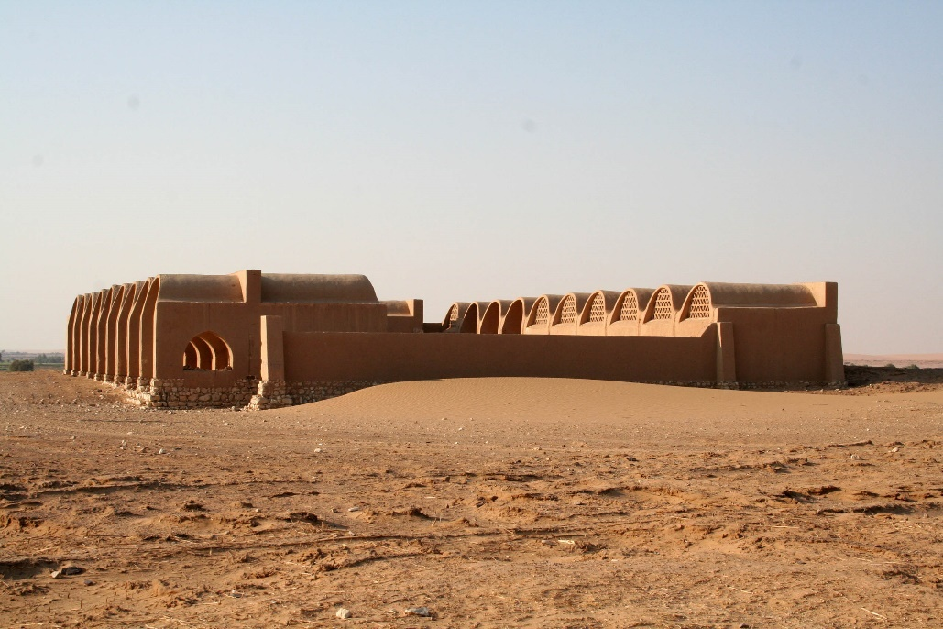

Figure 15: New Baris Village (Credit: V. Bertini)

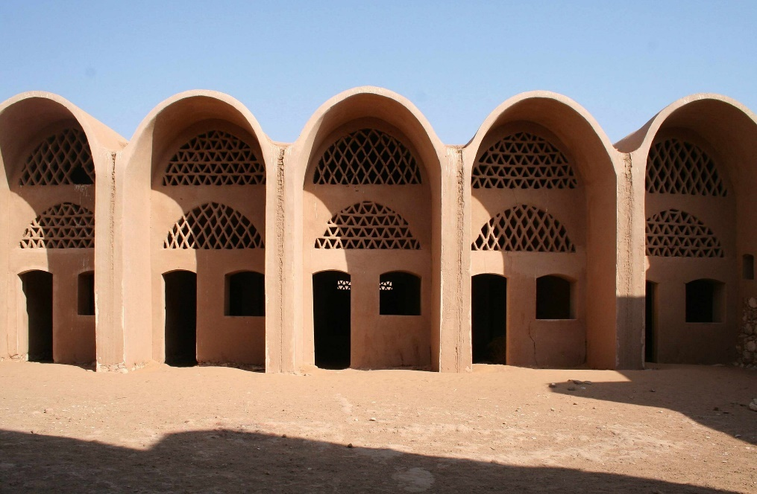

Figure 16: Vaults in New Baris Village (Credit: V. Bertini)

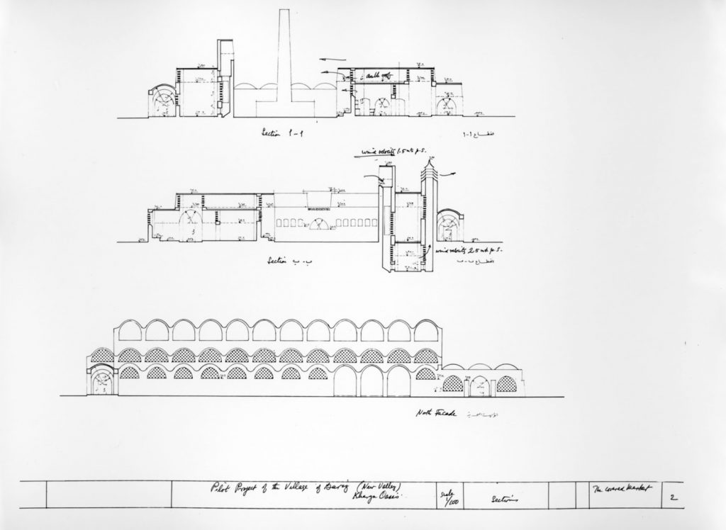

Figure 17: Sections from New Baris Village (Credit: Hassan Fathy)

With consideration, by putting storage facilities below grade and refining the wind catcher design he had previously used in New Gourna, with addition of baffles, incrementally reducing air shaft acceleration and use of secondary towers to accelerate the circulation of circulation in accordance with his studies into Bernoulli principle, he was able to reduce the temperature in the spaces by 15 degrees Celsius. This is all seen in Hassan Fathy’s drawings in figure 18.
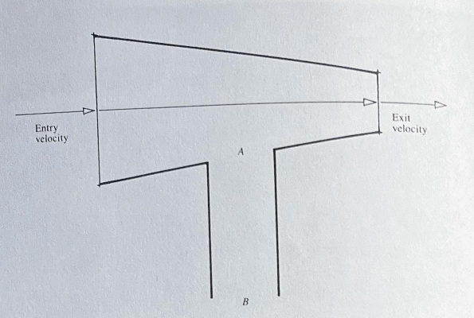

Figure 18: Bernoulli Principle (Credit: Hassan Fathy)

Construction was halted in 1967 due to war, and unfortunately was never resumed. The success in overcoming potential insurmountable obstacles with previous untested natural ventilation methods, as well as the powerful visual impression made by the resulting forms, made New Baris a tectonic lesson for architectural experiment and design today (Steele, 2018).

Chapter VI – Qatar University

Embedded in the heart of Doha, Qatar university campus, designed in 1985 by Egyptian architect Kamal El Kafraw; stands as a testament to architectural innovation and sustainable design, blending its Arabic traditional elements with modern functionality to create a harmonious environment for learning and research. At the heart of this architectural landmark lies the integration of windcatchers, ancient structures revived by Hassan Fathy, with a contemporary context to harness natural ventilation and promote environmental sustainability. These windcatchers mark the entire project, placed on top of the octagonal and square geometry to use natural light and prevailing winds (Abdullatif, 2023). Mashrabiyas, the small, latticed opening seen in figure 20, are supplemented with this design to further protect the inside spaces from the sun, diffusing the light without isolating the space.

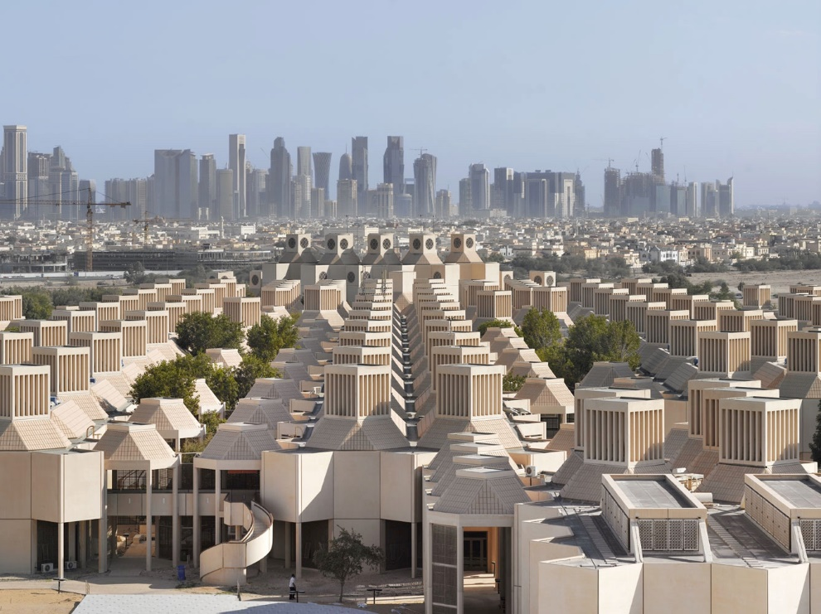

Figure 19: Qatar University Campus (Credit: R. Halbe)

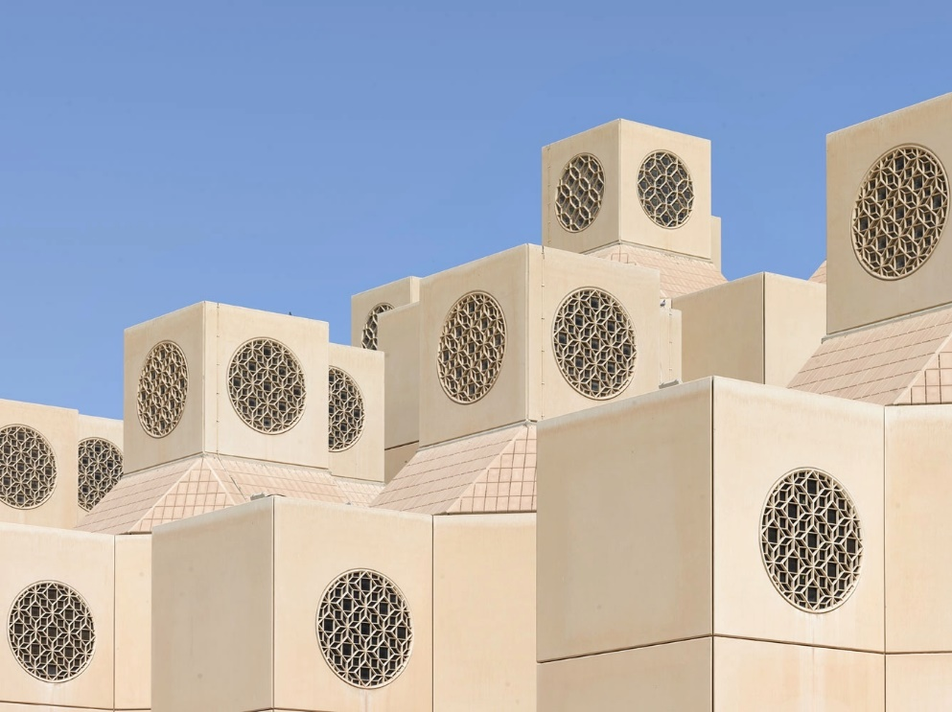

Figure 20: Wind catchers at Qatar University (Credit: R. Halbe)

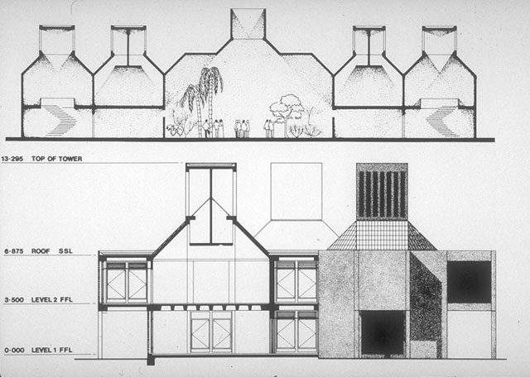

Figure 21: Sections of Qatar University block (Credit: Hiddenarchitecture.net)

In the arid landscape of Qatar, where scorching temperatures are norm, effective ventilation is paramount to ensure indoor comfort and reduce energy consumption, especially with the purpose and constant use of these spaces. Recognising the inherent challenges posed by the tropical harsh conditions, the project embraced windcatchers as a solution to mitigate the impact of heat, while honouring its rich heritage. Windcatchers, known as “Barjeel” in Arabic, have been an integral part of traditional Arabic architecture for centuries, and with the transition to modern architecture, Kamal El Kafraw, much like Fathy believed that restoring and reviving these ancient ideas is important for upkeeping identity.
The campus layout is carefully designed to maximise the effectiveness of the windcatcher, with buildings strategically orientated to capture prevailing winds and promote the natural air flow. These structures are not merely functional; they also serve as aesthetic focal points, adding a distinctive character to the campus skyline and enhancing its visual appeal.
Windcatchers in this establishment serve as living examples of sustainable design principles and traditional architectural techniques, providing valuable educational opportunities for students who live and study from these spaces and visitors alike. These structures offer a first person hands-on learning experiences, interdisciplinary exploration, research opportunities and avenues for public outreach and engagement. Researchers at Qatar University have leverage windcatchers for experiments, simulations and field of studies contributing to the advancement of knowledge in sustainable ventilation and its importance upon health and wellbeing.
These windcatchers also enhance the campus environment by providing shaded gathering spaces, which are integrated into outdoor shaded spaces, promoting social interaction among students, and hence fostering a sense of community and belonging within the campus.
In conclusion, while Qatar university and Hassan Fathy’s designs may seem divergent in terms of time period, context, and architectural style, they share the same fundamental principles that underscore their commitment to sustainability, vernacular architecture, and climate responsive design. Both Qatar university and Fathy’s architectural work prioritise creating space that response to their respective environment.
Moreover, Qatar university’s incorporation of windcatchers into its campus design exemplifies the modern architectural design practice with its traditional elements, echoing Fathy’s emphasis on integrating vernacular architecture with contemporary design principles. These windcatchers not only serve practical functions in naturally ventilating the spaces, but also symbolises the university’s commitment to sustainability, education, and cultural preservation.

Chapter VII – De Montfort University
Located in Leicester, United Kingdom, the Queens building of De Montfort University is a prime example of natural ventilation in a temperature to continental region, being typically warm to cool summers and mild winters. Completed in late 1993, this project was lauded at the time for being the first in a new generation of low energy, naturally ventilated buildings (Sibley, 2023).

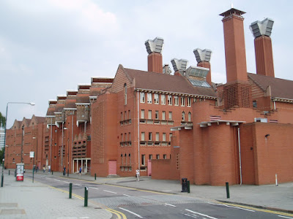

Figure 22: DeMontfort University, The Queens Building (Credit: Short and Associates)

The original brief for the queens building called for educational and laboratory facilities with innovative solutions reflecting the creative nature of the university. Architect Short-Ford Associates and environmental engineers Max Fordham LLP, backed by advisors of Cambridge Architectural Research, who focused on the stack effect chimney and Bristol University, contributing with the physics of airflow, crafted a highly insulated, thermally massive envelope with shallow plan floor plates and generous ceiling heights. The 10,000 m2 L shaped building boasts a south facing wing with a full height engineering laboratory and four storey west wing housing laboratories, classrooms, and offices, interconnected by a long, winding lightwell (GOV.UK, 1997).
Almost exclusively naturally ventilated, the building utilises cross ventilation for narrow wings, and chimney stack wind towers for the main structure, with top floors ventilated by motorised ridge windows. Much like the other buildings covered; central to the buildings design is the concept of passive ventilation, which relies on the natural forces of wind to drive in the air flow. Operable windows, louvers, and vents are strategically positioned throughout the building to facilitate the ingress of fresh air and the egress of stale air (BSRIA, 2006). This is shown in figure 23.
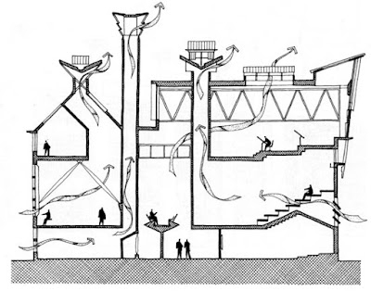

Figure 23: Working Airflow Section (Credit: Short and Associates)

The floor plans of this building was dictated by the architect goal to design a completely naturally ventilated building. The labs are designed to have narrow plans and operable windows to allow for the process of cross ventilation to occur. The main buildings floor plan has a wider area therefore cannot rely on methods of cross ventilation therefore are supplied with 8 large venting chimney structures, which exhaust the warm stale air created by the occupants, computers, and solar gain. The chimney relies on the stack ventilation strategy to operate and draws in cool air from vents located in the space below. Initially, the building was designed with fewer towers, however due to the constant use of these spaces, it was not adequate enough, resulting in the increased number. These chimneys were also designed to be structural elements in the build, to prevent the discussion of importance of them during the construction process (GOV.UK, 1997).

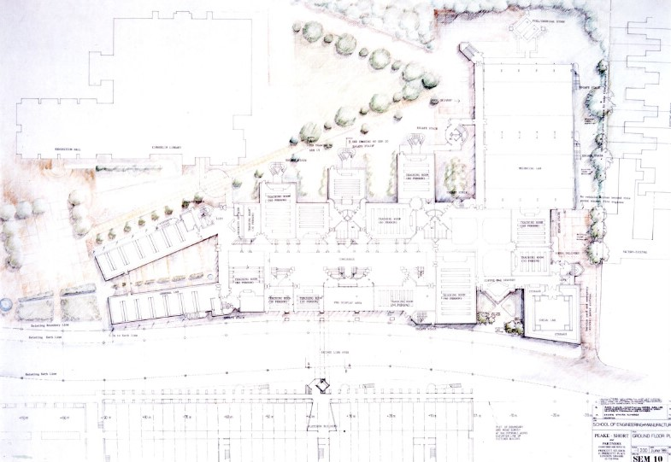
Figure 24: Plan of the Queens Building (Credit: Short and Associates)

The brick enclosure acts as a thermal wrap, buffering the risk of solar and thermal gain during summer peaks, paired with wide insulation filled cavity walls and concrete slab ceilings, which create thermal mass, absorbing the heating throughout the day when the building is functional, and releasing it at night when it is empty. As the building increases in height, the floor plans also increase, creating a shadowed environment in the laboratories, minimising the solar gain from direct sunlight penetrating through the three floors. Within the spaces, there are light shelves which bounce the daylight off the ceiling and deeper into the space. Surrounding courtyard walls are painted white to bounce the light down into the lower levels that are over shadowed (GOV.UK, 1997)
Unlike buildings before using this type of ventilation system, the queens building came equipped with a number of mechanical devices that complemented the natural systems with mechanical controls and sensoring, to allow continuous monitoring, data collection and analysis, and to optimise the system to its most efficient and comfortable settings. To ensure the building can be used in the colder winter months, the chimneys have been equipped with finned tubes positioned behind vertical supply grills to heat air that is captured. A simple punkah fan is installed in stacks to aid ventilation when necessary. Moisture dampers can be found located at the top of each stack, which are adjusted by a building energy management system (BEMS) to maintain room temperatures, and in more important rooms such as the auditoriums, modulating dampers control the air inlets, with more sensitive controls (GOV.UK,1997)
In 1996, it was subject to a post-occupancy analysis under the post-occupancy review of buildings and their engineering (PROBE) project, which evaluated its performance and sustainability in newly built buildings, with experimental technologies. The initial PROBE survey uncovered challenges stemming from a compressed commissioning period and unresolved defects in critical mechanical and control systems. Despite effective thermal massing and natural ventilation, occupant surveys revealed dissatisfaction with high summertime temperature and noise levels. While the building demonstrated low energy consumption gas and energy consumption being 143kWh/m2/y and 52kWh/m2/y, which compared with the energy efficiency offices low target for consumption for university buildings of 185kWh/m2/y and 75kWh/m2/y, was very favourable, issues with daylight utilisation and lighting control were apparent (GOV.UK, 1997).
Ten years later, in 2006, the queens building had undergone significant transformations, with some areas evolving dramatically. The institute of energy and sustainable design (IESD) now occupies spaces previously utilised by different purposes, demonstrating adaptability and flexibility.
Notable improvements include the replacement of failed motors for rooflights, enabling enhanced control and functionality of the light within the space and process of air flow control in the process of stack ventilation. Manual and motorised window actuators facilitate night cooling, much like the cooling methodology Hassan Fathy used in prospect with New Gourna and used in the Eastgate centre, by Mick Pearce.

The Auditorium
Designers face a challenge in adequately removing heat, odour and carbon dioxide in auditoria and lecture theatres due to the intermittent high populations. Over the past 25 years, mechanical ventilation, often coupled with air conditioning, has become the norm for environmental control. However, the auditorium at de Montford university’s queen building took a different approach, prioritising effective natural ventilation over the use of fans and refrigerants.
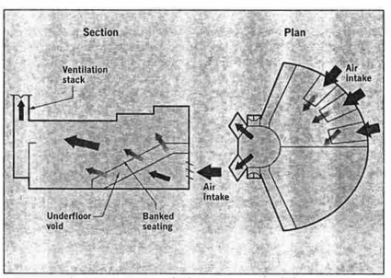

Figure 25: Auditorium working airflow section (Credit: Building Services Journal 1997)

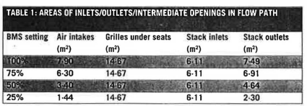
Figure 25 above shows the plan and cross section of the theatre hall. Air enters an underfloor void via adjustable intake louvers through upwards sloping ducts. It then enters the space through openings in continuous strips beneath each row of seats. Finned tube heat exchangers behind the openings heat the air before it enters the auditorium. The air leaves through multiple high level rectangular openings in the foot of two 13.7m high rhombic section ventilation stacks with four adjustable, top hinged windows forming the exit at the top. The total vertical distance from inlet to outlet centres is 17.6m (Building Service Journal, 1997)
Figure 26: Table showing interzonal openings data (Credit: Building Services Journal 1997)
Figure 26 highlights the areas of various inter-zonal openings in the air path and the free areas of the adjustable inlets and outlets at a 25%, 50%, 75% and completely open position.
The original design followed methods outlined in the Chartered Institution of Building Services Engineering (CIBSE) Guide A and described by Thomas Randall, in his book of Environmental Design, published in 1996; ‘using conventional buoyancy theory to determine available pressure for overcoming system resistance, estimated from pressure drop data found in sources such as CIBSE Guide C. For the queen building, additional design tools were used to evaluate temperature and airflow during this critical period. These are summarised by Herbert Eppel and Kevin J. Lomas, upon a case study of simulating the thermal performances of naturally ventilated spaces (Eppel, and Lomas, 2017). The use of a computer simulation to predict the number of occurrences of high temperature through the year, proved to be a good assessment of the beneficial effect of the high thermal capacity of the building, and underlining the importance of the ventilation system come the summertime.
To summarise, the auditorium stack ventilation system had been shown to provide more than adequate ventilation throughout most of the year, with its range of sensoring and controls to assist the natural air flow induced by the use of stack and chimney effect ventilation strategies.

Main building
This central space acts as a lightwell and thermal buffer zone for the adjoining rooms. With the auditoriums and classrooms located on the ground floor, using the chimney ventilation systems, this space also benefits and acts as an additional route for stack effect to occur with the use of rooftop ventilators. Air from the concourse passes up through drawing studios to the ridge ventilators, which are glazed and have a northerly orientation to optimise daylight without solar gain penalties (GOV.UK, 1997).

Mechanical laboratories
To mitigate noise levels near a terrace of private residences, the naturally ventilated machine hall is positioned adjacent to a two-storey block housing of specialised laboratories. This arrangement serves a dual purpose: not only does it provide an additional acoustic barrier, but it also acts as a structural support for the travelling gantry crane by counteracting lateral forces. To address these forces, buttresses are installed along the east elevation. These buttresses are designed with hollow cores, serving as channels for fresh air intake, with corresponding voids above and between ground floor offices, facilitating air circulation from the western façade (GOV.UK, 1997).

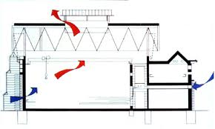

Figure 27: Mechanical labs working ventilation diagram (Credit: T. Peffer)

Machine halls ventilation system includes acoustically baffled ridge vents and inlet louvers on the west façade, which operate automatically through the Building Energy Management System. Additionally, timber doors within the breathing buttresses can be manually opened to regulate airflow. Glazed ridge vents and triple glazed, west facing gable windows ensure ample daylight within the machine hall while effectively minimising noise transmission to the exterior. Furthermore, roof overhangs and reveals are strategically designed to shade machinery from direct sunlight, enhancing the overall functionality of the space.

Electrical laboratories
The electrical laboratories occupy two shallow plan, four-storey wings flanking the entrance courtyard, allowing for straightforward cross ventilation to occur and even distributes the natural light. Both low level and high-level windows are generously sized to facilitate this ventilation effectively, aiding in the dispersion of internal heat generated by computers and equipment (GOV.UK, 1997).

In conclusion, De-Montfort University’s Queens building and Hassan Fathy’s architectural work, on first instance distinct, share similarities on their fundamental principles that underscore their commitment to sustainable ventilation system design, experimental design and human-centric design. Both examples of New Baris, and the Queens building prioritise environmental responsibility, cultural preservation, and occupant well-being, demonstrating the transformative potential of architecture to shape-built environment that resonate people, without the potential devastating affects through global warming.
The Queens buildings construction from red brick is reminiscent of local architectural tradition, similarly, emphasised by Hassan Fathy’s philosophies on the use of vernacular materials and construction techniques.
Additionally, both examples prioritise sustainable design strategies through the ventilation strategies of stack ventilation, within the main building and cross ventilation for the narrow wings. The Queens building utilise the traditional method to promote the natural airflow within the entirety of the building, reducing the need for mechanical cooling systems and enhancing occupant comfort, much like Fathy’s design. This project serves as a inspirational example of architectural power showing that Fathy’s experimental designs stand as an educational precedent, which can further be developed, resulting in a reduction of mechanical system and energy used within out built environment.

Last Chapter - Houghton Le-Springs Primary Care Centre – 2011

Situated in Sunderland, England, Houghton Le-Springs Primary Care Centre stands as a beacon of sustainable healthcare architecture. Constructed started in 2009, finishing in 2011 (Breathing Buildings, 2011) this facility represents a pioneering approach to healthcare design, integrating cutting edge technology with eco conscious principles. From its inception, the centre’s vision was to create a space that not only meets the healthcare needs of the community but also embodies environmental stewardship and energy efficiency. The collaboration between architectural firm P+HS and construction company Willmott Dixon, the centre has set a new standard for sustainable healthcare infrastructure.

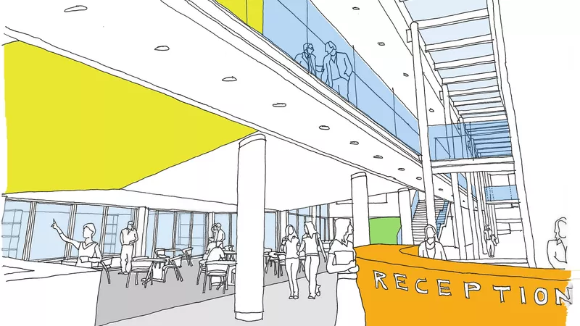

Figure 28: Houghton Le-Springs reception – concept (Credit: P+HS Architects)

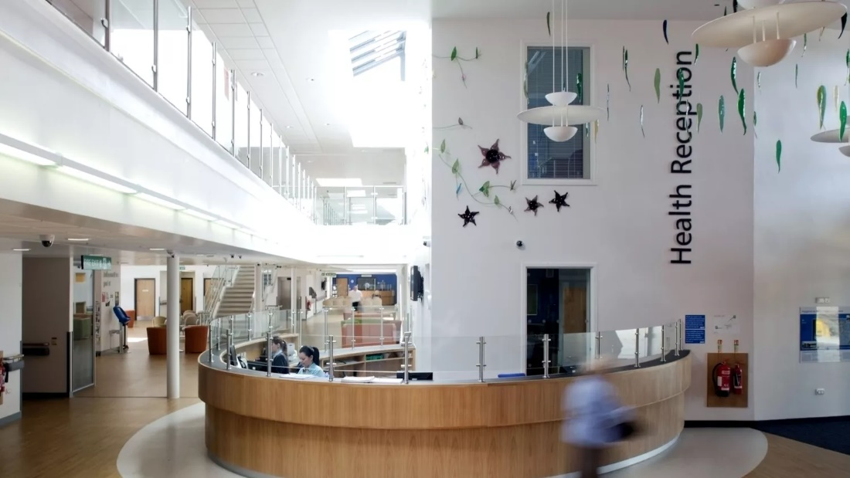

Figure 29: Houghton Le-Springs reception (Credit: P+HS Architects)

NHS Sunderland embarked on a project to construct a new primary care centre, envisioning expansive public spaces, a café, waiting areas, and patient and consulting rooms. Collaborating with the Primary Care Trust (PCT), Breathing buildings, UK’s leading corporation devoted to supplying controlled hybrid ventilation systems, was tasked to develop a design strategy for natural ventilation particularly in the public spaces. With completion of this stage, breathing buildings worked closely with the project team to design and deliver bespoke ventilation equipment.
The Primary Care Trust presented a formidable challenge, stipulating that the interior temperature of the new facility must not exceed 25 degrees Celsius for up to 100 hours per year to ensure patients are kept comfortable and in well ventilated conditions at all times, as well as provide a low-carbon solution (Breathing Buildings, 2011). Traditionally, achieving this would involve mechanical ventilation and air conditioning, however the design team aimed to explore new sustainable solutions for summer cooling, leveraging natural ventilation, and thermal mass.
Breathing buildings conceived a tailored 50-metre-long thermal wall, positioned along the building’s spine, catering to ventilation needs in consultancy rooms, including the open plan waiting area and cafeteria. The wall design incorporates 49 individual shafts to segregate ventilation for different spaces, thereby minimising the risk for infection transfer and cross contamination (P+HS, 2011).
To optimise comfort and energy efficiency, distinct strategies were used for summer and winter ventilation. In summer, the thermal wall facilitates passive cooling by drawing cold air down the shafts during the night and utilising the cooled shafts to temper warm outside air brought into the spaces the following day. In the winter, a mixing ventilation approach is adopted, with the thermal wall serving the consultancy rooms and breathing buildings e-stack R-series units catering to the open plan areas (Breathing Buildings, 2011). The strategy involves brining cold external air into the building, then blending it with recycled warm air from within.

Thermal wall

The thermal wall initiates a cooling process by chilling the hot air, causing it to become denser than outside air. IN doing so, the denser air descends and encounters more night-cooled thermal mass, further cooling the air. This downward movement of cold air displaces the warmer air, creating the illusion of hot air descending, when in fact it is the falling dense cold air that propels this. The cooling capacity of the thermal wall and plenum, as seen in figure 30, is sufficient to maintain the air entering the occupied space at a comfortable 19 degrees Celsius. As the air circulates within the building and encounters internal heat sources, such as equipment and occupants, it warms slightly to a desirable range of 21-22 degrees Celsius, ideal for ensuring interior comfort on hot summer days. When outdoor temperatures exceed this range, the ventilation system adjusts to maintain the CO2 levels in the occupied space at optimal levels (CIBSE, 2015).
Critical to the summertime cooling strategy is the effective night cooling of the thermal wall. The envisioned flow pattern during the design phase involved the descent of cold night air through the thermal wall, its entry into the occupied space, and exit at high level, typically at the top of the atrium, central to the buildings open spaced lobby.

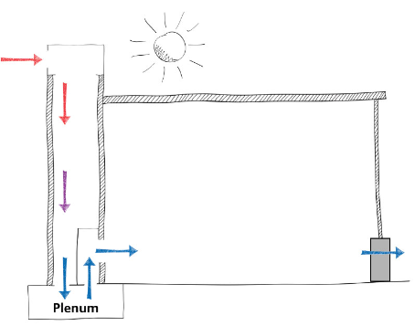

Figure 30: Thermal wall working principle (Credit: CIBSE)

During the winter, flow patterns was proven to operate as per the design. The building doesn’t use this thermal wall during the winter months, and instead use a E-stack R-series ventilation method instead. The most obvious difference was a reversal of daytime operation in that cold air would enter through the atrium opened space, be heated in the plenum, and rises through the thermal wall (Breathing Buildings, 2011) CIBSE, 2015). The reason for this flow regime is that the thermal wall is warm in comparison to the night air, and source of buoyancy.
In order to combat this process, Breathing Buildings had included ceiling fans within the thermal wall to control the flow of direction, and would only operate if necessary. As a result, Breathing Buildings undertook a series of experiments, with fans running three hours each night. The data taken showed that with the use of fan-assisted, nighttime cooling strategies, the thermal wall could be exposed to more cold night air, which proved more cooling the following day, with reductions in interior temperatures of 1-2 degrees Celsius (CIBSE, 2015). The increase of cold air being drawn through the stack, resulted in cooler thermal mass ready for the daytime.
Furthermore, use of sensors in the open space below, monitoring CO2 levels, ensured that the building would not exceed the maximum average recommended level. Figure 31 illustrates the monitorisation of CO2 levels, which were kept very low during the summer, generally around 600ppm (CIBSE, 2015).

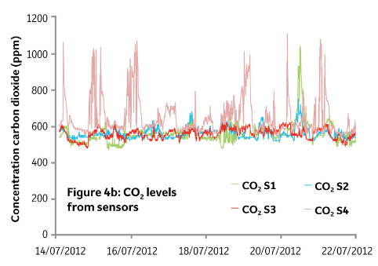
Figure 31: CO2 levels taken from sensors (Credit: CIBSE)

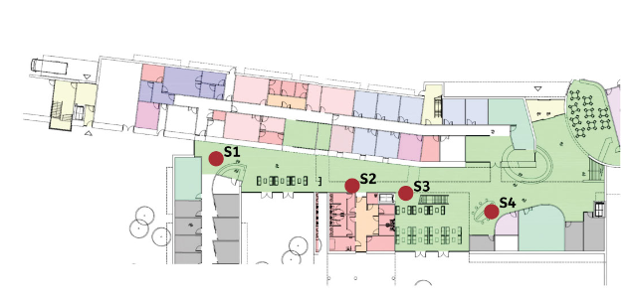
Figure 32: Plan of sensor locations (Credit: CIBSE)

E-stack R-series

The R-series E-stack system is tailored for rooms that have direct access to the outdoors through the roof, making it particularly well suited for the offices, consultation, and treatment rooms at Houghton Le-Springs. Breathing Buildings natural and hybrid system uses a unique ventilation strategy that adapts to seasonal changes. During the summer, the system collaborates with low level openings which facilitate natural ventilation, through the stack ventilation strategy, as shown in figure 34.
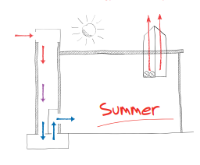
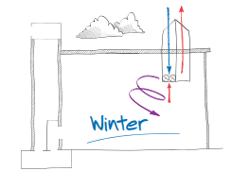
Figure 34: Summer ventilation system (Credit: Breathing Buildings)
Figure 33: Winter ventilation system (Credit: Breathing Buildings)
In the winter (figure 33), a mixing ventilation approach is used, effectively eliminating cold drafts without relying on preheated radiators or heated batteries, resulting in significant energy saving. Through its patended e-stack strategy, the system harnesses incidental heat gains within the room to warm incoming air during cooler weathers, reducing the need for conventional heating elements. IN heavily ocupied spaces, the heat gains are substantial enough that heating is often unnecessary until external air temperature drops below 7 degrees Celcius (CIBSE, 2015).
Commenting on the solution, Andy Mackintosh, director at the construction company Willmott Dixon, expressed delight in the collaborative effort leading to the achievement of a BREEAM ‘outstanding’ award, a first in the UK healthcare sector (Breathing Buildings, 2011)
In conclusion, Houghton Le-Springs Primary Care Centre, wit its emphasis on natural ventilation techniques with use of the thermal wall and e-stack r-series, aligns with Hassan Fathy’s design philosophies in a number of ways. Fathy advocated for passive cooling strategies that leverage natural airflow and environmental conditions to maintain comfortable indoor temperatures, which is demonstrated in the care centre with the incorporation of stack ventilation strategies, reducing the reliance on mechanical systems resulting in lower energy costs and reduced environmental impact without sacrificing comfort and the health benefits.

Conclusion

To conclude, the study of Hassan Fathy’s sustainable design and ventilation strategies emphasise the importance of holistic, culturally sensitive, and experimental architectural design. With integration of historic traditional methods being implied with modern techniques, Fathy was able to create environments suited to human comfort while maintaining little to no energy consumption. This cycle is replicated throughout Qatar University, De-Montfort University and Houghton Le-Springs.
The adoption of natural ventilation techniques mitigates the increase of greenhouse gases and subsequent warming of the Earth, as well as contributing to a significant reduction in carbon emissions. The reduction in carbon emissions is achieved through the decreased energy demand associated with mechanical systems, leading to a more environmentally friendly built environment. Furthermore, the reduction in carbon emissions results in cleaner air, which in turn provides health benefits and reduces the prevalence of respiratory diseases (World Health Organisation, 2023). This highlights the multifaceted advantages of natural ventilation in promoting both sustainability and human well-being.
Fathy’s approach of vernacular construction, emphasises the use of locally sourced materials, minimises the reliance of importing and exporting materials, further contributing to a significant reduction of carbon emissions. This approach fosters the creation of culturally sensitive buildings that honour and preserve heritage while promoting the idealism of environmental sustainability. By integrating indigenous building techniques and materials, Fathy’s design philosophies underscore the importance of harmonising architecture with its nature and cultural context. Qatar university is an example of this, incorporating locally sourced materials like marble, sandstone, and limestone, minimising its requirement to import materials, and therefore retaining traditional construction methods and structure.
Qatar university campus embodies a direct approach to Fathy’s design philosophies, evident in its embrace of vernacular architecture, preserving its cultural identity and adaptation to local climate conditions. The incorporation of elements such as the wind catcher demonstrates a commitment to natural ventilation principles, while strategies like shading and the design of enclosed spaces to create cooler environments below resonate with Fathy’s innovation approaches to passive cooling techniques. These design elements demonstrate the universities dedication to sustainability and environmental responsiveness, along with serving as an educational example of Fathy’s design techniques, showcasing practical applications of his principles in a modernised setting.
The DeMontfort University’s Queens Building and Houghton Le-Springs Primary Care Centre stand as contemporary exemplars of Hassan Fathy’s architectural principles, drawing upon a blend of traditional design strategies and modern technologies. These buildings integrate shading devices and reflective surfaces to optimise natural daylight, enhancing indoor comfort with the reduction of solar gain. Additionally, they employ standard natural ventilation strategies such as stack ventilation and cross ventilation, paired with monitoring systems for optimal efficiency.
By harnessing modern technologies to monitor and regulate natural ventilation systems, these buildings achieve greater precision and effectiveness in maintaining indoor environmental quality. The incorporation of sensors and automated controls allows for real-time adjustments based on environmental conditions, ensuring a comfortable and healthy indoor environment while minimising energy consumption.
Moreover, these projects demonstrate how Fathy’s principles can be adapted and applied in cooler climates, showcasing the versatility and adaptability of vernacular design strategies.
In the endeavour to normalise natural ventilation strategies, traditional ventilation systems are undergoing a transformation through the integration of modern technologies. This evolution represents a concerted effort to adapt age-old techniques to meet the demand of contemporary building practice, while addressing current climate challenges.
Furthermore, the wind catcher ventilation strategy is directly undergoing modernisation with the new technology available to our disposal, future proofing and promoting the use of this natural vernacular strategy. With disadvantages of dust and insects, and low efficiency due to low velocity of winds being identified, experimental technologies have been implemented, further enhancing Fathy’s philosophies of experimental design and adjustment to context (Sangdeh, P. and Nasrollahi. N, 2020)
Examples of this is wind catcher systems being installed using rotational heads which can be adjusted to be against the winds direction at all times while profiting from increased daylight exposure in the space below.
Down-draft evaporation can be implemented as an active or passive system. Firstly, air enters through the windcatcher shaft, where it is then sprayed with water, making the air denser. The kinetic energy from the sprayed drops is then conveyed into the air, further pushing the air downwards. This system has been used in wind catchers located in the Torrent Research centre, in India, with a high level of residence (Sangdeh, P. and Nasrollahi. N, 2020).
A system called an air tree, comprises a cluster of 16 wind catchers, each constructed with metallic framework and a dual layer plastic enclosure. Currently, this system is being trialled in Madrid, employing three mechanisms to elevate ambient air temperature: Shading, ventilation, and evaporative cooling. Utilising fans and a network of water services in its lower section, the air tree facilitates the ventilating and evaporative cooling process. Research indicates that the air tree can reduce local temperatures by up to 8 degrees Celsius. This research has also led the institute experimenting with different elements leading to more efficient outcomes (Sangdeh, P. and Nasrollahi. N, 2020).
These examples highlight the constant growth and evolution of traditional systems, in hope of making the future of ventilation cleaner and sustainable.
Hassan Fathy’s philosophies offer valuable insights and lessons for sustainable ventilation and design practice. His emphasis on vernacular architecture and the use of locally sourced materials underscore the importance of contextually appropriate solutions that minimise environmental impact. By prioritising passive cooling techniques and natural ventilation strategies, Fathy demonstrated the potential to create comfortable and energy-efficient built environments without relying on mechanical systems.
A key lesson from Fathy’s approach is the integration of traditional wisdom with modern solutions to enhance sustainability. By combining older techniques with innovative solutions such as smart sensoring, automated controls, and computational design tools, architects and designers can optimise natural ventilation systems for maximum efficiency and effectiveness.
Fathy’s advocacy for community engagement and participatory processes highlights the importance of considering the needs and aspirations of end-users in the design and implementation of design strategies. By involving users throughout the design process, architects are able to ensure that the solution to ventilation is tailored to its context and needs of occupants.

Reference List

Abdolhamidi. S. (2018) An ancient engineering feat that harnessed the wind. Available at: https://www.bbc.com/travel/article/20180926-an-ancient-engineering-feat-that-harnessed-the-wind. [Accessed: 12/01/2024]
Abdullatif. K. (2023) Egyptian architect Kmal El Kafrawi’s design of Qatar University. Available at: https://scenehome.com/Architecture/Egyptian-Architect-Kamal-El-Kafrawi-s-Design-of-Qatar-University#:~:text=Wind%20catchers%20mark%20the%20entire,winter%20and%20scorching%20during%20summer. [Accessed: 28/01/2024]
Agenda. D. (2021) We can’t tackle the climate crisis without changing construction. Here’s why. Available at: https://www.weforum.org/agenda/2021/01/planet-warming-emissions-buildings-construction-climate-goals-risk/. [Accessed: 29/11/2023]
ArchDaily. (2013) Lee house / Studio MK27. Available at: https://www.archdaily.com/419521/lee-house-studio-mk27-marcio-kogan-eduardo-glycerio. [Accessed: 18/03/2024]
Bemkan. N. et al. (2017) Design and performance comparison of two patterns of wind catcher for a semi-enclosed courtyard. Available at: https://www.researchgate.net/publication/319942783_Design_and_performance_comparison_of_two_patterns_of_wind-catcher_for_a_semi-enclosed_courtyard. [Accessed: 06/04/2024]
Bertini. V. (2020) Hassan Fathy(1900-1989) Available at: https://www.architectural-review.com/essays/reputations/hassan-fathy-1900-1989. [Accessed: 15/01/2024]
Breathing Buildings (2011) Case study – Houghton Le-Springs Primary Care Centre
BSRIA (2006) Queens Building. Available at: https://www.bsria.com/uk/news/article/queens-building/ [Accessed: 15/03/2024]
Clean air stars. (no date) Natural ventilation. Available at: https://cleanairstars.com/naturalventilation/ [Accessed: 17/03/2024]
Damluji. S. and Bertini. V. (2018) Hassan Fathy: Earth and Utopia. London: Laurence King Publishing.
Dimitroulopoulou, S. et al. (2023) Indoor air quality guidelines from across the world: An appraisal considering energy saving, health, productivity, and comfort, Environment international, 178, Available at: https://www.sciencedirect.com/science/article/pii/S0160412023004002 [Accessed: date]
Earth Observatory (2023). Five factors to explain the record heat in 2023. Available at: https://earthobservatory.nasa.gov/images/152313/five-factors-to-explain-the-record-heat-in-2023. [Accessed: 29/11/2023]
Eppel, H. and Lomas, K (2017) Simulating the thermal performance of naturally ventilated spaces: a case study. Available at: M:\E-Drive_Backup\Herb_DMU\xOLD_STUFF\Zip files\apollo\herb\papers\plea_engin\paper_OS4.ps (hetranslations.uk). [Accessed: 03/04/2024]
Fathy, H. (1989) Gourna: A tale of two villages. USA: Prism Publication Office.
Fathy. H. (1986) Natural energy and vernacular architecture: Principles and examples with reference to hot arid climates. USA: The University of Chicago Press.
Gandhi, P. (2023) New Gourna Village (1945-1952): A paradigm of sustainable community design by Hassan Fathy. Available at: https://www.archiinterio.com/magazine/new-gourna-village--1945-1952---a-paradigm-of-sustainable-community-design-by-hassan-fathy. [Accessed: 15/01/2024]
Gov.UK. (1997) The Queens Building DeMontfort University – Feedback for designers and client. Available at: https://ia801202.us.archive.org/10/items/GPCS335/NPCS102.pdf. [Accessed: 15/03/2024]
Kassir. R. (2015) Passive downdraught evaporative cooling wind towers: A case study using simulation with field-corroborated results. Available at: https://journals.sagepub.com/doi/abs/10.1177/0143624415603281?journalCode=bsea. [Accessed: 15/03/2024]
Kensek, K. and Nobile, D. (2015) Innovation in green design: Examples from sustainable architecture. Oxfordshire: Routledge
Kloosterman. K. (2023) New Gourna and Hassan Fathy’s earth architecture for the people of Egypt. Available at: https://www.greenprophet.com/2023/10/new-gourna-hassan-fathy-sustainable-architecture-egypt/. [Accessed: 15/01/2024]
NASA. (2023) Global climate change: Vital signs of the planet. Available at: https://climate.nasa.gov/%C2%A0%C2%A0/. [Accessed: 29/11/2023]
National Geographic. (2018) See how termites inspired a building that can cool itself I Decoder. 29th May. Available at: https://www.youtube.com/watch?v=620omdSZzBs. [Accessed: 29/11/2024]
Rodrigues, A. M. et al. (2019) Impact of natural ventilation on the thermal and energy performance of buildings in a mediterranean climate. Available at: https://www.mdpi.com/2075-5309/9/5/123. [Accessed: 13/12/2023]
Sangdeh, P. and Nasrollahi, N. (2020) Windcatchers and their application in contemporary architecture. Vol 3, 1, pp. 56-72. Available at: https://www.sciencedirect.com/science/article/pii/S2666123320301070. [Accessed: 12/01/2024]
Sangdeh. P. and Nasrollahi. N. (2022) Windcatchers and their application in contemporary architecture, Vol 3, 1 pp. 56-72. Available at: https://www.sciencedirect.com/science/article/pii/S2666123320301070. [Accessed: 11/01/2024]
Shokoohi. K. (2021) The ancient Persian way to keep cool. Available at: https://www.bbc.com/future/article/20210810-the-ancient-persian-way-to-keep-cool. [Accessed: 12/01/2024]
Sibley, A (2023) The Queens building at 30: A look back at its storied history, and exploration of the futuristic building design. Available at: The Queen's Building at 30: A look back at its storied history, and exploration of the futuristic building design. (dmu.ac.uk) [Accessed: 15/03/2024]
Steele. J. (2018) An architecture for people: The complete works of Hassan Fathy. London: Laurence King Publishing.
Stouhi. D. (2021) Back to basics: natural ventilation and its use in different contexts. Available at: https://www.archdaily.com/963706/back-to-basics-natural-ventilation-and-its-use-in-different-contexts. [Accessed: 16/01/2024]
Stouhi. D. (2021) What is a traditional windcatcher. Available at: https://www.archdaily.com/971216/what-is-a-traditional-windcatcher. [Accessed: 12/01/2024]
Ostergaard, P. et al. (2022) The four generations of district cooling – A categorization of the development in district cooling from origin to future prospect. Vol 253. Available at: https://www.sciencedirect.com/science/article/pii/S0360544222010015. [Accessed: 11/01/2024]
UK Health Security Agency. (2021) Ventilation to reduce the spread of respiratory infections, including COVID-19. Available at: Ventilation to reduce the spread of respiratory infections, including COVID-19 - GOV.UK (www.gov.uk). [Accessed: 19/02/2024]
World Monuments Fund. (2011) Outreach and education – past, present and future of Hassan Fathy’s New Gourna, Egypt. 16th August. Available at: https://www.youtube.com/watch?v=v5K7cGmSTtE. [Accessed: 28/02/2024]
World Monuments Fund. (2021) New Gourna Village. Available at: https://www.wmf.org/project/new-gourna-village. [Accessed: 28/02/2024]

Bibliography

Architects’ Journal. (2023) Retrofirst: The greenest building is the one that already exists (long version). 27th May. Available at: https://www.youtube.com/watch?v=p6nQLjJFXqc. [Accessed: 24/02/2024]
Archnet. (No Date) New Gourna Village. Available at: https://www.archnet.org/publications/15120. [Accessed: 05/03/2024]
Compton. M. (2006) Queens Building, DeMontfort University. Available at: https://www.webpages.uidaho.edu/arch504ukgreenarch/CaseStudies/QueensBldg-DeMontfortU.pdf [Accessed: 15/03/2024]
Cross-ventilation. (2022) Available at: https://www.designingbuildings.co.uk/Cross_ventilation [Accessed: 26/01/2024]
DW Planet A. (2023) How to cool our homes (even without Acs). 4th August. Available at: https://www.youtube.com/watch?v=sKbEOMCsqaI. [Accessed: 25/02/2024]
Garcia. A. and Bajo. H (2015) New Barris Village. Hidden Architecture. Available at: https://hiddenarchitecture.net/new-barrid-village/. [Accessed: 08/03/2024]
Gattupalli. A. (2022) Healthy spaces: the rise of wellness design in 2022. Available at: https://www.archdaily.com/994250/healthy-spaces-the-rise-of-wellness-design-in-2022 [Accessed: 23/01/2024]
Ghanavati. M. (No Date) Windcatcher I Representative of Iranian desert architecture. Available at: https://iranindepth.com/windcatcher-representative-of-iranian-desert-architecture/. [Accessed: 01/03/2024]
Hassan Fathy: Building in the desert in New Baris. (2020) Available at: https://www.sensesatlas.com/hassan-fathy-building-in-the-desert-in-new-baris/. {Accessed: 08/03/2024]
Hayton. N. (2023) The Queens Building at 30: Reshaping campus for a sustainable future. Available at: https://library.dmu.ac.uk/archivesblog/home/The-Queens-Building-at-30-reshaping-campus-for-a-sustainable-future. [Accessed: 15/03/2024]
HOMETUBE. (2023) How this ancient windcatcher make building cool. 2nd September. Available at: https://www.youtube.com/watch?v=aARLB7C0Les. [Accessed: 23/01/2024]
Knoji. (2012) Windcatcher (Malqaf): A traditional natural ventilation system – part 1. Available at: https://knoji.com/article/windcatcher-malqaf-a-traditional-natural-ventilation-system-as-an-alternative-to-the-modern-cooling-system-in-hotclimate-regions-part-1/. [Accessed: 28/02/2024]
Leaf of life. (2023) How this desert city stays cool with an ancient air conditioning system. 18th June. Available at: https://www.youtube.com/watch?v=AiiGznaH0mE. [Accessed: 23/02/2024]
Malik. V. (2023) What’s ventilation: Types and the importance of natural ventilation: HSEblog.com, 20 October. Available at: https://www.hseblog.com/ventilation/. [Accessed: 24/02/2024]
Natural ventilation of buildings. (2023) Available at: https://www.designingbuildings.co.uk/Natural_ventilation_of_buildings#:~:text=The%20types%20of%20ventilation%20covered%20include%3B,mechanical%2C%20passive%20stack%2C%20background%20and%20purge%20%28rapid%29. [Accessed: 24/02/2024]
Royal Academy of Engineering. (no date) Ventilation matters – why clean air is vital to health. Available at: https://explainers.raeng.org.uk/ventilation-matters. [Accessed: 20/02/2024]
Sykes. K. (2007) The architecture reader: Essential writings from Vitruvius to the present. New York: George Braziller Publishers.
UGREEN_US. (2023) How stack ventilation works – sustainable architecture animated glossary #13. 12th June. Available at: https://www.youtube.com/watch?v=y_HIkLrAjGY. [Accessed: 20/02/2024]
Wallner. P et al. (2017) Health and wellbeing of occupants in highly energy efficient buildings: a field study. Available at: https://www.ncbi.nlm.nih.gov/pmc/articles/PMC5369150/#:~:text=A%20few%20studies%20reported%20that%20ventilation%20systems%20in,and%20thus%20an%20improvement%20in%20indoor%20air%20quality. [Accessed:18/02/2024]
Zaineldine. A. (2021) The Egyptian ‘architect of the poor’: Hassan Fathy and why his vision still matters. Available at: https://egyptianstreets.com/2021/09/25/the-egyptian-architect-of-the-poor-hassan-fathy-and-why-his-vision-still-matters/ [Accessed: 15/03/2024 ]

