Control System Design
Instrumentation and control, acda5011
Luke Malcolm (2030773)
2023
Contents
1. Abstract 2
2. Background 2
2.1 Phalanx CIWS 2
2.2 Relevance of control theory 2
3. Control Theory 3
3.1 Basics 3
3.2 The PID controller 4
3.3 Feedback 5
3.4 Accuracy, Stability, and Precision 5
3.5 Control systems in context 6
4. Simulation 7
4.1 Background 7
4.2 Limitations 7
4.3 Results 8
4.4 Discussion 11
5. Conclusion 12
6. Future work 12
Bibliography 12

Abstract
This report will discuss the fundamentals of control theory and its relevance to defence systems, using the Simulink software package to perform a simulation demonstrating PID tuning and finding the closed-loop transfer function of a system. It will also demonstrate that the closed-loop transfer function can be used as a substitute for the PID block.
Many variants of the Close-In Weapons Systems exist, while most use a rapid-fire gun system as the main effector, other variants exist utilising missiles (SeaRAM) – or even combining a gun system and short-range missiles (Russian “Kashtan”). This report will focus on the American “Phalanx” CIWS as an example, though the control theory will apply to all variants.

Background

2.1 Phalanx CIWS
The Close-In Weapons System, or CIWS (“sea-whiz”) for short, plays a pivotal role in the last-ditch point defence of ships from incoming missile, aircraft, or small boat threats. It Is typically only employed when other countermeasures have failed to be effective, or the threat has evaded detection.
The Phalanx is a self-contained CIWS system is made up of two key parts – a 20mm air-cooled six-barrelled rotary cannon, and a Ku-band fire control radar (later versions are also fitted with an IR sensor). The gun fires at circa. 4,500rpm. The internal magazine holds 1,550rds of 20mm Tungsten APDS ammunition. The typical burst length is usually 100 or 300 rounds, however this can go up to 1000rds if necessary. It is only expected that a small number of rounds from the burst hit the target, though only a small amount of damage is necessary to aerodynamically destabilise, encourage in-flight breakup, or damage the command/flight control systems – all of which lead to a crash.
The Phalanx system also tracks outgoing rounds and is able to make the necessary adjustments to bring them into the path of the threat.
A ground-based variant of the Phalanx – the Centurion “CRAM” (Counter-Rocket, Artillery, Mortar) is also in service. It uses virtually the same hardware as the sea-based Phalanx, but fires high-explosive ammunition containing fragments that self-destruct at circa. 2000yds. This is necessary, as the threats it is designed to defeat are significantly smaller than an anti-ship missile or air/sea drone – however, the tungsten rounds have a significantly longer range as they do not self-destruct at 2000 yards. [1]

2.2 Relevance of control theory
The control theory underpinning the operation of the CIWS is not fundamentally any different to that of any other machine containing a PID controller – however, the consequences of underperformance or failure are much higher when it comes to the point defence of ships.
The main benefits of having a high-performing control system are listed below:
- Higher terminal engagement distance
  - The terminal engagement distance (distance from the ship that the threat is destroyed) is usually relatively low. In the case of an anti-ship missile travelling at Mach 2-3, the vessel may still be severely damaged by large sections of partially-fuelled anti-ship missile impacting it (with the risk from sympathetic detonation of the warhead) even if the missile is no longer in stable controlled flight.
- Higher kill probability for a manoeuvring threat
  - An increasing amount of threats are able to perform complex high-G evasive manoeuvres in their terminal phase – a CIWS with an adequately tuned control system has a higher probability of tracking and defeating them at a reasonable terminal engagement distance
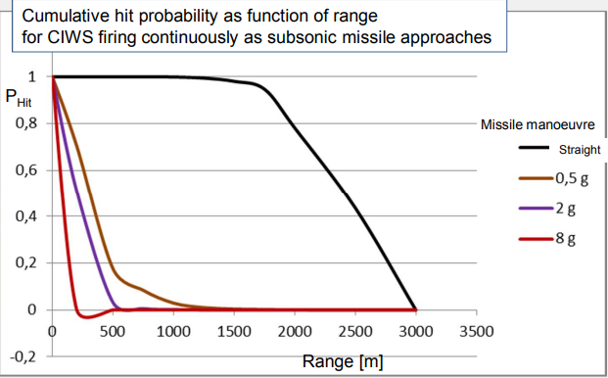
Figure 1 - Cumulative hit probability against range for a manoeuvring threat [2]
- Efficiency
  - A smaller number of rounds will be required to guarantee the destruction of a given threat, meaning more threats can be destroyed with a single magazine. Reloads take approximately 5 minutes with a crew of two. A widely-accepted method of defeating a CIWS system is to swarm it with enough attacks that it fires all of its ammunition – at which point a more complex attack can be orchestrated while the system is reloaded, and a portion of the ship is defenceless.
- Barrel life
  - Barrel life is in the order of low tens of thousands of rounds. Barrel replacement is costly.
  - Also ensures lower live training cost
- Reduced munitions cost per kill
  - Also ensures lower live training cost

Control Theory

3.1 Basics
All systems must have a method of control. There are three main types [3]:
- Open loop control
  - Analogous to a garden hose – the tap can be used to regulate flow rate, but there is no method of automatic regulation.
- On-off (“bang-bang”) control
  - The most basic form of closed-loop control, a good example being the household thermostat. The user picks a “setpoint”. If the system measured value is below the setpoint, it switches on; if the measured value is above it switches off. There is no intermediate stage and no ability to finely vary the output. While an effective method of control in situations where precision is not required, it can cause problems with inrush current in an industrial setting.
- Proportional control
  - A “continuous” control method, which allows for more refined performance compared to the on-off control, at the cost of a more complex program. The PID (proportional, integral, derivative) controller is used to achieve this, in conjunction with a sensor.
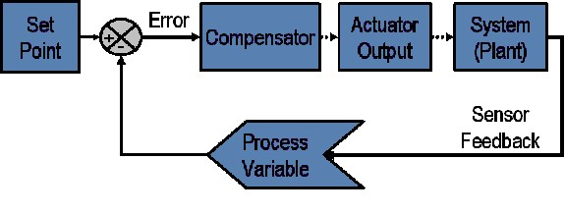
Figure 2 - Block diagram of closed-loop system with feedback loop [4]

3.2 The PID controller
A sensor measures an output variable that requires controlling. It sends a signal corresponding to the measured value. This is measured by the controller, and compared to a setpoint value. The output signal of this comparison is known as the error signal.
Proportional: The proportional response depends on the delta between the variable and the setpoint. The proportional gain determines ratio of output response to a given error signal. Too small and it will not bring the process under control adequately, too large and it will cause uncontrollable oscillations as the system overshoots its setpoint value.
P: If you’re not where you want to be, get there
Integral: The integral portion adds up the error over time – thus even a small error will cause the integral component to increase, unless the error is zero.
I: If you haven’t been where you want to be for a long time, get there quicker
Derivative: The derivative response is proportionate to the rate of change of the process variable – if the process variable is increasing rapidly, the output will decrease. This is useful for bringing a process under control, however it’s very sensitive to noise in the sensor signal.
D: If you’re getting close to where you want to be, slow down
The P, I, and D parameters are varied to achieve an ideal response – the ideal values will depend on the system [4] [5].

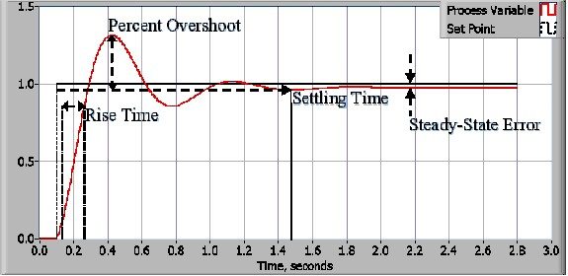
Figure 3 - Response of a closed-loop system [4]

3.3 Feedback
Feedback is a key concept within the closed-loop system. It exists in two forms, positive and negative [6]:
- Positive feedback
  - The output signal is in phase with the applied input, and fed back to the reference input – essentially adding the signals. Gain is high.
- Negative feedback
  - The output signal is out of phase with the input is fed back into the input, essentially subtracting the signals. Gain is low.

3.4 Accuracy, Stability, and Precision
A system must have a reasonable degree of accuracy, stability, and precision to work effectively – each is important [7]
- Accuracy
  - The difference between the measured value and the true value.
- Stability
  - The ability of system characteristics to remain stable over time – values and measurements should not drift.
- Precision
  - The ability of the system to repeat a measurement and get the same result each time.
The difference between accuracy and precision is more easily visualised in the below figure:
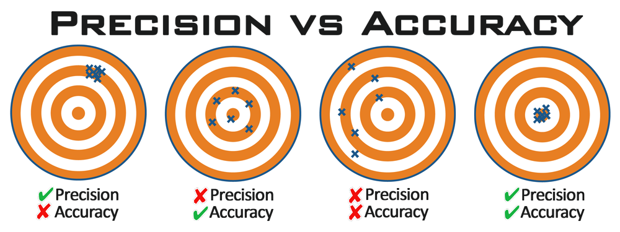
Figure 4 - Accuracy versus precision [8]

3.5 Control systems in context
A straightforward example of the proportional control systems used in a basic ship-mounted CIWS when engaging a target drone in flight is given below:
The CIWS radar detects and recognises the target drone as a threat. The speed and bearing of the threat is now known, as is the speed of the ship and its angle of list. The basic aeroballistic data pertaining to the 20mm round (muzzle velocity, flight time, trajectory, etc) is known – thus a basic firing solution can be calculated at that given point in time. The system now knows where it needs to lay itself in both azimuth and elevation to ensure the rounds fired hit the target - this is the setpoint. The controller compares the current azimuth and elevation to the values just computed, required for effective fire. An error signal is generated, which is fed into the controller. The controller outputs a signal to the stepper motors which drive the CIWS. The unit moves in both azimuth and elevation towards the calculated setpoint and the error signal approaches zero – however, as the threat is in motion, and a new firing solution is being calculated continuously – the setpoint is changing continuously. This leads to the CIWS system effectively tracking and following the motion of the target, while maintaining the appropriate lead and elevation for the rounds to impact the target, as the error signal – while changing – never fully approaches zero. A burst is fired towards the target, but misses – the outgoing rounds have been tracked by the fire control radar. The radar measures the difference in the trajectory of the rounds versus where they “should” have been (this delta can be caused by a number of factors, both environmental and mechanical – in cold climates muzzle velocities will be lower, in hotter environments the velocities will be higher due to propellant performance characteristics and air density, wind, barrel heating/barrel wear, etc etc.). This is fed into the fire control computer and the “setpoint” recalculated again – meaning the error signal is re-evaluated and the turret is driven to a new fire solution. The CIWS fires another burst, and the target is struck – it crashes and disappears from the radar screen. The unit returns to the ready state to await another threat.
Properly tuned PID values are key to a high-performing CIWS. If settling time is too high, then the CIWS may not acquire the threat in time and the drive motors may fail to keep up with the output of the fire control computer, meaning the threat is not correctly tracked. If the overshoot is too high, the fire would be inaccurate.

Simulation

4.1 Background
The goal of the exercise undertaken in this report is to design a system that will bring a process under control in less than two seconds, with an overshoot less than 5%. While a much higher-performing system would be required for a CIWS, this work offers a starting point. A tool called Simulink (within the MATLAB family) was used to undertake this task. The system will use the following basic transfer function initially:
$$G\left(s\right)=\frac{1}{7s^{2}+7s+3}$$

4.2 Limitations
The traditional limitations of computer-aided engineering apply to this task – namely, the ability of the operator to effectively use the chosen software package and the ability to validate results independently of the model.
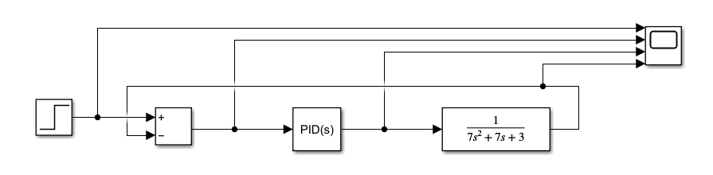
Figure 5 – Basic simulink system diagram
four variations of the above system were simulated.
- 1. PID values set to 1, 1, 0, 1 (P, I, D, N) with transfer function as shown in fig. 5
- 2. PID values tuned to achieve a settling time and overshoot within the prescribed limits, with transfer function as shown in fig. 5
- 3. PID values set to 1, 1, 0, 1 (P, I, D, N) with the closed loop transfer function of the system as a whole (Equation 1) – then PID re-tuned to match the previous settling time & overshoot (minimal alterations)
- 4. No PID controller, using the closed loop transfer function of the system as a whole (figure 10)

The yellow trace, at the bottom of each oscilloscope screenshot, will be the focus of the comparison.

4.3 Results
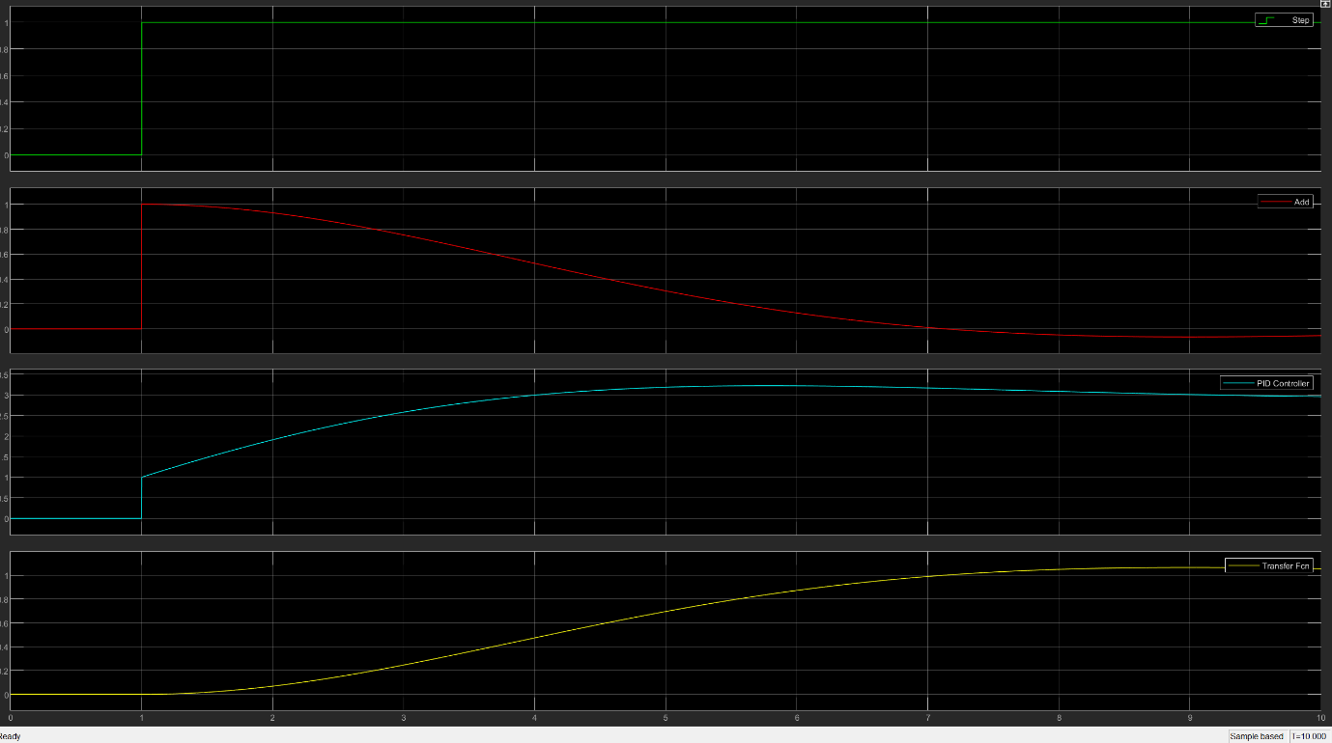
Figure 6 - Un-tuned response
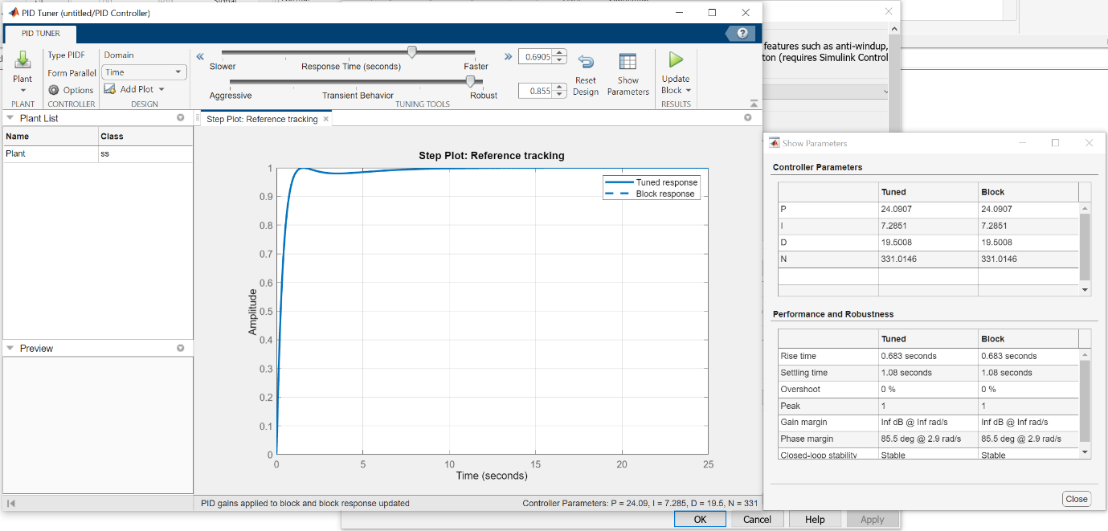
Figure 7 - Tuned PID parameters, demonstrating a 1.08s settling time with 0% overshoot

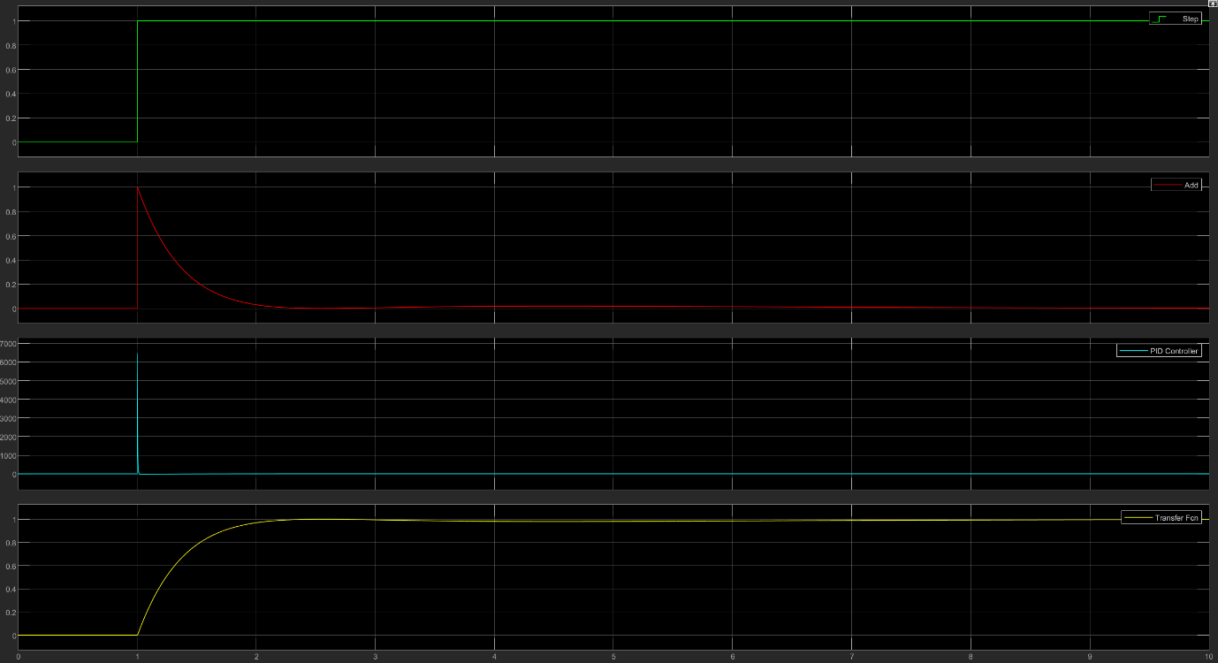
Figure 8 - Scope trace post initial PID tune
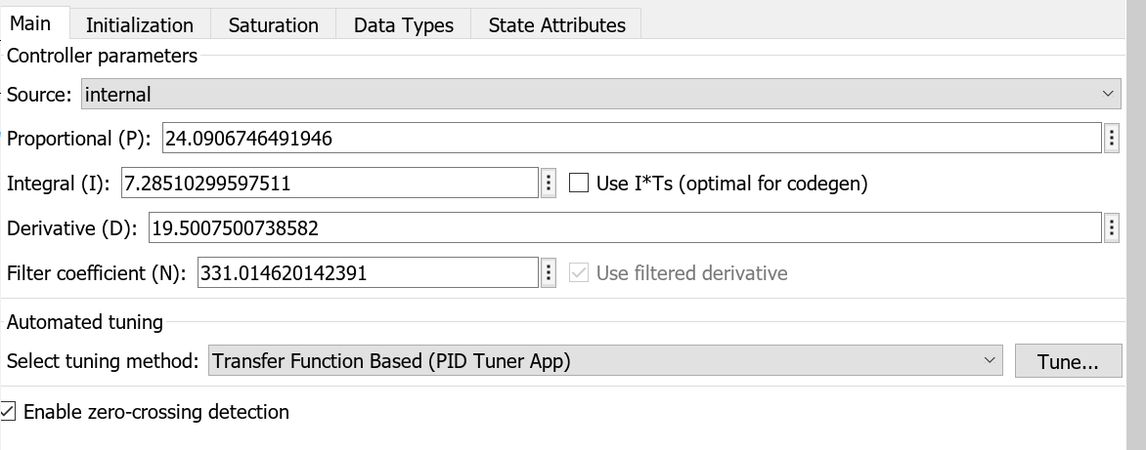
Figure 9 - PID values post-tuning
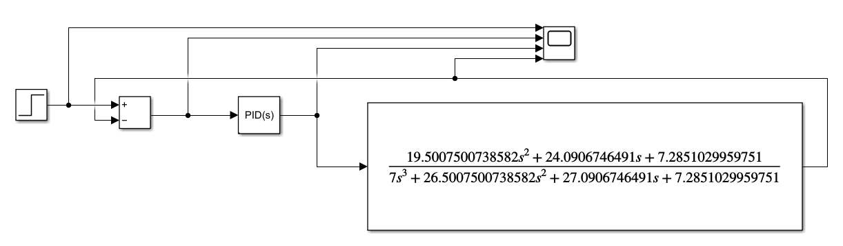
Figure 10 - Complete closed-loop transfer function in Simulink
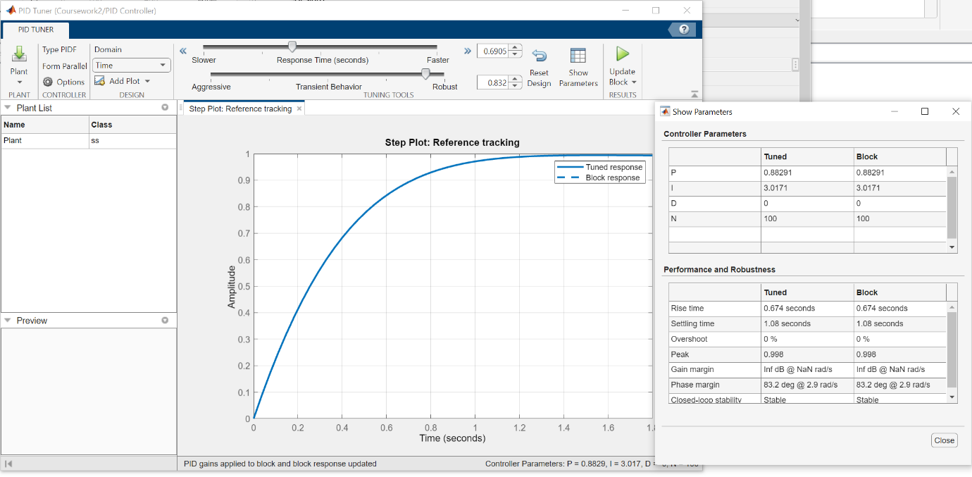
Figure 11 - PID tune menu, values re-matched, minimal alteration
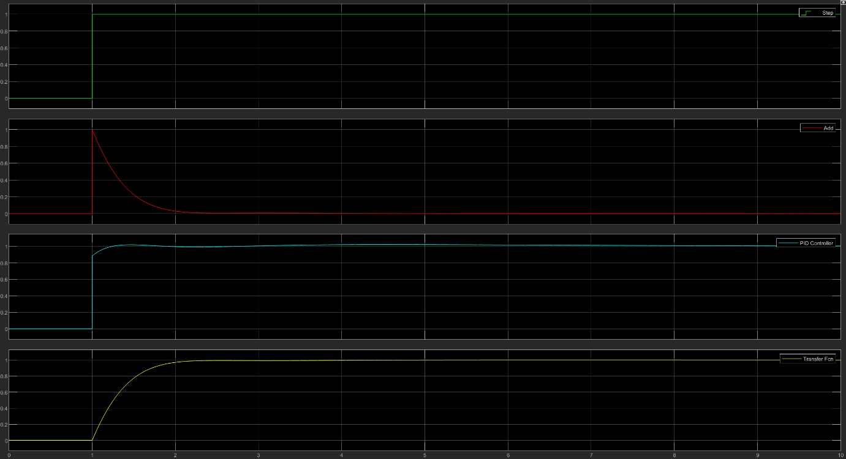
Figure 12 - Scope traces from figures 9 & 10
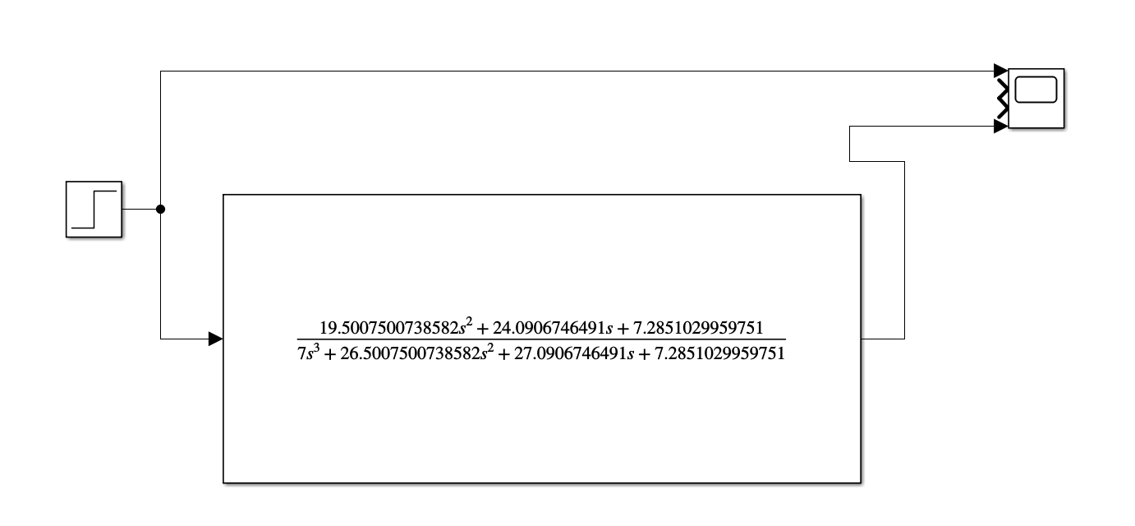
Figure 13 – Closed loop transfer function, no PID controller
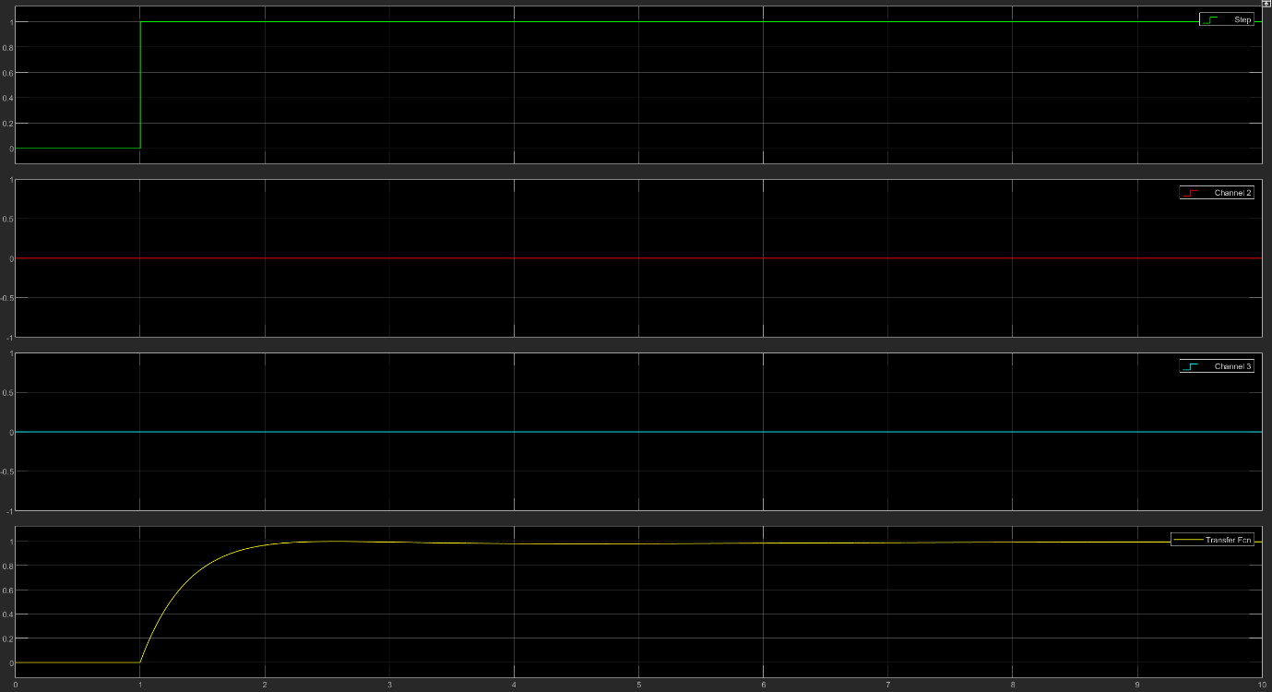
Figure 14 - Scope traces from figure 11 transfer function

4.4 Discussion

Figure 7 – the untuned response shows a very long settling time.
Figure 8 – PID controller tuned, demonstrating a 0% overshoot and settling time of 1.08s (thus meeting the requirement).
Figure 9 – trace following initial PID tune, representing the baseline for comparison.
Figures 9 & 10 - The values were taken from the above figure and used to calculate the closed-loop transfer function of the system as a whole. Most of the workings have been omitted for brevity, though the output is per equation 1.
Equation 1: $G\left(s\right)\frac{19.5007500738582s^{2}+24.0906746491+7.2851029959751}{7s^{3}+{26.5007500738582}^{2}+27.0906746491+7.2851029959751}$

The above closed-loop transfer function was transposed into Simulink, and the PID/filter values were reset to 1, 1, 0, 1 respectively.
Figure 11 – PID values re-tuned to match original overshoot and settling time. Only minor changes (circa. 0.02) of the “transient behaviour” parameter was required to get the settling time to match exactly – this is not unexpected.
Figure 12 scope trace is an exact match to that in figure 8.
Figure 13 – the PID controller was removed from the system, and the whole closed-loop transfer function applied in its place.
Figure 14 – the scope trace resulting from the simulation in figure 13, which is also a match to the traces in figures 8 and 12.

Conclusion
The study shown in section 4 demonstrates PID tuning, and that the PID values can be used to find the closed-loop transfer function of the entire system, which can then be used to replace the PID - controller with identical results, as the signal generated is identical. This is useful as it allows the user to validate the components within the system.

Future work
It would be of much interest to recreate this circuit on a physical board with a servo and potentiometer to control it – this would provide a useful visual aide to help with any future PID tuning work.

Bibliography

[1] | Intergalactic, “PHALANX CIWS: THE NAVY’S AUTOMATED, RADAR-GUIDED 20MM GATLING GUN FOR SHIP DEFENSE (AND MORE!),” [Online]. Available: https://ig.space/commslink/phalanx-ciws-everything-you-need-to-know-about-the-gatlin-gun-navy-ship-defense.
[2] | E. Berglund, “Cooperative engagement capability Anti-ship missiles,” 2015.
[3] | N. Charaig, “PID Controller - Definition and explanations,” 2020. [Online]. Available: https://www.power-and-beyond.com/pid-controller-definition-and-explanations-a-a69cf75cceed7b82932c0793458f58c9/.
[4] | National Instruments, “The PID Controller & Theory Explained,” 2023. [Online].
[5] | H. 4. Electronics, “PID Demo,” 2016.
[6] | Circuit Globe, “Difference Between Positive and Negative Feedback,” [Online].
[7] | Apogee Instruments, “Uniformity, Repeatability, Stability, and Accuracy,” [Online].
[8] | C. Zant, “Precision Rifle Blog,” 2015. [Online].

