


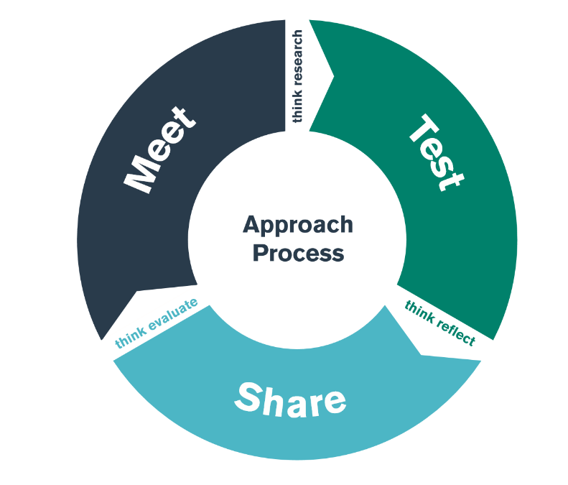

Bridging BA Ed Yr 2

Module ECAD5008
Leading the learning: what, how and why am I teaching?

Student-Teacher Enquiry Evidence Record

MEET day – 15th Nov 2023
TEST days 16th-28th Nov 2023
SHARE day – 29th Nov 2023

Student-Teacher Enquiry Evidence Record

11th -25th November 2020

What is the purpose of this bridging activity?

MEET phase. (UNIVERSITY)

During the MEET day you will develop an understanding of the four broad dimensions of ‘Great Teaching’:

- ​Effective teachers understand the content they are teaching and how it is learnt.
- Effective teachers create a supportive environment for learning.
- Effective teachers manage the classroom to maximise the opportunity to learn. ​
- Effective teachers present content, activities and interactions that activate their students’ thinking​.

The MEET day will also enable you to identify and critically reflect upon specific Assessment for Learning strategies that you will trial during the TEST phase:

- Sharing criteria with others​
- Quality of questioning / Quality of talk​
- Quality and use of Feedback​
- Peer and self-assessment ​

TEST phase (PTE NETWORK SCHOOL)

During the TEST phase you will be expected to trial, reflect and develop your use of identified AfL strategies in a range of contexts. You should aim to trial at least one strategy for each element of Assessment for Learning listed below:

- Sharing criteria with others
- Quality of questioning / Quality of talk
- Quality and use of Feedback
- Peer and self-assesssment

SHARE phase (LEAD NETWORK SCHOOL or ONLINE)

In the SHARE phase you will be expected to report on two of the AfL strategies which you trialled during the TEST phase. This will provide evidence for related teaching standards within your PLP.

You will need to prepare a 5-10 minute presentation in the form of a video, photographs or a live presentation (e.g. by demonstrating the strategy with your student-teacher peers) to illustrate your findings from the TEST phase in your placement school. Remember to include a degree of criticality by making links to any research, reading, or theory you have encountered. Use WWW/EBI to peer assess your experience.

Points to consider:

- This presentation is a critical reflection of the different AfL strategies trialled in your placement school. Whilst an element of criticality is expected in your work, i.e. references to literature/research/theory/, there should be no criticism or judgements on your placement school’s provision made in your work.​

- Keep all pupils, staff and other stakeholders anonymous throughout.​

- If more than one of you are at the same placement school ensure that you address different strategies, where possible.​

- Your peers will be ready to ask questions about your presentation. This will allow useful feedback from peers, school staff and university tutors.

Reading

Essential linked reading:
Black, P., Wiliam, D. (1998) Inside the black box : raising standards through classroom assessment, London: nferNelson.
Coe, R. Rouch, C.J., Kime, S., Singleton, D. (2020)
Donaldson G. (2018) Successful futures: a summary https://gov.wales/sites/default/files/publications/2018-03/succesful-futures-a-summary-of-professor-graham-donaldsons-report.pdf
Great Teaching Toolkit: Evidence Review Evidence Based Education: available here
Hattie, J., 2012. Visible learning for teachers : maximizing impact on learning, London ; New York: Routledge.
Rosenshein B. (2010) Principles of Instruction http://www.ibe.unesco.org/fileadmin/user_upload/Publications/Educational_Practices/EdPractices_21.pdf
Rosenshein B. (2012) Principles of Instruction https://www.teachertoolkit.co.uk/wp-content/uploads/2018/10/Principles-of-Insruction-Rosenshine.pdf
Wales Government. (2010) How to develop thinking and assessment for learning https://hwb.gov.wales/curriculum-for-wales-2008/assessment/how-to-develop-thinking-and-assessment-for-learning-in-the-classroom

Using your studies from ECAD5008.

During the delivery of ECAD5008 you will have already have had subject specific input based on theoretical content. Please apply the work covered with your university tutors to this TEST phase. Prior to Bridging, university-based teaching will have provided the following:

- Focused input on relevant AoLEs, identifying specific aspects of content, skill development, common misconceptions and effective teaching approaches to achieve planned learning outcomes
- An overview of the types of assessment (summative and formative) and the potential benefits and problematic aspects of each
- An introduction to the background, research, evidence and theories underpinning the use of Assessment for Learning within the teaching and learning cycle.
- Practical examples of the four elements of Assessment for Learning
- Sharing criteria with others
- Quality of questioning / Quality of talk
- Quality and use of Feedback
- Peer and self-assesssment

Looking beyond Bridging 2 –

How does the bridging activity support professional development?

Student-teachers are asked to gather evidence for the required elements of their Professional Learning Passport. This could include a reflection of their testing of a variety of Assessment for Learning principles in practice. Students are required to reflect on their progress, and are asked to identify and justify areas for development.

With this in mind, the bridging experience will connect student-teachers with the theory relating to the evidence base for the ‘Great Teaching Toolkit’ and provide opportunities for students to observe, explore and discover the practical strategies, policies and approaches employed by schools inline with this. Overall, the bridging will provide the student with the knowledge, experience and evidence from which they may draw to support the pedagogical decisions for effective teaching and learning.

The professional standards listed below are there as a reminder and a prompt, for reflection during and beyond this Bridging phase.

OBSERVATION NOTES

Make notes on the four broad dimensions of ‘Great Teaching’ observed in your school.

Effective teachers understand the content they are teaching and how it is learnt.

Effective teachers create a supportive environment for learning.

Effective teachers manage the classroom to maximise the opportunity to learn. ​

Effective teachers present content, activities and interactions that activate their students’ thinking​.

Make notes on the examples of the Assessment for Learning strategies you are introduced to.
What makes them effective?
Are there any limitations/barriers to the strategies?

Sharing criteria with others​

Quality of questioning / Quality of talk​

Quality and use of feedback​

Peer and self-assessment ​

PERSONAL TARGET

As a result of what you have learnt/reflected upon during the meet, test and share days of this bridge, please set yourself a target to improve your own practice.

TARGET

What area do you want to develop in your own practice?
TIMESCALE

When do you want to achieve this by?
RESOURCES

What do you need to help you achieve this? Who do you need to talk to/observe? What do you need to research?
SUCCESS CRITERIA/
OUTCOME

How will you judge whether it has been successful or not? What impact do you hope to see in teaching and learning?
MONITORING/
EVALUATION

How will you check that you have successfully achieved your target? Lesson observation? Book scrutiny? Pupil voice?

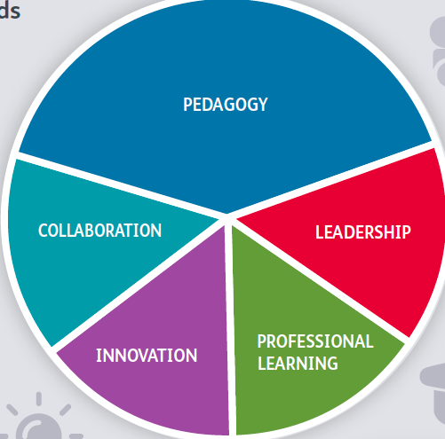
PLP AND LINKS TO PROFESSIONAL STANDARDS

Your bridging experience will support your development of the Professional Teaching Standards. Consider how you might use the experience to create an Experience Template for Tab 7 (standards).
You will not necessarily hit all the standards in any one bridging experience.
Remember that you can only link a maximum of five of the sub-headings within each standard to an Experience Template.
The assignment linked to this bridging experience can be used as an asset for your PLP.

PEDAGOGY
During your test period did you use assessment for learning with the following outcomes?
Refining:
Managing the learning environment
Assessment
Differentiation
Recording and reporting
Involving partners in learning.
Advancing:
Four purposes for learners
Exploiting subject disciplines in areas of learning
Blended learning experiences
Real life, authentic contexts
Progression in learning
Cross curricular themes
Influencing learners:
Challenge and expectations
Listening to learners
Learners leading learning
Sustained effort and resilience in learners
Reflection on learning
Learning outcomes and well being.
COLLABORATION
Were there opportunities to work productively with all partners in learning in order to extend professional effectiveness?
INNOVATION
Did you employ an innovative outlook which is exemplified through the controlled and measured development of techniques and approaches to improve pedagogic outcomes?

PROFESSIONAL LEARNING
Were there opportunities to extend knowledge, skills and understanding and can show how reflection and openness to challenge and support informs professional learning to progressively develop pedagogy.

LEADERSHIP
Were there opportunities to support the efforts of others across the school and beyond to fulfil the educational ambitions for Wales?

BRIDGING – CHECKLIST

 | What to do? | When? | Notes | Done
1 | Test AfL strategies in your placement classes.  Make ongoing notes on the four broad dimensions of ‘Great Teaching’ observed in your school. | Between 16th- 28th Nov 2023 | Discuss with your class mentor in your placement school at the start of PTE placement to ensure they are aware of the TEST expectations.
2 | Prepare a presentation on 2 trialled AfL strategies to share with the Network Lead, Curriculum tutor and peers on the SHARE day.  Complete notes on the four broad dimensions of ‘Great Teaching’ observed in your school ready for discussion. | 29th Nov 2023 | Ensure that there is no criticism or judgements on your placement school’s provision in any aspect of your work.  Keep all pupils, staff and other stakeholders anonymous throughout.​
3 | Complete you personal target in the STEER booklet. | 1st Dec 2023 | Share with your class mentor in your placement school to ensure that the focus of the Bridging is linked to targets in your “Learning Journal”.
4 | Complete “PLP and Links to Professional Standards” section of STEER booklet. | 1st Dec 2023 | Link to pedagogy but you may have evidence for other standards.

