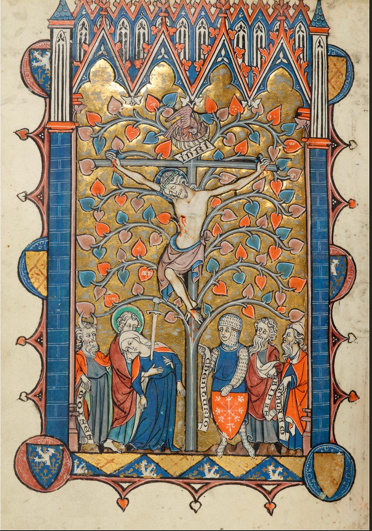
Medieval world
Assignment 2

The enigmatic figure with horns is likely a representation of a demon or a symbol of evil, juxtaposed against the divine suffering of Jesus. The blue-clad woman, likely Mary, signifies and exemplifies the profound grief and compassion of a mother witnessing her son's agonizing sacrifice. Her presence amplifies the emotional weight of the scene, evoking empathy from those who contemplate the artwork.

“This depicts Mary with one or several swords in her breast or heart, symbols of the sorrow she endured upon witnessing her Son’s crucifixion. She is usually dressed in a red gown and blue mantle with hands folded in prayer.” (‘Mater Dolorosa - Mother of Sorrows’)

The figures surrounding the crucifixion create a powerful display of human emotions ranging from sorrow to awe. The artist's meticulous attention to detail, from the wounds on Jesus' body to the expressions on the faces of the onlookers, conveys a visceral sense of the intensity and gravity of this pivotal moment in Christianity.

“A single sword is sometimes added going through her heart, referring to the passage of Luke (“a sword shall pierce…”) and brings to mind the sorrows she endured during her lifetime, especially during the crucifixion.”
(pakosloski)

The frame that encases this image is a masterful work of art in of itself, a testament to the craftsmanship of its creator and the skill of medieval calligraphers, as well as an indication of the value of such an object. Intricately detailed, it weaves together vibrant shades of red and blue, creating a mesmerizing tapestry. At its head, the frame morphs into the shape of a cathedral roof, a deliberate homage to the sanctity of the scene it encompasses.

“Christ: Crucifixion -- Christ, cross-nimbed, wears a crown of thorns on His inclined head and long loin cloth. He bleeds from His wounds. He is affixed with three nails to the Tree of Life with a titulus inscribed INRI. On top of the tree is a pelican in her piety. Flanking the tree are the horned Moses with a scroll with his name inscribed MOISES, Evangelist John, nimbed, supporting the veiled Virgin Mary whose breast is pierced by a sword, Longinus of Jerusalem in chain mail, holding a shield, Caiaphas, and Balaam wearing a pointed cap, the last three holding scrolls with their names inscribed CHENTURIO, KAIPAS, and BALAAM.
The scene is within a Gothic architectural frame decorated with cusps of foliate terminals, six French heraldic shields, including Moreuil (three), in medallions, and heraldic devices, including Moreuil.” (The Morgan Library and Museum)

The cross upon which Jesus is crucified is part of a silvery tree The tree stands tall, its branches reaching towards the heavens. Below, a bed of wildflowers blooms, red and blue.
Above the crucifix, a delicate nest cradles a family of birds, their presence offering a poignant counterbalance to the weighty gravity of the scene below. The mother bird, wings outstretched in a protective embrace, tends to her brood with unwavering care, even amidst the backdrop of suffering.

Six crested shields adorn the frame, each bearing its own emblem. These symbols, likely representing revered saints or noble families, speak to the esteemed lineage and history associated with this artefact. The prominence of the colour blue hints at a potential French origin, evoking parallels to the iconic Fleur de Lys, an emblem synonymous with French royalty and nobility.

“fleur-de-lis, (French: “lily flower”) , also spelled fleur-de-lys, also called flower-de-luce, stylized emblem or device much used in ornamentation and, particularly, in heraldry, long associated with the French crown. One legend identifies it as the lily given at his baptism to Clovis, king of the Franks (466–511), by the Virgin Mary. The lily was said to have sprung from the tears shed by Eve as she left Eden. From antiquity it has been the symbol of purity and was readily adopted by the Roman Catholic church to associate the sanctity of Mary with events of special significance. Thus, when Pope Leo III in 800 crowned Charlemagne as emperor, he is reported to have presented him with a blue banner covered (semé) with golden fleurs-de-lis.” (The Editors of Encyclopedia Britannica, ‘Fleur-de-Lis’)

Upon closer examination, it becomes evident that this book of hours, or possibly a sacred bible, transcends its role as a mere vessel for prayer. Its pages, beautifully adorned with delicate tracings of gold leaf, stand as a tangible testament to the social importance of its owner. In an era where such treasures were scarce and the word of God was absolute, the possession of such a book served as a resounding affirmation of one's standing and influence within the community, a tangible marker of their elevated stature.

“book of Hours, devotional book widely popular in the later Middle Ages. The Book of hours began to appear in the 13th century, containing prayers to be said at the canonical hoursin honour of the Virgin Mary. The growing demand for smaller such books for family and individual use created a prayerbook style enormously popular among the wealthy. The demand for the books was crucial to the development of Gothic illumination. These lavishly decorated texts, of small dimensions, varied in content according to their patrons’ desires.” (The Editors of Encyclopedia Britannica)

Works Cited
(‘Mater Dolorosa - Mother of Sorrows’)
‘Mater Dolorosa - Mother of Sorrows’. Trinitystores, https://trinitystores.com/collections/mater-dolorosa-mother-of-sorrows-aosdd. Accessed 5 Nov. 2023.
(pakosloski)
pakosloski. ‘The Symbolism behind Mary’s Immaculate Heart’. Aleteia, 24 June 2017, https://aleteia.org/2017/06/24/the-symbolism-behind-marys-immaculate-heart/.
(The Editors of Encyclopedia Britannica, ‘Book of Hours’)
The Editors of Encyclopedia Britannica. ‘Book of Hours’. Encyclopedia Britannica, 30 Nov. 2017.
(The Editors of Encyclopedia Britannica, ‘Fleur-de-Lis’)
---. ‘Fleur-de-Lis’. Encyclopedia Britannica, 31 Aug. 2022.
(The Morgan Library and Museum)
The Morgan Library, and Museum. ‘Psalter-Hours, MS M.729 Fol. 345v - Images from Medieval and Renaissance Manuscripts - the Morgan Library & Museum’. Themorgan.org, http://ica.themorgan.org/manuscript/page/110/128492. Accessed 5 Nov. 2023.

