Tom Clement
PCET
ECPT6006
Digital Innovation and Professional Practice



MODULE CODE: ECPT6006

ASSESSMENT COMPONENT: Digital Innovation and Professional Practice

STUDENT NAME: Tom Clement

STUDENT NUMBER: 2106402

Use of Generative AI in Assessment

(Lecturer to indicate Yes or No against each element)

RESEARCH | For this assessment, you can use Generative AI to support you in research, including searching for bibliography, using tools to summarise, compare and interrogate materials. | Yes ☒  No ☐
STRUCTURE | For this assessment, you can use Generative AI to support you in structuring your submission, including creating a draft argument structure, identifying parts and headings, etc. | Yes ☒  No ☐
PROOFREADING | For this assessment, you can use Generative AI to check your own text/creation for grammatical and syntactical mistakes, including rephrasing of your own work within specific standards. | Yes ☒  No ☐
WRITING | For this assessment, you can use Generative AI to create text for submission. | Yes ☐  No ☒
CREATIVE | For this assessment, you can use Generative AI to create creative materials, such as images. | Yes ☐  No ☒
PROGRAMING | For this assessment, you can use Generative AI to create and check code. | Yes ☐  No ☒
NONE | For this assessment, you are not allowed to use any type of Generative AI support. This includes research support, structure support, writing/proofreading support and creative support. | Yes ☐  No ☒

AI Acknowledgement
I confirm that I have not used any AI tools in the research and creation of this assignment.
I confirm that I have not presented any AI generated materials as my own work.
I confirm that I have copies of my drafts, notes, and other resources I used, which I may be asked to provide in evidence.

Introduction

To develop a stronger comprehension of how I may use digitally innovative tools to enhance my teaching practice, I will discuss, identify and critically evaluate the application of modern digital tools and their role within the post compulsory classroom.
Analysing how digitally innovative tools may enhance learning environments, student learning, and supporting practitioners approaches and strategies to provide the best service, delivery and experience to students.
To enforce and justify this discussion, I will refer to legislation, industry examples, government missions, teaching strategies and professional practice where appropriate. I will apply Bloom’s Taxonomy of Action Verbs, (1956). To effectively identify and explain points discussed throughout.

I will also utilise the application of a modern digital tool within my practice, to demonstrate, discuss and evaluate its uses, application, and the effects it may have on my profession practice, pedagogical approach, and how it may enhance students’ learning experiences, while supporting well-being in the moder era.
By adopting digital resources within appropriate learning environments, I aim to enhance my practice improving, and assisting my communication, and delivery of information more efficiently to students. While recognising the creative uses digital tools may have in assisting me to create lesson plans, and content in my professional practice. References to Welsh Government (2017). “Professional Standards for Teaching and Leadership” will be used to justify my findings.

An action plan regarding the future uses of digital tools within my pedagogy will be included, in accompaniment to my lesson plan using a technologically based framework to explore, apply and analyse the uses of a digital tool within the classroom, based around my specialist area of Creative Music Technology (CMT).
I will reflect on the use of digital tools, their place within my practice, my current thoughts regarding the use of innovative technologies, and their inclusion within the educational ecosystem.

The role of creativity and Digital Innovation

The use of technology within teaching and learning environments is becoming more synonymous as time goes by. As stated by St Martin’s School Northwood, (2024). “With advances in technology, schools are gaining unprecedented access to digital learning tools, enhancing educational experiences and outcomes.” This is easily observed across modern educational environments, which now appear to have technology integrated into almost every sector and stage of teaching. From the use of interactive whiteboards (IWBs) displaying information during lectures, to online educational quiz tools such as ‘Kahoot!’ enhancing formative and summative assessment of students’ knowledge.

Practitioners now need to understand, identify and accept how to make use of available digital tools, as well as when to use them appropriately within their respected learning environments, upholding the Welsh Government (2017). “Professional Standards for Teaching and Leadership” in “Maintaining an update knowledge of my subject(s) and how best to teach and assess them.”
Through this action, practitioners may greatly complement their pedagogical approaches with the enhancement of digital innovation, identifying what digital tools are available, as well as when and where they are appropriately applied.

Digital hardware such as IWBs, have developed a core component into classrooms within the UK, in support of this, the Department for Education (DFE), (2023), “estimates suggesting that over 90% of classrooms have them.”
This innovation has as enabled teachers to display prepared documents or web-based information, graphics, interactive programmes and videos throughout the lesson. Enabling teachers to communicate information at a faster speed than more traditional approaches, upholding the professional standard to “plan and deliver effective learning, teaching and assessment.”
Notably IWBs can also make learning more accessible by displaying larger text for students who may have Alternative Learning Needs (ALNs) such as sight impairments. Upholding the professional standard to “value and promote diversity, equality of opportunity and inclusion.”

In addition to hardware, software-based programmes such as Canva, Multimeter, VeVox, Padlet or Kahoot! are extremely valuable for practitioners when creating a digital arsenal of web-based tools. These tools can be ustilised to engage and develop students learning, while maintain behaviours through interactive activities, also enabling learners to participate in self-assessment.
The use of these quiz and poll tools aids in retaining attention, allow less confident students to answer questions anonymously, and provide opportunity to work collaboratively creating learning resources such as mind maps or digital posters. This upholds the professional standards of “build positive and collaborative relationships” and “Demonstrating commitment to learners, their learning, safety and well-being.”

Due to these tools being online, teachers can implement their use in creating revision resources or setting home tasks. Another advantage is enabling students with mobility or transport issues, to engage in class activities from home, upholding the UK Equalities Act (2010).

When introducing technology into these environments, it is important to consider students with physical and/ or mental ALNs who may be affected using certain technologies, such as the choice of colour used on a PowerPoint Presentation for colour blind students. However, technologies such as using text to speech (read aloud functions such as “ReadSpeaker”), can provide inclusivity for visually impaired students.

Consideration should also be given to those students who may be technologically excluded. They may not have access to the use of smartphones or laptops. This may be due to financial issues, family issues, or being digitally challenged.
As further evidenced into Wales being a more technologically active environment, as stated by BusinessNewsWales (2020) “One in three (33%) people in Wales lack the ‘essential digital skills’ needed for day-to-day life online”. This was pre-Covid conditions in Wales with the article continuing “almost a third (29%) have boosted digital skills during lockdown”. This study could argue that the pandemic was a key turning point for the inclusion of technology in Welsh education. During this tie educational placements had to learn and adapt online programs such as Microsoft Teams to create digital classrooms.
During the Covid-19 pandemic BBC News (2021) stated that “colleges reported a range of 0-20% of learners lacked access to devices.” This may be a low number of students in post-compulsory education, but it is still a potential factor to consider. Educators need to be aware of what support they can offer in class and know where to signpost students to relevant support networks.

As educational practitioners, we must continuously ask ourselves if digital tools are necessary additions to our pedagogy, identifying which tools enhance and which stagnate and hinder students learning, upholding the professional standard to “maintain and update knowledge of my subject(s) and how best to teach and assess them.”

Being an educational practitioner in Wales it is arguably the most crucial time to adopt digital innovation into our pedagogy, as it falls in line with the Welsh Governments “digital strategy” for a 2030. The goal of the framework is to improve the lives of people in Wales via the use of technology, with much of the focus being to improve quality and security of the use of technology in the public service sector. Welsh Government aims for “the whole public sector to work together”, and as educational practitioners in the public sector, it is important that we play our part in keeping up with modern standards.

The 2030 goal responds to the rate of which technology has boomed over the past decades, as digital innovation has grown faster than many members of society can keep up with. The correct implementation of technology within the right areas of education can help us play our part in educating Welsh students with greater effect. And in a technologically driven society, with much information and resources still not yet being realised or used to the best of their potential by many, it is up to us as educators to learn and transfer these skills.

Particularly, since the Covid-19 pandemic a need for a more technologically based practice has become more relevant. We as a people are moving on from more traditional teaching methods within learning spaces, having now adopted a more technological approach in both how learners take in information and how practitioners deliver information. This of course, is not to say that all educational practitioners should throw out their white boards and maker pens just yet, but to educate themselves on how the modern learner takes in information, as well as how the introduction of technology in the classroom can at times assist the practitioner in their methodologies in communicating their knowledge effectively to students.
Reflecting on work by Jones, K and Ravi, S. (2021) regarding “The Digital Transformation of Classroom Lectures to Blended Learning” the Covid-19 Pandemic is cited as a turning point in education, with educational attendance pre-pandemic becoming a rising issue. However, post-pandemic education has been forced to adopt the use of technology and online classes, along with this “blended” option of face-to-face classes in tandem with online options for attendance, higher education attendance levels may start to rise again as well as give students more options to access class learning.

Looking to the future, as technology develops and society learns how to implement it further into education, technology such as Virtual Reality (VR), Augmented Reality (AR), and immersive learning environments such as ‘Igloo Suites’ pose an interesting development for learning experiences, a potential wealth of possibilities for the future of education. Education will continue to experiment and implement technology, constantly innovating both teachers’ pedagogy and students learning along the way.

Finally, a good practitioner should find a good balance of the use of technology within their pedagogy, not being too reliant on digital tools, but understanding that they have their place now deeply rooted in education.

Selection and Justification of appropriate teaching tool(s)/resources

During the research and selection of my chosen digital tool ‘Vevox.’ I have analysed both theory-based studies, and search engine results relating to digitally innovative tools to apply in my practice.

I aim to demonstrate how my digital tool could be used in my profession practice and its effect on my pedagogical theory.

While searching through the growing options of digital tools available for educational practitioners, I considered my readings on Singh and Hardakers (2014) work “Barriers and enablers to adoption and diffusion of eLearning” which states that “One of the most cited factors hindering the adoption of eLearning is the perceived time required to learn”, this falls much in line with some of Bennett, L (2014) study on “Developing the Digital Practitioner” findings. Which in result made me consider the time in which I must learn and adopt a newly learnt digital tool in my practice effectively within my pedagogical approach in class.

Having researched many digital tools during class, and independently. I have decided to adopt the use of the digital quiz and polling tool ‘VeVox.’ This has a paid and free version, for the sake of this unit I will just be using the free version.

Please find below the overview of ‘VeVox’ used during my practice detailing some of its features and uses:
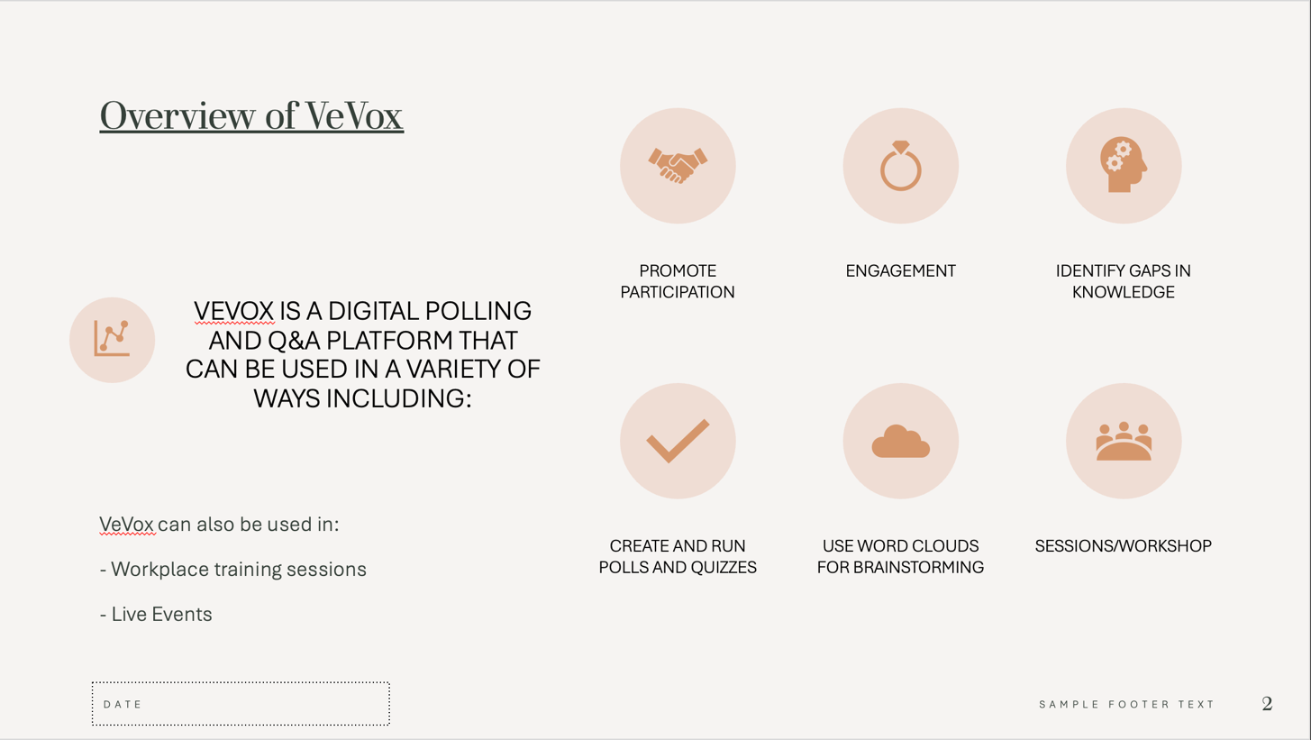
(Fig. 1. VeVox Overview. PowerPoint Slide. Source: Tom Clement)

As both a learner and practitioner, to hone my skills and knowledge of this unit I have researched into the use of the Digital Tool VeVox, applying it practically in a class environment. I will demonstrate and discuss the application of the use of this digital learning tool in practice, testing it in practice to gauge a further consideration and application of how certain digital tools may assist my pedagogy as a practitioner, as well as reform my approach in teaching practice, reaffirming my understanding of this module and my understanding of its principles and meaning.

I aim to create a small lesson plan where I can test out the polling features of VeVox, which I believe will be a great way for me to test students within the music department on multiple subjects related to the units covered on the course. By creating a lesson plan I aim to uphold the professional standard to “Plan and deliver effective learning, teaching and assessment.”

Application of the chosen learning tool(s)

During the development of research into VeVox, I devised a simple lesson plan to evaluate the application of VeVox in my respected learning environment.

The application of this tool was made with the use and consideration of the “active” section of the Technology Integration Matrix (TIM), Framework, (2005), as students would be engaged in using technology rather than passively receiving information through a spoken lecture.

Which of the 5 levels of technology integration am I planning to use?
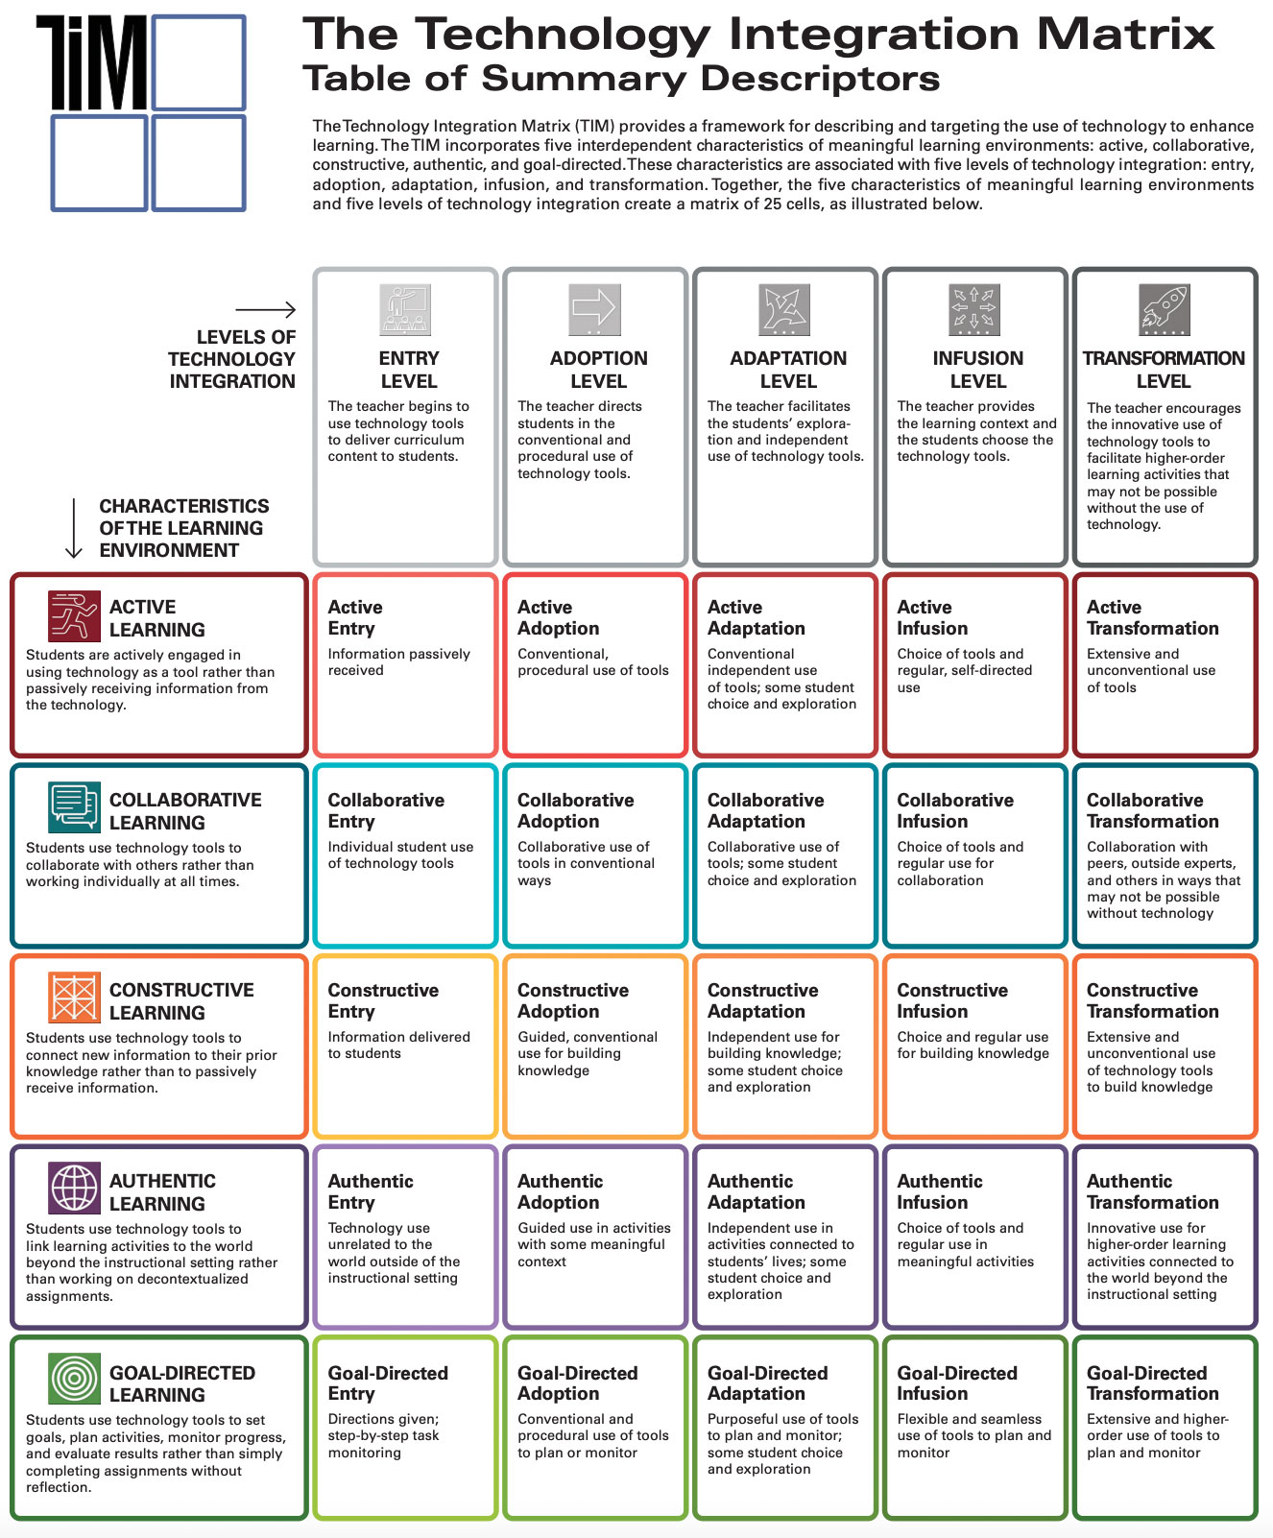
Fig. 2. TIM Matrix (2024). Source: Novatech.unl.ptp.)
- “Entry Level” applying the technology tool to deliver curriculum content to students.
- “Active Entry” Passively providing information to students.
- “Collaborative Entry & Adoption” where students individually vote and collaboratively discuss answers post quiz.
- “Authentic Adoption” guiding students in the use of activities within the context of the cohort of CMT.
- “Goal-Directed Adaption” to plan and monitor student learning and further exploration

Following this framework, I can assess learners’ levels and knowledge to create further learning appropriate for their development ‘demonstrating commitment to learners, their learning, safety and well-being.” While upholding other professional standards such as “value and promote diversity, equality of opportunity and inclusion,” to “maintain and update knowledge of my subject(s) and how best to teach and assess them” and to “plan and deliver effective learning, teaching and assessment”
The collaborative discussion of students results also help to “build positive and collaborative relationships” within the class.

Lesson plan created for the session:



Lesson Plan

Topic: Application of a Digital Tool |  | Class: Level 4 Music Technology
Date: 20/11/2024 | Length of lesson: 30 minutes |  | Number of students: 6-12
Resources required:

- Laptop or PC
- PowerPoint
- Display/Interactive Whiteboard/Projector
- Access to VeVox via internet connection

Aim of Lesson:

To demonstrate the application, functionality and features of VeVox within a Music Technology class environment.

Learning Outcomes – The Learners Should Be Able To:

- Communicate answers clearly
- Identify the uses of VeVox

Previous student knowledge required for the session:

No previous knowledge is required for this session. However, a level 3 knowledge or above would be useful for answering some of the questions featured.

Anticipated difficulties (if applicable):

- Laptop/PC not working
- Whiteboard/Screen not working
- No internet connections
- Software issues

Professional Standards (where are these being met within the session)

“Demonstrating commitment to learners, their learning, safety and well-being”:
Upheld in the response to creating an activity to promote an engaging positive environment, with consideration to use results to expand further teaching sessions.
Consideration of students with ALNs such as Attention-Deficit/Hyperactive Disorder (ADHD), to create an activity better suited for their learning approach, in order to maintain student well-being.

“Value and promote diversity, equality of opportunity and inclusion”:
Displayed in the use of a digital tool that can create more equal learning opportunities for the inclusion of students with ALNs.

“Maintaining an update knowledge of my subject(s) and how best to teach and assess them”:
By applying appropriate and relevant course knowledge through the implementation using a modern digital tool.

“Plan and deliver effective learning, teaching and assessment”:
Via the creation of a lesson plan with consideration of formative assessment for future learning opportunity.

“Enable learners to share responsibility for their own learning and assessment”:
Students can partake in self-assessment of knowledge during this session, as well as have an opportunity to partake in peer-assessment and collaboration through discussion post quiz.

“Critically reflect on my own values, knowledge and skills to improve learning”:
Post session, I will create an action plan to consider how the session may be adapted and what I can and will do to improve this approach in a later session.

Lesson Detail:

Stage | Focus | Strategy | Time
Introduction  Development  Plenary/conclusion | Discussion of VeVox, what it is?  VeVox Poll on Music Technology general questions.  Give thanks and review thoughts on VeVox with class. Encourage students to partake in a peer-review/collaborative discussion post quiz. | Lecture  Activity: Poll/Quiz  Q&A/Discussion | 5 Min  15 Min  10 Min

Assessment Strategies: when and how are they included within the lesson?
Formative assessment – The results from this quiz may give insight to formatively assessing areas of student knowledge, providing opportunity for further development of skills where students answer incorrectly to questions. To be carried out in either a 1:1 support session, or class lectures.

The creation of this lesson plan has enabled me to strengthen my professional practice being prepared for the session to uphold the professional standard to “plan and deliver effective learning, teaching and assessment.” The duration of each stage and focus has been timed in a self-timed rehearsal of the session to keep a consistent time and delivery. By creating this lesson plan I have also developed an approach to which Assessment Strategy was best suited for this session, identifying formative assessment as an appropriate approach where I can provide questioning, and feedback to any questions students may have about the topics covered during the session.

Post session, having critically evaluated and reflected on the application and uses of a digital tool such as VeVox, I have discovered that I can further develop the uses of this tool within my practice, apart from providing an engaging activity for learner, by using the results from this activity I can assess learners knowledge effectively to apply and develop future lesson plans, identifying areas of learning where students may have gotten questions wrong. This will also aid in upholding the professional standard to “Critically reflect on my own values, knowledge and skills to improve learning”

Below please find evidence and results of the VeVox tool carried out in practice in a class of eleven students displaying:

- The main page of VeVox is displayed
- The highlighted AI Feature
- Leaderboard
- The percentage of what participants answers

“Main Poll Page of VeVox” (Displayed below). Here users can easily create, adjust and move questions within their Polls/Quiz: 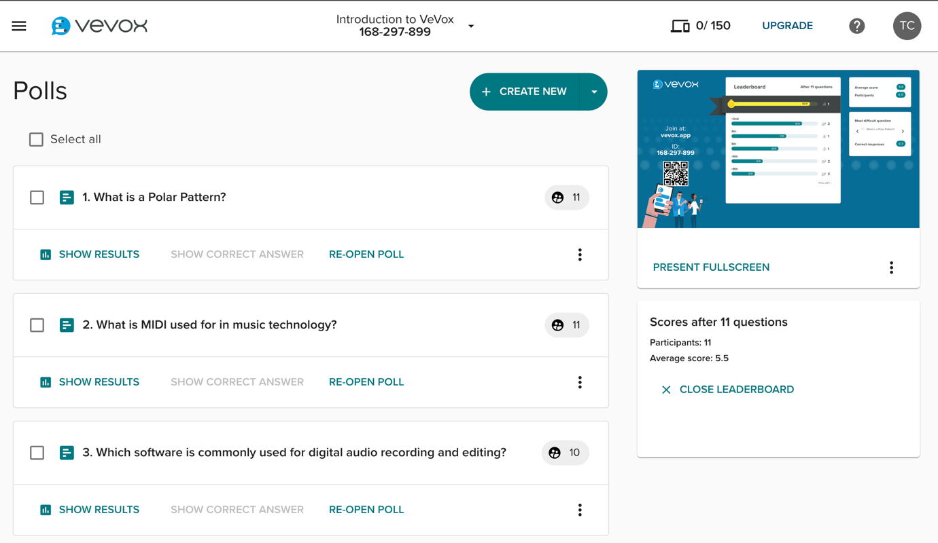
(Fig. 3. VeVox Poll. Screenshot 1. Source: Tom Clement)
“VeVox AI Feature” (Displayed below). Here users can input a promot for the AI to create a Poll/Question: 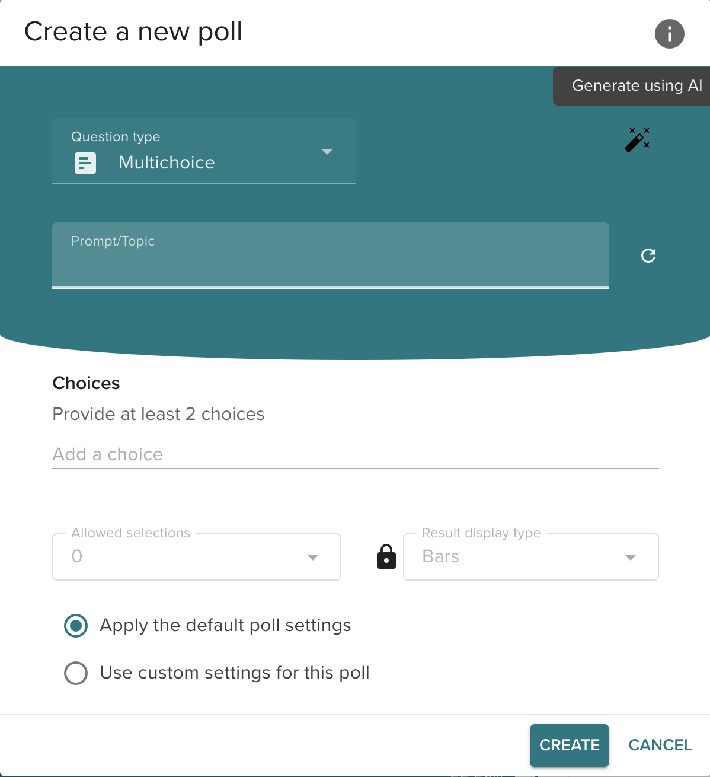
(Fig. 4. VeVox Poll. Screenshot 2. Source: Tom Clement)

“VeVox Leaderboard” (Displayed below). Here participants can see who has answered the most questions correctly as well as connect directly to the session via the generated QR code: 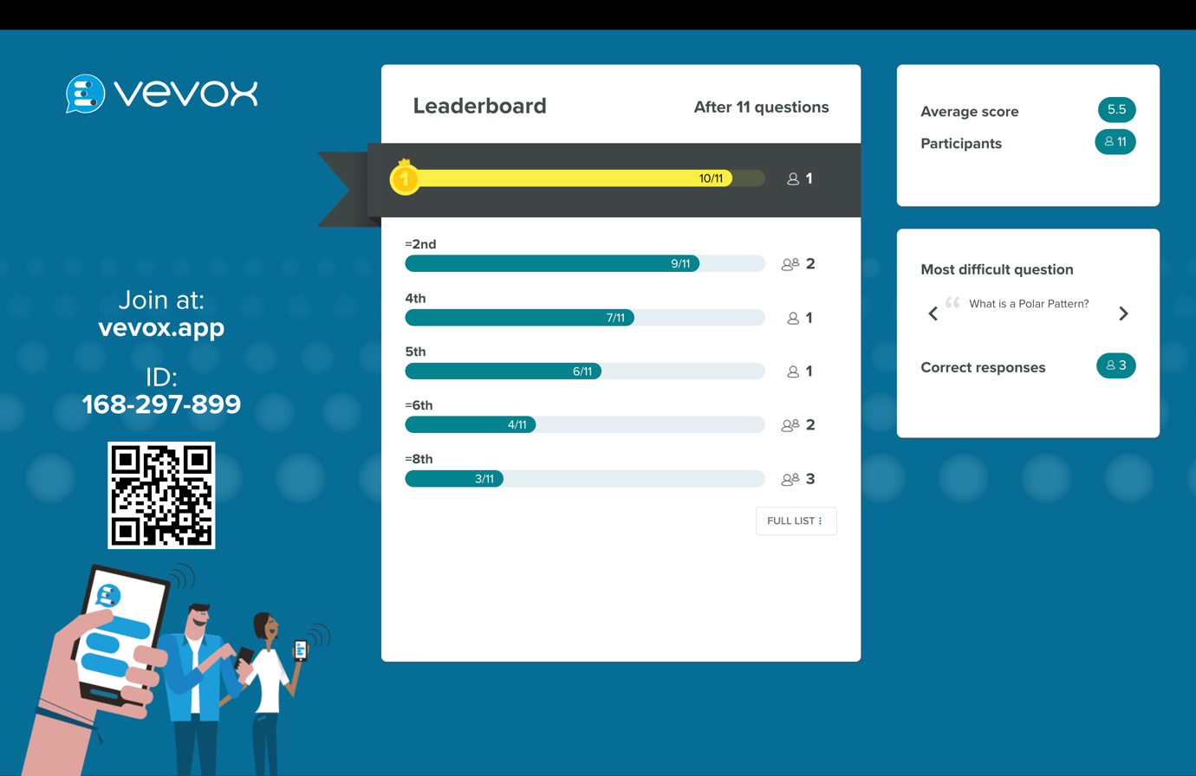
(Fig. 5. VeVox Leaderboard. Screenshot 3. Source: Tom Clement)

“Participants results” (Displayed below). Here participants can see the answers as well as percentage of answers in real time: 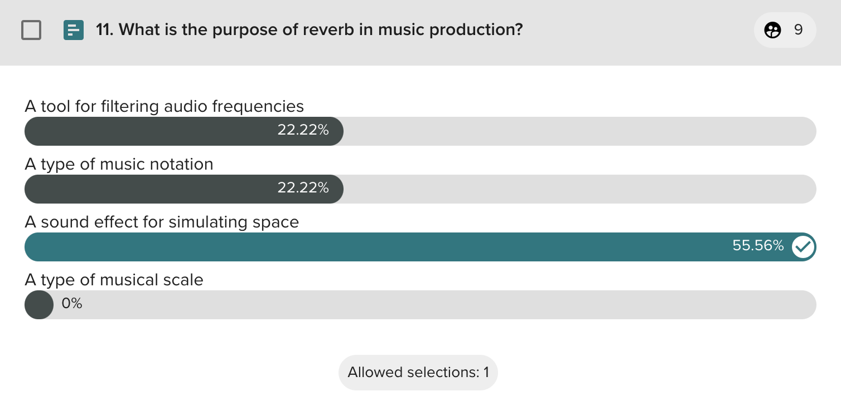
(Fig. 6. VeVox Results. Screenshot 4. Source: Tom Clement)

“Scores after questions” (Displayed below). Here users can see participants average score, a potentially useful insite into how the session went for further future development:
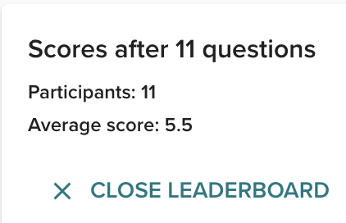
(Fig. 7. VeVox Scores. Screenshot 5. Source: Tom Clement)

As seen in Fig. 6. I can expand on this data to include more knowledge on the topic of reverb during later session in my given cohort. “Maintaining an update knowledge of my subject(s) and how best to teach and assess them”

Evaluation and Reflection

However positive the innovation of digital tools can be for many practitioners' pedagogy, Liz Bennetts (2014) work on “Developing the Digital Practitioner” explores “the way that lecturers make use of digital tools in their pedagogical practice”. In this work, one practitioner involved with the short-term study was quoted as stating: “The main obstacle to that is volume of work … I feel like I haven’t got the space to take time out to learn a new skill properly and that is a real, a significant and real hindrance. [Emily]”
This enforces my personal opinions on the use of digitals tools within my own pedagogy.
Although being open to the use of tools when appropriate, I understand that to work with these tools can take up time that some practitioners may not have or simply do not have a use for in their individual practice.
I believe that the inclusion of digital tools within my practice is important, however, it is not something to rely on completely, and it is, respectfully, up to each individual practitioner to decide which tools they wish to adapt in their own pedagogy.

Regarding my use of VeVox as a digital tool utilised for teaching, I can appreciate it’s features and functionality in education placements, and I found the AI generated polling questions particularly interesting.

The feedback I received post-lecture from students was reasonably positive:

- “Explanations with quiz are good for learning
Could've consolidated learning more at the end
Many ways of assessing music students learning
Fun with competition
Some students were disruptive” - Erin.

- “I thought you used the tool vevox really well. It was super interesting and I feel like I learnt a lot. The use of the poll made it fun and interactive. Definetely made good use of the tool. I think only thing I would add is try make it more visual (if the tool allows) but other than that it was awesome” - Kurtis.

- “Taught like a pro on ve vox the tool is only as good as the person wielding it. You are very knowledgeable & confidant with your subject & talked around subject well. Maybe you could use a image to identify A, b , or c. but understand images are premium. Liked it gave me time to consider answers so didn’t feel rushed or loose interest. Esay use with QR code u smashed that out.” - Emma.

- “- You showed a good demonstration of your content knowledge of music tech whilst utilising technology knowledge in the form of this digital tool to deliver it.
- You kept your multiple choice answers challenging but still easy enough for anyone of other subject areas to have a chance of finding the correct answers
- It was not clear if Vevox displayed everyone's names on the final leaderboard
- Was there more options to choose from on Vevox in terms of different means of presenting questions? (much like Mentimeter)
- You expanded on the answers as you revealed them so that students could still learn new things
- You validated students that answered incorrectly by commenting that there was logic behind why they might have chosen that answer” - Rhys.

Initially after presenting this tool to the class, I did not think that I would implement it into my future pedagogy. My reasoning was notable limitations to the tool, such as the use of images which is a feature that is not available with the free version of VeVox.
However, following the student’s positive response to using VeVox, I have changed my approach, validating its ability to take student ethics and well-being into account, aiding to “demonstrate commitment to learners, their learning, safety and well-being.”

I will also consider the negative effects this tool can have on students, leaving opportunities for students to be disruptive in class as mentioned in my peer feedback. During the polling stage the room was quiet but left an opportunity for disruptive behaviour to take place. Perhaps I can combat this by maintaining speech during the polling time.

I believe the feedback I received demonstrated good subject and curriculum knowledge.

I will continue to further my studies into digital tools more suited for my specialist area. For example, I believe the use of the programme “BlackHole” would be most useful for learners being able to route audio online to a shared music session together, to work on projects in real-time over the internet. This would be a great tool for learners to be introduced to for use in class and for collaborative work at home.
Retrospectively, I wish I had chosen a more physical digital tool such as the interactive Igloo Suite on the UWTSD site, or maybe even using my prior game development skills to design a Virtual Reality (VR) environment to hold classes in. However, with the duration of the course in mind and the time I had to work on this module, I believe that VeVox was a decent choice. Allowing me to learn and consider alternative tools available.

Since my personal specialist area of learning (Music Technology) is technologically driven, much of this module has been important, and or second nature in many regards. I already have a personal interest in technology and the value it can add within the learning environment.

Following my studies, this learning has enforced my opinion on the importance of the use of technology within education. It has broadened my knowledge on the tools available to practitioners and I will continue to keep up to date regarding the use of technology within the learning environment. As I move forward in my practice, I intend to adopt respected innovative digital tools, while still maintain a healthy respect and understanding of the traditional approaches to education.

I will continue to cultivate and hone the transferable skills learnt during this module to improve my professional practice. Reflecting on the theoretical frameworks, legislations, professional standards, assessment strategies used throughout. Ultimately, a valuable exercise in developing the necessary skills for becoming a capable practitioner.

List of Figures

- Fig. 1. VeVox Overview. PowerPoint Slide. Source: Tom Clement)
- Fig. 2. Novateach.unl.pt. (2024). The Technology Integration Matrix – NOVA Teach. [online] Available at: https://novateach.unl.pt/2019-tim-summary-descriptors/.

- Fig. 3. VeVox Poll. Screenshot 1. Source: Tom Clement

- Fig. 4. VeVox Poll. Screenshot 2. Source: Tom Clement

- Fig. 5. VeVox Leaderboard. Screenshot 3. Source: Tom Clement

- Fig. 6. VeVox Results. Screenshot 4. Source: Tom Clement

- Fig. 7. VeVox Scores. Screenshot 5. Source: Tom Clement)

‌

Reference List

- BBC News. (2021). Covid: Fifth of pupils in some schools lack digital device. “Available at: https://www.bbc.co.uk/news/uk-wales-politics-55767263“. [Accessed Date 27/11/24]

- Bennett, L (2014) Learning from the Early Adopters: Developing the Digital Practitioner. Jarfalla: Co-Action Publishing.

- Business News Wales. (2020). One in Four People in Wales Lack Basic Digital Skills “Available at: https://businessnewswales.com/one-in-four-people-in-wales-lack-basic-digital-skills/“ [Accessed date: 13/11/24]

- Canva (2025). Free Design Tool: Presentations, Video, Social Media | Canva. canva.com. Available at: https://www.canva.com/en_gb/.

- Crowncommercial.gov.uk. (2020). Technology to support education | Technology | Crown Commercial Service. [online] Available at: https://www.crowncommercial.gov.uk/news/technology-to-support-the-education-sector

- Department for Education (2023). 2022-23 Technology in Schools Survey Contents. [online] Available at: https://assets.publishing.service.gov.uk/media/655f8b823d7741000d420114/Technology_in_schools_survey__2022_to_2023.pdf.

- GOV.WALES. (n.d.). Additional learning needs | Sub-topic. [online] Available at: https://www.gov.wales/additional-learning-needs.

- GOV.UK (2010). Definition of Disability under the Equality Act 2010. [online] Gov.uk. Available at: https://www.gov.uk/definition-of-disability-under-equality-act-2010.

- Igloo Vision. (2025). Immersive Classrooms for Education | Igloo Vision. [online] Available at: https://www.igloovision.com/about/blog/immersive-classrooms

- Jones, K and Ravi, S. (2021) Higher Education 4.0: The Digital Transformation of Classroom Lectures to Blended Learning. London, England: SAGE Publications.

- Kahoot (2024). Kahoot! [online] Kahoot! Available at: https://kahoot.com/.

- Mentimeter. (n.d.). Free Quiz Maker: Create Live & Interactive Quizzes. [online] Available at: https://www.mentimeter.com/features/quiz-presentations.

- Microsoft (n.d.). Microsoft Teams. [online] www.microsoft.com. Available at: https://www.microsoft.com/en-us/microsoft-teams/group-chat-software.

- Padlet (2025). Padlet. [online] Padlet. Available at: https://padlet.com/.

- ReadSpeaker. (2017). Lifelike Text to Speech (TTS). [online] Available at: https://www.readspeaker.com/.

- Singh, G and Hardaker, G. (2014). Barriers and enablers to adoption and diffusion of eLearning. London: Emerald Group Publishing Limited.

- St Martins School Northwood (2024). Technology For Education in Schools | St Martin’s. [online] St Martin’s Preparatory School | Northwood | Middlesex. Available at: https://www.stmartins.org.uk/technology-for-education-how-schools-invest-in-digital-futures/

- University of South Florida. (2024). TIM Framework “Available at: https://fcit.usf.edu/matrix/tim-in-the-classroom/“. [Accessed date: 13/11/24]

- University of Central Florida (n.d.). Bloom’s Taxonomy. [online] Ucf.edu. Available at: https://fctl.ucf.edu/teaching-resources/course-design/blooms-taxonomy/.

- Vevox (n.d.). Vevox | The No.1 rated Polling and Q&A platform for hybrid. [online] Available at: https://www.vevox.com/.

- Welsh Government (2019). Digital 2030 A strategic framework for post-16 digital learning in Wales 2019. [online] Available at: https://www.gov.wales/sites/default/files/publications/2019-06/digital-2030-a-strategic-framework-for-post-16-digital-learning-in-wales.pdf.

- Welsh Gov. (2022) Digital strategy. “Available at: https://www.gov.wales/digital-strategy-overview”. [“Accessed date: 20/11/24]

- Welsh Government (2017). Professional Standards for Teaching and Leadership. [online] Hwb. Welsh Government. Available at: https://hwb.gov.wales/api/storage/19bc948b-8a3f-41e0-944a-7bf2cadf7d18/professional-standards-for-teaching-and-leadership-interactive-pdf-for-pc.pdf.

