

Assessment 1 – Reading Task Template
PART 1: Upload your photo of your A3 in-class notes here:
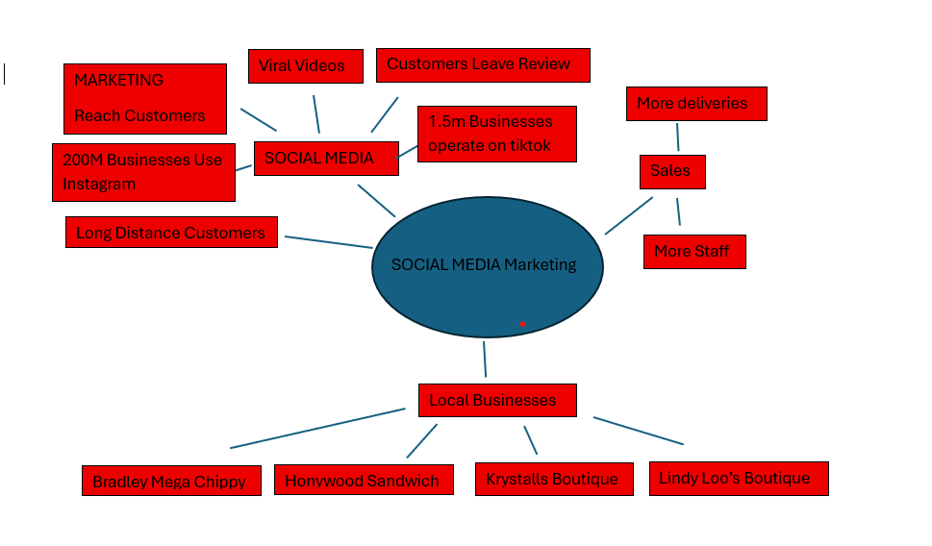

PART 2:
- Answer every question below in 1-3 full sentences.
- Use your own words. Do not use generative AI to answer these questions.
- Include a specific detail from the text when asked.
REMINDER
- The main idea is the overall message of the whole text.
- A key point helps to explain the main idea.
- A specific detail or example from the text shows that the key point is true.

- What is the main idea of the whole text?
The main idea of the whole text is how social media helps you to grow a small business and become viral. Nowadays people use social media like TikTok, instagram etc. That helps businesses get attention for the customer. People follow customers reviews and feedback which increases your business and become popular.
- What is one key point that supports the main idea, and which specific example from the text shows this?
Key points social media, TikTok can help small businesses attract customers for increase sale. Honywood sandwich shop Basildon customer travel long distance after promoted through social media. The owner Murat Mutlu was surprised people had travelled three hours for just chicken burger.

- What is a different key point that supports the main idea, and which specific example from the text shows this?
Social media can change people’s lives ordinary people become famous. For example, “spudman”- aka Ben Newman saw jacket potato seller becomes popular after video viral. Sometime popular personality attracts new customer because people enjoy watching them.

- Which part of the text do you think is most important, and why?
The main part is social media can make your business famous and where it says Murat Mafus owns sandwich shop. One of the customers posted about his chicken burger now people are travelling from far way. This shows that social media had a big effect on businesses and it can attract people from far away and help the business become more well known not just in the area it is but also in other places.

Reflection:
- What did you find difficult in this task (including in-class components), and why was it difficult?
I find difficult to chose main point of the task because it is hard to tell which examples support the main also there are too many choices.

- What helped you with this difficulty, and how did it help you?
The text helped me to get the key points. Reading slowly and carefully helped me to find the main points which helped me to easier to understand the topics.

