Three keywords: Typography, Disney, Colour
Student number: 1902544
BA Course Title: Illustration
Word Count: 2435
Tutors: Louise Burston

Research in Practice

Three keywords: Typography, Disney, Colour

In this essay I’m going to talk about how typography have evaluated through historical timelines to the most used fonts throughout time, to how Walt Disney career kicked off in the animation industry and how did he become the most non professional animator in America and worldwide and then on to the innovation of colour throughout the characterised of abstract expressionist work and how colour gives audience the type of feeling it does by the colours using throughout the history of art movements and the meanings of colour when creating a piece for yourself or the target audience you are working towards.

Typography

Typography is a movable type of craft that was invented by Bi Sheng in the eleventh-century in China. Movable typography was manufactured from ceramic materials like earthenware, porcelain, stoneware and bone China this practice continued until Wang Zhen become the pioneer of the abvertion of wooden movable type typography. Typography was created by the industrial Revolution to be able to communicate with masses of audience throughout signs, posters, periodicals newspapers and advertisement, to catch the eye of the audience and worldwide tourists typefaces had become larger and catchier with bolder letting with colour and shading as well as being experimental to the attraction point of the direction and location of the industry. Typography traces back to the roots of hieroglyphs and pictograms used in ancient civilisation of representing worldwide ideas where images evolved soon into alphabetical photographic writing which developed various typographic systems. Giambattista Bodoni who is the known father of typography designer who’s outstanding marks was lefted on the world in 1740 to 1813. Bodoni designed typefaces were well-known “more of a work of art and layout” (“illustration by Work Design Group/David E.Wilkinson 2014”), than presented as actual reading materials worldwide. Bodoni was a main leader of originating pseudoclassical typography classes that helped him produce 1,200 fine typeface editions. One of the 1,200 typefaces was created by Bondi and collaborating with Firmin Didot was called ‘New Face’, a style of lettering where the letters are cut to show a shadow of contrast between the thin and thick parts of the typeface lettering and then its all set off with a bold thick margining to show that it’s the typeface that means business to get your point across to the masses of people. Still to this day, Bodoni is still the most popular fashion font and is associated with the biggest fashion companies out there like Elizabeth Arden, Armani Exchange and of course the worldwide non fashion icons Calvin Klein logo because what we see today is the several modern results of an original typeface still being as successful as it was in the 1790 as a visually striking modern society typeface ranged in to font adaptations like FF Bodoni and ITC Bodoni which each featured and captures a unique and stylistic characteristics.

What are the 4 major font types?

Most typefaces are classified into four basic groups which are serifs, script, decorative style and those without serifs, for many years scholars or typography and typographers has categorised various systems of typefaces some of which are sub-categorised.

Classifications of the 4 font type groups:

Sans serif type styles:
- Humanistic
- Geometric
- Grotesque
Decorative:
- Graffiti
- Psychedelic
- Grunge
Script type style:
- Calligraphic
- Blackletter
- Lombardi
- Formal

Serif type style:
- Neoclassical
- Old style
- Didone
- Glyphic
- Slab

Old style typeface:

Old style typeface fits in to the category of Roman types that was created in the 15th and mid 18th centuries. The old style typeface as an axis curved stroke to inclined the left hand of this typeface so that all the pressure is leaned approximately at eight and two o’clock this is to help the characters stoke contrast the weight of the typeface so it don’t tend to look heavy on one side and don’t stand out as looking to much as a dramatically typography.

Neoclassical:

The neoclassical typeface was created in the late 18th century by the man Giambettista Bondi that was a well known man of the century to create typefaces of that period because of his epitomises style of typography that is still being using to this very day and his advertising through well known business and creators. These typefaces wasn’t always called ‘classical’ designs mind until the 20th century where classification typography name was changed to ‘modern’ and also known as neoclassical or didone. The axis of neoclassical has curved stroke with little or sometimes no bracketing showing the thin and thick stroke contrast between the strokes terminals of ball shaped than evocation of broader pen effect with a clearly constructed typography.

The practically endless body of work represented by typography have made it hard and a endless journey for graphic designers and illustrations these days to be able to be familiar with every single typeface design out there that exists however this is an important part of historical research to have of different verses of typographic styles, common typefaces and iconic typefaces because the typographic history helps you as a designer to meet the needs and understandings of future clients.

Peter Strain Typography Artists:

Peter Strain is an choice award-winning illustrator that creates carefully composed hand-rendered typography, illustrations and animations that experiments with mark making, textures and evolving digital techniques in to the mix of his mixed textured awarded winning work. Peter Strain aims to tackle broad topical subjects throughout his work like social, cultural issues and politics that have a distinct hand written lettering style with humour and eye catching imagery that is influenced by films and music. I like the style of work Peter does because the typography build the format of the picture up that makes you stop and want to find out how and way he creates work like this and does the working that build up the picture have a meaning to the working he’s does.
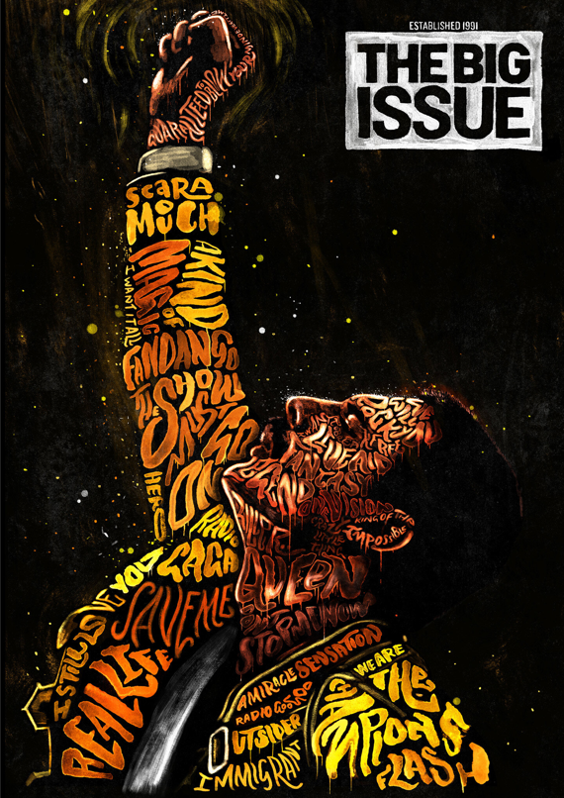

Disney:

Walt Disney started his professional career in 1920 has a renowned animator, film producer and theme park designer. Walt Disney was a determined man that had a vision for happier and brightening up places for children and adults worldwide. Walt Disney first ever cartoon was called Alice’s Wonderland, about a little girl in a cartoon world of Kansas City that was used as a “pilot” film a series of ‘Alice’s comedies’. Alice’s comedies was the main start of the Disney company in October 16th, 1923 that was originally known for the Disney brothers cartoon studios that was equal partners ship with Walt Disney and his brother Roy that soon changed when there decided to change the name to Walt Disney Studios.
In 1926 with the loss of Oswald the lucky rabbit cartoon, Walt had to create a new character that endeared the audience worldwide and that character was Mickey Mouse that Walt and his Ub animated team created two silent films but was unable to catch on and sell because sound revolutionising was hitting the movie industry. Walt and his Ub animation team worked on a third Mickey Mouse cartoon that had fully synchronised sound and that was the making of Steamboat Willie that outstandingly brought the film to Colony Theatre in New York 18th November, 1928 and this was the starting of a world renowned character Mickey Mouse, this was immediately poplar that produced more lengthy series was made and Walt Disney come up was producing another series called ‘silly symphonies’ that featured characters in each film and enabled animator to experiment with laughter and quick humour but also the emotion and musical themes throughout the production of Steamboat Willie and Silly Symphonies.
Walt Disney continuing on with the success of Walt Disney studios and Steamboat Willie he taken a risking move in 1934 and began the production of Snow White and the Seven Dwarfs (1937). Snow White come smashing in to the animation industry providing a vehicle feature-length stories of these Seven Dwarfs helping this princess Snow White with her daily routine this was a big and different approach for Disney with experimenting and limited animations with live-action films that led to Snow White to be a successful animation.

In 1941 there was a major setback for Disney because the studios animators take it up one themselves and go on strike for three months, “Disney took action personally, many of the studios top animators were compelled to resign”, (“Britannica by Aakanksha Gaur, August 8th, 2013”), this but a real damper on Disney and the studio had a permanently dampened effect which led to the studio and animators producing little level of work on the production of Pinocchio and Dumbo this was for the next decade or so, but this lack of motivation for production films had a successful turn out for producing short cartoons such as ‘The Three Caballeros (1945)’, ‘Song of the South (1946)’, ‘Cinderella (1950)’, ‘Alice Wonderland (1951)’ and ‘Peter Pat (1953)’ these was fine efforts of animations but lacked the dimensions of the early 40s featured because Walt Disney increasingly devoted himself and his time to live-action television productions and the opening of his world renowned theme park Disneyland that opened in 1955 Anaheim, California.
Return to prominence in 1990s were Disney had a hugely successful year on their hands with the release of The Little Mermaid (1989), that was success and effectiveness as Disney’s best animated blockbuster for more than other 40 years, this was a big relief and just what Disney need to pick up the mood and this led to great success as Disney and the animating team made some killer blockbusters movies such as Beauty and the Beast (1991), The Lion King (1994) and The Hunchback of Notre Dame (1996) these blockbusters was recognised worldwide and had great success, and that’s when Disney released that there had the computerised live-action features and went on to produce two more successful blockbusters which was Toy Story (1995) and Toy Story 2 (1999) that was developed with the help of Pixar Animation Studios.

Exploring the world of Disney through the media networking that internationally brings Disney to hundreds of millions of people’s homes of which there are 23 Disney channels and over 70 brands blocks and international airing in 80 countries worldwide. Walt Disney pursing new media opportunities of internet groups that function 40 international branding licenses and websites in over 30 countries. This led to great success to where the theatrical productions business brought the musicals Lion King, Beauty and the Beast and Mary Poppins to live stages to 14 international venues and tours which includes the success of Disney on Ice shows.

Jason Deamer Disney Illustrator:

Jason Deamer is a character art director that began his career as a sketch artists at Pixar Animation studios in 1998. Jason has worked as a character designer that have worked on a number of Pixar Award-winning films such as Finding Nemo, Wall.E and Ratatouille. Deamer’s work is well known in the character design industry of working on Monster University as well as Finding Dory. Deamer had many talents that he have achieved over many of years such as a freelance editorial illustrator and a team leader for Pixar Animation studios. I found Jason’s work interesting because I’ve always had a interest in how Disney animations are made and the work that’s goes in making and working on an animation film and the colours that represent the work that is produced.


Colour:

There is a lifetime of knowledge to learn about the master of artists and their way there is colour throughout there work as we discover the intense passions and the staunch beliefs of power of colours used in exhibitions to view colour through the eye of artists and worldwide audience of exhibitions.
Helen Frankenthaler innovative in the use of colour that evolved throughout her career when she started exhibiting large-scale abstract expressionist paintings that’s was known as ‘colour field’ which is a characterised style of large fields of flat and solid colour that is spread across or is stained on to the canvas and this is exactly what Helen Frankenthaler work does by strips of colour near the edges of the canvas and blots of solid colour formed in to geometric shapes that has a characteristic calm relaxing feeling and look to her abstract expressionist paintings.
The history of colour goes all the way back to 40,000 years ago where pigments like soil, animal fat, chalk and burnt charcoal all combined together to create a basic five colour palette combination like white, black, brown, yellow and red since this history of colour making as been perpetual discovery that developed the greatest movements like Renaissance to Impressionism and that’s what started the colour of historical paintings off.
The history of colour have changed many things since the making of colour mixtures like when Sir Isaac Newton taking the rainbow from 5 colours to 7 just by mixing orange and indigo to a fondness of supposedly mystical properties and since Newton we’ve settled on 7 colours that’s were the rhyme children perplexed to sing ‘Red and yellow and pink and green, purple and orange and blue, ‘I can sing a rainbow’, and that seems that the colours of the rainbow can differ because of the dip into the cultural history of colours and what can be made by adding mixtures together just like Sir Isaac Newton.

Claude Monet Colour Artist:

Many artists claim colour as an important tool because there can express themselves, share beliefs, convey a message or intellectually transform emotions, but Claude Monet describes it as “colour is my day long obsession, joy and torment”, he tends to repeatedly paint the same objects but with different light and time zones and weather conditions to see the different effects the colour used given by light hitting on the reflection of the painting and to see if the mood of the painting changes when looking at it from different angles and explore the myriad of colour and mood of a piece of work.
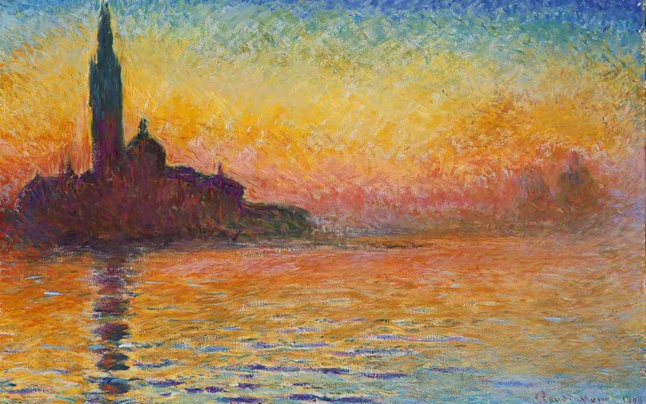

After researching in to my three keywords I have learnt a lot about how you can always come back kicking with success after having a damper in the works and what started of with a handful of animations producing short children cartoons can turn in to iconic companies like Disney, I’ve learnt that typography can have a society striking impacted of the emotions of worldwide audiences and that colour can have a intense passions on work of how light can affect the colour of your subjects and explore a different motion throughout and that’s how I’ve come up with my question
“How typography and colour have an impacted on work and it’s appearance?”.

Biography

https://www.britannica.com/topic/Disney-Company/Expansion-ABC-Pixar-Marvel-Entertainment-and-Lucasfilm

https://d23.com/disney-history/

https://www.healing-power-of-art.org/master-artists-and-their-relationship-with-color/

https://www.thestreet.com/world/history-of-disney-15136801

https://www.sciencefocus.com/science/the-colourful-history-behind-the-science-of-colour/

http://www.worksdesigngroup.com/creative-leader-walt-disney-dream-began-mouse/

