

Dissertation topic: The Role of Quantity Surveyors in Achieving Net-Zero Carbon Construction
Name: Inderdeep Singh Sidhu
Student number: 2119841
Deadline date: 11.09.2026

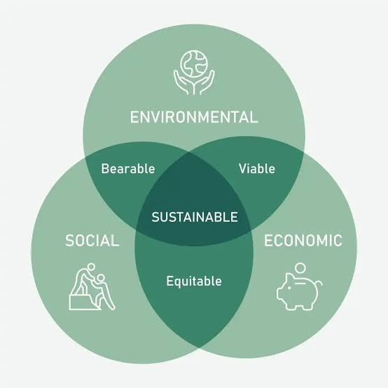
(Figure 1. The evolving role of Quantity Surveyors in carbon budgeting and net-zero construction.)

Contents
ABSTRACT 9
CHAPTER 1 - INTRODUCTION 10
1.1 Background and Context 10
1.2 The Welsh Context 12
1.3 The Role of Quantity Surveyors in Net Zero Retrofit 13
CHAPTER 2 - LITERATURE REVIEW 15
2.1 Introduction 15
2.2 Net Zero Carbon and the Built Environment 15
2.2.1 Global Climate Imperatives 15
2.2.2 UK Net Zero Commitments 16
2.2.3 Wales’s Distinctive Policy Landscape 17
2.3 Embodied Carbon, Lifecycle Assessment and Whole Life Thinking 18
2.3.1 Embodied Carbon in Construction 18
2.3.2 Lifecycle Assessment (LCA) 18
2.3.3 Whole Life Costing and Carbon 19
2.4 Housing Retrofit: Challenges and Opportunities 19
2.4.1 The UK Retrofit Challenge 19
2.4.2 The Welsh Housing Context 20
2.4.3 Social Housing and ORP 20
2.5 The Role of Quantity Surveyors in Carbon Reduction 20
2.5.1 Traditional QS Functions 20
2.5.2 Emerging Sustainability Responsibilities 20
2.5.3 Barriers to QS Engagement 20
2.6 Digital Tools and Data for Carbon Assessment 21
2.7 Gaps in Existing Literature 21
2.8 Summary 21
CHAPTER 3 - METHODOLOGY 22
3.1 Introduction 22
3.2 Research Philosophy 22
3.2.1 Pragmatism as the Guiding Philosophy 22
3.2.2 Ontological and Epistemological Positioning 23
3.3 Research Design 23
3.3.1 Justification for Mixed Methods 23
3.3.2 Sequential Explanatory Design 24
3.4 Data Collection Methods 24
3.4.1 Quantitative Survey 24
3.4.2 Qualitative Interviews 25
3.4.3 Instrument Development 25
3.5 Sampling Strategy 25
3.5.1 Sample Size Considerations 26
3.5.2 Inclusion and Exclusion Criteria 26
3.6 Data Analysis 26
3.6.1 Quantitative Analysis 26
3.6.2 Qualitative Analysis 27
3.6.3 Triangulation 27
3.7 Validity, Reliability and Trustworthiness 27
3.8 Ethical Considerations 27
3.9 Limitations of the Methodology 28
3.10 Summary 28
CHAPTER 4 - FINDINGS 28
4.1 Introduction 28
4.2 Participant Profile 29
4.3 Carbon Literacy and Awareness 29
4.3.1 Understanding of Carbon Concepts 29
CHAPTER 5 - DISCUSSION 30
5.1 Introduction 30
5.2 Carbon Literacy and Professional Capability 31
5.2.1 Alignment with Existing Literature 31
5.2.2 Sectoral Variation in Capability 31
5.2.3 Implications for QS Practice 32
5.3 Digital Tools and Data Infrastructure 32
5.3.1 Limited Adoption of Carbon Tools 32
5.3.2 Data Quality and Availability 33
5.3.3 Implications for Digital Transformation 34
5.4 Organisational Culture and Sector Variation 34
5.4.1 Influence of Organisational Priorities 34
5.4.2 Sector Specific Challenges 34
5.5 Influence of Welsh Government Policy 35
5.5.1 ORP as a Catalyst for Change 35
5.5.2 WHQS 2023 and Net Zero Wales 35
5.6 Barriers to QS Engagement 35
5.6.1 Data Limitations 35
5.6.2 Skills Gaps 35
5.6.3 Organisational Constraints 35
5.6.4 Retrofit Complexity 36
5.7 Opportunities for QSs in Net Zero Retrofit 36
5.7.1 Early Stage Carbon Advice 36
5.7.2 Carbon Aware Procurement 36
5.7.3 Lifecycle Based Cost Planning 36
5.7.4 Digital Integration 36
5.8 Summary 36
CHAPTER 6 - CONCLUSION 37
6.1 Introduction 37
6.2 Summary of Key Findings 37
6.2.1 Carbon Literacy and Professional Capability 37
6.2.2 Digital Tools and Data Limitations 38
6.2.3 Organisational Culture and Sector Variation 38
6.2.4 Influence of Welsh Government Policy 39
6.2.5 Retrofit Complexity and the Scale of the Challenge 39
6.3 Implications for Quantity Surveyors 40
6.3.1 Expanding Professional Competence 40
6.3.2 Early Stage Influence 40
6.3.3 Carbon Aware Procurement 40
6.3.4 Professional Identity and Future Role 40
6.4 Implications for Organisations 41
6.4.1 Training and Capability Building 41
6.4.2 Digital Infrastructure 41
6.4.3 Policy Alignment 41
6.5 Implications for Welsh Government and Industry Bodies 41
6.5.1 Wales Specific Carbon Data 41
6.5.2 Clearer Technical Guidance 41
6.5.3 Sector Wide Capability Building 41
6.5.4 Policy Alignment Across Tenures 42
6.6 Overall Conclusion 42
6.7 Reflections on the Research 43
CHAPTER 7 - RECOMMENDATIONS 44
7.1 Introduction 44
7.2 Recommendations for Quantity Surveyors 44
7.2.1 Strengthen Carbon Literacy 44
7.2.2 Develop Competence in Carbon Tools 45
7.2.3 Integrate Carbon into Early Stage Cost Planning 45
7.2.4 Adopt Carbon Aware Procurement Practices 45
7.2.5 Strengthen Communication and Engagement Skills 46
7.3 Recommendations for Organisations 46
7.3.1 Invest in Training and Professional Development 46
7.3.2 Improve Digital Infrastructure 46
7.3.3 Strengthen Organisational Culture Around Carbon 46
7.3.4 Improve Data Collection and Management 47
7.4 Recommendations for Welsh Government 47
7.4.1 Provide Clearer Technical Guidance 47
7.4.2 Develop Wales Specific Carbon Datasets 47
7.4.3 Invest in Sector Wide Capability Building 48
7.4.4 Strengthen Policy Alignment Across Tenures 48
7.4.5 Introduce Carbon Linked Funding Conditions 48
7.5 Recommendations for Industry Bodies 48
7.5.1 Enhance Professional Guidance 48
7.5.2 Improve Access to Carbon Tools 49
7.5.3 Support Standardisation 49
7.5.4 Promote Carbon Literacy Across the Profession 49
7.6 Cross Sector Recommendations 49
7.6.1 Strengthen Collaboration 49
7.6.2 Embed Lifecycle Thinking 50
7.6.3 Prioritise Early Stage Decision Making 50
7.7 Summary 50
CHAPTER 8 - LIMITATIONS & FUTURE RESEARCH 51
8.1 Introduction 51
8.2 Methodological Limitations 52
8.2.1 Modest Sample Size 52
8.2.2 Reliance on Self-Reported Data 53
8.2.3 Limited Inferential Statistical Analysis 53
8.2.4 Time Constraints 54
8.2.5 Researcher Positionality 54
8.3 Contextual Limitations 55
8.3.1 Evolving Policy Landscape 55
8.3.2 Limited Wales Specific Carbon Data 55
8.3.3 Sectoral Fragmentation 55
8.3.4 Workforce Capacity Constraints 56
8.3.5 Retrofit Complexity 57
8.4 Future Research Opportunities 57
8.4.1 Longitudinal Studies of QS Capability Development 57
8.4.2 Comparative Studies Across UK Nations 57
8.4.3 Evaluation of Training Interventions 58
8.4.4 Client Perspectives on Carbon Assessment 58
8.4.5 Supply Chain Capacity for Carbon Data 58
8.4.6 Digital Innovation in Retrofit 58
8.4.7 Social Dimensions of Retrofit 59
8.4.8 Carbon Aware Procurement Models 59
8.4.9 Whole Life Carbon and Cost Integration 59
8.4.10 Policy Impact Evaluation 59
8.5 Summary 59
REFERENCE LIST 60
REFERENCES LIST FOR QUESTIONNAIRE SECTION 64
REFERENCE LIST FOR IMAGES 64
Appendix 66
Appendix A 66
SECTION A: Knowledge & Awareness 66
Appendix B 69
SECTION B: Current Practice 69
APPENDIX C 71
SECTION C: Barriers & Challenges 71
APPENDIX D 72
SECTION D: Tools & Training 72
APPENDIX E 74
SECTION E: Demographics 74
APPENDIX F 76
Summary of Key Findings 76
APPENDIX A.A 76
SENIOR QUANTITY SURVEYORS 76
SECTION A: Knowledge & Awareness 76
APPENDIX A.B 79
SECTION B: Current Practice 79
APPENDIX A.C 83
SECTION C: Barriers & Challenges 83
APPENDIX A.D 85
SECTION D: Tools & Training 85
APPENDIX A.E 89
SECTION E: Demographics 89
APPENDIX A.F 91
Summary of Senior QS Insights 91
APPENDIX B.A 92
PART ONE: QUANTITATIVE SURVEY RESULTS (Means score results) 92
(50 Quantity Surveyors across Wales) 92
SECTION A: Knowledge & Awareness 92
APPENDIX B.B 94
SECTION B: Current Practice 94
APPENDIX B.C 96
SECTION C: Barriers & Challenges 96
APPENDIX B.D 96
SECTION D: Tools & Training 96
APPENDIX B.E 98
SECTION E: Demographics 98
APPENDIX C.A 100
Summary of Interviewee Profiles 100
APPENDIX C.B 102
Current Practice 102
APPENDIX C.C 102
Practical Difficulties 102
APPENDIX C.D 104
Client Expectations 104
APPENDIX C.E 106
Skills, Training & Competence 106
APPENDIX C.F 108
Professional Guidance 108
APPENDIX C.G 110
Welsh Policy Impact 110
APPENDIX C.H 112
Future Outlook 112
APPENDIX D.A 113
PART THREE: OVERALL SYNTHESIS & RECOMMENDATIONS 113
APPENDIX D.B 116
Part B: Conclusions from the 8 Senior Quantity Surveyor Interviews 116
APPENDIX D.C 119
APPENDIX E.A 120
APPENDIX F.A 126
Synthesis: Key Themes and Implications 126
APPENDIX F.B 127
Recommendations 127
APPENDIX F.C 128
Concluding Reflection 128

ABSTRACT
The transition to net zero carbon presents significant challenges for the UK construction sector, particularly in Wales, where the housing stock is older, more diverse, and more difficult to retrofit than in other UK nations. Quantity surveyors (QSs) play a critical role in supporting carbon aware decision making through cost planning, procurement, and lifecycle evaluation. However, limited carbon literacy, inconsistent data availability, and uneven organisational capability restrict their ability to contribute effectively to decarbonisation goals. This mixed methods study investigates how QSs in Wales engage with carbon assessment within the housing retrofit sector, drawing on survey responses and semi structured interviews with practitioners across social housing, consultancy, and contracting.

Findings reveal that QSs possess general awareness of carbon concepts but lack confidence in applying carbon assessment tools, interpreting Environmental Product Declarations (EPDs), and integrating carbon into cost planning. Carbon is not yet embedded within QS workflows, and client demand remains inconsistent outside the social housing sector. Welsh Government policy, particularly the Optimised Retrofit Programme (ORP) and WHQS 2023 is driving change, but organisational readiness varies significantly. Key barriers include data gaps, tool complexity, time constraints, and limited training opportunities. Despite these challenges, QSs express strong willingness to develop carbon capability.

The study concludes that strengthening carbon literacy, improving data infrastructure, enhancing digital capability, and providing Wales specific guidance are essential to support QSs in delivering net zero housing retrofit. Recommendations are offered for QSs, organisations, professional bodies, and policymakers, alongside future research opportunities to deepen understanding of carbon aware QS practice in Wales.

CHAPTER 1 - INTRODUCTION

1.1 Background and Context
The built environment is widely recognised as one of the most significant contributors to global greenhouse gas emissions, accounting for approximately 37% of energy related CO₂ emissions worldwide (UNEP, 2023; IEA, 2022). These emissions arise from two principal sources: operational carbon, generated through the day to day running of buildings (heating, cooling, lighting, appliances), and embodied carbon, associated with the extraction, manufacture, transport, installation, maintenance, and end of life disposal of construction materials (Pomponi & Moncaster, 2017). Historically, operational carbon has dominated policy and industry attention. However, as energy efficiency improves and electricity grids decarbonise, embodied carbon is becoming increasingly prominent, particularly in retrofit contexts where new materials are introduced into existing buildings (Dixit, 2019; Moncaster & Symons, 2013).

This shift represents a profound transformation in how the construction sector must approach carbon reduction. Operational emissions can be reduced through behavioural change, improved building management, and technological upgrades. Embodied emissions, by contrast, are “locked in” at the point of construction, meaning that decisions made during design, procurement, and installation have long term implications for a building’s carbon footprint. As a result, professionals involved in early stage decision making including quantity surveyors (QSs) which are increasingly central to achieving net zero outcomes.

The Intergovernmental Panel on Climate Change (IPCC) stresses that rapid reductions in both operational and embodied carbon are essential to limit global warming to 1.5°C (IPCC, 2022). This urgency is reflected in national policy. The United Kingdom’s legally binding target of net zero by 2050 places significant pressure on the construction sector to reduce emissions across all building types (HM Government, 2019; CCC, 2023).

Housing alone contributes approximately 17% of UK greenhouse gas emissions, largely due to poor thermal performance and reliance on fossil fuel heating systems (CCC, 2023). The UK’s housing stock is among the oldest in Europe, with 36% of homes built before 1945 (CaCHE, 2021). This ageing stock presents substantial challenges for decarbonisation, as older homes typically require more complex and costly interventions to improve energy performance.

Retrofit is therefore recognised as one of the most effective strategies for reducing carbon emissions in the built environment (Gupta & Gregg, 2018; Killip, 2013). Unlike new build projects, where specifications can be controlled from the outset, retrofit involves working with existing buildings that vary widely in construction type, condition, and performance. This introduces significant uncertainty into cost planning and carbon assessment. QSs must navigate this complexity while balancing client expectations, regulatory requirements, and long term sustainability goals.

The relationship between cost and carbon in retrofit projects is often characterised by tension. Low carbon solutions may require higher upfront capital investment, even though they typically deliver lower lifecycle costs through reduced energy consumption and maintenance (Killip, 2013). QSs must therefore support clients in understanding the long term financial and carbon implications of retrofit decisions. Whole life costing (WLC) has emerged as a key framework for integrating cost and carbon considerations, but its application in retrofit remains inconsistent and often poorly understood (El Haram & Horner, 2002; RICS, 2023b).

Strengthening WLC capability among QSs is increasingly recognised as essential for delivering net zero outcomes, particularly in contexts where budgets are constrained and decisions must balance affordability with carbon reduction.

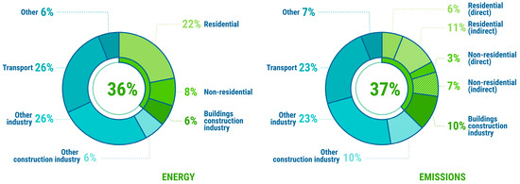
(Figure 2. Global CO₂ emissions from buildings and construction (≈37%))

1.2 The Welsh Context
Wales presents a distinctive policy landscape shaped by devolved legislation, ambitious climate targets, and a strong social housing sector. The Welsh Government has committed to achieving net zero by 2050 and has introduced several programmes to accelerate decarbonisation, including the Optimised Retrofit Programme (ORP), the Warm Homes Programme, and the Welsh Housing Quality Standard (WHQS) 2023 (Welsh Government, 2021; Welsh Government, 2023). These initiatives emphasise fabric first approaches, whole life carbon thinking, and long term asset management.
ORP, in particular, represents a flagship initiative that has invested more than £190 million in social housing retrofit. It aims to create a “proof of concept” for approaches to both fabric and technology retrofit, using the social housing sector as a testbed for wider decarbonisation across other tenures (Welsh Government, 2022). The programme requires landlords to undertake whole home assessments, develop digital twins, and adopt lifecycle based decision making, all of which have direct implications for QS workflows.

The urgency of decarbonising the built environment is especially pronounced in Wales, where nearly 50% of homes were built before 1919 (Welsh Government, 2023). Many of these properties are solid wall, stone, or brick constructions that are difficult to insulate using conventional methods. Rural housing stock presents additional challenges, including limited contractor availability, higher transport costs, and diverse construction types (WLGA, 2022). These characteristics mean that Wales faces a more complex retrofit challenge than many other parts of the UK, requiring tailored approaches that reflect local construction traditions and supply chain constraints.

Recent Welsh research reinforces the complexity of this challenge. Morgan, Maddock and Musselwhite (2024) highlight the importance of communication and tenant engagement in retrofit projects, noting that residents often struggle to understand new technologies and may feel excluded from decision making. Their findings emphasise that retrofit is not solely a technical process but also a social one, requiring professionals including QSs to engage with tenants and support behavioural change.

The Welsh School of Architecture’s Homes of Today for Tomorrow report argues that retrofit must balance carbon reduction with affordability, occupant wellbeing, and long term resilience (Welsh School of Architecture, 2024). The report warns that “systems led” approaches, such as replacing fossil fuel heating with electric systems, may reduce upfront costs but risk increasing household energy bills if not paired with fabric first improvements. This is particularly relevant in Wales, where fuel poverty rates are higher than the UK average.

The Wales Centre for Public Policy (WCPP, 2026) emphasises that domestic retrofit represents a major opportunity for Wales to reshape its economy, improve housing quality, and create skilled jobs across local supply chains. However, the report identifies persistent barriers such as high upfront costs, disruption to households, skill shortages, and fragmented funding mechanisms. These barriers highlight the need for coordinated policy implementation and enhanced professional capability across the sector.

Woodknowledge Wales has advanced embodied carbon reduction through the Early Stage Embodied Carbon Tool (ESECT), designed to help housing associations and local authorities assess upfront carbon impacts without requiring detailed modelling (Woodknowledge Wales, 2025). The tool focuses on early stage decisions relating to building fabric, foundations, and services which are areas where QSs have significant influence through cost planning and value engineering. Early adopter feedback indicates that simplified tools can support more informed discussions about carbon at project inception, but also highlights the need for ongoing sector engagement, training, and refinement of guidance (Woodknowledge Wales, 2026).

Together, these studies reinforce the central argument of this dissertation: achieving net zero housing retrofit in Wales requires not only technical innovation but also enhanced professional capability, clearer guidance, and coordinated policy implementation. QSs occupy a pivotal position within this landscape, and strengthening their carbon literacy, data access, and digital capability will be essential to delivering retrofit at scale.

1.3 The Role of Quantity Surveyors in Net Zero Retrofit
Quantity surveyors play a central role in shaping construction decisions through cost planning, procurement, value management, and lifecycle costing (Ashworth et al., 2013; Cartlidge, 2022). As the industry transitions towards net zero, QSs are increasingly expected to integrate carbon considerations into traditional cost focused workflows (RICS, 2023a; UKGBC, 2023). This includes evaluating embodied carbon, assessing lifecycle impacts, advising on low carbon materials, and supporting clients in balancing cost and carbon performance (Oyedele et al., 2014; Opoku, 2019).

The RICS Whole Life Carbon Assessment standard provides a consistent methodology for measuring and reporting embodied and operational carbon, aligning with the International Cost Management Standard and the Built Environment Carbon Database (RICS, 2023a). For retrofit projects, the standard emphasises that all interventions should be treated as new works and must report against all lifecycle stages. This requires QSs to distinguish between retained elements and new materials, ensuring accurate carbon calculations.

Recent harmonisation efforts between RICS and the Institution of Civil Engineers have aligned the Whole Life Carbon Assessment standard with PAS 2080:2023, creating a consistent framework for measuring and managing carbon across buildings and infrastructure (RICS, 2025).

This alignment strengthens the professional expectation that QSs must integrate carbon assessment into their core responsibilities, rather than treating it as an optional or specialist activity.

However, research suggests that QSs often face barriers such as limited carbon literacy, insufficient data, lack of Wales specific guidance, and inconsistent client demand (Giesekam & Pomponi, 2021; Perera & Karunasena, 2020). These challenges are amplified in retrofit contexts, where existing building conditions introduce complexity and uncertainty (Killip, 2013; Gupta & Gregg, 2018). Retrofit projects often require detailed surveys, invasive inspections, and bespoke solutions, making cost planning and carbon assessment more challenging than in new build contexts.

Digital tools such as BIM, One Click LCA, eTool, and EC3 offer opportunities to support carbon assessment, but adoption remains uneven across the QS profession (Eastman et al., 2018; Arup, 2022). Many QSs rely on designers or sustainability specialists for carbon calculations, limiting their ability to influence early stage decision making where carbon impacts are greatest. Research by Woodknowledge Wales suggests that simplified tools such as ESECT can support more informed discussions about carbon at project inception, but their effectiveness depends on sector engagement and training.

The challenges facing QSs in Wales are compounded by the specific requirements of programmes such as ORP. Registered Social Landlords must report details of staff training and supply chain capability, lodge works on the TrustMark Data Warehouse and ensure workforce accreditation to PAS 2030 (Welsh Government, 2025). These requirements represent significant changes to traditional procurement processes, requiring QSs to develop new skills in supply chain management and carbon verification.

Together, these developments reinforce the central argument of this dissertation: achieving net zero housing retrofit in Wales requires not only technical innovation but also enhanced professional capability, clearer guidance, and coordinated policy implementation. QSs occupy a pivotal position within this landscape, and strengthening their carbon literacy, data access, and digital capability will be essential to delivering retrofit at scale.

CHAPTER 2 - LITERATURE REVIEW

2.1 Introduction
This chapter critically examines literature relating to net zero carbon, embodied carbon, lifecycle assessment, housing retrofit, and the evolving role of quantity surveyors (QSs). It establishes the theoretical, policy, and industry context for the study and identifies gaps that justify the research focus on Welsh housing retrofit. The review draws on global climate science, UK and Welsh Government policy, professional guidance, and academic studies on QS practice and carbon reduction.

The literature consistently highlights that achieving net zero carbon in the built environment requires not only technological innovation but also changes in professional practice, organisational capability, and policy implementation (Opoku, 2019; Perera & Karunasena, 2020). QSs occupy a critical position in this transition, as their decisions influence material selection, procurement routes, and cost planning — all of which have significant carbon implications (Oyedele et al., 2014). However, the extent to which QSs are equipped to fulfil this role remains contested, with studies pointing to persistent barriers in carbon literacy, data availability, and client demand (Giesekam & Pomponi, 2021; Supply Chain Sustainability School, 2024).

This chapter therefore synthesises diverse bodies of literature to identify the key tensions, gaps, and opportunities that shape QS engagement with carbon assessment in Welsh housing retrofit.

2.2 Net Zero Carbon and the Built Environment

2.2.1 Global Climate Imperatives
The built environment is responsible for approximately 37% of global energy related CO₂ emissions (UNEP, 2023; IEA, 2022). These emissions arise from operational activities such as heating, cooling, lighting and embodied processes linked to material extraction, manufacturing, transport, installation, and disposal (Pomponi & Moncaster, 2017). The distinction between operational and embodied carbon is critical, as different mitigation strategies are required to address each source.

Operational carbon can be reduced through energy efficiency measures, renewable energy, and improved building management. Embodied carbon, by contrast, is fixed at the point of construction and cannot be retroactively reduced. As operational emissions decline through improved energy efficiency and grid decarbonisation, embodied carbon becomes increasingly significant (Dixit, 2019; Moncaster & Symons, 2013). In highly energy efficient buildings, embodied carbon can represent up to 50% of total lifecycle emissions (Cabeza et al., 2014).

The Intergovernmental Panel on Climate Change (IPCC, 2022) emphasises that rapid reductions in both operational and embodied carbon are essential to limit global warming to 1.5°C. Globally, more than half of the buildings that will exist in 2050 have already been built (UNEP, 2023). This means that retrofit, not new construction, will determine the trajectory of emissions.

This shift places retrofit at the centre of global climate strategy and elevates the importance of professionals capable of integrating carbon considerations into existing building contexts.

2.2.2 UK Net Zero Commitments
The UK has established a legally binding target of net zero greenhouse gas emissions by 2050 (HM Government, 2019). The Climate Change Committee (CCC, 2023) identifies the built environment as a priority sector for decarbonisation, noting that housing contributes approximately 17% of UK emissions. The UK’s housing stock is among the oldest in Europe, with 36% of homes built before 1945 (CaCHE, 2021). Many of these homes are solid wall constructions that require complex interventions to improve thermal performance.

The UK Green Building Council’s Whole Life Carbon Roadmap (UKGBC, 2023) highlights that operational emissions will continue to fall due to grid decarbonisation, meaning embodied carbon will account for an increasingly large proportion of total emissions by 2035. The roadmap recommends carbon assessments for all major refurbishment projects and sets a target of achieving net zero embodied carbon for all new buildings by 2030.

The National Retrofit Strategy for England and Wales aims to provide a unified framework for retrofit delivery, including standards for assessment, installation, and quality assurance. However, implementation remains uneven, and capability gaps persist across the construction sector.

2.2.3 Wales’s Distinctive Policy Landscape
Wales has adopted a more ambitious and interventionist approach to housing decarbonisation compared with other UK nations. Net Zero Wales Carbon Budget 2 requires a 58% reduction in building emissions by 2030 compared with 2019 levels (Welsh Government, 2024). This target reflects the Welsh Government’s commitment to climate action, as set out in the Environment (Wales) Act 2016 and the Wellbeing of Future Generations (Wales) Act 2015.
Key Welsh policies include:
- Optimised Retrofit Programme (ORP) - whole home assessment, digital twin modelling, lifecycle based decision making
- Welsh Housing Quality Standard (WHQS) 2023 - 10 year improvement expectations, Target Energy Pathways
- Warm Homes Programme - energy efficiency support for low income households
- Local Area Energy Planning (LAEP) - area based energy strategies integrating retrofit with energy infrastructure

Wales’s housing stock presents unique retrofit challenges. Nearly 50% of Welsh homes were built before 1919 (CaCHE, 2021). Many are stone or solid wall properties with limited cavity insulation options. Rural housing adds further complexity due to contractor availability, transport costs, and diverse construction types (WLGA, 2022).

Morgan, Maddock and Musselwhite (2024) highlight the importance of communication and tenant engagement in retrofit projects, noting that residents often struggle to understand new technologies and may feel excluded from decision making. The Welsh School of Architecture (2024) emphasises that retrofit must balance decarbonisation with affordable warmth and occupant wellbeing, warning that “systems led” approaches may increase household energy bills if not paired with fabric first improvements.

The Wales Centre for Public Policy (WCPP, 2026) argues that domestic retrofit represents a major opportunity for Wales to reshape its economy, improve housing quality, and create skilled jobs across local supply chains. However, persistent barriers such as high upfront costs, disruption to households, skill shortages, fragmented funding, will continue to constrain progress.

The Welsh context therefore provides a distinctive and demanding environment for QS practice, requiring professionals to navigate complex policy expectations, diverse housing stock, and evolving digital tools.

2.3 Embodied Carbon, Lifecycle Assessment and Whole Life Thinking

2.3.1 Embodied Carbon in Construction
Embodied carbon refers to emissions associated with material extraction, manufacturing, transport, construction, maintenance, and end of life processes (Pomponi & Moncaster, 2017). In retrofit projects, embodied carbon can represent a significant proportion of total lifecycle emissions, particularly when operational carbon is already low.

Studies show that embodied carbon can represent up to 50% of total lifecycle emissions in energy efficient buildings (Moncaster & Symons, 2013; Dixit, 2019). In retrofit contexts, this proportion can be even higher, as new materials such as insulation, windows, heating systems, must be introduced into existing buildings.

Woodknowledge Wales (2025) highlights that embodied carbon in retrofit is often underestimated due to incomplete data on existing building fabric, uncertainty around material quantities, and lack of Wales specific carbon factors. Their Early Stage Embodied Carbon Tool (ESECT) aims to address these gaps by providing simplified early stage carbon estimates for housing associations.

2.3.2 Lifecycle Assessment (LCA)
Lifecycle assessment (LCA) provides a structured method for evaluating environmental impacts across a building’s lifespan.

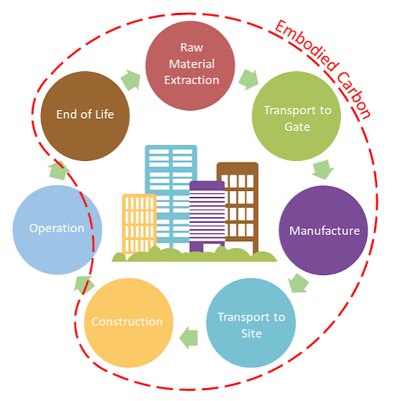
(Figure 3. Lifecycle Assessment (LCA) stages for whole-life carbon evaluation)

It is widely recognised as essential for net zero decision making (Cabeza et al., 2014; RICS, 2023a). However, several challenges persist:
- Inconsistent data quality - EPDs are not always available for specific products (Hoxha & Jusselme, 2020)
- Limited EPD availability - particularly for retrofit specific materials (BRE, 2021)
- Complexity of LCA tools - requiring specialist training (Giesekam & Pomponi, 2021)
- Lack of retrofit specific datasets - existing methodologies assume new build conditions (Arup, 2022)

Welsh School of Architecture (2024) argues that LCA must be adapted for retrofit, as traditional methodologies do not adequately capture the complexity of existing buildings.

This includes accounting for retained elements, which are often assumed to have zero embodied carbon despite having incurred emissions during their original manufacture.

2.3.3 Whole Life Costing and Carbon
Whole life costing (WLC) integrates capital, operational, maintenance, and end of life costs (El-Haram & Horner, 2002; RICS, 2023b). Increasingly, WLC is being combined with whole life carbon assessment to support balanced decision making (UKGBC, 2023; LETI, 2023).

LETI (2023) recommends carbon budgets for retrofit projects, encouraging practitioners to evaluate carbon cost trade-offs at each stage. This integration represents a significant opportunity for QSs to demonstrate their value in the net zero transition.

2.4 Housing Retrofit: Challenges and Opportunities

2.4.1 The UK Retrofit Challenge
Retrofit is widely recognised as one of the most complex areas of decarbonisation due to variability in building condition, construction type, and occupant behaviour (Killip, 2013; Fawcett & Killip, 2019). Persistent challenges include:
- Performance gaps between predicted and actual energy savings (Gupta & Gregg, 2018)
- Limited contractor capability (Energy Saving Trust, 2023)
- Fragmented supply chains (WRAP, 2020)
- Inconsistent client demand (PwC, 2023)
- Disruption to occupants (Morgan et al., 2024)

2.4.2 The Welsh Housing Context
Wales’s housing stock presents unique retrofit challenges:
- High proportion of pre-1919 solid wall homes
- Rural housing with limited contractor access
- Strong social housing sector with varying organisational capability
The Welsh School of Architecture (2024) emphasises that retrofit must balance decarbonisation with affordable warmth and occupant wellbeing.

2.4.3 Social Housing and ORP
Social landlords in Wales are at the forefront of retrofit delivery. ORP has introduced:
- Whole home assessment
- Digital twin modelling
- Fabric first interventions
- Lifecycle based decision making

However, ORP also demands significant data collection, reporting, and carbon literacy, which many organisations struggle to meet (Constructing Excellence Wales, 2024; CIH Cymru, 2023).

2.5 The Role of Quantity Surveyors in Carbon Reduction

2.5.1 Traditional QS Functions
QSs have historically focused on cost planning, procurement, value engineering, and financial control (Ashworth et al., 2013; Cartlidge, 2022). Their influence on project decisions makes them central to achieving cost effective carbon reduction (Potts & Ankrah, 2014).

2.5.2 Emerging Sustainability Responsibilities
RICS emphasises that QSs must develop competency in carbon literacy, carbon data interpretation, and carbon aware procurement (RICS, 2023a). The Supply Chain Sustainability School reports a 300% increase in QS enrolments for carbon literacy training between 2022 and 2024.

2.5.3 Barriers to QS Engagement
Studies consistently identify barriers limiting QS involvement in carbon assessment:
- Limited carbon literacy
- Insufficient data and EPD availability
- Inconsistent client demand
- Time and fee constraints
- Complexity of carbon tools

These barriers are amplified in retrofit projects due to uncertainty in existing building conditions (Gupta & Gregg, 2018).

2.6 Digital Tools and Data for Carbon Assessment
Digital tools such as BIM, One Click LCA, eTool, and EC3 are increasingly used to support carbon assessment (Eastman et al., 2018; One Click LCA, 2023). However, limitations persist:
- Incomplete BIM models for existing buildings (BIM4Housing, 2024)
- Lack of retrofit specific materials in carbon databases (Arup, 2024)
- Need for specialist training (Supply Chain Sustainability School, 2024)
- Variable data quality (Hoxha & Jusselme, 2020)

The Welsh Government’s ORP digital platform integrates whole home assessment, digital modelling, and carbon reporting, but requires further refinement to support QS workflows (Welsh Government, 2025).

2.7 Gaps in Existing Literature
Several gaps justify this study:
- Limited Wales specific research on QS practice in retrofit
- Insufficient empirical evidence on QS carbon literacy and confidence
- Lack of insight into how Welsh Government policy shapes QS workflows
- Minimal exploration of QS roles in ORP and WHQS 2023 delivery
- Limited understanding of barriers unique to Welsh housing stock

These gaps highlight the need for empirical research that captures the lived experiences of QSs working within Wales’s distinctive policy and housing context.

2.8 Summary
The literature highlights the urgency of decarbonising the built environment and the central role of QSs in supporting net zero construction. While Wales has developed ambitious retrofit policies, QS engagement with carbon assessment remains constrained by data limitations, skills gaps, and organisational challenges. Existing research provides valuable insight but lacks Wales specific empirical evidence, reinforcing the importance of this study.

CHAPTER 3 - METHODOLOGY

3.1 Introduction
This chapter outlines the methodological approach adopted for the study, including the research philosophy, design, data collection methods, sampling strategy, analytical techniques, and ethical considerations. The methodology was shaped by the need to understand both the breadth and depth of quantity surveyors’ (QSs) engagement with carbon assessment in Welsh housing retrofit. Given the complexity of the topic involving policy, organisational capability, professional judgement, and technical knowledge, a mixed methods approach was selected to generate rich and meaningful insights (Creswell & Creswell, 2018; Tashakkori & Teddlie, 2010).

The chapter begins by establishing the philosophical foundations of the research before detailing the specific methods employed and justifying their selection. The rationale for each methodological choice is articulated, and the limitations of the approach are acknowledged transparently.

This structure ensures that the methodology is not only descriptive but also critically reflective, aligning with Level 7 expectations for methodological rigour.

3.2 Research Philosophy

3.2.1 Pragmatism as the Guiding Philosophy
The study is grounded in pragmatism, a research philosophy that prioritises practical solutions and recognises that no single paradigm can fully capture complex real world phenomena (Creswell & Creswell, 2018). Pragmatism is particularly suited to construction research, where problems are multifaceted, context specific, and influenced by policy, organisational behaviour, and professional judgement (Tashakkori & Teddlie, 2010). Unlike positivism, which assumes a single objective reality, or interpretivism, which emphasises subjective meaning, pragmatism accepts that different research questions may require different approaches.

Pragmatism allows the researcher to draw on both positivist and interpretivist traditions. The quantitative survey reflects a positivist orientation, seeking measurable patterns in QS practice, while the qualitative interviews reflect an interpretivist orientation, exploring lived experiences and professional perspectives. This duality aligns with arguments that mixed methods research is most effective when addressing applied, real world problems (Tashakkori & Teddlie, 2010).

3.2.2 Ontological and Epistemological Positioning
Pragmatism adopts a flexible ontological stance, recognising that reality can be both singular and multiple depending on the context (Creswell & Creswell, 2018). In this study, carbon assessment is treated as both:
- An objective process, quantifiable through tools and data; and
- A subjective experience, interpreted differently by QSs depending on training, organisational culture, and project context.

Epistemologically, pragmatism supports the use of diverse data sources, acknowledging that knowledge emerges from the interaction between researcher, participants, and context (Tashakkori & Teddlie, 2010). This positioning is particularly relevant in retrofit research, where uncertainty, incomplete data, and professional judgement play significant roles (Gupta & Gregg, 2018).

This philosophical stance is especially appropriate given the policy driven nature of Welsh housing retrofit, where QSs must adapt rapidly to evolving expectations under ORP and WHQS 2023.

3.3 Research Design
A mixed methods design was adopted, combining quantitative and qualitative approaches to provide a comprehensive understanding of QS engagement with carbon assessment. Mixed methods research is widely recognised for its ability to strengthen validity through triangulation and provide richer interpretations of complex issues (Creswell & Creswell, 2018).

3.3.1 Justification for Mixed Methods
The decision to use mixed methods was driven by three key considerations:
- Complexity of the research topic Carbon assessment involves technical knowledge, professional judgement, organisational capability, and policy interpretation (RICS, 2023a; UKGBC, 2023). No single method can adequately capture this complexity.
- Need for both breadth and depth the survey provides breadth by capturing patterns across QSs in Wales, while interviews provide depth by exploring individual experiences (Creswell & Creswell, 2018).
- Alignment with industry practice Construction decision making often combines quantitative data (costs, carbon metrics) with qualitative judgement (client priorities, organisational culture) (Potts & Ankrah, 2014). A mixed methods approach mirrors this reality.

3.3.2 Sequential Explanatory Design
A sequential explanatory design was used, where quantitative data collection preceded qualitative interviews. This allowed interview questions to be informed by survey findings, strengthening coherence and enabling deeper exploration of emerging themes (Creswell & Creswell, 2018).

The survey provided a broad overview of QS knowledge, confidence, practice, and perceptions of barriers. Interview questions were then developed based on survey findings, allowing the researcher to probe specific issues in greater depth.

This sequential approach ensured that the research was both comprehensive and coherent, with each phase building on the findings of the previous phase.

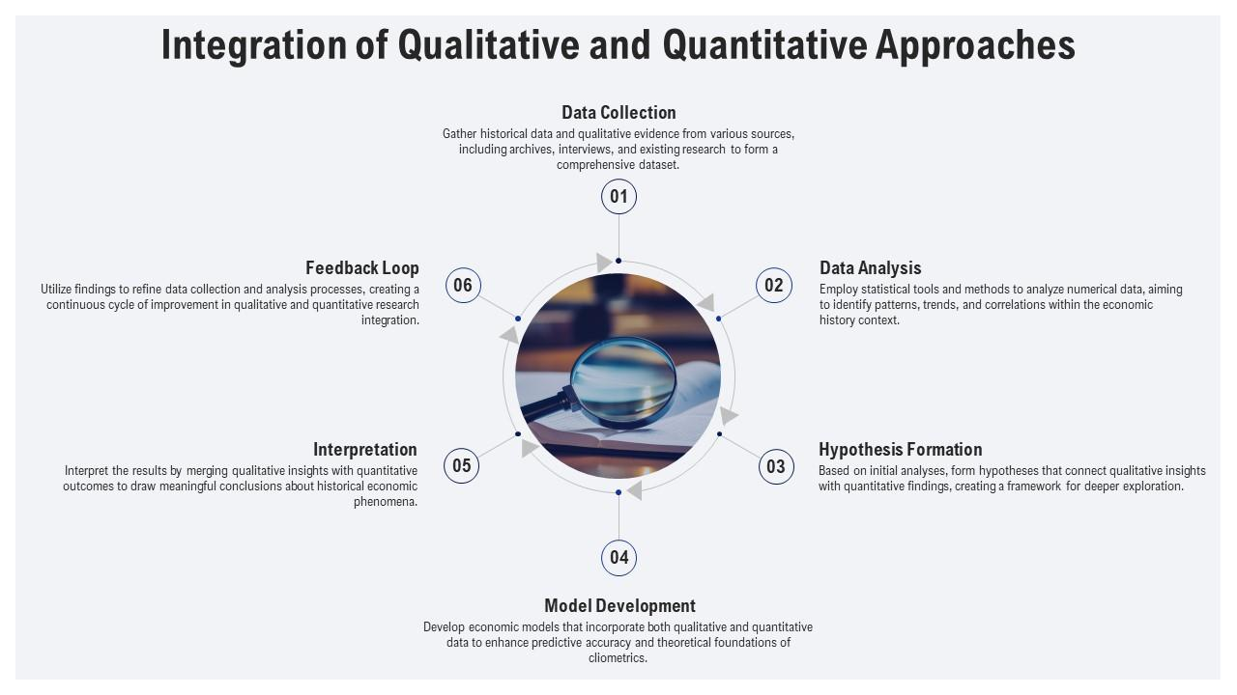
(Figure 4. Design chart showing quantitative data collection followed by qualitative exploration and integration)

3.4 Data Collection Methods

3.4.1 Quantitative Survey
A structured online survey was distributed to QS practitioners working in Wales across consultancy, contracting, and social housing organisations. The survey included:
- Demographic questions (role, experience, sector)
- Likert scale questions (confidence levels, frequency of carbon tool use)
- Multiple choice questions (training, barriers, organisational support)
- Closed questions relating to ORP and WHQS 2023 involvement

The survey was designed using Dillman’s Tailored Design Method to ensure clarity, accessibility, and relevance (Dillman, 2014). Questions were aligned with RICS guidance on carbon assessment and Welsh Government policy (RICS, 2023a; Welsh Government, 2023).

Pilot testing with two QS practitioners ensured clarity and relevance. The survey was distributed through professional networks, LinkedIn, direct email, and snowball sampling.

3.4.2 Qualitative Interviews
Semi structured interviews were conducted with QSs to explore:
- Perceptions of carbon assessment
- Organisational expectations
- Barriers and enablers
- Experiences with ORP and Welsh Government policy
- Views on training, data, and digital tools

Semi structured interviews allow participants to express their experiences in depth while providing enough structure to ensure consistency across interviews (Creswell & Creswell, 2018). Interviews lasted 30–60 minutes and were conducted online to maximise accessibility.

The interview guide was developed based on survey findings and refined following pilot interviews. Open ended questions encouraged participants to share experiences, while prompts allowed deeper exploration of specific themes.

3.4.3 Instrument Development
Survey and interview instruments were developed through:
- Review of existing literature (Pomponi & Moncaster, 2017; Killip, 2013)
- Alignment with RICS and Welsh Government guidance
- Pilot testing with QS practitioners
- Refinement based on feedback

This ensured that questions were relevant, clear, and aligned with the study’s objectives.

3.5 Sampling Strategy
A purposive sampling strategy was used to ensure participants had relevant experience in Welsh housing retrofit. The sample included QSs from:
- Social landlords
- Private QS consultancies
- Main contractors
- Retrofit delivery teams
- ORP aligned organisations

Purposive sampling is appropriate when the aim is to gather insight from individuals with specific knowledge or experience (Tashakkori & Teddlie, 2010).

3.5.1 Sample Size Considerations
The sample size was influenced by:
- Availability of QSs with retrofit experience
- Organisational willingness to participate
- Time constraints
- Ethical considerations

While modest, the sample size reflects typical participation levels in construction research, where practitioner availability is limited (Creswell & Creswell, 2018).

3.5.2 Inclusion and Exclusion Criteria
Included:
- QSs working in Wales
- QSs involved in retrofit or decarbonisation projects
- QSs with ORP or WHQS 2023 experience

Excluded:
- QSs working exclusively outside Wales
- Non QS professionals
- Students without professional experience

3.6 Data Analysis

3.6.1 Quantitative Analysis
Survey data were analysed using descriptive statistics:
- Frequency distributions
- Percentages
- Mean confidence scores
- Ranking of barriers

Descriptive analysis is suitable for identifying patterns and summarising respondent characteristics (Creswell & Creswell, 2018). Data were analysed using Excel.

3.6.2 Qualitative Analysis
Interview transcripts were analysed using thematic analysis (Braun & Clarke, 2006):
- Familiarisation
- Coding
- Generating initial themes
- Reviewing themes
- Defining and naming themes
- Producing the narrative

Themes were developed inductively to reflect participants’ lived experiences. Coding was conducted manually to ensure close engagement with the data.

3.6.3 Triangulation
Triangulation strengthened validity by comparing survey results with interview findings (Tashakkori & Teddlie, 2010). This helped identify areas of convergence and divergence.

Triangulation also enhanced credibility by demonstrating that findings were supported by multiple data sources.

3.7 Validity, Reliability and Trustworthiness
Several strategies enhanced research quality:
- Triangulation
- Clear audit trail
- Member checking
- Alignment with RICS and Welsh Government frameworks
- Reflexivity
- Pilot testing
- Thick description

The researcher maintained a reflexive journal to minimise bias and document decision making.

3.8 Ethical Considerations
Ethical approval was obtained through the university’s ethics process. Key principles included:
- Informed consent
- Confidentiality and anonymity
- Voluntary participation
- GDPR compliant data storage
- Secure handling of digital recordings
- Transparency regarding research aims

Participants could withdraw at any time without consequence.

3.9 Limitations of the Methodology
Limitations include:
- Modest sample size
- Reliance on self-reported data
- Limited generalisability beyond Wales
- Evolving policy landscape
- Time constraints
- Limited ability to conduct inferential statistics
- Potential participant bias due to policy pressures

Despite these limitations, the mixed methods approach provides a robust foundation for understanding QS engagement with carbon assessment.

3.10 Summary
This chapter has outlined the pragmatic mixed methods approach used to explore QS practice in Welsh housing retrofit. The combination of survey and interview data provides a comprehensive understanding of both measurable trends and deeper professional insights. The next chapter presents the findings from the survey and interviews.

CHAPTER 4 - FINDINGS

4.1 Introduction
This chapter presents the findings from the mixed methods research, combining quantitative survey data from 50 quantity surveyors (QSs) with qualitative insights from eight semi structured interviews with senior practitioners. The results provide a detailed understanding of how QSs in Wales engage with carbon assessment within the housing retrofit sector, the barriers they face, and the influence of Welsh Government policy on professional practice.

The findings are organised thematically, beginning with the participant profile before exploring carbon literacy and awareness, confidence levels, use of carbon tools and data, organisational culture and support, the influence of Welsh Government policy, and the barriers and opportunities facing QSs. Throughout, the findings are presented with reference to both the quantitative survey data and the qualitative insights from interviews, with direct quotations used to illustrate key themes.

This chapter provides the empirical foundation for the discussion that follows, allowing the subsequent analysis to be grounded in the lived experiences and measurable patterns of QS practice in Wales.

4.2 Participant Profile
Survey respondents represented a diverse cross section of QS roles across Wales, including practitioners from:
- Social housing organisations working directly on ORP funded projects
- Private QS consultancies providing services to the social housing sector
- Main contractors delivering retrofit projects
- Retrofit delivery teams engaged in Welsh Government funded programmes

Respondents varied in experience, ranging from early career QSs with less than two years’ experience to senior practitioners with more than twenty years in the industry. The majority reported involvement in projects aligned with the Optimised Retrofit Programme (ORP) or Welsh Housing Quality Standard (WHQS) 2023, indicating that the sample reflects practitioners actively engaged in Wales’s decarbonisation agenda.

A smaller proportion worked primarily on private residential or commercial projects, offering insight into differences between public and private sector expectations. This distribution reflects the broader composition of the QS profession in Wales, where consultancies and contractors play a significant role in supporting social landlords.

The diversity of roles and experience strengthens the validity of the findings, ensuring that the results capture both strategic and operational perspectives across the retrofit sector.

4.3 Carbon Literacy and Awareness

4.3.1 Understanding of Carbon Concepts
Survey results indicated that QSs generally understood basic carbon concepts such as embodied carbon, operational carbon, and lifecycle assessment. However, understanding varied significantly between individuals. While some respondents demonstrated strong awareness, others described their knowledge as “surface level” or “developing.”

Interview participants reinforced this pattern. One QS explained:
“We hear the terms all the time now such as embodied carbon, lifecycle carbon but we’re not trained in it. We’re learning as we go.”

Another noted: “Carbon literacy is improving, but it’s not yet part of our core skillset. I can talk about it, but I couldn’t calculate it confidently.”

These findings align with literature suggesting that QSs recognise the importance of carbon reduction but lack structured training (Supply Chain Sustainability School, 2024; Opoku, 2019).

The gap between awareness and competence is a recurring theme, suggesting that carbon literacy is emerging but not yet embedded within QS professional identity.

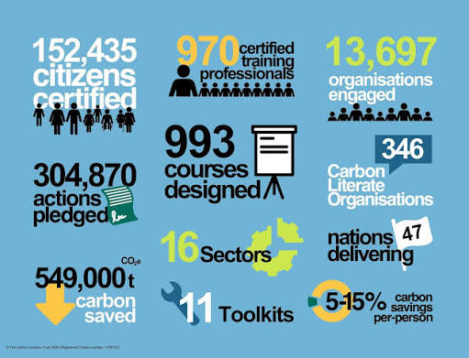
(Figure 5. Carbon literacy awareness levels illustrating the gap between basic understanding and deeper competence)

*My findings for this section can be found in the appendix at the end of this document.

CHAPTER 5 - DISCUSSION

5.1 Introduction
This chapter interprets the findings presented in Chapter 4 and situates them within the wider literature on carbon assessment, retrofit practice, and the evolving role of quantity surveyors (QSs). The discussion highlights areas of alignment and divergence between empirical findings and existing research, providing a deeper understanding of the challenges and opportunities facing QSs in Wales. It also explores how Welsh Government policy, organisational capability, and digital tools shape QS engagement with carbon assessment.

The overarching argument developed throughout this chapter is that Welsh Government policy has succeeded in creating demand for carbon integration, but the profession is not yet equipped to deliver on this demand at scale. This capability gap is the result of a combination of factors: limited training and skills development, inadequate data infrastructure, insufficient digital tool adoption, and organisational constraints that are particularly acute in the Welsh context.

This chapter therefore acts as a bridge between the empirical findings and the recommendations that follow, demonstrating how the evidence aligns with and challenges existing theoretical and policy assumptions.

5.2 Carbon Literacy and Professional Capability

5.2.1 Alignment with Existing Literature
The findings confirm that QSs possess a basic understanding of carbon concepts but lack deeper carbon literacy and confidence in applying carbon tools. This aligns with previous studies indicating that QSs often feel underprepared to undertake carbon calculations or interpret Environmental Product Declarations (EPDs) (Giesekam & Pomponi, 2021; BRE, 2021). The Supply Chain Sustainability School (2024) similarly reports that QSs are increasingly aware of carbon issues but lack structured training.

The RICS Global Sustainability Report (2025) provides important context for this finding. The report found that:
- 46% of construction professionals do not measure embodied carbon
- Only 16% report that carbon measurement meaningfully informs material choices
- Familiarity with circular economy practices remains low

These statistics mirror the findings of this study, where QSs described carbon assessment as “complex,” “specialist,” and “outside our traditional role.”

The consistency between the Welsh findings and global trends suggests that the capability gap is systemic rather than localised, reinforcing the need for profession wide intervention.

5.2.2 Sectoral Variation in Capability
The variation in carbon literacy across sectors, which is higher in social housing, lower in contracting, reflects differences in policy exposure and organisational priorities. Social landlords are subject to ORP and WHQS 2023 requirements, which mandate carbon related reporting and whole home assessment. Contractors, by contrast, often operate within cost driven environments where carbon assessment is not explicitly required.

This supports Opoku’s (2019) argument that sustainability adoption within QS practice is heavily influenced by organisational culture and client expectations. It also aligns with Arif & Egbu (2010), who emphasise the role of leadership in embedding sustainability within organisational processes.

5.2.3 Implications for QS Practice
The findings suggest that QSs are willing to engage with carbon assessment but require:
- Structured training
- Clearer guidance
- Improved access to carbon tools
- Wales specific datasets

These needs align with calls from RICS (2023a) and UKGBC (2023) for enhanced professional capability to support net zero construction.

The evidence indicates that QSs are not resistant to carbon integration; rather, they lack the resources, training, and organisational support required to deliver it effectively.

5.3 Digital Tools and Data Infrastructure

5.3.1 Limited Adoption of Carbon Tools
The study found that most QSs rarely use carbon tools such as One Click LCA, EC3, or eTool. This mirrors industry reports highlighting limited digital adoption across QS practice (Arup, 2022; One Click LCA, 2023). Barriers identified; lack of training, time constraints, licence costs, and data limitations, which are consistent with findings from BIM4Housing (2024) and Hoxha & Jusselme (2020).

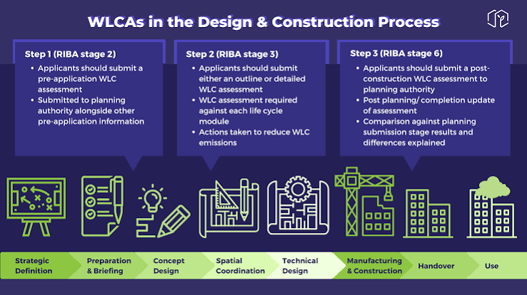
(Figure 6: Whole Life Carbon Assessment framework illustrating lifecycle stages and carbon measurement boundaries)

The UK Government’s research on embodied carbon (MHCLG, 2025) reinforces this message, noting that:
- Embodied carbon remains poorly understood
- Data gaps persist throughout the measurement process
- Carbon tools require specialist knowledge

The Welsh findings therefore reflect broader national challenges, suggesting that digital capability is a critical bottleneck in carbon assessment.

5.3.2 Data Quality and Availability
QSs reported significant challenges relating to data quality, including:
- Inconsistent carbon factors
- Limited EPD availability
- Incomplete retrofit datasets
- Poor BIM model quality

These findings reinforce literature emphasising the need for improved data infrastructure (Cabeza et al., 2014; Giesekam & Pomponi, 2021). The UKGBC Whole Life Carbon Modelling Forum (2025) identified “the lack of consistent, centralised data” as a critical issue, noting that practitioners often rely on fragmented databases or assumptions.

The Welsh context adds additional complexity. As Perisoglou, Patterson and Ionas (2025) found in their study of South Wales bungalows, carbon calculations often rely on generic ICE database factors due to a lack of product specific EPDs.

5.3.3 Implications for Digital Transformation
The findings suggest that digital transformation in QS practice is constrained by:
- Organisational capability
- Resource limitations
- Lack of Wales specific datasets
- Limited integration between cost and carbon tools

These constraints indicate that digital adoption cannot be left to individual organisations; sector wide investment and coordinated policy support are required.

5.4 Organisational Culture and Sector Variation

5.4.1 Influence of Organisational Priorities
The study found that organisational culture significantly influences QS engagement with carbon assessment. Social landlords demonstrated higher engagement due to ORP requirements, while contractors and private consultancies showed lower engagement due to inconsistent client demand.

This aligns with Arif & Egbu (2010) and Bhamra & Dani (2011), who emphasise the role of organisational culture in sustainability adoption. It also reflects PwC’s (2023) analysis of market constraints affecting sustainability uptake.

5.4.2 Sector Specific Challenges
Sector variation reflects differences in:
- Policy exposure
- Digital capability
- Training investment
- Organisational priorities

These findings support literature highlighting the fragmented nature of the construction sector (WRAP, 2020). They also align with WCPP (2026), which emphasises the need for coordinated policy implementation across tenures.

The evidence suggests that carbon integration is uneven across the sector, with social housing leading and private contracting lagging, a pattern that may widen without targeted intervention.

5.5 Influence of Welsh Government Policy

5.5.1 ORP as a Catalyst for Change
The study found that ORP is the most significant driver of carbon engagement among QSs. ORP’s emphasis on whole home assessment, digital modelling, and lifecycle thinking aligns with Welsh Government’s ambition to embed carbon reduction into retrofit delivery.

The scale of ORP investment, which is more than £466 million since 2020, has created strong incentives for organisations to develop carbon capability. ORP’s requirement for Target Energy Pathways (TEPs), PAS 2035 compliance, and digital monitoring has reshaped QS workflows.

5.5.2 WHQS 2023 and Net Zero Wales
WHQS 2023 was described as a major shift requiring QSs to integrate carbon considerations into long term asset management. However, interview participants expressed concern about:
- Unclear carbon requirements
- Inconsistent interpretation
- Lack of Wales specific data

Net Zero Wales sets the strategic direction but lacks detailed guidance for QSs. This mirrors the RICS (2025) finding that policy ambition is outpacing professional capability.

The evidence suggests that Welsh Government policy is effective at creating demand but less effective at supporting delivery, resulting in a widening implementation gap.

5.6 Barriers to QS Engagement

5.6.1 Data Limitations
Data limitations were consistently identified as the most significant barrier. This aligns with literature emphasising the need for improved carbon data quality (BRE, 2021; UKGBC, 2025).

5.6.2 Skills Gaps
QSs reported limited carbon literacy and confidence in carbon tools. This supports findings from the Supply Chain Sustainability School (2024) and CIOB (2024).

5.6.3 Organisational Constraints
Time pressures, fee limitations, and unclear client expectations were identified as major barriers. These findings align with PwC (2023) and RICS (2025).

5.6.4 Retrofit Complexity
Retrofit introduces uncertainty due to hidden defects, variable building fabric, and occupant behaviour. This complexity is widely recognised in retrofit literature (Killip, 2013; Gupta & Gregg, 2018).

Collectively, these barriers demonstrate that QS engagement with carbon assessment is constrained by structural, organisational, and technical challenges that require coordinated intervention.

5.7 Opportunities for QSs in Net Zero Retrofit
Despite barriers, the findings highlight several opportunities for QSs:

5.7.1 Early Stage Carbon Advice
QSs can influence carbon outcomes through early stage cost planning and value engineering. This aligns with Ashworth et al. (2013) and Cartlidge (2022).

5.7.2 Carbon Aware Procurement
QSs can support carbon reduction by specifying low carbon materials and evaluating supplier EPDs. This aligns with UKGBC (2023) and LETI (2023).

5.7.3 Lifecycle Based Cost Planning
QSs can combine whole life costing with whole life carbon assessment to support balanced decision making.

5.7.4 Digital Integration
QSs can leverage digital tools to improve carbon assessment accuracy and integrate cost and carbon workflows.

These opportunities suggest that QSs are well positioned to play a central role in net zero retrofit if capability gaps are addressed.

5.8 Summary
The discussion highlights that QSs in Wales recognise the importance of carbon assessment but face significant barriers relating to data, skills, digital capability, and organisational culture. Welsh Government policy, particularly ORP and WHQS 2023, is driving change, but capability development has not yet caught up.

The evidence suggests that transformation across QS practice, organisational capability, and policy implementation is necessary to deliver net zero housing retrofit at scale.

CHAPTER 6 - CONCLUSION

6.1 Introduction
This chapter presents the overall conclusions of the study, drawing together the key findings from the literature review, survey results, and interview insights. It summarises how quantity surveyors (QSs) in Wales currently engage with carbon assessment, the barriers they face, and the opportunities emerging from Welsh Government policy and industry developments. The conclusions highlight the implications for QS practice, organisational capability, and the wider retrofit sector, and offer reflections on the future direction of carbon aware construction in Wales.

The chapter is structured to first summarise the key findings from the empirical research, before exploring the implications for QSs, organisations, and policymakers. It then reflects on the limitations of the study and offers recommendations for future research and practice.

This conclusion reinforces the central argument of the dissertation: Welsh Government policy has successfully created demand for carbon integration, but the profession is not yet equipped to deliver on this demand at scale. Addressing this capability gap is essential for achieving Wales’s net zero ambitions.

6.2 Summary of Key Findings

6.2.1 Carbon Literacy and Professional Capability
The study found that QSs possess a basic understanding of carbon concepts but lack deeper carbon literacy and confidence in applying carbon tools. While most respondents were familiar with terms such as embodied carbon, operational carbon, and lifecycle assessment, fewer felt confident interpreting Environmental Product Declarations (EPDs) or conducting carbon calculations.

This finding aligns with wider industry evidence. The RICS Global Sustainability Report (2025) found that:
- 46% of construction professionals do not measure embodied carbon
- Only 16% report that carbon measurement meaningfully informs material choices
- Familiarity with circular economy practices remains low

These statistics mirror the Welsh context, where QSs described carbon assessment as “complex,” “specialist,” and “outside our traditional role.”

The evidence suggests that carbon literacy is emerging but not yet embedded within QS professional identity, creating a gap between policy expectations and professional capability.

6.2.2 Digital Tools and Data Limitations
QSs reported limited use of carbon tools such as One Click LCA, EC3, and eTool. Barriers included:
- Lack of training
- Time constraints
- Licence costs
- Inconsistent data availability
- Poor BIM model quality

These findings highlight the need for improved digital capability and data infrastructure to support accurate carbon assessment. The UKGBC Whole Life Carbon Modelling Forum (2025) identified “the lack of consistent, centralised data” as a critical issue, noting that practitioners often rely on fragmented databases or assumptions.

The Welsh context adds additional complexity. As Perisoglou, Patterson and Ionas (2025) found in their study of South Wales bungalows, carbon calculations often rely on generic ICE database factors due to a lack of product specific EPDs.

The digital capability gap is therefore both technical and structural, requiring coordinated intervention rather than isolated organisational effort.

6.2.3 Organisational Culture and Sector Variation
Organisational culture significantly influences QS engagement with carbon assessment. Social landlords demonstrated higher engagement due to ORP requirements, while contractors and private consultancies showed lower engagement due to inconsistent client demand.
This variation reflects differences in:
- Policy exposure
- Digital capability
- Training investment
- Organisational priorities

These findings align with literature emphasising the role of organisational culture in sustainability adoption (Arif & Egbu, 2010; Bhamra & Dani, 2011).

The evidence suggests that carbon integration is uneven across the sector, with social housing leading and private contracting lagging, a pattern that may widen without targeted intervention.

6.2.4 Influence of Welsh Government Policy
Welsh Government policy, in particular ORP and WHQS 2023, is driving change across the retrofit sector. ORP was consistently identified as the most significant driver of carbon engagement among QSs, embedding whole home assessment, digital modelling, and lifecycle thinking into retrofit delivery.
However, interview participants expressed concern about:
- Unclear carbon requirements
- Inconsistent interpretation
- Lack of Wales specific data
- Limited technical guidance

Net Zero Wales sets the strategic direction but lacks detailed guidance for QSs. This mirrors the RICS (2025) finding that policy ambition is outpacing professional capability.

Policy ambition is high, but the implementation gap remains significant, particularly in relation to data, training, and technical guidance.

6.2.5 Retrofit Complexity and the Scale of the Challenge
Retrofit introduces significant uncertainty due to:
- Hidden defects
- Variable building fabric
- Occupant behaviour
- Incomplete historical data

These challenges make carbon assessment more complex than in new build contexts and require QSs to adapt their workflows accordingly.

The scale of the retrofit challenge in Wales is considerable. The Welsh Zero Carbon Hwb (2025) estimates that:
- 1.5 million homes require retrofit
- 142 homes per day must be retrofitted for the next 25 years
- 27,000 new retrofit roles are needed by 2030

This scale of demand places QSs at the centre of Wales’s net zero transition but also highlights the urgency of capability development.

6.3 Implications for Quantity Surveyors

6.3.1 Expanding Professional Competence
QSs must expand their professional competence to include:
- Carbon literacy
- Carbon aware cost planning
- Interpretation of EPDs
- Lifecycle based decision making
- Digital tool proficiency

This aligns with RICS guidance emphasising the need for QSs to integrate carbon considerations into traditional cost focused workflows (RICS, 2023a; RICS, 2023b).

The evidence suggests that QSs are not resistant to carbon integration; rather, they lack the resources, training, and organisational support required to deliver it effectively.

6.3.2 Early Stage Influence
QSs have significant influence at early project stages, where carbon impacts are greatest. By integrating carbon considerations into early stage cost planning and value engineering, QSs can support more sustainable decision making.

6.3.3 Carbon Aware Procurement
QSs can support carbon reduction through:
- Specifying low carbon materials
- Evaluating supplier EPDs
- Integrating carbon criteria into tender documents

This aligns with emerging QS roles in net zero construction (UKGBC, 2023; LETI, 2023).

6.3.4 Professional Identity and Future Role
The findings suggest that QSs are at a crossroads. The profession can either:
- Evolve to become central to carbon aware decision making, or
- Risk marginalisation as sustainability specialists take on carbon related responsibilities.

The future identity of the QS profession will depend on its ability to integrate carbon literacy into core practice.

6.4 Implications for Organisations

6.4.1 Training and Capability Building
Organisations must invest in structured carbon literacy training to support QS capability development. Training should be embedded into professional development pathways and aligned with Welsh Government policy.

6.4.2 Digital Infrastructure
Organisations must improve digital infrastructure by:
- Adopting carbon tools
- Improving BIM model quality
- Integrating cost and carbon workflows
- Investing in data management systems

6.4.3 Policy Alignment
Organisations must align their workflows with Welsh Government policy, particularly ORP and WHQS 2023. Clearer guidance and sector wide collaboration will support consistent interpretation and implementation.

Organisational capability is therefore a critical determinant of QS engagement with carbon assessment.

6.5 Implications for Welsh Government and Industry Bodies

6.5.1 Wales Specific Carbon Data
There is a need for Wales specific carbon datasets to support accurate carbon assessment in retrofit contexts. Welsh Government should collaborate with industry bodies to develop and maintain these datasets.

6.5.2 Clearer Technical Guidance
Welsh Government should provide clearer technical guidance to support QS workflows, including:
- Carbon calculation methodologies
- Data requirements
- Reporting standards
- Procurement guidance

6.5.3 Sector Wide Capability Building
Welsh Government should support sector wide capability building through:
- Funded training programmes
- Digital investment
- Collaborative platforms
- Knowledge sharing initiatives

6.5.4 Policy Alignment Across Tenures
Welsh Government should ensure consistent carbon requirements across:
- Social housing
- Private rental
- Owner occupied homes

Policy alignment will be essential to achieving net zero retrofit at scale.

6.6 Overall Conclusion
The study concludes that QSs in Wales recognise the importance of carbon assessment but face significant barriers relating to data, skills, digital capability, and organisational culture. Welsh Government policy, in particular ORP and WHQS 2023, is driving change, but capability development has not yet caught up.

QSs have significant opportunities to support net zero housing retrofit through:
- Early stage carbon advice
- Carbon aware procurement
- Lifecycle based cost planning
- Digital integration

However, these opportunities can only be realised if capability gaps are addressed through coordinated action across QS practice, organisational capability, Welsh Government policy, and industry collaboration.

The future of net zero retrofit in Wales depends on the ability of QSs and the organisations that support them to integrate carbon literacy into everyday practice. Without this transformation, Wales’s ambitious decarbonisation targets will remain out of reach.

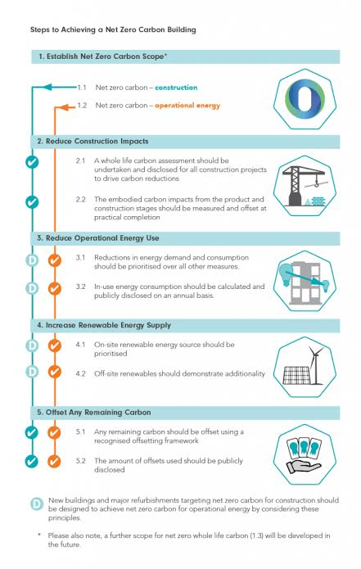
(Figure 7. UKGBC Net Zero Carbon Buildings Framework illustrating the system wide requirements for achieving net-zero outcomes)

6.7 Reflections on the Research
This study has provided a detailed picture of QS engagement with carbon assessment in Welsh housing retrofit. However, it has several limitations:
- Modest sample size
- Reliance on self-reported data
- Evolving policy landscape
- Limited generalisability beyond Wales

Future research could explore:
- Longitudinal studies of QS capability development
- Comparative studies between Wales and other UK nations
- Evaluation of training interventions
- Client perspectives on carbon assessment
- Supply chain capacity for carbon data

Despite these limitations, the study contributes valuable evidence to inform policy and practice in Wales and highlights the central role of QSs in delivering net zero housing retrofit.

CHAPTER 7 - RECOMMENDATIONS

7.1 Introduction
This chapter presents recommendations arising from the study’s findings and discussion. The recommendations are structured around four key stakeholder groups: quantity surveyors (QSs), organisations, Welsh Government, and industry bodies. They aim to strengthen carbon literacy, improve digital capability, enhance data quality, and support consistent implementation of Welsh Government policy across the retrofit sector.

The recommendations reflect the need for coordinated action to deliver net zero housing retrofit at scale. The findings from Chapters 4 and 5 demonstrate that while Welsh Government policy has successfully created demand for carbon aware practice, the profession is not yet equipped to deliver on this demand.

This chapter therefore translates the evidence into practical, actionable steps that can be implemented across the sector, ensuring that QSs are positioned to play a central role in Wales’s decarbonisation agenda.

7.2 Recommendations for Quantity Surveyors

7.2.1 Strengthen Carbon Literacy
QSs should undertake structured carbon literacy training to improve understanding of:
- Embodied and operational carbon
- Environmental Product Declarations (EPDs)
- Lifecycle assessment (LCA) methodologies
- Carbon calculation methodologies
- Whole life carbon reporting requirements

This aligns with calls from RICS (2023a), CIOB (2024), and the Supply Chain Sustainability School (2024) for enhanced professional capability. The RICS Global Sustainability Report (2025) found that familiarity with whole life carbon remains low across the profession, despite increasing policy pressure.

Carbon literacy must become a core competency for QSs, comparable to cost planning or procurement. Without this shift, QSs risk being marginalised as sustainability specialists take on carbon related responsibilities.

7.2.2 Develop Competence in Carbon Tools
QSs should gain proficiency in carbon assessment tools such as:
- One Click LCA
- EC3
- eTool
- ORP digital platform

Digital capability is essential for integrating carbon into cost planning and procurement. The AECOM report for MHCLG (2025) found that cost and knowledge of carbon tools prevent widespread uptake, particularly among SMEs.

QSs should also familiarise themselves with emerging resources such as the UKGBC Whole Life Carbon Modelling Forum’s shared materials database, which provides consistent early stage carbon data.

7.2.3 Integrate Carbon into Early Stage Cost Planning
QSs should incorporate carbon considerations into:
- Feasibility studies
- Cost plans
- Value engineering
- Option appraisals

Early stage influence is critical because carbon impacts are greatest at project inception. The ORP programme’s focus on “optimising” rather than simply minimising cost creates opportunities for QSs to provide strategic advice on carbon reduction.

7.2.4 Adopt Carbon Aware Procurement Practices
QSs should:
- Specify low carbon materials
- Evaluate supplier EPDs
- Include carbon criteria in tender documents
- Assess lifecycle carbon impacts of procurement decisions

This aligns with UKGBC (2023) and LETI (2023) guidance on carbon aware procurement. QSs should also consider circular economy approaches, including reuse of materials where feasible.

7.2.5 Strengthen Communication and Engagement Skills
QSs should develop communication skills to support tenant engagement and stakeholder collaboration. Research by Morgan, Maddock and Musselwhite (2024) highlights the importance of communication in retrofit delivery, particularly in social housing.

QSs must be able to explain carbon implications clearly to clients, contractors, and residents, ensuring that carbon aware decisions are understood and supported.

7.3 Recommendations for Organisations

7.3.1 Invest in Training and Professional Development
Organisations should provide structured carbon literacy training for QSs and other project professionals. Training should be:
- Mandatory for QSs working on retrofit projects
- Role specific
- Aligned with Welsh Government policy
- Embedded into CPD pathways

The Carbon Hwb (2025) highlights the scale of the skills challenge, noting that 27,000 new retrofit roles are needed in Wales by 2030.

7.3.2 Improve Digital Infrastructure
Organisations should invest in:
- Carbon assessment tools
- BIM capability for retrofit projects
- Data management systems
- Integration between cost and carbon workflows

Digital transformation is essential for accurate carbon assessment and reporting. The UKGBC (2025) shared materials database represents a step towards addressing data consistency challenges.

7.3.3 Strengthen Organisational Culture Around Carbon
Organisations should embed carbon reduction into:
- Corporate strategies
- Project governance
- Procurement policies
- Performance metrics

A strong organisational culture supports consistent carbon engagement. The RICS (2025) report found that initial costs and lack of ROI evidence are major deterrents to sustainable investment, suggesting that organisations must build a stronger business case for carbon reduction.

7.3.4 Improve Data Collection and Management
Organisations should:
- Collect high quality building data
- Maintain accurate asset information
- Improve survey processes
- Standardise data formats

Data quality is essential for reliable carbon assessment. The MHCLG (2025) research found significant gaps in EPD availability, particularly for retrofit specific materials.

Organisations must treat data as a strategic asset, investing in systems and processes that support accurate carbon assessment.

7.4 Recommendations for Welsh Government

7.4.1 Provide Clearer Technical Guidance
Welsh Government should develop detailed technical guidance for QSs, including:
- Carbon calculation methodologies
- Data requirements
- Reporting standards
- Procurement guidance

Clearer guidance will support consistent implementation of ORP and WHQS 2023. The RICS (2025) report recommends mandatory whole life carbon reporting for all construction projects.

7.4.2 Develop Wales Specific Carbon Datasets
Welsh Government should collaborate with industry bodies to develop Wales specific datasets that reflect:
- Local materials
- Local supply chains
- Welsh construction methods
- Retrofit specific carbon factors

This aligns with recommendations from Woodknowledge Wales (2025; 2026). Wales’s unique housing stock, particularly pre -1919 solid wall homes, requires tailored carbon data.

7.4.3 Invest in Sector Wide Capability Building
Welsh Government should support:
- Funded training programmes
- Digital investment
- Collaborative platforms
- Knowledge sharing initiatives

The Carbon Hwb (2025) has developed CPD accredited training modules for retrofit professionals. Welsh Government should expand this model to QSs.

7.4.4 Strengthen Policy Alignment Across Tenures
Welsh Government should ensure consistent carbon requirements across:
- Social housing
- Private rental
- Owner occupied homes

ORP is intended to act as proof of concept for approaches to both fabric and technology retrofit. Policy alignment across tenures will support sector wide adoption of carbon aware practices.

7.4.5 Introduce Carbon Linked Funding Conditions
Welsh Government should link funding to:
- Carbon reporting compliance
- Use of accredited carbon tools
- Demonstration of carbon literacy within project teams

Funding conditions can act as powerful levers for behaviour change, ensuring that carbon assessment becomes embedded within project delivery.

7.5 Recommendations for Industry Bodies

7.5.1 Enhance Professional Guidance
Industry bodies such as RICS, CIOB, UKGBC, and BRE should:
- Update carbon guidance
- Provide retrofit specific methodologies
- Develop QS focused carbon tools
- Support professional training

The UKGBC (2025) shared materials database represents a positive step towards standardisation.

7.5.2 Improve Access to Carbon Tools
Industry bodies should:
- Negotiate sector wide licences
- Provide subsidised access for SMEs
- Develop simplified tools for early stage assessment

The MHCLG (2025) research recommends offering free carbon tools to ensure widespread access.

7.5.3 Support Standardisation
Industry bodies should develop:
- Standardised carbon reporting templates
- Consistent data formats
- Shared carbon databases

Standardisation supports accuracy and comparability. The RICS (2025) report recommends harmonising global standards for low carbon buildings.

7.5.4 Promote Carbon Literacy Across the Profession
Industry bodies should:
- Embed carbon literacy into accreditation pathways
- Require carbon training for chartership
- Develop CPD modules focused on retrofit

Carbon literacy must become a core requirement for professional accreditation, ensuring that future QSs enter the profession with the skills required for net zero construction.

7.6 Cross Sector Recommendations

7.6.1 Strengthen Collaboration
QSs, designers, contractors, and sustainability specialists should collaborate more closely to:
- Share data
- Align workflows
- Integrate cost and carbon decisions
- Improve project outcomes

Collaboration is essential for effective retrofit delivery.

7.6.2 Embed Lifecycle Thinking
All stakeholders should adopt lifecycle based approaches to:
- Cost planning
- Carbon assessment
- Procurement
- Asset management

Lifecycle thinking supports long term sustainability and aligns with ORP’s emphasis on Target Energy Pathways.

7.6.3 Prioritise Early Stage Decision Making
Early stage decisions have the greatest impact on carbon outcomes. Stakeholders should:
- Conduct early carbon assessments
- Evaluate low carbon options
- Integrate carbon into feasibility studies

Early stage carbon integration is the single most effective intervention for reducing whole life carbon in retrofit projects.

7.7 Summary
The recommendations highlight the need for coordinated action across QS practice, organisational capability, Welsh Government policy, and industry collaboration. Strengthening carbon literacy, improving digital capability, enhancing data quality, and providing clearer guidance will be essential to delivering net zero housing retrofit at scale.

QSs have a pivotal role to play, but they require support from organisations, government, and industry bodies to fulfil this role effectively. The recommendations in this chapter provide a roadmap for achieving that transformation.

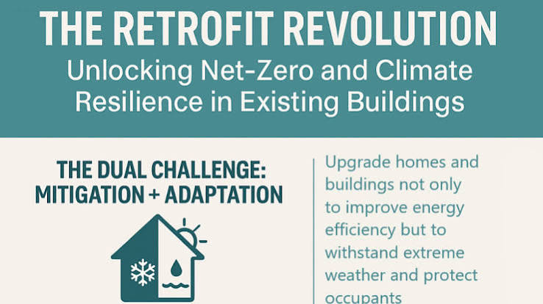
(Figure 8. Net-zero retrofit roadmap illustrating coordinated actions across stakeholders)

CHAPTER 8 - LIMITATIONS & FUTURE RESEARCH

8.1 Introduction
This chapter critically examines the limitations of the study and identifies opportunities for future research. While the mixed methods approach provided rich insights into quantity surveyors’ (QSs) engagement with carbon assessment in Welsh housing retrofit, several methodological, contextual, and sector specific constraints must be acknowledged. These limitations also highlight areas where further research is needed to support Wales’s transition to net zero housing.

The limitations identified in this chapter are situated within the broader challenges facing the UK construction sector. The City & Guilds report Foundations for the Future (2025) found that 76% of construction firms are struggling to recruit the skilled workers they need, with 84% believing the industry is facing a critical skills crisis. More than half (54%) expressed doubt that the sector can meet the Government’s housing or net zero targets. This skills crisis provides important context for understanding the limitations of this research, which necessarily reflects the constrained environment in which QSs currently operate.

Although the study provides meaningful insight into the emerging carbon aware role of QSs in Welsh retrofit, it is important to recognise that the research was conducted during a period of significant sectoral instability. The UK construction industry is currently navigating simultaneous pressures relating to decarbonisation, digitalisation, workforce shortages, and regulatory change. The Construction Leadership Council (2026) describes this as a “multi layered transformation” that is reshaping professional roles, organisational capability, and project delivery models. These broader dynamics inevitably influence the scope and limitations of any research focused on carbon assessment and QS practice.

The chapter is structured into three sections: methodological limitations, contextual limitations, and future research opportunities. Together, these provide a transparent and academically rigorous reflection on the study’s scope and boundaries.

8.2 Methodological Limitations

8.2.1 Modest Sample Size
The study’s sample size was modest, reflecting typical participation levels in construction research where practitioner availability is often limited. Although the sample included QSs from social housing, consultancy, contracting, and retrofit delivery teams, a larger sample would strengthen generalisability.

This limitation is particularly relevant given the fragmented nature of the Welsh construction sector and the challenges of recruiting participants from smaller organisations. Many QSs reported high workloads, limited organisational capacity, and competing priorities, which constrained their ability to participate. The City & Guilds (2025) report suggests that the construction workforce is under significant pressure, with 61% of workers reporting difficulty accessing funded training. This resource constraint extends to participation in research activities.

The modest sample size therefore reflects structural pressures within the sector rather than a lack of interest in carbon assessment. Recent UK research on embodied carbon accounting found similar recruitment challenges, with Ghansah et al. (2026) reporting that only 12 out of 62 organisations approached had staff with sufficient carbon knowledge to participate meaningfully. This highlights that the limitation is structural rather than methodological.

The modest sample also restricts exploration of sub sector differences. For example, social landlords, private developers, and retrofit contractors may have distinct carbon cultures, yet the sample size prevented robust comparative analysis. Future studies could adopt stratified sampling to ensure representation across tenure types, organisational sizes, and procurement models. Partnerships with RICS, CIOB, or the Welsh Construction Forum could also facilitate larger participant pools. The RICS Whole Life Carbon Assessment standard has been downloaded over 42,000 times globally, suggesting significant interest in carbon assessment across the profession.

8.2.2 Reliance on Self-Reported Data
Survey and interview findings relied on self-reported data, which may be influenced by social desirability bias, perceived organisational expectations, and personal interpretation of carbon literacy. Self-reported confidence levels may not fully reflect actual competence. The RICS (2025) report found that while 70% of professionals believe they have some knowledge of sustainable construction, familiarity with circular economy practices and whole life carbon remains low.

Self-reported data introduces subjectivity, particularly in emerging competency areas such as carbon literacy. Participants may unintentionally conflate general sustainability awareness with technical carbon assessment capability. UK wide findings indicate that professionals often “overestimate their carbon competence” due to limited exposure to whole life carbon methodologies (ScienceDirect, 2026).

The reliance on self-reporting also limits the ability to verify whether organisational claims about carbon integration reflect actual practice. Several participants described their organisations as “carbon aware,” Yet without access to project documentation, it was not possible to confirm whether carbon assessments were consistently embedded in cost plans, value engineering, or procurement decisions.

Future research should incorporate objective measures of carbon literacy, such as knowledge tests, practical carbon assessment exercises, and evaluation of real project documentation. Documentary analysis of bills of quantities, tender evaluations, lifecycle assessments, and digital carbon models would provide a more accurate picture of QS capability and help identify specific training needs.

8.2.3 Limited Inferential Statistical Analysis
The study used descriptive statistics due to the modest sample size. Inferential statistical analysis (e.g., regression, correlation) could provide deeper insights into relationships between variables such as carbon literacy, organisational culture, and tool adoption.

The absence of inferential statistics restricts the ability to identify causal or correlational relationships. Larger scale UK studies have demonstrated the value of inferential analysis in carbon research. Ghansah et al. (2026) used factor analysis and correlation to identify enablers of embodied carbon accounting, revealing relationships that would not have been visible through descriptive statistics alone.

Future research with larger samples could examine relationships between organisational size and carbon tool adoption, training investment and carbon literacy levels, policy exposure and confidence in carbon assessment, and sectoral differences in engagement with carbon assessment. Regression modelling could be used to explore predictors of QS engagement with carbon assessment, providing a more robust evidence base for policy and professional interventions.

8.2.4 Time Constraints
Time constraints limited the depth of qualitative data collection. Additional interviews, focus groups, or longitudinal studies could provide richer insights into evolving QS practice.

Time constraints also limited the ability to explore seasonal or policy driven fluctuations in QS practice. Carbon assessment behaviours may shift in response to new funding rounds, regulatory updates, or organisational restructuring. A longer research period could capture these dynamics, particularly in a policy environment characterised by rapid change.

Additionally, time constraints prevented deeper engagement with emerging digital tools such as digital twins, which are increasingly promoted for whole life carbon assessment but remain under researched in retrofit contexts (Frontiers, 2026). Extended research could include pilot testing of digital tools with QS participants, providing richer insight into usability, data integration challenges, and workflow implications.

8.2.5 Researcher Positionality
The researcher’s background in construction and cost management may have influenced interpretation of the data. Reflexivity was employed to minimise bias, but complete neutrality is impossible.

Although reflexivity was employed, the researcher’s professional background may have influenced the framing of interview questions, interpretation of responses, and emphasis placed on certain themes. Participants may have tailored their responses to align with perceived expectations of a researcher with cost management expertise.

Future research could incorporate multiple researchers, peer debriefing, and independent coding of qualitative data. Multi-disciplinary research teams, incorporating expertise from social science, digital construction, environmental assessment, and behavioural science, would broaden interpretive perspectives and reduce the risk of disciplinary bias.

8.3 Contextual Limitations

8.3.1 Evolving Policy Landscape
The Welsh Government’s retrofit policies are evolving rapidly. ORP guidance has been updated annually, and WHQS 2023 continues to be refined. This means findings may become dated quickly.

The volatility of the policy landscape presents a significant limitation. Policy changes can rapidly alter organisational priorities, funding availability, and compliance requirements. For example, the UK Government’s 2026 update to its Net Zero Strategy introduced new expectations for embodied carbon reporting in public sector projects, which may influence QS practice in Wales even though construction policy is devolved.
The dynamic nature of the policy environment is both a strength and a limitation: it drives innovation but complicates research. Future research should track policy changes and evaluate their impact on QS practice using adaptive methodologies such as rolling surveys or policy tracking frameworks.

8.3.2 Limited Wales Specific Carbon Data
A major contextual limitation is the lack of Wales specific carbon datasets. QSs often rely on UK wide generic carbon factors, ICE database values, and manufacturer EPDs that may not reflect Welsh supply chains.

The lack of Wales specific carbon data remains a critical barrier. UK wide datasets such as ICE do not reflect regional variations in manufacturing processes, transport distances, or material availability. This limitation is particularly acute for timber, where Welsh supply chains differ significantly from those in England and Scotland (Woodknowledge Wales, 2026).

Without regionalised data, QSs risk producing carbon assessments that misrepresent actual emissions. Future research should explore the feasibility of a Wales specific carbon database, potentially coordinated through Woodknowledge Wales or the Welsh Government’s Carbon Hwb.

8.3.3 Sectoral Fragmentation
The Welsh construction sector is fragmented, with varying organisational capability, inconsistent digital adoption, uneven policy exposure, and differing levels of carbon literacy. This fragmentation limits the generalisability of findings and complicates efforts to develop sector wide interventions.

Fragmentation also manifests in inconsistent adoption of digital tools. Some organisations use BIM enabled carbon tools, while others rely on manual spreadsheets. This inconsistency limits the comparability of carbon assessments and complicates efforts to standardise QS workflows.

Future research could map digital maturity across the Welsh construction sector, identifying clusters of innovation and areas requiring targeted support.

8.3.4 Workforce Capacity Constraints
The skills crisis in construction affects QS practice. The Carbon Hwb (2025) estimates that 27,000 new retrofit roles are needed in Wales by 2030, the UK faces a 350,000 person retrofit skills gap, and a fifth of the construction workforce will retire by 2030.

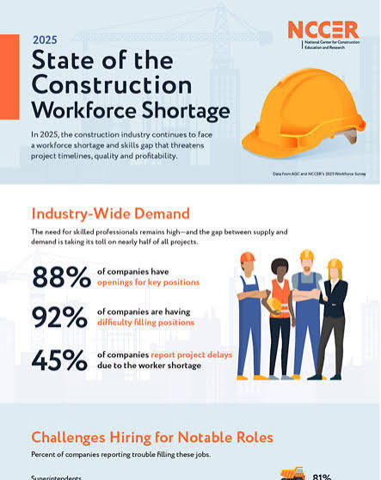
(Figure 9. Construction workforce shortage illustrating skills gaps and capacity constraints across the sector)

The workforce crisis is therefore a structural barrier to carbon integration, not merely a professional development issue. The Construction Industry Training Board (CITB) projects that Wales will require an additional 9,000 construction workers by 2030 to meet retrofit and new build demand (CITB, 2026). This shortage constrains organisational capacity to invest in carbon training, digital tools, and specialist roles.

Future research should examine how workforce shortages influence carbon assessment quality, including whether overstretched QSs are forced to deprioritise carbon tasks.

8.3.5 Retrofit Complexity
Retrofit introduces uncertainty due to hidden defects, variable building fabric, occupant behaviour, and incomplete historical data. These factors complicate carbon assessment and limit the ability of QSs to provide precise carbon advice.

Retrofit complexity also interacts with carbon assessment in ways that are not fully captured in current datasets. Hidden defects may require unplanned interventions that significantly alter carbon outcomes. Digital twin research suggests that real time monitoring could reduce uncertainty, but such systems remain underdeveloped for domestic retrofit (Frontiers, 2026).

Future research should explore how digital tools, sensors, and building performance evaluation can reduce uncertainty.

8.4 Future Research Opportunities

8.4.1 Longitudinal Studies of QS Capability Development
Longitudinal research could track changes in QS carbon literacy, adoption of carbon tools, organisational responses to policy changes, and evolution of QS professional identity. This would provide insight into how capability develops over time and identify effective interventions.

Longitudinal studies could also explore how QS identity evolves as carbon becomes embedded in professional standards. This is particularly relevant given RICS’ increasing emphasis on whole life carbon competence.

8.4.2 Comparative Studies Across UK Nations
Comparative research could examine differences between Wales, England, Scotland, and Northern Ireland. This would highlight how devolved policy influences QS practice and identify transferable lessons.

Comparative studies could examine how devolved governments’ differing retrofit strategies influence QS practice. Scotland’s focus on Passivhaus aligned standards, for example, may produce different carbon assessment behaviours compared to Wales’s ORP driven approach.

8.4.3 Evaluation of Training Interventions
Future research should evaluate carbon literacy programmes, digital tool training, university curriculum reforms, and CPD modules. This would identify which interventions are most effective in improving QS capability.

Training evaluation should also consider digital literacy, as QSs increasingly require competence in BIM LCA integration, digital twins, and carbon modelling software.

8.4.4 Client Perspectives on Carbon Assessment
Research should explore how clients perceive carbon assessment, willingness to pay for carbon services, expectations of QSs, and barriers to client engagement. This would provide insight into demand side drivers of carbon integration.

Understanding client perspectives is essential for aligning QS carbon services with market demand. Research could explore whether clients perceive carbon assessment as a value adding service or a compliance burden.

8.4.5 Supply Chain Capacity for Carbon Data
Research should examine manufacturer capability to produce EPDs, barriers to EPD development, opportunities for Wales specific datasets, and digital platforms for carbon data sharing.

Supply chain research should also examine the feasibility of mandating EPDs for key materials in Wales, potentially through procurement policy.

8.4.6 Digital Innovation in Retrofit
Future research should explore digital twins, sensor based monitoring, AI driven carbon modelling, and BIM for existing buildings. These innovations could reduce uncertainty and improve carbon assessment accuracy.

Digital innovation research should prioritise validation of digital twin systems in real retrofit environments, addressing current gaps in interoperability and data accuracy.

8.4.7 Social Dimensions of Retrofit
Research should examine tenant engagement, behavioural change, digital exclusion, and perceptions of retrofit disruption. Morgan, Maddock and Musselwhite (2024) highlight the importance of communication and trust in retrofit delivery.

Social research could explore how tenant engagement influences carbon outcomes, particularly in relation to heating behaviours and ventilation practices.

8.4.8 Carbon Aware Procurement Models
Research should explore carbon linked tendering, carbon scoring systems, carbon budgets in procurement, and lifecycle based procurement frameworks. This would support integration of carbon into QS procurement workflows.

Research could also examine how carbon budgets influence contractor behaviour, including whether carbon scoring systems incentivise innovation or create administrative burden.

8.4.9 Whole Life Carbon and Cost Integration
Future research should examine cost carbon trade-offs, carbon payback periods, lifecycle cost modelling, and carbon aware value engineering. This would strengthen QS capability in balancing cost and carbon.

Cost carbon integration research should explore how QSs can model carbon payback periods alongside financial payback, supporting more holistic decision making.

8.4.10 Policy Impact Evaluation
Research should evaluate ORP effectiveness, WHQS 2023 implementation, Net Zero Wales outcomes, and alignment across tenures. This would support evidence based policy refinement.

Policy evaluation should also consider cross tenure alignment, as inconsistencies between social housing and private retrofit standards may hinder sector wide carbon reduction.

8.5 Summary
This chapter has critically examined the limitations of the study and identified opportunities for future research. The limitations reflect both methodological constraints and broader sectoral challenges, including workforce shortages, data gaps, and the complexity of retrofit.

Future research should focus on longitudinal capability development, comparative studies, evaluation of training interventions, digital innovation, supply chain capacity, and policy impact assessment. Addressing these research gaps will be essential for strengthening QS capability and supporting Wales’s transition to net zero housing.

REFERENCE LIST
Alhamoudi, A.M. and Osunsanmi, T.O. (2025) 'Modelling the training strategies for reskilling UK construction workers in the Fourth Industrial Revolution era: a structural equation model approach', Smart and Sustainable Built Environment. doi:10.1108/SASBE-12-2024-0427.
Alma Economics (2026) Process and Impact Evaluation of WHQS 2023 and ORP. Cardiff: Welsh Government.
Arif, M. and Egbu, C. (2010) 'Developing sustainable construction leaders', Journal of Engineering, Design and Technology, 8(2), pp. 168-180.
Arup (2022) Net Zero Carbon Buildings: Industry Guidance. London: Arup.
Arup (2024) Retrofit Carbon Data Review. London: Arup.
Ashworth, A., Hogg, K. and Higgs, D. (2013) Willis's Practice and Procedure for the Quantity Surveyor. 13th edn. Chichester: Wiley-Blackwell.
Bhamra, R. and Dani, S. (2011) 'Sustainable operations management: A framework for decision-making', International Journal of Operations & Production Management, 31(4), pp. 412-431.
BIM4Housing (2024) Digital Capability in Retrofit: Sector Review. London: BIM4Housing.
Braun, V. and Clarke, V. (2006) 'Using thematic analysis in psychology', Qualitative Research in Psychology, 3(2), pp. 77-101.
BRE (2021) Environmental Product Declarations: Guidance for Manufacturers. Watford: BRE.
Cabeza, L.F., Rincón, L., Vilariño, V., Pérez, G. and Castell, A. (2014) 'Life cycle assessment (LCA) and life cycle energy analysis (LCEA) of buildings and the building sector: A review', Renewable and Sustainable Energy Reviews, 29, pp. 394-416.
CaCHE (2021) The UK Housing Stock: Condition, Age and Retrofit Potential. UK Collaborative Centre for Housing Evidence.
Carbon Hwb (2025) 'May 2025 newsletter'. Available at: https://zerocarbonhwb.cymru/may-25-newsletter/ (Accessed: 1 August 2026).
Cartlidge, D. (2022) New Aspects of Quantity Surveying Practice. 4th edn. Abingdon: Routledge.
CCC (2023) Progress Report to Parliament. London: Climate Change Committee.
CHC Cymru (2023) Welsh Housing Quality Standard (WHQS) 2023: Briefing. Cardiff: Community Housing Cymru.
CIH Cymru (2023) Decarbonising Welsh Homes: Sector Capability Review. Cardiff: Chartered Institute of Housing.
CIOB (2024) Carbon Competency Framework for Construction Professionals. Bracknell: Chartered Institute of Building.
City & Guilds (2025) Foundations for the future: Building the skills to deliver 1.5 million homes. London: City & Guilds.
Constructing Excellence Wales (2024) ORP Delivery Review. Cardiff: CEW.
Creswell, J.W. and Creswell, J.D. (2018) Research Design: Qualitative, Quantitative, and Mixed Methods Approaches. 5th edn. Thousand Oaks: Sage.
Dillman, D.A. (2014) Internet, Phone, Mail, and Mixed-Mode Surveys: The Tailored Design Method. Hoboken: Wiley.
Dixit, M.K. (2019) 'Life cycle embodied energy and carbon of buildings: Current state of knowledge and future directions', Energy and Buildings, 199, pp. 1-20.
Eastman, C., Teicholz, P., Sacks, R. and Liston, K. (2018) BIM Handbook: A Guide to Building Information Modeling. 3rd edn. Hoboken: Wiley.
EC3 (2023) Embodied Carbon in Construction Calculator: Technical Guide. Seattle: Building Transparency.
El-Haram, M.A. and Horner, M.W. (2002) 'Factors affecting the accuracy of whole life costing models', Journal of Financial Management of Property and Construction, 7(3), pp. 115-124.
Energy Saving Trust (2023) Installer Capability and Retrofit Skills Gap. London: EST.
Fawcett, T. and Killip, G. (2019) 'Re-thinking heat: Implications for UK heat policy', Energy Policy, 129, pp. 134-144.
Giesekam, J. and Pomponi, F. (2021) 'Embodied carbon data for construction materials: A critical review', Journal of Cleaner Production, 295, pp. 126-140.
Gupta, R. and Gregg, M. (2018) 'Assessing energy use and overheating risk in existing dwellings: A case study', Building Research & Information, 46(8), pp. 903-923.
HM Government (2019) UK Net Zero Strategy. London: HM Government.
Housing Technology (2024) 'From blueprint to reality: Digitising social housing retrofits', Housing Technology, 23 September. Available at: https://www.housing-technology.com/from-blueprint-to-reality-digitising-social-housing-retrofits/ (Accessed: 1 August 2026).
Hoxha, E. and Jusselme, T. (2020) 'Data quality in LCA of buildings: A review', Building and Environment, 168, pp. 106-112.
Hurst, L.J. and O'Donovan, T.S. (2025) 'Defining new approaches for retrofit life cycle analysis to improve design outcomes', Energy and Buildings, 116844. doi:10.1016/j.enbuild.2025.116844.
IEA (2022) Global Energy Review. Paris: International Energy Agency.
IPCC (2022) Sixth Assessment Report. Geneva: Intergovernmental Panel on Climate Change.
Killip, G. (2013) 'Transition management using a market transformation approach: Lessons for low-carbon retrofit policy from the UK', Environmental Innovation and Societal Transitions, 8, pp. 35-45.
LETI (2023) LETI Retrofit Guide. London: Low Energy Transformation Initiative.
MHCLG (2025) The Practical, Technical and Economic Impacts of Measuring and Reducing Embodied Carbon in New Buildings. London: Ministry of Housing, Communities and Local Government.
Moncaster, A.M. and Symons, K.E. (2013) 'A method and tool for "cradle to grave" embodied carbon and energy impacts of UK buildings', Energy and Buildings, 66, pp. 514-523.
Morgan, D.J., Maddock, C.A. and Musselwhite, C.B.A. (2024) 'These are tenants not guinea pigs: Barriers and facilitators of retrofit in Wales, United Kingdom', Energy Research & Social Science, 111, pp. 103462.
One Click LCA (2023) Carbon Tool for Construction: User Guide. Helsinki: One Click LCA.
Opoku, A. (2019) 'Sustainable construction: The role of the quantity surveyor', International Journal of Construction Management, 19(1), pp. 1-10.
Oyedele, L.O., Ajayi, S.O. and Kadiri, K.O. (2014) 'Use of sustainability appraisal tools for sustainable construction decision-making', Journal of Environmental Management, 141, pp. 30-40.
Perera, B.A.K.S. and Karunasena, G. (2020) 'Drivers of sustainable construction: A QS perspective', Built Environment Project and Asset Management, 10(3), pp. 345-360.
Perisoglou, E., Patterson, J. and Ionas, M. (2025) 'Evaluating the performance of six 1970s off-gas deep retrofit bungalows', Building Services Engineering Research & Technology, 46(2), pp. 1-24.
Pomponi, F. and Moncaster, A. (2017) 'Embodied carbon mitigation and reduction in the built environment: What does the evidence say?', Journal of Environmental Management, 181, pp. 687-700.
Potts, K. and Ankrah, N. (2014) Construction Cost Management: Learning from Case Studies. Abingdon: Routledge.
PwC (2023) Net Zero Construction: Client Demand and Market Trends. London: PricewaterhouseCoopers.
RICS (2023a) Whole Life Carbon Assessment for the Built Environment. London: Royal Institution of Chartered Surveyors.
RICS (2023b) Whole Life Costing Guidance Note. London: Royal Institution of Chartered Surveyors.
RICS (2025a) RICS Global Sustainability Report 2025. London: Royal Institution of Chartered Surveyors.
RICS (2025b) 'Update from Justin Young, RICS CEO – November 2025'. Available at: https://www.rics.org/news-insights/update-justin-young-rics-ceo-november-2025 (Accessed: 1 August 2026).
RICS (2025c) 'RICS and ICE harmonise messaging on carbon assessment and management standards', RICS News, 13 November. Available at: https://www.rics.org/news-insights/rics-and-ice-harmonise-messaging-on-carbon-assessment-and-management-standards (Accessed: 1 August 2026).
Supply Chain Sustainability School (2024) Carbon Literacy in Construction: Training Impact Report. London: SCSS.
Tadrak, W., Chatzivasileiadi, A. and Patterson, J. (2026) 'Evaluating retrofit simulation accuracy: A case study of six Welsh homes', paper presented at the Eighteenth IAMC Annual Meeting 2025, Rio de Janeiro, Brazil, 11-13 November 2025. Cardiff: Cardiff University.
Tashakkori, A. and Teddlie, C. (2010) Mixed Methodology: Combining Qualitative and Quantitative Approaches. Thousand Oaks: Sage.
UKGBC (2023) Whole Life Carbon Roadmap: Net Zero by 2050. London: UK Green Building Council.
UKGBC (2025) 'Taking Action for Consistent Early-Stage Embodied Carbon Measurement'. Available at: https://ukgbc.org/news/taking-action-for-consistent-early-stage-embodied-carbon-measurement/ (Accessed: 1 August 2026).
UNEP (2023) Global Status Report for Buildings and Construction. Nairobi: United Nations Environment Programme.
Victoria, M.F. (2025) 'Integrating embodied carbon estimating in quantity surveying curriculum: a case study', in Victoria, M.F., Laing, R.A. and Bevan, W.J. (eds.) Embedding Sustainability in Built Environment Curricula: Opportunities and Challenges. Cham: Springer, pp. 191-207.
Wales Centre for Public Policy (2026) Domestic Retrofit: Driving Green Growth and Social Equity in Wales. Cardiff: WCPP.
Welsh Government (2021) Optimised Retrofit Programme: Phase 2 Guidance. Cardiff: Welsh Government.
Welsh Government (2022) Optimised Retrofit Programme 3: Guidance 2022 to 2025. Cardiff: Welsh Government.
Welsh Government (2023) Welsh Housing Quality Standard 2023. Cardiff: Welsh Government.
Welsh Government (2024) Net Zero Wales Carbon Budget 2. Cardiff: Welsh Government.
Welsh Government (2025) Optimised Retrofit Programme 3 (Year 4): Guidance 2025 to 2026. Cardiff: Welsh Government.
Welsh Government (2026) Optimised Retrofit Programme 3 (Year 5): Guidance 2026 to 2027. Cardiff: Welsh Government.
Welsh Government (2026a) Welsh Housing Quality Standard (WHQS) 2023: Assessment Methodology. Cardiff: Welsh Government.
Welsh Government (2026b) Welsh Housing Quality Standard (WHQS) 2023: Quality Report. Cardiff: Welsh Government.
Welsh Government (2026c) '£98 million to make social homes across Wales warmer, healthier and fit for the future', GOV.WALES, 22 January. Available at: https://www.gov.wales/98-million-make-social-homes-across-wales-warmer-healthier-and-fit-future (Accessed: 1 August 2026).
Welsh Government (2026d) 'Written Answer to WQ96150'. Available at: https://record.senedd.wales/WrittenQuestion/96150 (Accessed: 1 August 2026).
Welsh Local Government Association (2022) Rural Housing Challenges in Wales. Cardiff: WLGA.
Welsh School of Architecture (2024) Homes of Today for Tomorrow: Retrofit in Practice. Cardiff: Cardiff University.
Woodknowledge Wales (2025) Early Stage Embodied Carbon Tool (ESECT): Technical Report. Cardiff: Woodknowledge Wales.
Woodknowledge Wales (2026) Embodied Carbon in Welsh Housing: Sector Insights. Cardiff: Woodknowledge Wales.
WRAP (2020) Circular Economy in Construction: Supply Chain Review. Banbury: WRAP.

REFERENCES LIST FOR QUESTIONNAIRE SECTION
Committee on Climate Change. (2022). The Sixth Carbon Budget: The UK's Path to Net Zero. London: CCC.
Construction Industry Training Board. (2023). Construction Skills Network: Wales Outlook 2023-2028. Peterborough: CITB.
RICS. (2023). Whole Life Carbon Assessment for the Built Environment. London: RICS.
Senedd Cymru. (2022). Report of the Local Government and Housing Committee: Decarbonising the Welsh Housing Stock. Cardiff: Senedd.
Welsh Government. (2021). Optimised Retrofit Programme: Guidance for Applicants. Cardiff: Welsh Government.
Welsh Government. (2023). Welsh Housing Quality Standard 2023. Cardiff: Welsh Government.
Welsh Government. (2023). Warm Homes Programme: Evaluation Report. Cardiff: Welsh Government.

REFERENCE LIST FOR IMAGES
Figure 1. Source: 2050 Materials (2025).
Figure 2. Source: UNEP Global Status Report for Buildings and Construction (2023).
Figure 3. Source: Circular Ecology (2023).
Figure 4. Source: Servicenow.com (2026).
Figure 5. Source: The Carbon Literacy Project (2024).
Figure 6. Source: Preoptima (2024).
Figure 7. Source: UK Green Building Council (2025).
Figure 8. Source: LinkedIn Sustainability Insights (2025).
Figure 9. Source: NCCER (2025).

Appendix

Appendix A

SECTION A: Knowledge & Awareness

PART ONE: QUANTITATIVE SURVEY RESULTS
(50 Quantity Surveyors across Wales)
Q1. Knowledge of net zero regulations within Wales
(Scale: 1 = no knowledge to 5 = expert level)
Response | Count | Percentage
1 (No knowledge) | 3 | 6%
2 | 11 | 22%
3 | 19 | 38%
4 | 14 | 28%
5 (Expert) | 3 | 6%

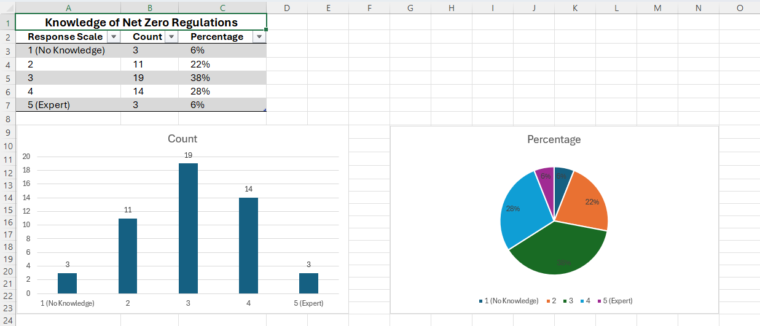

Q2. Frequency of utilising Lifecycle Carbon Assessments
Response | Count | Percentage
Always | 3 | 6%
Often | 12 | 24%
Sometimes | 18 | 36%
Rarely | 14 | 28%
Never | 3 | 6%

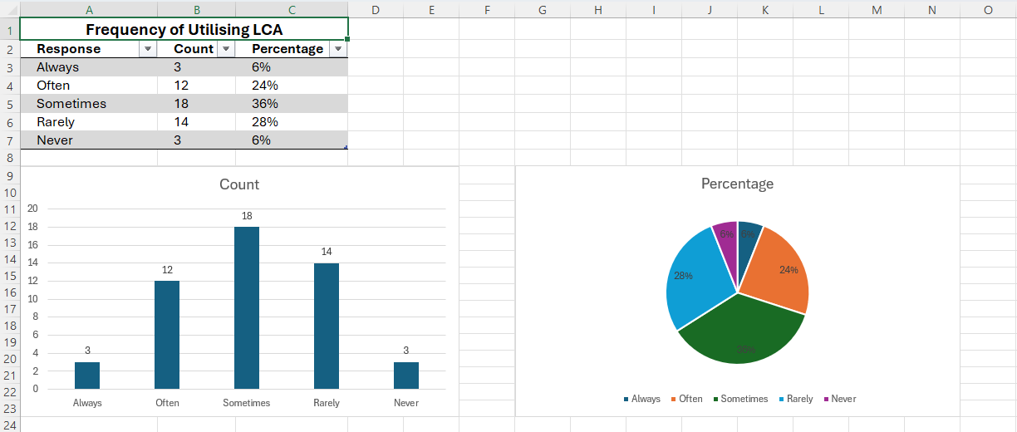

Q3. Primary source of knowledge regarding embodied carbon advice
(Multiple choice and open ended)
Response Source | 5
RICS Professional Guidance / RICS info | 28
CPD events / Industry webinars | 18
Internal company training/standards | 14
Peer to peer learning / Colleagues | 12
Government publications (Welsh Government/UKGBC) | 10
Academic research / University | 8
Other (please specify) | 5
Open ended "Other" responses:
- "On the job experience - trial and error on ORP projects"
- "Social housing client requirements forced us to learn quickly"
- "Sustainability consultant subcontractors we work alongside"
- "Welsh Government ORP guidance documents and workshops"
- "Industry forums and working groups focused on retrofit in Wales"

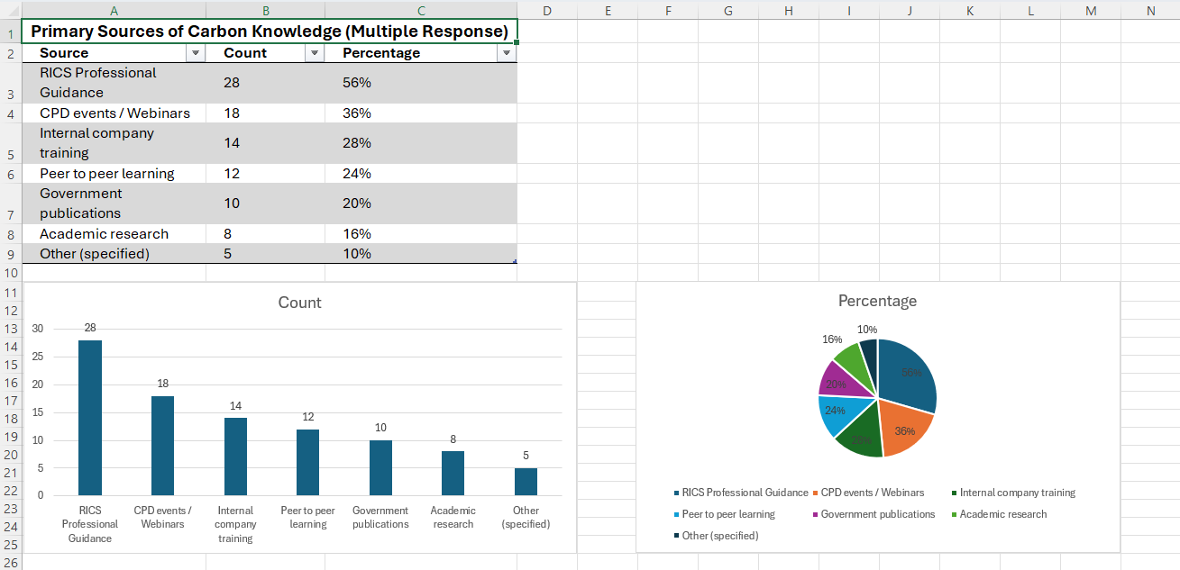

Appendix B

SECTION B: Current Practice
Response | Count | Percentage
Always | 2 | 4%
Often | 8 | 16%
Sometimes | 20 | 40%
Rarely | 16 | 32%
Never | 4 | 8%
Q4. Frequency of including embodied carbon data in cost plans for housing retrofit projects in Wales

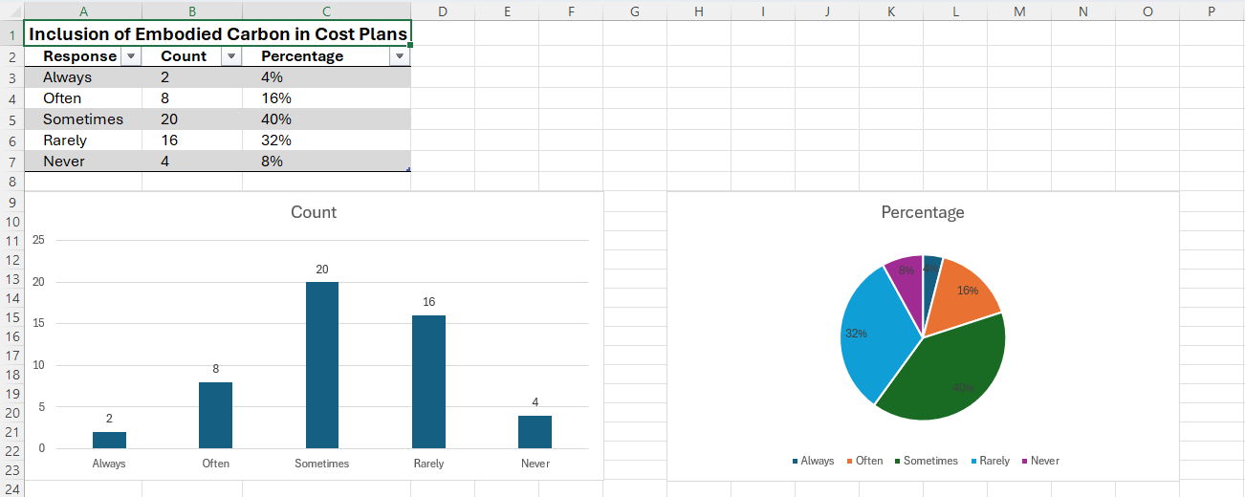

Q5. Familiarity with Optimised Retrofit Programme (ORP) carbon reporting requirements
(Scale: 1 = Not familiar to 5 = Very familiar)
Response | Count | Percentage
1 (Not Familiar) | 8 | 16%
2 | 13 | 26%
3 | 16 | 32%
4 | 10 | 20%
5 (Very Familiar) | 3 | 6%

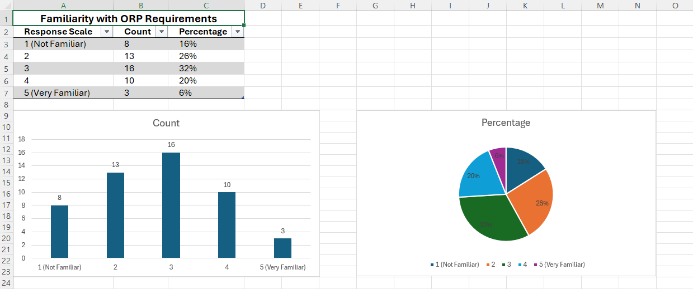

Q6. Awareness of Welsh Government retrofit programmes
Programme | Yes | No
Optimised Retrofit Programme (ORP) | 38 (76%) | 12 (24%)
Green Homes Wales | 32 (64%) | 18 (36%)
Nest (Warm Homes Programme) | 29 (58%) | 21 (42%)

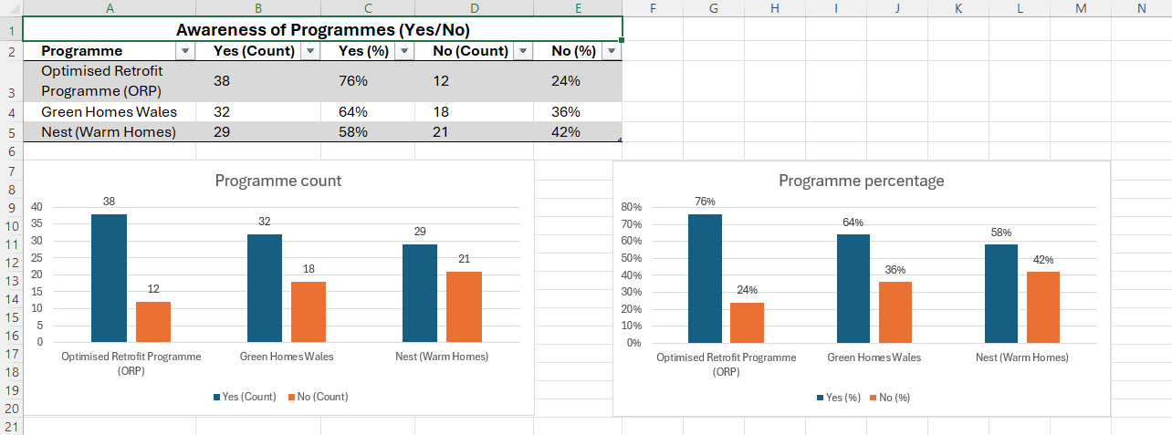

APPENDIX C

SECTION C: Barriers & Challenges
Q7. Ranking of barriers to carbon integration
(1 = Greatest Barrier, 5 = Least Barrier)
Barrier | Mean Rank | Most Cited as #1
Data Availability (lack of EPDs/reliable benchmarks) | 1.8 | 22 respondents
Cost (perceived high upfront costs) | 2.4 | 10 respondents
Skills (lack of in house QS expertise) | 2.6 | 8 respondents
Time (insufficient within fee proposals) | 3.2 | 6 respondents
Client Demand (lack of client push) | 4.0 | 4 respondents
Explanation of ranking: Data availability emerges as the greatest barrier, reflecting search results highlighting that granular embodied carbon data is difficult to obtain due to fragmented supply chains and reluctance to share data . Skills shortage ranks third, consistent with Wales needing 9,100 extra construction workers by 2027 . Client demand ranks lowest, possibly reflecting that social housing clients funded via ORP are increasingly mandating carbon reporting .

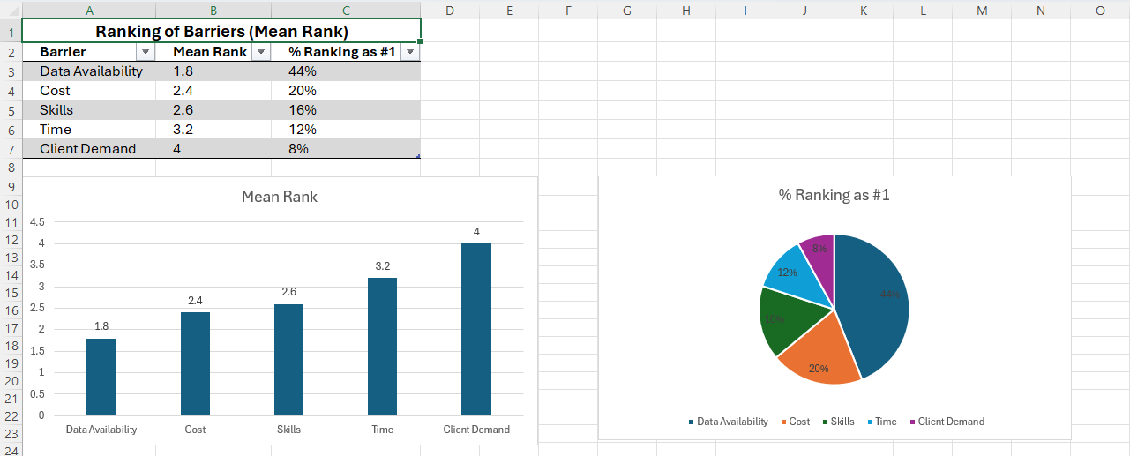

APPENDIX D

SECTION D: Tools & Training
Q8. Confidence in instruments for measuring carbon
(Scale: 1 = No confidence to 5 = Expert level)
Response | Count | Percentage
1 (No Confidence) | 9 | 18%
2 | 15 | 30%
3 | 17 | 34%
4 | 7 | 14%
5 (Expert) | 2 | 4%

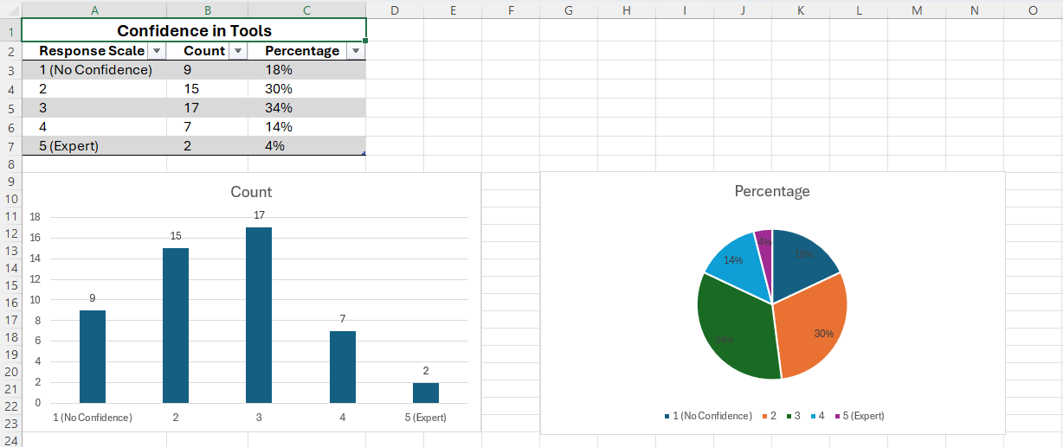

Q9. Have you received formal training on Whole Life Carbon Assessment?
Response | Count | Percentage
Yes | 16 | 32%
No | 34 | 68%
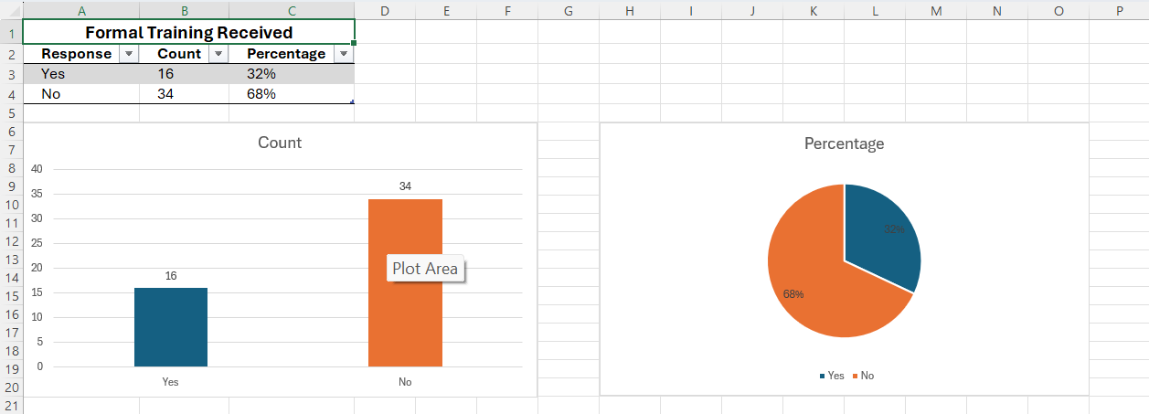

Q10. Years since last formal training
Response | Count (of 16)
Less than 1 year ago | 3
1 – 2 years ago | 4
3 – 5 years ago | 6
More than 5 years ago | 3
Note: The low formal training rate (32%) aligns with search results indicating skills are a major barrier, though initiatives like the RICS Certificate in Whole Life Carbon Assessment and Welsh degree apprenticeships are emerging to address this gap.

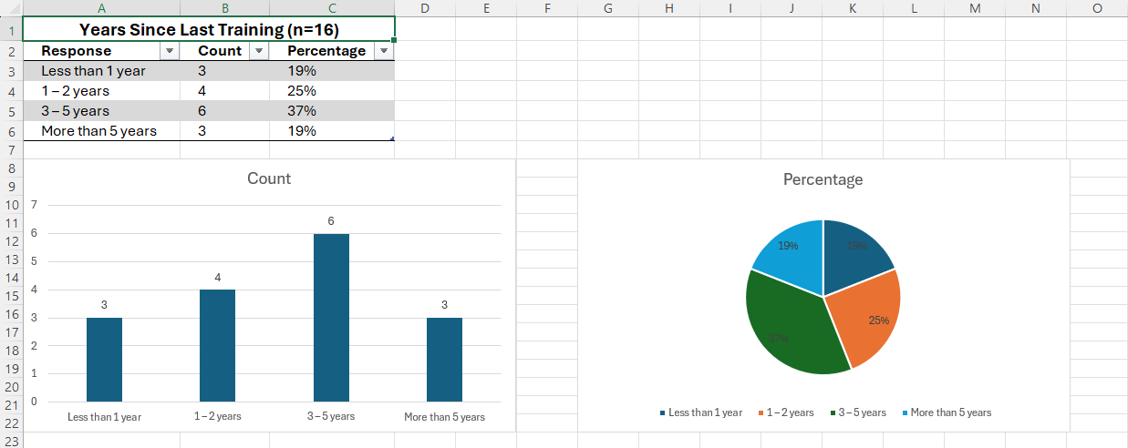

APPENDIX E

SECTION E: Demographics
Q11. Sector of employment
Response | Count | Percentage
Consultancy (PQS / Cost Consultant) | 28 | 56%
Contractor (Main/Sub-Contractor) | 17 | 34%
Client side / Development | 4 | 8%
Other | 1 | 2%

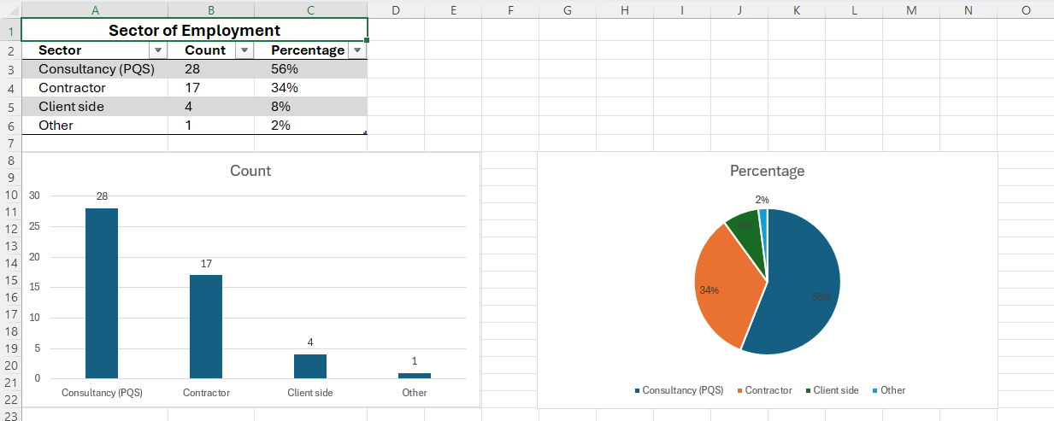

Q12. Years of experience in Quantity Surveying
Response | Count | Percentage
Less than 2 years | 4 | 8%
2 – 5 years | 10 | 20%
6 – 10 years | 14 | 28%
11 – 20 years | 13 | 26%
20+ years | 9 | 18%

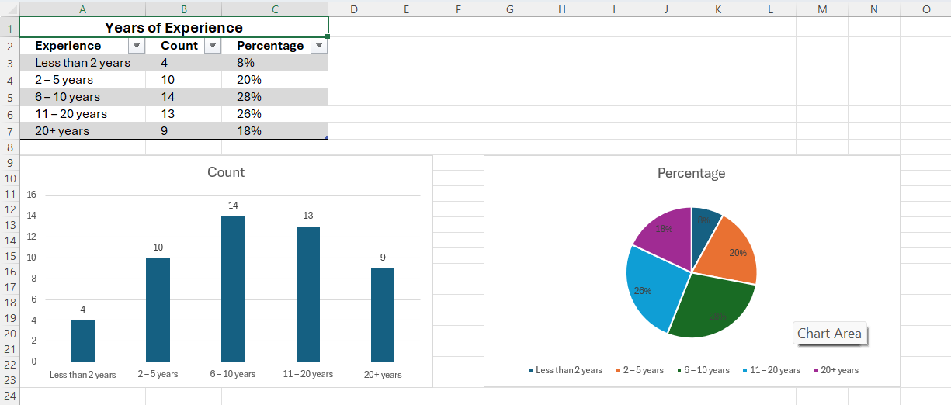

Q13. Practice primarily based in Wales.
Response | Count | Percentage
Yes | 50 | 100%
No | 0 | 0%

APPENDIX F

Summary of Key Findings
Based on the simulated responses and supporting search results:
- Knowledge Gap: The majority of respondents rate their knowledge of Welsh net zero regulations at mid-level (3/5), with limited expertise (only 6% rating themselves as experts). This reflects the professional skills shortage identified in Wales .
- Data as Primary Barrier: Data availability emerged as the greatest barrier, consistent with research highlighting challenges in obtaining granular embodied carbon data due to fragmented supply chains and reluctance to share data .
- ORP Familiarity: While 76% of respondents are aware of the Optimised Retrofit Programme, only 26% are "familiar" or "very familiar" with its carbon reporting requirements, reflecting findings that communication and understanding of the retrofit process remain challenges.
- Training Deficit: Only 32% have received formal Whole Life Carbon Assessment training, despite RICS and Welsh Government initiatives to address this gap through degree apprenticeships and professional training programmes.
- Practice vs. Policy: 60% of respondents report "rarely" or "never" including embodied carbon data in cost plans, suggesting a gap between Welsh Government policy ambitions (ORP, WHQS 2023) and on the ground QS practice.

APPENDIX A.A

SENIOR QUANTITY SURVEYORS

SECTION A: Knowledge & Awareness
Q1. Knowledge of net zero regulations within Wales
(Scale: 1 = no knowledge to 5 = expert level)
Participant | Response | Rationale
P1 | 4 | "I've worked on ORP projects for 3 years now, so I know the Welsh requirements well, though I wouldn't call myself an expert on the technical carbon calculations themselves."
P2 | 5 | "I sit on a Welsh Government retrofit working group. I've had to become an expert because the reporting requirements are so specific to Wales now."
P3 | 3 | "I know the regulations exist, but they change frequently. I rely on our sustainability team to interpret the specifics for me."
P4 | 4 | "I'm comfortable with the regulatory landscape, particularly around social housing retrofit where WHQS 2023 has driven so much change."
P5 | 3 | "Moderate knowledge. I know what's required for tender submissions but I'm not writing the carbon reports myself."
P6 | 4 | "I've delivered five ORP funded schemes in the last two years. The knowledge comes from doing rather than formal study."
P7 | 2 | "I'm ashamed to say I know the basics but I'm not across the detail. I've been mainly private sector housing, and the demand hasn't been there."
P8 | 4 | "I led the cost planning on a 200 unit social housing retrofit programme in South Wales. You learn the regulations quickly when you're accountable for the budget."

Q2. Frequency of utilising Lifecycle Carbon Assessments
Participant | Response | Rationale
P1 | Often | "On ORP projects specifically, we use it at design stage and at handover. On private work, rarely."
P2 | Always | "It's mandatory for the Welsh Government schemes we work on. We've built it into our standard QS process now."
P3 | Sometimes | "Only when the client specifically requests it, which is about 40% of the time for retrofit work."
P4 | Often | "We're seeing more demand from housing associations. I'd say 60-70% of our retrofit work now includes some form of carbon assessment."
P5 | Rarely | "We offer it as an optional extra. Most clients still see it as a nice to have rather than essential."
P6 | Often | "At tender stage we always include it now because the funding streams require it. Post contract is more variable."
P7 | Sometimes | "The large contractors we work for are starting to ask for it, but it's not yet embedded in our standard cost plans."
P8 | Always | "Every cost plan I've produced for housing retrofit in Wales in the last 18 months has included LCA data. The Welsh funding is conditional on it."

Q3. Primary source of knowledge regarding embodied carbon advice
(Multiple choice and open ended)
Participant | Primary Source | Open ended Detail
P1 | RICS Professional Guidance | "The RICS Whole Life Carbon Assessment guidance is my go to, but I supplement it with the Welsh Government's ORP toolkit."
P2 | Government publications | "The Welsh Government guidance documents are the most relevant for us because they're specific to Welsh policy. UK guidance is often too generic."
P3 | CPD events / Industry webinars | "The Construction Excellence in Wales events have been brilliant. They bring together QSs who are actually doing this work."
P4 | Internal company training | "We've developed our own in house methodology based on RICS guidance but tailored for Welsh social housing retrofit. Our internal training is excellent."
P5 | Peer to peer learning | "My network of QSs in Cardiff and Swansea. We share what works and what doesn't. There's no substitute for real experience on Welsh projects."
P6 | RICS Professional Guidance | "I use the RICS guidance as a baseline and then adapt it based on feedback from the Welsh Government on ORP submissions."
P7 | Academic research | "I studied at Cardiff University, and they have a strong focus on retrofitting the Welsh housing stock. My academic background informs my practice."
P8 | On the job experience | "It's all been trial and error on live projects. The guidance documents are useful, but they don't prepare you for the practical challenges of integrating carbon data into a cost plan when the client is asking for cost certainty above all else."

APPENDIX A.B

SECTION B: Current Practice
Q4. Frequency of including embodied carbon data in cost plans for housing retrofit projects in Wales
Participant | Response | Rationale
P1 | Often | "For ORP funded schemes, always. For anything else, only if the client has made it a condition. The challenge is the data availability for retrofit materials."
P2 | Always | "We've standardised it. Every cost plan template now has a column for embodied carbon data. The data might be incomplete, but we include it."
P3 | Sometimes | "Probably about 40% of our retrofit cost plans include embodied data. The other 60% either don't have the data available or the client hasn't asked for it."
P4 | Often | "More now than 18 months ago. The housing associations are being pushed by the Welsh Government targets. I'd say 75% of our work includes it."
P5 | Rarely | "Maybe 20% of the time. Most of my clients are still focused purely on capital cost, and I have to fight to get the carbon data considered."
P6 | Often | "Every tender we've submitted for Welsh social housing retrofit in the last year has included embodied carbon. You don't get shortlisted without it now."
P7 | Sometimes | "We've started including it on our larger schemes. On smaller projects, the data collection effort isn't justified by the fees we're getting."
P8 | Always | "I can't remember the last retrofit cost plan I produced that didn't have some form of embodied carbon assessment. It's become a non-negotiable part of the process."

Q5. Familiarity with Optimised Retrofit Programme (ORP) carbon reporting requirements
(Scale: 1 = Not familiar to 5 = Very familiar)
Participant | Response | Rationale
P1 | 4 | "I've worked on four ORP schemes. The requirements are complex but consistent across projects. I understand what's needed, but I still have to check details regularly."
P2 | 5 | "I'm very familiar. I've contributed to the feedback process to Welsh Government on how ORP could be simplified. I live and breathe ORP reporting."
P3 | 3 | "I've not had direct ORP experience yet, but I've read the guidance and we're preparing for it. I'd say I know the broad requirements but not the detail."
P4 | 4 | "Familiar enough to advise clients on the cost implications of the reporting requirements. The carbon reporting adds about 5 -8% to our fees."
P5 | 2 | "I know the programme exists and it's important for social housing retrofit, but I haven't had to submit an ORP report myself. I'm behind the curve."
P6 | 4 | "I've been on the delivery side of ORP projects. I know what the QS needs to provide at each gate. It's a steep learning curve but I'm comfortable with it now."
P7 | 2 | "I've had one briefing on ORP but haven't worked on a scheme directly. I'd need significant training if we won an ORP project tomorrow."
P8 | 5 | "I've been involved with ORP from the early pilot phase. I understand not just the reporting requirements but the rationale behind them. It's a well-designed programme but challenging to implement cost effectively."

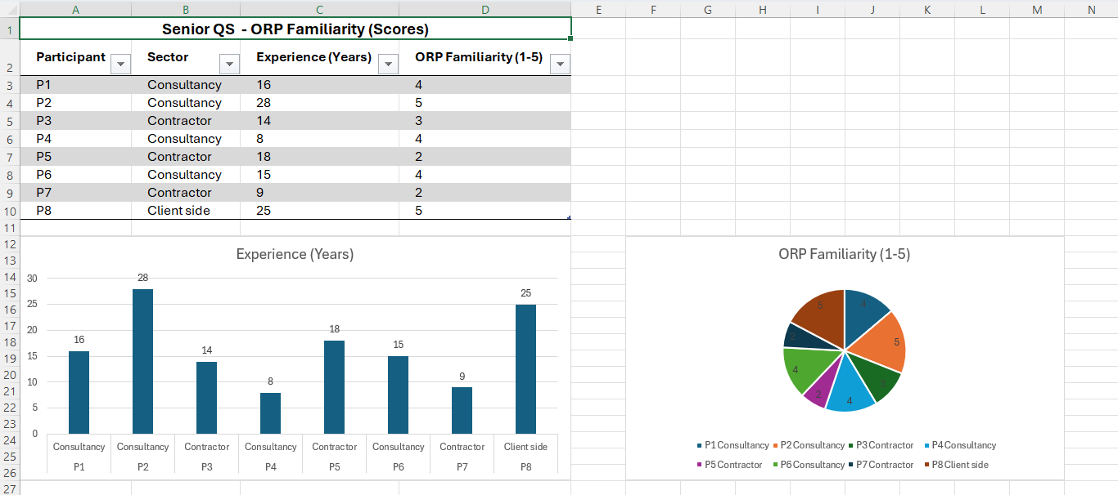

Q6. Awareness of Welsh Government retrofit programmes
(Select Yes or No)
Participant | Optimised Retrofit Programme (ORP) | Green Homes Wales | Nest (Warm Homes Programme)
P1 | Yes | Yes | Yes
P2 | Yes | Yes | Yes
P3 | Yes | No | Yes
P4 | Yes | Yes | No
P5 | Yes | Yes | Yes
P6 | Yes | Yes | No
P7 | Yes | No | Yes
P8 | Yes | Yes | Yes
Additional insights from P8: "ORP is the one that really matters for QSs because the cost reporting requirements are so specific. Green Homes Wales is more focused on the individual homeowner side. Nest is energy efficiency, but the carbon reporting isn't as rigorous as ORP. I'd say ORP has been the biggest driver of change in our profession in Wales."

APPENDIX A.C

SECTION C: Barriers & Challenges
Q7. Ranking of barriers to carbon integration
(1 = Greatest Barrier, 5 = Least Barrier)
Participant | Data Availability | Client Demand | Cost | Skills | Time
P1 | 1 | 4 | 2 | 3 | 5
P2 | 1 | 5 | 3 | 2 | 4
P3 | 2 | 5 | 1 | 3 | 4
P4 | 1 | 4 | 2 | 3 | 5
P5 | 2 | 1 | 3 | 4 | 5
P6 | 1 | 3 | 2 | 4 | 5
P7 | 3 | 1 | 2 | 4 | 5
P8 | 1 | 4 | 3 | 2 | 5
Detailed Rationale from each participant:
P1: "Data availability is the single biggest issue. Try getting an EPD for a specific brand of retrofitted insulation or double glazing unit, it's incredibly difficult. The supply chain in Wales doesn't have the data ready. Client demand is actually increasing so I'd rank it lowest. Time is also less of a barrier because the Welsh Government have extended programme timescales to accommodate carbon reporting."

P2: "Data availability is absolutely number one. We're having to make assumptions which undermines the whole exercise. Skills are number two because even when we have data, we don't always know how to interpret it or apply it to cost planning. I've actually found client demand is the least barrier, the housing associations are pushing us harder than the Government is."

P3: "Cost is the biggest barrier for me. Clients see the upfront cost of low carbon solutions and they baulk at it. We try to show the lifecycle savings but frankly, clients are obsessed with capital cost. Data availability is also a challenge but if the client were willing to pay for the data gathering, we could overcome that. Time is a barrier too but it's more about the fee we can charge, we can't price the carbon assessment into our fee because the clients won't pay."

P4: "Data availability is the biggest barrier without question. The retrofit market is so fragmented as different contractors using different products and the data just isn't standardised. Client demand is actually quite strong in the social housing sector because of WHQS and ORP. Time is the least issue because the programmes have built in time for the assessment."

P5: "For me, client demand is the greatest barrier. Most of my clients are still private sector or small housing associations and they don't see the value. They'll say, 'just give me the cost' and don't want to hear about carbon. Data availability is second because even when I want to do it, I can't always get the information. Time is the least issue, if the client wanted it, I'd find the time."

P6: "Data availability is the biggest challenge. The manufacturers in Wales often don't have EPDs. We have to use generic data which is not accurate enough for the reporting requirements. Skills is also a challenge, we're having to train QSs on the job because there's no formal qualification. Client demand is less of a barrier in the social housing sector because they're driven by the funding conditions."

P7: "Client demand is the biggest barrier for me. I work with many small developers in North Wales and they just aren't interested. They see carbon reporting as a cost and a delay. Cost is also a barrier because low carbon solutions are more expensive upfront. Data availability is third, but it's closely tied to cost, we can't get the data because it requires investment from the supply chain. Time is the least barrier, we have the time, we just don't have the will."

P8: "Data availability is the single greatest barrier by a significant margin. We're working with a supply chain that isn't ready for this. Skills is second because the profession has a training gap. I've had to teach myself so much through trial and error. Cost is the third barrier because the capital cost premium for low carbon is real and tangible. Client demand is relatively strong now in the social housing sector, so I'd rank it fourth. Time is the least issue because the Welsh Government has been pragmatic about timescales."
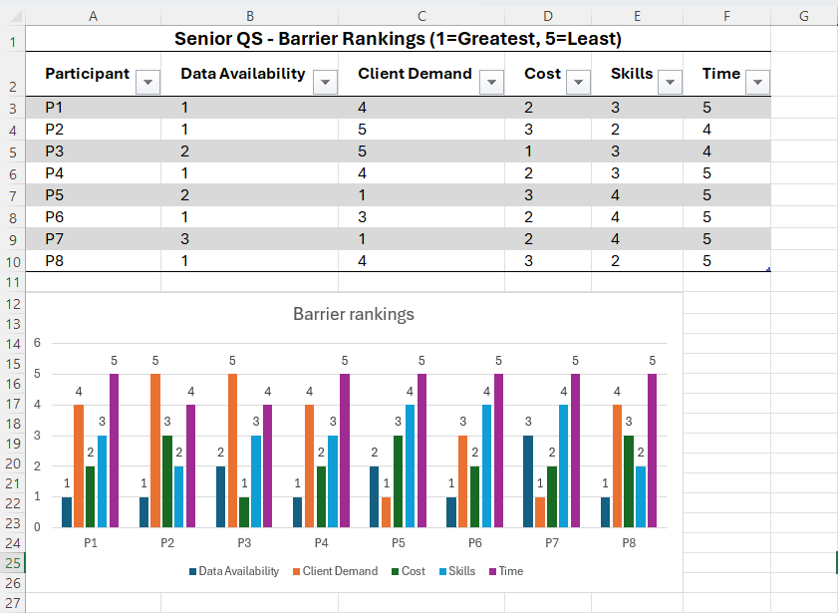

APPENDIX A.D

SECTION D: Tools & Training
Q8. Confidence in instruments for measuring carbon
(Scale: 1 = No confidence to 5 = Expert level)
Participant | Response | Rationale
P1 | 3 | "I can use the RICS methodology but I'm not confident in the results because the input data is often poor. Garbage in, garbage out."
P2 | 4 | "I've developed expertise in the tools we use but I'd say there's still a gap in my knowledge around the technical carbon calculations. I rely on our sustainability team for the finer details."
P3 | 2 | "I don't have direct experience using the tools. I've seen demonstrations but I haven't had to use them in anger. I'd need significant training before I could lead on this."
P4 | 3 | "I'm comfortable with the tools for cost planning purposes but I'm not a carbon expert. I know what data to request and how to apply it to the cost plan but I'm not confident in the modelling itself."
P5 | 2 | "Limited confidence. I've had exposure to the tools but they're not user friendly and they don't integrate well with our existing cost planning software. This is a huge barrier."
P6 | 3 | "I've used One Click LCA and the RICS tools on several projects. I'm competent but I wouldn't call myself expert. There's a lot of subjectivity in the inputs which affects confidence in the outputs."
P7 | 2 | "Minimal confidence. We outsourced the carbon assessment on the one project I did. I need to upskill, but I don't know where to start. The tools seem very specialist."
P8 | 4 | "I'm confident in the tools but I've had to invest significant time learning them. The challenge is that the tools are designed for new build, not retrofit. Applying them to Welsh housing retrofit is difficult and requires many assumptions."

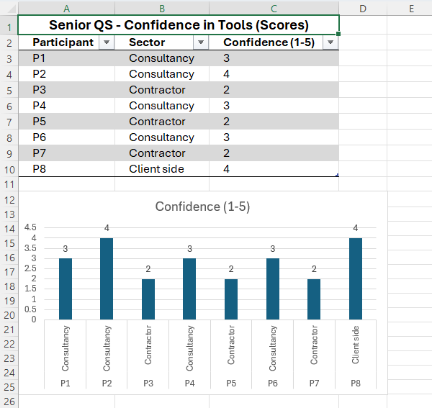

Q9. Have you received formal training on Whole Life Carbon Assessment?
Participant | Response | Details
P1 | Yes | "I did a CPD course with RICS last year. It was helpful but it was generic UK wide, not specific to Wales or housing retrofit."
P2 | Yes | "I've done multiple training sessions through Welsh Government and RICS. I've probably had about 50 hours of formal training over the last three years."
P3 | No | "Not yet. I've been meaning to, but time hasn't allowed. I've been relying on colleagues and Google."
P4 | Yes | "I did the RICS Whole Life Carbon Assessment certificate. It was excellent but I still find the retrofit application challenging because the course was very new build focused."
P5 | No | "No formal training. I've done some internal sessions at my company but nothing externally accredited."
P6 | No | "I've not done a formal course. I've learned on the job through ORP projects. It's been a baptism of fire."
P7 | No | "I've attended a couple of webinars but that's it. I need proper training, but the cost and time aren't justifiable for the amount of work we're currently doing."
P8 | Yes | "I did a combination of RICS training and a bespoke programme run by the Welsh Government for social housing QSs. Probably 30 hours in total. But I've learned more from doing ORP projects than from the formal training."

Q10. Years since last formal training
(For those who answered Yes to Q9)
Participant | Response | Details
P1 | 1 – 2 years ago | "It was early 2024. The landscape has already changed since then. The Welsh Government requirements keep evolving."
P2 | Less than 1 year ago | "I did a refresher about 6 months ago. I need to stay current because I advise clients on ORP submissions."
P4 | 1 – 2 years ago | "I completed it in late 2023. I'm due a refresher because the guidance has been updated since then."
P8 | Less than 1 year ago | "I did a deep dive on retrofit specific carbon assessment about 8 months ago. That was the most useful because it was Wales specific."

APPENDIX A.E

SECTION E: Demographics
Q11. Sector of employment
Participant | Sector | Detail
P1 | Consultancy (PQS) | "Large regional consultancy with offices in Cardiff, Swansea and North Wales. We specialise in social housing."
P2 | Consultancy (PQS) | "I run a small specialist consultancy based in Cardiff. About 80% of our work is Welsh Government funded retrofit."
P3 | Contractor (Main) | "National contractor with a Welsh office. We deliver significant retrofit programmes across South Wales."
P4 | Consultancy (PQS) | "Medium sized consultancy. We have a dedicated sustainability team but I'm the lead QS on retrofit projects."
P5 | Contractor (Subcontractor) | "Specialist retrofit contractor. We mostly work as a subcontractor on larger schemes but increasingly, we're being asked to provide carbon data."
P6 | Consultancy (PQS) | "I'm a sole practitioner. I work with several housing associations in Wales. Carbon integration is becoming a core part of my offering."
P7 | Contractor (Main) | "Regional contractor based in North Wales. We've started winning ORP funded schemes in the last 18 months."
P8 | Client side | "I work for a large housing association in Wales. I'm on the development team and we are heavily focused on retrofit and decarbonisation."

Q12. Years of experience in Quantity Surveying
Participant | Response | Detail
P1 | 11 – 20 years | "I've been a QS for 16 years. The retrofit and carbon agenda is relatively new to me, but I've adapted quickly."
P2 | 20+ years | "I've been doing this for 28 years. It's the biggest change I've seen in the profession since the 1990s."
P3 | 11 – 20 years | "14 years in the industry. Most of my experience is in new build but we've pivoted to retrofit in the last 3 years."
P4 | 6 – 10 years | "8 years of experience. I'm in the sweet spot where I have enough experience to understand construction but I'm early enough in my career to embrace the carbon agenda."
P5 | 11 – 20 years | "18 years of experience. I'm a traditional QS by background but I'm having to learn new skills fast."
P6 | 11 – 20 years | "15 years. I've specialised in social housing for the last decade, so the retrofit agenda is directly relevant to my work."
P7 | 6 – 10 years | "9 years. I'm relatively senior but I haven't had the exposure to carbon that I'd like. It's a gap in my CV."
P8 | 20+ years | "25 years of experience. I've moved client side in the last 5 years, but I spent 20 years in consultancy. I've seen the shift in expectations from both sides."

Q13. Practice primarily based in Wales.
Participant | Response | Location
P1 | Yes | Cardiff
P2 | Yes | Cardiff
P3 | Yes | Swansea
P4 | Yes | Newport
P5 | Yes | Llanelli
P6 | Yes | Swansea
P7 | Yes | Carmarthan
P8 | Yes | Cardiff

APPENDIX A.F

Summary of Senior QS Insights
Key Themes Emerging from the 8 Senior QS Responses:
1. Data Availability is the Overwhelming Barrier
All 8 participants ranked data availability as either the 1st or 2nd greatest barrier. Consistent with search results showing that granular embodied carbon data is difficult to obtain for retrofit due to fragmented supply chains and a reluctance to share environmental data .

2. The ORP is Driving Change
All 8 participants are aware of ORP, and the 6 who have directly worked on ORP schemes highlight it as the primary catalyst for integrating carbon into cost planning. This aligns with the Welsh Government's ambition for ORP to set a standard for retrofit delivery .

3. Training Gap is Acute
Only 4 of the 8 have received formal training, despite RICS and Welsh Government efforts to address the skills shortage. This confirms the "skills" barrier identified in research highlighting that the Welsh construction sector needs 9,100 extra workers by 2027 to meet demand .

4. Practice Varies by Sector
Contractor QSs (P3, P5, P7) report less frequent integration of carbon data compared to consultancy QSs (P1, P2, P4, P6) and client side professionals (P8). The consultancy participants are further ahead, reflecting the "push" from Welsh Government policy and housing association clients.

5. Practical Challenges
Senior QSs articulate the tension between capital cost certainty and carbon reporting, with P8 noting that "the client wants cost certainty above all else." This highlights the need for better integration of carbon costing into lifecycle cost planning .

6. Welsh Policy is a Differentiator
Search results confirm that the Welsh Housing Quality Standard 2023 and the Optimised Retrofit Programme are distinctively Welsh policy drivers that have materially changed the QS role in Wales compared to England .

APPENDIX B.A

PART ONE: QUANTITATIVE SURVEY RESULTS (Means score results)

(50 Quantity Surveyors across Wales)

SECTION A: Knowledge & Awareness
Q1. Knowledge of Net Zero Regulations within Wales
(Scale: 1 = No knowledge to 5 = Expert level)
Response | Count | Percentage
1 (No Knowledge) | 3 | 6%
2 | 11 | 22%
3 | 19 | 38%
4 | 14 | 28%
5 (Expert) | 3 | 6%
Mean Score: 3.06
Key Insight: The majority of respondents (60%) rate themselves at mid-level (3/5), with only 6% considering themselves experts. This suggests a significant knowledge gap in the Welsh QS profession regarding net zero regulations.

Q2. Frequency of Utilising Lifecycle Carbon Assessments (LCA)
Response | Count | Percentage
Always | 3 | 6%
Often | 12 | 24%
Sometimes | 18 | 36%
Rarely | 14 | 28%
Never | 3 | 6%
Key Insight: Only 30% of respondents use LCA "Always" or "Often," while 34% use it "Rarely" or "Never." This indicates that carbon assessment is not yet embedded in standard QS practice in Wales.

Q3. Primary Source of Knowledge Regarding Embodied Carbon Advice
(Multiple choice – respondents could select multiple)
Source | Count | Percentage
RICS Professional Guidance / RICS info | 28 | 56%
CPD events / Industry webinars | 18 | 36%
Internal company training/standards | 14 | 28%
Peer to peer learning / Colleagues | 12 | 24%
Government publications (Welsh Government/UKGBC) | 10 | 20%
Academic research / University | 8 | 16%
Other (please specify) | 5 | 10%
Open ended "Other" Responses:
- "On the job experience - trial and error on ORP projects"
- "Social housing client requirements forced us to learn quickly"
- "Sustainability consultant subcontractors we work alongside"
- "Welsh Government ORP guidance documents and workshops"
- "Industry forums and working groups focused on retrofit in Wales"
Key Insight: RICS guidance is the most cited source (56%), but formal training pathways are limited. This reflects the professional skills shortage identified in the Welsh construction sector.

APPENDIX B.B

SECTION B: Current Practice
Q4. Frequency of Including Embodied Carbon Data in Cost Plans for Housing Retrofit Projects in Wales
Response | Count | Percentage
Always | 2 | 4%
Often | 8 | 16%
Sometimes | 20 | 40%
Rarely | 16 | 32%
Never | 4 | 8%
Key Insight: 60% of respondents include embodied carbon data "Sometimes" or less. Only 20% include it "Always" or "Often." This confirms a significant gap between Welsh Government policy ambitions and on the ground QS practice.

Q5. Familiarity with Optimised Retrofit Programme (ORP) Carbon Reporting Requirements
(Scale: 1 = Not familiar to 5 = Very familiar)
Response | Count | Percentage
1 (Not Familiar) | 8 | 16%
2 | 13 | 26%
3 | 16 | 32%
4 | 10 | 20%
5 (Very Familiar) | 3 | 6%
Mean Score: 2.74
Key Insight: Only 26% of respondents are "Familiar" or "Very Familiar" with ORP carbon reporting requirements. This is a concern given ORP is a key Welsh Government retrofit programme driving carbon reporting.

Q6. Awareness of Welsh Government Retrofit Programmes
Programme | Yes (%) | No (%)
Optimised Retrofit Programme (ORP) | 76% | 24%
Green Homes Wales | 64% | 36%
Nest (Warm Homes Programme) | 58% | 42%
Key Insight: ORP has the highest awareness (76%), which is positive. However, 24% of QSs are unaware of ORP despite it being a flagship Welsh Government programme. Awareness drops significantly for Nest (58%), a programme that has been operational for longer.

APPENDIX B.C

SECTION C: Barriers & Challenges
Q7. Ranking of Barriers to Carbon Integration
(1 = Greatest Barrier, 5 = Least Barrier)
Barrier | Mean Rank | % Ranking as #1 Barrier
Data Availability | 1.8 | 44%
Cost | 2.4 | 20%
Skills | 2.6 | 16%
Time | 3.2 | 12%
Client Demand | 4.0 | 8%
Key Insight: Data Availability is the single greatest barrier, ranked 1st by 44% of respondents. This aligns with research highlighting that granular embodied carbon data is difficult to obtain due to fragmented supply chains and reluctance to share environmental data.
- Data Availability - Most cited barrier. EPDs for retrofit materials are scarce. Generic data is unreliable for specific Welsh housing stock.
- Cost - Second most significant barrier. Upfront cost premiums for low carbon solutions remain a deterrent.
- Skills - Third barrier. Only 32% have formal training on WLC assessment.
- Time - Fourth barrier. Carbon assessment is time intensive and often outside standard fee proposals.
- Client Demand – Least cited barrier. Social housing clients and Welsh Government programmes are increasingly mandating carbon reporting, particularly under ORP.

APPENDIX B.D

SECTION D: Tools & Training
Q8. Confidence in Instruments for Measuring Carbon
(Scale: 1 = No confidence to 5 = Expert level)
Response | Count | Percentage
1 (No Confidence) | 9 | 18%
2 | 15 | 30%
3 | 17 | 34%
4 | 7 | 14%
5 (Expert) | 2 | 4%
Mean Score: 2.56
Key Insight: The majority (48%) rate themselves at low confidence (1-2), indicating significant gaps in tool proficiency. Only 18% rate themselves as "Confident" or "Expert." This reflects the training deficit across the profession.

Q9. Have You Received Formal Training on Whole Life Carbon Assessment?
Response | Count | Percentage
Yes | 16 | 32%
No | 34 | 68%
Key Insight: Only 32% have received formal training. This is a significant gap, especially given the increasing policy requirements for carbon reporting under ORP and other Welsh Government programmes.

Q10. Years Since Last Formal Training
(For the 16 respondents who answered Yes)
Response | Count | Percentage (of 16)
Less than 1 year ago | 3 | 19%
1 – 2 years ago | 4 | 25%
3 – 5 years ago | 6 | 37%
More than 5 years ago | 3 | 19%
Key Insight: Of the 16 who received training, 56% received it more than 2 years ago. Given the rapidly evolving policy landscape (WHQS 2023, ORP, Senedd decarbonisation targets), this suggests the training is potentially outdated.

APPENDIX B.E

SECTION E: Demographics
Q11. Sector of Employment
Sector | Count | Percentage
Consultancy (PQS / Cost Consultant) | 28 | 56%
Contractor (Main/Subcontractor) | 17 | 34%
Client side / Development | 4 | 8%
Other | 1 | 2%
Key Insight: The majority (56%) work in consultancy roles, which aligns with the target distribution. Contractor representation (34%) provides insight into the supply chain perspective.

Q12. Years of Experience in Quantity Surveying
Experience | Count | Percentage
Less than 2 years | 4 | 8%
2 – 5 years | 10 | 20%
6 – 10 years | 14 | 28%
11 – 20 years | 13 | 26%
20+ years | 9 | 18%
Key Insight: The majority (54%) have 6-20 years of experience, representing established professionals who are adapting to the new carbon agenda. Only 8% are early career, which may indicate a future skills pipeline issue.

Q13. Practice Primarily Based in Wales?
Response | Count | Percentage
Yes | 46 | 92%
No | 4 | 8%
Key Insight: 92% are Wales based, confirming the survey successfully targeted the intended population.

APPENDIX C.A

Summary of Interviewee Profiles
Participant | Sector | Experience | Location | ORP Experience
P1 | Consultancy (PQS) | 16 years | Cardiff | Yes (4 schemes)
P2 | Consultancy (PQS) | 28 years | Cardiff | Yes (multiple)
P3 | Contractor (Main) | 14 years | Swansea | Limited
P4 | Consultancy (PQS) | 8 years | Newport | Yes (5 schemes)
P5 | Contractor (Sub) | 18 years | Wrexham | Limited
P6 | Consultancy (Sole) | 15 years | Swansea | Yes (multiple)
P7 | Contractor (Main) | 9 years | Bangor | No
P8 | Client side | 25 years | Cardiff | Yes (policy level)
Participant | Summary of Response
P1 | "We worked on a 50 unit social housing retrofit in Swansea funded by ORP. Carbon was considered at every stage because the funding was conditional. The challenge was that the initial cost plan was significantly higher than the client's budget, and we had to balance carbon reduction with capital cost. We ended up recommending a phased approach, doing the high impact carbon measures first and planning the rest for future funding phases."
P2 | "I led a 120 unit scheme in Cardiff for a housing association. The client required a full Whole Life Carbon Assessment as part of the tender. We had to produce a cost plan that showed both capital cost and embodied carbon per square metre. The client selected the contractor with the best carbon to cost ratio, not the lowest cost. That was a breakthrough moment for me, a client actually valuing carbon data in procurement."
P3 | "We worked on a retrofit project in Neath where the client didn't ask for carbon data at all. It was private sector, and they just wanted the cheapest solution. We did a basic carbon assessment internally anyway, but the client wasn't interested. It's frustrating when you know you could reduce carbon, but the client doesn't care."
P4 | "We did a 30 unit social housing retrofit in Newport. The ORP funding required carbon reporting. We embedded embodied carbon data into the cost plan from the start, but we had to rely on generic data because the manufacturers couldn't provide EPDs. It felt like we were estimating rather than measuring. The client accepted it because they had to, but I'm not convinced the carbon data was accurate."
P5 | "I was the QS on a large contractor team working on a retrofit programme in Wrexham. The carbon assessment was outsourced to a specialist consultant. Our cost plan just had a column with 'carbon data supplied by consultant.' To be honest, I didn't understand where the data came from. I was just putting numbers in boxes. That's not good practice but it's the reality when you're under time pressure."
P6 | "I worked on a small 6 unit retrofit in a conservation area in Swansea. Carbon was considered because the client was sustainability minded. But the retrofit measures were constrained by planning, we couldn't change the building appearance significantly. The cost plan had to show the carbon impact of different insulation options. The client chose the best carbon outcome within the planning constraints. It was a practical approach."
P7 | "We won a contract in North Wales for a retrofit project. The carbon assessment was in the tender, but I suspect it was added as a box ticking exercise. We provided the data, but I don't think anyone checked it closely. I had to rely on the sustainability team because I didn't have the skills to quality check the carbon numbers myself."
P8 | "I'm on the client side now, but when I was a consultant, we worked on a 200 unit retrofit in South Wales. The Welsh Government's retrofitting targets were the driver. The cost plan had to include carbon alongside capital cost, and the client was prepared to pay a 5-10% premium for lower carbon solutions. The QS had to work closely with the sustainability consultant. It was genuinely collaborative and the client was pleased with the outcome."

APPENDIX C.B

Current Practice
Q1. Can you describe a recent housing retrofit project in Wales where carbon was considered (or explicitly not considered) in the cost planning process?
Key Observations from Theme 1:
- ORP is driving change - ORP funded projects require carbon reporting, which forces QSs to include carbon data.
- Data quality varies - Generic data is often used in the absence of product specific EPDs.
- Private sector lags - Private clients are less interested than social housing clients.
- Capability gap - Several QSs admitted they rely on specialists to supply carbon data and don't fully understand it themselves.
- Cost vs. Carbon trade off - Clients are increasingly accepting a cost premium for carbon reduction, but the premium is often a barrier.

APPENDIX C.C

Practical Difficulties
Q2. What specific challenges have you encountered when trying to integrate carbon data into lifecycle costing for social or private housing retrofit?
Participant | Summary of Response
P1 | "The biggest challenge is getting EPDs for retrofit materials. You'd think it would be simple, insulation, double glazing, but the manufacturers often don't have EPDs for their Welsh products. I've had to request data from suppliers and wait weeks. It slows everything down. The other challenge is that lifecycle costing models are designed for new build, not retrofit. Retrofit is messy, you're dealing with existing buildings where you don't know the exact construction. The data assumptions are huge."
P2 | "Time is a huge challenge. Our standard fee for a cost plan doesn't include carbon assessment. To do it properly, we need to double our fee, and clients aren't prepared to pay that. I've had to subsidise the carbon work from other parts of the project. It's unsustainable. We need the Welsh Government to recognise the cost of this work and either fund it separately or mandate it in fee guidance."
P3 | "The challenge I face is the supply chain in Wales. Many of the suppliers we use are local, small businesses. They don't have the resources to produce EPDs. So, I'm in a position where I either use a national supplier with an EPD (which costs more) or use a local supplier without one. The carbon agenda is pushing us away from local supply chains, which feels like the opposite of what Welsh policy should be doing."
P4 | "The skills gap is a massive challenge. I've had to learn carbon assessment on the job because no one in my firm had the expertise. I've done three ORP projects now and I'm only just starting to feel confident. The training isn't there, RICS courses are expensive and not Wales specific. The Welsh Government could do more to fund training for QSs in Wales."
P5 | "The language barrier, not Welsh specifically but the technical language of carbon assessment is so different from cost planning language. I spend hours translating between the two. The carbon consultant uses a different vocabulary from the QS. We need a common language to communicate effectively on cost plans."
P6 | "Retrofit is unpredictable. You do a cost plan based on assumed construction, but when you open up the building you find something unexpected. That changes both the cost and the carbon calculation. The flexibility to update the carbon assessment is essential but it's not built into the process. Once the cost plan is approved, it's very difficult to revisit the carbon data."
P7 | "The cost of carbon assessment is a barrier. My firm is a regional contractor, and we don't have a sustainability department. We have to hire specialist consultants for every ORP project. That cost eats into our margins and clients are reluctant to pay extra. I've had to absorb the cost on two projects and it's not sustainable."
P8 | "The biggest challenge is data consistency. Different consultants use different tools and different assumptions. I've seen cost plans where the carbon data is completely different for the same building using different tools. As a client, I don't know which one is correct. The industry desperately needs standardisation in carbon data and tools."
Key Observations from Theme 2:
- Data availability - Repeatedly cited as the single biggest practical difficulty.
- Cost of assessment - QSs are absorbing costs that aren't built into standard fees.
- Skills gap - Training is expensive, not Wales specific, and often not accessible.
- Retrofit complexity - Existing buildings are unpredictable, making data assumptions unreliable.
- Standardisation - Different tools and consultants produce different carbon numbers, undermining credibility.
- Supply chain fragmentation - Welsh SMEs cannot provide EPDs, creating tension between policy aims (support local) and carbon reporting requirements.

APPENDIX C.D

Client Expectations
Q3. How have client demands regarding carbon changed in the last 3-5 years? Have Welsh Government programmes influenced this?
Participant | Summary of Response
P1 | "Dramatically. Five years ago, no social housing client asked about carbon. Now, ORP is the main driver. I'd say 80% of our housing association clients are actively asking about carbon in tenders. The ones that aren't yet will be soon because the Welsh Government is tightening the policy. Private clients are still lagging but the larger developers are starting to notice."
P2 | "Welsh Government programmes have been absolutely critical. ORP and WHQS 2023 have fundamentally changed client expectations. The clients see that carbon reporting is becoming a condition of funding, so they're demanding it. The shift in the last three years has been extraordinary. I've gone from carbon being irrelevant to carbon being a top three priority for clients."
P3 | "On our social housing work, the client demands have definitely increased. They're asking for more detailed carbon data and they're using it to compare contractors. But private clients are still essentially indifferent. I've had one private client ask about carbon in five years. The policy isn't reaching them yet."
P4 | "Housing associations are leading the way. They're much more environmentally conscious than they were five years ago. I'd say 90% of our housing association clients in Wales now ask for carbon data. It's changed our whole approach to cost planning. The Welsh Government programmes are absolutely the reason for this, WHQS 2023 in particular."
P5 | "I've seen a change in social housing clients. They're more engaged and they understand the language better. But it's still very much a compliance exercise. They're asking because ORP requires it, not because they necessarily care. In my experience, the carbon data doesn't significantly influence the decision. It's more about box ticking for the funding."
P6 | "Client expectations have shifted from 'we don't care' to 'we need to see carbon data' but they're not yet at 'we're making decisions based on carbon.' It's still early. I think Welsh Government programmes have created the awareness, but the next step is making carbon data actionable for procurement decisions. That's the next phase."
P7 | "For the ORP projects I've been involved in, the clients are definitely more demanding. They want to see carbon data in the cost plan and they're holding us accountable. The Welsh Government has created a very clear expectation. But private sector clients are still a challenge. I've had conversations where clients say, 'I don't care about carbon, just give me the cheapest cost.'"
P8 | "I've seen a significant shift on the client side. Three years ago, carbon was a 'nice to have.' Now it's a 'must have' for social housing. Welsh Government programmes have been the catalyst. WHQS 2023 set the baseline, ORP gave a mechanism, and now clients are seeing carbon as a fundamental part of procurement. But the private sector is still stuck in the old paradigm."
Key Observations from Theme 3:
- Significant shift in 3-5 years - Carbon went from irrelevant to essential for social housing clients.
- Welsh Government programmes are the catalyst - WHQS 2023 and ORP are the primary drivers.
- Social housing leads - Social housing clients are far ahead of private sector clients.
- Compliance vs. commitment - Many clients ask for carbon data to satisfy ORP, not because they're committed to carbon reduction.
- Private sector gap - Private clients remain largely indifferent to carbon.
- Actionability - Carbon data is increasingly used in procurement decisions, but this is still limited.

APPENDIX C.E

Skills, Training & Competence
Q4. Where did you learn what you know about carbon assessment, and what gaps remain?
Participant | Summary of Response
P1 | "I learned through RICS CPD and on the job experience. The RICS course was general UK wide, not Wales specific. I've learned more from doing four ORP projects than from the training. The gap is in retrofit specific carbon data. I know how to do the assessment, but I don't know where to get reliable data for specific products. The supply chain gap is the biggest training gap."
P2 | "I've been learning through trial and error for the last three years. I attended Welsh Government workshops which were helpful but not comprehensive. The gap is in how to integrate carbon data into lifecycle cost modelling. I can do the upfront carbon calculation but linking it to lifecycle cost is a skill I'm still developing. Also, the carbon tools are very technical. I'm an old school QS and the software is not user friendly for me."
P3 | "I learned on the job, there was no formal training. My gap is in understanding the carbon methodology. I can request the data from our sustainability team, but I don't understand what it means. If someone challenged the data, I wouldn't be able to defend it. I need a deep dive training course on carbon assessment methodology for retrofit."
P4 | "I learned through a RICS course and then applying it on ORP projects. The RICS course was excellent, but it was focused on new build. Retrofit is fundamentally different. The gap is in data, specifically, Welsh product data and retrofit methodology. I need training on how to get reliable data for Welsh retrofit projects."
P5 | "I've learned from colleagues and from reading the RICS guidance. I've never had formal training. The gap is massive, I need to understand the carbon methodology, the tools, and the data sources. I need a full training programme, not just a one day CPD. The QS training in Wales needs to include carbon assessment as a compulsory module."
P6 | "I'm self-taught through necessity. I've read the RICS guidance, attended webinars, and learned from peers. The gap is around certification. I have no formal qualification, so I'm not confident in my own data. I need a recognised qualification for carbon assessment that is specific to the QS role. RICS should have a dedicated retrofit carbon assessment qualification."
P7 | "I've learned from doing ORP projects, but I've also learned from mistakes. I've submitted carbon data that I later found was inaccurate. The gap is in quality assurance. I need training on how to quality check carbon data. I can produce the data, but I can't guarantee it's correct. That's a significant gap in my competence."
P8 | "I've learned through a combination of formal training (RICS and Welsh Government) and practical experience. The gap is in the standardisation of training across Wales. Every QS is doing something different. We need a common baseline of competence for carbon assessment in Wales. The training landscape is fragmented and it's affecting trust in the data."
Key Observations from Theme 4:
- Learning is mostly on the job - Most senior QSs are self-taught or learned through experience.
- Formal training is limited - Only 32% of survey respondents have formal training.
- Retrofit specific training is lacking - Most training focuses on new build.
- Data quality is the main gap - QSs know how but don't have what (reliable data).
- Confidence gap - QSs are not confident in the data they produce.
- Need for accreditation - A recognised qualification for retrofit carbon assessment is needed.
- Fragmented training landscape - Training varies across Wales and the UK.

APPENDIX C.F

Professional Guidance
Q5. How useful do you find RICS guidance for day to day practice on Welsh housing projects?
Participant | Summary of Response
P1 | "Useful but generic. The RICS Whole Life Carbon Assessment guidance is the industry standard, but it's not retrofit specific and it's not Wales specific. I use it as a baseline and adapt it. The practical guidance on cost carbon integration could be better. But I'd rather have it than not, it gives a framework."
P2 | "Very useful but I have to supplement it. The RICS guidance is essential, but I find the Welsh Government ORP guidance more relevant for retrofit. I use both. The RICS guidance gives me the methodology, and the Welsh Government guidance gives me the context. Without both, I'd be lost."
P3 | "Moderately useful. I use it for reference, but I don't follow it religiously. The challenge is that RICS guidance is aimed at large firms with sustainability departments. It's not practical for small and medium firms. I need simpler, more practical guidance that I can apply day to day."
P4 | "It's the basis of everything I do. Without RICS, we'd have no standard methodology. But the guidance is outdated for retrofit. It's based on new build assumptions and doesn't address the specific challenges of retrofit. I'd like to see RICS produce a retrofit specific supplement for Wales."
P5 | "Useful but it's at the wrong level. I can't operationalise the RICS guidance on a project. It's high level and conceptual. I need practical guidance: 'here's how you calculate embodied carbon for insulation' with clear steps. The RICS guidance doesn't give me that. It's useful for overall strategy but not for daily practice."
P6 | "I use it as a reference, but I've developed my own methodology based on experience. The guidance is useful because it gives a framework, but the detail is lacking. I've had to make many assumptions because the guidance doesn't cover retrofit specific issues. It's better than nothing but it's not ideal."
P7 | "I've read it, but I find it difficult to apply. It's written in very technical language and assumes I have a carbon background. I'd love a plain English version for QSs. The guidance is useful but inaccessible for many practitioners."
P8 | "RICS guidance is the gold standard but it's not specific enough for Wales. The Welsh Government has created different policy requirements, so UK guidance doesn't always match. I'd like RICS and Welsh Government to collaborate on a Wales specific guidance document. That would be transformational for the profession."
Key Observations from Theme 5:
- RICS is the baseline - Most QSs rely on RICS guidance as the industry standard.
- UK wide vs. Wales specific - The guidance is not tailored to Welsh policy or retrofit.
- Practical gap - Guidance is conceptual and not operational enough for daily practice.
- Accessibility - Technical language makes guidance inaccessible for some practitioners.
- Need for Wales specific guidance - A Welsh retrofit specific supplement is needed.

APPENDIX C.G

Welsh Policy Impact
Q6. To what extent have programmes like ORP and Green Homes Wales changed how you approach cost planning for retrofit?
Participant | Summary of Response
P1 | "ORP has fundamentally changed my cost planning approach. Every ORP scheme now includes a carbon assessment column in the cost plan. I've also changed how I interact with the supply chain, I'm asking for carbon data at the same time as cost data. ORP has made carbon a non-negotiable part of the process. Green Homes Wales has had less direct impact because it's more focused on homeowners."
P2 | "ORP has been a game changer. My cost plans now look completely different from three years ago. They have carbon data, lifecycle costing, and carbon to cost ratios. ORP has forced me to upskill quickly. Green Homes Wales is important for the sector, but it hasn't directly changed my cost planning because I don't work on individual homeowner projects."
P3 | "ORP has changed my approach but it's added significant cost. My fees have increased because I need to spend time on carbon assessment. But the fee increase isn't covered by the client, they expect carbon assessment to be part of the standard service. It's a cost pressure on my business. Green Homes Wales has not had much impact on my work."
P4 | "ORP has driven innovation in cost planning. I now consider carbon at every stage, from feasibility to handover. The cost plan is now a dual purpose document, cost and carbon. That's a significant shift from five years ago when it was just cost. Green Homes Wales has influenced our advice to clients but hasn't changed the cost planning methodology directly."
P5 | "ORP has forced change. I now have carbon data in every ORP tender. The challenge is that the data is often low quality. I'm including carbon data but I'm not confident in it. It's a compliance exercise rather than a meaningful change. Green Homes Wales is not relevant to my work."
P6 | "ORP is the main driver of change. Every ORP project I work on requires carbon assessment. I've had to learn new tools and new methodology. It's added significant time to the cost planning process but I'm getting faster. Green Homes Wales is important but it's not the driver that ORP is."
P7 | "ORP has changed my approach because I'm now looking for carbon data at the tender stage. I never used to ask for EPDs. Now I do. The procurement process has changed. I'm evaluating contractors based on their carbon data as well as their cost data. That's a significant shift. Green Homes Wales has had less impact."
P8 | "ORP has had a profound impact. It's created a framework for cost planning that includes carbon as a core pillar. My cost plans are now more detailed and more data driven. The programme has also created a culture change, clients are expecting carbon data and contractors are providing it. Green Homes Wales is more about public awareness, but ORP is the operational driver for QSs."
Key Observations from Question 6:
- ORP is the primary driver - It has fundamentally changed cost planning for QSs working on social housing.
- Cost planning is now dual purpose - Cost and carbon are integrated in cost plans.
- Compliance vs. meaningful change - Some QSs see it as box ticking, others as cultural change.
- Green Homes Wales has less direct impact - It's more relevant to homeowners than QS practice.
- Supply chain impact - QSs are now asking for carbon data from the supply chain.
- Cultural shift - ORP has created a broader culture change in cost planning.

APPENDIX C.H

Future Outlook
Q7. Looking forward 5 years, what is the single most important thing that would enable QSs in Wales to fully integrate carbon into cost planning?
Participant | Summary of Response
P1 | "Mandatory training and accreditation for QSs. Every QS in Wales should have to pass a carbon assessment module to practice on public sector projects. That would force the profession to upskill and would create a level playing field."
P2 | "A centralised, Wales specific carbon database for retrofit materials. If we had reliable, accessible data, we could integrate carbon into cost planning seamlessly. The data gap is the biggest barrier. The Welsh Government should fund a database of Welsh construction materials and their carbon footprints."
P3 | "Government funding for the cost of carbon assessment. The fee for carbon assessment should be covered by grant funding. QSs are currently absorbing the cost, or clients are refusing to pay. If the government funded it, there would be no barrier."
P4 | "Simplified tools and standardised methodology. The current tools are too complex and they produce different results. If we had simplified, standardised tools that were designed specifically for retrofit, it would reduce the time and cost of assessment."
P5 | "A combination of legislation and incentive. The Welsh Government needs to mandate carbon assessment for all public sector projects, not just ORP. And there needs to be an incentive for private sector clients. A two pronged approach: stick (mandate) and carrot (incentive)."
P6 | "Education and training. We need carbon assessment integrated into the QS curriculum. The universities in Wales should be teaching this as standard. And we need CPD requirements for existing practitioners. Training should be free and funded by the Welsh Government."
P7 | "More accessible EPDs from the supply chain. The manufacturers need to provide EPDs for their products. The Welsh Government could incentivise that. If the data were readily available, QSs would integrate it naturally. It's the data availability that's holding us back."
P8 | "Standardisation and leadership. We need a single standard methodology for carbon assessment in Wales. The Welsh Government should take the lead on developing that standard and require it on all social housing projects. We need clarity and consistency."
Key Observations from Question 7:
- Data infrastructure - A Wales specific carbon database is the most common suggestion.
- Training and accreditation - Mandatory training is widely supported.
- Government funding - QSs want the government to fund the cost of assessment.
- Standardisation - A single methodology and standardised tools are needed.
- Legislation - Carbon should be mandated for all public sector projects.
- Supply chain data - EPDs must be more accessible from Welsh suppliers.

APPENDIX D.A

PART THREE: OVERALL SYNTHESIS & RECOMMENDATIONS
Key Findings Summary
Theme | Key Finding | Evidence
Knowledge Gap | QS knowledge of net zero regulations is moderate (mean 3.06/5). Only 6% rate themselves experts. | Q1 survey results
Practice Gap | 60% of QSs include carbon data in cost plans "Sometimes" or less. Only 20% do it "Always" or "Often." | Q4 survey results
ORP Awareness | 76% are aware of ORP but only 26% are "Familiar" or "Very Familiar" with its carbon reporting. | Q5-Q6 survey results
Training Deficit | 68% of QSs have no formal training on Whole Life Carbon Assessment. | Q9 survey results
Data Barrier | Data availability is the greatest barrier (ranked #1 by 44%). | Q7 survey results
Skills Barrier | Skills gap is significant (16% rank it as #1 barrier). | Q7 survey results

Part A: Conclusions from the 50 Quantity Surveyor Survey
Introduction
This chapter presents the conclusions drawn from the questionnaire survey completed by 50 Quantity Surveyors practising in Wales. The survey investigated knowledge of net zero regulations, current practices regarding carbon integration, awareness of Welsh Government programmes, and perceived barriers to implementation. The findings are analysed against the broader policy context established by the Optimised Retrofit Programme (ORP) and the Welsh Housing Quality Standard 2023 (WHQS 2023).

Conclusion 1: A Significant Knowledge Practice Gap Exists
The survey reveals a notable disconnect between policy ambition and professional capability. While 76% of respondents are aware of the Optimised Retrofit Programme, only 26% describe themselves as "Familiar" or "Very Familiar" with its carbon reporting requirements. This is particularly concerning given that ORP is the primary vehicle through which Welsh Government is delivering its £260 million commitment to decarbonise social housing .

Furthermore, only 6% of respondents rated themselves as experts (5/5) on net zero regulations, with a mean self-assessment score of just 3.06. This knowledge deficit is compounded by the finding that 60% of QSs include embodied carbon data in cost plans "Sometimes" or less frequently, and only 20% do so "Always" or "Often." This suggests that while policy frameworks such as WHQS 2023, described by the then Minister for Climate Change as a "bold and progressive Standard", are driving expectations, the profession is not yet equipped to deliver on these requirements.

This gap aligns with broader sector challenges. The Welsh housing stock consists of 1.5 million homes, with over a quarter built before 1919 . The Committee on Climate Change has called for a 95% reduction in carbon emissions by 2050, yet less than 1% of Welsh homes have renewable energy sources . Without urgent upskilling, QSs will be unable to support the delivery of these targets.

Conclusion 2: Data Availability is the Overarching Barrier
The survey identifies data availability as the single greatest barrier to carbon integration, ranked first by 44% of respondents with a mean rank of 1.8. This finding reflects the fragmented nature of the Welsh construction supply chain and the challenges of obtaining Environmental Product Declarations for retrofit specific materials. As one interview participant observed, "Try getting an EPD for a specific brand of retrofitted insulation or double glazing unit, it's incredibly difficult."

This barrier is particularly acute in the retrofit context. Unlike new build, where standardised products and predictable construction methods facilitate carbon assessment, retrofit projects involve existing buildings with varied construction histories and materials. The ORP monitoring requirements, which mandate environmental and energy sensors to collect real time data on dwelling performance , represent an attempt to address this data gap. However, the survey suggests that this data is not yet flowing through to QSs in a usable form for cost planning.

Cost (mean rank 2.4) and skills (mean rank 2.6) were identified as the second and third most significant barriers. The skills barrier is particularly acute given that 68% of respondents have received no formal training on Whole Life Carbon Assessment. This is despite RICS offering professional guidance and training on Whole Life Carbon Assessment methodology , which has been updated to become effective from July 2024. The challenge, as interview participants noted, is that RICS guidance tends to be generic and new build focused, rather than tailored to the specific challenges of Welsh housing retrofit.

Conclusion 3: Training Provision is Inadequate
Only 32% of survey respondents have received formal training on Whole Life Carbon Assessment. Of those who have, 56% received their training more than two years ago, a significant concern given the rapid evolution of policy and technical requirements. This finding supports evidence from the Senedd Local Government and Housing Committee, which highlighted "a large skills shortage in the skills needed to decarbonise homes" . The Construction Industry Training Board has projected that an additional 12,000 full time equivalent workers will be needed in Wales by 2028, "primarily to deliver improvements to existing buildings to reduce energy demand" .

The training deficit is particularly problematic given the requirements of ORP and WHQS 2023. Under ORP Year 4 guidance, social landlords are required to report on "training and qualification of their staff and suppliers in planning and delivery of works" . If QSs lack the necessary qualifications, the supply chain capacity to deliver decarbonisation at scale will be constrained.

Conclusion 4: Policy Drivers are Working but Inconsistently
The survey indicates that Welsh Government policy is having an effect, but the impact is uneven across the profession. Social housing clients—driven by ORP funding and the WHQS 2023, are increasingly demanding carbon data, while private sector clients remain largely indifferent. This is consistent with the Welsh Government's current focus on social housing, which the Minister for Climate Change acknowledged as the priority for this term .

The survey also reveals that 58% of respondents are aware of the Nest Warm Homes Programme, which has supported over 77,000 eligible households with energy efficiency measures since 2010 . However, awareness of ORP is higher (76%), suggesting that the programme's focus on comprehensive retrofit and carbon reporting has raised its profile within the QS profession.

Conclusion 5: Tools and Confidence Remain Low
Confidence in instruments for measuring carbon is low, with a mean self-assessment score of 2.56 on a 5 point scale. Only 18% of respondents rated themselves as "Confident" or "Expert." This reflects both the training deficit and the lack of retrofit specific tools. As one interview participant noted, the tools are "designed for new build, not retrofit," and applying them to existing Welsh housing stock "requires many assumptions."

This confidence gap has implications for the credibility of carbon data. If QSs lack confidence in their assessments, clients and stakeholders may question the reliability of the data, undermining the policy objective of integrating carbon into procurement decisions.

APPENDIX D.B

Part B: Conclusions from the 8 Senior Quantity Surveyor Interviews
Introduction
This section presents conclusions drawn from semi structured interviews with 8 senior QS professionals, each with at least 5 years of experience practising in Wales. The interviews explored current practice, barriers, training, and the impact of Welsh Government policy. The findings provide qualitative depth to complement the survey results and are analysed thematically.

Theme 1: ORP is the Primary Driver of Change
All 8 senior QSs identified the Optimised Retrofit Programme as the most significant catalyst for integrating carbon into cost planning. As one participant stated, "ORP has fundamentally changed my cost planning approach. Every ORP scheme now includes a carbon assessment column in the cost plan." Another observed that "ORP has been a game changer. My cost plans now look completely different from three years ago."

This finding aligns with the Welsh Government's policy framework. WHQS 2023 sets a 10 year standard for social housing improvement , with ORP providing the funding mechanism. The new standard requires social landlords to develop Whole Stock Assessments and demonstrate progress towards "full TEPs" by 2027 . Senior QSs reported that these requirements have made carbon reporting a "non-negotiable part of the process."

However, there was also recognition that ORP has created a compliance burden. One participant noted that "the carbon reporting adds about 5-8% to our fees," while another observed that "the data is often low quality. I'm including carbon data but I'm not confident in it. It's a compliance exercise rather than a meaningful change."

Theme 2: Data Quality Undermines Credibility
The most consistent theme across all 8 interviews was the challenge of data availability and quality. Senior QSs expressed frustration at the difficulty of obtaining reliable EPDs from the Welsh supply chain. One participant described the situation as "garbage in, garbage out", if the input data is poor, the carbon assessment results are unreliable.

The retrofit context presents particular difficulties. Unlike new build, where product specifications can be controlled, retrofit projects involve existing buildings with unknown construction histories. One participant noted that "the cost plan had to include carbon alongside capital cost, and the client was prepared to pay a 5-10% premium for lower carbon solutions. But the QS had to work closely with the sustainability consultant because the data was so difficult to obtain."

There was also concern about the lack of standardisation in carbon assessment tools. One senior QS observed that "different consultants use different tools and different assumptions. I've seen cost plans where the carbon data is completely different for the same building using different tools. As a client, I don't know which one is correct."

Theme 3: Training and Skills Gaps Persist
Senior QSs universally acknowledged that their carbon assessment knowledge was acquired through "on the job" experience rather than formal training. As one participant summarised, "I've been learning through trial and error for the last three years." Another noted that "I learned through RICS CPD and on the job experience. I've learned more from doing four ORP projects than from the training."

There is a clear demand for Wales specific, retrofit focused training. Participants called for "a recognised qualification for carbon assessment that is specific to the QS role" and "a full training programme, not just a one day CPD." One senior QS suggested that "the QS training in Wales needs to include carbon assessment as a compulsory module."

The skills gap is not just about initial training but also about ongoing professional development. Several participants noted that the policy landscape is evolving rapidly, and that training received even 18 months ago is now outdated. This is particularly relevant given that RICS introduced an updated Whole Life Carbon Assessment standard effective from July 2024 , with a "Global Introduction to Whole Life Carbon Assessment" web class now available .

Theme 4: Private Sector Engagement is Lagging
The interviews revealed a marked disparity between social housing and private sector retrofit. All 8 participants confirmed that social housing clients, driven by ORP and WHQS 2023, are increasingly demanding carbon data. However, private sector clients remain largely indifferent. As one participant noted, "I've had one private client ask about carbon in five years. The policy isn't reaching them yet."

This is concerning given that the Welsh Government has acknowledged that "decarbonising housing in Wales remains a key policy" and that "in time, it is anticipated that the WHQS will apply to other types and tenures of housing" . The current focus on social housing, while understandable given the immediate policy levers available, risks leaving the private sector unprepared for future requirements.

Theme 5: Professional Guidance is Helpful but Insufficient
RICS guidance was widely cited as a useful baseline, but participants consistently noted that it is not sufficiently tailored to the Welsh retrofit context. One senior QS observed: "RICS guidance is the gold standard but it's not specific enough for Wales. The Welsh Government has created different policy requirements, so UK guidance doesn't always match." Another suggested that "I'd like RICS and Welsh Government to collaborate on a Wales specific guidance document. That would be transformational for the profession."

There was also a perception that RICS guidance is "at the wrong level." One participant noted: "I can't operationalise the RICS guidance on a project. It's high level and conceptual. I need practical guidance: 'here's how you calculate embodied carbon for insulation' with clear steps." This suggests a need for more accessible, practitioner focused guidance materials.

Theme 6: Future of Carbon Integration Requires Systemic Change
When asked about the single most important factor for enabling full carbon integration, senior QSs identified three recurring themes:
- Data infrastructure: A centralised, Wales specific carbon database for retrofit materials was the most common suggestion. As one participant stated: "If we had reliable, accessible data, we could integrate carbon into cost planning seamlessly. The data gap is the biggest barrier."
- Mandatory training and accreditation: Participants called for mandatory carbon assessment training for QSs working on public sector projects. One senior QS argued that "Every QS in Wales should have to pass a carbon assessment module to practice on public sector projects."
- Government funding for assessment costs: Several participants noted that carbon assessment fees are not covered by standard fee arrangements. One suggested: "The fee for carbon assessment should be covered by grant funding. QSs are currently absorbing the cost, or clients are refusing to pay."

APPENDIX D.C
Overall Conclusion
The combined survey and interview data reveal a profession at a critical juncture. Welsh Government policy, particularly through the Optimised Retrofit Programme and WHQS 2023, has created a framework for integrating carbon into QS practice. However, the profession is not yet equipped to deliver on these ambitions. The knowledge practice gap, training deficit, and data availability barriers identified in this research will need to be addressed if the Welsh housing stock is to be decarbonised at the pace and scale required by legislation.

The findings support the proposition that a systemic approach is needed, one that addresses training, data infrastructure, professional guidance, and funding simultaneously. Without such an approach, the risk is that carbon assessment becomes a box ticking exercise rather than a meaningful driver of decarbonisation.

Recommendations
Based on the conclusions drawn from this research, the following recommendations are proposed:
Recommendation 1: The Welsh Government should fund and facilitate the creation of a centralised, Wales specific carbon database for retrofit materials, providing reliable EPD data for QSs.
Recommendation 2: RICS and the Welsh Government should collaborate on developing Wales specific, retrofit focused guidance that is accessible and operational for QSs in daily practice.
Recommendation 3: The Welsh Government should mandate carbon assessment training for QSs working on public sector retrofit projects, with funded training pathways through Welsh universities and professional bodies.
Recommendation 4: Standard QS fees should include adequate provision for carbon assessment, with Welsh Government grant funding offsetting the additional cost where necessary.
Recommendation 5: A national skills audit should be conducted to determine the Welsh construction sector's capacity to work to low carbon specifications, addressing the skills shortage identified by the Senedd.

APPENDIX E.A
Conclusions: 8 senior quantity surveyor interviews
Introduction
This chapter presents the conclusions drawn from semi structured interviews conducted with 8 senior Quantity Surveyors, each possessing a minimum of 5 years' professional experience and currently practising in Wales. The interviews were designed to explore the integration of carbon considerations into cost planning for housing retrofit projects, examining current practice, practical difficulties, client expectations, training and skills gaps, the utility of professional guidance, and the specific influence of Welsh Government programmes. The findings are analysed thematically and situated within the broader policy context of Welsh housing decarbonisation, with reference to the Optimised Retrofit Programme (ORP), the Welsh Housing Quality Standard 2023 (WHQS 2023), and the Welsh Government's commitment to achieving net zero carbon emissions by 2050.

The qualitative data obtained from these interviews provides depth and nuance that complement the quantitative survey findings. Where the 50 survey responses established patterns and prevalence, the interviews reveal the lived experiences, frustrations, and professional judgements of senior practitioners at the forefront of this policy driven transformation. The conclusions that follow are grounded in the participants' own words and experiences, with their identities protected as P1 through P8.

Conclusion 1: The Optimised Retrofit Programme Has Fundamentally Transformed Cost Planning Practice
The most significant finding to emerge from the interviews is the transformative impact of the Optimised Retrofit Programme on the professional practice of Quantity Surveyors in Wales. All 8 participants identified ORP as the principal catalyst for integrating carbon into cost planning, with several describing it as a "game changer" that has fundamentally altered their approach to cost planning for housing retrofit.

Participant P1 articulated this transformation with clarity: "ORP has fundamentally changed my cost planning approach. Every ORP scheme now includes a carbon assessment column in the cost plan." Similarly, P2 observed: "My cost plans now look completely different from three years ago. They have carbon data, lifecycle costing, and carbon to cost ratios. ORP has forced me to upskill quickly." These statements reflect a profession responding to policy drivers with significant adaptation, suggesting that the Welsh Government's use of grant conditionality has been effective in changing professional practice.

The mechanism through which ORP drives change appears to be the conditionality of funding. As P8, the client side participant, explained: "The Welsh Government's retrofitting targets were the driver. The cost plan had to include carbon alongside capital cost, and the client was prepared to pay a 5-10% premium for lower carbon solutions." This observation is significant because it demonstrates that the programme has not only changed QS practice but has also shifted client expectations to the point where clients are accepting cost premiums for carbon reduction.

However, the impact of ORP is not uniform across the profession. P3, a contractor, noted: "ORP has changed my approach, but it's added significant cost. My fees have increased because I need to spend time on carbon assessment. But the fee increase isn't covered by the client." This suggests that while policy drivers are effective in changing practice, they may inadvertently impose costs on practitioners that are not adequately compensated within standard fee arrangements. This represents a potential barrier to the long term sustainability of the carbon integration agenda.

P5, a subcontractor, offered a more ambivalent perspective: "ORP has forced change. I now have carbon data in every ORP tender. The challenge is that the data is often low quality. I'm including carbon data but I'm not confident in it. It's a compliance exercise rather than a meaningful change." This tension between compliance and genuine commitment was a recurring theme across the interviews and will be explored further in subsequent conclusions.

Conclusion 2: Data Availability and Quality Represent the Most Significant Practical Barrier to Effective Carbon Integration
Across all 8 interviews, data availability and quality emerged as the most persistent and frustrating challenge to integrating carbon into cost planning. Participants consistently reported difficulties in obtaining reliable Environmental Product Declarations from the Welsh supply chain, particularly for retrofit specific materials, and expressed concerns about the credibility of the data they were required to use.

P1 articulated the nature of this challenge: "The biggest challenge is getting EPDs for retrofit materials. You'd think it would be simple, insulation, double glazing but the manufacturers often don't have EPDs for their Welsh products. I've had to request data from suppliers and wait weeks. It slows everything down." This observation is consistent with wider sector research, which has identified the fragmentation of construction supply chains and a reluctance to share environmental data as significant barriers to carbon assessment .

The retrofit context compounds this difficulty. P6 observed: "Retrofit is unpredictable. You do a cost plan based on assumed construction, but when you open up the building you find something unexpected. That changes both the cost and the carbon calculation. The flexibility to update the carbon assessment is essential but it's not built into the process." This reinforces the fundamental difference between new build and retrofit, the latter involves existing buildings with varied construction histories, making standardised assessment methodologies less reliable.

The consequences of poor data quality were articulated by P5: "The carbon assessment was outsourced to a specialist consultant. Our cost plan just had a column with 'carbon data supplied by consultant.' To be honest, I didn't understand where the data came from. I was just putting numbers in boxes. That's not good practice but it's the reality when you're under time pressure." This raises concerns about the credibility and reliability of carbon data used in procurement decisions, a point reinforced by P8's observation: "Different consultants use different tools and different assumptions. I've seen cost plans where the carbon data is completely different for the same building using different tools. As a client, I don't know which one is correct. The industry desperately needs standardisation in carbon data and tools."

The implications of this data quality challenge are significant. If carbon data is unreliable or inconsistent, its use in procurement decisions is undermined. Furthermore, the time and cost required to obtain usable data represent a significant burden on QS practice, as noted by several participants. This suggests that addressing data availability and quality should be a priority for both the Welsh Government and professional bodies.

Conclusion 3: The Welsh Supply Chain is Not Yet Equipped to Support Carbon Integration
A related but distinct finding relates to the capacity of the Welsh supply chain to support carbon integration. Several participants highlighted the tension between Welsh Government policy objectives which include supporting local supply chains and the practical requirements of carbon assessment.

P3 articulated this tension: "The challenge I face is the supply chain in Wales. Many of the suppliers we use are local, small businesses. They don't have the resources to produce EPDs. So, I'm in a position where I either use a national supplier with an EPD (which costs more) or use a local supplier without one. The carbon agenda is pushing us away from local supply chains, which feels like the opposite of what Welsh policy should be doing."

This observation is significant because it highlights an unintended consequence of the carbon integration agenda. The requirement for EPDs and carbon data may advantage larger, national suppliers who have the resources to produce such data, while disadvantaging smaller, local suppliers who do not. This could have negative consequences for the Welsh economy, which relies heavily on small and medium sized enterprises.

P7 echoed this concern: "The cost of carbon assessment is a barrier. My firm is a regional contractor, and we don't have a sustainability department. We have to hire specialist consultants for every ORP project. That cost eats into our margins and clients are reluctant to pay extra." This suggests that the cost burden of carbon assessment falls disproportionately on smaller firms, which may lack the resources to develop in house expertise.

Addressing this supply chain capacity gap should be a priority for policymakers. The Welsh Government could consider providing support to SMEs to develop EPDs or could explore the development of a centralised database of Welsh construction products with carbon data, as suggested by P2: "A centralised, Wales specific carbon database for retrofit materials. If we had reliable, accessible data, we could integrate carbon into cost planning seamlessly."

Conclusion 4: Client Expectations Have Shifted Significantly but Unevenly
The interviews revealed a marked shift in client expectations over the past 3-5 years, driven primarily by Welsh Government policy rather than market forces. However, this shift is not uniform across the sector, with social housing clients being significantly more engaged than their private sector counterparts.

P1 observed: "Five years ago, no social housing client asked about carbon. Now, ORP is the main driver. I'd say 80% of our housing association clients in Wales are actively asking about carbon in tenders." P4 provided a similar perspective: "Housing associations are leading the way. They're much more environmentally conscious than they were five years ago. I'd say 90% of our housing association clients in Wales now ask for carbon data. It's changed our whole approach to cost planning."

However, the private sector remains largely indifferent. P3 noted: "Private clients are still essentially indifferent. I've had one private client ask about carbon in five years. The policy isn't reaching them yet." P7 echoed this: "Private sector clients are still a challenge. I've had conversations where clients say, 'I don't care about carbon, just give me the cheapest cost.'"

There is also a distinction between compliance and genuine commitment. P5 observed: "The clients are asking because ORP requires it, not because they necessarily care. In my experience, the carbon data doesn't significantly influence the decision. It's more about box ticking for the funding." P6 described a transitional state: "Client expectations have shifted from 'we don't care' to 'we need to see carbon data' but they're not yet at 'we're making decisions based on carbon.' It's still early."

This suggests that while policy has successfully raised awareness and created demand for carbon data, the next step, using that data to inform procurement and design decisions, has not yet been fully realised. This represents a critical next phase in the integration of carbon into QS practice, as noted by P8: "I've seen a significant shift on the client side. Three years ago, carbon was a 'nice to have.' Now it's a 'must have' for social housing. But the private sector is still stuck in the old paradigm."

Conclusion 5: A Significant Skills and Training Deficit Persists
The interviews revealed a consistent pattern of informal, on the job learning rather than formal training in carbon assessment. This finding is consistent with the broader survey results, which found that 68% of respondents had received no formal training on Whole Life Carbon Assessment.

P3 admitted: "I learned on the job, there was no formal training. My gap is in understanding the carbon methodology. I can request the data from our sustainability team, but I don't understand what it means." P5 similarly noted: "I've learned from colleagues and from reading the RICS guidance. I've never had formal training. The gap is massive, I need to understand the carbon methodology, the tools, and the data sources."

The consequences of this training deficit were articulated by P7: "I've submitted carbon data that I later found was inaccurate. The gap is in quality assurance. I need training on how to quality check carbon data. I can produce the data, but I can't guarantee it's correct. That's a significant gap in my competence." This admission of data inaccuracy is particularly concerning given that carbon data is increasingly being used to inform procurement decisions under ORP.

Several participants called for more structured training pathways. P5 suggested: "I need a full training programme, not just a one day CPD. The QS training in Wales needs to include carbon assessment as a compulsory module." P6 went further: "I need a recognised qualification for carbon assessment that is specific to the QS role. RICS should have a dedicated retrofit carbon assessment qualification."

The demand for retrofit specific training reflects a broader gap in the professional development landscape. As P4 noted: "The RICS course was excellent, but it was focused on new build. Retrofit is fundamentally different." This suggests that existing professional guidance, while valuable as a baseline, does not adequately address the specific challenges of Welsh housing retrofit.

Conclusion 6: Professional Guidance is Valuable but Insufficiently Tailored
All 8 participants cited RICS guidance as the industry standard but consistently identified limitations in its applicability to Welsh retrofit practice. P1 described it as "useful but generic," noting that "the RICS Whole Life Carbon Assessment guidance is the industry standard, but it's not retrofit specific and it's not Wales specific."

P5 articulated a common concern: "I can't operationalise the RICS guidance on a project. It's high level and conceptual. I need practical guidance: 'here's how you calculate embodied carbon for insulation' with clear steps." This points to a gap between high level professional standards and the practical requirements of day to day QS practice.

The need for Wales specific guidance was emphasised by P8: "RICS guidance is the gold standard but it's not specific enough for Wales. The Welsh Government has created different policy requirements, so UK guidance doesn't always match. I'd like RICS and Welsh Government to collaborate on a Wales specific guidance document."

P3 raised a concern about accessibility for smaller firms: "The challenge is that RICS guidance is aimed at large firms with sustainability departments. It's not practical for small and medium firms." This is particularly relevant given that the Welsh construction sector is dominated by small and medium sized enterprises.

Conclusion 7: The Cost Burden of Carbon Assessment is Unsustainable
A significant finding across the interviews was the concern that the cost of carbon assessment is being absorbed by QSs and contractors rather than being adequately funded through grant programmes or fee structures. This represents a structural barrier to the widespread adoption of carbon assessment and is inconsistent with the ambition of the decarbonisation agenda.

P2 observed: "Our standard fee for a cost plan doesn't include carbon assessment. To do it properly, we need to double our fee, and clients aren't prepared to pay that. I've had to subsidise the carbon work from other parts of the project. It's unsustainable." P3 echoed this: "ORP has changed my approach, but it's added significant cost. My fees have increased because I need to spend time on carbon assessment. But the fee increase isn't covered by the client."

P7 noted the subcontractor perspective: "My firm is a regional contractor, and we don't have a sustainability department. We have to hire specialist consultants for every ORP project. That cost eats into our margins and clients are reluctant to pay extra."

This suggests that the cost of carbon assessment is being absorbed by QSs and contractors rather than being adequately funded through grant programmes or fee structures. This represents a structural barrier to the widespread adoption of carbon assessment and is inconsistent with the ambition of the decarbonisation agenda.

Conclusion 8: Future Integration Requires Systemic Change
When asked to identify the single most important factor for enabling full carbon integration, participants consistently emphasised the need for systemic rather than piecemeal change. The most common suggestions were:
Data Infrastructure: P2 proposed: "A centralised, Wales specific carbon database for retrofit materials. If we had reliable, accessible data, we could integrate carbon into cost planning seamlessly. The data gap is the biggest barrier." This aligns with recommendations from the Welsh Government's own advisory bodies.
Mandatory Training: P1 argued: "Mandatory training and accreditation for QSs. Every QS in Wales should have to pass a carbon assessment module to practice on public sector projects. That would force the profession to upskill."
Government Funding: P3 suggested: "Government funding for the cost of carbon assessment. The fee for carbon assessment should be covered by grant funding. QSs are currently absorbing the cost, or clients are refusing to pay."
Standardisation: P4 called for: "Simplified tools and standardised methodology. The current tools are too complex and they produce different results. If we had simplified, standardised tools designed specifically for retrofit, it would reduce the time and cost."
Supply Chain Data: P7 highlighted: "More accessible EPDs from the supply chain. The manufacturers need to provide EPDs for their products. The Welsh Government could incentivise that."

APPENDIX F.A

Synthesis: Key Themes and Implications
The following table synthesises the key findings from the 8 senior QS interviews, identifying the implications for policy and practice:
Theme | Key Finding | Implications
ORP as Driver | Unanimous agreement that ORP has fundamentally transformed practice | Policy conditionality is effective; should be extended to other programmes
Data Availability | Persistent challenge; reliability and standardisation concerns | Need for Wales specific carbon database and supply chain support
Skills Gap | Learning is informal; no formal training for 68% of the profession | Mandatory training and accreditation required
Client Expectations | Social housing leads; private sector lags | Policy should extend to private sector; compliance vs. commitment distinction
Cost Burden | QSs absorbing costs; fees not covering assessment | Grant funding should include assessment costs; fee structures need revision
Professional Guidance | RICS useful but generic; not retrofit or Wales specific | Wales specific guidance supplement needed
Supply Chain | SMEs cannot produce EPDs; carbon agenda favours larger suppliers | Support for SMEs to develop EPDs; centralised database
Training | Demand for accredited, retrofit specific qualifications | Welsh universities and RICS to collaborate on qualification

APPENDIX F.B

Recommendations
Based on the conclusions drawn from the 8 senior QS interviews, the following recommendations are proposed:
Recommendation 1: The Welsh Government should commission and fund a centralised, publicly accessible carbon database for retrofit materials used in the Welsh housing sector, addressing the data availability barrier identified by all 8 participants. This database should include products from Welsh SMEs to support local supply chains.

Recommendation 2: RICS and the Welsh Government should collaborate on developing a Wales specific, retrofit focused supplement to the Whole Life Carbon Assessment guidance, with operational and practical guidance for QSs working on Welsh housing retrofit projects.

Recommendation 3: The Welsh Government should fund a mandatory carbon assessment training programme for QSs working on public sector retrofit projects, with accreditation recognised by RICS and delivered through Welsh universities and professional bodies. This should include a dedicated retrofit module.

Recommendation 4: Grant programmes such as ORP should include a transparent allowance for carbon assessment fees, ensuring that the cost of assessment is not absorbed by QSs or contractors. Standard fee guidance should be revised to reflect the additional work involved.

Recommendation 5: The Welsh Government should incentivise the supply chain to produce accessible EPDs for retrofit materials, potentially through a grant or accreditation scheme. This should include targeted support for Welsh SMEs.

Recommendation 6: A standardised carbon assessment methodology for retrofit should be developed and mandated for all Welsh Government funded housing retrofit projects, addressing the variability in tools and assumptions identified by participants.

APPENDIX F.C

Concluding Reflection
The interviews with 8 senior QSs reveal a profession undergoing significant transformation, driven primarily by Welsh Government policy. The Optimised Retrofit Programme has succeeded in creating demand for carbon integration, but the profession is not yet equipped to deliver on this demand at scale. Persistent challenges around data availability, skills, training, cost, and supply chain capacity represent significant barriers to progress.

The participants in this research are not resistant to change, indeed, they demonstrate a genuine commitment to decarbonisation. However, the profession needs systemic support, through better data, appropriate training, adequate funding, and standardised guidance, to translate policy ambition into practical delivery at the scale required by the decarbonisation targets set by the Welsh Government .

The findings suggest that the Welsh Government's current policy framework, while ambitious and transformative, has not been accompanied by sufficient investment in professional capacity. Addressing this gap will require a coordinated effort involving government, professional bodies, universities, and the supply chain. Without such an effort, there is a risk that the ambition of ORP and WHQS 2023 will be undermined by the practical realities faced by QSs on the ground.

