Digital Skills and Research Methods

Student name: Md Sajjadur Rahman
Student Number: 2011252
Module Code: BMSW4003
Tutor Name: Suneth Fernando

TABLE OF CONTENTS
Contents
1.0 INTRODUCTION (SECONDARY RESEARCH) 3
Overview of Virtual Learning Environment 3
2.0 BACKGROUND (SECONDARY RESEARCH) 4
Literature Review – Virtual Learning Environment 4
3.0 AIMS AND OBJECTIVES OF THIS RESEARCH 6
AIMS OF THIS RESEARCH 6
Positive impact of VLE 6
Negative impact of VLE 6
Ways to improve virtual learning environment services 7
OBJECTIVES OF THIS RESEARCH 8
4.0 METHOD (PRIMARY RESEARCH) 9
APENDIX 10
5.0 RESULTS 13
6.0 DISCUSSION 17
7.0 CONCLUSION 18
REFERENCES 19

1.0 INTRODUCTION (SECONDARY RESEARCH)

Overview of Virtual Learning Environment

Virtual learning environment (VLE) is a combined by university in which students can access online admission and courses, Link with lecturer and other students, VLE platform use by educational institutions all over the world.
After arrival of the internet during the early 1990s, several new devices and manufactured goods have been built to develop its profits fully. Ever Since the mid-1990s the teaching society software products branded Virtual Learning Environments have emerged with the goal of help to study and training movements within the internet. The Common Communication Techniques Board Controlled Learning Environment Managing Company has said that VLEs relate towards ‘the modules in which learners and lecturers take part in online communications of many kinds, as well as online learning.
The VLE allows students to visibility lectures topic and take test, VLE has an e-mail facility and chat facility and multimedia teleconferencing systems. Technology such as computer, Laptop, Mobile, Software, Hardware etc, VLE required internet for this virtual learning environment is more attractive and suitable for both lecturer and students,
Virtual learning education refers to academic institutions where lecturer and student both separated but connect with technology provide course topic and management through applications multimedia and videoconferencing, etc, Due to current COVID-19 pandemic situation most of the institutes using VLE.

2.0 BACKGROUND (SECONDARY RESEARCH)

Literature Review – Virtual Learning Environment

VLE services available
Due to COVID-19 pandemic Teaching practice impacted both teacher and students, Teacher produce online class, task, discuss module topic, take test, give feedback, online learning resources, IT support, assignment marking and grading etc. all these services done by technologies videoconference and apps. Technology creates positive effect on the learning results and prospects of learners. It also recommended a model of the VLE that will be applied to develop the teaching and learning method using the open-resource platforms.
The cyber space presents such prospective advantages as flexible entry and different techniques of connecting and evaluating for learners and tutors. Though, for the teacher, making internet assets that are interesting, attractive, simple to apply and academically sound is time using and needs substantial skill. VLEs allow tutors to make assets instantly and deprived of the requirement to improve technological skills.
The benefits of virtual education are various for all participants as well as the course provider, the lecturer, and the learner at first, virtual education supports organizations to expand their overstep to those students who want to be learning from far away. it assists the institution to expand the student intake. VLE help to reduce cost for both universities and students, Huge numbers of students can join online class with videoconferences, Virtual education is flexible, and suitable access students to entry various courses.
Challenges faced by lecturer and students while taking Virtual Learning Environment online courses such as lack of body movement, Lack of circumstances for emerging social communication services, Lack of communicate with lecturer, Hearing difficulties, Absence of time and condition to exercise speaking with lecturers and students, Connection difficulties, often student find difficult to focus on long time online classes which is result in tiredness and boredom and loss of concentrate.
Opportunities of VLE is cost effectiveness for both institutes Teaching staff and students as well, Time consuming, class schedule and flexibility.
Learning new technology, the institutes virtual training is completely virtual education assets. Effect method of using VLE at teaching procedure inside one department of the institutes, immediately at education value and whatever results can be achieved therewith. The job importance comprises of researching the virtual environment result as an alternative of usual educational outlook and on-lining education in academic field. We think virtual educational sources, their prospective variation to learner's personality and understanding throughout educational procedure at the university.

3.0 AIMS AND OBJECTIVES OF THIS RESEARCH

AIMS OF THIS RESEARCH

Positive impact of VLE
Virtual learning environments were launched to improve learners from inactive to active learners. Active learning encourages the crucial idea talents necessary for the transmission use up of teaching space-developed understanding interested in the scientific establishing. A VLE structures a gradually more crucial part of scientific skills growth in a variety of arenas’ is very useful and it became more interesting in academic institutes. Technologies improve educational facilities. For the Duration Of the previous years ever since of the substantial advantages it creates for all, the usage of communication and communication skills in the education area gets develop extensive all over the globe. Especially in United Kingdom, corresponding to the useful part of learning in institutes, these kinds of education got more interest from the most important and recognized institutes.

Negative impact of VLE

Virtual Learning Environment not able to engage students fully in their studies, it can affect student concentrating in online classes often student face difficulty with internet connection, Communication difficulty with other students and lecturer. Higher education institutes need to develop technology facility’s, Students in VLE might facing feelings of isolation, Frustration, Nervousness, and confusion. Decrease interest in the module matter. Students success has also been questioned. VLE is affect lecturer interact with students during online classes, facing difficulty with understanding lesson throughout online courses, VLE affects difficulty to Interact with other group member in VLE class student cannot work out group task.

Ways to improve virtual learning environment services

Across recent years, learning institutes have been producing improving use of virtual environments to set up collective activities for students. Whilst it is established that lecturer participate a crucial part in helping student co-operation online, they might not have the required skills to do so effectively. As a Result, a small-amount skilled improvement curriculum was built and conducted by two separate academies. The goals remained to improve lecturer skill of online group work and to recognize qualified improvement requirements in this field. and introduces the skills that lecturer must promote online collective learning in the virtual classroom. Quantitative and qualitative information have been stored, analysing the amounts of involvement between participants, the collective activity of two groups, and tutors’ opinion of the alliance that got position. The skills recognized include organizing and managing the teamwork, inventing suitable activities, providing strong directions, and making learners to discuss ground regulations for involvement, managing at the appropriate level, and selecting the appropriate environment and the proper tools. Whilst this research was conducted out with language tutors, lots of the outcomes are relevant to other topic areas where increasing importance positioned on the education of collective skills. VLE should be more interact and interesting for both students and lecturers. Students can learn new technology through virtual learning environment such as online task, communication skills with other students and lecturers, using online tools etc. Lecturer can choose proper tool which is can be convenient for students and help to understand topics, Teamwork can be maintained with many technologies, and technology in institutes has the potential to meaningfully progress in student learning. While studying technology, several kinds of virtual learning environment develop several kinds of interaction. Environments, like Moodle, include opportunities.

OBJECTIVES OF THIS RESEARCH

Technical developments have managed to huge amounts of data that has been collected, accumulated, and archived, and that is currently easily available for research. Because of that using existing data for research is developing further common, and thus secondary data analysis. Although secondary analysis is flexible and be able to be developed in several ways, it is also an experimental training and a organized method with practical and appraising actions, just as in accumulating and estimating primary data. This paper emphasizes that secondary data analysis is a workable method to develop in the method of analysis when a regular method is pursued and presents an instructive research presentation using secondary data analysis in library and data knowledge research.
The existence of virtual learning environment in campus set modify feature of current education and coaching interactions. Study literature shows that improved involvement with learning technology may be able to impact of drawing teacher and students nearer together (both physically and virtually) instead of promoting university-based institutes to provide more of their requirement on a distance. This will show how in institute campus peers may benefit from proper use of technology in a way that can communicate even more with their institute and students, consuming qualitative data, we discover how active use of technology can benefit to connection the face-to-face gap among the pupils, their organisation, and their peers and how the mixture of substantial and virtual learning environments can be used to make an active education and coaching skill. Both qualitative and quantitative methods have being applied as well as subject assessment and half-defined concentrate-grouping discussions. To improve the inner authenticity and objectivity in encrypting the replies and data analysis several researchers were applied.

4.0 METHOD (PRIMARY RESEARCH)

For the Period of my research, Secondary research method was utilized and applied to collect quantitative and qualitative data as it supports to realize the services available in virtual learning environment. To have VLE technology required help, disadvantage and the provocation met by educational institutes, lecturer. Pupils and administration.in this situation many types of books, journal and articles used to collect qualitative and quantitative data. Academic Moodle, e-library accessed and online resources from the internet was collected.
After this primary research method was collected from qualitative and quantitative data, after this online tool was applied to make an online survey this is survey contains 10 questions linked to academic Moodle and then shared with lecturer. colleague and friends to get their response. This survey was sent by email and data was gathered and saved for analysis method.

APENDIX

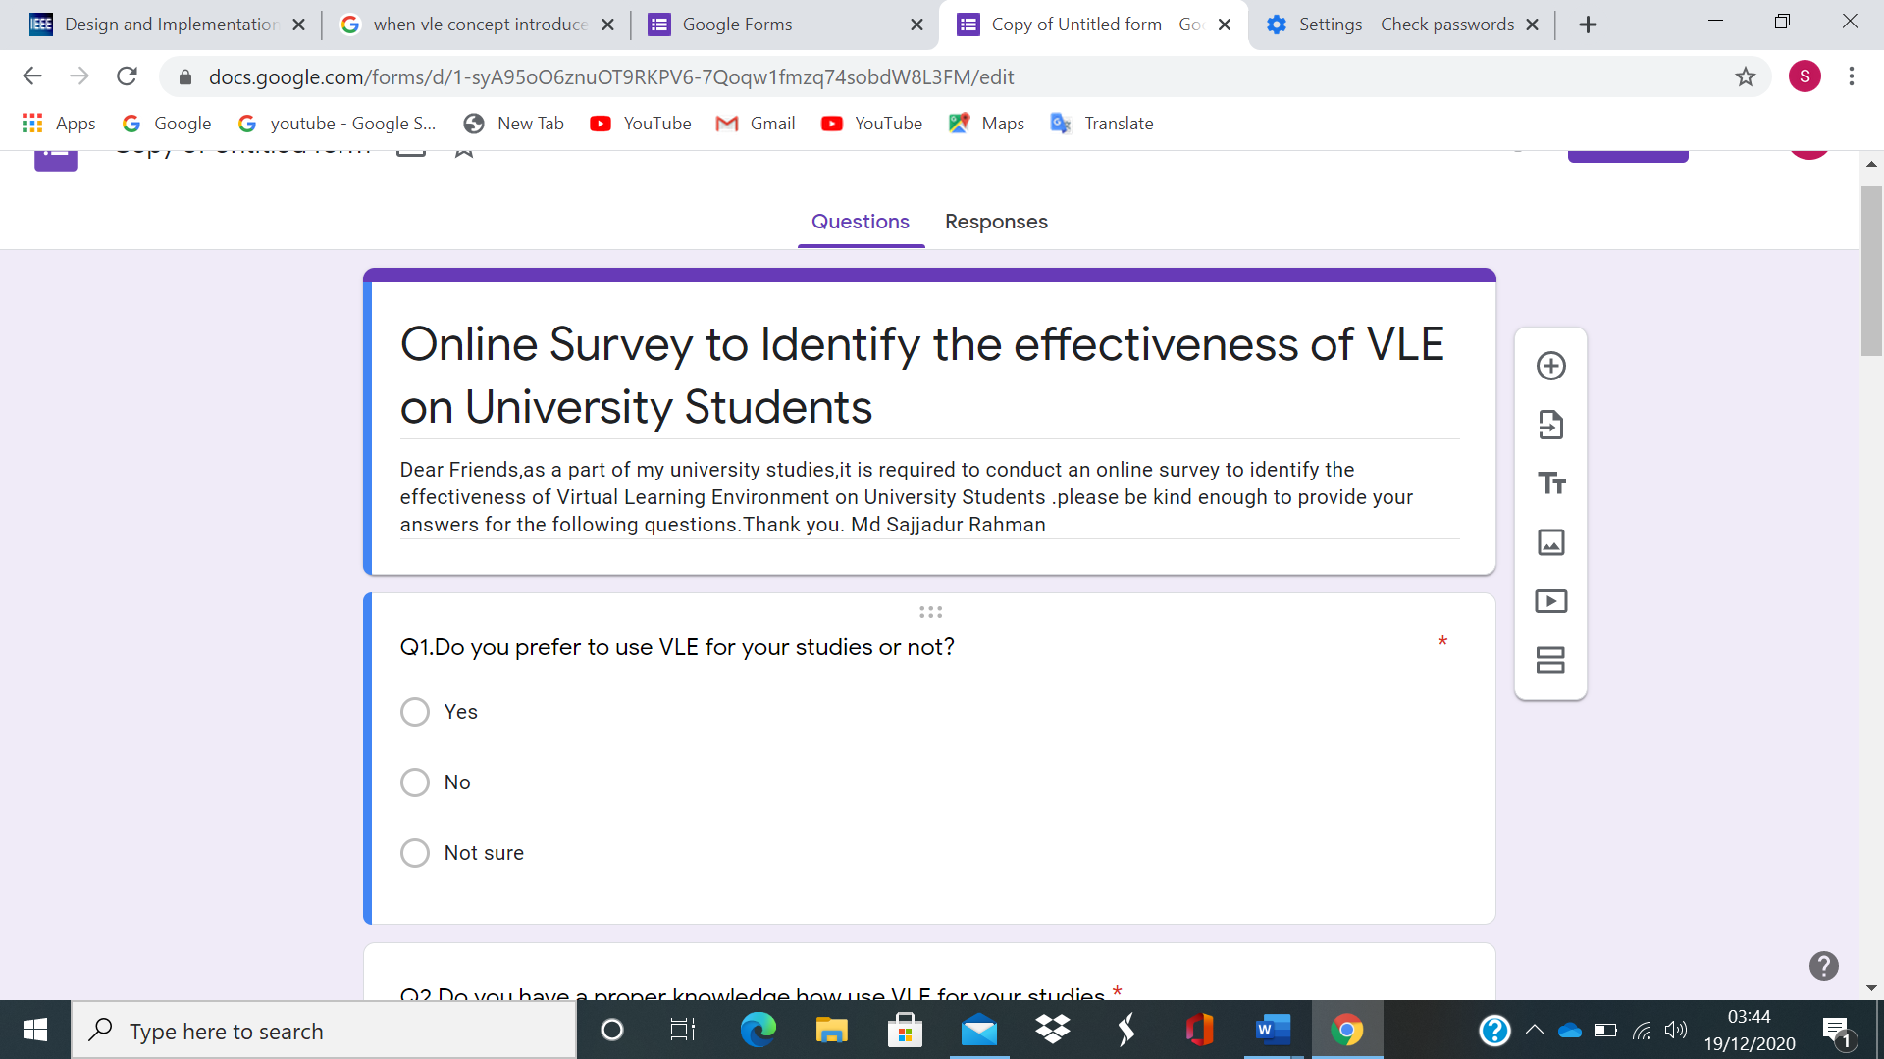
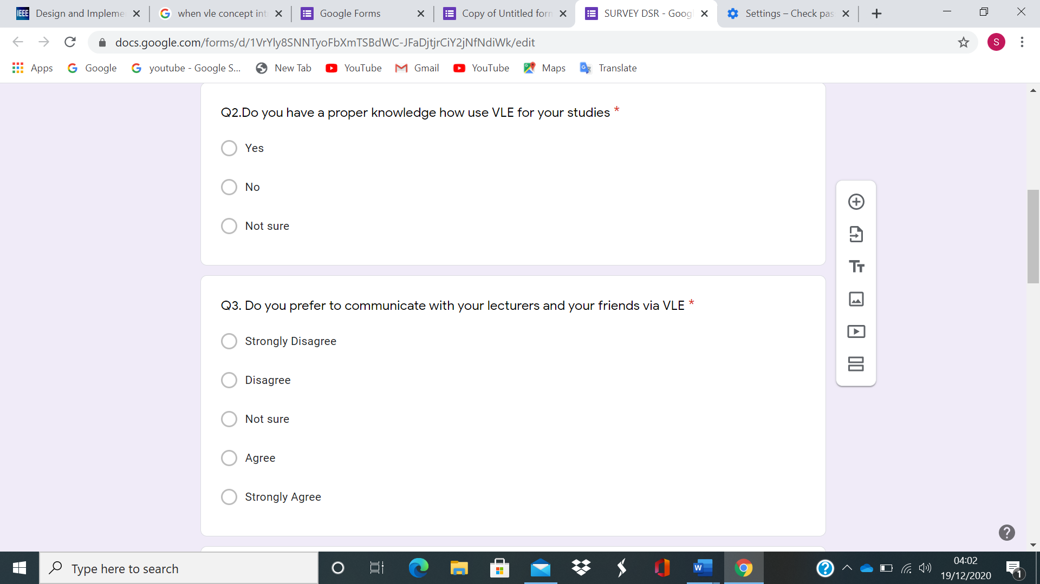

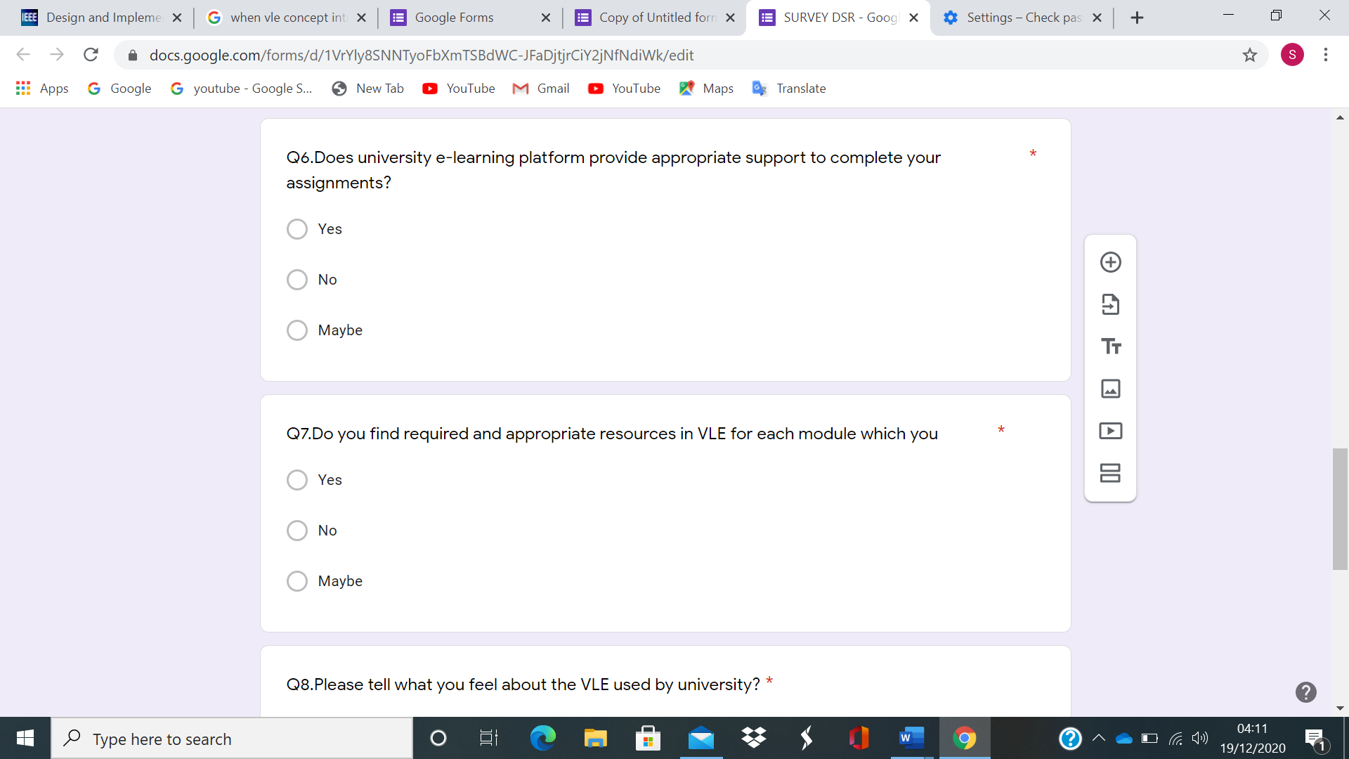
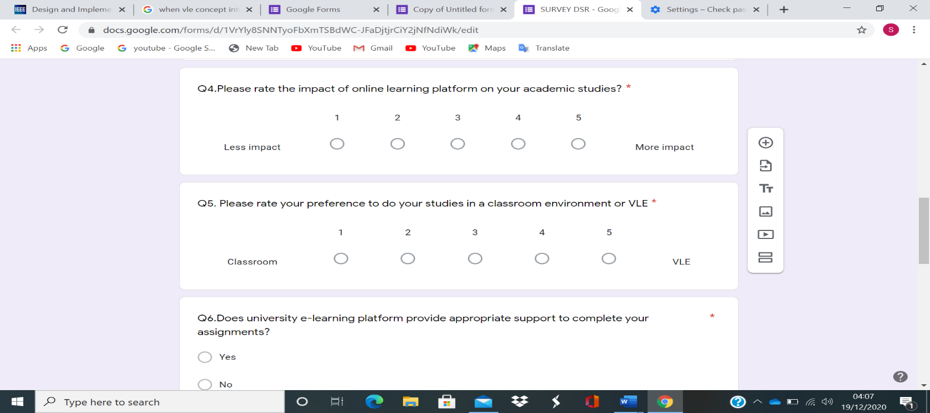

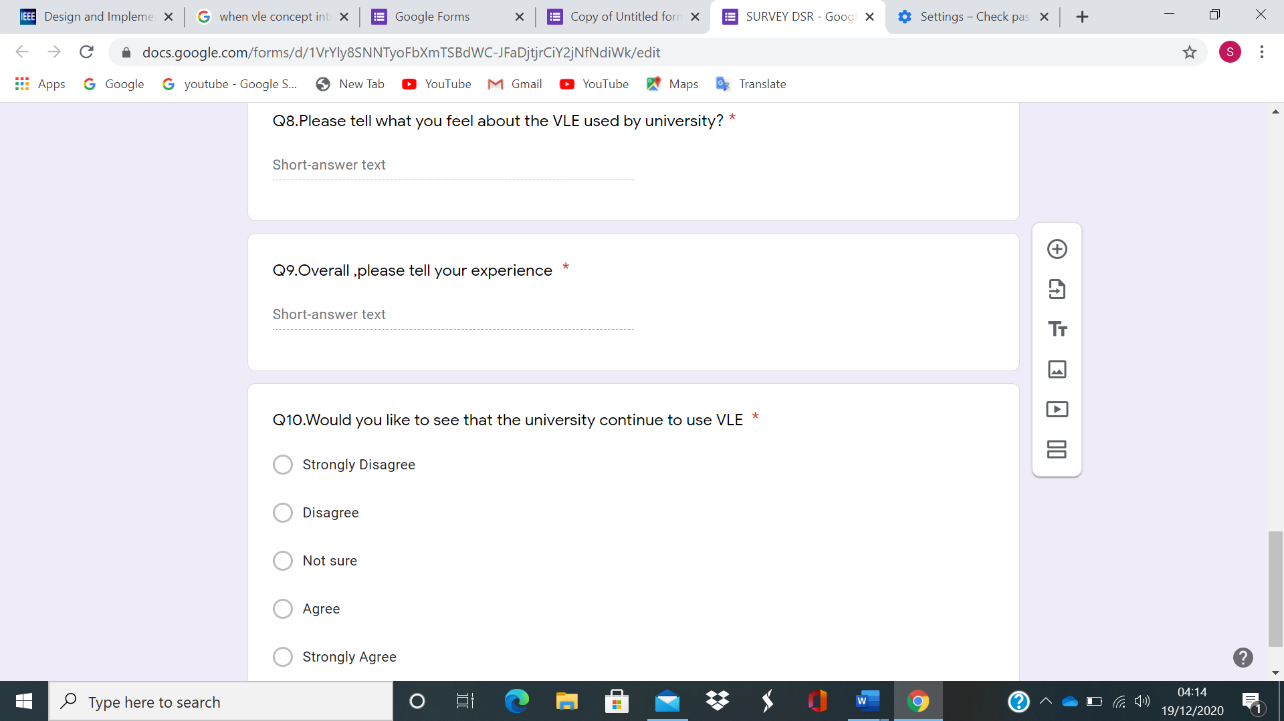

5.0 RESULTS

Based on online survey Virtual learning environment (VLE) has some positive, negative, and various responses. Details of the results are below.
Questions | Yes | No | Not Sure/Maybe
Question 01 | 14 | 01 | 06
Question 02 | 19 | 0 | 02
Question 06 | 16 | 02 | 03
Question 07 | 15 | 01 | 05

Questions | Strongly Disagree | Disagree | Not Sure | Agree | Strongly Agree
Question 03 | 0 | 04 | 03 | 12 | 02
Question 10 | 0 | 05 | 05 | 09 | 02

Responses
Response for Question 04 and 05

Question | 1 | 2 | 3 | 4 | 5
Question 04 | 01 | 0 | 04 | 07 | 09
Question 05 | 01 | 05 | 06 | 03 | 06

Responses for Question 08 and 09
Question | Positive | Negative
Question 08 | 21 | 0
Question 09 | 19 | 2

6.0 DISCUSSION

During my primary research data conducted most of the responses was positive impact of VLE, Basis of analyzing outcome VLE is cost-effective, students can take admission online flexible, easy to access online topic, take part online exam, E-mail, chat facility, VLE is more attractive and suitable for both lecturer and students.
There are some negative data stored during my research some of them preferred to attend university physically classroom learning, Information collected from survey that sometime its difficult to concentrate on VLE, Communication difficulty with lecturer and other students. Internet connection etc. Teacher and students faced challenges on VLE platform such as interact with each other, Teamwork, contact with individual students, Lack of circumstances for social communication services, Hearing difficulties, Long hour online classes which is result of boredom and tiredness. Absence of time and condition to exercise speaking with teachers and students.
Recommendation for improve virtual learning environment is it should be more interact, interesting, analyzing the amount of involvement between participants, organizing, and managing teamwork. Inventing suitable activities, select appropriate tools and appropriate environment, providing strong directions, universities should provide developing use of technology.
Lesson learned from this research VLE have positive negative and mixture of responses from survey most of students want to continue using VLE in current COVID-19 pandemic situation, there is some negative impact of VLE as well. Learned how to use online software tool to create survey/questionnaire and how to get online feedback and learned how to use MS-Excel to create charts.

7.0 CONCLUSION

Throughout this research report primary and secondary research was performed to invention and discover several parts of virtual learning environment used by educational institutes. Result of the research collected, saved, and examined with improve of proper software tools and providing commendations to develop the services of VLE.

REFERENCES

- Kumar, A., Pakala, R., Ragade, R. & Wong, J., (2002) The virtual learning environment system. [Online]

2. Clements, M. and Smalley, M. (2000) ‘Opportunities to enhance the student learning experience using a Virtual Learning Environment’,

3.Hamill, D., (2020) Using Blackboard (VLE) to support teaching practice of academic staff in response to COVID-19.
4. Kerimbayev, N., (2016) Virtual learning: Possibilities and realization 21, pp.1521–1533

5. Ryan, E., (2019). Impact of Virtual Learning Environment on Students’ Satisfaction, Engagement, Recall, and Retention

6. Demian, P., & Morrice, J. (2012). The use of virtual learning environments and their impact on academic performance

7. Ernest, P., (2012) Online teacher development: collaborating in a virtual learning environment pp. 311-313.

8. Johnston, P.M., (2017). Qualitative and Quantitative Methods in Libraries

9. Zuzana, S., (2018) Developing Reflective Skills of Student Teachers in the Virtual Learning Environment, pp.107-121.

10. Schmidt, M., (2012) Developing methods for understanding social behaviour in a 3D virtual learning environment, pp.405-413.

