Accounting fundamentals

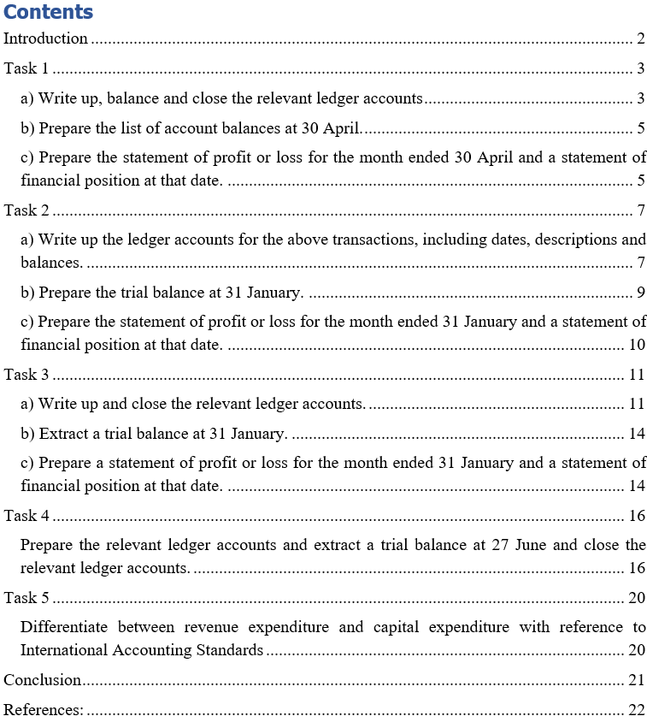

Introduction
The report encompasses the preparation of the ledger accounts arising out of the transactions undertaken in sums. The appropriate ledger accounts will help in understanding the balances of the different components of the transactions which will ultimately help in the preparation of the trial balance, income statement and balance sheet. The revenue and capital expenditure arising out of the transactions have been properly classified and accounted for in the income statements (Armstrong, et al., 2006). The cash and credit transactions, debtor and creditor accounts have been properly classified and prepared accordingly to reflect the transactions. As a result, the trial balance and balance sheet have matched perfectly.

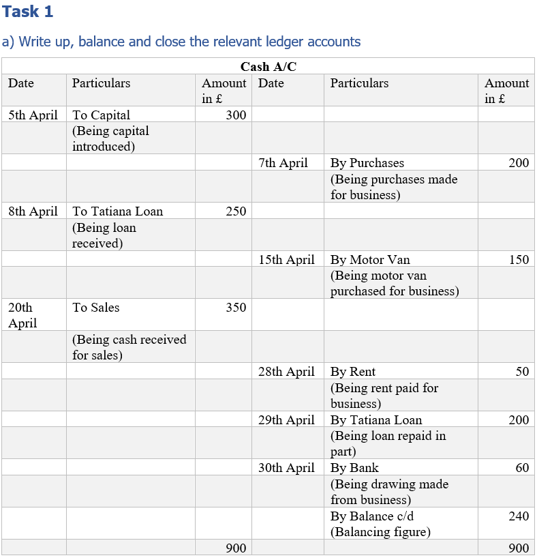
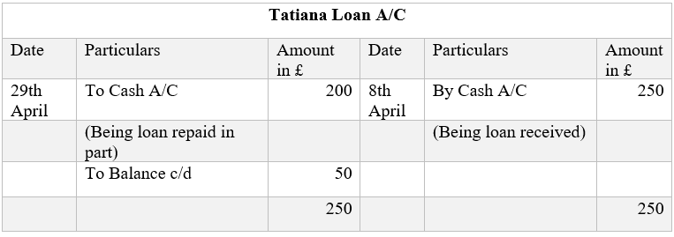

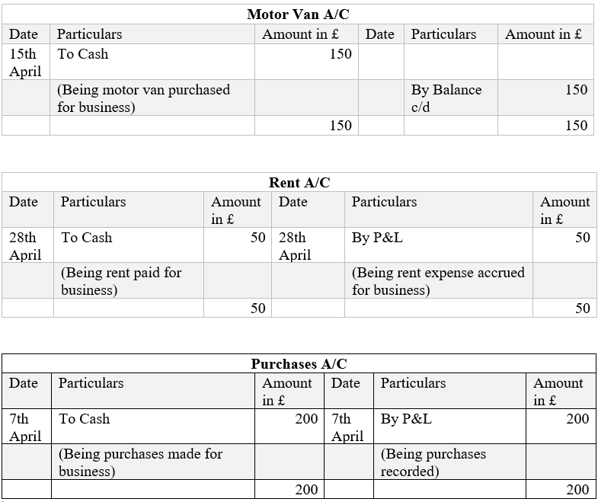
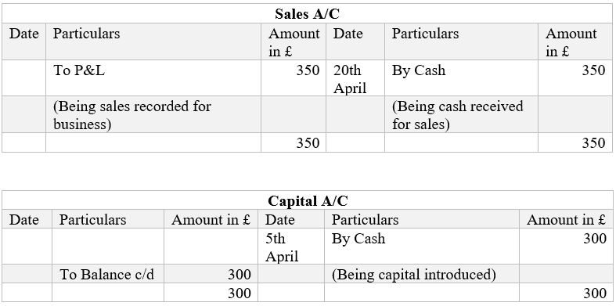

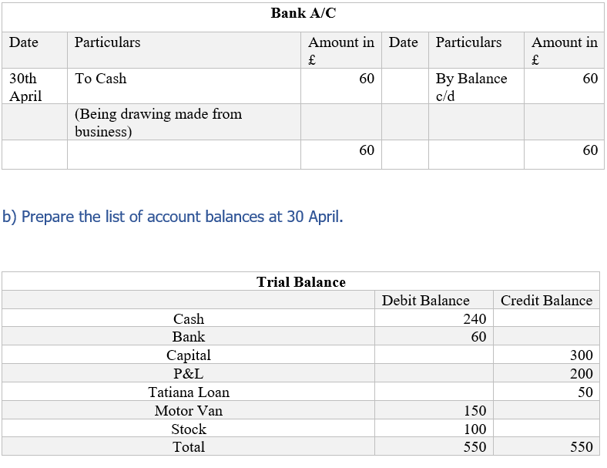
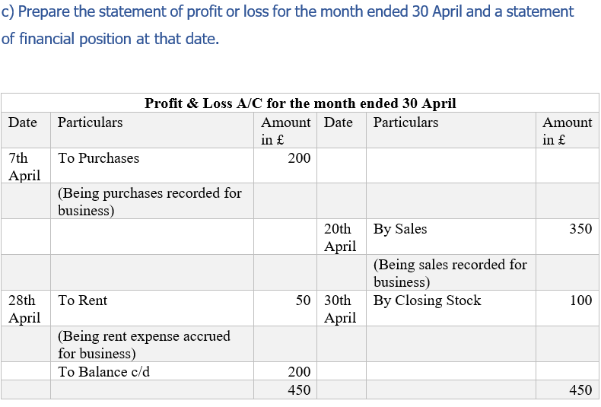
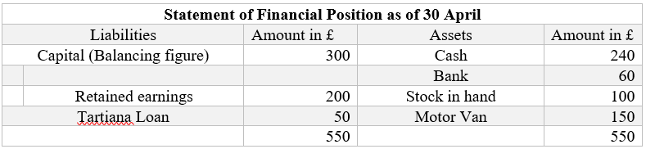

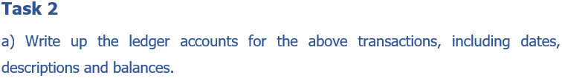
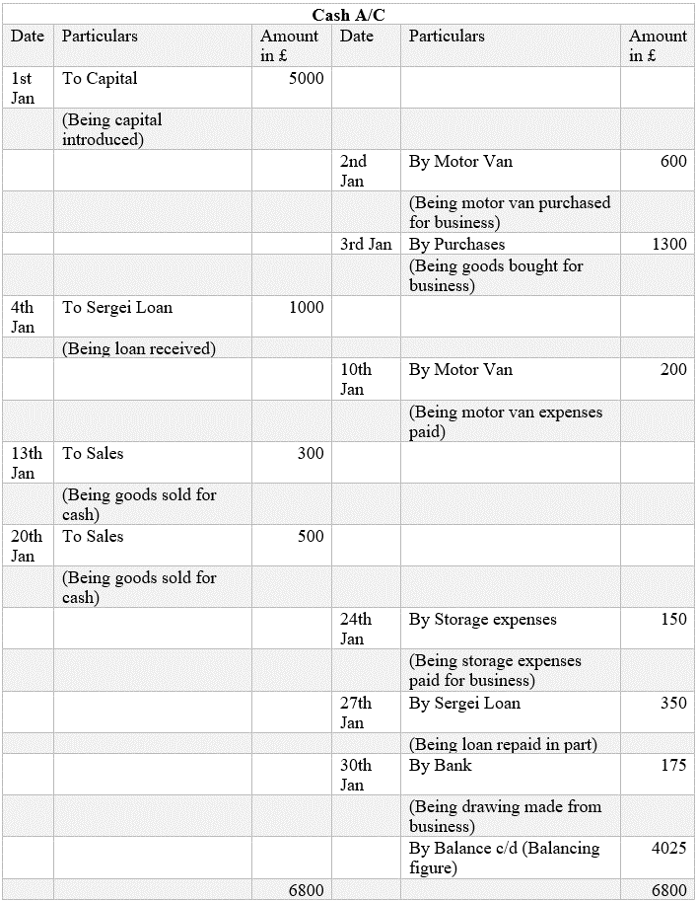

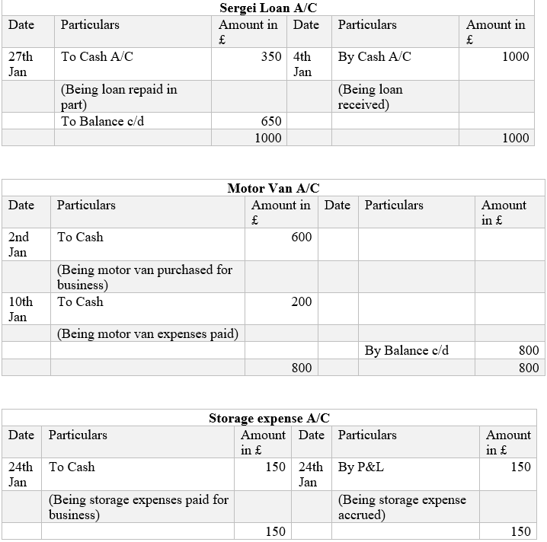
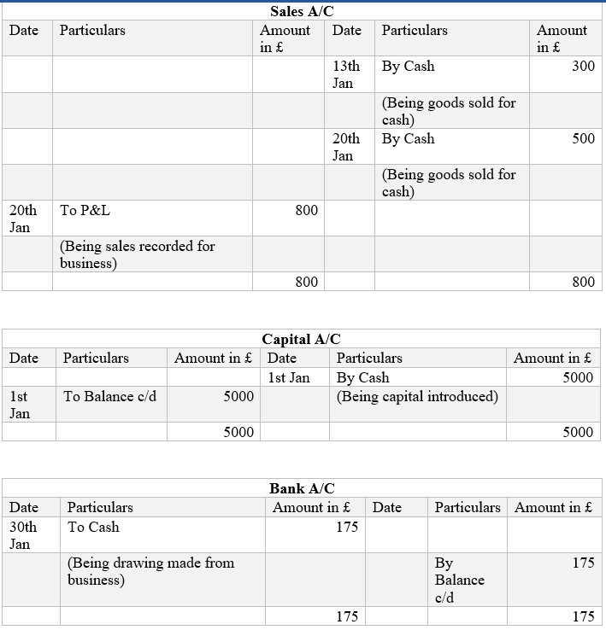
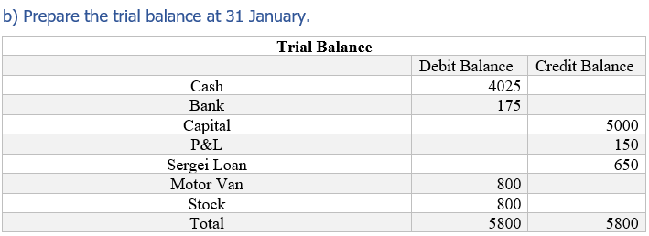

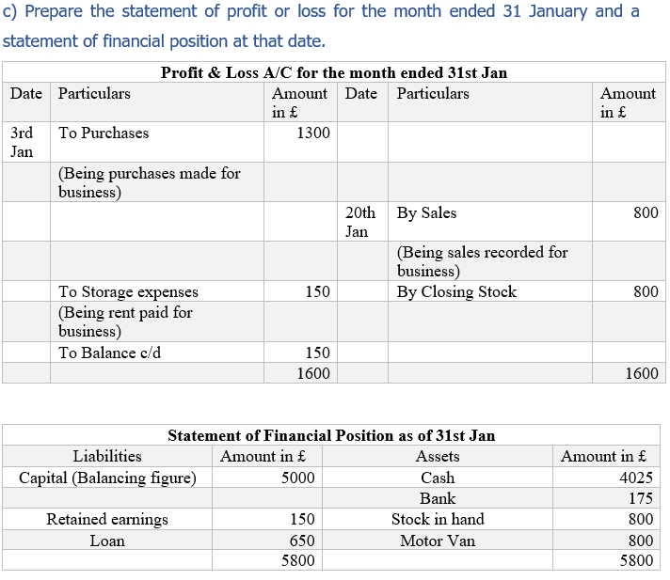

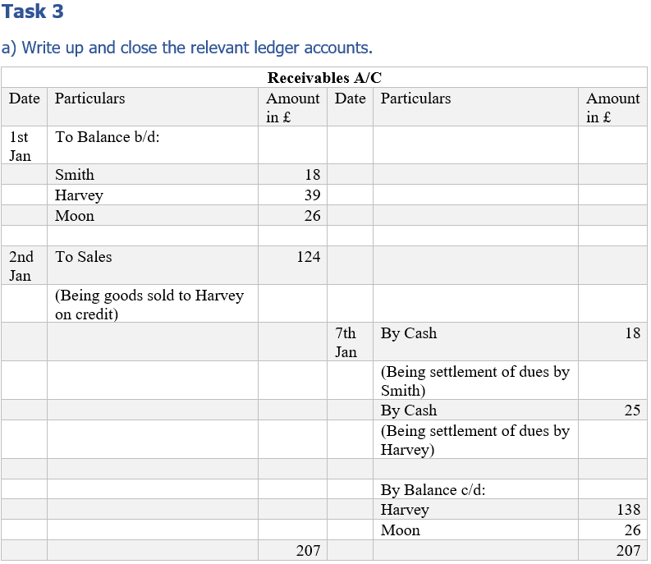
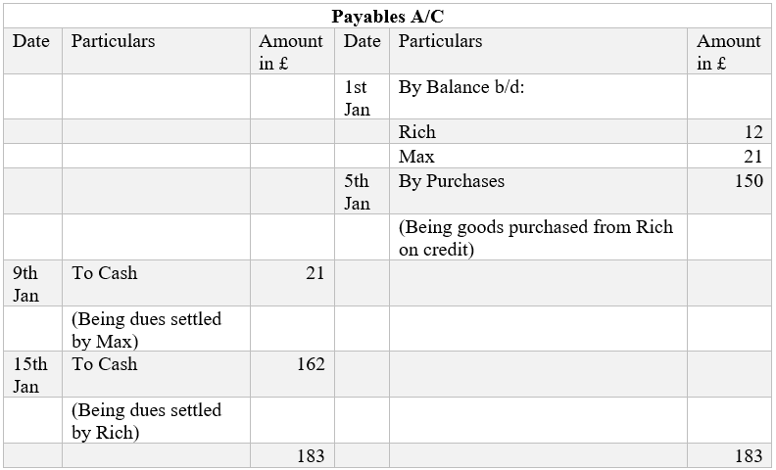
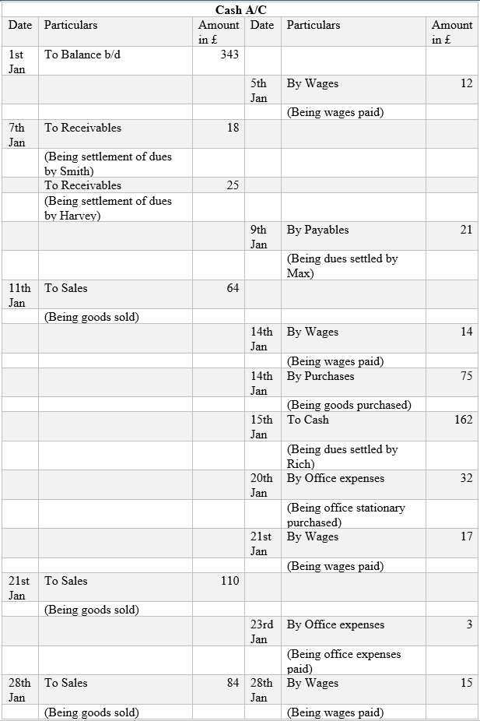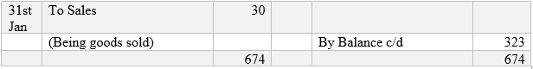

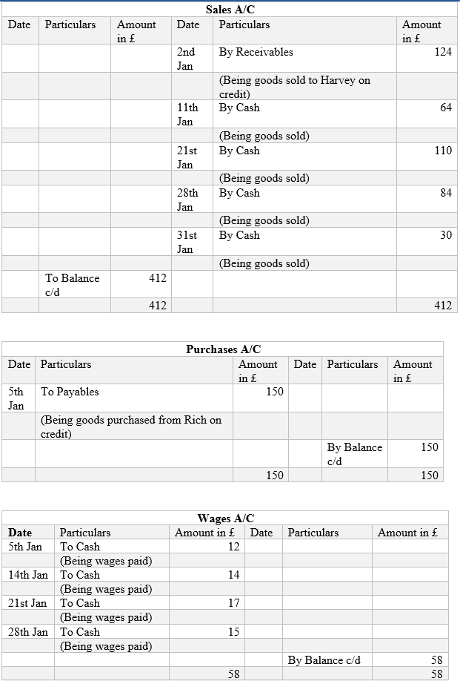

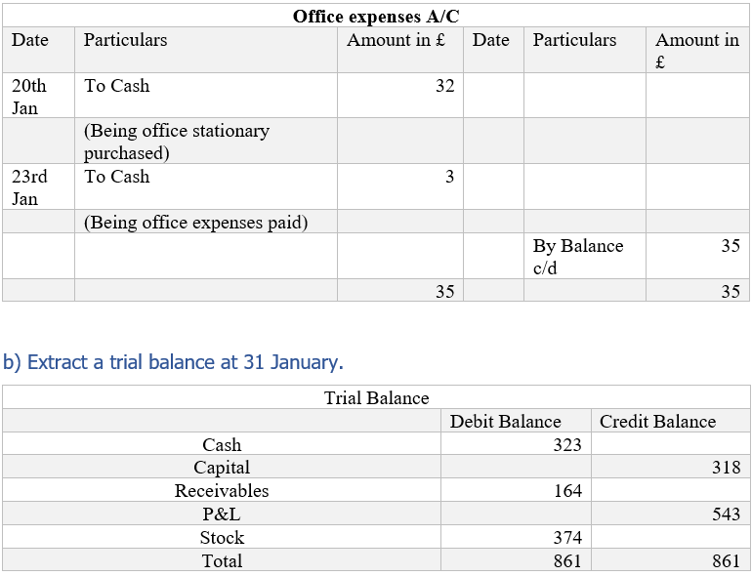

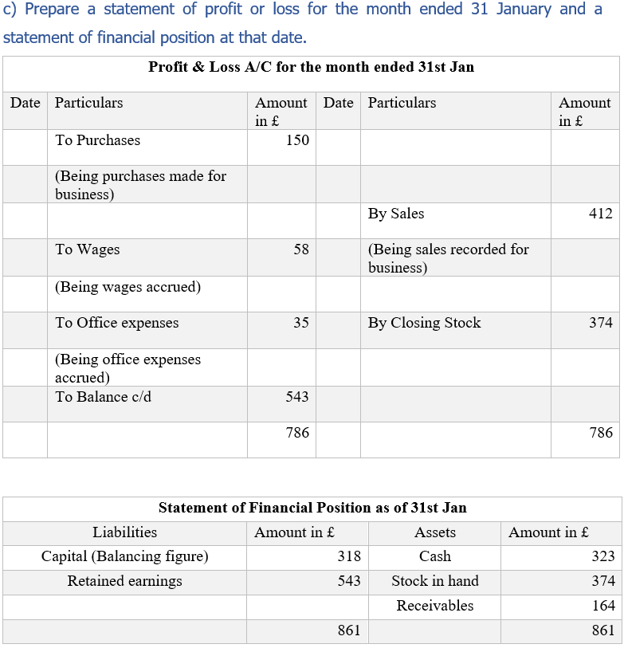

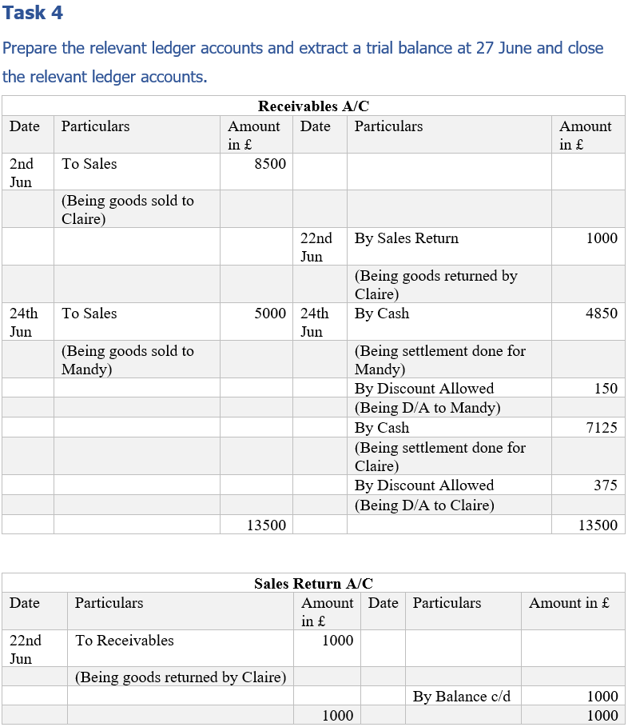

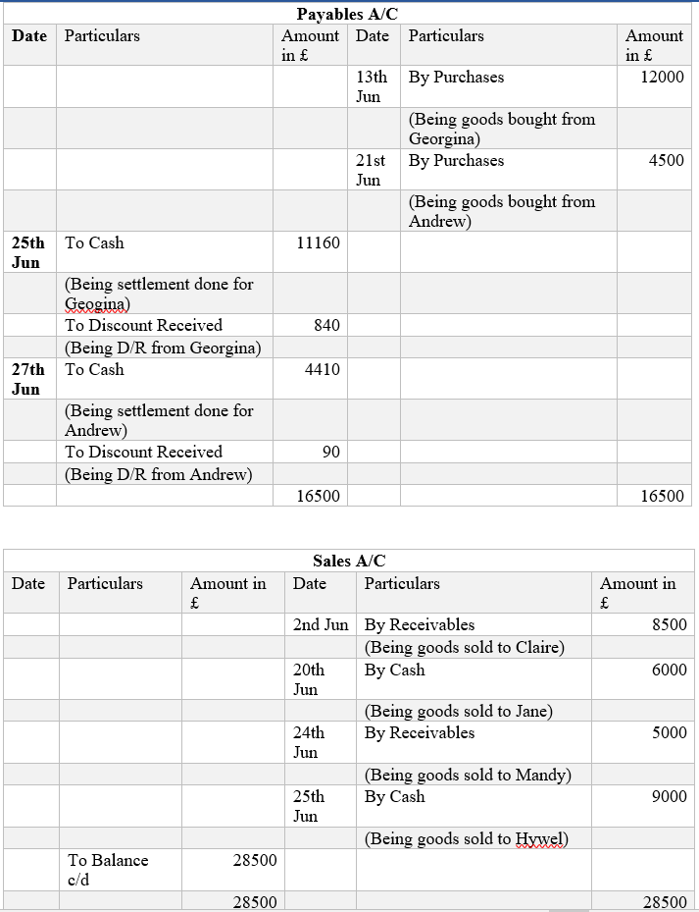

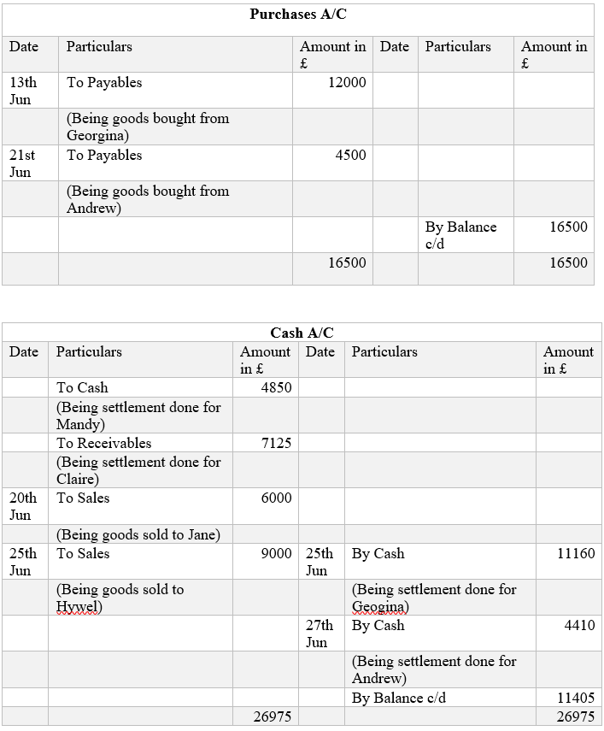

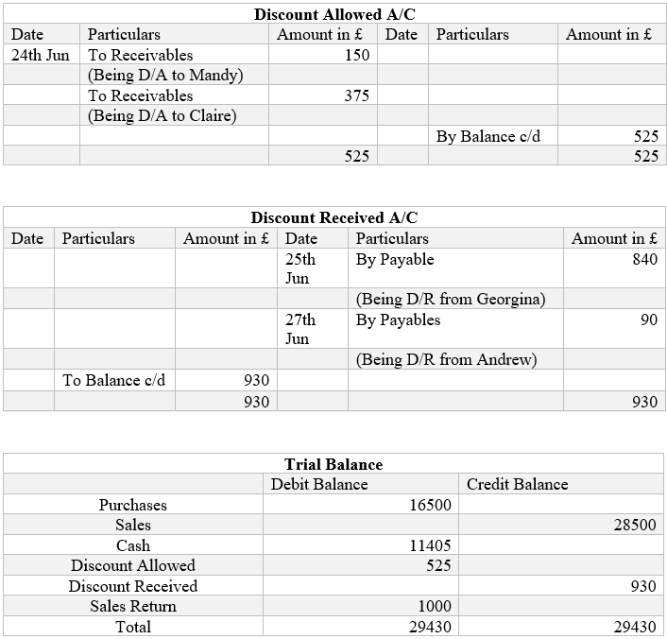

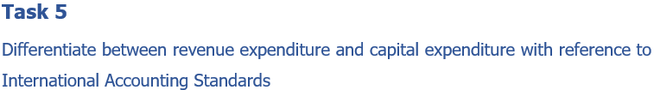
Revenue expenditure denotes expenses incurred for items whose benefit lasts for a year. The expenses are concerned with particular revenue transactions or accounting periods like cost of sales (Saunoris and Payne, 2010).
They are usually charged to the expenditure for the current accounting period or upcoming period which is usually shorter in nature compared to capital expenditure.
The revenue expenditure is expensed over a shorter time span compared to capital expenditure.
As a result, the amount of revenue expenditure is relatively lower than capital expenditure.
Examples of revenue expenditure include the cost of goods sold like direct labour and material; operating expenses like selling, general and administrative expenses, research and development expenses. The items usually appear in the trading and profit and loss account.
Capital expenditure denotes expenses whose benefits extend for several years. They usually relate to the fixed assets which last for several years (Appuhami, 2008).
The capital expenditure is gradually charged to the expenditure via depreciation or amortization and it occurs over a larger span of time compared to revenue expenditure.
The capital expenditure is expensed across the life of the particular fixed asset.
Capital expenditure amount is larger in value compared to revenue expenditure.
Examples of capital expenditure include purchase of fixed assets business acquisitions. They can be seen in the cash flows from investing activities and balance sheet.

Conclusion
The above ledger accounts with appropriate narration will help the reader to understand the nature and type of transactions. All of which have ultimately helped in the preparation of the trial balance, income statement and balance sheet. The different kind of expenditure have been classified accordingly in terms of revenue and capital expenditure towards an accurate trial balance, profit and loss account and balance sheet. Compliance with the accounting standards can be ensured when the trial balance and balance sheet balances perfectly.

References:
Appuhami, B., 2008. The Impact of Firms' Capital Expenditure on Working Capital Management: An Empirical Study across Industries in Thailand. International Management Review, 4(1).
Armstrong, C., Davila, A. and Foster, G., 2006. Venture-backed private equity valuation and financial statement information. Review of Accounting Studies, 11(1), pp.119-154.
Saunoris, J.W. and Payne, J.E., 2010. Tax more or spend less? Asymmetries in the UK revenue–expenditure nexus. Journal of Policy Modeling, 32(4), pp.478-487.

