3/16/2026
Assessment
Design and Implementation of a Relational Database System


Student Name:Semra Ozturk
Student ID: 2510165

Module NaMe: INTRODUCTION to WEB and DATABASE CONCEPTS
Module Code: ACCA 4023
Lecturer: Dr. ANUM PARACHA
Trinity saint david University of Wales (London Campus)

Table of Contents
1. Introduction 2
2. Scenario Overview 2
2.1. Entity 3
2.2. Single Attribute 3
2.3. Primary Key 3
2.4. Relationship 4
2.5. Foreign Key 4
3. System Analysis 4
3.1. Identification of Entities 4
3.2. Relationships Between Entities 5
4. Database Design and Implementation 6
4.1. ER Diagram 6
4.2. Table Structure 7
4.3. Normalisation 7
5. Query Development 8
5.1. Daily Sales Summary 8
5.2. Medicines with an Expiry of 6 Months 9
5.3. Medicines Low in Stock 10
5.4. Most Frequently Sold Medicines 10
6. Forms and Reports 11
7. Validation and Testing 13
8. Reflection and Future Improvements 16
9. Conclusion 16
10. References 17

Introduction

This report gives the design and the implementation of a relational database system. The system was designed and implemented in the MediLink Pharmacy using Microsoft Access. The objective of the system is to get rid of the manual record-keeping method with a systematized and automated system, which increases efficiency, accuracy, and data processing. The database will be related to the management of medicine, suppliers, customers, prescriptions, and sales. By applying the use of relational tables, primary and foreign keys, queries, forms and reports, the system enhances the overall service delivery in the pharmacy facility by promoting the right Administration of stock, sales observations, and regulatory compliance, and knowledgeable usage of the system.

Scenario Overview

MediLink Pharmacy is a developing chain of pharmacies in the community that now keeps its inventory, prescription, supplier data, and sales paperwork in manual files. This is one of the old systems that involves the use of paper, which increases the chances of human error, loss of records, miscalculation of the stocks, and time wastage in acquiring valuable information. As the business expands, there is a need to have an effective and reliable database system. The purpose behind developing a relational-based database at MediLink Pharmacy is to not only systematise operations that are happening daily but also centralise all the business information in a system. It will be in the database that will handle the medicines, number of suppliers, customers, prescriptions, and sales of the medicines, and ensure the integrity and accuracy of the data. With the help of Microsoft Access, the pharmacy will be able to enhance the stock monitoring, regulate the prescriptions of the customers, create sales reports, and comply with the regulations by putting this system into action. Finally, the system increases the degree of efficiency in the operations, decision-making, and the efficiency of service delivery to the customers.

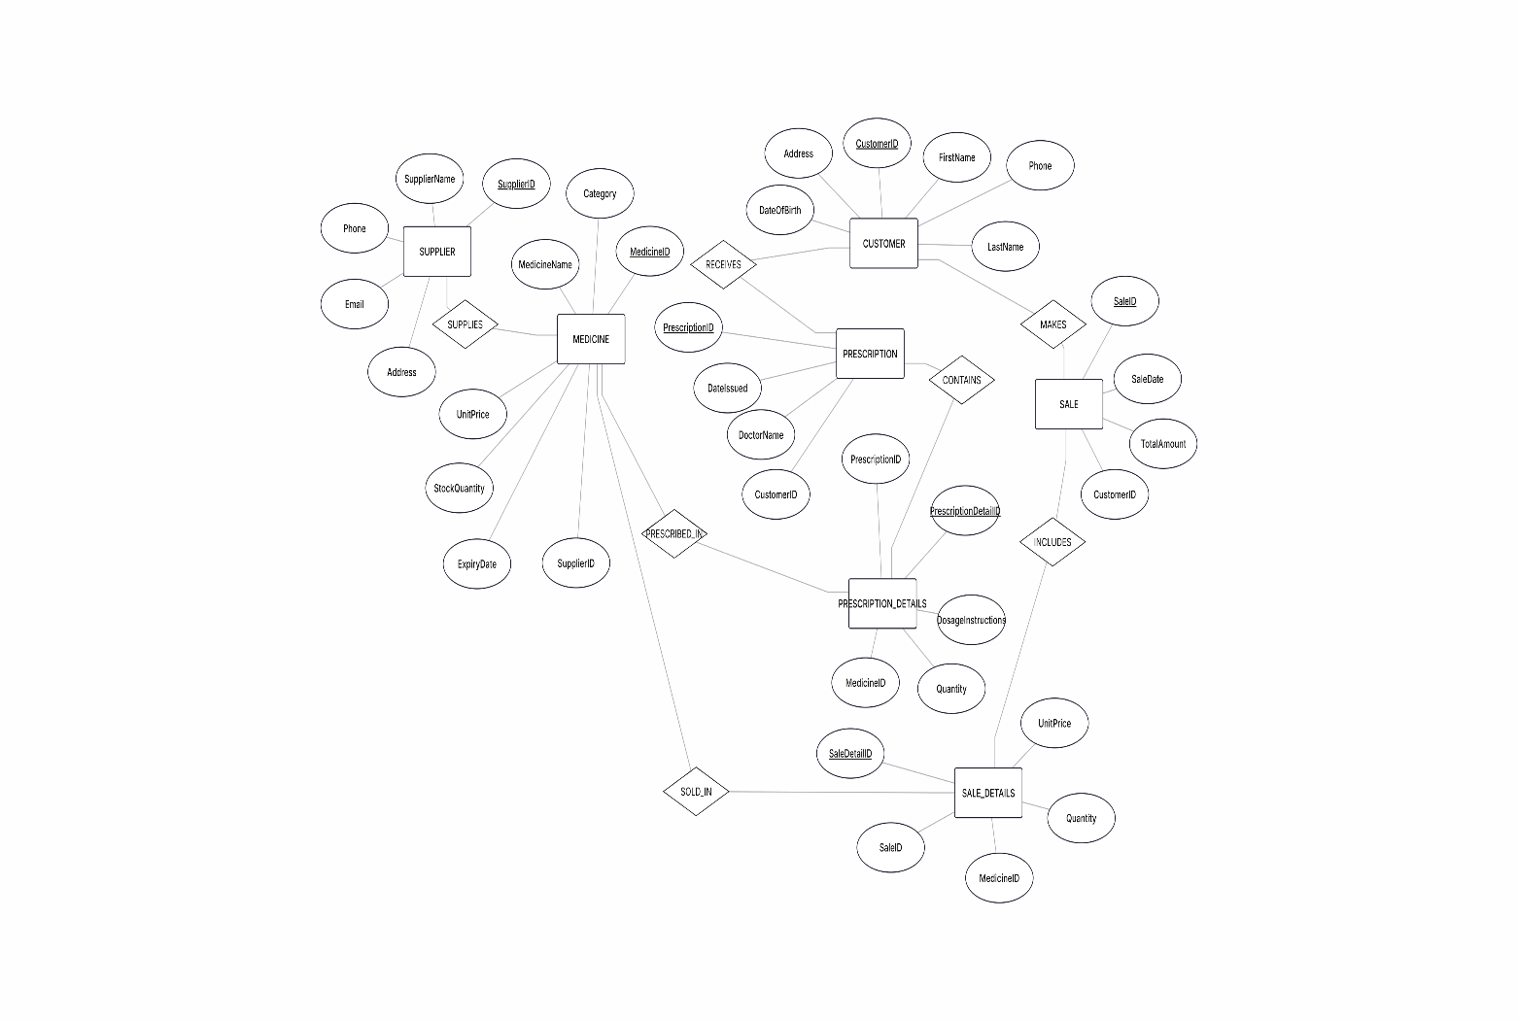
Figure 1: ER Diagram

Entity
An entity refers to a real-world entity or object concerning which the information is contained in a database. The Customer, Supplier or Medicine can be used as examples.

Single Attribute
A single attribute is an attribute, which cannot be broken into smaller parts and consist of one value. Age, salary, phones are some examples.

Primary Key
A key is a field that distinctly identifies every record of a table. It makes sure that each record does not have a duplicate and non-nullable value.

Relationship
A relationship explains the interrelationships between 2 or more objects in a database. As an example, a Sale is made by a customer.

Foreign Key
In a foreign key, the attribute is in a table that refers to the primary key of another table. It is applied to establish a relationship between two connected tables.

System Analysis

Identification of Entities

The MediLink Pharmacy database has been created after identifying the key entities that operate in the daily activities within the pharmacy. The main entities selected were Supplier, Medicine, Customer, Prescription Details, Sale, and Sale Details. These are the primary records on which the fundamental information to be used in stock administration, customer data, prescriptions, and transactions is handled.
Other data that are taken care of by the Supplier entity are information on companies supplying medicines. Medicine entails records such as name, type, cost, inventory, expiry, and supplier name. The customer entity is where personal and contact data of patients are located. The prescription entity stores the prescription records provided to customers, including the doctor who has ordered the prescription and the date. The sales entity records all the information about the sale of the medicines.
These tables have a primary key that uniquely refers to each of the records, i.e., SupplierID, MedicineID, CustomerID, PrescriptionID, and SaleID. Foreign keys were required to establish a relationship between the tables. The SupplierID element of the Medicine table would be utilised in connecting medicines to their suppliers, and the CustomerID in the Sale table would be used in connecting the sales to the customers.
Junction tables were required to solve many-to-many relationships. To allow the purchase of more than one medicine in one sale, relationship between Sale and Medicine were added, with the addition of the Sale_Details table. In the same file, Prescription is related to Prescription_Details and Medicine. This would ensure that the database complies with the concepts of relational database design and third normal form (3NF).

Relationships Between Entities

There are also several one-to-many relationships (1:M) in the system. One Supplier could be involved in the provision of high number of Medicines, and one Medicine could be offered by one Supplier [1]. There can be many prescriptions for one Customer, as well as there can be a single prescription for many customers. In addition to that, there can be more than a single medicine in the Sale_Details table.
The integrity of references was implemented to ensure uniformity of data. This ensures that the values of the foreign keys must be NULL or match the existing Primary Key, and otherwise the record values would be invalid and orphans.

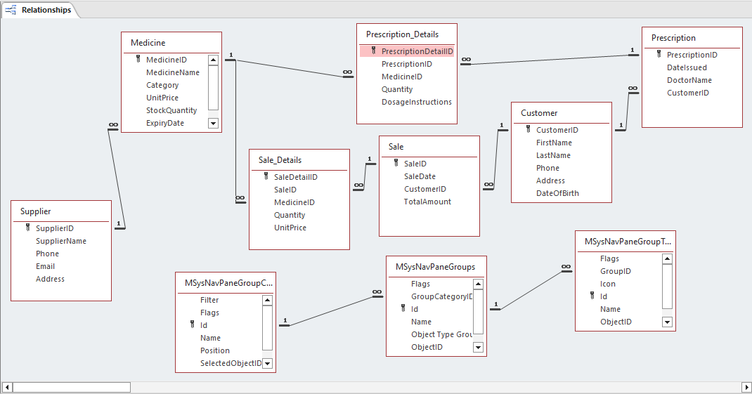
Figure 2: Relationship Diagram in MS Access

Database Design and Implementation

ER Diagram

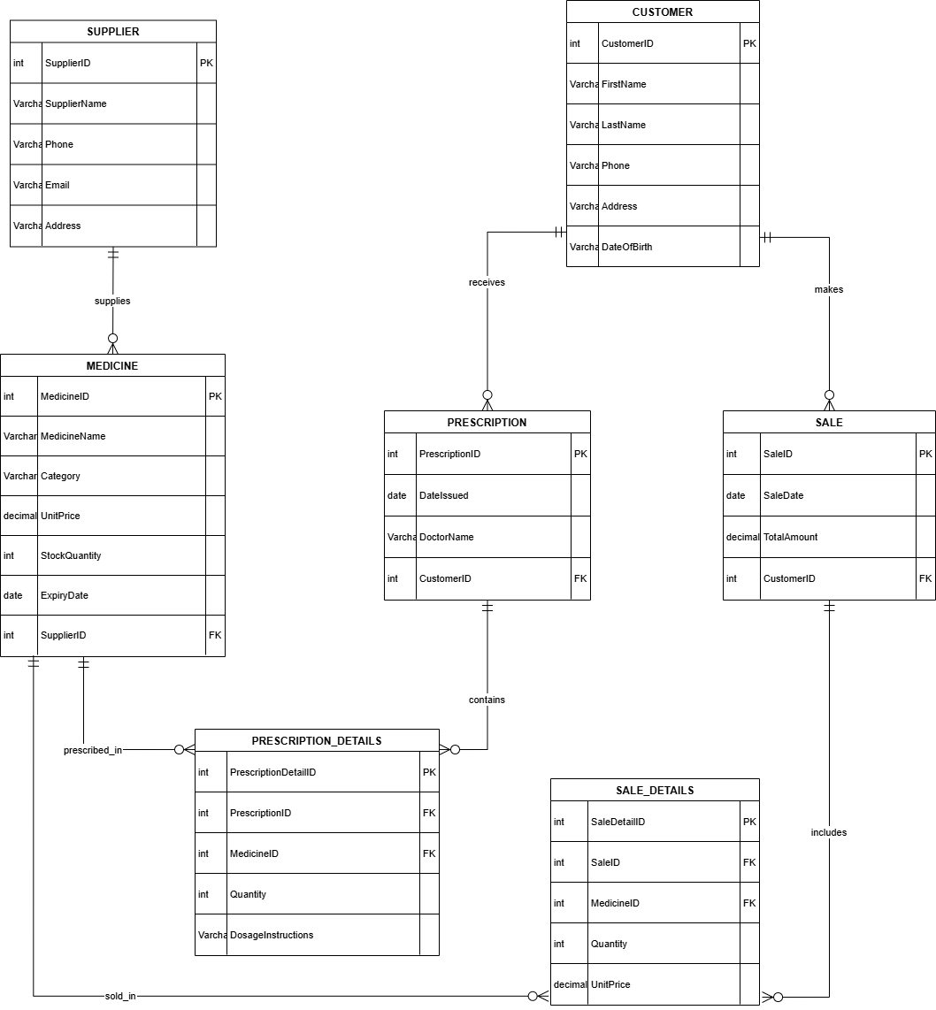
Figure 3: Entity Relationship Diagram for MediLink Pharmacy

An Entity Relationship Diagram (ERD) represents the logical architecture of the MediLink Pharmacy database system [2] . The design has seven major entities, namely Supplier, Medicine, Customer, Prescription, Prescription-Details, Sale, and Sale-Details. Each one of the entities is a fundamental part of the pharmacy’s functioning procedures.
The SupplierID, MedicineID, CustomerID, PrescriptionID, and SaleID are the primary key, which identifies each record in their respective table unique place. The relationship among entities are created by foreign keys. As an example, SupplierID in the Medicine table goes together with medicines and suppliers, whereas CustomerID in the Sale and Prescription table ties the transactions and prescriptions to the customers.
One of the relationships shown in the ERD is that of a one-to-many. Multiple Suppliers supply a lot of Medicines and multiple Customers who have several Prescriptions and Sales. The relationships of many-to-many between Sale and Medicine and Prescription and Medicine are resolved with the help of junction tables (Sale_Details and Prescription_Details). These relationships guarantee the correct representation of real-life transactions and, at the same time, relational integrity.

Table Structure

Data types in the database tables were made to be right to prevent errors and inconsistencies. Text attributes like names and addresses are stored using VARCHAR that is effective in storing variable-length data. Monetary values like UnitPrice, TotalAmount, etc., take the CURRENCY type of the data to avoid round-off errors. SaleDate and ExpiryDate are among the dates are the dates that are calculated using the DATE data type.
The primary keys are set with the help of the AUTOINCREMENT in order to create a unique identifier automatically. Where it is necessary, NOT NULL constraints are used to make sure that there are no incomplete records.

Normalisation

The database architecture is the Third Normal Form (3NF). In 1NF, all the attributes have atomic values and no repeated groups. Second Normal Form (2NF) In 2NF, all the non-key attributes rely on the entire primary key. In the Third Normal Form (3NF), transitive dependencies do not exist [3]. As an example, in the Medicine table, all attributes are based exclusively on the MedicineID, and this poses complete adherence to the 3NF principles.

Query Development

To illustrate how the MediLink Pharmacy database can be practically used, a number of meaningful queries were developed to assist with business operations, reporting, and decision-making [4].

Daily Sales Summary
This query sums up the amount of sales on each day by grouping the records according to SaleDate. It is calculated using aggregate functions to calculate the daily revenue. This will enable the management to track the financial performance, spot trends in the sales activity, and assess the overall productivity of the business during a certain time.
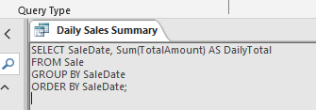
Figure 4: Daily Sales Summary: Query

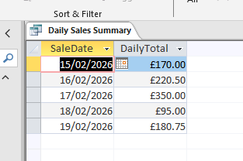
Figure 5: Daily Sales Summary: Output

Medicines with an Expiry of 6 Months
This query will bring medicines that have an expiry date of less than six months. It assists in keeping to regulations and avoiding the sale of expired products. By detecting the medicines that are almost out of date, the pharmacy will be able to ensure the rotation of stock and minimize the loss of money associated with the sale of unused medicines.

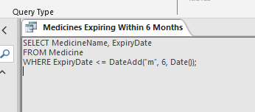
Figure 6: Medicines with an Expiry of 6 Months: Query

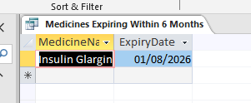
Figure 7: Medicines with an Expiry of 6 Months: Output

Medicines Low in Stock
This query determines medicines for which the stock level is lower than a certain amount. It helps to control the inventory proactively since it reminds employees to order goods in advance before shortages take place. This will ensure that the necessary medicines are always available and result in better customer satisfaction.
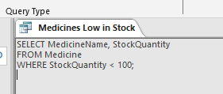
Figure 8: Medicines Low in Stock: Query

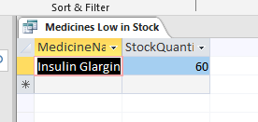
Figure 9: Medicines Low in Stock: Output

Most Frequently Sold Medicines
This query finds the totals of quantities sold of each medicine by use of the table Sale_Details. It determines the bestselling products, allowing it to purchase them using data, negotiate with suppliers, devise marketing plans, and keep the high-demanding medicines stocked sufficiently.

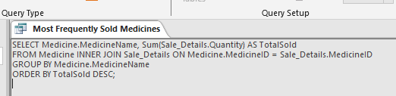
Figure 10: Most Frequently Sold Medicines: Query

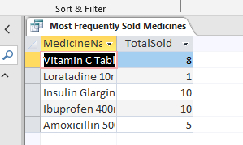
Figure 11: Most Frequently Sold Medicines: Output

Forms and Reports

Forms and reports were created to make the database easier to use and facilitate efficient data management in the MediLink Pharmacy database. The forms were designed in order to make the entry of data easier and to have some kind of consistency in the data that is recorded about customers, prescriptions, and sales information. The customer form enables the user to add and update patient information in an organized manner, and this would minimize entry errors in the data [5].

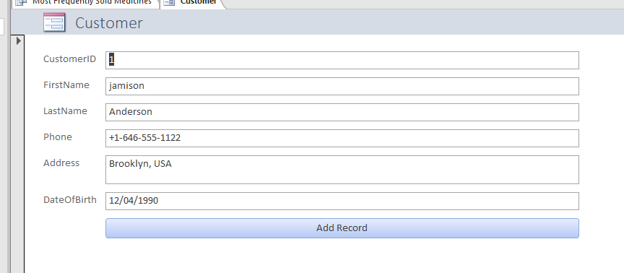
Figure 12: Customer Form for Inserting the Data

The reports were to give orderly and meaningful summaries of the transactional data. The Sale report provides structured information on transactions, such as the dates and the total sum of transactions, so that it can be tracked financially. Report calculations like the total revenue are very helpful in understanding the performance of the business [6]. Such reporting capabilities help the management in decision making, stock valuation, and performance analysis, besides displaying information in a readable and professional format to be reviewed and kept as records.

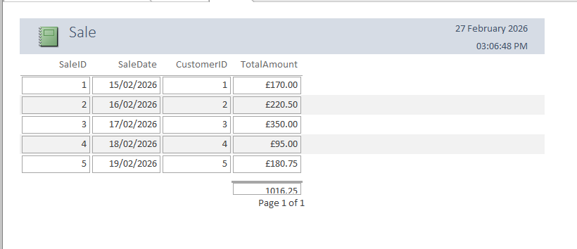
Figure 13: Sale Report

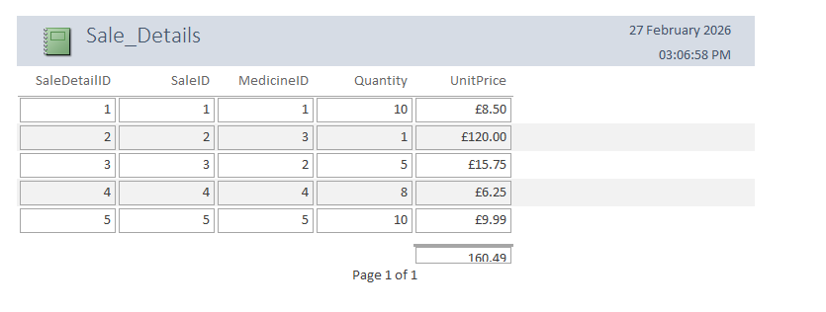
Figure 14: Sale Detail Report

Validation and Testing

The database system of MediLink Pharmacy must ensure that the database system has met the functional requirements and data integrity. We applied referential integrity between related tables so as to remove invalid orphan records. One of them is that a sale cannot be recorded and a prescription made of medicines that are not present in the Medicine table without a valid CustomerID. This gives them consistency in the database.

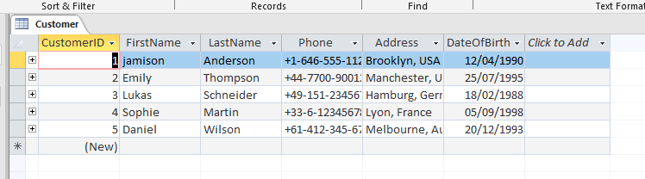
Figure 15: Customer Data

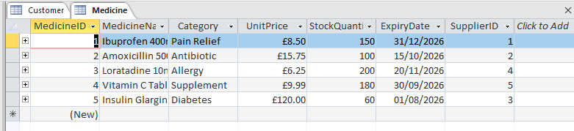
Figure 16: Medicine Data

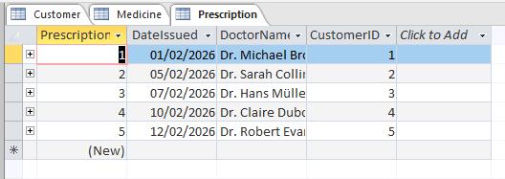
Figure 17: Prescription Data

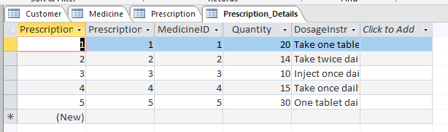
Figure 18: Prescription Details Data

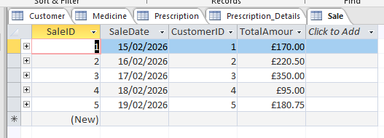
Figure 19: Sale Data

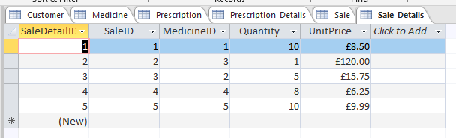
Figure 20: Sale Details Data

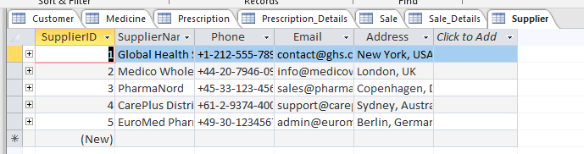
Figure 21: Supplier Data

All the tables contained sample data, and it was entered to replicate real-life transactions to allow queries and reports to be compared with real-life ones. The queries, such as the Daily Sales Summary and Medicines Low in Stock, were executed, and the results were reviewed to make sure that the right result were obtained. The objective of the testing forms was to make sure that data entry was designed to be easy to use, as well as reports generated to make sure that data entry was designed to be easy use, as well as reports generated to make sure that all totals and calculations had been established properly. Overall, the given system was stable, and it addressed the specified requirements.

Reflection and Future Improvements

The architecture and development of the MediLink Pharmacy was a good practice in relational database design and implementation. One of the main problems that were encountered was the correct establishment of relationships and referential integrity of tables. The many-to-many relationships were to be handled using the junction tables that were to be designed carefully. During this process, the process of normalization and much more information about the query construction were learned.
User authentication, automatic notification of stocks, barcode scanning, and the dashboard like reports could be added to the system what would bring real-time analytics in the future. The efficiency, security, and decision-making capacities in the pharmacy scene would also be enhanced by the improvements.

Conclusion

In conclusion, the design and implementation of the MediLink Pharmacy database system using Microsoft Access were successfully implemented in order to improve its efficiency in operations. The system integrates turnkey medicines, suppliers, customers, prescriptions, and sales transactions through tabular, relational, and query respectively. The use of the concept of relational database and normalization to the Third Normal Form reduced redundancy of data and ensured integrity. The queries and reporting functionalities created can help in informed decision-making and monitoring in the business. Overall, the database provides a scalable and successful solution that enhances the accuracy, organisation, and service provision in the pharmacy environment.

References

[1] | S. Esser and D. Fahland, Multi-Dimensional Event Data in Graph Databases, vol. 10, pp. 109-141, 2021.
[2] | A. M. Stuebe, R. Blanco, M. Horvath, M. G. Kibria, L. Kucirka, K. Shieh, D. Page, M. N. Gurcan and W. E. Hammond, Development and Implementation of an Entity Relationship Diagram for Perinatal Data, vol. 8, no. 5, 2025.
[3] | M. Hardini, V. Agarwal, D. Apriani, I. A. Widjaya, E. Setiawaty and N. Nurasiah, Application of Database Normalization in Increasing Data Storage Efficiency, vol. 3, no. 2, pp. 201-211, 2025.
[4] | A. Azcorra, Lightning Guide to Databases with Microsoft Access and SQL, Arturo Azcorra, 2021.
[5] | R. Kumar, Sales and Collection-MS Access Application: A Comprehensive Reporting and Data Management Solution, vol. 4, no. 2, pp. 58-67, 2025.
[6] | T. L. Dim and W. P. P. Kyaw, “Implementation of a Database Using Microsft Access for Managing Personal Data,” MERAL Portal.

