DS 1 Template

My Screenshots/Photos
- Please add 4–6 screenshots or photos of your digital life.
- You can use your phone or laptop.
- For each screenshot, write one or two sentences explaining what it shows.

Screenshot/Photo 1
[Insert Photo/Screenshot below]
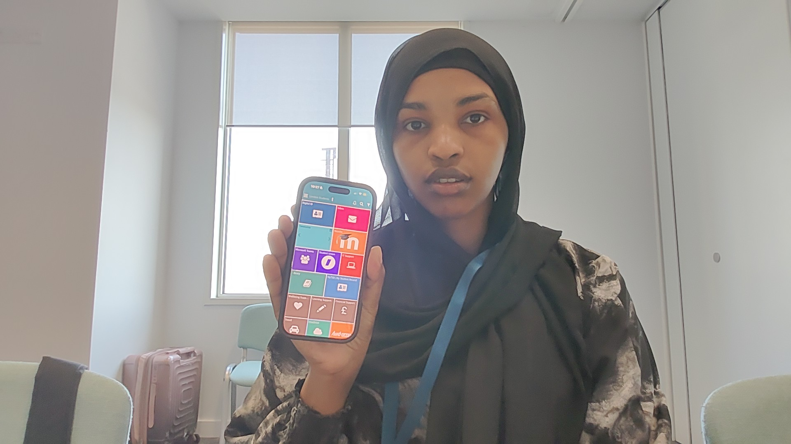
[Write what this shows of your digital life]
Moodle where I get all my assignments and work.

Screenshot/Photo 2
[Insert Photo/Screenshot below]
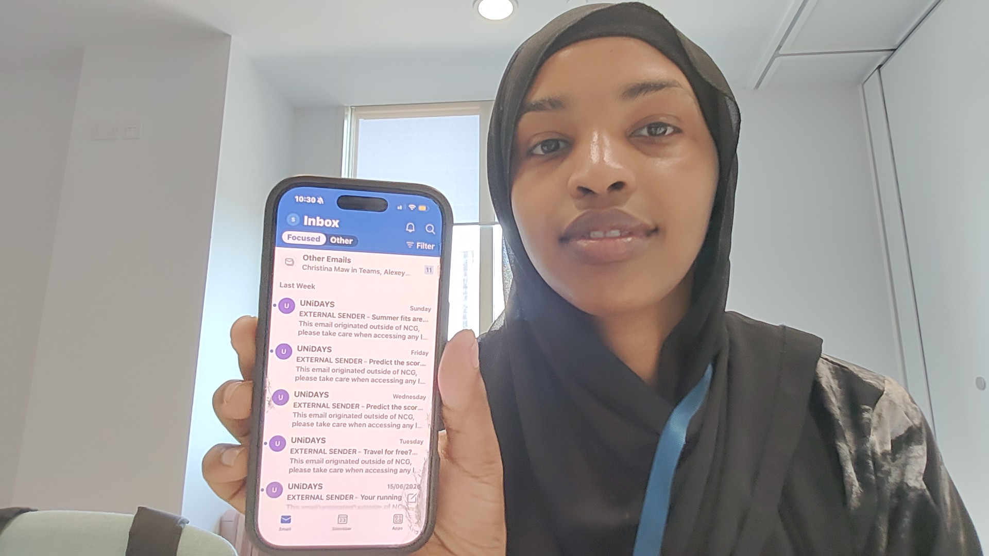
[Write what this shows of your digital life]
My student @mail:college massages timetable and updates .

Screenshot/Photo 3
[Insert Photo/Screenshot below]
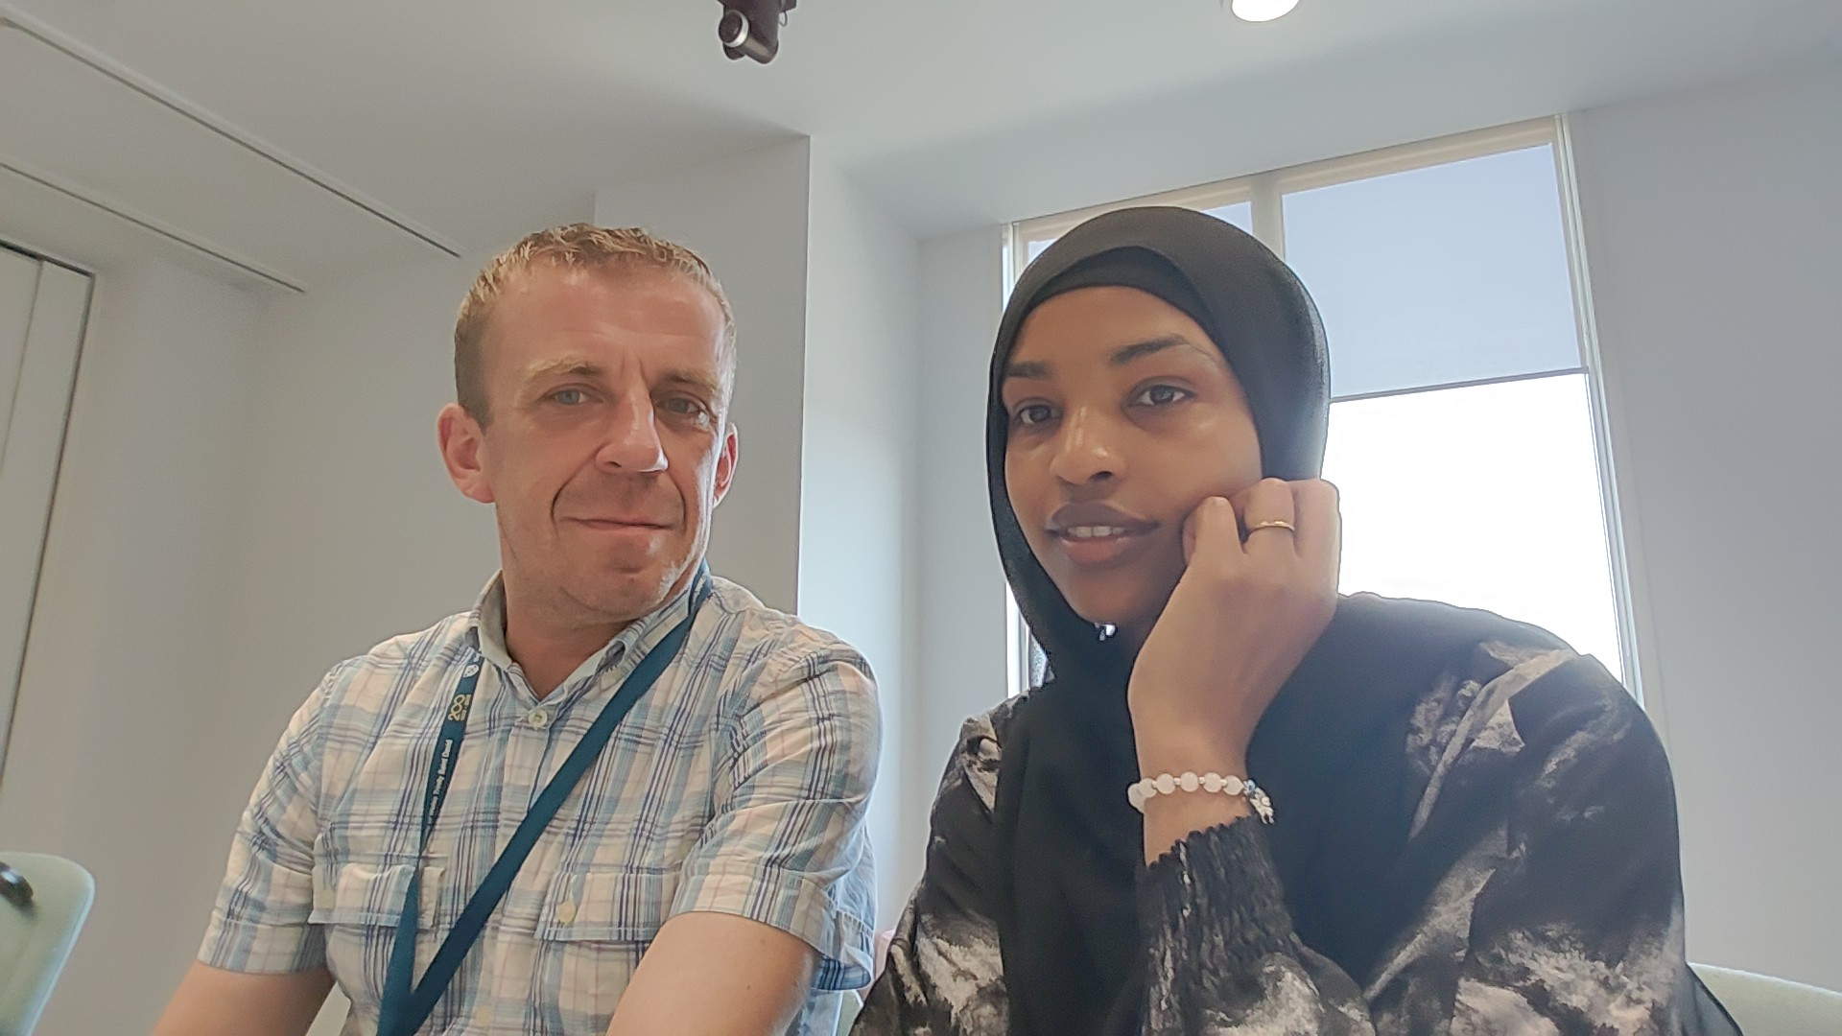
[Write what this shows of your digital life]
Me and my classmate.

Screenshot/Photo 4
[Insert Photo/Screenshot below]
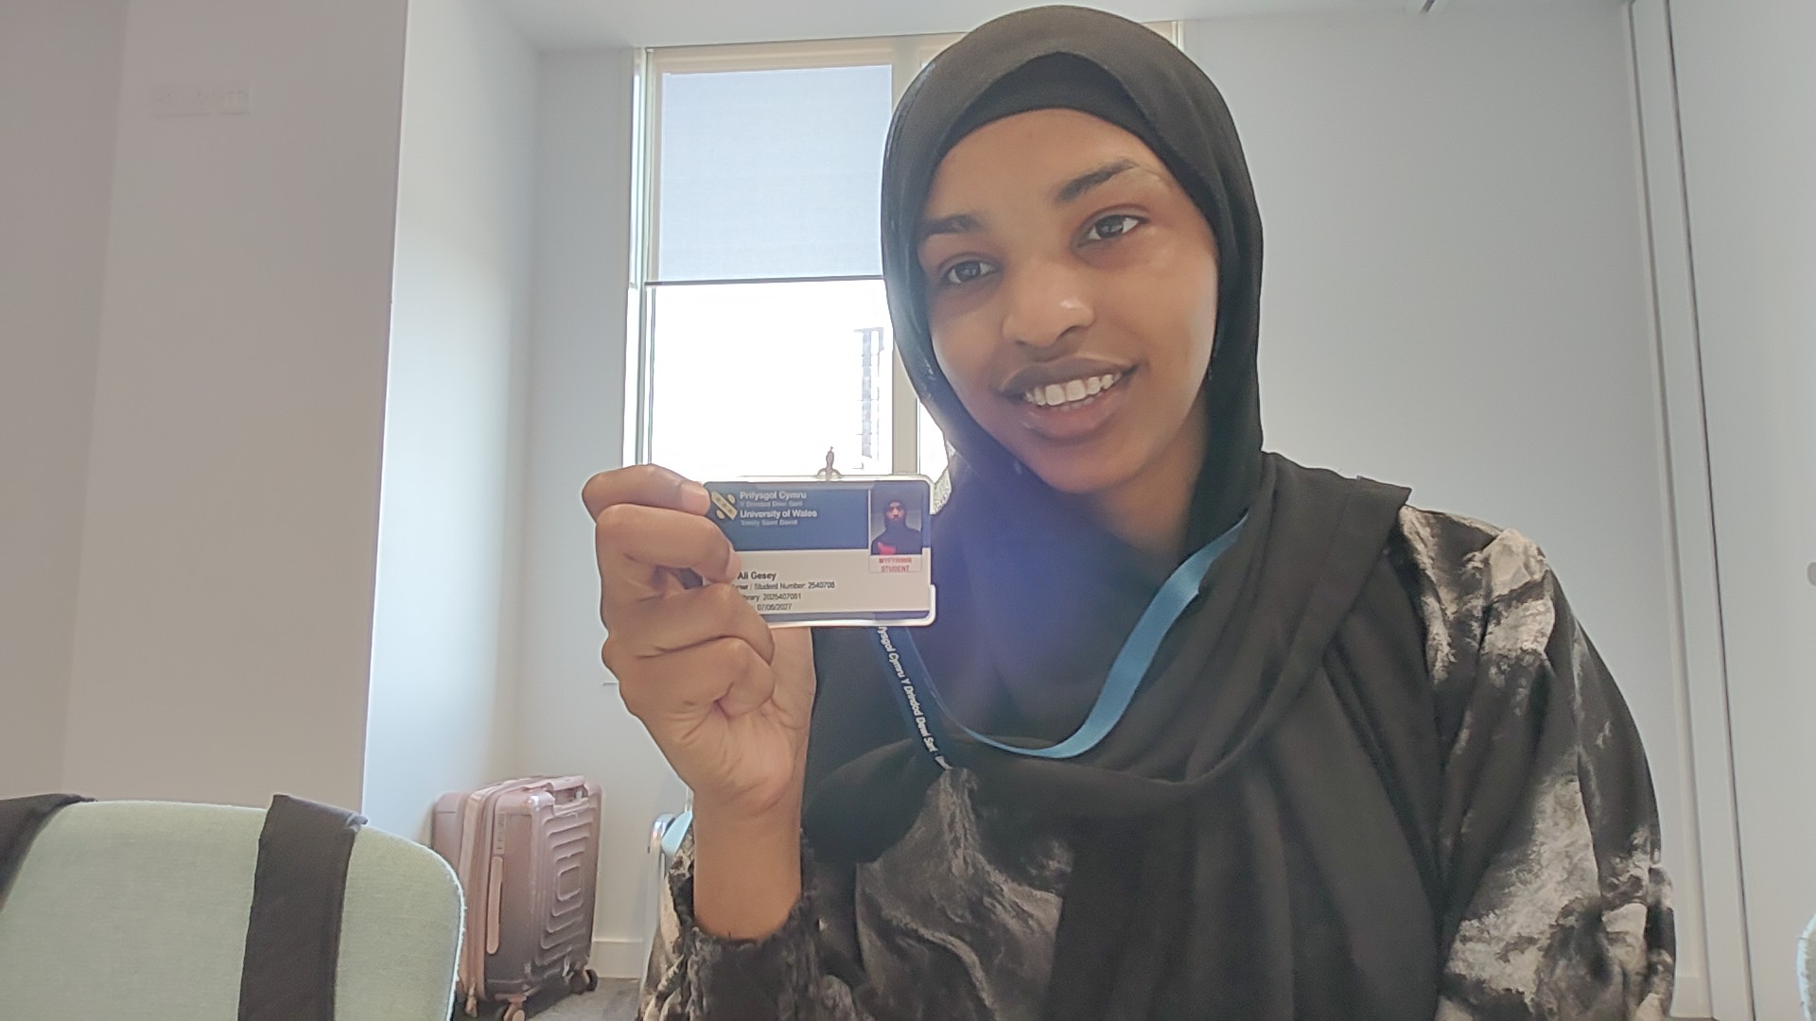
[Write what this shows of your digital life]
I use my ID to open my class door to open it.

Screenshot/Photo 5

Screenshot/Photo 6
[Insert Photo/Screenshot below]

[Write what this shows of your digital life]
My attention with the teacher.

My Short Reflection
- Write 5–8 simple sentences about your digital life.
- You can use the sentence starters below if helpful.
1: I send messages and @mails in seconds.
2: I find information quickly online.
3: I keep all my wark safe .
4: everything is fast and simple.
5: digital tools help me work and study from any where.
6: I talk easily to teachers and classmates.

Sentence starters
- I use digital tools to … study

- I feel confident when I … I save files.
- I want to improve … my word skills .
- I often use these tools: … hub moodle.
- I sometimes feel nervous about … making mistakes .
- I hope this module will help me … learn more .
- Digital skills are important for me because … I need them for college and future work .
You can write more if you want.

Submission Checklist
Before you submit, please check:
​​​ ☐ I added 4–6 screenshots
☐ I wrote short sentences for each screenshot
☐ I wrote my short reflection
☐ My work is my own
☐ My file opens correctly
​​☐ My file opens correctly

