HPHP4008 – Creating Culture
– Slavery and Roman economic and social activity

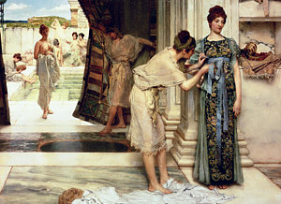

In this short workshop (second workshop), we will briefly consider the plight of slaves, their activities and the types of conditions they faced in the Roman world. A number of extracts from a range of different ancient sources have been given on the accompanying PDF. You should read the sections that have been highlighted (these are indicated by black marker lines on the pages) and consider the following questions below:

Questions
1) What various roles did slaves perform? What time of economic and social functions did they serve?
2) What impression do you get about how slaves were viewed (in the abstract) from the legal and contractual (e.g. sales) documents?
3) How was the problem of runaway slaves dealt with – how common a problem do you think it may have been?
4) What living conditions did different types of slaves appear to live in? Do we see any evidence for care with regards to their wellbeing (albeit in a limited manner)?
5) In what circumstances might manumission occur and how might it come about?

