The Global Business Environment
LCCB4005

Assessment 1: Environmental Analysis of Automobile Industry

Student Name: Milko Marinov
ID: 2028014
Module Coordinator/ Lecturer: Tushara Balendran

University of Wales Trinity Saint David

Table of Contents
Introduction 3
Overview of Aston Martin Plc 3
Internal Environment Analysis of Aston Martin 4
SWOT Analysis 4
External Environment Analysis of Aston Martin 5
PESTLE Analysis 6
Challenges That Aston Martin Encounters in Trading in global marketplace 8
Value Chain Analysis of Aston Martin 8
Primary Activities 9
Supportive Activities 10
Ensuring The Sustainability of Aston Martin 10
Conclusion 11
Reference 12

Introduction
The automobile industry, automotive industry named in other words, comprises vehicles, bikes, buses, cars and other public transport. With the invention of automobile, there have been revolutionary changes in the field of communication worldwide. In the 21st century, many more modifications have resulted in luxury cars, modern transports that save our costs, time, and ensure comfortable commuting (Love, 2006). Vehicles, cars have become an integral part of our daily lives.
Apart from commuting us from place to place, vehicles play significant roles in our economy and society to transport goods and services. Following the demand for vehicles in the market, the automobile industry is still growing. Many more enter in the market to thrive with their competitiveness that makes the industry intensely competitive too. That’s why understanding basic environmental issues of doing business in automobile industry is important that will help in formulating effective strategies to ensure smooth operations with profitably sustainable growth.
Here in this report the internal and external factors associated with the automotive industry will be analyzed using SWOT, PESTLE and Value Chain analysis framework for Aston Martin Plc and necessary recommendations will be provided to ensure sustainable operations of the business.

Overview of Aston Martin Plc
Aston Martin, an exclusive and modern sports car brand, is well-recognized worldwide for its iconic sports and modern-luxury cars. Customers are often introduced with newly designed cars surprisingly. This British-owned car manufacturing company was incorporated in 1931 by Robert Bamford and Lionel Martin.
What makes the global recognition of this auto-brand is that some iconic persons namely James Bond and some other from cinema industry, have been used cars from this brand. People consider Aston Martin’s cars as cultural icon in the industry. At present, Aston Martin has operations in more than sixty countries, connected with one hundred and sixty car dealerships where more than three thousand employees working.



Internal Environment Analysis of Aston Martin
SWOT analysis is a widely used framework to analyze the internal environmental factors that affect operations of a business (Lewin and Delgado, 2011). Organizational culture, brand image, human resources, along with many others, are the most important internal environmental factors of a business. Businesses evaluate to understand their strengths and weaknesses, opportunities and threats. Internal business environment factors are under control of a business and are to be managed well to attain organizational goals.

SWOT Analysis
Strengths
- Aston Martin is a globally accepted brand in the market. Strong brand equity for its iconic and modern cars makes it unique.
- With innovatively designated cars, this brand also dominates racing industry.
- This market dominant brand also thrives in the market with luxury and powerful cars.
- With cutting-edge innovation and technology, Aston Martin ensures various effective services.
- Effective branding and marketing strategies help the business to reach and reign in the global marketplace.

Weaknesses
- Despite having global acceptance and strong preference to customers of Aston Martin’s cars, this company is not a familiar name in the market. Rather customers commonly prefer its products only.
- Having been manufacturer of luxury and uniquely designed cars, Aston Martin has a small scale target customer in the market. It covers only top one percent customers of total customers of automobile industry.
- This company has less-diversified product portfolio compared to its competitors in the market.
Opportunities
- This company can expand its operations in growing economies in different parts of the world adopting market penetration strategies.
- Currently this company follows premium pricing strategy. Adopting competitive pricing strategy, this company can attract more customers.
- Having been backed by strong market acceptance, Aston Martin can introduce a well-diversified product portfolio with innovation and development of new cars.
Threats
- With the growing concern for environmental issues, Tesla and some other competing brands introduce electronic cars that make Aston Martin’s position in the market challenging.
- Rising cost of fuel in the international market may impact the demand for cars in the market.
- Growing competition in the automobile companies in the same marketplace.

External Environment Analysis of Aston Martin
Businesses do not have any control over external environmental factors, often resulted in market risk. Changes in such factors affect operations of all businesses in the industry. But managing internal environmental factors prudently, businesses can maximize or minimize the impacts of such changes in business operations (Tan et al, 2010). Managers need to be careful of adopting strategy to take benefits from opportunities or tackle threats.

PESTLE Analysis
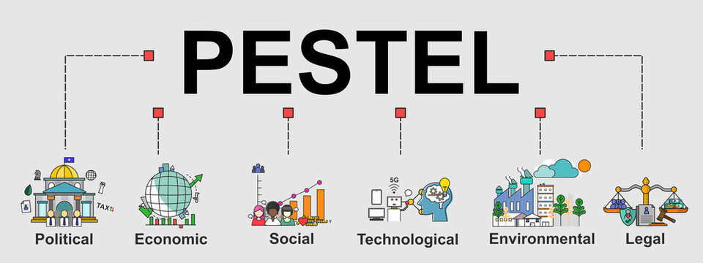
Figure: Gereffi and Fernandez-Stark, (2011)
Political factors
Following changes in government, government policies in taxation, trade and tariffs, businesses need to take effective decisions. BREXIT results in increased costs in export and export of products, raw materials that result in increased costs of production and ultimately customers bear the costs paying higher prices. But having been operated globally, Aston Martin will experience quite a little impact on its operations. Moreover, following the Covid-19 restrictions, labor flow in different countries is often prohibited which may result in increased labor costs in manufacturing and refurbishing in different geographical manufacturing bases. With the introduction of advanced technologies in production bases, Aston Martin faces challenges from public interest in host country because skilled labors need to hire from foreign countries.
Economic factors
Income level, purchasing powers, etc. are key determinants of customers (Craig and Campbell, 2012). In covid-19 pandemic, there have been closures of industries, economic activities that made millions unemployed. Potential customers lost their income. People started to cut their non-essential cost items let alone purchase a luxury and sports cars for entertainment. Moreover, rising costs of fuel and energy in the market resulted in upward inflation as well as increased costs of maintenance for a car.
Social factors
People often follow trend to choose brands; when it comes about a luxury brand for cars, trends play crucial role. People’s perception changes with the passage of time. And in automobile industry customers tastes and preferences change following time to time innovation and advancement of newly designed cars by competing brands. Moreover, only a little portion of entire customer base is the target market for Aston Martin.
Technological factors
Today world is mostly tech-driven – in all aspect of our life. Businesses are now highly focused on fourth industrial revolution (4iR) to reap fruits of tech-oriented industry (Botha, 2014). Automobile industry will also be impacted with artificial intelligence (AI), robotics, internet of things (IoT), etc. in designing and developing new cars as well as driving and operating automatic cars.
Legal factors
Having operations in more than sixty countries, Aston Martin requires to comply international and national trading laws in different geographically detached markets. This corporation requires to ensure safety protocols, minimum wage payment and other restrictions to ensure smooth operations sustainably.
Environmental factors
Automobiles are largely responsible for greenhouse gas emission that results in increased global warming. Most importantly, following the global concern for climate change, customers tend to use electric cars.

Challenges That Aston Martin Encounters in Trading in global marketplace
Here are some challenges that Aston Martin might face operating worldwide-
- Aston Martin might face challenges in terms of launching new technology, obsoleting existing manufacturing technologies, necessity of people with changed skill sets and small scale production for limited customer base, which will result in high costs in production.
- With the introduction of advanced technologies in production bases, Aston Martin faces challenges from public interest in host country because skilled labors need to hire from foreign countries. Otherwise, these employees can be hired from the host countries and it is common that with the investment from foreign companies, it is expected that there will have employment opportunity for locals.
- Following the growing concern for rising global warming, people are more prone to have electric cars that use clean energy sources. To fuel this change in customers’ choice, increase price oil has been added. Following the economic depression in covid-19, people are more likely to avoid purchase of costly luxury cars. On the other hand, competing brands introduce electric cars in the market that meet customers’ demands in terms of clean energy use, no costs for increase oil, petrol, etc.

Value Chain Analysis of Aston Martin
Value chain analysis involves with the identification of primary and supportive objectives to create and enhance value for products a business serve and later, analyze such objectives to reduce costs or increase differentiation (Chen and Kodono, 2012). This analytical tool helps to ensure optimum value creation and delivery to target customers and thus, create greater profits.
Here are the primary and supportive objectives that Aston Martin needs to attain adopting changes in operations to create value for customers following value chain analysis-
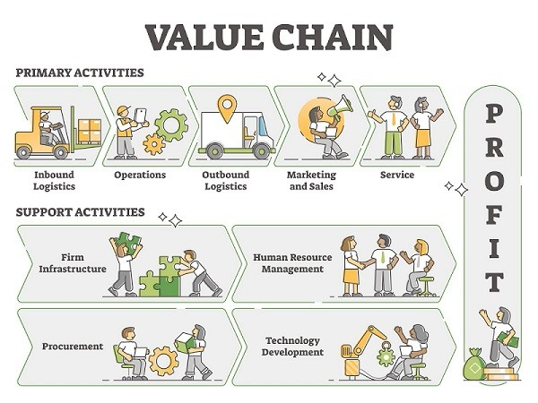
Figure: Value Chain (Haksever, 2016)

Primary Activities
Primary activities in manufacturing companies are those activities that have direct relation with
Inbound Logistics
Aston Martin effectively handles products and warehouse procedure. Customer information also stored to understand customers’ preferences and trends based on their demographic characteristics.
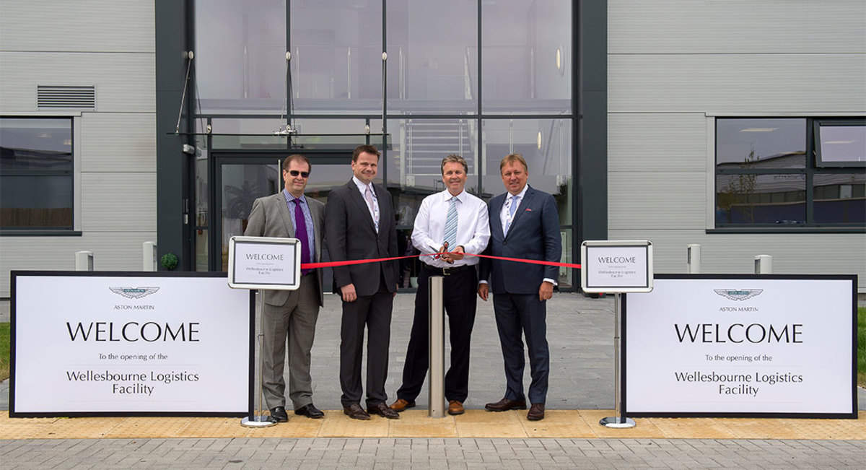

Operations
In this segment, raw materials are transformed into finished products following different production stages. Aston Martin can reduce plastic use to follow growing concern against plastic burning as it results in greenhouse gas, rather use eco-friendly materials.

Outbound Logistics
Aston Martin has 160 dealers in 60 countries and more than 3,000 thousand employees to distribute and deliver products – luxury or sports car, worldwide.
Marketing and Sales
Aston Martin has effective branding and marketing strategies help the business to reach and reign in the global marketplace. It can identify more effective and efficient marketing and sales strategies to gain larger customer base in the market.

Supportive Activities
Aston Martin needs to be careful of supportive activities as they help to attain primary activities.
Firm infrastructure
Aston Martin requires to develop plans, budgets, benchmarks for quality management, general management and legal services to ensure smooth accomplishment of primary activities.
Human resource
Human resources are crucial part especially for operationalizing firm resources as per organizational goals (Bui and De Villiers, 2017). In Aston Martin, employees need to have proper skill sets and training facilities to ensure they have update skills and knowledge to continue with newly adopted technologies in manufacturing processes.

Ensuring The Sustainability of Aston Martin
Here are a few recommendations for Aston Martin-
- Electric car is a new reality for automobile industry. Following growing concern for conserving temperature rise below 1.5 degree Celsius and changing customers’ preferences, Aston Martin can introduce electric cars. It will also be helpful to cope up with the rising costs for fuel in international market.
- Plastic burning results emissions of greenhouse gases. Aston Martin can use less plastic in manufacturing process and highlight it as part of marketing strategies to attract customers.
- Aston Martin can expand its operations in growing economies beyond sixty countries where it has operations now. Even in developing nations, some people have the ability and choice for luxury cars that Aston Martin can focus to grab.
- Austin Martin has a very limited product range. It can diversify its product portfolio with competitive pricing strategy for some of its competing models while maintaining currently adopted premium pricing strategy for uniquely designed luxury cars.

Conclusion
So far discussed, it is manifest that there have been changes in the trends, preferences and shifts in automobile industry with the passage of time. The advancement of technologies, increased oil prices, growing concern for climate changes have fueled such changes in recent years that Austin Marin needs to consider carefully to ensure its competitiveness in the market. It can introduce electric cars, use less plastic in car manufacturing, expand markets ion growing economies, and diversify product range with the adoption of competitive pricing strategy to remain relevant in the market.

Reference
Botha, A., 2014. Coping with continuous change in the business environment: Knowledge management and knowledge management technology. Elsevier.
Bui, B. and De Villiers, C., 2017. Business strategies and management accounting in response to climate change risk exposure and regulatory uncertainty. The British Accounting Review, 49(1), pp.4-24.
Chen, F. and Kodono, Y., 2012, November. SWOT analysis and five competitive forces of Chery automobile company. In The 6th International Conference on Soft Computing and Intelligent Systems, and The 13th International Symposium on Advanced Intelligence Systems (pp. 1959-1962). IEEE.
Craig, T. and Campbell, D., 2012. Organisations and the business environment. Routledge.
Elkington, J., 2014. Towards the sustainable corporation: Win-win-win business strategies for sustainable development. California management review, 36(2), pp.90-100.
Haksever, C., 2016. Total quality management in the small business environment. Business Horizons, 39(2), pp.33-41.
Gereffi, G. and Fernandez-Stark, K., 2011. Global value chain analysis: a primer. Center on Globalization, Governance & Competitiveness (CGGC), Duke University, North Carolina, USA.
Lewin, A. and Delgado, J.M.Q., 2011. The impact of the business environment on the business creation process. In Entrepreneurship and Economic Development (pp. 108-123). Palgrave Macmillan, London.
Love, I., 2006. Business environment and the incorporation decision. Journal of Banking & Finance, 30(11), pp.2967-2993.
Tan, J.H., Chua, W.L., Chow, C.K., Chong, M.C. and Chew, B.C., 2012. PESTLE Analysis on Tesla Vehicles. In Proceedings of the International Conference on Technology Management and Technopreneurship.

