Bushfires Pre-Production
Documents
HPMF4007

Bushfires

Description of character:

The main character is a single father with a young child living alone in Australia. The goal of the protagonist is to safely get himself and his child away from the bushfires that are going to destroy the house and everyone in it if they don’t escape in time.

Description of story world:

I want to portray a realistic representation of the experiences that people have had to go through in the last 6 months in Australia. The story is set in the Blue Mountains of rural New South Wales, Australia, where some of the bushfires devastated entire towns.

Logline

A stubborn father and his innocent child must run for their lives to escape the raging bushfires.

Step Outline

- The father is watching the news while enjoying a beer. The local news is warning people to evacuate the imminent fires, but this father doesn’t seem to be bothered and switches the channel to something else. We then see the child outside playing with the sunset in the smoky sky and an orange glow of fires.
- The next scene will start with the son waking his father up in a frightened panic while the house is partially burning around them. The father gets up in a rush, stumbling around his room before getting his bearings and rushing himself and his child out of the house. They leave the house to see the roof up in flames. They run to the pickup truck, but it’s already been engulfed in the flames, so they turn around and run into the bush.
- As they’re running through the bushes, you see fires all around them and following closely behind them. The father and son stumble through the bush until a tree that has been burning for a while falls over and lands of the son’s legs. The father drops to the floor and tries to move the tree and free his son but there’s no hope. You see the son start to panic while the father tries to stay calm but has the look of pure terror on his face.
- The next scene fades in from black with a wide shot of the lone father walking slowly through the forest with a plume of smoke behind him and a distant glow of the fire. This shot will match the wide shot of his son that we see at the start of the sequence.

Treatment

The sun sets over a smoky landscape and the orange glow of the distant fires' blends into the fading light of dusk. A man sits in his recliner with a beer in hand and gazes at the television with a catatonic stare. There’s an unnerving element of calmness in the room as the local news broadcast begins speaking of immediate evacuation alerts due to the fast approaching fires. The man finally breaks out of his catatonic state to reach over and grab the remote, changing the channel to something more entertaining. A football hits the sliding glass door which startles the dad, making him grumble under his breath. The football is followed by a small boy who appears in the door to retrieve the ball before apologizing and running back into the garden.

The man wakes up to his son crying and screaming while trying to get his father to move. He coughs out a lung of smoke before realizing what's going on. As he stumbles to his feet, he knocks over the array of beer bottles at his feet, smashing one of them, but he’s too occupied to notice. As he looks around what was once his living room, he sees a smoke-filled inferno. He tries to gather his bearings and snap back to reality but before he can he’s being lead out of the house by his son. The view from outside his house isn’t much better. Looking back at the house and the surrounding bushland is like peering into hell. The roof of his once loved home was now completely ablaze along with the ground and trees of the surrounding area. The father drags his son around to the side of the house towards the vehicle, but upon turning the corner, the vehicle is completely ablaze too. The father leads his son towards the only other possible direction of safety, which is into the forest behind them.

The two of them rush through the bush trying their best to dodge the branches and holes in the ground. The fire seems to be chasing them through the forest and surrounding them at every turn. They pause for a moment to look around, looking for any way through the flames. The father spots a small gap between some burning trees ahead of them and darts towards it dragging his son along with him before the boy could react. As they get nearer to the fires the boy grows more and more concerned and begins to voice his concerns to his father with frightened cries, but the father is too panicked to react to it and continues forward. As they reach this gap in the fires, the father reassures his son as best he can before he leaps through this small gap, dragging his unprepared son along. The father clears the gap but he knocks the bottom of the burning tree, causing it to fall and collapse onto his son, trapping the boy's legs beneath it. The father, stunned, quickly realizes what's going on and instantly drops to the floor to try and move the tree. He desperately tries to move the tree, but with no success, he then tries pulling his son out from under the tree which is followed by the frightened screams of his son. He glances around seeing that the big fires are approaching from every angle and they are soon to be engulfed by flames. He looks back down at his terrified son with a look of pure numbness as his son begins to scream in pain because of the heat.

It’s early morning. The father is walking alone through the bush with plumes of smoke rising in the distance from the remanence of the previous bushfires. All is quiet except for the whistling wind rustling through the trees as this broken man continues to walk off into the bush.

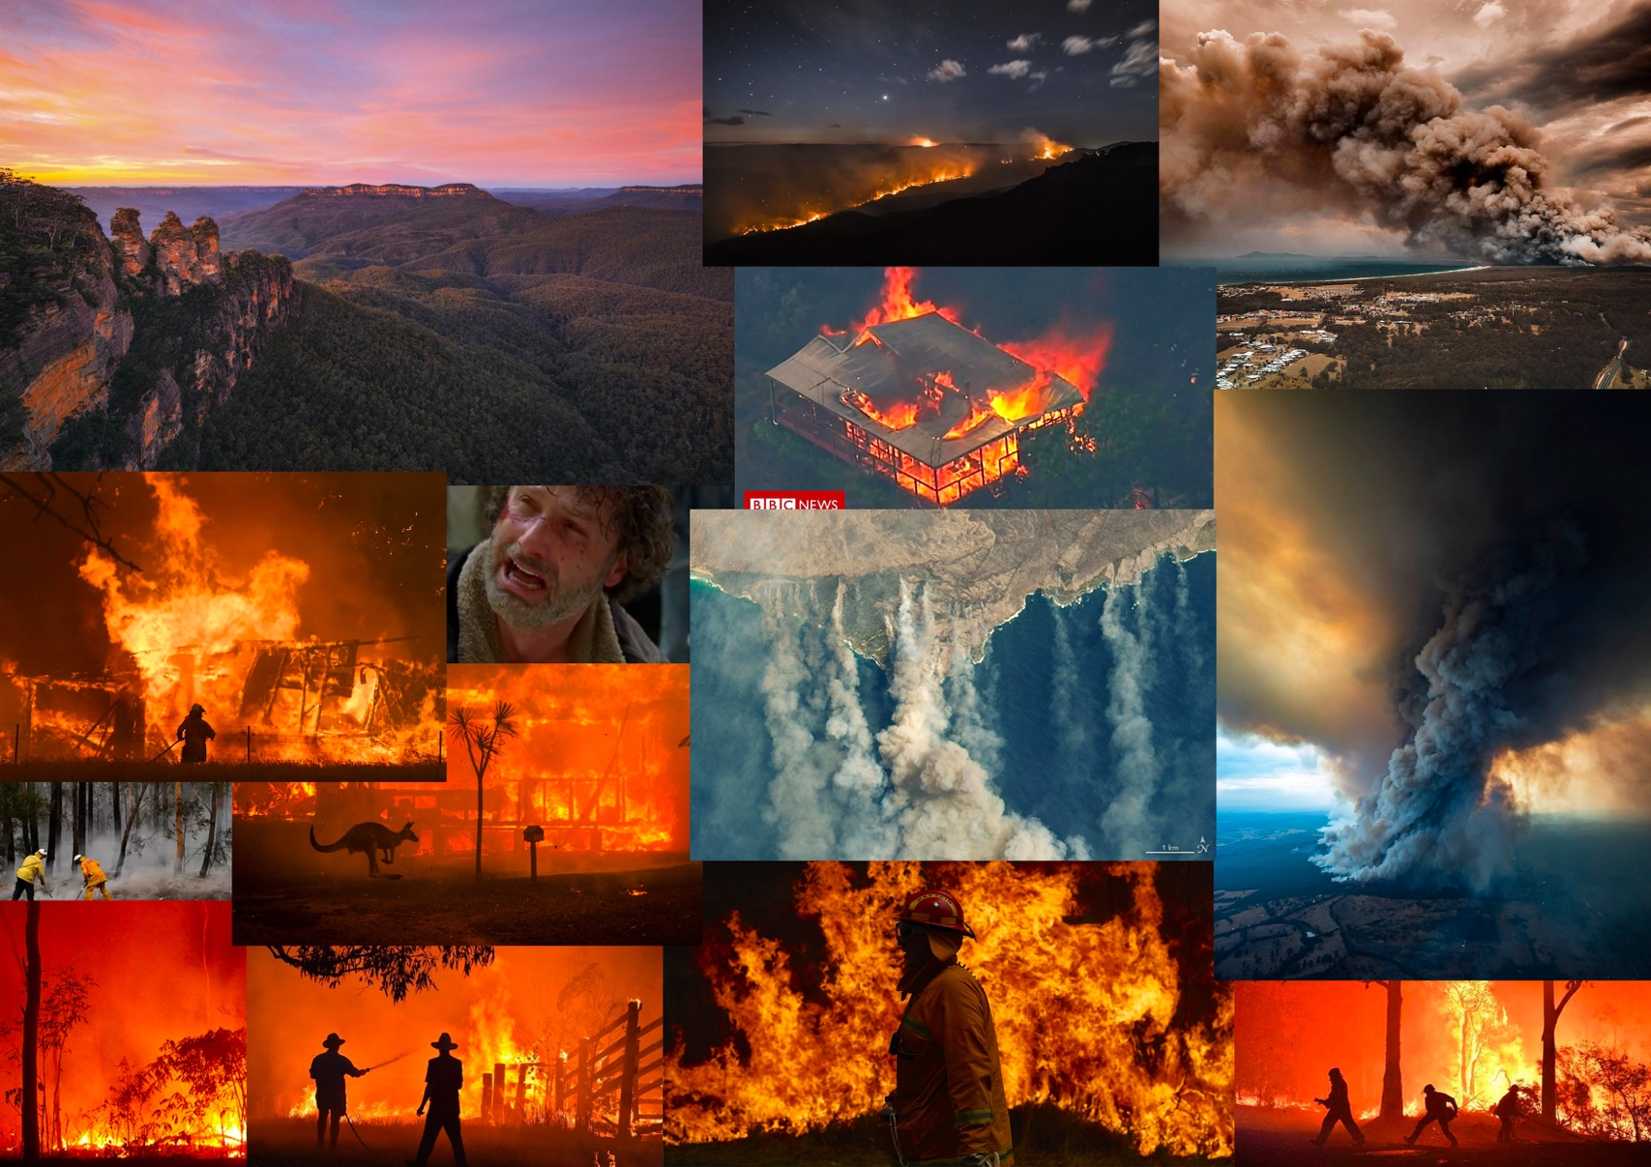

Audio | Visual
Background audio of the TV and cicadas. | Lower angle medium dirty shot directly in front of the father with empty beer bottles out of focus in the foreground. You can see the light of the TV bouncing of the bottles and the father as he stares above the camera at the TV.
Audio of the news report warning of the fire and cicadas. | Over the shoulder shot of the father as he does his actions then tracking around to his left showing a profile view of him with the late dusk light in the garden through the sliding door in the backrgound. Keep this shot until the son has been established in the garden.
Child in the garden playing with a football and a distant burning sound. | Tracking shot that follows the son for a short while from a lower angle before stopping and panning to reveal the child playing in front of the bush with the glow of fires in the background.
Child screaming his dad’s name, starting distorted but becoming more real as the father wakes up. | (Fade in from black) Looking from the father’s POV upwards at the ceiling and his son screaming down on him. POV shot holds as he gets up and looks around for a second or two, but it will be shaky and a little blurry.
Muffled screaming continues. Loud burning sounds and bottles being smashed. | Tracking in around the father in the opposite direction to his rotation while showing the destruction of the fire in his house.
Loud burning sounds continue. Coughing and choking on the smoke. | Tracking the father and son as the leave through the sliding door.
Coughing and choking continues as they run out the door. | Tracking shot picks up from in front of the two as they run out of the house, showing the roof of the house burning. The camera then tracks around to show their reactions as they look at their burning house.
The burning sounds continue in the background along with the sounds of heavy breathing and panting. | Continuing on with the tracking shot, we follow the two as the father grabs the son by his arm and drags him around the corner of the house.
Continued burning sounds. | Static shot from around the corner of the burning house showing the father and son’s reaction their car on fire before we actually see the shot.
Continued burning sounds. | Reverse dirty shot in-between the father and the son with a focus pull showing the burning car with flames climbing high out of frame.
Continued burning sounds and dialogue. | Close up of the fathers face as he stares at his car burning. He’s clearly struggling to come up with a safe way out of this situation. He grabs his son by the arm and dragging him backwards into the bush behind them.
Heavy breathing and running through bushes approaching from far away. | Static wide shot showing a forest with big fires in the background. You see the silhouettes of the two running from left to right with a background of fires.
Continued heavy breathing and running through foliage. Small bits of dialogue. | Tracking of the father and son running through the forest from in front of them. They slow down to look around them to find a safe path through the forest. They continue towards a break in the fire, but the camera stays stationary panning with them as them move.
Loud burning sounds with dialogue and heavy breathing. | Narrow shot through the gap in the burning trees showing the father and son through a foreground of flames.
Loud burning with screams. | As the father jumps through the gap dragging his son, you see it from the side view tracking the father and son jump through and catching the tree falling on the son at the end.
Continued loud burning and screams | Reaction shot from a lower angle of the father followed by a shot of the son with his legs lodged under the tree.
Continued loud burning, screams and dialogue. Towards the end the screams fade into white noise. | Long take of the father and son struggling to get him free with the fires fast approaching ending with a close up of the fathers face with the light of the fires bouncing off his face. (Cut to black)
Wind through trees. | (Fade in from black) Static wide shot of the father walking alone through the forest in the morning with plumes of smoke in the background. This shot matches the shot of the son in the garden with fires and smoke in the background.

Bushfires Crew List

Crew Position | Names
Director | Liam Newitt
Producer | Will Sharp
Director of Photography | Lloyd Grayshon
Assistant Director | Dan Bailey
Camera Operator | Kat Seaton
Sound Operator | Jack Laytham
Scoring | Matt Jones
Hair and Makeup | Rhiannon Richards
Actor 1 | Felix Mackle
Actor 2 | Tommy Simpson
VFX | Elliot Oakes
Editing | Jack Laytham
Catering | Merlin Cafe
2nd Camera Operator | James Lewis
2nd Unit Director | Will Sharp

Bushfires Equipment List

Cameras and Lenses | Sony A7III, Sigma 18-35mm lens Sony E-mount, Lumix S1R with sigma full frame mount lenses, Samyang cinelens
Sound equipment | Zoom sound recorder, Tascam sound recorder, Shotgun microphone with deadcat and blimp, rode boom pole, counterweighted boom pole
Tripods | Benro lightweight tripod, Manfrotto heavy duty tripod with video head, Ronin SC, Ronin S, Ronin M
Other | DJI Inspire 3

Bushfires SWOT Analysis
Strengths  - Locations – Our crew has a good understanding and knowledge of the locations which will make the shoot run more efficiently.  - Equipment – We have access to a wide range of equipment through the University which means we shouldn’t have to source much equipment externally.  - Knowledge and Understanding – With our course we have the chance to work and speak with professionals who can advise us on the best way to produce and shoot our projects. | Weaknesses  - Locations – I’ve decided to shoot a lot of this on locations in the Blue mountains so getting to the location with all the equipment and crew will be a challenge.  - Equipment – For the shoot on location, we may need to source some equipment externally which means we’ll have to look into renting the equipment we need.  - Knowledge and Understanding – While on the shoot, we won’t be able to consult with anyone except the crew we have, therefore a lot of preproduction work must be put in place to ensure that everyone knows what is needed from the shoots.
Opportunities  - Locations – While shooting we have the chance to explore these locations further, and we have already done the location scouting on these locations for future shoots. This allows us to expand our knowledge of locations allowing for a more efficient shoot in future.  - Equipment – Renting equipment externally gives us the opportunity to learn and develop new skills on working with equipment that we don’t fully know. Also sourcing the equipment externally allows us to build connections with other companies for future reference. | Threats  - Locations – The locations we’re shooting in can be challenging in terms of terrain. We will need to ensure that we have first aid trained staff on set at all times while shooting on location in case of any incidents.

Recce Sheet

Date: 25/12/19
Production title: Bushfires
Location: Faulconbridge, New South Wales

Local Condition:
Any known problems? | Yes | The wild areas of Faulconbridge where we’ll be filming has unknown terrain and potential encounters with deadly wild animals. To ensure safety I must make sure we have a local on set with outdoor first aid training.
Aid needed? | No
Permission needed? | Yes | Permission needed to film on this private property.
Protective clothing needed? | No
Viewpoints:
Appropriate viewpoints isolated? | Yes
Any obstructions? | Yes | Some areas of the bush can be obstructed and hard to get through.
Easy to reach and safe? | Yes
Requirements:
Power available? | Yes | Power is available at the house which can act as a media hub as well as the set.
Lighting appropriate? | Yes | Shooting at night will require lighting to match the lighting of a fire.
Sound equipment needed? | Yes | Sound equipment will be needed to ensure all audio that is needed is captured.
Anticipated problems:
Sound? | No
Picture? | Yes | Night time filming will require very careful and specific lighting along with specialised low light cameras.
People? | No
Other? | No
Other considerations:
Security considered? | No | Private land doesn’t require any security.
Welfare considered? | No | Catering is available from the local shops.
Set dressing required? | Yes | Set dressing and props will be needed to complete this shoot.
Props required? | Yes
Comments:

GANTT Chart

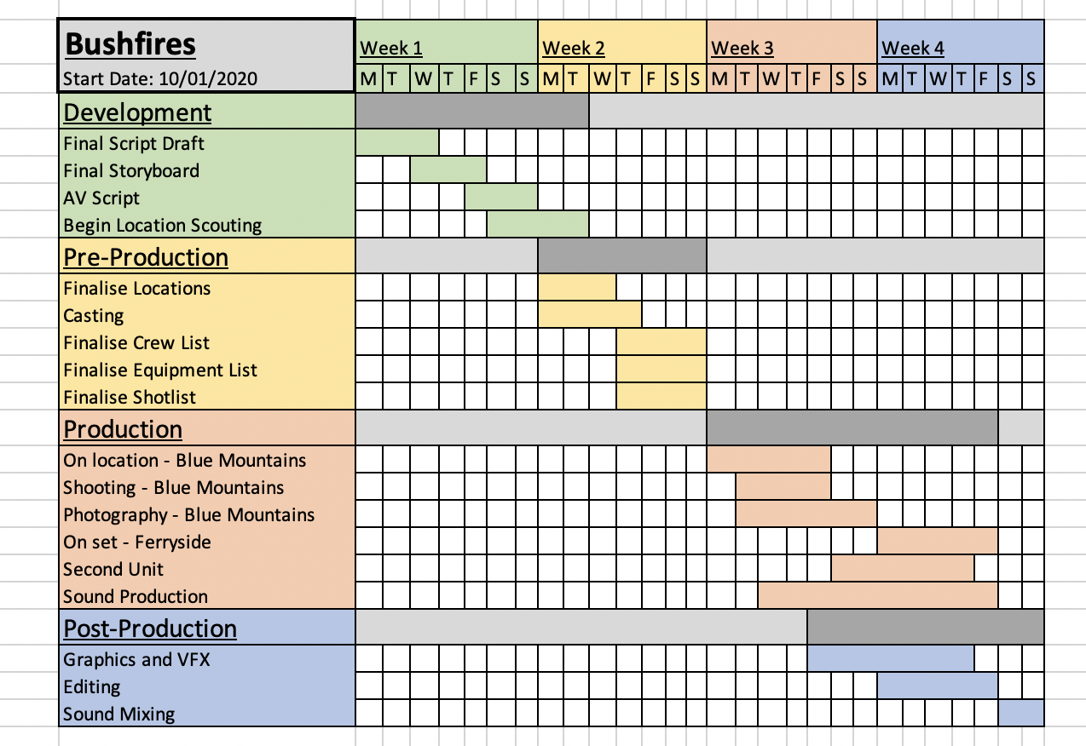

Location Release Form
PRODUCTION TITLE: Bushfires
PRODUCTION DATE: 10/1/20
Permission is hereby granted to Liam Newitt to use the property located in and around the town of Faulconbridge, New South Wales, Australia, consisting of the property of Mr Jack Laytham and the surrounding bushland, for the purpose of photographing and recording scenes for the above program produced by Liam Newitt.
Permission includes the right to bring personnel and equipment onto the property and to remove them after completion of the work. The permission herein granted shall include the right, but not the obligation, to photograph the actual name connected with the premises and to use such name in the program(s).
The undersigned hereby gives to Liam Newitt, its assigns, agents, licensees, affiliates, clients, principals, and representatives the absolute right and permission to copyright, use, exhibit, display, print, reproduce, televise, broadcast and distribute, for any lawful purpose, in whole or in part, through any means without limitation, any scenes containing the above described premises, all without inspection or further consent or approval by the undersigned of the finished product or of the use to which it may be applied.
Liam Newitt hereby agrees to hold the undersigned harmless of and free from any and all liability and loss which Liam Newitt, and/or its agents, may suffer for any reason, except that directly caused by the negligent acts or deliberate misconduct of the owner of the premises or its agents.
The undersigned hereby warrants and represents that the undersigned has full right and authority to solely enter into this agreement concerning the above described premises, and that the undersigned hereby indemnifies and holds Liam Newitt, and/or its agents, harmless from and against any and all loss, liability, costs, damages or claims of any nature arising from, growing out of, or concerning the use of the above described premises except those directly caused by the negligent acts or deliberate misconduct of Liam Newitt, or its/his/her agents.
By (Property Owner/Manager):_____Mr Jack Laytham ________
Signature of Authorised Property Representative
Date:_1/1/20_________________

2nd Location Release Form
PRODUCTION TITLE: Bushfires
PRODUCTION DATE: 10/1/20
Permission is hereby granted to Liam Newitt to use the property located in Ferryside, Carmarthenshire, Wales, for the purpose of photographing and recording scenes for the above program produced by Liam Newitt.
Permission includes the right to bring personnel and equipment onto the property and to remove them after completion of the work. The permission herein granted shall include the right, but not the obligation, to photograph the actual name connected with the premises and to use such name in the program(s).
The undersigned hereby gives to Liam Newitt, its assigns, agents, licensees, affiliates, clients, principals, and representatives the absolute right and permission to copyright, use, exhibit, display, print, reproduce, televise, broadcast and distribute, for any lawful purpose, in whole or in part, through any means without limitation, any scenes containing the above described premises, all without inspection or further consent or approval by the undersigned of the finished product or of the use to which it may be applied.
Liam Newitt hereby agrees to hold the undersigned harmless of and free from any and all liability and loss which Liam Newitt, and/or its agents, may suffer for any reason, except that directly caused by the negligent acts or deliberate misconduct of the owner of the premises or its agents.
The undersigned hereby warrants and represents that the undersigned has full right and authority to solely enter into this agreement concerning the above described premises, and that the undersigned hereby indemnifies and holds Liam Newitt, and/or its agents, harmless from and against any and all loss, liability, costs, damages or claims of any nature arising from, growing out of, or concerning the use of the above described premises except those directly caused by the negligent acts or deliberate misconduct of Liam Newitt, or its/his/her agents.
By (Property Owner/Manager):_____Mr Dan Bailey ________
Signature of Authorised Property Representative
Date:_1/1/20_________________

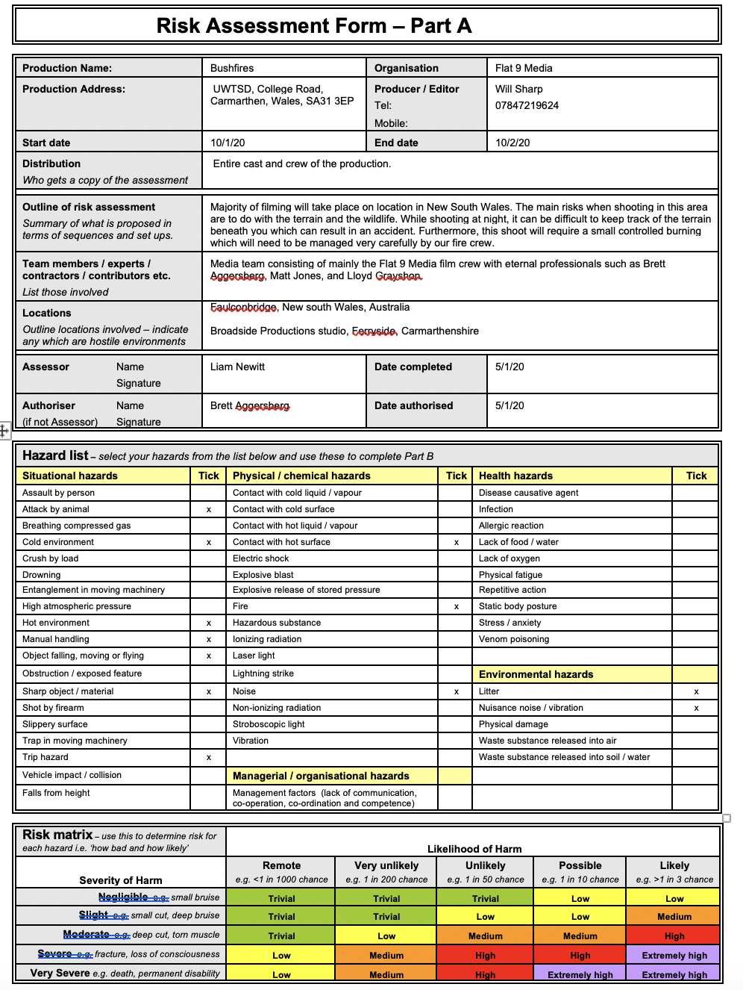

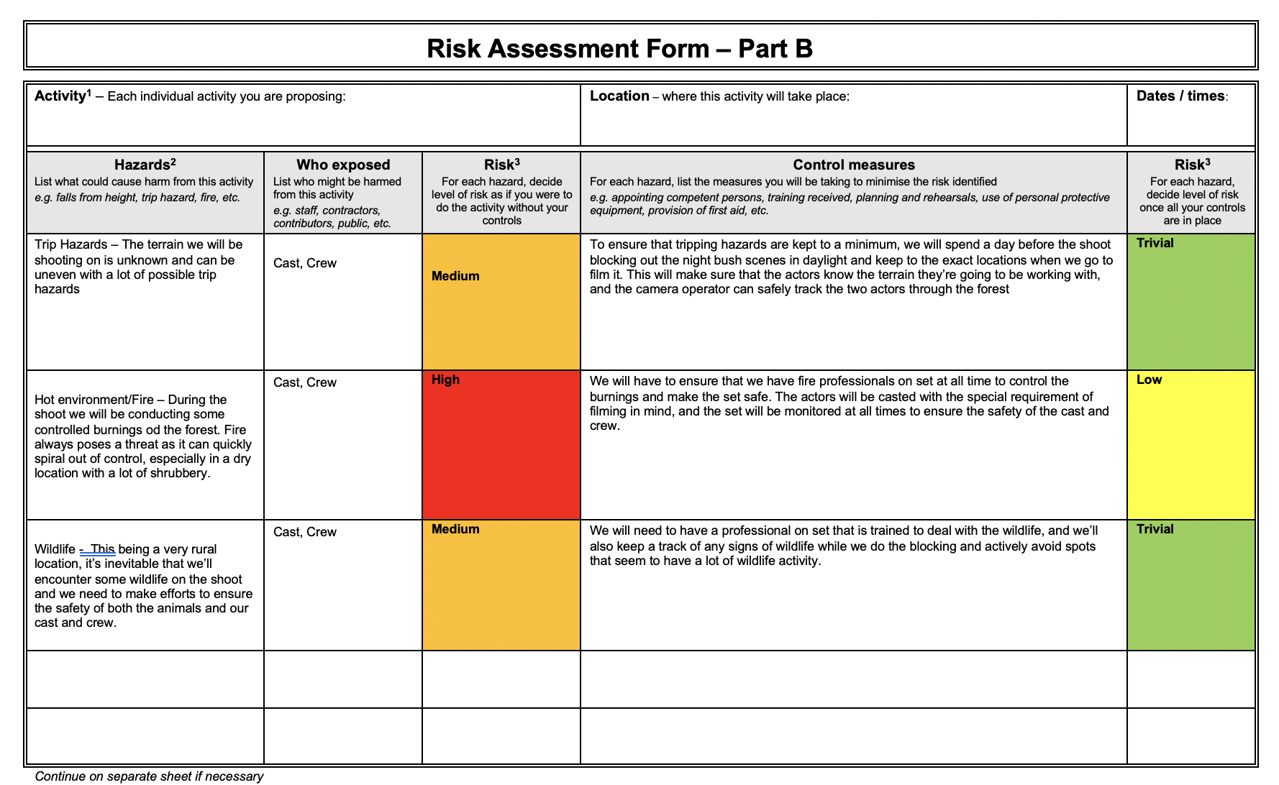

1st Draft Script
INT. LIVING ROOM - DUSK

The father sits in his chair with a beer in hand staring at the television. The news starts giving out evacuation alerts due to the fires. The father changes the channel to something more entertaining. A ball collides with glass startling the father.

(Aggressively)
Father: Watch the fucking door you little shit!

A little boy appears in the sliding glass door to retrieve his ball.

(Apologetic) Son: Sorry Dad.

The son runs back off into the garden and plays with his ball with the distant light of fires burning in the background.

INT. LIVING ROOM - NIGHT

The father is awoken from his sleep in front of the television to his son screaming to wake him up. The fires have engulfed the house and its not safe for them to be in there.

(Screaming)
Son: Dad! Dad wake up!

The father stumbles to his feet knocking over a few beer bottles as he does. He takes a second to gather his bearings before rushing out of the room, dragging his son. As they leave the house they're both coughing with smoke-filled lungs. They both storm out the door and turn back to see the roof of their house engulfed in flames. They look around to see fires also surround the house. The father grabs his son by the arms once again.

Father: Come on!

They both run around the side of the house to see the car also engulfed in flames. The both stand there for a moment staring at the car before the father grabs his son by the arm again while turning around and storming into the forest behind them.

EXT. BUSH – NIGHT
They both run through forest as fast as they possibly can. The fire appears to be surrounding them totally but there's a small gap ahead that they can try and jump through. As the father leaps through the burning gap in the trees, dragging his son with him, a fire damaged tree falls over landing on the son's legs, crushing them.

(Screams in pain) Son: AHHHHHHH DAD!

The father drops to his knees and rushes to try and move the tree but it's too heavy for him to move alone. After a few unsuccessful attempts, the father glances around at the fast approaching fires. The son is getting more and more panicked

(Panicked)
Father: It'll be fine mate don't worry.

The father tries a grabbing his son under the arms and trying to pull his legs from under the tree.

(Screams in pain)
Son: Ahhhhhhh Dad stop! Stop!

Father: Mate we've gotta get you out here

Son: It hurts!

The father stops and sits back, realising that his efforts are hopeless. By now the fire was nearly upon them, and the boy was starting to scream in fear and pain. You see the father staring at hi son with a numb expression as the fires dance and glare on his face. The sound of his son's screams fades out into white noise while we see the fathers face.

CUT TO BLACK

EXT. BUSH - MORNING

FADE IN FROM BLACK

We see the father walking alone through the forest with smoke plumes and the distant glow of fires in the background. This shot matches the shot that introduces the son at the start of the sequence.

FADE TO BLACK

2nd Draft Script

INT. LIVING ROOM - DUSK

The father sits in his chair with a beer in hand staring at the television. The news starts giving out evacuation alerts due to the fires. The father changes the channel to something more entertaining. A ball collides with glass startling the father.

(Aggressively)
Father: Watch the fucking door you little shit!

A little boy appears in the sliding glass door to retrieve his ball.

(Apologetic) Son: Sorry Dad.

The son runs back off into the garden and plays with his ball with the distant light of fires burning in the background.

INT. LIVING ROOM - NIGHT

The father is awoken from his sleep in front of the television to his son screaming to wake him up. The fires have engulfed the house and its not safe for them to be in there.

(Screaming)
Son: Dad! Dad wake up!

The father stumbles to his feet knocking over a few beer bottles as he does. He takes a second to gather his bearings but before he could even react, his son had grabbed him by the arm and began dragging him out of the glass sliding door. As they leave the house they're both coughing with smoke- filled lungs. They both storm out the door and turn back to see the roof of their house engulfed in flames. They look around to see fires also surround the house. The father grabs his son by the arm.

Father: Come on!

They both run around the side of the house to see the car also engulfed in flames. The both stand there for a moment staring at the car before the father grabs his son by the arm again while turning around and storming into the forest behind them.
EXT. BUSH - NIGHT

They both run through forest as fast as they possibly can. The fire appears to be surrounding them totally but the father spots a small gap ahead that they can try and jump through and heads towards it. As they approach the gap the son begins to grow weary.

Son: Dad! Please this doesn't look safe!

The father seems to be too preoccupied with the situation to reply to his distressed son. As the get to the opening, the father turns to reassure his son.

Father: Trust me mate

As the father leaps through the burning gap in the trees, dragging his son with him, he knocks the bottom of a fire damaged tree which falls over landing on the son's legs, crushing them.

(Screams in pain) Son: AHHHHHHH DAD!

The father drops to his knees and rushes to try and move the tree but slumps back to the floor after a few attempts. He glances around at the fast approaching fires. The son is getting more and more panicked

(Panicked)
Father: It'll be fine mate don't worry.

The father tries a grabbing his son under the arms and trying to pull his legs from under the tree.

(Screams in pain)
Son: Ahhhhhhh Dad stop! Stop!

The father stops and sits back, realising that his efforts are hopeless. By now the fire was upon them, and the boy was starting to scream in fear and pain. You see the father staring at hi son with a numb expression as the fires dance and glare on his face. The sound of his son's screams fades out into white noise while we see the fathers face.

CUT TO BLACK

EXT. BUSH - MORNING

FADE IN FROM BLACK

We see the father walking alone through the forest with smoke plumes and the distant glow of fires in the background. This shot matches the shot that introduces the son at the start of the sequence.

FADE TO BLACK

