
Hajra Niaz

2129740

BMHP 5015

CHANGEMAKER BUILDING YOUR PERSONAL BRAND FOR SUSTAIABLE EMPLOYMENT

LECTURER; PARESE AHMED

Table of Contents
- Personal Brand and Career Development ........................................................................ 1
- Network Map and Rationale .......................................................................................... 2
- Blog: Funding Constraints in NHS Digital Transformation ........................................ 3
- NHS Equality, Diversity, and Inclusion Quiz ................................................................ 4
- Letter to My Younger Self ........................................................................................... 5
- Gantt Chart: Future Employment Goals ...................................................................... 6
- Making Changes – Care Home Report ....................................................................... 7
- Reflective Report .......................................................................................................... 8
- References .................................................................................................................. 9

Task 1 – Personal Brand
Personal Brand and Career Development as a Psychiatric Technician.
My personal brand is grounded in compassion, resilience, and a steadfast commitment to supporting individuals with mental health challenges. In my role as a mental health support worker or psychiatric technician, I aim to cultivate a professional identity rooted in empathy, active listening, and empowering service users toward autonomy and recovery. Personal branding extends beyond superficial presentation encompasses how I build trust, prove reliability, and consistently live my values in practice.
To strengthen my brand, I will continue to develop my communication and reflective practice skills so that I can adapt to the needs of diverse individuals. Continuous professional development (CPD) will help me remain current with evidence-based interventions, evolving mental health policies, and new models of care (Melillo et al., 2025). This argues, effective personal branding involves being distinct and consistent in communicating one’s values and strengths therefore, in every professional context I will highlight my dedication to recovery focused and holistic care.
Building a credible professional identity also requires an authentic online presence that reflects compassion and professionalism. By volunteering, undertaking relevant training, and engaging responsibly on professional digital platforms, I can reinforce my values and credibility to prospective employers (Du, 2025). This process also aligns with the growing emphasis on strengthening the public image and trust of healthcare professionals through transparent communication and consistent practice (Yeo et al., 2025).
Ultimately, my goal is to progress within mental health services, contributing meaningfully to the recovery and wellbeing of service users. This approach mirrors recovery-oriented and trauma-informed principles that promote human rights, empowerment, and person-centred care (Melillo et al., 2025; Jackson-Blott et al., 2019).

Task 2 - Network Map and Rationale
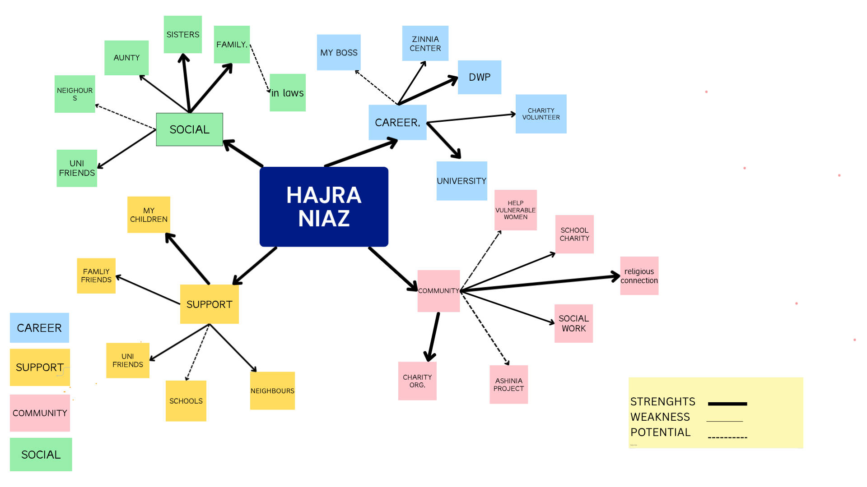

My mind map highlights a rich network of social capital encompassing bonding, bridging, and linking connections. My bonding capital is strong, rooted in close family relationships with my sisters, children, and family friends, offering emotional and practical support (Gillani et al., 2025; Nguyen & Le, 2024). Bridging capital emerges through my engagement with university friends, charity work, school involvement, and community projects such as the Ashinia Project and helping vulnerable women, which connect me to diverse social groups and foster collaboration beyond my immediate circle (Gillani et al., 2025; Exploring the Impact of Bonding, Bridging and Linking Social Capital, 2023). Meanwhile, my linking capital is reflected in ties with formal institutions like my boss, the DWP, Zinnia Center, university, and religious charity organizations, providing access to resources, professional growth, and structured opportunities (Gillani et al., 2025; Exploring the Impact of Bonding, Bridging and Linking Social Capital, 2023). Overall, my network shows solid strengths in family and community engagement, growing outreach through volunteer and educational activities, and potential for expanding partnerships with institutions to enhance leadership and social impact.

Task 3- Blog
Title.
Funding Constraints in NHS Digital Transformation
Introduction.
One of the most significant barriers to achieving successful digital transformation within the National Health Service (NHS) is the issue of funding constraints. While the NHS has set ambitious targets for digital innovation, the financial realities across many trusts have hindered progress and created inconsistencies in the pace of digital adoption.
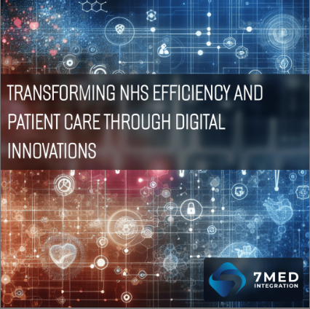
Main body
A 2024 survey by NHS Providers, which gathered responses from 185 trust leaders across 134 NHS trusts, revealed that 73% of respondents found financial pressures as the primary barrier to digital transformation. This challenge surpassed other concerns such as operational pressures and infrastructure issues (Digital Health, 2024). The survey further showed that many trusts struggle to distribute sufficient capital funding to upgrade legacy IT systems, including Electronic Patient Records (EPRs), due to competing budgetary priorities and limited revenue streams (NHS Providers, 2024).
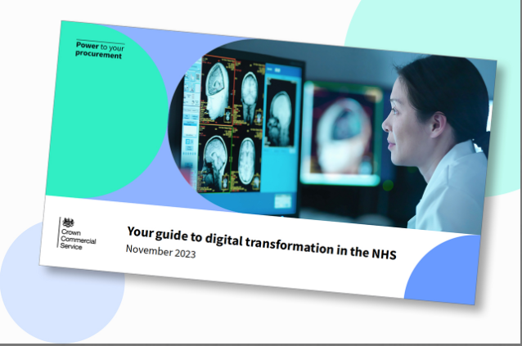

A critical dimension of this issue lies in the structure and timing of NHS funding allocations. Digital funding is often distributed in fragmented “pots” or short-term grants, which are typically awarded late in the financial year. This practice prevents trusts from engaging in long-term strategic planning or investing in sustainable system improvements (NHS Providers, 2024). Furthermore, while capital funding is essential for the acquisition of digital infrastructure, revenue funding needed for staffing, training, maintenance, and software licensing is often insufficient. This imbalance creates ongoing financial pressure and undermines the sustainability of digital systems.
conclusion
The result is a digital divide between well-funded trusts that can pursue innovation and those that cannot, perpetuating inequalities in digital capability across the NHS (Digital Health, 2024). Trust leaders have called for a shift toward multi-year funding models that combine capital and revenue streams to support strategic, locally driven digital investments. Without such reforms, the NHS risks continued fragmentation and inefficiency in its digital transformation journey.

Task 4- NHS Equality, Diversity and Inclusion Quiz
1. What is the primary goal of the NHS Equality, Diversity, and Inclusion Improvement Plan?
The primary goal is to improve equality, diversity, and inclusion by creating a culture of belonging, ensuring fair treatment, and addressing discrimination across all NHS staff groups (NHS England, 2023).

2. How does the NHS EDI Improvement Plan propose to tackle the gender pay gap?
NHS organisations should analyse pay gaps by protected characteristics, with plans for sex and race by 2024, disability by 2025, and others by 2026, while promoting flexible working.

3. What is meant by the term ‘intersectionality’ as used in the NHS EDI Improvement Plan?
Intersectionality recognises that people have multiple, overlapping identities and that different forms of inequality can combine to create unique barriers to inclusion (NHS England, 2023).

4. Why is it important for the NHS to create a psychologically safe work environment?
A psychologically safe workplace allows staff to raise concerns and admit mistakes without fear, improving morale, teamwork, and patient care.

5. How does the NHS EDI Improvement Plan suggest improving the experience of internationally recruited staff?
It recommends comprehensive induction and onboarding programmes to support belonging and reduce bullying or harassment among internationally recruited staff.

6. What role does leadership play in advancing EDI aims according to the NHS Improvement Plan?
Leaders are accountable for setting inclusive cultures, with measurable EDI aims included in annual appraisals for chief executives, chairs, and board members.

7. Find one way the NHS EDI Improvement Plan aims to reduce health inequalities within the workforce.
It promotes addressing workforce health and wellbeing concerns and improving access to fair training and progression opportunities.

8. Why does the NHS EDI Improvement Plan emphasise the importance of collecting and analysing data on protected characteristics?
Data analysis helps find pay and representation gaps, track progress, and guide targeted actions to drop inequalities.

9. Explain how flexible working policies can contribute to equality and inclusion in the NHS workforce.
Flexible working supports work-life balance, helps attract and keep diverse staff, and ensures fair opportunities for all employees.

10. What is one strategy mentioned in the NHS EDI Improvement Plan to combat bullying and harassment in the workplace?
The plan calls for cutting environments where bullying occurs by tracking staff survey data and improving leadership accountability and culture.

Task 5- A Letter to Yourself
Dear Younger Me,

When you first started your university journey, you remember feeling completely overwhelmed. Balancing lectures, assignments, and home life with four children felt almost impossible. You constantly questioned whether you could manage it all, and there were many moments when you doubted yourself. Looking back now, developing emotional intelligence and resilience would have made that time so much easier.
Through experience, you have learned that emotional intelligence supports you in understanding and managing your emotions instead of letting stress take over (Goleman, 1995). You now pause before reacting, communicate calmly, and show yourself compassion when things don’t go perfectly. Recognizing your emotional triggers has helped you stay grounded through late nights and busy mornings, strengthening your emotional resilience (Revich & Shatté, 2002).
Resilience, on the other hand, has taught you that setbacks are not failures they are opportunities to grow stronger. When deadlines pile up or family life gets hectic, resilience pushes you to adapt, seek support, and keep moving forward. You have come to understand that resilience enables people to recover from stress and adapt positively in the face of challenges (Southwick et al., 2014).
If you could tell your younger self one thing, it would be to be kinder to yourself. Every small achievement each completed assignment, every balanced day proves that you are capable and strong. You should be proud of how far you have come.
With love and respect,
to you.

Task 6- GANTT Chart

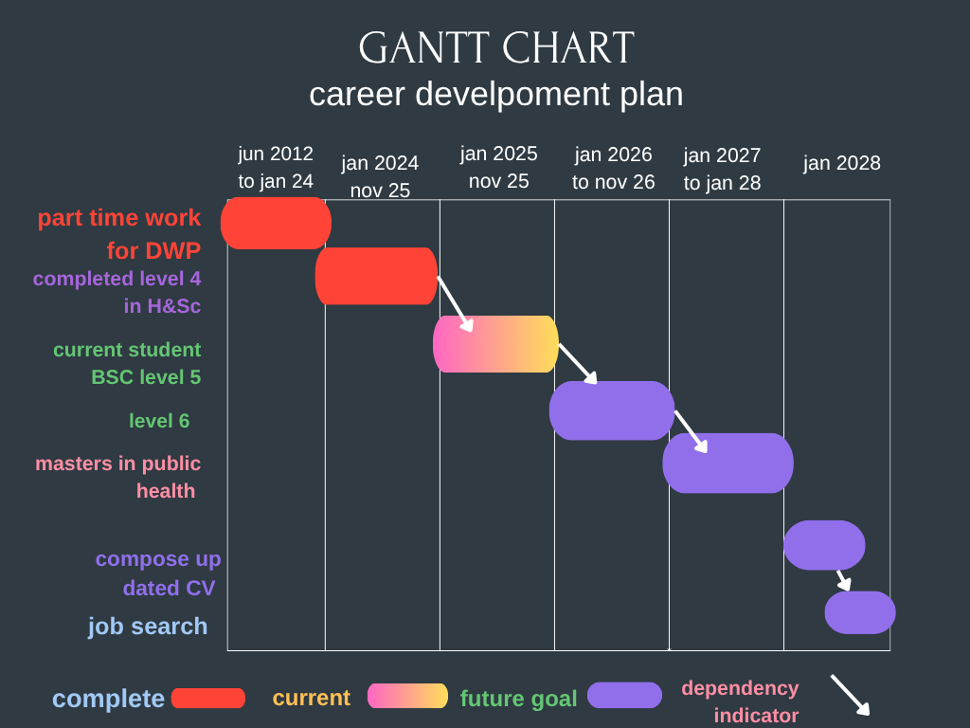

Task 7- Making Changes- Report
One specific change I want to implement within the care home is 1 hour protected relationship and presence time per resident daily that is not task-linked. This is to shift culture from task completion relational care. Evidence shows therapeutic presence reduces distress, reduces escalations and reduces inappropriate medication use in adults with cognitive impairment.
Change method (Lewin 1947)
Unfreeze: present incident data, carer feedback and family feedback showing negative effects of task-only models and moral injury in staff. Facilitate reflective sessions showing how quality presence prevents future workload. Staff need to clearly see this change benefits them also, not only residents.
Change: pilot with 3 residents first with rota protected time. Skills needed: therapeutic communication, emotional atonement, non-verbal communication, trauma informed dementia care, and interpreting behaviour as communication.
Refreeze: 4-week evaluation cycle. Embed into rota permanently, embed into supervision, reflective practice and into care plans. Weekly reflective team sessions will anchor values and prevent regression to task culture.
Possible barriers
implementations include staffing shortages, the pervasive feeling amongst clinical teams that there is “no time for this”, and fear that the intervention will generate increased regulatory documentation burden. Mitigation strategies include Rota redesign rather than Rota addition (maintains finite load not increases it), ultra short documentation using a 3-line reflective template, and measurement of reduction in distress behaviors and repeated task demand to show time return and create visible efficiency / capacity feedback (Cane et al., 2023).
Conclusion
Targeted mitigation which preserves load neutrality and demonstrates visible time return is critical. By reducing documentation to the minimum effective reflective signal and redesigning Rota rather than adding Rota, the intervention becomes implementable inside real operational constraint. This enables culture + behavior change to embed sustainably rather than becoming perceived extra work.

Task 8- Self-Reflection
Throughout this Moodle, I have gained valuable insights into my personal and professional development, particularly in my journey to becoming a psychiatric technician. Completing tasks such as developing my personal brand, mapping my network, and exploring NHS policies has allowed me to reflect on my strengths, areas for growth, and professional identity.
1. Description
This reflection focuses on the experiences that challenged you during this module, particularly balancing university studies while caring for four children, alongside developing your professional identity within mental health.
2. Feelings
At the start, you felt overwhelmed, unsure whether you could manage competing demands of academic work, parenting, and professional expectations. You felt pressure to perform well academically and remain present in your caring role, while still being yourself professionally.
3. Evaluation
Some moments were positive, such as improving communication with peers, lecturers, and service users as you learned to pause and respond thoughtfully. Other moments felt difficult when stress built up or expectations clashed. Developing your personal brand showed the value of being compassionate, reliable and credible (Avery & Greenwald, 2023).
4. Analysis
Emotional intelligence and resilience were essential in managing stress and staying focused academically and professionally. Learning how to regulate emotions supported clearer communication and reduced reactive responses. Networking through bonding, bridging and linking social capital provided support, opportunity and access to resources (Gillani et al., 2025). Engaging with tasks like the EDI quiz and the NHS digital transformation blog helped you understand organisational policy, equality structures, and systemic challenges in the NHS.
5. Conclusion
This module improved your self-awareness and strengthened your reflective skills. You recognise that resilience, personal brand clarity, and emotional intelligence are needed to develop into an effective mental health practitioner.
6. Action Plan
Moving forward, you will continue applying emotional regulation strategies, use reflective practice consistently, keep a professional personal brand, and build social capital networks to support your academic journey and career development. You aim to progress as a compassionate, competent, and confident mental health professional.
Conclusion,
Overall, using Gibbs’ Reflective Cycle (1988) has helped me recognise how emotional intelligence, resilience, self-branding, and networking have strengthened my confidence and professional identity. I now feel more prepared for future opportunities and committed to continuous self-reflection and growth.

Reference List

7Med Integration (2024) Transforming NHS efficiency and patient care through digital innovations. 7Med Integration website. © 7Med Integration. (Accessed: 9 November 2025).
Avery, J. and Greenwald, R. (2023) ‘A new approach to building your personal brand’, Harvard Business Review. Available at: https://hbr.org/2023/05/a-new-approach-to-building-your-personal-brand (Accessed: 07 November 2025).
Cane, J., Richardson, M., Johnston, M., Ladha, R., West, R. and Michie, S. (2023) ‘Advances in the Behaviour Change Wheel and COM-B model: refining mechanisms, capability/ opportunity load and system implementation’, Implementation Science, 18(1), pp.1–14
Crown Commercial Service (2023) Your guide to digital transformation in the NHS. Crown Commercial Service. (Cover image).
Digital Health (2024) ‘Finances are main barrier to digital transformation say NHS leaders’. Available at: https://www.digitalhealth.net/2024/10/finances-are-main-barrier-digital-transformation-say-nhs-leaders/ (Accessed: 07 November 2025).
Du, W. (2025) ‘Building physicians’ personal brand and boosting online presence: A study using social media affordances theory’, Journal of Interactive Advertising. Available at: https://www.tandfonline.com/doi/abs/10.1080/10864415.2025.2471674 (Accessed: 07 November 2025).
Gibbs, G. (1988) Learning by doing: A guide to teaching and learning methods. Oxford: Oxford Polytechnic.
Gillani, M., Nguyen, H. and Tran, L. (2025) ‘Measuring bonding, bridging and linking dimensions of social capital’, Journal Name.
Gillani, N. et al. (2025) ‘Exploring the impact of bonding, bridging, and linking social capital’, Journal/Publisher.
Goleman, D. (1995) Emotional Intelligence: Why It Can Matter More Than IQ. New York: Bantam Books.
Jackson-Blott, K., Lau, A. and Roberts, G. (2019) ‘Recovery-oriented training programmes for mental health: A review of outcomes’, The Lancet Psychiatry, 6(4), pp. 310–319. Available at: https://www.sciencedirect.com/science/article/abs/pii/S2212657018300953 (Accessed: 07 November 2025).
Kitwood, T. (1997) Dementia reconsidered: The person comes first. Open University Press.
Lewin, K. (1947) ‘Frontiers in group dynamics’, Human Relations, 1(1), pp. 5–41.
Melillo, A. et al. (2025) ‘Recovery-oriented and trauma-informed care for people with mental disorders to promote human rights and quality of mental health care: A scoping review’, BMC Psychiatry, 25, p.125. Available at: https://bmcpsychiatry.biomedcentral.com/articles/10.1186/s12888-025-06473-4 (Accessed: 07 November 2025).
Nguyen, T.N. and Le, H. (2024) ‘Exploring the role of social capital in urban resilience for sustainable development: The case of Ho Chi Minh City’, International Journal of Sustainable Development and Planning.
NHS England (2023) NHS equality, diversity and inclusion improvement plan. London: NHS England.
NHS Providers (2024) Digital transformation survey 2024: Challenges, opportunities and priorities for trust leaders. Available at: https://nhsproviders.org/digital-transformation-survey-2024-challenges-opportunities-and-priorities-for-trust-leaders (Accessed: 07 November 2025).
Reivich, K. and Shatté, A. (2002) The Resilience Factor. New York: Broadway Books.
Southwick, S.M. et al. (2014) ‘Resilience definitions, theory, and challenges: Interdisciplinary perspectives’, European Journal of Psychotraumatology, 5(1), 25338. https://doi.org/10.3402/ejpt.v5.25338

