IKEA HOLDINGS US: ORGANIZATIONAL CULTURE

Name: Svetla Maksimova Markova

Module name: BMSW5105
Lecturer name: Hossein Shokri

Date:30/12/2020

Table of Contents
Introduction to IKEA holdings USA and the present organizational culture 3
Typical organizational cultures 5
Organizational culture at IKEA Holdings US 6
Pestle Analysis: A Theoretical View 8
Political factors 8
Economic factors 8
Socio-cultural factors 8
Technological factors 9
Legal factors 9
Environmental factors 9
Critical evaluation of the external environment at IKEA Holdings USA and the impact of COVID-19 9
Political factors 9
Economic factors 10
Socio-cultural factors 12
Technological factors 13
Legal factors 14
Environmental factors 15
How present cultural and ethical standards and the personal ethical standards, values and beliefs of most employees influence performance 15
List of References 17

Introduction to IKEA holdings USA and the present organizational culture
A list consisting of the most successful companies in the realm of the retail industry, and specifically the furnishing niche in the United States would be incomplete without mentioning IKEA Holdings US. IKEA Holdings US is a branch of its parent company, IKEA which saw its founding in the early 1940s. IKEA is an acronym for the founder’s name, his village farm back in Sweden, and the neighboring village; Ingvar Kamprad (founder), Elmtaryd (village farm), and Agunnaryd his neighboring village. The company was formed out of Ingvar Kamprad’s desire to provide modern furnishing to the Swedish retail market at affordable rates (Glusac,2019). However, with continued success over the years, and the profound transformations that hallmarked a bigger part of the last half of the past century, the company found a reason to diversify its market overseas to reach the affluent US market and other regions such as Europe and Asia. Perhaps the need to diversify its geographical reach to tap into previously untouched markets overseas is the underlying cause for its continued referral to as the “world’s largest furniture retailer”, serving millions of clients across the world. In 2016, the company branch with an arrowed target on the US retail market, IKEA Holding US, was Fortune’s 63rd top 100 best companies to work for (Fortune ,2016). By then, the parent company, IKEA, had hired a little over 128000 employees across the world serving in different areas across its robust supply chain. Of the 128000, 14224 employees were attached to IKEA Holding US (Fortune, 2016). Although the parent company was formed in 1943, it was only 41 years later that IKEA Holdings US saw its founding. Being a child company to the world’s largest furniture retailer, IKEA Holdings US has also secured a market leader position in the US furniture retail market. This monumental success can be attributed to its diverse portfolio that includes smart appliances, furniture, beds and mattresses, storage equipment, kitchen appliances, kids’ furniture, home décor, home textiles, lighting and even laundry. What’s more, IKEA Holding US is known to offer all these products in designs that spell simplicity and at affordable prices.
As earlier mentioned, IKEA Holdings US operates as a furniture retailer serving millions of clients across the United States. A review of its performance as a major player in the furniture retailing niche places IKEA holdings as one of the market leaders in the furniture retailing landscape. The furniture retail industry stands among the most affluent industry in the United States with an estimated US$233,037 million worth of revenue in 2020 (Statista, 2020). Notably, the industry is projected to grow at historically unprecedented rates to reach a per person average of US$704.03 by the end of 2020 (Statista, 2020). With such levels of affluence, the industry also stands among the most profitable and competitive with such big-name companies such as Ashley Furniture, IKEA Holdings US, Williams-Sonoma, Berkshire Hathaway Furniture and American signature competing stiffly to secure their market leadership positions in the industry’s hierarchy. As a market leader in furniture retailing, the company has featured in top three highest-earning furniture retailers in the past decade, with 2019 seeing IKEA Holdings US earn an estimated 5.33 billion U.S. dollars in total revenue across its 50 stores in the country according to( Statista 2020). Organizational culture
Organizational culture
Organizational culture is arguably one of the most tangible aspects of a firm and may be portrayed as consisting of values and norms interwoven in a manner that instinctively guides employee practice while at work. Organizational culture is distinct and unique to an organization in every aspect. While the term is broadly defined in scholarly literature, a basic definition by (Arnold ,2005) who defines organizational culture as “the distinctive norms, beliefs, principles and ways of behaving that combine to give each organization its distinct character” can be insightful in understanding the concept that underlies organizational culture. From the definition by Arnold, it is notable that organizational culture is, just like culture as defined from a social perspective, a distinctive factor between firms or business groups.

Typical organizational cultures
There are plethora of models that have been used to explain the underlying concept of organizational culture, but across these models, three yardsticks remain unchallenged. Firstly, there are values. These are considered the most abstract of the components that comprise the organizational culture and are basically the desired qualities that leaders of a firm purport to nurture within members by having them on board and having the perform functions that directly impact the firm’s performance. In most organizations, they are labelled as “core values” suggesting how primal they are to the organization. Most notable core values in organizations operating in modern-day include but not limited to honesty, loyalty, commitment, and consistency. Another component of organizational culture comprises of norms. Norms are components of the organizational culture which are learned through an iterative process of socialization among members and which dictate the predictability of employee behavior during their time at work. Unlike values, norms are pre-established, and employees are required to align their behavior with the expectations of norms. Norms, although may vary from one firm to another, may include transparency, trust, accountability, and selflessness. In their whole sense, norms tend to create strong bonds which restrict members from violating them in fear of social sanctions from peers or punishment. Another component of equal importance consists of “culture forms” which may comprise of rites, gestures, symbols and even stories. Culture forms are used to provide a binding fabric in the organization by joining members throng distinctive communication. They also foster the seamless interaction between members in the firm. These three components, when they exist collegially in a firm, comprise the organizational culture of the firm.

Organizational culture at IKEA Holdings US

IKEA Holdings US, just like other players operating in the US market, has also adopted a distinct organizational culture that aligns with its goals. The company has a well-established set of core values which hallmark the qualities leaders desire to nurture among employees. These include environmental preservation and humanity as employees believe that they have the potential required to make significant change not only to people but also to the environment; togetherness as employees believe that with unity, they get stronger; simplicity; and innovation as employees are obligated to ensure client satisfaction at all times (About IKEA, n.d.). Other cited values include cost-consciousness such that although the company produces trendy furniture, it is committed to ensuring that all families get to own an IKEA-furnished home despite their wallet size; difference with a meaning as IKEA Holdings US seeks to stand out as the company that is unconventional and atypical in every sense; leading by example such that at IKEA, leadership is perceived as an action but not as a position, and empowering people such that employees are nurtured to convince the public that they too can make change if they adopt a positive attitude (About IKEA, n.d.). These are the core values that are highly emphasized at IKEA Holdings US.

Although IKEA Holdings US is focused on serving the American retail market, the company cannot outrun the culture forms adopted by its parent company, IKEA. As earlier mentioned, IKEA has its roots in a village in Småland, Sweden, In Småland, as typical in a good part of Sweden, fishing and forestry are a significant part of geography and social life. For this reason, the company has, over the years, displayed an exquisite love for nature. It is for this reason that the company has decided to only source its raw materials from renewable and recycled materials by 2030 (Ringstrom, 2018). Another culture form that distinguishes the company is its advocacy for gender parity. The company is well known to advocate for gender parity and seeks to ensure a 50/50 gender balance in the near future across its hierarchy. The company’s equivocal interest in gender parity has been factorial in its securing of a chance in the first UN high-level panel on Women Economic Empowerment (UN Women, 2017) which is focused on empowering women particularly to participate in economic activities and achieve financial liberation.
Although the company has a well-established organizational culture, it is evident that an integral piece of a typically complete organizational culture is missing, norms. Norms, just like core values and cultural forms, are equally important especially in ensuring the seamless interaction of teams and individual employees attached to the firm. The company should therefore consider highlighting a set of principles that align with its long-term and short-term goal such as, say, accountability, selflessness, consistency and courage. With such principles in place, the firm can foster a favorable environment for seamless interaction between members and teams.
Part 2
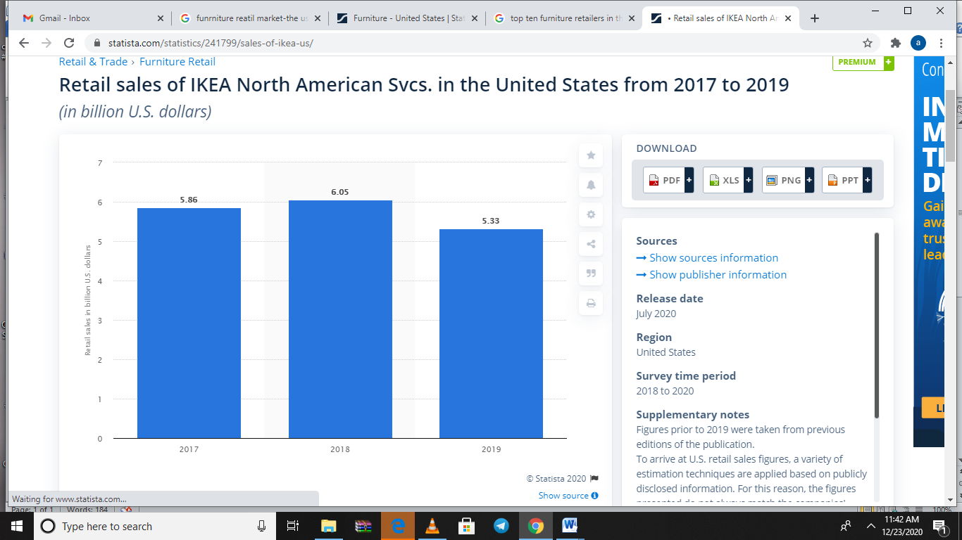
Figure 1.Retall sales in bullian u.s. dolars

Pestle Analysis: A Theoretical View
In order to, comprehensively scan the external environment of IKEA holdings US, a PESTLE analysis can be insightful. A PESTLE analysis involves a review of the company external environment by approaching the analysis from six pillars which are conventionally recognized as comprising a firm’s external environment. For a complete and exhaustive review of the company’s external environment using the PESTLE analysis, all the six components of an external environment will be reviewed.

Political factors
Political factors determine to what extent the government, through its legal agencies, may interfere with industry performance, and the company in specific. It is common knowledge that government dictate industry practice through different multidimensional ways which may include but not limited to tax policies, trade tariffs, fiscal policies and even company-specific sanctions. All these factors comprise some of the ways the government can levy and introduce profound implications to industry practice. What’s more, governments tend to display variations in their application of such policies. For the case of IKEA Holdings US, this paper will only limit the political factors levied by the US government.

Economic factors

Economic factors include distinct factors of an economic nature in a market that dictate company performance because of the far-reaching consequences they tend to trigger with their existence. Such factors may include economic growth rates, foreign exchange rates, and inflation rates. Economic factors have a huge bearing on the performance of a firm and vary widely with national and regional markets.

Socio-cultural factors

Socio-cultural factors comprise factors that consist of a blend of the social and cultural variations that distinguish a market and, just like economic and political factors, have far-reaching implications to firm performance. Like the political and economic factors, they vary widely with every market and dictate industry performance by influencing purchase power and product attractiveness from a consumer’s point of view. Socio-cultural factors may include culture, demographics, and social trends.

Technological factors

Technological factors determine industry practice majorly through innovation and improving production efficiency. They comprise of factors that directly affect production, distribution and marketing in the firm in question, and the industry at large. While there is an endless list of examples of technological factors in the present scheme of matters, research and development, and social media marketing remain the most cited in scholarly literature.

Legal factors

Legal factors comprise of government-imposed restrictions and policies that affect industry practice. Typically, they comprise of policies applicable within country borders and sometimes in regional ones such as in the European Union. However, newer developments also consider organization-wide policies and principles as legal factors that affect company performance and therefore part of the legal environment of a firm in question.

Environmental factors

Environmental factors determine a firm’s commitment to ensuring a friendly relationship with its immediate natural environment and also local policies that seek to protect the environment from degradation. Such may also include natural factors like global warming and climate change.

Critical evaluation of the external environment at IKEA Holdings USA and the impact of COVID-19

Political factors
Being a Swedish company and entering the United States, the company suffers the fate of all foreign firms with an interest in establishing presence in the affluent American market. Some of the major political factors that hallmark IKEA holdings US’ presence in the United States include higher public and government scrutiny. It is common knowledge that in most countries local firms are protected from foreign invasion companies majorly through high levels of scrutiny and regulative policymaking. This is also the case with IKEA in the US market. However, the past decade has seen the United States adopt more accommodating policies to streamline entry and survival in the US market. This has been particularly helpful in fostering a favourable environment for seamless company performance in the United States. It is for these reasons that the United States stands among the countries with the highest number of IKEA stores (50) of the total around 350 stores worldwide.
In the wake of COVID-19, the US government has been largely supportive by adopting cushioning policies for such firms as IKEA. Many nations in the world, as one of the ways to ensure companies survive the adverse implications of loss, adopted relief strategies by extending help to companies through stimulus packages. While different countries pursued different paths towards this direction, the United States resorted to favourable policy-making by most importantly, on May 27 2020, signing The CARES Act into law. The CARES Act would place every SEC-registered firm in a position that could ensure their reception a maximum of $5 billion (Dorsey & Whitney LLP, 2020). This would be made possible by deducting net operating losses ("NOLs). However, companies that did not have taxable income could not benefit from the act if the period from the year of loss to the last time they had income tax is beyond five years. With such stimulus packages, IKEA found a platform to ensure it rebound its performance to pre-pandemic levels.

Economic factors
One of the most salient economic factors that affect company performance is the living standards of the United States at large. While a diverse array of factors may be helpful in measuring the living standards of the market in question, the wage per hour and the ratio of the working population to the unemployed one can be particularly insightful in understanding the market dynamics of the US market. Basically, the wage per hour in the United States is $7.25 making the United States one of the countries with the most favourable living standards (U.S. Department of Labor, 2000). For a more deliberative analysis of the economic environment of the United States as a market, the ratio of the working population to the unemployed population can also be insightful. According to recent estates, there were over 155.76 million people working in the USA by 2018 (Plecher, 2020). This is nearly half of the population if compared with the total population.
Further, a review of the United States’ inflation rate, which may be defined as the rate at which price indices fall within a specific time further quantifies the attractiveness of the US market especially when viewed from an investor perspective. Figure 2 below provides the projected infiltration rates of the US market from 2010 to 2021.
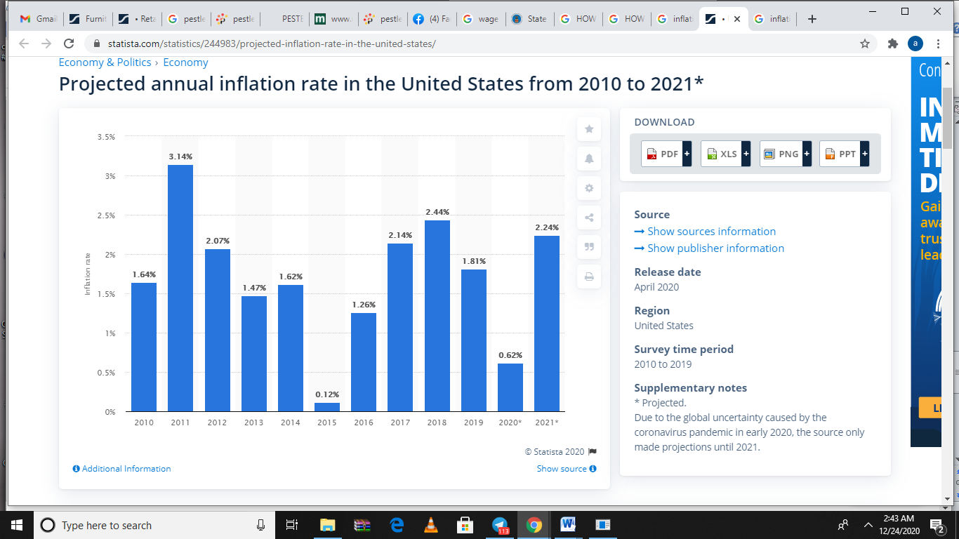
Figure 2.Inflation rates
The outbreak of coronavirus has led to a global recession, and the furniture retailing industry suffers the same fate. With limited movement and restriction on large crowd gatherings, it is hard to underplay the impact of COVID-19 on the demand for furniture in the United States. Even with the government extending stimulus packages to different sectors of the economy, inflation rates observable in the United States companies spark worry and concern. Worse still, with production shutting down and millions losing jobs, it is clear that consumer behaviour will shift to only focus on essentials. Therefore, the firm, just like hundreds of others in the market, will continue to bear loss due to decreased demand for products due to outbreak of COVID-19.

Socio-cultural factors
IKEA Holdings US understands that the US culture is diverse and tries to incorporate this quality in production. For instance, with the USA, being a society that is highly sensitive to homosexuality, the company was prompted to develop a catalogue featuring a gay couple (Cole 2016). This an example of the company’s understanding of the need to realign production and marketing with the new American dream which puts monumental emphasis on zero discrimination.
In light of ,the COVID-19 outbreak, a company’s corporate citizenry was tested by the extent to which it gives back to the society. Corporate philanthropy is an important part of the United States market and is known to strengthen brand identity with the people. In fact, a study that sought to establish the extent to which millennials would want firms to pledge their corporate citizenry suggested that 81% of millennials would rather identify with companies that exhibit good corporate citizenry (Rudominer, n.d). IKEA understands this and has been a conspicuous front liner in giving back to the community majorly through donations. In April 2020 the company pledged its good citizenry by donating products worth $1.6 million to Americans across the country (IKEA.com n.p). In this way, it is easy to understand how COVID-19 has changed the socio-cultural environment of IKEA Holdings USA

Technological factors
For a company operating in the 21st centuries and in an affluent market, technology is a staple. IKEA Holdings US has ensured the maximum utilization of technology in its bid to improve performance and product efficiency. One case example of how technology has been used to guarantee product efficiency at IKEA is observable in its portfolio diversification efforts. In the beginning of the 1980s, where technology was still a young idea and before firms leveraged its power to change production and ensure high levels of innovation, the company had a limited product portfolio majorly consisting of beds, chairs and mattresses. However, as technology continues to evolve, the company has assumed a cheerleader in diversifying its product portfolio to include smart appliances such as smart Wi-Fi and other smart appliances.
Another possible way in which technology has affected the external environment at IKEA Holdings US is the introduction of a digital catalogue. Although the company still offers its items through paper catalogues, it has advanced its marketing strategies to ensure wider client access. The company now, apart from the paper catalogue, offers a digital catalogue. This may be due to the large number of Americans owning a smartphone and having access to the internet.
A large number of smartphone users in the United States may also be the underlying reason for the company’s reinforcement of its marketing efforts with social media marketing in platforms such as Instagram and Facebook. In these ways, the company seeks to adapt to changes that stem from the impact of technology in the American market. Perhaps IKEA’s digital catalogues can be regarded as the best marketing tool especially in a market that has been hit by COVID-19 because they are accessible online. This allows the company to market its products to the American market even with the restriction of movement and large crowd gatherings.

Legal factors
IKEA stands among the most popular companies in the United States, which increases the level of public scrutiny it is exposed to. A review of the legal history of the company reveals multiple cases where the company was on the wrong side of the law. For starters, it is important to consider the case when IKEA Holdings US was sued for violating federal labour policies (UFCW, 2020). In this case, the firm was allegedly interrogating employees on the unions they had joined without consent. The company was also accused of adopting an overly broad social media policy that did not allow individual employee privacy. Another notable case involving the firm can be noted in 2020 when the company paid a total of $46 million worth of damages for a case of wrongful death that involved a toddler (Mitchell, 2020). In the ensuing contest, it is gatherable that a dresser bought from the company tipped over and hit a toddler causing his untimely death. The $46 million compensation is a record high cost of damages ever awarded for a case involving wrongful death in the history of the United States (Mitchel, 2020). In another case still in 2020, attorneys also claimed that the company’s product, MALM dresser, was an errant one and responsible for multiple deaths and that although the company had promised to recall the product, the attempts were feeble (Mitchell, 2020). These legal issues involving federal labour policies and public uproar paint a picture of the company’s legal environment in the United States.
Following the outbreak of COVID-19, IKEA Holdings USA was compelled to close down its 50 stores across the country (Wilson, 2020). This was in mid-march 2020 when the company, in response to a government directive to close down stores in order to prevent large crowd gatherings and curtail the possible spread of the deadly virus among employees, decided to close down its stores. Closure of the company’s stores reveals how impactful COVID-19 is to the legal environment of IKEA Holdings USA.

Environmental factors
It is common knowledge that environmental sustainability stands among the most contentious issues in most countries and so is in the US. Ikea Holdings US operates in a market that is struggling to ensure environmental sustainability through the adoption of green models such as The Green New Deal. With such levels of environmental consciousness, firms operating on a country-wide basis such as IKEA Holdings US are compelled to display matching levels of environmental consciousness. IKEA Holdings US operates in an industry that requires the use of nature (trees), which starkly conflicts with the philosophy underlying environmental conservation. However, the company is currently considering a shift to the use of renewable and recyclable materials such as cotton in its production. The shift to renewable raw materials is necessitated by the environmental policies adopted in the United States.

How present cultural and ethical standards and the personal ethical standards, values and beliefs of most employees influence performance
As earlier mentioned, IKEA Holdings USA is a market leader in the United States and its year to year performance reflects this market leader status. In 2019, the company made 5.33 billion U.S. dollars' worth in revenue (Statista Research Department, 2020). This is an impeccable performance as the company managed to surpass big-name companies that also enjoy physical presence in the United States furniture retailing market. For instance, in the same year, Amazon, which is the largest retailer in the world, only sold furniture worth $2.62 billion (What Competitors.com). Another key player in the furniture retail landscape is Ashley Furniture Industries who, unlike Amazon, focuses solely on offering furniture to the American market. A review of the company’s retail sales by the end of FY19 revealed that the company had sold furniture worth $4.961 billion (What Competitors, 2020). These comparisons reveal how IKEA Holdings US has managed to carve out a significant section of the American market despite being foreign.
While a diverse array of factors may be factorial in the impeccable performance displayed by IKEA Holdings US, a cursory review may reveal the profound role of the company’s organizational culture in the company’s performance. As mentioned in the previous paragraphs, the company’s culture places monumental emphasis on unity. Viewing this from the philosophical standpoint of “two heads are better than one”, then it is easy to picture high levels of employee coordination which translates to exemplary customer service at IKEA Holdings US. Such values, coupled with others such as innovation, cost-consciousness, leadership and love for human life and the environment, are a reflection of the company’s impeccable performance in the United States furniture retail market.
IKEA Holdings US’s corporate social responsibility spells sustainability and the roots of its commitment to such levels of corporate citizenry are succinctly reflected in its parent company’s manifesto. The last few decades has seen IKEA, the parent company, invest into deliberative efforts of creating networks that align with its commitment to corporate social responsibility. For instance, amid public uproar of massive use of child labor by some IKEA subcontractors especially in ASIA, the parent company decided to develop networks with key stakeholders such as UNICEF to curtail such practices (Lindgreen, Maon and Swaen, 2011). Furthermore, IKEA has also shown its unwavering desire to protect its strong brand identity by adopting swift measures to efforts that threaten its brand identity. For instance, in Denmark back in the 1980s, IKEA allegedly used poisonous substances in is particleboards and elicited public uproar. IKEA responded swiftly by embarking on large-scale testing of its particleboards shorty after. A further look into the company’s marketing mix reveals that across its marketing strategies, the company puts monumental emphasis on environment and family and trivializes the need to include efforts such as its commitment towards corporate social responsibility. This is because it holds environmental conservation in high regard possibly because of its Scandinavian roots (Lindgreen, Maon and Swaen, 2011). For this reason, the company is largely identified as environmentally protective in its markets, including the USA (Lindgreen, Maon and Swaen, 2011). These factors are probably the underlying reasons for its monumental success in Europe and the United States at large.

List of References
About IKEA (n.d.). IKEA culture and values. Available at: https://about.ikea.com/en/about-us/ikea-culture-and-values. [Accessed 18 Dec.2020]
Arnold, J., Silvester, J., Cooper, C.L., Robertson, I.T. and Patterson, F.M., 2005. Work psychology: Understanding human behaviour in the workplace. Pearson Education.
‌Cole, J.M. (2016). IKEA Unveils LGBT-Friendly ‘All Homes Are Created Equal’ Ad Campaign. The News Lens International Edition. Available at:
https://international.thenewslens.com/article/50834. [Accessed 20 Dec.2020]
Dorsey & Whitney LLP (2020). Covid-19 Tax Relief Makes Winners out of Losses .JD Supra. Available at: https://www.jdsupra.com/legalnews/covid-19-tax-relief-makes-winners-out-35012/. [Accessed 26 Dec.2020]
Fortune (2016). 100 Best Companies to Work For 2016. Fortune. Available at: https://fortune.com/best-companies/2016/. [Accessed 18 Dec. 2020]
Glusac, M. (2019). Why IKEA is called IKEA - and the origin of other company names. [online] The Sydney Morning Herald. Available at: https://www.smh.com.au/business/companies/why-ikea-is-called-ikea-and-the-origin-of-other-company-names-20190301-p5113g.html [Accessed 27 Dec. 2020].
Lindgreen, A., Maon, F. and Swaen, V. (2011). (PDF) IKEA’s road to corporate social responsibility. ResearchGate. Available at: https://www.researchgate.net/publication/259568802_IKEA [Accessed 27 Dec. 2020].
Mitchell, M. (2020). Ikea Settles Fatal Dresser Tip-Over Case for $46M.The Legal Intelligencer. Available at: https://www.law.com/thelegalintelligencer/2020/01/06/ikea-settles-fatal-dresser-tip-over-case-for-46m/. [Accessed 24 Dec.2020]
Mitchell, M. (2020). Ikea Sued Over “Feeble” Product Recall Efforts in Wake of Fatal Tip-Over Incidents. The Legal Intelligencer. Available at: https://www.law.com/thelegalintelligencer/2020/05/11/ikea-sued-over-feeble-product-recall-efforts-in-wake-of-fatal-tip-over-incidents/ . [Accessed 21 Dec. 2020].
Plecher, H. (2020). United States - Employment 2019 | Statistic. Available at: https://www.statista.com/statistics/269959/employment-in-the-united-states/. [Accessed 18 Dec. 2020]
‌Ringstrom, A. (2018). IKEA to use only renewable and recycled materials by 2030. Available at: https://www.reuters.com/article/us-ikea-sustainability-idUSKCN1J31CD [Accessed 26 Dec. 2020].
Rudominer, R. (n.d.). Corporate Social Responsibility Matters: Ignore Millennials at Your Peril. Center for Social Impact Communication. Available at: https://csic.georgetown.edu/magazine/corporate-social-responsibility-matters-ignore-millennials-peril/#:~:text=Corporate%20Social%20Responsibility%20Matters%3A%20Ignore%20Millennials%20at%20Your%20Peril. [Accessed 24 Dec. 2020].
Statista Research Department (2020). Retail sales of IKEA North American Svcs. U.S. 2017-2019. Available at: https://www.statista.com/statistics/241799/sales-of-ikea-us/ [Accessed 20 Dec. 2020].
‌U.S. Department Of Labor (2000). Minimum Wage | U.S. Department of Labor. Available at: https://www.dol.gov/general/topic/wages/minimumwage. [Accessed 20 Dec.2020]
UFCW (2020). IKEA USA Charged with Violating Federal Labor Law - The United Food & Commercial Workers International Union. Available at: http://www.ufcw.org/press-releases/ikea-usa-charged-with-violating-federal-labor-law [Accessed 27 Dec. 2020].
UN Women (2017). It’s time to act for women’s economic empowerment, say global leaders.. Available at: https://hlp-wee.unwomen.org/en/news/stories/2017/09/news-event-hlp-wee-roundtable-dialogue [Accessed 27 Dec. 2020].
What Competitors (2020). Top 10 Ikea Competitors In 2020. Available at: https://whatcompetitors.com/ikea/. [Accessed 22 Dec.2020].
Wilson, M. (2020). Ikea closes all stores in the United States in response to COVID-19. Fast Company. Available at: https://www.fastcompany.com/90478393/ikea-closes-all-stores-in-the-united-states-in-response-to-covid-19. [Accessed 22 Dec. 2020].

