University of Wales Trinity Saint David

Digital surveying and Highway Design practical surveying assessment.

Written By: Ethan Perez Naidoo ( 2501814)
Course: Quantity Surveying (K241)
Module: Fundamentals of Construction Technology (ACBA4022)
Lecturer: Rhodri Thomas
Due Date: 08/01/2026
Word Count:
Declaration: Throughout the assignment I have not used any Artificial Intelligence to aid me.

Introduction:

The following assessment will analyse the row of houses displayed at Saint Fagans National Museum of History; this specific row of houses called the Rhyd-y-car Terrace displayed the different construction techniques and materials used throughout the years in Wales. Each house within the row is used to show a different time period within the Welsh construction industry. The house at the start of the row of houses is the oldest house showing the construction techniques and materials of the time period, the first house was originally built to represent buildings in 1805 and each house after shows a different year of building within the construction industry. The last in the row of houses was built to show the techniques and building practices in 1985. The Rhyd-y-car Terrace was originally built in 1795 by Richard Crawshay for his workers that worked in the iron mine and is now used to display the different years of construction within Wales (Museum Wales. (2025)). These houses will all be analysed individually to see the gradually change of construction techniques, materials and technologies used within the Welsh construction industry throughout the years from roughly 1805 to 1985.

The first house within the Rhyd-y-car terrace (1805):
To analyse the changes over the years it would be easier to compare each house to the next house within the terrace. The main features that will be compared are the windows, doors, Wall Coverings, Roof Coverings, Eaves details and rainwater goods, Floor coverings and Internal Joinery. In 1805 transport for material was very limited and due to this fact almost all the materials used in construction would have been sourced locally. Due to this fact window frames would have been a timber such as Baltic pine and been joined with traditional tenon joints with a piece of hand blow glass in the middle held together with glazing bars. The doors would have also been made from local timber that was hand planed into long planks and joint by iron nails, this door would have then been fixed in place with iron hinges. Wall covering during the time period would have varied in composition due to the materials available however a lime-based covering would have likely been used due to price, location and time period. Roof coverings for the times would have been slate that would have been source locally. The slate would have been fixed to the roof using iron or copper nails. Eaves details would have been made from predominantly slate hand made into eaves. Rainwater goods would have likely included lead or cast-iron gutter, and it was more likely to have been lead guttering due to how common lead was. There were no floor coverings during this period, and floors were made of exposed stone this resulted in and extreme amount of heat loss within the house. The internal joinery of the house would have likely all been handmade out of locally sourced timber. The internal joinery included an internal plank door that was hung with iron hinges, cabinets that were handcrafted and fixed with iron nails. The other significant internal joinery was the wooden staircase that lead upstairs that was hade made.
The Second House (1855):
In 1855 the window frames were still made from locally sourced timber and blown glass was still set into those frames using glazing bars however what may have differed was the glass as in the 1850s, cylinder glass became more popular. Cylinder glass was a method of making larger plains of glass by blowing larger cylinder sheets of glass when it was in its molten form (Glass). Doors remained plank doors produced with local timber and joined with iron nails and mounted with iron hinges. The wall coverings remained lime-based coverings however ratios of these covering recipes would have likely changed due to material availability. Roof coverings remained slat and where still fixed to roofs with nails however iron nails became more popular around this time rather than copper. Eaves were likely to have remained made out of locally sourced slate and very little about the designed would have changed. Rainwater goods such as guttering would have been mainly cast iron as lead were slowly been phased out of guttering systems during this period. Floor coverings remained very basic being quarry tiles or the floor was left with exposed in this specific house the stone floor was left exposed like the previous house. The internal joinery remained the same with everything being hand made. The door, cabinet and staircase remained timber and were fixed and installed using the same methods.
Third House (1895):
From the second to the third house there wasn’t any significant changes that occurred to the doors, Wall Coverings, Roof Coverings, Eaves details and rainwater goods, Floor coverings and Internal Joinery. The only change that occurred from the second to the third house were the windows being sash windows and rather than the glass being handmade cylinder glass a large part of the cylinder glass creation was mechanized creating cleaner looking glass. The glass was also set into the sash frame using putty rather than glazing bars.
Fourth House (1925):
From the third house to the fourth house the doors and windows remained the same however, processes such as timber plaining and cutting became more mechanized and resulted in more accurate and cleaner looking doors and window frames however the design and overall materials used remained the same. The wall coverings saw a huge change as it moved from lime-based coatings to wallpapers that were commonly used during that era of the construction industry. These wallpapers were thinly mass-produced papers that were made to be glued directly to the wall. The roof covering remained slate however the were more precisely machined slate tiles that were still nailed down using iron nails. These more modernised techniques left the roof looking more streamlined and neater. Eaves ere still made of slate however machined late aloud for neater looking eaves. Cast iron guttering remained the same however more mechanised production methods made for a neater looking cast iron guttering system. Floor coverings in this specific house remained absent and exposed stoned was what the floor was made from. Internal joineries were still made using the same designs and materials however a large part of the manufacturing process was mechanised resulting in neater and more precise looking furniture. Timber shirting board was introduced in this housing; the skirting board was made by machine and fixed to the wall with metal nails.
Fifth House (1955):
From the fourth to the fifth house the doors remained the same in that the materials and production process was the same however a glass plain was added into the door and this and was fixed to the door using putty. Steel casement windows were introduced during this era, these meant window frames made of steel and crown glass fitted in the frame and fixed through putty. The wall coverings remained wallpaper, the wallpaper was still thin paper that was to be glued directly to the wall. The roof covering remained slate, and the machined slate was still nailed down to the roof with iron or steel nails. Eaves remained the same from the fourth to the fifth house. The Guttering has change from the standard cast iron to a lighter and more easily mass-produced aluminium guttering. Wooden floor coverings were added on top of the stone flooring; this wooden flooring was fixed with mortar. This wooden flooring allowed for the house to retain a considerable amount of heat as compared to the houses that had exposed stone flooring. The internal joinery remained the same from the fourth to the fifth house however many more processes when manufacturing became mor mechanised and therefore this made the overall look of the house neater and cleaner.
Sixth House (1985):
The window frames from house five to house six changed from steel casement window frames to aluminium window frames and along with the window frames the glass type also changed from crown glass to double glazed glass. These double-glazed glass panels were attached to the aluminium frames via rubber gaskets or glazing bedding. For the era glazing bedding was not as common as rubber gaskets so it can be assumed that rubber gaskets were used. The door also changed from plank doors to a panel door with glass inserted into the door. Panel doors joined with mortise and tenoned joints, the glass within the door is with glazing. The wall coverings remained wallpaper that had to be glued directly to the wall. The roof tiles changes from traditional slate to clay roof tiles. These roof tiles used a combination of mechanical fastening, the tiles were made to fit together and that is how the mechanical fastening works, as well as nails and mortar. This creates a roof that releases less heat due the method of fixing the tiles as well as how the insulation works with the tiles. The eaves were made out asbestos cement sheeting, even though asbestos has been proven to be harmful to your health it was a common building material during the 1980s. The guttering systems changed from aluminium guttering systems to plastic (PVC) guttering systems. The floor covering changed again from the fifth to the sixth house instead of wooden floors it was carpet flooring in the last house. The carpet was likely fitted to the subfloor using the tackles strip method. The internal joinery is still all made from timber however all joinery is machine made and covering a layer of paint, joinery is still fitted to the wall by nails but also with the aid of adhesives that may vary.

Overall comparison:
Windows- Window frames remained wooden remained timber from 1805 to 1895 with blown glass set with glazing rods. From 1855 to 1895 blown cylinder glass was specifically used. In 1925 machines wood was used making the frames look neater. A drastic change occurred in 1955 steel casements were used with crown glass and the final house changed the frames as well instead using steel casement it used aluminium with doubled glazed glass set into it.
Doors- Doors remained plank doors from 1805 to 1895, from 1925 to 1955 the doors were still plank doors but thicker to retain more heat and glass set into the door in 1955. The last door in 1985 was a panel door with glass set into the door.
Wall Coverings- A lime-based wall covering was used from 1805-1895 the lime base mixture may have differed however main component remained a constant. 1925-1985 a thin wallpaper that was to be glued straight to the wall is used.
Roof Coverings- Roof coverings remained slate 1925 when it became machined slate stones making to a much neater look. However, in 1985 clay tiles were used due to the increased heat retention and faster fitting time.
Eaves details and rainwater goods- Eaves were made from slate till 1985 when asbestos concrete was used instead. Guttering remained cast iron till 1925 and in 1955 aluminium guttering was used and in 1985 aluminium was replace with plastic (PVC) guttering systems
Floor coverings- Exposed stone was used till 1925 and in 1955 wooden floor replace the exposed stone to increase the heat retention of the floor and finally in 1985 the wooden flooring was replaced with carpet to further increase heat retention.
Internal Joinery- The joinery mostly remained constant other than machine timber being used from 1925 onwards and skirting board being introduced in 1955.
After analysing the differences between each house in the Rhyd-y-car terrace it is easy to see how progression of technology effects the progress and the quality of buildings as from the first house just the lack of transport effect the materials that were available and therefore only local materials were incorporated where as later on in the last house the material could have been transported from anywhere. In conclusion this shows us that with time and progression of technology the progression of the construction industry comes with it.

Part 2:
Pre 1900s House:

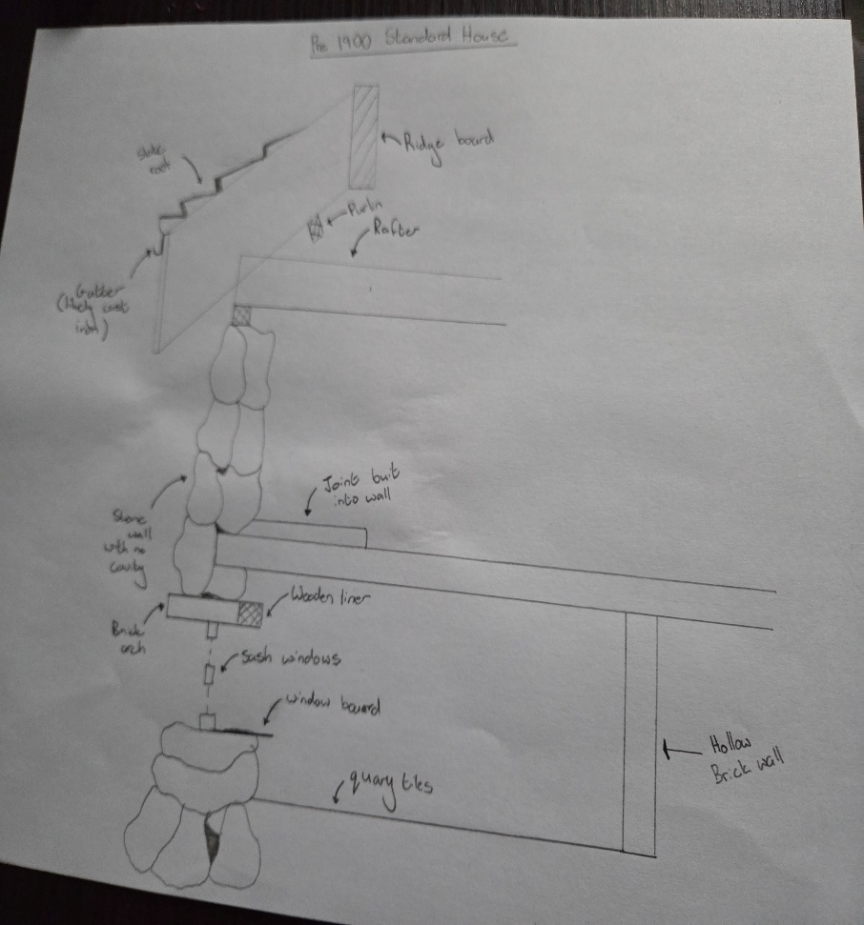

1950s House:

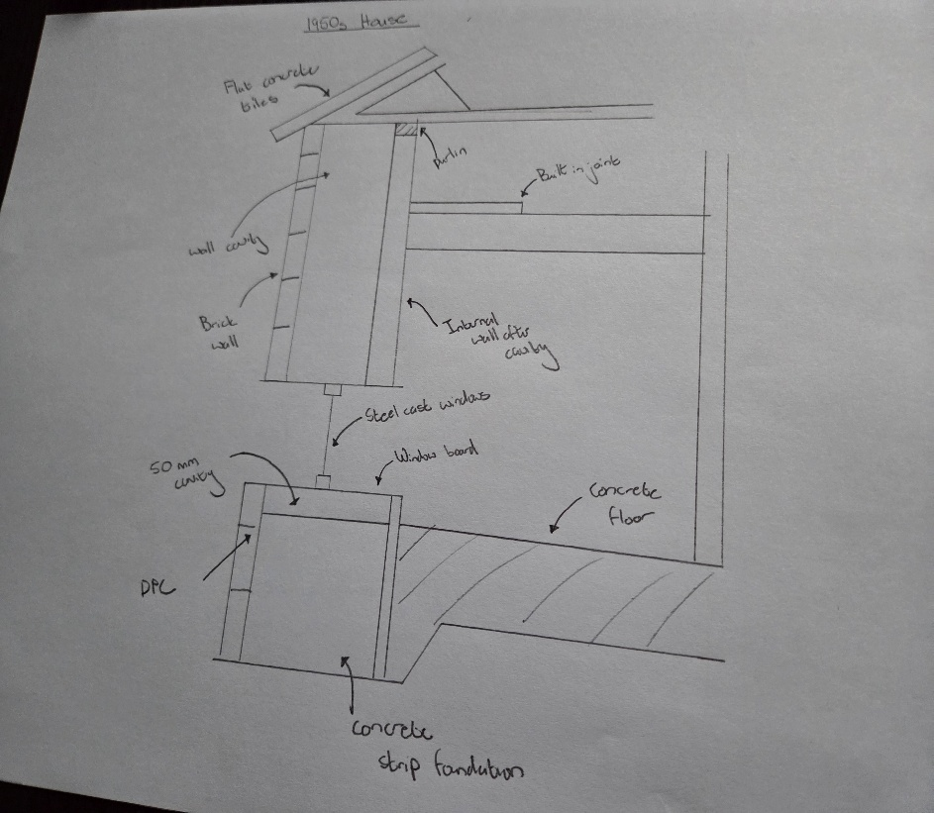

Post 2000s House:

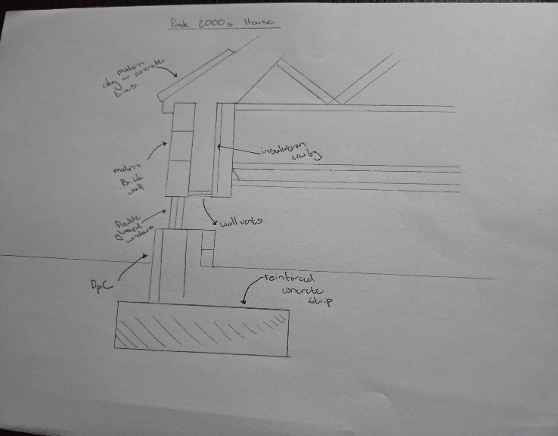

Reference list:
- Museum Wales. (2025). Rhyd-y-Car cottages - Collections Online. [online] Available at: https://museum.wales/collections/historic-buildings/29/Rhyd-y-car-Terrace/.
- Glass, Cylinder. “Cylinder Glass — Definition & Quiz.” Ultimate Lexicon, 21 Dec. 2025, ultimatelexicon.com/definitions/c/cylinder-glass/#google_vignette. Accessed 8 Jan. 2026.

