VISUAL STUDIES 1/LEVEL 4
M4X01602
SOLO
PROFESSOR SUE WILLIAMS
sue.williams@uwtsd.ac.uk
The actual basis of colour is instability. Once you accept that in lieu of something which is stable, which is form, you are dealing with something which is unstable in its basic character, you begin to get a way of dealing with it. (Bridget Riley)


YAYOI KUSAMA

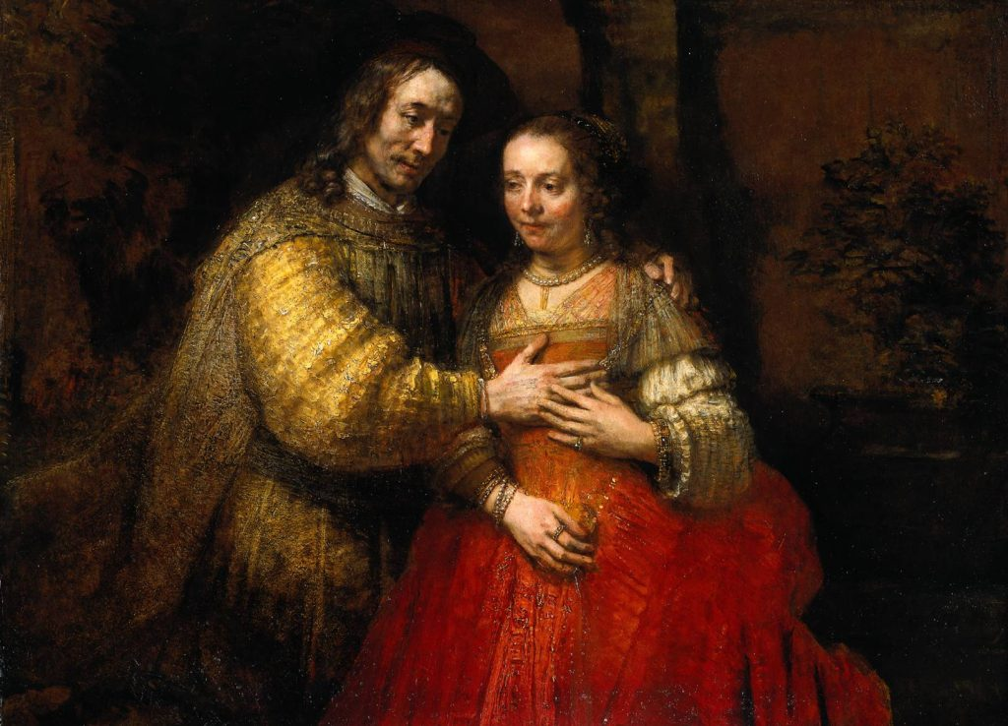
REMBRANDT

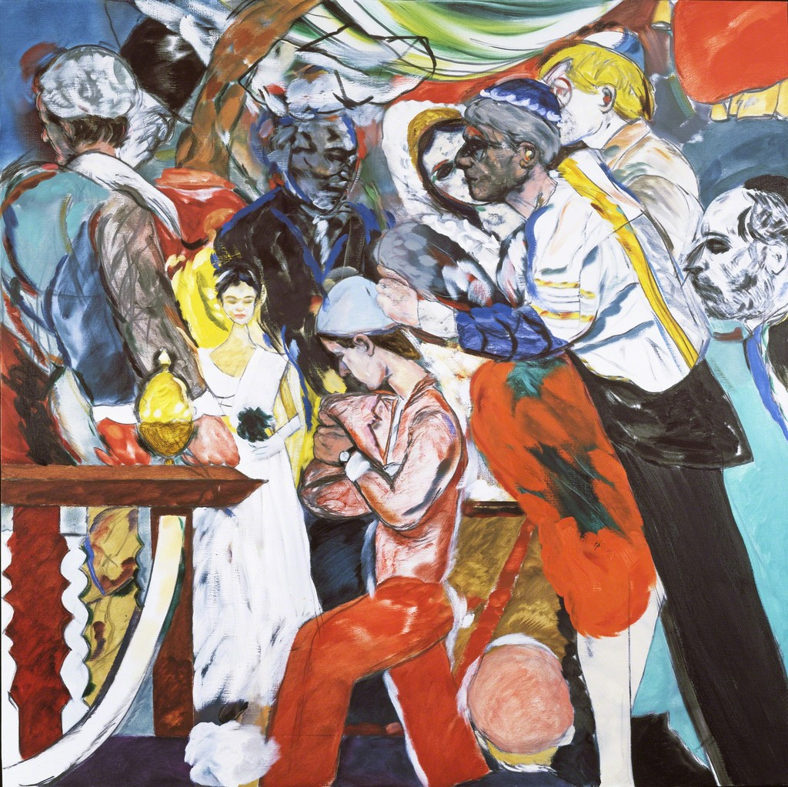
R B KITAJ


KERRY JAMES MARSHALL


BRIDGET RILEY

You have been given a selection of artists who work with paint – not always in the conventional way. Take time to research the above artists and use the blank space below each image to write your research up. Take time this week to explore another 3 artists who work with paint in an unusual manner and 3 artists who work with paint in a conventional way.

