Shelina Begum (1704954)
University of Wales Trinity Saint David
18th December 2020
Module: Strategic Management (BMMB7013) | Tutor: Glenn Behenna
Developing A New Landscape for Customer Care for Primark.
Task: creatively reshaping the organisation’s strategic direction to discover a new way forward for delivering innovative customer care ensuring future resilience and sustainable competitive advantage against a backdrop of a pandemic.

Executive Summary
The report discusses about the strategic management of Primark and what strategic direction could be implemented for the future to avoid situation such as the pandemic. The report contains strategic analyses of Primark by using strategic tools: stakeholder analysis; PESTLE; Porter’s Five Force; Porter’s generic strategies; cultural web; resource-based view of strategy; VRIO; Porter’s value chain; SWOT; TOWS; and SOAR analysis. Thus, the report explains the strategic purpose of Primark and analyses the different strategic aspect within the organisation.

Furthermore, the report identifies the threats and opportunities from the analysis. By using the strategic management tools, it has been identified that Primark does not have an online strategy which their competitors have. Thus, the report contains recommendations for Primark which are to segment further to develop more product lines; capturing market intelligence; developing an online e-commerce; and visual merchandising, as well as the incorporation of advanced technology into respective stores.
Contents
Executive Summary 1
1.0 Introduction 4
1.1 Strategy 4
1.1.1 Strategic Management 5
1.2 Introduction to the organisation – Primark. 5
1.2.1 Background Information 5
2.0 Findings 6
2.1 Strategic Position of Primark 6
2.1.1 Strategic Purpose 6
2.1.1.1 Strategy Statement 6
2.1.1.2 Levels of Strategy 7
2.1.2 Stakeholder Analysis of Primark 7
2.1.3 Macro-Environment – External Analysis 9
2.1.3.1 PESTLE Analysis of Primark 9
2.1.4. Industry Analysis 11
2.1.4.1 Porter’s Five Force Analysis of Primark 11
2.1.4.2 Porter’s Generic Strategies 12
2.1.5 Culture 13
2.1.5.1 Cultural Web Analysis of Primark 13
2.1.5.2 Corporate Social Responsibility (CSR) 14
2.1.5.3 Human Resource Management (HRM) at Primark 14
2.1.5.4 Society for Human Resource Management (SHRM) at Primark 15
2.1.6 Resources and Capabilities -Internal Analysis 15
2.1.6.1 Resource Based View of Strategy (RBV) 15
2.1.6.2 VRIO 16
2.1.6.3 Porter’s Value Chain of Primark 16
2.2 Generating Strategic Options 18
2.2.1 SWOT Analysis of Primark 18
2.2.2 The TOWS Analysis of Primark 19
2.2.3 SOAR Analysis of Primark 20
3.0 Conclusions 21
4.0 Recommendations 22
5.0 Appendices 24
Appendix A – Detailed Background of Primark 24
Primark’s Timeline 25
Appendix B – Definitions of Strategy 26
Appendix C - The Exploring Strategy Framework 26
Appendix D – Primark’s Stakeholders 27
Appendix E – The TOWS Matrix of Primark 28
Appendix F -SWOT Analysis of Primark 29
Reference List 30

1.0 Introduction
The report was requested by the Senior Management on 15th October 2020 to participate in a sudden onset emergency project team. The report is compiled by Shelina Begum and submitted on 18th December 2020. The procedures utilised to research and prepare this report include books, eBooks, journals, articles and websites. The aim of this report is to focus on creatively reshaping the organisation’s strategic direction to discover a new way forward for delivering innovative customer care by ensuring future resilience and sustainable competitive advantage against a backdrop of a pandemic. The report will contain the strategic analysis of the internal and external analyses of the organisation. Furthermore, it will also contain the critical evaluation of the strategic options for more personalised customer care for the organisation. The organisation chosen for this report is Primark.

1.1 Strategy
According to Whittington et al. (2020, p.17), strategy is “the long-term direction of an organisation, formed by choices and actions about its resources and scope, in order to create advantages positions relative to changing environment and stakeholder contexts”. Moreover, strategy involves managing people, relationships and resources which is sometimes referred to as ‘strategic management’. Mckeown (2019, p. 5) stated “strategy is about shaping the future”, it is how individuals achieve the desired end with the resources that are available. Furthermore, a manager lacking a good strategy for an organisation may consider that strategy is irrelevant (Rumelt, 2011).

However, many authors and researchers have defined strategy differently. They have pointed out the vital aspects of strategy. (Please see Appendix B for the definitions from different authors). Chandler (1963) underlined the need for a logical flow from the decisions of goals and objectives to the distribution of resources. Whereas Porter (1996) concentrates on deliberate choices, difference and competition. Drucker (1996) indicated strategy is a theory how a company is going to win. Furthermore, Mintzberg (2007) holds the opinion that the strategy is less secure and utilised the word ‘pattern’ in order to enable the reality that strategies will not always pursue a deliberate choice and logical plan, although strategy can occur in more informal methods. Therefore, strategies signify a set of incremental decisions which simply correspond into an identifiable pattern or ‘strategy’ after a certain time.

1.1.1 Strategic Management
The process which involves or incorporates setting aims and objectives analysing the competitive advantage, identifying the internal organisation and evaluating strategies for ensuring better management process within the organisation is known as strategic management (Lynch, 2018). Strategic management is responsible for developing a new landscape for the business (Barney and Mackey, 2016). Thus, it helps a decision maker in getting equipped with different managerial tools and accordingly anticipating changes and directing the business or organisational activities toward the right direction (Trigeorgis and Reuer, 2017). As a result, strategic management reduces the operational risk of an organisation by helping the organisations in innovating on time and taking action early (Makadok, Burton and Barney, 2018). Thus, strategic management also incorporates evaluating business goals along with organisational vision and objectives set for the future (Hitt and Duane Ireland, 2017).

1.2 Introduction to the organisation – Primark.

1.2.1 Background Information
Primark is an Irish fast fashion retail organisation that was founded by Arthur Ryan in June 1969 (Primark, 2020). The organisation is headquartered in Dublin, Ireland and is a subsidiary of British Food processing ‘Associated British Foods’ (ABF). Primark operates in several business markets (please see Appendix A for the detailed background of Primark). Primark has been able to position itself as one of the marketing fashionable organisation at competitive prices, generating more profits and income for the organisation. Primark is also known for selling its products at competitive prices, thus attracting more customers towards the business. Henceforth the success of the organisation is entirely based on sourcing supply, manufacturing clothes while keeping the designs simple, targeting young customer segments and offering high quality clothes and apparels to the customers associated with Primark’s business (Primark, 2020).

To evaluate Primark’s strategy, the ‘Exploring Strategy Framework’ (please see Appendix C) would be utilised. The framework has three parts, strategic position, strategic choices and strategy in action, which highlights the ‘interconnected nature of strategic issues’ (Whittington et al., 2020).

2.0 Findings

2.1 Strategic Position of Primark
The ‘strategic position’ is concerned with the influence on strategy of the external environment, the company's strategic resources, capabilities, goals and the culture (Whittington et al., 2020).

2.1.1 Strategic Purpose
Strategic purpose is vital for an organisation's existence and success as it provides the vision, mission, goals and objectives to exceptional performance (Kinyuira, 2018). However, by having an unclear purpose which is too grand and ambitious could harm the organisation. For instance, employee’s will not clearly understand what the purpose is, which then will affect the employee’s ability to fulfil the specified purpose (Quain, 2017).

2.1.1.1 Strategy Statement
An organisation having a strategy statement sets the organisation’s long-term strategic direction. According to Collis and Rukstad (2008), all business leaders and managers should be able to summarise their company's strategy with a ‘strategy statement’. Strategy statements are required to have three main topics: the fundamental goals such as mission, vision or objectives that the company is looking for; the scope or domain of the company's actions; and the specific advantages or abilities it possesses to deliver all of the following mentioned.

Primark’s strategy is to supply inexpensive garments that are excellent value for money (ABF Annual Report, 2020). Their aim is to stay up to date with the latest looks at the cheapest price (Primark, 2020). However, when Primark first started their purpose was “pile-them-high, sell-them-cheap” to the customers (McQuillan, 2016). This explains the Primark strategy has changed over the years.

Furthermore, Primark follows three main strategies for its organisational business. These include effective supply chain and rapid turnover; limited or restricted operational cost; and large stores (Hitt and Duane Ireland, 2017). These strategies assist the organisation in staying focused towards their desired or strategic goals and objectives set by the organisation (Primark, 2020). Primark’s niche is low, including affordable costs which allow the organisation to use a cheap production process within the organisation (Barney and Mackey, 2016). In the same way, Primark chooses low rent costs and does not have big advertising budgets. These strategies assist in reducing the operational cost of the organisation in numerous ways (Itani, Goad and Jaramillo, 2019).

2.1.1.2 Levels of Strategy
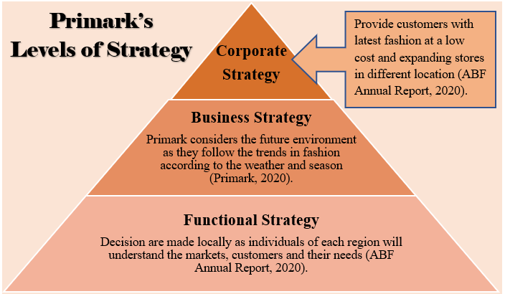
Primark’s corporate level of strategy is to provide customers with the latest fashion at a low cost and expand their stores in different locations. Their purpose is to function in a more sustainable, ethical, effective and safe way (ABF Annual Report, 2020). Primark’s business level of strategy is more dynamic as the company follows with trends in fashion in accordance with the weather. In a dynamic environment, managers take into account the future environment and not only the past. The company utilises structured frameworks to understand the importance of future, such as the views of individuals working lower down in the company (Whittington et al, 2020). The functional level of strategy is operated locally as Primark believes decisions made regionally are more successful as the individuals would understand the markets, customers and their needs (ABF Annual Report, 2020).

2.1.2 Stakeholder Analysis of Primark
Primark is one of the largest retailers of Europe and owns over 384 stores across the globe. As a result, Primark is associated with several stakeholders (internal and external) which allows the organisation to formulate better strategies and stay in profits for longer (Barney and Mackey, 2016). Primark understands that every stakeholder is different, and therefore, it is the responsibility of the organisation to meet the needs and preferences of the stakeholders and keep them satisfied. (please see Appendix F for stakeholders list).

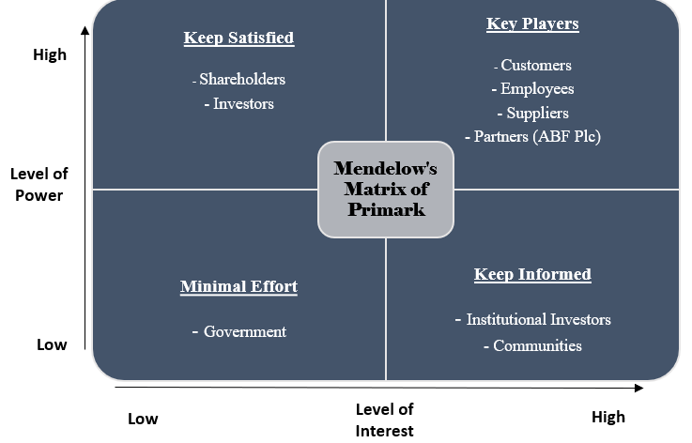

The main key players of stakeholders are:
- Suppliers: they produce goods for Primark for their customers. Primark rely on their suppliers for good quality products, at volume and in time (Barney and Mackey, 2016).
- Customers: they buy Primark’s products. Customers (irrespective of the organisational size) plays a crucial role for an organisation and it becomes crucial for the organisations in satisfying the needs and requirements of the customers. Primark has understood this well and therefore, treats the customers by providing them good customer satisfaction.
- Employee: they are the ‘face’ of the company and they deal directly with the customer.

These three main key stakeholders are important because they have the power to make or break the business. Primark believes that every stakeholder group has their own rights within the organisation, and therefore, it is necessary for Primark in making strong relationships with all their stakeholders for better conduction of organisational business. As a result, the prime objective of Primark is to attain and accordingly hold these stakeholders by offering great products and services, offering good value in terms of choice, safety, cost and environmental impact.

2.1.3 Macro-Environment – External Analysis

2.1.3.1 PESTLE Analysis of Primark
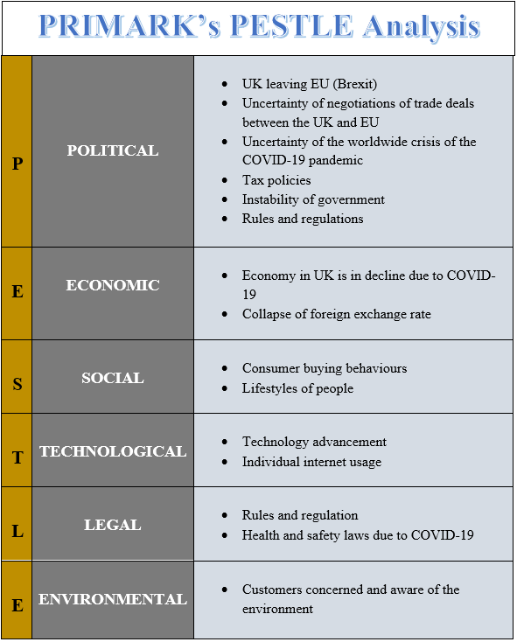
Political: the company has stores around the globe, therefore, they need to follow the rules and regulations to continue in several different economies. Thus, Primark will be impacted when the UK leaves the EU without a trade deal. This is because Primark mainly operate separate supply chains for their stores in the UK, US and Europe which is aligned to the end market (ABF Annual Report, 2020). The major impact currently Primark is facing is the uncertainty of COVID-19 pandemic as the government continuously closes all non-essential sectors and goes into national lockdown.

Economic: According to OECD, the economy in the UK has declined by 11.5% due to the COVID-19 lockdown (BBC News, 2020). During 23rd March 2020 to 15th June 2020, Primark in UK have made no sales due to the lockdown and it has also impacted all stores worldwide. Thus, Primark operates in several nations and therefore, the organisation must keep in mind different jurisdictions resulting in trading across different currencies. Hence, Primark could be highly exposed to considerable financial losses if any of the foreign exchange rates fail (Matovic, 2020).

Social: Primark’s decision of keeping it traditional (brick and mortar stores) could impact the organisation negatively, thus decreasing the potential sales and revenues of the organisation (Wu, 2020). Thus, the demographic changes will impact the consumers buying behaviour. Furthermore, the habits of individuals continue to change towards apparel retail. It happens through fashion changes which fashion concepts get invented (Barrientos, 2019).

Technological: due to technological advancement, the consumer behaviour has evolved and therefore incorporating advanced technology within the organisation could help Primark in reaching out to the customer’s needs and preferences easily and accordingly deliver the same range of products (Wu, 2020). This will ultimately lead to increased profits and sales for the organisation. Information technology is essential via mobile technologies to generate effectiveness. Hence, since 2015, Primark is well-known for fast fashion bulk buying because of technology. On the other hand, Primark is not operating an online transactional service. However, one study revealed that fifty-one percent consumers prefer to shop online rather than in-store (Empathy Broker, 2018). Additionally, a survey conducted by McKinsey & Company revealed that consumer usage of online has risen for unrestricted product groups. Buyers are reporting that they are expecting to lessen high traffic, in person activities such as going to the stores. Due to the social distancing rules, customers have embraced digitally enabled omnichannel fulfilment such as “buy online pickup in-store” which has increased by nearly fifty percent since the pandemic started (Dekhne et al., 2020).

Legal: Primark impacted by COVID-19 pandemic where they must follow the health and safety law to keep customers and employees safe. Thus, Primark could continue working with reliable partners in order to ensure that the organisation offers safe and comfortable working conditions to the employees and is exceptionally well in keeping the stakeholders satisfied and interested towards the organisation.

Environmental: at present, customers have become more concerned and aware of the environment (Wu, 2020). Hence, it is essential that Primark becomes proactive in promoting their Corporate Social Responsibility (CSR) activities as this will help in attracting more customers towards the business.

2.1.4. Industry Analysis

2.1.4.1 Porter’s Five Force Analysis of Primark
Bargaining Power of Suppliers: LOW.
- Low overheads or salary cost depending upon the nation Primark operates (Arriaga, Domingo and Silvente 2017).
- Suppliers of Primark could be easily substituted (however, Primark will encounter loss of efficiency, time and resources while doing the same) (Zhang and Yang, 2017).
- Primark is trying to improve the relationship with suppliers after different scandals encountered by the organisation (Burke, Van Stel and Thurik, 2016).

Bargaining Power of Buyers: MODERATE.
- Based on the responses from some of the loyal customers of Primark it is evident that Primark is capable of offering a guilt free shopping experience to the customer associated with the business (primarily due to the affordable prices of the good quality products) (Zhang and Yang, 2017).
- In addition to this, the good brand image and reputation of Primark across Europe allows the customers associated with the organisation to make informed decision and purchase from Primark.

Competitive Rivalry: HIGH.
- There are numerous retail channels and retailers across the world, creating a huge stress for Primark to handle. Hence, people or customers could easily switch if they feel they are not valued or responded appropriately (Burke, Van Stel and Thurik, 2016).
- Primark is capable of the entertaining loyal customer for the business; however, due to numerous competitors, the customer may switch based on the variety offered by other players (Burke, Van Stel and Thurik, 2016).

Threats of New Entrants: MODERATE.
- The price factor, along with brand loyalty, does not impact the threats to new entrants.
- The sound strategies of the organisation help in maintaining a competitive edge; thus, new entrants could pose no threat to a giant like Primark (Arriaga, Domingo and Silvente, 2017).
- For new entrants, it would be extremely complex to build the same reputation and loyalty for the brand in its initial stages (Kurnianto et al., 2019).

Threats of Substitutes: HIGH.
- Since the customers of Primark do not have an option of buying online, therefore, customers can for instance differ to other players offering the same experience at similar or cheaper rates (Zhang and Yang, 2017).
- Hence customers only have the accessibility to physical stress (Abalkhail, 2019); therefore, sometimes it might be difficult for the customers to visit the stores physically due to geographical complexities and issues (Burke, Van Stel and Thurik, 2016).

2.1.4.2 Porter’s Generic Strategies
Primark is known for using cost leadership and differentiation strategy together. Semuel et al. (2017) stated that by using the differentiation strategy indicates that the business approaches a target market that is not cost sensitive but rather favourable towards the differentiating goods and services that are being offered to them. However, the differentiating strategy is not triggering many advantages to the business. They are rather changing their emphasis in the direction of employing a cost leadership strategy that allows them to decrease the operational costs. Primark is utilising sustainable measures to decrease their existing operational costs and become familiar with the brands operating in the high streets. Thus, the business is embracing renewable energy sources and is attempting to decrease their utilisation level rather than considering other conventional approaches that have been applicable for many years (Primark, 2020).

2.1.5 Culture

2.1.5.1 Cultural Web Analysis of Primark
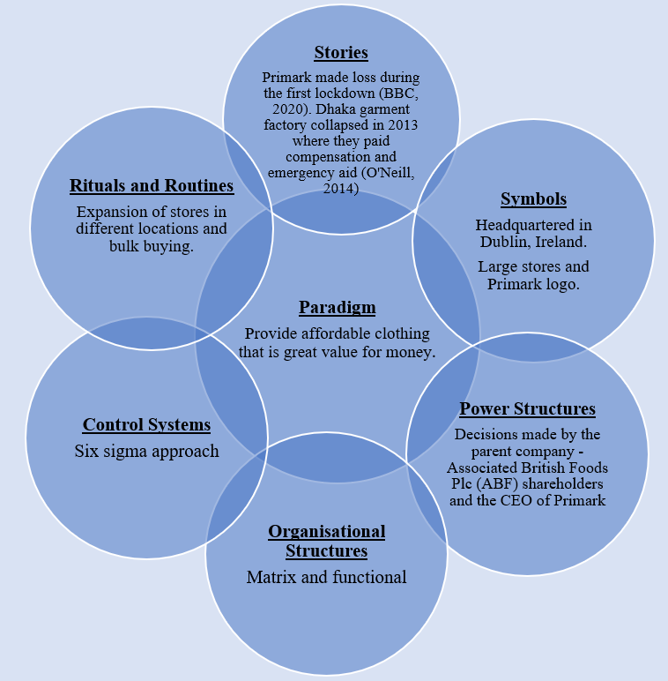
Organisational structure: Primark follows a matrix organisational structure which allows the organisational employees in working similar to functional organisational structure (Lukinaitė and Sondaitė, 2017). Besides, the matrix organisational structure also allows Primark to manage departments that are highly function based within the organisation, assigning different tasks by different managers from Primark (Arriaga, Domingo and Silvente, 2017).

Power structures: Primark operates with the power culture and all the organisational activities and the shares of the organisation are owned by the shareholders of the organisation (Itani, Goad and Jaramillo, 2019). In addition to this, it allows Primark in having full control of the shareholders and not by any other second or a third party of the organisation.

Control systems: the six-sigma approach of Primark allows the organisation to successfully satisfy customers and keep them engaged in the longer run. However, it is essential that Primark concentrates in improving the customer satisfaction level by training the employees appropriately with advanced technologies and cost reduction strategies (Itani, Goad and Jaramillo, 2019). This will also allow Primark in increasing its customer base and manage the control process feasibly.

2.1.5.2 Corporate Social Responsibility (CSR)
Primark cares about the environment and has recently joined United Nation’s Fashion Charter, supporting Charter’s net zero ambition and commitment. In addition to this, Primark has also initiated a range of programs and activities that supports the CSR of the organization, ensuring that the organisational trading meets the ethical standards and values of Primark. Besides, the involvement of Primark in the HER (Health Enables Returns) project also allows the organisation to raise awareness and accordingly deliver education and healthcare to female employers in supplier nations of Primark. This project also focuses on encouragement and mutual help by understanding the local culture of the region in which Primark operates currently.

2.1.5.3 Human Resource Management (HRM) at Primark
Primark considers employees as their most essential asset and therefore, induces several HR activities such as training and development, values and diversity and rewards and benefits of the employees. Hence, the human resource management of Primark is directly associated with the growth of the brand making it important for the business to put different human resource departments at the place for better monitoring and managing organisational operations (keeping the employees happy and satisfied).

2.1.5.4 Society for Human Resource Management (SHRM) at Primark
The prime responsibility of the HR manager at Primark is to perform the evolution of the organisation’s current policies and procedures with proper guidelines. This allows Primark to determine a precise approach with the organisation and develop the business design accordingly. There are typically three types of strategic management tools that Primark uses for ensuring maximised strategy success (Arriaga, Domingo and Silvente, 2017). These include strategic planning within the organisation, strategic development phase within Primark and strategy control tools as well (Itani, Goad and Jaramillo, 2019). These tools allow Primark to manage different aspects of the business strategically and increase the success rate of the organisation addressing every question of the employees effectively.

2.1.6 Resources and Capabilities -Internal Analysis

2.1.6.1 Resource Based View of Strategy (RBV)
Resource Based View (RBV) is a strategic method of analysing and identifying Primark’s strategic advantages that are based on the distinct combination or integration of the organisational skills, capabilities, assets and other intangible assets and resources of the organisation (Barney and Mackey, 2016).

Core competencies: Primark is capable of fast changing the designs based on the needs and preferences of the customers and therefore primarily emphasises on the quality of the products at affordable prices to the customers (Dubey et al., 2019). Primark also has an ownership advantage due to its ability to produce clothes and fashionable materials trending in the market and accordingly reaching to the individual or physical stores offering a competitive edge over other players (Arriaga, Domingo and Silvente, 2017).

Employees: Primark offers employment to any individuals across the globe and considers employees as the most precious and valuable asset for the organisation. In addition to this, the brand reputation is also valuable to Primark offering a better competitive edge to the organisation (Arriaga, Domingo and Silvente, 2017).

Customers: due to the positive image of the brand in the business market, Primark holds a strong position in the market (mainly due to quality, affordable price and designs offered by the organisation) (Popli, Ladkani and Gaur, 2017).

Suppliers: due to the strong strategic suppliers of the organisation, Primark is able to create a better balance between lead time, price and compliance with the Code of Conduct easily (Yu et al., 2018). This allows better sampling within the organisation as Primark majorly concentrates on outsourcing different production units to selected suppliers located in Asia (Arriaga, Domingo and Silvente, 2017).

2.1.6.2 VRIO
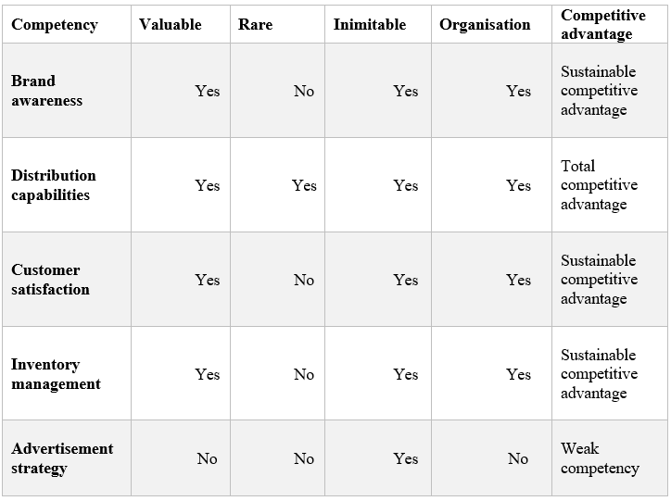

Since distribution systems and computer warehousing are interlinked with each there in order to derive the daily sales and stock information at Primark, it acts as a core competitive advantage for the organisation. Hence, Primark could use these competencies in future for delivering desired results to the customers and ultimately to the business market (Arriaga, Domingo and Silvente, 2017).

2.1.6.3 Porter’s Value Chain of Primark
Primary activities
Inbound logistics: each and every product of Primark is transported to different Primark stores across several nations (Molitor, 2019). These nations include the UK, Europe, Ireland and several others (Barney and Mackey, 2016). The effective supply chain of Primark helps the organisation in bringing together different emerging and new nations, thus benefiting the organisation to a great extent (Arriaga, Domingo and Silvente, 2017). Some of the emerging nations include India, China, Turkey, Bangladesh and different others as well.

Service: Primark offers a limited level of sales to the customers associated with its business hence, sometimes, this is the prime reason of lowered sales number of the organisation (primarily in the physical stores) (Arriaga, Domingo and Silvente, 2017). This requires to be improved by formulating better strategies in order to acquire new customer segments for the organisation (Barney and Mackey, 2016).

Outbound logistics: Primark has not introduced online retailing for the customers associated with the business. Hence, all the sales are conducted within the 374 stores (physical) introduced by the organisation (Arriaga, Domingo and Silvente, 2017). This allows better sales sometimes; however, many of the people fail to avail full service from the same due to complexities and unavailability of proper channels to reach the respective stores of Primark (Barney and Mackey, 2016). Similarly, transporting of the products are done by the customers themselves after sales or purchasing of the products (Xydia, 2019).

Marketing and sales: the prime target customer of Primark is the people who are fashion conscious and are wanting value for money (value proposition). The organisation involves in no commercials, no advertisements and no magazines as well (Arriaga, Domingo and Silvente, 2017). This sometimes creates a little havoc as the organisation fails to reach out to a maximum number of customers decreasing the sales and revenues of the organisation (Barney and Mackey, 2016).

Operations: Primark operates in over thirteen nations of the globe and has 384 stores to access (ABF Annual Report, 2020).

Support activities
Procurement: Primark believes in sourcing highest quality products from different nations carried out in strict accordance with the Primark Codes of Conduct (which primarily incorporates, United Nations Charter, article 55 and others) (Xydia, 2019).

Technological development: Primark has not yet introduced online retailing; hence, it is essential that Primark constantly reinforces its existing business models across different social media sites as its one of the prime marketing strategies (Arriaga, Domingo and Silvente, 2017).

HR Management: Primark has a partnership with SAVE providing support to the workers and their according communities in different parts of the world (Duff, 2017). In addition to this, Primark believes in introducing a high level of HRM practices to keep the human resources intact.

Infrastructure Firm: Primark usually has immense stress which induces and encourages volume shopping for the customers, thus, making the business of Primark profitable (Duff, 2017).

2.2 Generating Strategic Options

2.2.1 SWOT Analysis of Primark
Strengths:
- Large involvement with organisations and business partners to maintain as well as develop the ethical agenda of the organisation effectively (Newman et al., 2017).
- Creation of multi flagship stores along with space (freehold) allows Primark in growing and developing without an extra rental expense for the organisation.
- Primark generally has largest and open stores creating a positive image in the minds of the customers (by giving fresh look and ambience to the store).
- Primark somehow understands the segmentation of the markets and associated customers effectively, which allows the organisation in establishing and launching a variety of products in comparison to other players in the business market.
- Primark relies on positive word of mouth as its core advertising; thus, this gives an opportunity to make the customers feel special and valued.

Weaknesses:
- Poor or lack of customer service could degrade the brand image and lead to negative advertisements for the organisation.
- Low price rates may sometimes lead the customer to think that the organisation compromises with the quality of the products.
- Segmentation is somehow questionable as the organisation ignores potential online markets.

Opportunities:
- Creation of a transactional website would allow Primark in staying informed about the latest trends in the market.
- Emerging nations (Alabdullah et al., 2018).
- Use of in store and on receipt promotions could help Primark in promoting the organisation’s ethical standpoints and commitment towards different CSR activities.
- Incorporating more features to the physical stores will allow Primark in capturing the interest of the customers and keep them engaged with the organisation for a longer period of time.

Threats:
- Stiff competition from giant retailers such as George and F&F. Besides, H&M is offering best quality products at a similar and affordable price to the customers (Milton, 2018).
- Changing taste and preferences, along with changing the buying habits of the customers, could impact the segmentation and targeting of Primark directly (Hanke, 2019).
- Lack of advanced technology within the store could result in lagging behind other players.
- A limited number of stores and limited accessibility could result in failure in attracting new customers for the organisation easily. (Please see Appendix F for Primark’s SWOT Analysis).

2.2.2 The TOWS Analysis of Primark
SO strategies: Being one of the most recognised brands and a retail market leader, Primark could easily take advantage of this major strength by allowing different customers to go for different discount stores as no other retailer does the same. When a nation undergoes an economic downturn, it encounters reduced disposable income of the customers. Hence, Primark could retain customer loyalty by offering fashionable products at affordable prices.

WO strategies: There is a huge potential for retail organisations to increase their sales volume and profits. However, it is essential that Primark sets a clear mission statement as it will help the organisation in doing the same effectively (Walden, 2019). Since the majority of the buying patterns of customers are similar across different regions of the world, therefore, updating the customers about their new policies and products (both online and offline) could help Primark in understanding the buying pattern and meet their preferences (Keough and Kazimoto, 2018).

ST strategies: Due to the strong image of the brand, Primark encounters intense competition. However, this could be avoided by offering differentiated products at affordable prices and guarantee satisfaction among the customers (Ojala, 2016).

WT strategies: In order to avoid stiff competition, Primark must concentrate on its existing product line and invest more in advertising strategies to keep the competitors in pressure (Nallusamy, 2016). In addition to this, Primark must concentrate on adapting the culture of the customers in order to establish the brand in the emerging Asian markets (Nallusamy and Ahamed, 2017). (Please see Appendix E for TOWS Matrix).

2.2.3 SOAR Analysis of Primark
STRENGTHS  - Flexible organisational teams  - Customer focused organisation  - Positive community standing (Lemon and Verhoef, 2016) | OPPORTUNITIES  - Emerging markets  - Adoption of advanced technologies  - Integrating CRM of the organisation to allow better query solving.
ASPIRATIONS  - Improve customer service and satisfaction.  - Link queries to different product development cycles (La Rocca et al. 2016)  - Understanding the needs and preferences of the customers in a better way (Barnes et al. 2020). | RESULTS  - Increased sales and revenues (Itani, Goad and Jaramillo 2019)  - Enhanced customer experience

3.0 Conclusions
From the finding it can be concluded that strategic management helps a decision maker in getting equipped with different managerial tools and accordingly anticipating changes and directing the business or organisational activities toward the right direction or path. As a result, strategic management reduces the operational risk of an organisation by helping the organisations in innovating (on time) and take an action early

3.1 Strategic Choice:
Primark lacks a transactional website which gives customers the option of buying Primark products online directly. In addition to this, the sales within the Primark stores could possibly contribute to the increased sales of the product, better market share and enhanced capitalisation at the same time. The database collected by Primark would also help in promoting future products and services according to the interest and taste of the customers to the physical stores.

Primark is capable of fast changing the designs based on the needs and preferences of the customers and therefore primarily emphasises on the quality of the products at affordable prices to the customers. Primark also has an ownership advantage due to its ability to produce clothes and fashionable materials trending in the market and accordingly reaching to individual or physical stores offering a competitive edge over other players and is known for selling fashionable products at affordable rates to the customers. Therefore, Primark concentrates on making a deep positive relationship with all its suppliers and makes improvements only after the approval from suppliers. However, there are some serious issues that Primark encounters in terms of reaching out to the maximum number of customers as it lacks appropriate online strategy. The recommendations made for Primark could help the organisation in overcoming different issues encountered and make Primark’s business more profitable, thus making it a business leader in the retail industry.

4.0 Recommendations
Based on the strategic analysis, considering different marketing and strategic aspect of Primark, following recommendations could be implemented which could contribute to the longevity of growth for the organisation:

  - Segmenting further in order to develop more product lines for the organisation: Primark is known for understanding and identifying its target segment appropriately and this has accordingly helped Primark in introducing new product line that helps Primark in keeping with the lifestyle and tastes of the customers associated with the business (Rey et al., 2019). However, if Primark segments further, it will allow the organisation to explore and exploit different opportunities within the business markets and act as an additional profit and contribution to the organisation (Arriaga, Domingo and Silvente, 2017).

  - Capturing market intelligence:
Market intelligence will help Primark in continuously collaborating and gathering consumer data based on customer demographics, attitude, buying behaviour, taste and preferences and several others which could inform the future marketing strategies of Primark (Berg, Branka and Kismihók, 2018). The database collected by Primark would also help in promoting future products and services according to the interest and taste of the customers to the physical stores. This process is generally cost effective, and Primark could benefit hugely with the help of several data collection methods applied to the customers visiting the physical stores of Primark (Paajanen, Valkokari and Aminoff, 2017).

  - Developing an online e-commerce website:
Primark lacks a transactional website that gives customers the option of buying Primark products online directly (Arriaga, Domingo and Silvente, 2017). In addition to this, the sales within the Primark stores could possibly contribute to the increased sales of the product, better market share and enhanced capitalisation at the same time (Faraoni et al., 2019). This ability of organisations to have several buying options for the customers have taken over the typical style of purchasing products, thus making it necessary for different retailers to develop an online or digital strategy for the organisation (Arriaga, Domingo and Silvente, 2017). Hence, it is recommended that Primark invests in e-commerce websites in order to drive better sales and profits for the organisation in future (Ribadu and Rahman, 2019). This will also allow Primark to get a wider market reach and make space for new items within the physical stores (Arriaga, Domingo and Silvente, 2017).

  - Visual merchandising, as well as the incorporation of advanced technology into respective stores:
Experience in general, holds a better and remarkable encounter within the retail stores (Agila and Arumugam, 2018). This is primarily due to the communication and socialisation of the organisation. Hence, it is important that customers of Primark are highly motivated by the shopping background offered by Primark rather than only cheap pricing at the store (Arriaga, Domingo and Silvente, 2017). This is because the uniqueness of the store could have an impact on the buying behaviour of customers in several ways and act in a positive direction for Primark (Liu, Kim and Hong, 2018). Besides, the decision making sometimes becomes easy, and customers could easily and rapidly get to a conclusion that is mainly associated with the product purchase (Arriaga, Domingo and Silvente, 2017).

5.0 Appendices

Appendix A – Detailed Background of Primark
Native name of Primark: Penneys
Industry: Retail (Physical Brick and Mortar only)
Type: Subsidiary
Parent Company: Associated British Foods (ABF)
Founded: By Arthur Ryan on 13 June 1969
Headquartered: Dublin, Ireland
Number of Stores: 384 (ABF Annual Report, 2020)
Number of Countries stores operating: 13 countries (Ireland, Germany, Spain, the Netherlands, Portugal, Belgium, United Kingdom (UK), Austria, France, Italy, Slovenia, Poland and United States (US)) (Primark, 2020).
Number of Employees: 75,000 (ABF Annual Report, 2020)
Products sold: Women’s; Men’s; Kids; Home; Health and Beauty; and Gifts
CEO (key people): Paul Marchand
Competitors: Mark and Spencer; Next; H&M; and New Look (Hinsliff, 2019).
Financial Details:
 | Year Ending 2019 | Year Ending 2020
Revenue | £7,792 million | £5,895 million
Adjusted Operating Profit | £913 million | £362 million
(ABF Annual Report, 2020)
Mission: “Amazing Fashion at Amazing Prices” (Primark, 2020).
Values:
- Acting with integrity
- Respecting everyone’s dignity
- Progressing through collaboration
- Pursuing with rigour (ABF Annual Report, 2020).

Historical Development of Primark
- In 1969, The first store was inaugurated by Arthur Ryan in Dublin, Ireland in the name of ‘Penneys’ on behalf of the Weston family (Finn, 2015).

- In 1973, the first UK store opened in the name of ‘Penneys’. Due to the American retailer JC Penney who already had the name registered in the UK, the name had to be changed. Therefore, the name Primark was introduced. The stores in Ireland operates in the name of Penneys and all the other stores in the UK, Europe and America operate in the name of Primark (Primark, 2020).

- From 2005 to 2009, Retail outlets from other franchises such as Woolworths, C&A and Littlewoods have been bought over the past several years (Shawcross, 2014).

The below timeline show’s the development of stores over the years.

Primark’s Timeline
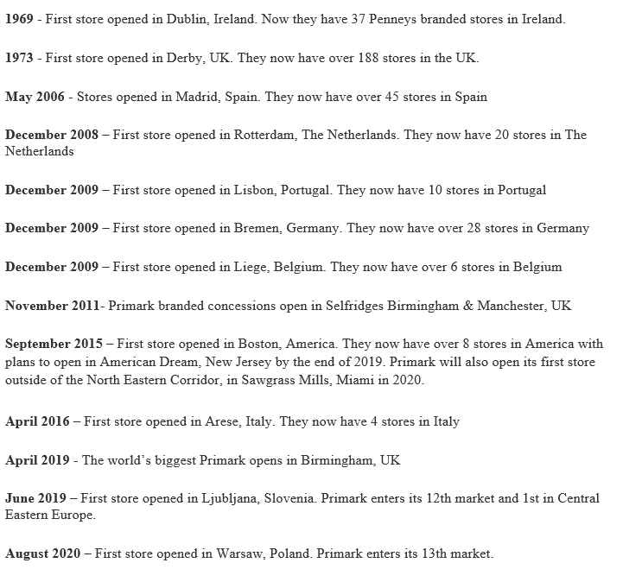
(Primark, 2020)

Appendix B – Definitions of Strategy

Appendix C - The Exploring Strategy Framework
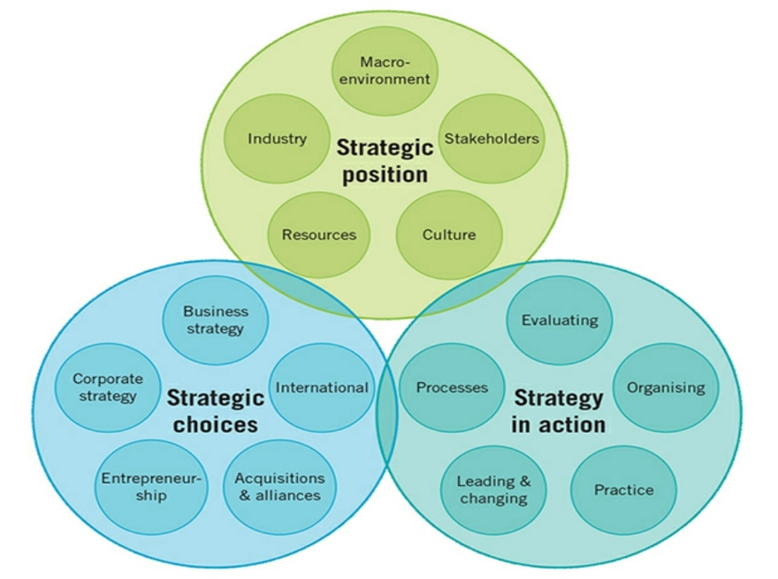
The Exploring Strategy Framework (Whittington et al., 2020)

Appendix D – Primark’s Stakeholders

- Government: these are the nations in which factories and stores are located.
- Trade unions: these are the bodies which represent the workers of the organization.
- Non-governmental organisations and institutions: this stakeholder group is responsible for providing support and help to the issues encountered by the employees within the organisation (Barney and Mackey, 2016).
- Shareholders: these are the prime investors of Primark
- Communities: this stakeholder group is also responsible for providing support and help to the organisation.
- Suppliers: these are third party and factory producing goods of Primark. Primark is one of the most popular organisations and is known for selling fashionable products at affordable rates to the customers (Barney and Mackey, 2016). Therefore, Primark concentrates on making a deep positive relationship with all its suppliers and makes improvements only after the approval from suppliers.
- Customers: these groups of stakeholders are responsible for knowing that the products manufactured by the organisation are ethical or not. Customers (irrespective of the organisational size) plays a crucial role for an organisation and it becomes crucial for the organisations in satisfying the needs and requirements of the customers. Primark has understood this well and therefore, treats the customers by providing them good customer satisfaction.
- Employee: employees are the main players for the organisation. employees are an essential stakeholder group of Primark and Primark provides employment to over 70000 individuals across the globe (Xydia, 2019). As employees are the main stakeholders of Primark, thus employees of Primark are highly influenced and affected by how the organisation treats their employees.

Appendix E – The TOWS Matrix of Primark
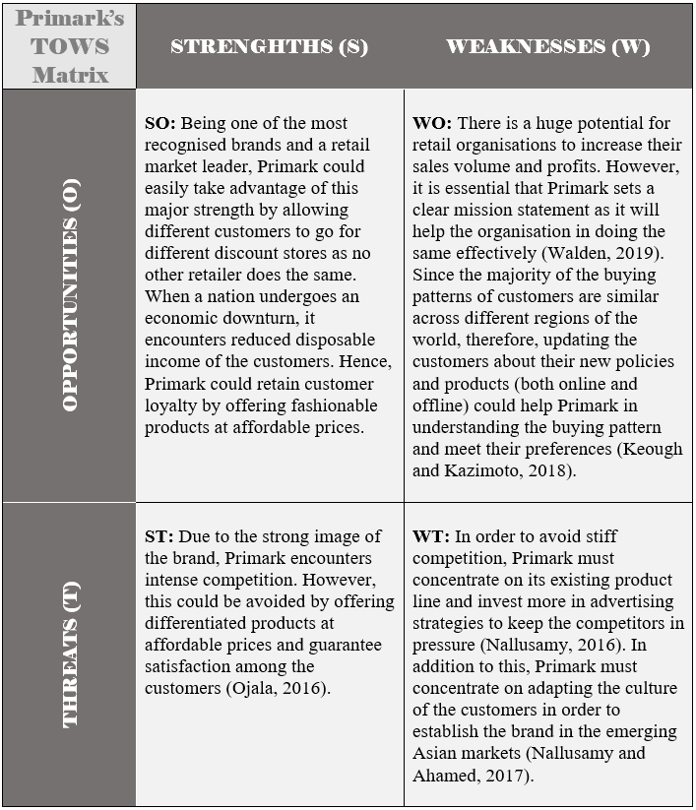

STRENGTHS | WEAKNESSES
- Large involvement with organisations and business partners.  - Creation of multi flagship stores along with space (freehold) allows Primark in growing and developing without an extra rental expense.  - Large and open stores.  - Strong understanding of segmentation of the market and customers.  - Strong advertising via word of mouth | - Poor or lack of customer service could degrade the brand image and lead to negative advertisements.  - Low price rates may sometimes lead the customer to think that the organisation compromises with the quality of the products.  - Segmentation is somehow questionable as the organisation ignores potential online markets.  PRIMARK’s  SWOT ANALYSIS
OPPORTUNITIES | THREATS
- Creation of a transactional website.  - Emerging nations  - Use of in store and on receipt promotions could help Primark in promoting the organisation’s ethical standpoints and commitment towards different CSR activities.  - Incorporating more features to the physical stores will allow Primark in capturing the interest of the customers and keep them engaged with the organisation for a longer period. | - Stiff competition from giant retailers such as George and F&F. Besides, H&M is offering best quality products at a similar and affordable price to the customers (Milton, 2018).  - Changing taste and preferences, along with changing the buying habits of the customers, could impact the segmentation and targeting of Primark directly (Hanke, 2019).  - Lack of advanced technology within the store could result in lagging behind other players.  - A limited number of stores and limited accessibility could result in failure in attracting new customers.

Appendix F -SWOT Analysis of Primark

Reference List
Abalkhail, T.S. (2019). ‘Entry and Expansion Strategies for Burberry in Oman by Applying Porter's Five Forces Model’. Indian Journal of Marketing, 49(1), 25-35. DOI: 10.17010/ijom/2019/v49/i1/140603.

ABF Annual Report (2020). Associated British Foods Plc – Annual Reports and Accounts 2020. [PDF] available: https://www.abf.co.uk/documents/pdfs/2020/ar2020/ar2020.pdf [accessed on 15.11.2020].

Agila, D.G. and Arumugam, D. (2018). ‘A Study On Effectiveness Of Promotional Strategies At Prozone Mall With Reference To Visual Merchandising’. International Journal of Innovations in Scientific and Engineering Research, 5(6), 47-56. [PDF] available at: http://www.ijiser.com/paper/2018/vol5issue6/Jun2018p102.pdf

Alabdullah, T.T.Y., Nor, M.I., Ahmed, E.R. and Yahya, S. (2018). ‘The determination of firm performance in emerging nations: Do board size and firm size matter’. International Academic Journal of Accounting and Financial Management, 5(3), 57-66. [PDF] available at: https://iaiest.com/data-cms/articles/20191104091652amIAJAFM1810017.pdf

Alexander, R., Murray, D. and Thompson, N. (2017). ‘Cross-cultural web usability model’. In International Conference on Web Information Systems Engineering (75-89). Springer, Cham. [PDF] available at: http://www.nikthompson.com/PDF/Alexander-Thompson-2017-Cross-CulturalWebUsabilityModel.pdf

Aririguzoh, S.A., Mogaji, E. and Odiboh, O.O. (2019). ‘The effect of celebrity endorsements on consumers' buying behavior in South West Nigeria’. In Exploring the dynamics of consumerism in developing nations (176-194). IGI Global. [PDF] available at: http://eprints.covenantuniversity.edu.ng/12323/1/The-Effect-of-Celebrity-Endorsements-on-Consumers%27-Buying-Behavior-in-South-West-Nigeria.pdf

Arriaga, J.L.D.O., Domingo, D.A. and Silvente, V.B. (2017). Facebook in the low-cost fashion sector: the case of Primark. Journal of Fashion Marketing and Management: An International Journal. DOI:10.1108/JFMM-08-2016-0069.

Barnes, D.C., Mesmer-Magnus, J., Krallman, A., Scribner, L.L. and Guidice, R.M. (2020). ‘Customer delight during a crisis: understanding delight through the lens of transformative service research’. Journal of Service Management. DOI: https://doi.org/10.1108/JOSM-05-2020-0146

Barney, J.B. and Mackey, A. (2016). ‘Text and metatext in the resource‐based view’. Human Resource Management Journal, 26(4), 369-378. DOI: https://doi.org/10.1111/1748-8583.12123.
BBC News (2020), Coronavirus: Evening update as PM announces further easing and economists voice recession fears. BBC News [online] available at: https://www.bbc.co.uk/news/amp/uk-52995405 [accessed on 24.11.2020].

Berg, A.M., Branka, J. and Kismihók, G. (2018). ‘Combining learning analytics with job market intelligence to support learning at the workplace’. In Digital Workplace Learning (129-148). Springer, Cham. Available at: https://link.springer.com/chapter/10.1007/978-3-319-46215-8_8 [accessed on 20.11.2020].

Burke, A., Van Stel, A. and Thurik, R. (2016). ‘Testing the Validity of Blue Ocean Strategy versus Competitive Strategy: An Analysis of the Retail Industry’. International Review of Entrepreneurship, 14(2), 123-146. [PDF] available at: https://tinyurl.com/yxdm5jja.pdf [accessed on 19.11.2020].

Collis, D. J. and Rukstad, M. G. (2008) ‘Can You Say What Your Strategy Is?’, Harvard Business Review, 86(4), 82–90. Available at: https://search.ebscohost.com/login.aspx?direct=true&db=bth&AN=31372942&site=ehost-live [accessed on 04.11.2020].

Dekhne, A., Gupta, S., Joglekar, A. and Kohli, S. (2020). How retail can adapt supply chains to win in the next normal. McKinsey & Company [online] available at: https://www.mckinsey.com/business-functions/operations/our-insights/how-retail-can-adapt-supply-chains-to-win-in-the-next-normal [accessed on 28.11.2020].

Dubey, R., Gunasekaran, A., Childe, S.J., Blome, C. and Papadopoulos, T. (2019). ‘Big data and predictive analytics and manufacturing performance: integrating institutional theory, resource‐based view and big data culture’. British Journal of Management, 30(2), 341-361. DOI: https://doi.org/10.1111/1467-8551.12355

Duff, K. (2017). An investigation into how the Primark brand use social media to influence the buying behaviour of Irish female customers (Doctoral dissertation, Dublin, National College of Ireland). [PDF] available at: http://norma.ncirl.ie/2916/1/karlduff.pdf [accessed on 20.11.2020].

Faraoni, M., Rialti, R., Zollo, L. and Pellicelli, A.C. (2019). ‘Exploring e-loyalty antecedents in B2C e-commerce’. British Food Journal, 121(2), 574-589. DOI: 10.1108/BFJ-04-2018-0216.

Finn, C. (2015). A household Irish name built from humble beginnings: The Penneys story. Thejournal.ie [online] available at: http://jrnl.ie/1957209 [accessed on 22.11.20].

Hanke, A. (2019). ‘Stiff competition’. Books+ Publishing, 99(2), p.10. [PDF] available at: https://search.informit.com.au/documentSummary;dn=713424908350548;res=IELLCC;type=pdf

Hitt, M. and Duane Ireland, R. (2017). ‘The intersection of entrepreneurship and strategic management research’. The Blackwell handbook of entrepreneurship, 45-63. DOI: https://doi.org/10.1002/9781405164214.ch3.

Itani, O.S., Goad, E.A. and Jaramillo, F. (2019). ‘Building customer relationships while achieving sales performance results: Is listening the holy grail of sales?’ Journal of Business Research, 102, 120-130. DOI: https://doi.org/10.1016/j.jbusres.2019.04.048.

Keough, R. and Kazimoto, P. (2018). Managing Organizational Structure for University Advancement: An Assessment at Asia-Pacific International University’. In Abstract Proceedings International Scholars Conference, 6(1), 186-186. DOI: https://doi.org/10.35974/isc.v6i1.1257.

Kinyuira, D.K. (2018). ‘INFLUENCE OF STRATEGIC PURPOSE ON SUSTAINABLE PERFORMANCE OF DEPOSIT TAKING SAVINGS AND CREDIT COOPERATIVES IN KENYA’. Journal of Strategy and Performance Management, 6(3), 87-101. Available at:
https://www-proquest-com.ezproxy.uwtsd.ac.uk/docview/2132563318?accountid=130472 [accessed on 04.11.2020].

Kurnianto, A.M., Syah, T.Y.R., Pusaka, S. and Ramdhani, D. (2019). ‘Marketing Strategy on the Project Planning of Retail Business for Garage Shop’. International Journal of Multicultural and Multireligious Understanding, 6(1), 217-228. DOI: http://dx.doi.org/10.18415/ijmmu.v6i1.513

La Rocca, A., Moscatelli, P., Perna, A. and Snehota, I. (2016). ‘Customer involvement in new product development in B2B: The role of sales’. Industrial Marketing Management, 58, 45-57. DOI: https://doi.org/10.1016/j.indmarman.2016.05.014.

Lemon, K.N. and Verhoef, P.C. (2016). ‘Understanding customer experience throughout the customer journey’. Journal of marketing, 80(6), 69-96. [PDF] available at: http://phavi.umcs.pl/at/attachments/2017/0321/083210-2016-customer-journej-verhoef.pdf

Liu, X., Kim, C.S. and Hong, K.S. (2018). ‘An fNIRS-based investigation of visual merchandising displays for fashion stores’. Plos one, 13(12). DOI: https://doi.org/10.1371/journal.pone.0208843.

Lukinaitė, E. and Sondaitė, J. (2017). ‘Mindset of employees working in a matrix organizational structure’. Business: Theory and Practice, 18, 144-151.

Lynch, R. (2018). Strategic management. 8th ed. Harlow: Pearson.

Makadok, R., Burton, R. and Barney, J. (2018). ‘A practical guide for making theory contributions in strategic management’. Strategic Management Journal, 39(6), 1530-1545. DOI: https://doi.org/10.1002/smj.2789.

Matovic, I.M. (2020). ‘PESTEL Analysis of External Environment as a Success Factor of Startup Business’. ConScienS, 96. DOI: 10.5281/zenodo. 4058794.

Mckeown, M. (2019). The Strategy Book: How to think and act strategically to deliver outstanding results. 3rd Ed. Harlow: Pearson.

McQuillan, D. (2016). Thanks, Penneys. The rise and rise of Primark. The Irish Times [online] available at: https://ww.irishtimes.com/life-and-style/fashion/thanks-penneys-the-rise-and-rise-of-primark-1.2602124 [accessed on 15.11.2020].

Milton, G.W. (2018). ‘Stiff competition’. Nature, 564, E1. DOI: https://doi.org/10.1038/s41586-018-0724-8

Molitor, M. (2019). ‘The Effect of Corporate Scandals on Customer Loyalty-A Case Study on Primark’ (Bachelor's thesis, University of Twente). [PDF] available at: http://essay.utwente.nl/78555/2/Molitor_BA_BMS.pdf

Morris, J.P. (2020). ‘Is this the culture of academies? Utilising the cultural web to investigate the organisational culture of an academy case study’. Educational Management Administration & Leadership, 48(1), 164-185. DOI: https://doi.org/10.1177/1741143218788580

Nallusamy, S. and Ahamed, A. (2017). ‘Implementation of Lean Tools in an Automotive Industry for Productivity Enhancement - A Case Study’. International Journal of Engineering Research in Africa, 29, 175–185. DOI: https://doi.org/10.4028/www.scientific.net/jera.29.175

Nallusamy, S. (2016). ‘Productivity Enhancement in a Small Scale Manufacturing Unit through Proposed Line Balancing and Cellular Layout’. International Journal of Performability Engineering, 12(6), 523-534. Available at: http://www.ijpe-online.com/EN/Y2016/V12/I6/523 [accessed on 19.11.2020].

Newman, A., Round, H., Bhattacharya, S. and Roy, A. (2017). ‘Ethical climates in organizations: A review and research agenda’. Business Ethics Quarterly, 27(4), 475-512. DOI: https://doi.org/10.1017/beq.2017.23.

Ojala, A. (2016). ‘Adjusting software revenue and pricing strategies in the era of cloud computing’. Journal of Systems and Software, 122, 40-51. [PDF] available at: https://jyx.jyu.fi/bitstream/handle/123456789/51115/3/Adjusting-software-Ojala-pre-print.pdf [accessed on 19.11.2020].

O’Neill, L. (2014). Why Penneys is no longer our little secret. Irish Examiner [online] available at: https://www.irishexaminer.com/lifestyle/arid-20255533.html [accessed on 28.11.2020].

Paajanen, S., Valkokari, K and Aminoff, A. (2017) ‘The opportunities of big data analytics in supply market intelligence’. In H Afsarmanesh, LM Camarinha-Matos & R Fornasiero (eds), IFIP Advances in Information and Communication Technology. Springer, IFIP Advances in Information and Communication Technology, 506, 194-205. DOI: https://doi.org/10.1007/978-3-319-65151-4_19

Perrault, E.K. and Clark, S.K. (2017). ‘Sustainability in the University Student's Mind: Are University Endorsements, Financial Support, and Programs Making a Difference?’ Journal of Geoscience Education, 65(2), 194-202. DOI: https://doi.org/10.5408/16-156.1.

Popli, M., Ladkani, R.M. and Gaur, A.S. (2017). ‘Business group affiliation and post-acquisition performance: An extended resource-based view’. Journal of Business Research, 81, 21-30. DOI: https://doi.org/10.1016/j.jbusres.2017.09.043.

Primark (2020). About Us. [online] available at: https://www.primark.com/en/aboutus [accessed on 03.11.2020].

Quain, S. (2017). What are the advantages & disadvantage of using mission statements? BizFluent [online] available at: https://bizfluent.com/info-12016817-advantages-disadvantages-using-mission-statements.html [accessed on 15.11.2020].

Rey, G.D., Beege, M., Nebel, S., Wirzberger, M., Schmitt, T.H. and Schneider, S. (2019). A meta-analysis of the segmenting effect. Educational Psychology Review, 31, 389-419. DOI: https://doi.org/10.1007/s10648-018-9456-4.

Ribadu, M.B. and Rahman, W.N.W.A. (2019). ‘An integrated approach towards Sharia compliance E-commerce trust’. Applied computing and informatics, 15(1), 1-6. DOI: https://doi.org/10.1016/j.aci.2017.09.002.

Rumelt, R. (2011). Good Strategy/Bad Strategy: The difference and why it matters. London: Profile Books.

Shawcross, J. (2014). The rise and rise of Primark. Aol. [online] available at: https://www.aol.co.uk/2014/03/23/the-rise-and-rise-of-primark/ [accessed on 22.11.20].

Trigeorgis, L. and Reuer, J.J. (2016). ‘Real options theory in strategic management’. Strategic Management Journal, 38(1), 42-63. DOI: https://doi.org/10.1002/smj.2593.

Walden, M. (2019). ‘The Project Manager's Perspective on Performance Management Implications in a Matrix Organizational Structure: A Case Study’ (Doctoral dissertation, Northcentral University). Available at: https://search.proquest.com/openview/05aed92eda42ee42d339abeb8c289222/1?pq-origsite=gscholar&cbl=18750&diss=y [accessed on 20.11.2020].

Whittington, R., Regner, P., Duncan, A., Johnson, G. and Scholes, K. (2020). Exploring Strategy. 12th Ed. Harlow: Pearson.

Wu, Y. (2020). ‘The Marketing Strategies of IKEA in China Using Tools of PESTEL, Five Forces Model and SWOT Analysis’. In International Academic Conference on Frontiers in Social Sciences and Management Innovation (IAFSM 2019), (348-355). Atlantis Press. DOI: https://doi.org/10.2991/assehr.k.200207.054.

Xydia, N. (2019). Sustainably-conscious consumers’ perceptions, attitudes and behaviours towards the fast fashion industry: A Case of Primark. [PDF] available at: https://tinyurl.com/yxhxqgtw [accessed on 20.11.2020]

Yu, W., Chavez, R., Jacobs, M.A. and Feng, M. (2018). Data-driven supply chain capabilities and performance: A resource-based view. Transportation Research Part E: logistics and transportation review, 114, 371-385. DOI: https://doi.org/10.1016/j.tre.2017.04.002

Yusop, Z.B.M. (2018). MARKETING THEORIES – PESTEL ANALYSIS. Professional Academy [online] available at https://www.professionalacademy.com/blogs-and-advice/marketing-theories---pestel-analysis [accessed on 19.11.2020].

Zhang, C.Q. and Yang, J.J. (2017). ‘The Exploration of Competitive State in Electricity Retail Company under the Background of New Power Market Reformation’. In 2017 2nd International Conference on Humanities and Social Science (HSS 2017). Atlantis Press. DOI: https://doi.org/10.2991/hss-17.2017.97.

