
A report on team working and communication within the workplace
Effective Teamworking and Communication

June 25, 2021
University of Wales Trinity Saint David

KESTUTIS GALDIKAS 2019919
UNIVERSITY OF WALES TRINITY SAINT DAVID
25th of June 2021
Word count: 2134

Executive Summary

The ABC Technology has new Artificial Intelligence software project that they must complete, but the team is nor working effectively at all, having constant conflicts, lack of communication, lack of leadership and the roles within the team are not defined, and they are behind the project with 6 months.
In order for the team to be effective, a few theories were applied. The first one is the Tuckman’s Stages of Development, which was helpful to identify that based on the team’s behaviour, they are currently at the Storming stage, which is the most difficult stage. The best solution to go pass this stage is to define the roles within the team, and here is where Belbin comes in hand by representing each type of role. The team members can find exactly what role they have by completing the questionnaire from the appendices. Doing this will help create more accurate tasks, appoint a leader, and overcome major conflicts.
The next step is to develop the communication within the team, and here it was demonstrated that the best way is to apply the Schramm theory, which is representative for the two-way, effective communication.
It was recommended for the team to define the roles and to have plenty of meetings to discuss and share ideas or advice in regards to their tasks or their role.

Table of Contents
Executive Summary 1
Terms of Reference 3
Procedure 3
Introduction 3
Findings 3
Conclusion 8
Recommendations 9
Bibliography/References 10
Appendices 11

Terms of Reference
The report about teamwork and communication at the workplace was required by the lecturer Melanie Squire from the University of Wales Trinity Saint David in order to verify each student’s understanding about the practical application of the theories learned at the Effective Teamworking and Communication course. The current report was created by Kestutis Galdikas, with student number 2019919, and it followed the practical application of teamwork theories such as Tuckman and Belbin and the communication theories such as Shannon-Weaver, Schramm and Berlo’s in a study case.

Procedure
The procedures used to compile this report were books, relevant websites and academic journal that can prove the concepts mentioned in the report.

Introduction
ABC Technology, a biggest UK company, is currently working at a new Artificial Intelligence software project but they are about 6 months behind the schedule due to the global pandemic which made the team be divided between Cardiff and Glasgow. Apart from the global situation which cannot be controlled, the team is also facing a few problems: they do not have a leader, they lack communication, the roles in the team are not defined and there are lots of conflicts and working remotely is not helping the team bond and be productive.
This report is looking to analyse each problem and come to effective solutions that will make the team productive. There will be used teamwork theories such as Tuckman to identify the current stage of the team and Belbin to successfully identify each members’ role in order to create the best strategy based on the team composition (Swailes, McIntyre-Bhatty, 2002). At the same time, based on the fact that the team also has communication issues, a few communication theories, such as Schramm, Berlo’s and Shannon-Weaver will be applied to identify the suitable theory to develop a two-way communication within the team.

Findings

Teamwork
The first step in creating an effective, well-balanced team within ABC Technology is to understand the level that they are now at. To do that, the Tuckman’s theory regarding the stages of team development will be applied. Tuckman’s theory argues that a team must pass through certain stages in order to become effective, and each stage has its importance and if one stage is passed the team is not effective, as it did not take the time to truly form and a bond was not created between the members of the team (Tuckman, Jensen, 1977). The stages that Tuckman identified are Forming, Storming, Norming, Performing and Adjourning.
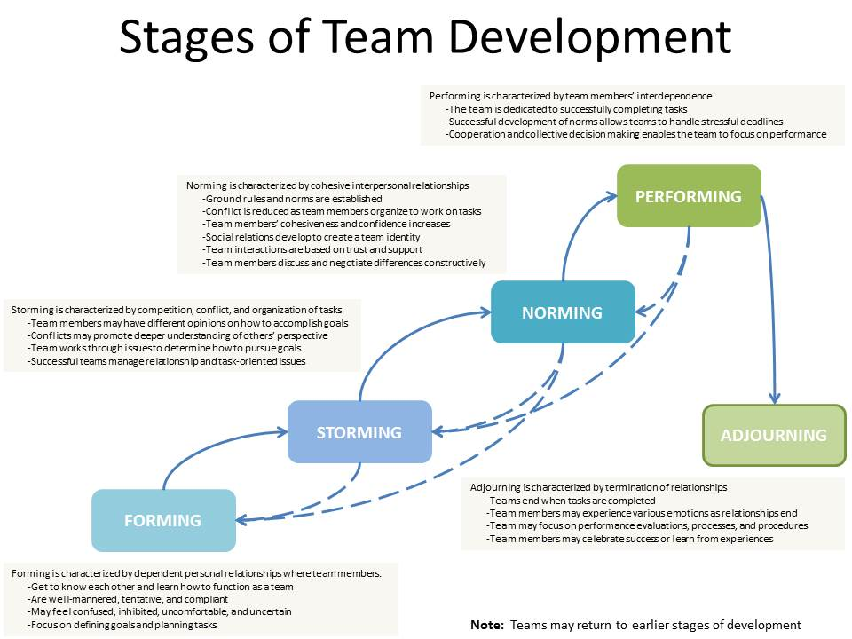
Image 1. Tuckman’s Stages of Team Development
As it can be seen on the image above, every stage is characterised by specific behaviour, and based on the information available about the ABC Technology team, it can be easily seen that the team is currently at the Storming stage. The reason for that is that there are different working style within the team, no leadership and constant conflict. The goal stage that the team must be at is the Performing stage, where all the conflicts are solved, the teamwork is excellent and effective, and the productivity is at its peak (Bonebright, 2009). In order to do so and to overcome all the obstacles, the team must go back a step into the Forming stage in order to determine what is the role of each member and to identify and to declare the leader which can help further in the stages of development (Broome, 2008). Here is where the Belbin’s theory regarding the team roles comes as a solution because this is one of the most easy and most used methods to identify the team roles within a team, and to further analyse the strengths and the weaknesses of the team, information which can be later used to create a suitable plan to go through each of the Tuckman’s stages in a healthy and effective way, and to make the team effective (Fisher, Hunter, Macrosson, 2011). According to Dr Meredith Belbin (2009), there are usually 9 roles in a team, but these roles can alternate from team to team, based on each member’s role, and they are important in recognising team members’ attitudes, strengths, and weaknesses and to help managers to solve conflicts faster, to improve the communication within the team and to increase the productivity.
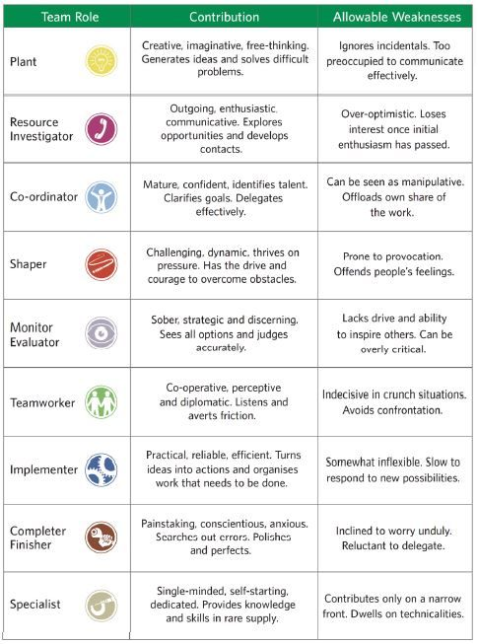
Imagine 2. Belbin’s Team Roles
As it can be seen in the image above, there are 9 roles: Plant, Resource Investigator, Co-ordinator, Shaper, Monitor Evaluator, Team worker, Implementer, Completer Finisher and Specialist, and every one of them has recognisable strengths, as well as recognisable weaknesses. The managers of the Artificial Intelligent project can identify what is the role of each member by either looking at the characteristics, or by organising a team meeting where each member can complete the Belbin’s questionnaire (Furnham, Steele, Pendleton, 1993). Because the members of the team have poorly defined roles which led them to conflictual situations, it is a crucial step to define each member’s role, as well as to choose a leader that can lead the team during difficult times and to help the team progress and become effective. Moreover, if all the members have defined tasks and goal, it will be easier to manage the conflicts and the team can advance from the Storming stage into the Norming stage, and then into the Performing stage. A useful advice here would be, after every member has an established role, the manager can make a list with the team’s strengths and weaknesses and based on that to create the best way to work as a team, minimizing the conflicts (Kumar, Deshmukh, Adhish, 2014).

Communication
Another problem that the ABC Technology is facing with the team is the poor communication, especially since all the communication moved online, and it is difficult to create a relationship between the members of the team. In order to be able to find the most suitable way to improve the communication within the team and to create a two-way communication, 3 communication theories will be applied: Shannon-Weaver, Berlo and Schramm. The first theory is the Shannon Weaver, which represents a mathematical communication theory which argues that an effective communication must have 6 concepts: Sender, Encoder, Channel, Noise, Decoder and Receiver (McQuail, 2008).
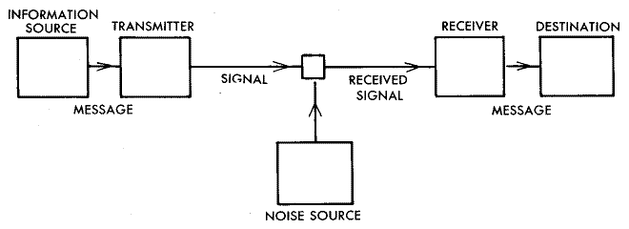

Imagine 3. Shannon-Weaver Model of Communication
This model was created for the online communication, and it is considered by many to be a one-way communication theory due to the lack of feedback and, at the same time, the ‘noise’ can create barriers in communication (Al-Fedaghi, 2014). As the ABC Technology’s team is currently working from home and the communication is online, one might think that the Shannon-Weaver is the suitable strategy for the team, but the fact that it is mostly one-way change that, and makes this theory not suitable for the team, at the moment, as the team needs to bond and to be able to share ideas and solve any potential conflicts, and this would not be possible if they will use the Shannon-Weaver strategy.
The next communication theory is Berlo’s, which has multiple elements, and it is not considered to be specific for a type of communication but has a few particularities which can determine if it is the right theory to use in a certain team (Narula, 2006).
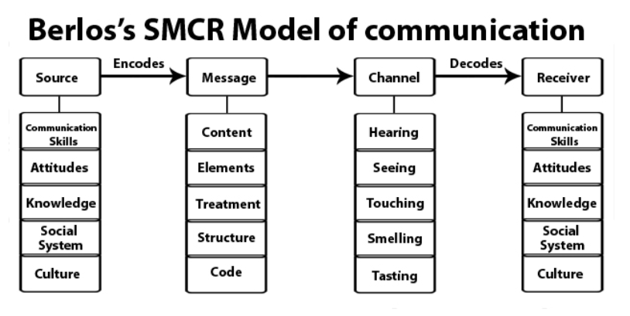
Imagine 4. Berlo’s SMCR Model of Communication
What characterises this theory the most, apart from the numerous elements, it is the fact that in order for the communication to be effective, the Source and the Receiver must be on the same level and share the same opinions (Stead, 2017), which makes the theory less applicable in a team that just starts to form and to overcome the conflicts, as the members are clearly not on the same page yet. Additionally, the Berlo’s theory does not include the feedback (Blythe, 2010) , which makes the theory be representative for the one-way communication which, again, is not effective for the discussed team.
The last theory that will be applied to the team is the Schramm theory, which was proposed in 1954 and is based on the idea that the communication is not complete or effective until the recipient shares his feedback with the sender (Sapienza, 2015), concept also known as cyclical communication or two-way communication. The theory also emphasises the idea that the encoding plays a crucial part in the understanding of the message, which is why the feedback is so important, to make sure that the receiver has the correct message and transmits the correct response back to the sender (Lawrence, 1979).
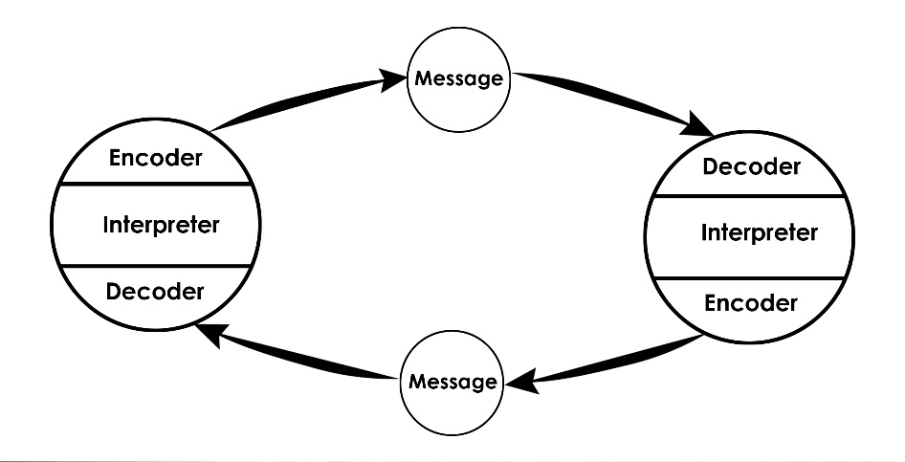
Imagine 5. The Schramm Model of Communication
Based on the characteristics of the Schramm’s theory and based on the needs of the team, it can be easily noticed that this is the most suitable strategy to improve the communication within the team. The reason for that is that the team needs a two-way communication in order to function properly and to adjust everyone’s working style into an only one, but this cannot be achieved unless the members discuss with eachother effectively and understand their ideas as they are, sharing experiences, advices and manage the conflicts faster and more effectively.
An effective teamwork is important in any environment because if the members of the team are not working together towards a common goal and they do not practice the two-way communication, they are less productive, as the team spends its time handling the conflicts created by the difference of opinion or they fight for leadership in a project (Miller, Gaida, 2019). ABC Technologies lacks an effective team working, which caused them to have the Artificial Intelligence software project delayed with 6 months because the team members cannot work together effectively. It is crucial for the team to overcome its differences and to become effective because this will help the team members relax, rely on eachother and start doing the work and the project will begin to see progress as well, once all the energy will be put into the project. The process of becoming an effective team is not easy, especially if the team is still in the Storming stage (Cho et al, 2010), where the conflict is everywhere, but the managers must interfere and they must establigh clear goal, task for each member and to find ways to apply a two-way communication based of the composition of their team.

Conclusion
In conclusion, the ABC Technology’s team is clearly at a stage where the progress or the productivity seems impossible. The good thing is that by taking it step by step, it was identified that there are multiple resources and theories which can be used to help the team become effective. Tuckman’s theory was important to establish at what stage is the team currently, and it was clear that they find themselves at the Storming stage, but they did not successfully complete the Forming stage, as the team members do not have clear and defined roles within the team. It was presented the Belbin theory which can help the member identify what roles to they have and then further analyse the overall team strengths and weaknesses. By identifying that, the team can then choose a leader and divide the work properly, based on their skills, which will solve the majority of the conflict. Additionally, the team had a communication issue, and in order to establish what strategy is the best for them, three theories were applied, but, in the end, the Schramm theory was considered the most suitable in this case.
The overall project was affected by the lack of communication between the members of the team, as well as by the pandemic, but in the end, if the managers will act and will apply the theories recommended, the chance that the team will improve and become effective and productive is really high.

Recommendations
The main recommendation is to book a meeting with the entire team where they will have to complete the Belbin’s questionnaire available in the Appendices, to establish the role of each member. After the role will be defined, it is mandatory to note the strengths and the weaknesses of the team and to create appropriate tasks for each member, as well as appointing a leader that the rest of the team can rely on in solving conflicts or motivate them. At the same time, more meetings will be beneficial, especially since the communication is online, where everyone must share their ideas and where the team can connect more. Additionally, more training is required for managers to learn how to work with different types of employees and how to adapt and be empathetic. For employees, it is recommended to attend trainings about handling conflict at work, resilience, adaptability, and communication. At the end of the training sessions, a good recommendation would be an open discussion about what they have learned and what is their opinion about the discussed topics.

Bibliography/References
- Al-Fedaghi, S. (2014) A Conceptual Foundation for the Shannon-Weaver Model of Communication. Computer Engineering Department, Kuwait University, pp. 5-8.
- Belbin, M. (2009) Team Roles at Work. Taylor& Francis, Oxon, pp. 3-5.
- Blythe, J. (2010), Trade fairs as communication: a new model. Journal of Business & Industrial Marketing, Vol. 25 No. 1, pp. 57-62.
- Bonebright, D. A. (2009) 40 years of storming: a historical review of Tuckman's model of small group development. Human Resource Development International. Vol. 13, Issue 1, pp. 111-120.
- Broome, J. (2008) How-to-stop-your-team-‘Storming’-and-get-them-‘Performing’. PM today, pp. 16-20.
- Cho, A.R. et al. (2010) Methods of effective team-based learning administration and expected effects on medical education. Korean Journal of Medical Education, 22(1), pp. 48-49.
- Fisher, S.G, Hunter, T.A, Macrosson, W.D.K. (2011) The structure of Belbin's team roles. Journal of Occupational and Organizational Psychology. Vol. 71, Issue 3, pp. 283-288.
- Furnham, A., Steele, H., Pendleton, D. (1993) A psychometric assessment of the Belbin Team-Role Self-Perception Inventory. Journal of Occupational and Organizational Psychology. Vol. 66, Issue 3, pp. 245-157.
- Kumar, S., Deshmukh, V., Adhish, V.S. (2014) Building and Leading Teams. Indian Journal of Community Medicine, 39(4), pp. 208–213.
- Lawrence, K. (1979) The convergence model of communication. East-West Communication Institute, Honolulu, pp. 28-35.
- McQuail, D. (2008) Models of Communication. The International Encyclopedia of Communication, pp. 5-6.
- Miller, J., Gaida, P. (2019) On the Agile Mindset of an Effective Team – An Industrial Opinion Survey. 2019 Federated Conference on Computer Science and Information Systems (FedCSIS), pp. 841-849.
- Narula, U. (2006) Communication Models. New Delhi, pp. 11-15.
- Sapienza, Z. (2015) Reading Lasswell's Model of Communication Backward: Three Scholarly Misconceptions. Mass Communication and Society, Vol. 18, Issue 5, pp. 610-612.
- Stead, B.A. (2017) Berlo's Communication Process Model as Applied to the Behavioural Theories of Maslow, Herzberg, and McGregor. Academy of Management Journal, Vol. 15, No. 3, pp. 30-33.
- Swailes, S. and McIntyre‐Bhatty, T. (2002), "The “Belbin” team role inventory: reinterpreting reliability estimates", Journal of Managerial Psychology, Vol. 17 No. 6, pp. 529-536.
- Tuckman, B.W. & Jensen, M.C (1977). Stages of small-group development revisited. Group & Organization Management, 2(4), pp. 419-427.

Appendices
Belbin’s questionnaire


