
Borislava Borisova
Student Number:2114506
Assignment 2
Lecture:Amitave Bani
Submmission Date:13.01.2023

Data Handling & Business Intelligence
Table of Contents
Introduction 3
Part 1 3
Functions of EXCEL 4
Superstore data set 5
Part 2 7
Data analysis of Ice-cream dataset 8
Data mining and text mining methods 8
Advantages and disadvantages of using SPSS and Excel 10
Conclusion 11
References 13

Introduction
Data processing occurs when information is gathered and converted into meaningful data, and it is mainly performed by a data scientist or their team. It is necessary to conduct it accurately, and if not, then it will negatively affect the business output. Generally, "data processing" means leveraging the information with the help of a computer, as well as transforming raw data into machine language, and the data flow from memory to output devices, as well as the renovation or design of output (Zhang et al., 2020). Data processing entails the various uses of computers to do a specific task. It provides various benefits to the business such as profit maximization, maximum output, diligence, and assistance in making appropriate and good decisions. It assists the business in developing business tactics and maximizes its competitive edge, and the data of the company has been explained in readable formats like charts, graphs, documents, etc. so that the business can interpret the data so can utilize it for business development. On the contrary, it also assists the business in lowering the price of the product. Easy accumulation, reporting, and allocation have been made possible by excellent presentation and analysis. Data processing is required by every business as well as helping the business maximizes its yield. It is considered an international practice that is a part of every business. This report mainly describes how to make a descriptive statistical analysis on an ice cream data set and also explains the approaches of data mining and text mining that are utilized within organizations. This report also outlines the merits and demerits of applying Excel and SPPS within the firm.

Part 1
The foremost step while analyzing the Superstore data set was to ascertain the data and select the data that the company wanted to estimate. Some data were not appropriate for the analysis, like the nominal data, although the main focus was on the appropriate data. The first column is appropriate for the analysis because it mainly represents the timeline and shows the timeline of four years, i.e., 2009 and 2012 (Zhang et al., 2020).
In order to evaluate the sales and profit, it is necessary to know about the order quantity, the sales revenue, and profit, cost per unit, and shipping costs. The column of province and region is also significant in the analysis as the main focus is on the sales and profits based on the business and where they ship the products (Waskom, 2021). The customer section is the most important part of a data set because it informs the company about the types of customers it serves with its services and products, as well as how much revenue it generates from each customer segment. If a company determines that home and office consumers account for the majority of its revenue in comparison to single customers, it will concentrate on this segment of the customer base (Waskom, 2021). This allows the company to make more informed decisions in the future. The product category column is also important for the company because it allows it to see which products generate the most revenue and which do not. The company can evaluate the data based on the data set from the standpoint of customer demand and discover which product category has the most demand and which product has the least demand (Sievert, 2020).

Functions of EXCEL
The functions of Excel that aid in evaluating the Superstore data set, like IF, LOOK, PIVIT TABLES, CHART, and Graphs, help in analyzing the data set are mentioned below:
Pivot tables: They help the company characterize the total number of orders, total sales, total profit, the total cost of unit price, and total shipping cost for each year. It is considered a powerful tool that is utilized to compute, evaluate, and summarise the data, as well as an interactive method to quickly summarise huge data sets and describe the numerical data sets in brief (Sievert, 2020). It is designed specifically for breaking down large data sets into numerous user-friendly methods. It aids the user in understanding the patterns, trends, and comparisons of the information, and it is done distinctly on each platform. It represents the data in its simplest form and entails some specifications, like recognizing the averages, ranges, sums, or outliers. It will assist the company in comparing the sales totals of various products, representing the product sales as a proportion of total sales, amalgamating duplicate data, and so on (Richardson et al., 2020).
IF: It is the most used formula in Excel as it enables the user to perform logical comparisons between a value and what the user expects, and it shows two results: the first is true and the second is false (Richardson et al., 2020). It is useful in classifying the requirements of the present in the Excel worksheets as well as important in concealing the mistakes made while computing. It can be utilized in adding the comments to the data, and its formula can be represented as =IF (A2>B2, "Over Budget," "OK").
LOOKUP: It enables the user to search for a piece of data in a row or column and can return an equivalent piece of data in another row or column. One of the cells of the excel worksheet has been referenced to search for the piece of data in another column or row opposite the cell and then reclaim the results from the particular columns and rows. It helps the user find any data from a huge data set or a piece of data from a column or row and then look for it in another row and column (Prince and Lovesum, 2020). The lookup table, also known as the lookup base object, stores a list of predefined values. The lookup table entails a list of keys and values, and the user can create a lookup table in the rules file or a separate file. It is a quicker process, but it uses excessive memory, and the lookup formula is represented as =LOOKUP (lookup_value, lookup_vector, [result_vector]).

Superstore data set
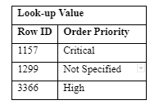
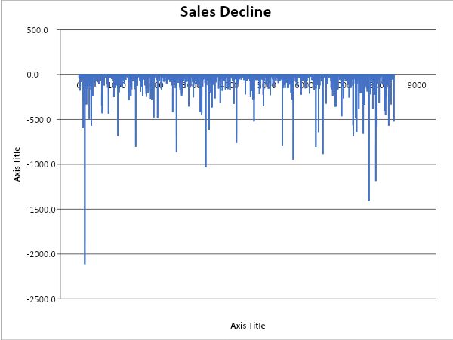
Result and discussion
Data processing is considered the essential procedure of mining and it makes an impact on the project success rate with the help of a data set, the company can enhance the quality of the company operations. According to the provided case, charts are the better way to evaluate the profits and losses of the superstore. The visualization of the data set can be done based on charts and it helps to make comparisons between the given data sets.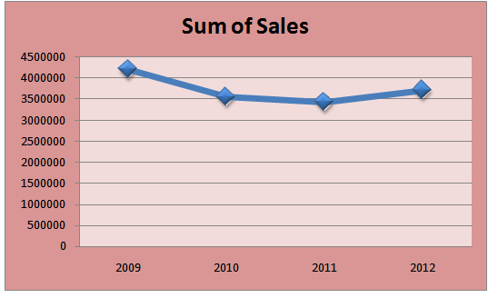
Figure 1: Total sales-(Prince and Lovesum, 2020)
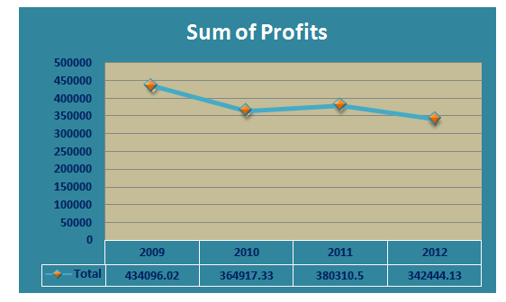
Figure 2: Total profits- (Murray, 2022)
The diagram represents the total profits of the company from 200 to 2012. The results illustrate that the profits got minimized sustainably and it has been seen that the sum of profit declined in 2009 and 2010. It has been observed that in 2009 and 2010 profits were 4, 34,096.02 and 3, 64,917.33 and the decline of the profit of the superstore is 69178.69 in the accounting year 2009 and 2010. Although the total profit of the superstore is increased by 15393.17.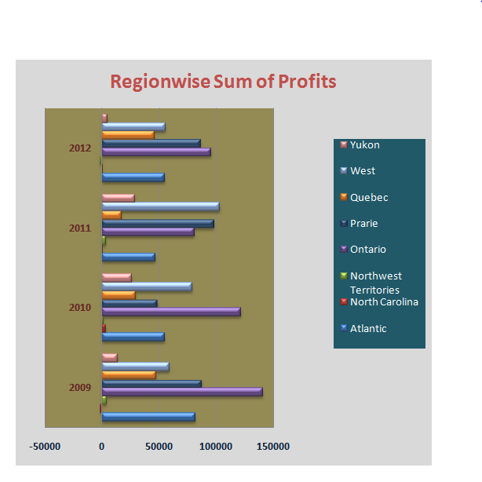
Figure 3: Region wise total profits- (Murray, 2022)
According to the provided data set, Ontario acquired the maximum profit in 2009, but the region-wise total profits declined in 2010 and 2011. However, in 2011, the data was changed, and the West earned more profit and became the most profitable province.

Part 2
This part of the report analyses the different statistical data that is obtained from SPSS as well as the descriptive statistical edge of the present data. SPPS is a preferable method, as many researchers use it to analyze complex statistical data, and it can be the best option for leading businesses or agencies (Moscoso-Zea et al., 2019). They can use it to analyze the survey data and mine the data to achieve better outputs. It can be useful in calculating the mean and median of the provided data set and it will also outline the various approaches to text mining and data mining. This section also discusses the advantages and disadvantages of Excel and SPSS.

Data analysis of Ice-cream dataset
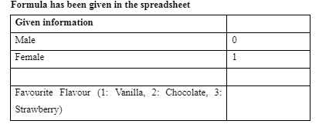
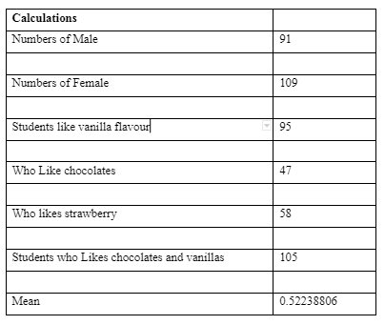

Data mining and text mining methods
Various approaches to data mining are regression, clustering, outer prediction, association rules, sequential prototypes, and classification; out of all of these methods, the clustering approach is the most preferable (Moscoso-Zea et al., 2019). The cluster is the term that is used for collecting the data objectives, and objectives are identical with the similar cluster that reflects that objects are identical to each other in an identical group. It can be dissimilar or different from the objects in other groups.
Clustering analysis represents the process of finding groups and also reflects the highest relationship between two objectives that belongs to the identical group; if it shows the lowest relationship between the two objectives, and then it does not belong to the identical group (Hendrycks et al., 2019). This approach mainly aids in finding the data by characterizing the files on the internet, but it can also be used to detect applications. In companies, the data mining approach is very useful as it helps the business discover the relationship among the diverse variables, i.e., sales, profit, operations, etc. It aids the company in recognizing prototypes and regularities in the data set (Hendrycks et al., 2019).
Regression is considered the most efficient method of data mining, and it is a preliminary type of modelling and planning (Jalil and Hwang, 2019). It is useful in evaluating and recognizing the relations of variables with each other, and it is because of the availability of the other elements in the business. Generally, it can be meaningful while describing the probability of specific variables. It is used in business, for example, to assess the feasibility of setting certain prices that are dependent on other factors such as competition, customer demand, resource availability, and so on (Jalil and Hwang, 2019).
Data mining | Text mining
- It acquires formal and structured procedures that help in financing the data and analytical models.  - It represents the homogeneous structure of the variables arranged in the simple alternatives phase.  - It utilized the various kinds of data sets that can be available in the computer system, like CRM, ERP, accounting software, etc (Jackson and Bazeley, 2019).  - It entails a variety of characteristics to find the relevant prototype as well as describe the relationship between the structured data. | - It represents both linguistic and statistical methods and involves the keyword "meta" in utilizing the structured data (Jackson and Bazeley, 2019).  - It entails amorphous textual information that is given in various structures as well as arranged diversely with a few types of software and systems.  - It contains emails, videos, files, social media sites, etc.  - It entails various types of characteristics that are related to the textual data as well as an effective presentation of the data analysis.

Advantages and disadvantages of using SPSS and Excel
The full name of SPSS is "Statistical Package for the Social Sciences," and it entails a group of software programs that can be useful for grouped or non-grouped statistical data analysis. It provides information in the simplest form and can easily calculate complicated data sets. It also allows for more accurate computation and protects businesses from estimates and errors caused by human errors and manual computations (Kabacoff, 2022). The main disadvantage of SPSS is that it is not useful in evaluating large data sets, and it is also expensive software when compared to other software, so small businesses do not use it. It contains the same features as Excel but has restricted properties. However, with the help of this software, a company can solve complicated database problems easily and quickly. Market researchers primarily focus on interpreting data, evaluating trends, planning, predicting, and reaching out to the market to obtain market trend data (Kabacoff, 2022).
The Excel application or software program was developed in the year 1985 by Microsoft, and it categorizes the data in rows and columns. It can store a huge amount of data and acquire 16384 columns and 1048576 rows. It is the most preferred software, as it is useful for users to arrange the data as per their preference, like charts, graphs, and so on. There are various templates available for using graphs and tables, and businesses are also using this application to improve their research skills and compare themselves to other platforms (Amarasinghe et al., 2020). Data mining software, such as Microsoft Excel and SPSS, which were developed specifically for statistical computation, assists the company in estimating complex data sets to make better decisions in the future. Although Excel entails the maximum risk of virus attack, any person can disrupt the file or computer with a virus. This application is also very costly, and only the correct formula will compute accurate answers; finding errors in the data set is also very difficult in Excel (Mao et al., 2019).
Merits and demerits of using Excel
Pros | Cons
- It consumes less time.  - It can be operated easily, and it is easy to teach (Mao et al., 2019).  - It can process large amounts of data in less time.  - It is considered a versatile software application. | - No collaborative work can be done.  - It is difficult to find errors throughout the dataset.  - It can be easily disrupted by virus attacks (Mehta, 2021).  - It is not simple to regulate the enhanced pricing policies.

Merits and demerits of using SPSS
Pros | Cons
- It manages the data efficiently.  - It can use both quantitative and qualitative data sets (Held et al., 2019).  - It entails a vibrant appearance that helps visualize the table and graphs.  - It provides accurate and quick results in one place (Mehta, 2021). | - When compared to Excel sheet data, it represents a complicated graph that is difficult to understand (Amarasinghe et al., 2020).  - To operate this software, necessary training is required to apply certain features of the application.  - It is a costly application, and only large companies can afford it.

Conclusion
This report primarily represents the data analysis and data visualization of the data sets. The first section of the report analyses the application of Excel for pre-processing the data as well as Excel's functions like IF and LOOKUP. Pivot tables are utilized to illustrate the declines in sales and profits. The second part of the report estimates the different statistical data that is obtained from SPSS and Excel, as well as the descriptive statistical edge of the present data. This report will also outline the various approaches to text mining and data mining, as well as the benefits and drawbacks of Excel and SPSS. It can be concluded that data visualization represents the graphical representation of the data and information, and data analysis represents the procedure of methodically using statistical and logical methods to explain and demonstrate, concentrate and recapitulate, and analyze the data.

References
Amarasinghe, S.L., Su, S., Dong, X., Zappia, L., Ritchie, M.E. and Gouil, Q., 2020. Opportunities and challenges in long-read sequencing data analysis. Genome biology, 21(1), pp.1-16.
Held, B., Moriarty, B. and Richardson, T., 2019. Microsoft Excel Functions and Formulas with Excel 2019/Office 365. Mercury Learning and Information.
Hendrycks, D., Mu, N., Cubuk, E.D., Zoph, B., Gilmer, J. and Lakshminarayanan, B., 2019. Augmix: A simple data processing method to improve robustness and uncertainty. arXiv preprint arXiv:1912.02781.
Jackson, K. and Bazeley, P., 2019. Qualitative data analysis with NVivo. Sage.
Jalil, N.A. and Hwang, H.J., 2019. Technological-centric business intelligence: Critical success factors. International Journal of Innovation, Creativity and Change, 5(2), p.1499.
Kabacoff, R., 2022. R in Action: Data Analysis and Graphics with R and Tidyverse. Simon and Schuster.
Mao, H., Schwarzkopf, M., Venkatakrishnan, S.B., Meng, Z. and Alizadeh, M., 2019. Learning scheduling algorithms for data processing clusters. In Proceedings of the ACM special interest group on data communication (pp. 270-288).
Mehta, M., 2021. Aggregate Functions. In Microsoft Excel Functions Quick Reference (pp. 103-138). Apress, Berkeley, CA.
Moscoso-Zea, O., Castro, J., Paredes-Gualtor, J. and Luján-Mora, S., 2019. A hybrid infrastructure of enterprise architecture and business intelligence & analytics for knowledge management in education. IEEE access, 7, pp.38778-38788.
Murray, A., 2022. Formulas with Data Types in Excel. In Advanced Excel Formulas (pp. 727-749). Apress, Berkeley, CA.
Prince, P. and Lovesum, S.P., 2020. Privacy enforced access control model for secured data handling in cloud-based pervasive health care system. SN Computer Science, 1(5), pp.1-8.
Richardson, J., Sallam, R., Schlegel, K., Kronz, A. and Sun, J., 2020. Magic quadrant for analytics and business intelligence platforms. Gartner ID G00386610.
Sievert, C., 2020. Interactive web-based data visualization with R, plotly, and shiny. CRC Press.
Waskom, M.L., 2021. Seaborn: statistical data visualization. Journal of Open Source Software, 6(60), p.3021.
Zhang, D., Gao, F., Jakovlić, I., Zou, H., Zhang, J., Li, W.X. and Wang, G.T., 2020. PhyloSuite: an integrated and scalable desktop platform for streamlined molecular sequence data management and evolutionary phylogenetics studies. Molecular ecology resources, 20(1), pp.348-355.

