

JSW Steel: Marketing Environment Analysis and Strategic Growth for a Lower-Carbon Future

Student Name - Omin Dineshbhai Dihora
Student ID - 2538975
Module - Marketing Management
Module code- LCMB7024
Programme - master of business administration
Assignment title - Marketing Environment Analysis
Lecturer - Taonga Kaonga Sobere-Snithers (Birmingham)
Word count - 2417

Table of Contents
1. Introduction 5
1.1 Background of JSW Steel 5
1.2 Purpose and Scope of the Report 5
Task 1: Marketing Environment Analysis 6
2. External Marketing Environment Analysis 6
2.1 Introduction to the Marketing Environment 6
2.2 Natural Environment Analysis 6
2.3 Political Environment Analysis 7
2.4 Critical Discussion of the Two Actors 8
2.5 Summary of Marketing Environment Analysis 8
Task 2: Strategic Growth and Competitive Positioning 9
3. Strategic Growth Strategy for JSW Steel 9
3.1 Introduction to the Ansoff Matrix 9
3.2 Recommended Growth Strategy: Product Development 9
3.3 Competitive Advantage Strategy 10
3.3.1 Porter's Generic Strategy 10
3.3.2 Sources of Competitive Advantage 11
3.4 Evaluation of Strategic Recommendations 11
3.5 Summary of Strategic Growth Analysis 12
Task 3: Critical Reflection on AI Usage 12
4. Critical Reflection on Artificial Intelligence Usage 12
4.1 AI Tool Disclosure 12
4.2 Critical Evaluation of AI Outputs 12
4.3 Contribution Analysis 13
4.4 Ethical and Professional Reflection 13
5. Conclusion 14
References 15

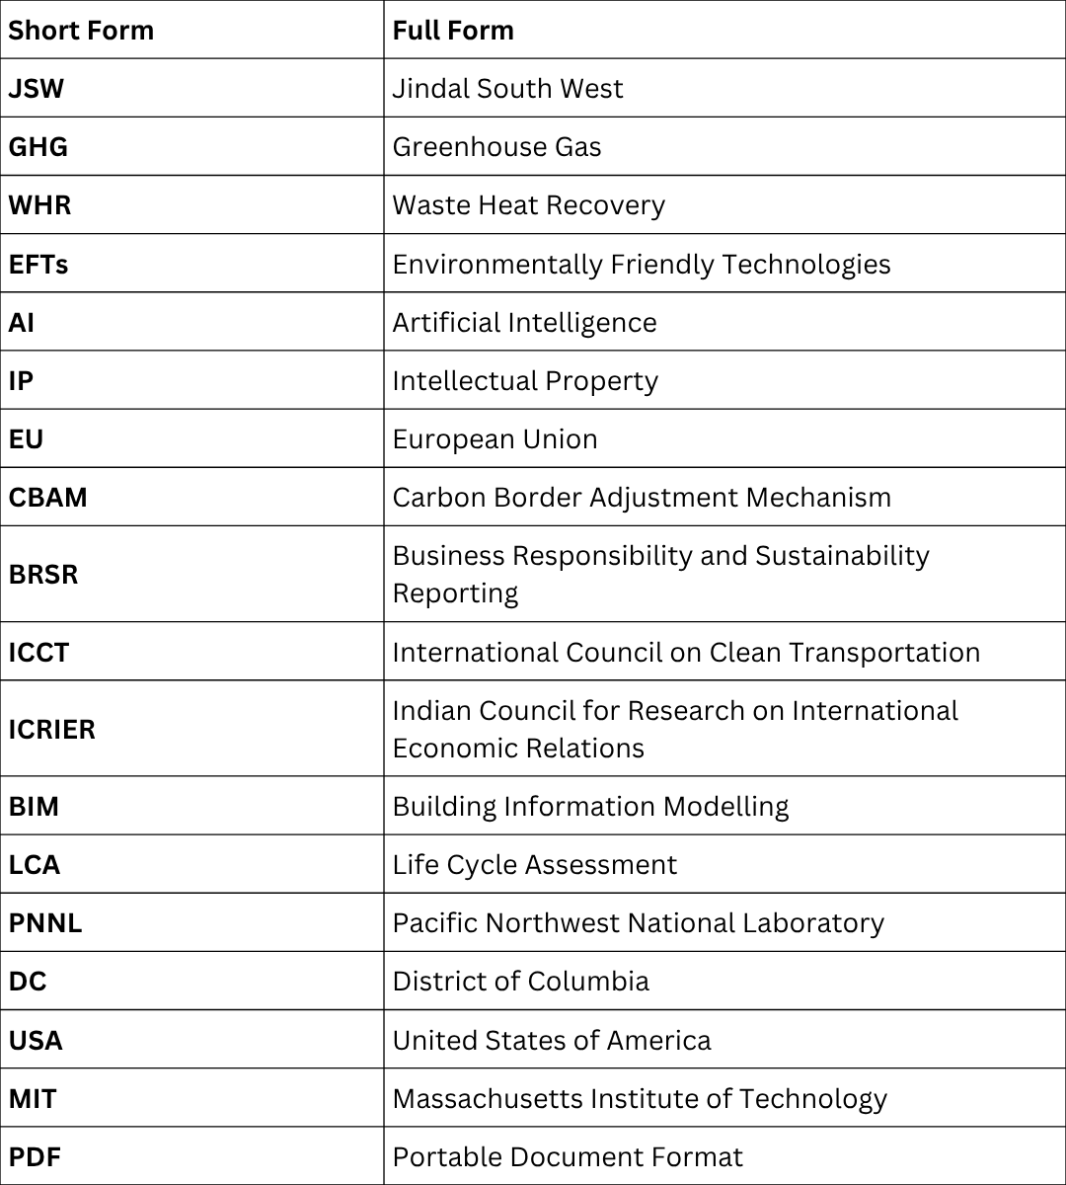

1. Introduction

1.1 Background of JSW Steel
JSW Steel is one of the biggest integrated steel producers in India and a part of the flagship company of the JSW Group. Currently, the company offers a diversified product line, in addition to high level technologies and a strong production capability that have helped it penetrate the international and local market. Steel industry is one of the largest emitters of greenhouse gas (GHG) and is also compelled by competition to reduce emissions to become economical (Lin et al., 2021).

Nowadays sustainable production is a key concern of the global industrial leaders. The fast-paced changes in the steel industry's competitive environment make the growing focus on ‘decarbonisation, climate change mitigation, and sustainable industrial development' inevitable. Competitive environment of the steel industry is changing dramatically; "decarbonisation, climate change mitigation and sustainable industrial development" is a sure focus.

Concurrently, considering sustainable practices to be in line with the stakeholder expectations and international scope of sustainable development, JSW Steel have been investing in renewable energy, energy efficient technologies and carbon reduction programs

1.2 Purpose and Scope of the Report
The external marketing environment analysed here is determining the transition from the higher carbon steel production of JSW towards lower carbon steel production. Analyses the problems in the external environment (natural and political) of the company and proposes the strategy framework for business growth of the company on the basis of Ansoff matrix and competitor position analysis.

Task 1: Marketing Environment Analysis

2. External Marketing Environment Analysis

2.1 Introduction to the Marketing Environment
Organisations can identify the opportunities and threats that lie outside of them and how these can affect their strategic planning by undertaking marketing environment analysis. A crucial understanding of the environmental factors is vital to companies working in carbon-intensive sectors such as a steel industry (Yu et al., 2021).

Therefore companies, their marketing strategies and their actions have to change, with sustainability at the top of the priority list of governments, customers and investors. In the context of business model transition to a lower carbon business model, sustainability, it helps to see the environment; it makes sense to look at the context- the challenges and opportunities.

2.2 Natural Environment Analysis
Obviously, the environment is one of the external factors that impact on JSW Steel's business and objectives. Climate change is contributing to pressures on the steel industry, since steel is very energy-intensive, and generates massive quantities of carbon emissions. Around the world, extreme weather events, limited resources, and an increase in average temperatures is promoting sustainable production in governments and enterprises. Cleaner technologies mandated by environment protection laws are a big hurdle steeper for steel companies to reduce their greenhouse gas (GHG) footprint.

Customers, especially those working on the automotive, construction, and infrastructure industries continually demand products which are environmentally-friendly, thus an increasing demand for so called green steel (Negri et al., 2024).
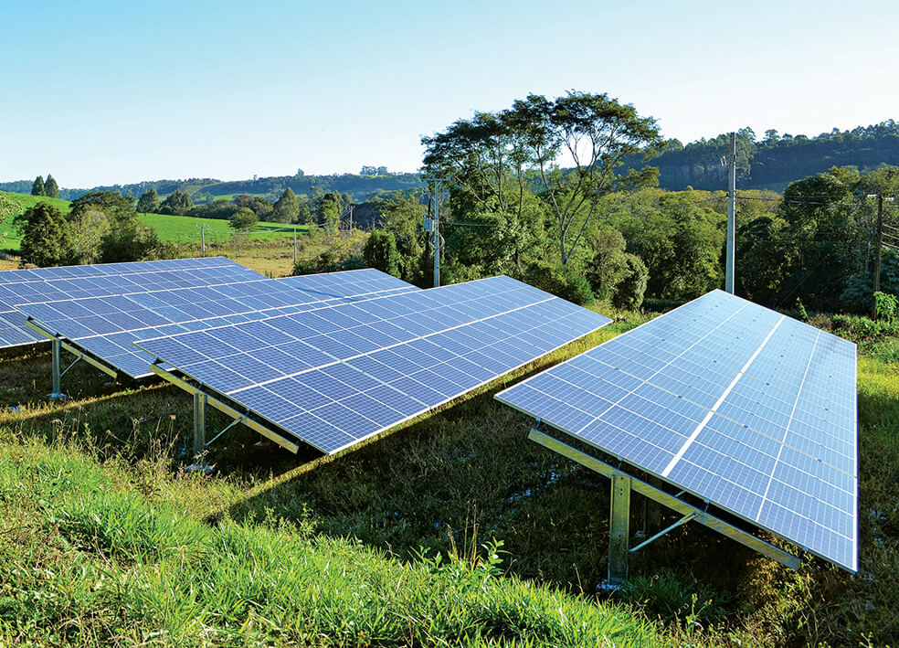
Figure-1: JSW Steel renewable energy solar power plant sustainability initiative
(Source: Negri et al., 2024)
This trend is a definite opportunity for JSW Steel with a view to developing differentiated products and position the company in the market. To address these challenges JSW Steel has taken several steps in the field of Renewable Energy, Waste Heat Recovery (WHR) Systems, Energy Efficient Production Processes, and Carbon Intensity reduction works. Through these actions the company will be able to deliver its sustainability commitments with a positive effect on its environmental reputation. There is a need for significant decarbonising effort, but there are sizeable capital costs and technical challenges, and dependence on existing and traditional blast furnace processes. In a transition there are numerous risks and challenges to be borne in mind, but there are also plenty of things that proactively done sustainability can provide benefits to stakeholders, support regulatory compliance and contribute to increased profitability over the long haul.

2.3 Political Environment Analysis
Government pressure: The Indian government’s ‘net-zero’ target and stringent global environmental regulations have made it necessary for JSW Steel to adopt eco-friendly technologies.

Financial benefits: Government subsidies, tax breaks and policy support reduce the cost of introducing new technologies such as green hydrogen and renewable energy.

Regulatory risk: Frequently changing carbon policies and laws can increase the company’s operating costs, which is a challenge for large long-term investments.

JSW’s strategy: The company complies with these regulations by maintaining good relations with lawmakers and aligning with government priorities, thereby increasing its credibility in the market.

2.4 Critical Discussion of the Two Actors
Nature and Politics: Both the natural and political environments are interconnected and play a significant role in JSW Steel’s sustainability journey.

Natural Environmental Pressures: Resource scarcity, environmental concerns and changing consumer preferences have made it necessary for the company to reduce carbon emissions and innovate. This factor has the greatest impact in the long run.

Importance of Political Will: Government regulations and policies encourage the company to take eco-friendly measures. Since pollution-free production is very expensive, the costs increase significantly if the government does not provide financial and policy support.

Opportunities and Concerns (for JSW): Environmental issues are driving the demand for ‘green steel’ and government policies are encouraging investment in new technologies. However, there are also concerns that the company’s operating and compliance costs will increase due to stringent regulations. 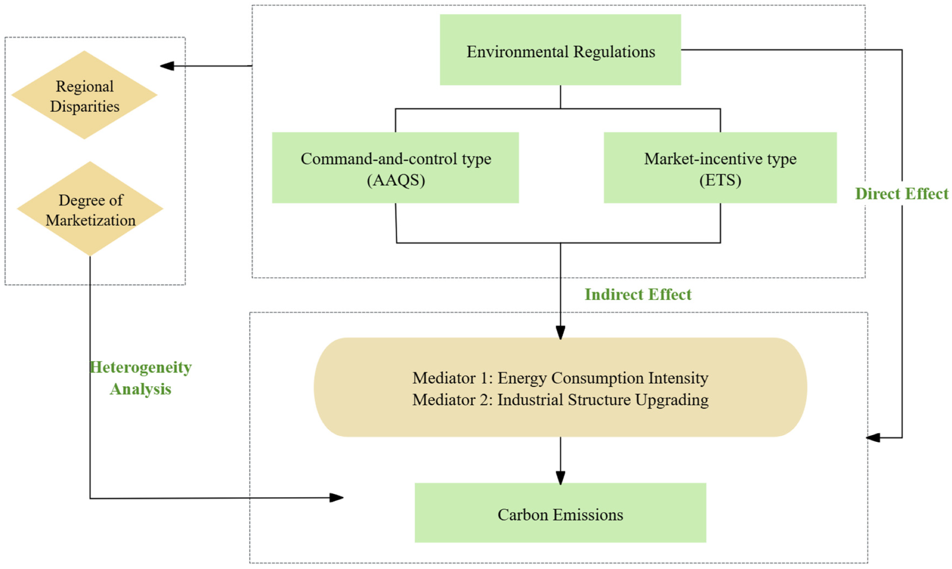
Figure-2: Environmental regulations and industrial sustainability framework
(Source: Mallett and Pal, 2022)

2.5 Summary of Marketing Environment Analysis
It is evident that natural and political environment has been playing significant role in the trend of production of iron steel, which is steered towards lower carbon version of iron steel produced by JSW Steel Limited. Opportunities and threats arise due to climate changing concerns, environment protection policies and increasing demands of sustainable products. Meanwhile, the country's regulations push for compliance and investment is promoted in favour of investing in cleaner technologies. Through these measures, JSW Steel can shore up its sustainability efforts, boost its competitive edge and become the market leader of the upcoming green steel industry.

Task 2: Strategic Growth and Competitive Positioning

3. Strategic Growth Strategy for JSW Steel

3.1 Introduction to the Ansoff Matrix
The Ansoff Matrix is a strategic planning tool that assists organisations in defining strategic options of growth via market penetration, market development, product development and diversification (Shee Weng, 2025). The model can be used for businesses to assess possible growth options for old and new products and markets. The Ansoff Matrix is useful for businesses in the process of transitioning to sustainability, as it enables them to balance opportunities for growth with their sustainability commitments. A plan is in place to help JSW find ways to expand its lower carbon product offering.

3.2 Recommended Growth Strategy: Product Development
Product Development Strategy: JSW Steel can further strengthen its position in the current market by introducing low-carbon and eco-friendly steel products. For this, the company is investing in new production methods, renewable energy and advanced technology.

Opportunities in various sectors: Through research and development (R&D), the company is developing 'green steel' options for sectors such as automotive, construction, renewable energy infrastructure and engineering, which are in line with their environmental goals.

Key advantages: This strategy will give the company an edge over competitors, engage customers for a longer period and open up new opportunities. Sustainable products will enable the company to command premium prices and improve its brand image among investors and customers.

Challenges and disadvantages: The development and sale of low-carbon products will require a large amount of capital investment. In addition, uncertain market demand, technological risks and changing government regulations can affect the returns on investment
.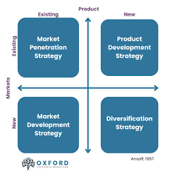
Figure-3: Ansoff Matrix product development strategy
(Source: Mishra et al., 2025)

3.3 Competitive Advantage Strategy

3.3.1 Porter's Generic Strategy
The strategy adopted by JSW Steel should be a differentiation strategy for gaining sustainable competitive advantage. Under Porter's Generic Strategies, organisations have to confront other organisations in an industry and offer customers products or services that they can turn into at a lower expense. Environmentally-friendly, low carbon steel products enable differentiation when it comes to sustainability. One of the areas where the international steel market is differentiating is green steel (Shee Weng, 2025). Consumers are becoming more and more green aware, seeking a supplier that will buy along with them toward their sustainability goals. JSW Steel's shift to sustainable steel will enable it to carve out a niche for itself in the market and improve customer relationships.
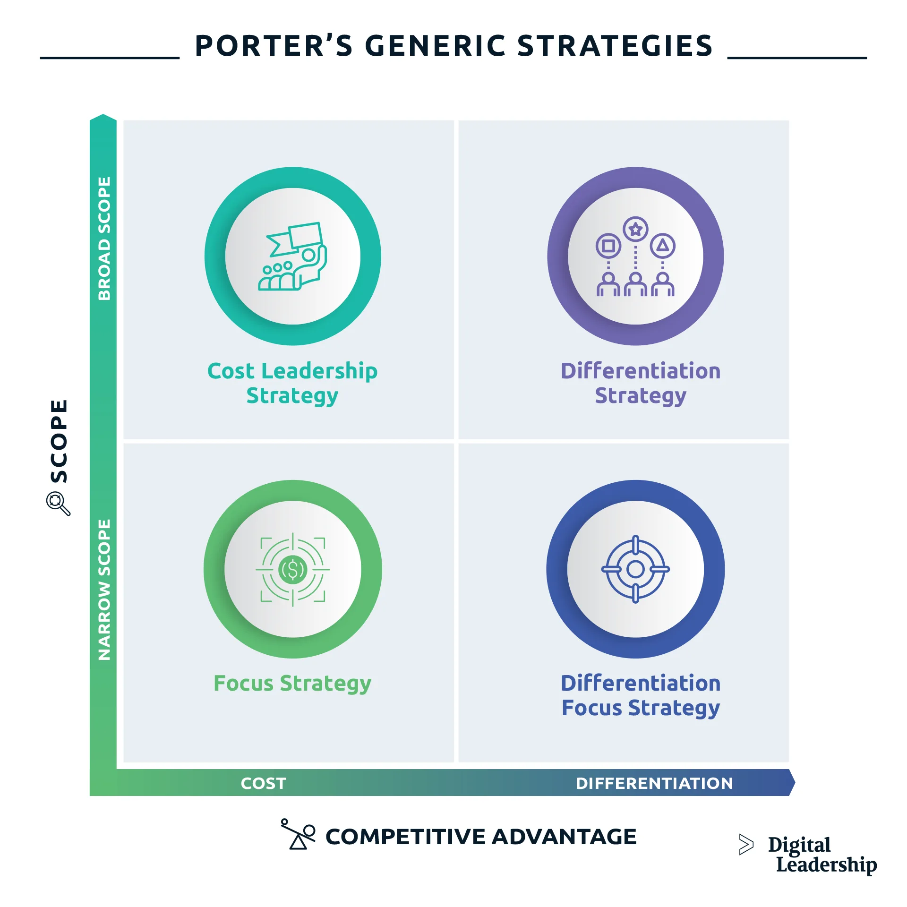
Figure-4: Porter's Generic Strategies differentiation strategy model
(Source: Shee Weng, 2025)

3.3.2 Sources of Competitive Advantage
JSW Steel has a potential competitive advantage for a number of reasons. Primarily, by investing in the sustainable production systems there are less and less damages to the environment, and the efficiency of the operation is increased. Secondly, a good sustainability reputation is likely to foster trust among stakeholders and to boost brand value (Naskar and Sharma, 2025). Thirdly, environmental regulation compliance is done without a wait, avoiding legal & reputation risk. Lastly, constant innovation and research and development assure the success of the company in the ever-evolving market environment. Each of these capabilities can prove to be helpful elements in building up barriers and differentiation which another competitor may have trouble duplicating. These benefits will grow steadily over time as a growing sustainable value is given to these attributes.

3.4 Evaluation of Strategic Recommendations
Growth and Innovation Opportunities: JSW Steel is an established company with sufficient capital, technology and capacity to produce low-carbon steel. The company is supporting global climate goals through environmental improvements and innovation.

Market Opportunities and Brand Value: The demand for ‘green steel’ is increasing significantly as the government and consumers become more aware of sustainability. This strategy will help JSW become a market leader and gain the trust of consumers.

Risks: This journey involves high risks of technological risks, legal changes and implementation, which can affect short-term profits. Also, rival companies are also entering this space.

Conclusion: Despite these risks, the short- and long-term benefits are high. JSW Steel will be able to achieve sustainable growth and a strong position in the market through product development (creating new products) and product differentiation (offering a product that is different from others).

3.5 Summary of Strategic Growth Analysis
JSW Steel's lower carbon transition is one of the best growth strategies suggested by this The Ansoff strategy and is a product development. The company can leverage on the changing market requirements, consolidate the competitive strengths and deliver sustainable steel products through its company differentiation strategy. Innovation investments, environment performance and technological advancements are investments in the long term and for sustainability. In an ever sustainability driven worldwide steel industry competitive advantage is possible through the recommended methods, which however have some implementation challenges.

Task 3: Critical Reflection on AI Usage

4. Critical Reflection on Artificial Intelligence Usage

4.1 AI Tool Disclosure
This report was assisted with the use of Artificial Intelligence tools. Overall, the most frequent use case for ChatGPT in the writing of high-school science reports was to brainstorm the theme for the report and suggest the structure of the report (Raj and Mohan, 2025). Information about trends related to land laws dealing with sustainability/ environment, their relation with strategic management and about JSW Steel was gathered by carrying out further Online research. Incorporating AI was primarily for research support and information gathering and not to create the final written content.

4.2 Critical Evaluation of AI Outputs
Before introducing the information generated by AI tools in the report, they were critically evaluated. Verification was done by comparing with academic journal articles, industry reports, reports from government organizations and company sustainability reports. In this method Paragraphs were checked for factual claims with their credible sources (Kumar et al., 2025). In the evaluation phase, some outputs were unclear and incomplete and some assumptions and claims were made which were not backed up. The problems identified were those that arose when the data on a number of sources were compared and then rectified or removed. As a key part of the verification process, it was revealed that critical thinking with AI-generated information is crucial.

4.3 Contribution Analysis
The utilization of AI in the research process started by helping to brainstorm ideas, collect concepts, and create possible analyses. Each of the elements of critical analysis, interpretation of findings, evaluation of strategic and the overall organization of report was developed separately, however. The analysis of environmental factors, strategic recommendations and competitive positioning are derived from may not be based on artificial writing, but from original judgments of the university. Finally, the outcome of the free learning and independent evaluation was the result, and AI was functioning as an aiding research tool.

4.4 Ethical and Professional Reflection
The opportunities and challenges inherent in AI are becoming commonplace for marketing. AI can help boost efficiency, gather information and enhance productivity. But over relying on AI technology could lead to a lack of critical thinking and introduce inaccurate information in school or work-based activities. Ethic issues are highlighted as transparency, ownership regarding the Internet of IP and responsible usage of technology (Sakhamuru, 2022). To resolve such worries, consumers should ensure that AI-powered information is correctly verified, and analyse the original data. When it comes to professional responsibility, it is essential to have transparency on the use of AI and on compliance with integrity applications. Therefore, the employment of AI and marketing analysis activities can have advantages, but shouldn't be regarded as an individual or stand-alone exercise of independent research, critical thinking, and professional judgment.

5. Conclusion
Various factors affecting JSW Steel transition to Low Carbon Businesses were discussed. It found that nature and politics are key external influences impacting the company's sustainability approach. Strategic opportunities and challenges from climate changes come from climate concerns, environmental law, and governmental policies. When Environmental Analysis was adhered by the product development strategy was identified as appropriate route of growth on the Ansoff matrix. The availability of low carbon steel variants is opening up new avenues for sustainable solutions and adapting to changing customer needs at JSW Steel. Besides that, the approach of differentiating the products produced, in the area of green steel, can be the base for the company to have competitive advantages. The economic and technical aspects are visible throughout the steel industry's journey towards sustainable steelmaking, but the potential gains in the long term remain very pronounced. With its sights set on innovation, environmental sustainability, and sustainable production approaches, JSW Steel is not just carving out a niche for itself but also paving the way for the global steel industry to be eco-friendlier and more sustainable.

References
Goldar, A., Ali, M.S., Kotal, M., Bhattacharya, P. & Haque, I. (2024) Policy Landscape for Transition Towards Carbon Neutral Steel Sector. ICRIER Policy Paper (33). Available at: https://icrier.org/pdf/pb-33-Green-Steel.pdf

Kumar, D., Maurya, K.K., Mandal, S.K., Halder, N., Mir, B.A., Nurdiawati, A. & Al‑Ghamdi, S.G. (2025) ‘A whole-life carbon assessment of a single-family house in North India using BIM-LCA integration’, Buildings, 15(13), p.2195. Available at: https://www.mdpi.com/2075-5309/15/13/2195

Lin, Y., Yang, H., Ma, L., Li, Z. & Ni, W. (2021) ‘Low-carbon development for the iron and steel industry in China and the world: status quo, future vision, and key actions’, Sustainability, 13(22), p.12548. Available at: https://www.mdpi.com/2071-1050/13/22/12548

Mallett, A. & Pal, P. (2022) ‘Green transformation in the iron and steel industry in India: Rethinking patterns of innovation’, Energy Strategy Reviews, 44, p.100968. Available at: https://dialnet.unirioja.es/servlet/articulo?codigo=10422841

Miani, F. (2025) Steel Decarbonization in India: Balancing Rapid Growth with Climate Ambitions. Available at: https://www.gotrawama.eu/estep25udine/pdf/D_India.pdf

Mishra, P.P., Sravan, C. & Shivali, R. (2025) ‘Circular economy in the Indian extractive industry: A preliminary analytical assessment of the major mining companies’, Cleaner Waste Systems, 11, p.100287. Available at: https://www.sciencedirect.com/science/article/pii/S2772912525000855

Naskar, J. & Sharma, A.K. (2025) ‘Resource and recycling: A comprehensive review of India’s coal landscape, characterization, and the current to future potential of fly ash from thermal power plants’, International Journal of Coal Preparation and Utilization, 45(11), pp.2472–2522. Available at: https://www.tandfonline.com/doi/abs/10.1080/19392699.2024.2428634

Negri, M.A.R.T.A., Bui, A., Ordonez, Y.S.A.K., Bieker, G. & Isenstadt, A. (2024) Which automakers are shifting to green steel? ICCT, Washington, DC. Available at: http://www.zcsvillages.com/upload/2024/0918/0be42696-0954-417a-93de-9501e7ec0ac3.pdf

Raj, J. & Mohan, R. (2025) ‘India’s Climate Finance Requirements: An Assessment’, Indian Public Policy Review, 6(4), pp.35–90. Available at: https://ippr.in/index.php/ippr/article/view/421

Sakhamuru, D.R. (2022) Techno-Economic Analysis and Strategic Decarbonization of the Indian Cement Industry. Doctoral dissertation, Massachusetts Institute of Technology. Available at: https://dspace.mit.edu/handle/1721.1/144640

Selvaraju, S. (2025) Promoting a transition with inclusion in India: the role of Business Responsibility and Sustainability Reporting (BRSR). Available at: https://justtransitionfinance.org/wp-content/uploads/2025/03/Promoting-a-transition-with-inclusion-in-India_The-role-of-BRSR.pdf

Shee Weng, L. (2025) The EU’s Carbon Border Adjustment Mechanism (CBAM): Balancing Climate Action and Global Trade. Available at: https://papers.ssrn.com/sol3/papers.cfm?abstract_id=5160814

Yu, S., Lehne, J., Blahut, N. & Charles, M. (2021) 1.5°C Steel: Decarbonizing the Steel Sector in Paris-Compatible Pathways. Pacific Northwest National Laboratory. Available at: https://www.e3g.org/wp-content/uploads/1.5C-Steel-Report_E3G-PNNL-1.pdf

