UWTSD: Ordnance, Munitions and Explosives
Level 4 Chemistry
Name: Andrew R Hurley
Student No. 1906810
Date: 30/11/2020
Module: ACDA4011
Lecturer: Dave Holley
Assignment Title: Chemistry Level 4 Report

Task: Detail the ignition train, time delay, main effect initiation and main effect of a simple explosive device.

Table of Contents
1 Table of Contents 2
2 Abstract 3
2.1 Scope 3
3 Introduction 3
3.1 The basis 3
3.2 The goal 3
4 Explosive device: Hand-grenade 3
4.1 Hand grenades 3
5 Explosive train 4
5.1 What is an Explosive train? 4
5.2 Primer 4
5.3 Fuse 4
5.4 Detonator/Booster 5
5.5 Main Charge 5
6 Manufacturing processes & Health Hazards 5
6.1 Lead(II) Azide 5
6.2 Flaked TNT 6
6.3 Tetryl 7
6.4 RDX 7
7 Works Cited 8

Abstract

Scope

An in depth review has been carried out on an explosive system, breaking down the energetic components to evaluate their composition and effectiveness in combination within the system.

Each energetic component is also evaluated for health and safety issues during manufacturing processes to ascertain whether the production could be made safer, but also to iterate upon the already in place safety methods and movements.

Introduction

The basis

Explosive devices are used daily by many industries, from lethal explosives designed for military use, mining explosives used to shift large quantities of material from their bedrock and pyrotechnics such as fireworks or pyro’s used in stadiums and theatres.

All explosive devices use multiple energetic components in different variations to attain a desired effect.

The goal

In this report a grenade will be broken down into its subcomponents with a focus on the energetics inside each one and how they work together to make the grenade function as desired.

Explosive device: Hand-grenade

Hand grenades

A widely used explosive device in Militaries capable of a deadly explosive blast or penetrating fragments.

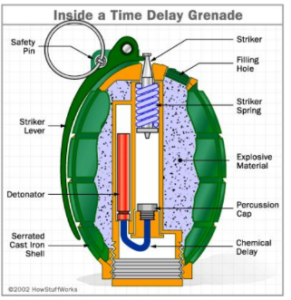
It is essentially a small bomb that is armed by removing the safety pin and allowing the safety lever to release. Once released a spring throws the lever off the grenade and rotates the striker into the primer of the grenade. The primer creates a small flash like that of a matchhead which ignites a slow-burning material that composes the fuse.

The fuse burns at a controlled rate and is designed to delay the initiation a set amount of time, commonly in grenades it is 3-7 seconds from point of initiation [1].
Once the flame reaches the detonator, it explodes and initiates the main charge of the grenade causing the desired effect, be it blast or fragmentation. (Sectioned Grenade drawing [2])

Explosive train

What is an Explosive train?

An explosive train is a series of explosive detonations increasing in size and force that is used in order to have a low energy input cause a high energy output.

Due the insensitivity of high explosives, they require a lot of energy to cause a detonation. Therefore using an explosive train allows for a smaller energy input to cause the detonation of a primary sensitive explosive, which in turn gives enough energy to the next stage of the train until it ultimately reaches the main charge of the train.

Explosive trains can differ in length, size and the type of input energy (friction, electric discharge, heat) but all follow the same principles of small highly sensitive charge start to large low sensitivity charge end.

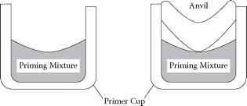
Primer

Primer caps are small explosive devices that are filled with a sensitive primary explosive such as Lead(II) Azide. The primary explosive is sandwiched between a the case and a piece of metal called an ‘Anvil’ that when struck with the striker, pinches the (Anvil in a primer cap [3])
primary explosive detonating it, creating the flash required for the initiation of the fuse.

Lead(II) Azide (Pb(N₃)₂) is a highly sensitive primary explosive with instant deflagration to detonation transition, detonating at 5,180m/s after any fall greater than 150mm, a discharge of 7mJ or if touched by an open flame.

Using the Modified Kirstiakowsky-Wilson rules to find the decomposition products of Lead(II) Azide, it is known that the balanced equation for detonation is as follows;
Pb(N₃)₂ Pb + 3N₂

The heats of explosion (ΔH) for Pb(N₃)₂ is found by taking the Energy of the products and deducting the energy of the reactants. In Lead Azide’s case ΔH is +469kJ/mol with an exothermicity of +1612kJ/kg. [4]

Fuse

The fuse of a grenade is used to create a time delay between initiation of primer to detonation of the grenades main fill.
This fuse is usually consisting of a slower burning powder fill that will burn at a known consistent rate, transferring the energy to the detonator for its own initiation.

This delay is a safety feature for the operator so they can throw the grenade away from themselves a safe distance before the device detonates.

The composition of the fuse can be any burning powder, Flaked TNT as an example could be used for this application as due to its lower sensitivity, when in a flake form it will deflagrate through without detonating. This will provide a good medium for the energy transfer from primer to detonator.

Using the Modified Kirstiakowsky-Wilson rules to find the decomposition products of TNT, it is known that the balanced equation for detonation is as follows;
C₇H₅N₃O₆ 4½C + 2½CO + 2½H₂O + 1½N₂

The heat of formation, ΔH, for Flaked TNT is -26kJ/mol, therefore the exothermicity is -115kJ/kg [5].

Detonator/Booster

The detonator/booster’s job is to take the energy from the fuse and create a large enough detonation wave to shock the main explosive fill into its own detonation.
Tetryl was first created in 1906 and was a common explosive at the time for blasting caps.

It is more sensitive than TNT but also more powerful being 1.25 times the explosive force than that of TNT, and is currently commonly found in boosters and fuzes in munitions such artillery shells [6].

Using the Modified Kirstiakowsky-Wilson rules to find the decomposition products of Tetryl, it is known that the balanced equation for detonation is as follows;
C₇H₅N₅O₈ 1½C + 5½CO + 2½H₂O + 2½N₂

These reactants and products give the heat of formation ΔH of +34kJ/mol and the exothermicity of +118kJ/kg.

Main Charge

The main charge is the largest net explosive quantity within the grenade, it will be the most stable of the explosive compounds hence the need for an ignition train.
Commonly in grenades the main charge is a variable of RDX, a more energetic explosive than TNT at 1.17 times the explosive force [7].

Using the Modified Kirstiakowsky-Wilson rules to find the decomposition products of RDX, it is known that the balanced equation for detonation is as follows;
C₃H₆N₆O₆ 3CO + 3H₂O + 3H₂

These reactants and products give the heat of formation is +62kJ/mol with an exothermicity of +279kJ/kg. [8]

Manufacturing processes & Health Hazards

Lead(II) Azide

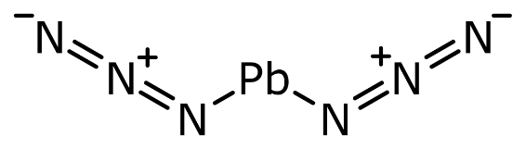
The manufacture of primary explosives is hazardous by nature due to the extremely high sensitivity of the compounds being created. Accidents and explosions can happen in the stages of preparation, before any mixing has begun. [5]

Due to this, it is vital that anyone manufacturing primary explosives follow a strict safety procedure and be fully trained with all the correct equipment present before setting foot in a manufacturing lab.

Lead Azide is prepared by dissolving a lead nitrate into a solution with dextrin at a pH level of 5 where sodium hydroxide is added to keep the pH stable.
The solution is then heated to a temperature between 60-65ºC and stirred.
The sodium azide is dissolved in a solution of sodium hydroxide and the mixture is added via drops into the lead nitrate solution.

The mixture is allowed to cool to room temperature (21-24ºC) with continuous stirring. Lead azide crystals are then washed with water and dried. [9]

The manufacture of Lead azide uses a lot of chemicals that are hazardous to health, along with the end product being sensitive to all forms of initiation means there has to be methods in place to keep the safety of the personnel in production.

For the end product explosive, a check needs to be done to see how the crystals have formed, as standard Lead Azide crystals are 0.07mm in size and spherical. If any crystals are larger than this, they are a hazard as they will be more sensitive and easier to initiate than the ‘standard’ sized crystals. In this instance, or before, the addition of dextrin to the crystals will act as a colloiding agent keeping the crystals to a uniform size and shape.

Lead Azide does have Lead salts within which are deadly for humans to ingest along with various alkalines and acids being used in its creation, it is best to know the COSHH sheets for each and the protocols in place in the case of someone being contaminated with one of the substances used.

Very careful transportation methods should also be put in place to avoid unsafe movement of the Lead Azide as a drop from a fall would easily detonate the substance.

Flaked TNT

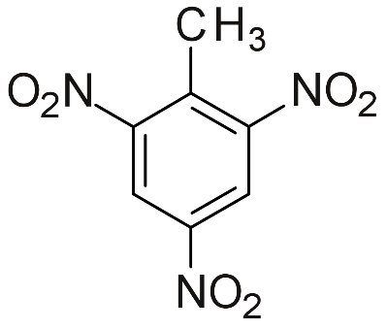
TNT has been being manufactured since 1902 and has gone through a few processes of manufacture.
TNT is produced by the nitration of toluene and mixed with nitric and sulfuric acids in several different steps.

Toluene is first nitrated to mononitrotoluene and then dinitrotoluene and finally crude trinitrotoluene. The trinitration step needs a high concentration of mixed acids with some free SO₃ groups.

Currently, the nitrating process of toluene is continuous and is attained by having toluene enter the reactor at one end and trinitrotoluene produced at the other. Nitrating acid flows opposing the direction of toluene and is topped up as required at various points. Stirring the components together helps to increase the nitration speed and therefore the yield of TNT [10].

Once the yield is formed the TNT must go through a purification process where it is treated with sodium sulfate solution to convert the impurities into by products which are then removed by washing them with an alkaline solution.

Once pure TNT is attained, it is washed with hot water, flaked and then packed ready for use. In this case where flaked TNT Is needed, it does not go through the packing process.

TNT is poisonous to humans and is well documented, 17000 cases of TNT poisoning with 475 fatalities recorded from World War 1 manufacturing operations. The primary route to exposure is via dust ingestion and inhalation of TNT particles. TNT poisoning has the ability to cause liver necrosis and aplastic anemia [11].

Because of this, it is important that all personnel to be in operation of manufacturing TNT must wear full PPE including particulate filter mask, goggles and suitable clothing. They must also be trained on all equipment and processes before starting any work.

Tetryl

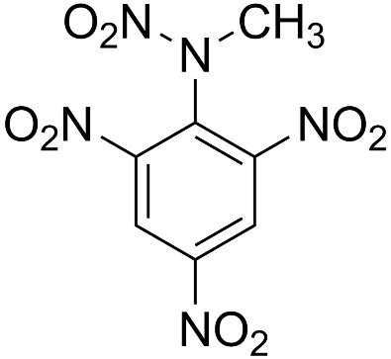
Tetryl is prepared by dissolving dimethylaniline in sulfuric acid and adding nitric and sulfuric acids at 70ºC.

Once Tetryl is created it is purified by washing in cold and boiling water, later hydrolyzing the tetra-nitro compounds.
Once that is complete the Tetryl is recrystallized by dissolving it in acetone and condensed with water.

Similar to the previously written explosive compounds, the processes to manufacture use harsh chemicals that can cause issues when in contact with human skin, eyes or internal organs if ingested.

Prolonged exposure to Tetryl can cause nausea, vomiting, headache, fatigue, sleeplessness and irritability. If exposed to high levels or for a longer period of time, nosebleeds, yellow staining and discolouration to hands, face and neck can also occur.

The best ways to reduce exposure is to have exhaust ventilation in the lab being used, whilst wearing protective clothing that is washed immediately after use [12].

RDX

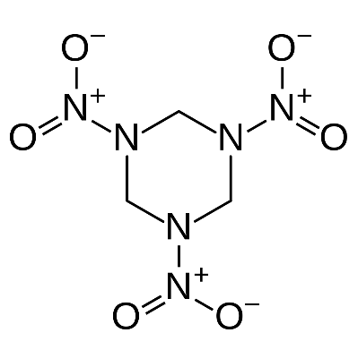
The simplest method of preparing RDX is by adding hexamethylenetetramine to an excess concentrated nitric acid at 25ºC and warming to 55ºC. RDX is condensed with cold water and then boiled to remove any soluble impurities.

RDX is them purified by recrystallization via the use of acetone. The impurities from RDX are what make the explosive HMX.

There are two main methods for RDX manufacture being the Woolich/Herz method which produces the impurities required for HMX alongside the RDX, or the Bachmann method which produces RDX type B.

The most common route of being exposed to RDX is via contaminated drinking water. RDX is not a classified human carcinogen however it does target the nervous system and can cause seizures if large amounts are ingested.

It is necessary for manufacturers of RDX to dispose of waste RDX in a responsible manor to avoid natural contamination. Along with previously stated correct PPE on personnel and up to date training for all who work in the manufacturing building [13].

Works Cited

[1] | I. V. Hogg, Small Arms, Grenades and Projected Munitions, Greenhill books, 1998.
[2] | A. Mahato, "SciLynk," 25 10 2018. [Online]. Available: https://www.scilynk.in/hand-grenade/#:~:text=The%20Mechanism%20of%20a%20Hand%20Grenade%20The%20firing,is%20held%20in%20place%20by%20the%C2%A0%20safety%20pin.. [Accessed 30 11 2020].
[3] | B. Fitchett's, " Bev Fitchett's Guns," 07 07 2020. [Online]. Available: https://www.bevfitchett.us/chemical-analysis-of-firearms/primer-cups-caps.html. [Accessed 07 12 2020].
[4] | J. Akhavan, The chemistry of Explosives 2nd edition, Swindon: RS.C, 2004.
[5] | J. P. Robert Matyáš, Primary Explosives, Pardubice: Springer, 2013.
[6] | Global Security, "Booster Explosives," 2000. [Online]. Available: https://www.globalsecurity.org/military/systems/munitions/explosives-booster.htm. [Accessed 07 12 2020].
[7] | R. T.A.Roberts, "A COMPARISON OF THE EXPLOSION HAZARDS ASSOCIATED WITH THE TRANSPORT OF EXPLOSIVES AND INDUSTRIAL CHEMICALS WITH EXPLOSIVE PROPERTIES.," ICHEME SYMPOSIUM, Merseyside & Derbyshire.
[8] | J. Akhavan, Chemistry of Explosives 3rd edition, Swindon: RSC Publishing, 2011.
[9] | W. Powell, ACB, New York: Barricade Books, 1989.
[10] | ATSDR, "Tox profiles," [Online]. Available: https://www.atsdr.cdc.gov/toxprofiles/tp81-c4.pdf. [Accessed 08 12 2020].
[11] | United States Environmental Protection agency , "Technical Fact Sheet - 2,4,6-Trinitrotoluene (TNT)," United States Environmental Protection agency , 2014.
[12] | New Jersey department of health and senior services, "Tetryl: Hazardous substance fact sheet," New Jersey department of health and senior services, Jersey, 2000.
[13] | United States Environmental Protection Agency, "Technical Fact Sheet - RDX," Environemntal Proteciton Agency, 2014.

