IOANA GABRIELA BODNAR
STUDENT NUMBER: 1817471
MODULE: Introducing the Modern Workplace
TUTOR: HUSAM HELMI
ASSIGNMENT 1

TESCO...
INTRODUCTION:

Founded in 1919 in London Tesco is a largest retailer in the country and fourth-largest worldwide. It holds 30 percent share of Great Britain’s supermarket sector. The Tesco was built by a young man named JACK COHEN, he had started selling his first own~ product, tea in 1924. Tesco’s first supermarket opened in 1956 in a converted cinema. It now has a total of 6,800 stores with over 3500 stores in Britain, employing 472,000 staff worldwide. In 1995 it introduced a loyalty scheme that now has over more than 35 million club card holders. It is reported that in 2010 company generated 62.5 billion pounds in sales and earned a profit of a 3.4 billion pounds. Through the years of existence it was involved in multiple fundraisings, charities and community grants. In my essay I will describe how this company operates and what structures it has. I will take a deeper look at Tesco’s culture and how it impacts sales, performance, staff and customer happiness. Culture of a company is a complex matter itself, every large business has its own based on what they are trying to achieve, built around company’s goals, internal policies and preferences regarding their staff members and their customers. Definition of “culture” itself states that it is a “way of life”, especially the general customs and beliefs, of a particular group of people at particular time; but also has its own characteristics:
Learnt -in process of “passing it down” (from elders or people who has been part of that culture longer).
Shared - as something that is shared among groups of people, it is not the thing that someone possesses individually.
Social - product of society and social interactions.
Continuous - it is a process of growing whole that includes in itself, achievements of the past and present.
Adaptive - to the people associated in that culture.
Varies - all the elements of culture like dressing, ways of eating, speaking varies from society to society
  - STRUCTURE
When it comes to company’s structures there are different categories of business and all of those affect how company is run, maintained, how much tax they pay and what are the legal risks to their own assets and company’s assets. A choice for a company to decide what kind of business they want to be should be balance between legal protection and benefits. These categories are:
Sole proprietorship – business where the owner has full control over his/her company and does not produce separate busses entity meaning that all assets and liabilities are also a personal ones.
Partnership – business owned by two or more partners. There are two subcategories of this kind of structure – limited partnership (LP) or limited liability partnership (LLP). Each LP most have only one general partner with unlimited liability and rest of the owners have limited liability, when in LLP’s all of the owners have limited liability.
Limited liability company (LLC) – it allows to have benefits of both partnership and corporation structures. LLC’s is much easier to protect from personal liability in most instances in cases of bankruptcy or lawsuit .Instead, profits and losses are listed on your personal income without facing corporate taxes. However, members of an LLC’s are considered self-employed and must pay self-employment tax contributions towards Medicare and Social Security.
Corporations.
Nonprofit Corporation – these are corporations made to pass on the profits for different kinds of goals, for example – charity, religious, educational or scientific. Because their work benefits the public, nonprofits can receive tax-exempt status, meaning they don't pay state or federal taxes income taxes on any profits it makes.
Cooperative – Essentially, cooperative is a business or organization owned by and operated for the benefit of those using its services. Profits and earnings are divided equally among the members , also known as user-owners.
(Tesco 2010)
Tesco’s itself is a public limited liability company, where “public” means that that it is open
to a stock market, and shares of the company can be bought. It makes sense for the major owners of the company as they still maintain status of self-employed person, having their private assets protected from any business failures; at the same time qualifying to pay less tax than they would as a corporation.
When it comes to supermarket’s internal structures and organization the company has an internal hierarchy starting with store director, down to store manager and multiple lower-rank manager assigned to specific tasks and roles for example personnel manager, stock manager or security manager, with smaller teams underneath them. (Fig. 2)
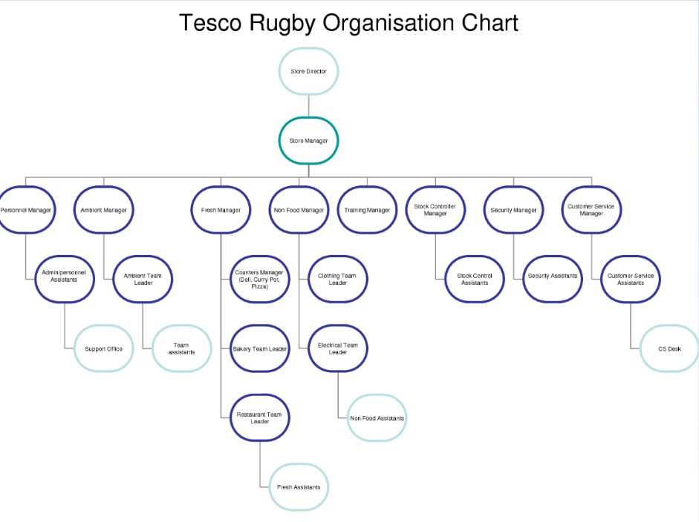
Fig. 2 Internal organization of Tesco’s structures
There are also different kinds of Tesco stores depending on store purpose and size such as Tesco Superstore, Tesco Extra, Tesco Express, Tesco Metro and Tesco gas stations.
Even though company does not have to do this Tesco’s is committed to corporate social responsibility through contributing 1.87 percent (in 2006) of its pre-tax profits to charities and local community organizations. Company is well known for its charitable actions like the one started in 1992 called “computer for schools scheme” where until 2004, 92 million pounds worth of equipment was donated to schools and hospitals.
  - CULTURE:
Culture also has its own institutions of influence – family, religion, school, politics and economics; and can be divided into different types like material culture, dressing, food, architecture, non-material culture, language, family, religion and education. It is a matter of great importance for companies like Tesco’s to develop and nurse culture of their own. It helps to communicate company’s vision to their staff members but also affect how they interact with each other and customers. It describes supermarket’s identity and dictates how members of this culture for example approach different problems, having in mind concepts and ethics that this company believes in (agrees upon) as a whole.

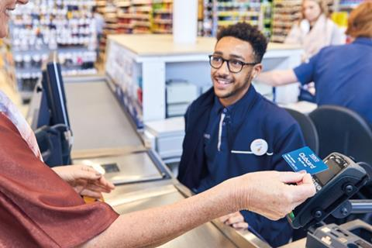
  - Fig 1.1 Photo of a cashier at one of TESCO `S supermarkets.
  - HOFSTEDE: NATIONAL CULTURE
In UK culture through the lens of the 6 models, they can get a good overview of the deep drivers of British culture to other world cultures. This article describes this 6 models of national cultures: Power Distance, Uncertainty Avoidance, Individualism /Collectivism, Masculinity /Femininity, Long /Short Term Orientation and Indulgence /Restraint. This conceptual shows and research efforts that preceded it and led up to it, and once it had become a paradigm for comparing cultures, research efforts that followed and built on it.(HOFSTEDE, G 2011 )
HOFSTEDE` S CULTURAL DIMENSIONS EXPLAINED WITH EXAMPLES

  - : 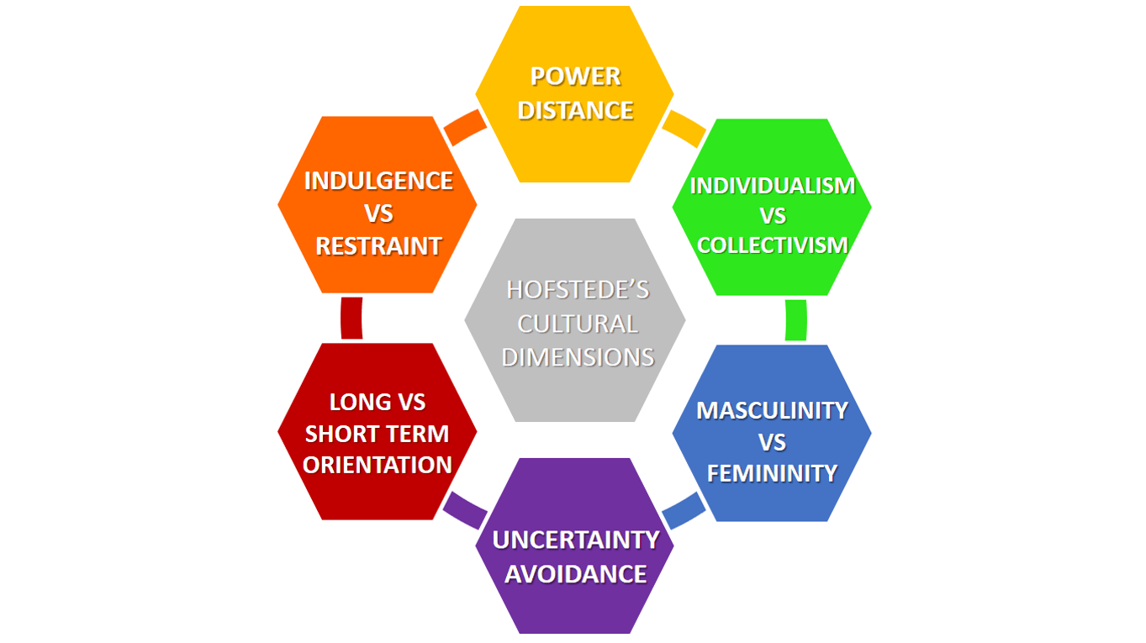
  - PEOPLE;
Tesco cares about their own employees and their personal needs. Motivated employee is an employee that is productive and creative, and supermarket is well aware of that. Company tries to motivate people by not only by showing the appreciation for their work or by offering them advancement within the business but also by making sure they help them out in different areas of their lives. This is based on Maslow’s pyramid that covers our needs as humans not only physiological ones but also intellectual, materialistic and spiritual. Pyramid starts at the bottom with basic psychical needs being the foundation such as water, food, place to sleep or clothing. Above that there are safety needs (personal security, resources, property), Love and belonging (sense of connection, intimacy, family, friendship), Esteem (respect, status, recognition) with self-actualization at the top of the pyramid being desire to become the most that one can be. As mentioned before Tesco’s tries to address all of these point and keep their employees happy by (starting from the bottom of the pyramid):
Physiological needs – Social rooms for employees including toilets, place to eat and rest, and lockers for personal belongings.
Security needs – Not only health and safety in the work place but also formal contrast that provide legal safety and cover social security or Medicare.
Love and belonging – Engagement with other employees, group work or opportunities to lead groups of people, crew events.
Esteem – Self-respect and respect for others, feedback that allows to recognize hard working individuals.
Self-actualization – Career development.
(Tesco 2019 ¬our Culture)
Other than that Tesco’s helps their employees with range of benefits such as flexible work hours, free or reduced health benefits, discount gym membership, competitive salaries and plenty more rewards for time of service.
On Tesco’s website they speak about their culture themselves where they state their values and goals, with their motto being “Every little help make a big difference” (also company sees it as their main value); meaning that they are aware of operating in diverse communities worldwide and try to make difference to social and environmental challenges for each and every of their customers and employees. They tend to achieve this through highlighting certain problems such as carbon reduction, health and safety, cyber security and anti-bribery and contribute to solving this issues through fundraising and charities. Tesco states that they are trying to be champions for their customers supporting this with their core values like “no one tries harder for our customers” and “we treat people how they want to be treated”. Their goal is to “serve Britain’s shopper a little better every day”.
  - Maslow`s Hierarchy of Needs
Maslow stated with five-stage model of needs with regards of motivation and he gave distinct names to each level. The first four levels of the pyramid are often referred to the most basic needs, and the most complex needs are at the top of the pyramid. The first model is about physiological need, he present in this level biological requirements for human mind and attainment of basic needs like clothes, food, water , air, sex etc. The second model is been recognized as the protection from elements where the individual will crave for certain levels of security like health insurance, order, anti –theft, stability, freedom from fear etc. (Kaur , 2013).The third level of need is social and include such things as love ,acceptance& belonging, the need for interpersonal relationships motivates behavior. At the fourth level Maslow `s hierarchy can be associated with self esteem needs where he classified into two categories: esteem for oneself and the desire for respect or reputation for others to fulfill the needs related to high prestige and status. In the last stage he explained, referring to deals with the time when the individual has attained fulfillment, seeking personal growth and peak experiences.
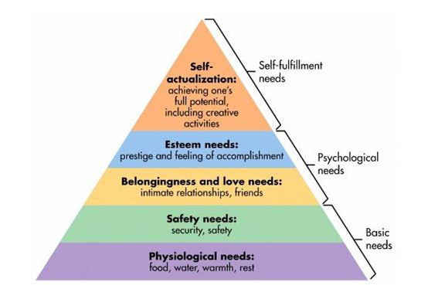
  - (Maslow, 1987, p. 64).
  - PERFORANCE:
It is worth mentioning that despite Tesco’s social awareness and efforts in problems solving company is not controversy-free with some of the biggest ones being price fixing, use of caged eggs and horse meat found in burgers. Another ones being cases where residents of Bourneville, Birmingham in March of 2007 had to legally fight company’s expansion from their historically alcohol-free area, and in 2014, as reported by The Guardian, cases of slavery in Thailand.
  - CONCLUSION:
In conclusion Tesco (that is a public limited company) is Britain’s largest retailer with almost 500,000 employees world-wide and as their website states with 66 customers a second. Company has its own culture where respect and little efforts help to make big changes, where both employees and customers have a clear vision of company’s goals and values. It is a very social aware chain of supermarkets where they address local issues and struggles of people around them. Tesco helps to solve this problems by multiple donations, found raisers, social programs and charities. It cares about their employees keeping them motivated and productive through multiple benefits and aids not only to their work life but also personal ones.

  - REFERANCES:
Paul J. Colbert (2010) Developing A Culturally Responsive Classroom Collaborative Of Faculty, Students, And Institution, Johnson & Wales University, Essay [Online] Available at: https://files.eric.ed.gov/fulltext/EJ1072673.pdf

Christopher Fuster Bueno (2012) The Characteristics of Culture, article [Online] Available at: https://hubpages.com/education/Characteristics-of-Culture

Tesco (2019) Our Culture [Online] Available at: https://www.tesco-careers.com/explore-our-world/our-culture/

McLeod, S. A. (2018, May 21). Maslow's hierarchy of needs. Retrieved from https://www.simplypsychology.org/maslow.html
Maslow, A. H. (1943). A theory of human motivation. Psychological Review, 50(4), 370-96.
https://geerthofstede.com/?utm_source=link%20to%20hofstede%20site&utm_medium=link&utm_campaign=link%20to%20hofstede%20site&utm_content=hofstedesite
"Tesco Performance Management: Performance And Productivity." My Assignment Help, 2017,
Maslow, A. H. (1962). Toward a psychology of being. Princeton: D. Van Nostrand Company.

